Student Name: Joelle Evans
P Number: 1703727
Programme of Study: BA Graphic Design
Module: ADAD5001

Question:
Do graphic designers have a responsibility to produce work that raises awareness for environmental concerns around the planet? Why does the responsibility lie with a graphic designer and can they change the perceptions of others through design?

Key Thinkers:
Lucienne Roberts
Ed and James Harrison
David Attenborough

Artists
Chris Jordan (photographer)
Ed and James Harrison (illustrator and printer)
Lucienne Roberts (graphic designer)

Key Words:
Environment and Graphic Design
Sustainability
Perception
Introduction
In this proposal, the main focus is to look at environmental concerns and how graphic design can contribute, educate and raise awareness of the current issues in today’s society. In order to understand the issue fully, research into global warming, extinction of species, biodiversity loss, recycling and pollution is needed to narrow down these larger issues and create a focused area of interest. The three key words that will be explored in more depth are: Environment and Graphic Design, Sustainability and Perception.

Environment and Graphic Design
Environment is a combination of two words, environ and ment which means “the aggregate of the conditions in which a person or things lives” (etymology dictionary, 2019). Design is derived from the middle French word in the late sixteenth century dessseign meaning “a scheme of plan in the mind” design (etymology dictionary, 2019). The amalgamation of these two areas of study creates an interesting partnership and a platform on which to create an awareness of current environmental issues.
“The first thing to remember is that we can’t be responsible for everyone and everything all of the time”. (Roberts, 2006, p. 90). Design plays a crucial role in raising awareness of the world’s environmental issues but there is only so much design can do. The rest of the work must be facilitated by the public, how they perceive, react and act on this information is up to them. Many graphic designers in the twenty first century feel a great responsibility to make changes in the world through their work. Furthermore to Roberts thinking on the designers remit, is it a designers job to single handily change perceptions and protect the world and are they able to achieve this whilst working for large companies. Can they in fact stand by their personal ethics to produce work that will be beneficial to the environment and therefore become a part of a movement larger than one individual. Arguably graphic designers have a role to play in raising awareness of the issues in the environment, does that mean that graphic designers have ethical responsibility to choose environmentally friendly jobs? Do they need to use more sustainable materials? When does the graphic designer get involved and how can they produce an item of work that would be recognised as an environmentalist designer? There are designers that are currently raising awareness for some of the global issues on earth, these include people such as Lucienne Roberts, companies such as WWF and under the skin of endangered animals. Lucienne Roberts believes that ‘we have a responsibility to make the best use of our talents.’ (Roberts 2006, p. 90) so if a designer can create a piece of work that can make a change in the world, they have a responsibility to do so. However, that is a lot of pressure being applied to the designer in the contemporary world and is it really their responsibility to do something about it? Chermyett believes that ‘Graphic design is not heart surgery. In the grand scheme of things, it’s a pretty small contribution’ (Chermyett 2005, p. 175) therefore, why are such big issues falling onto the shoulders of a person who realistically just wants to create artworks that deliver a message? Ultimately the blame for the planets issues today lies with us all, so how will a piece of art change a person’s perception or alter their beliefs. The world is going through a current environmental crisis, indeed it is such a large and overwhelming issue that ‘MPs have passed a motion making the UK parliament the first in the world to declare an “environment and climate emergency”’ (Cowburn, 2019), but it’s an issue we all need to solve together. People are aware of the problem, design works only act as a reminder or can it help those who are unknowingly oblivious, will anyone actually act on that imagery? The question is can they actually make any difference.

In his artwork, Gyre ll, Chris Jordan has recreated a famous piece of work by Vincent van Gogh by using 50,000 cigarette lighters, which is ‘equal to the number of pieces of floating plastic in every square mile in the world’s oceans’ (Jordan, 2011). In doing this Jordan is trying to raise awareness of the issues of litter and plastic in the oceans by recreating famous artworks in the hope that people will engage with the issues through his design work. It is an extremely powerful image, creating a visual impact on the mind, inducing an emotive reaction as the realisation of the impact humans are having on the planet enters the individual’s consciousness. Plastic is a product that has only been around for 100 years but has caused a huge impact on the environment, with every piece of plastic ever created still existing on our planet in some form according to Baker (Baker, 2018). Plastic is everywhere and we are creating more, statistically we have created more plastic in the last 10 years than ever before. This information makes Jordan’s art particularly powerful, timely and hopefully influential in raising awareness of such a large problem. However, it could be argued that the image is only made powerful through the tagline (as quoted above) that comes with the image. Does the image need the context in order to create that visual impact the artist is implying? The perspective could be diminished without knowing the context and lead to misunderstanding of the message he is trying to convey, creating the polar opposite effect and essentially creating the artwork as being a part of the problem. Does that take away the impact of the image?

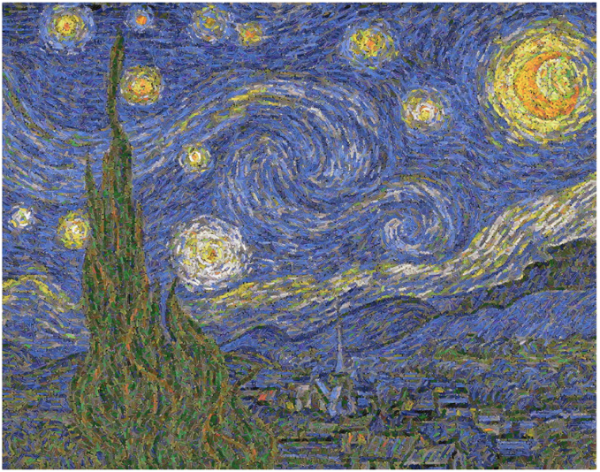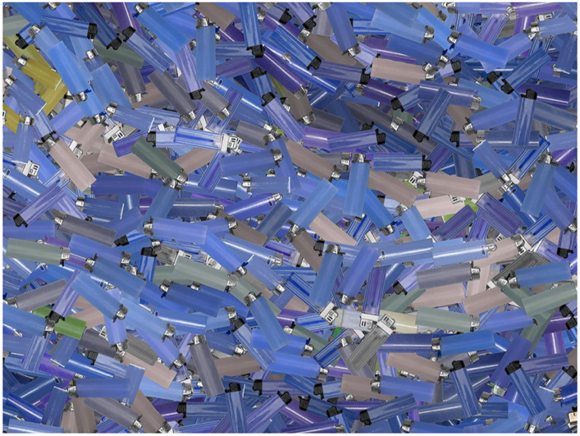
Figure 1 and 2 (Jordan, 2011).

Sustainability
The word sustainable originated in the early seventeenth century. It is a culmination of two words, sustain and able meaning “capable of being continued at a certain level” (etymology dictionary, 2019). The word has now evolved to portray more current issues and become a key ideology in contemporary society. Historically, design did not prioritise sustainability, however, from new research and evidence the realisation of how important sustainability is in design has changed perceptions, creating a transition of materials they use, processes and outcomes of the moral ethical designer.

‘The word sustainable can apply to any action that does not degrade the systems supporting it, and therefore can persist indefinitely’ (Dougherty, 2008, p. 28), it is a word that is being used regularly and becoming the “norm” of the contemporary world with everything becoming more “sustainable”. Electric cars, recycled clothes, solar powered systems are just a few of the steps society has taken to try and address the issue. With new information being formulated on a daily basis from technology and research, sustainability is becoming a more realistic life choice, however the financial circumstances of these new technologies can be costly, creating a negative impact to those who want to live a more sustainable life with the costs outweighing the benefits of sustainable living. Companies around the globe are trying to become more sustainable, by changing products, the way that they produce work or using more eco-friendly materials, they are raising awareness of the issues in the system, but is this because it matters to them or improves their own image? Designers themselves are becoming more aware of the products they are using, being taught to be sustainable and using the information that is available to them to be able to choose to work for environmentally friendly companies. Yet again, it is the human species fault that the planet is in a crisis, David Attenborough has said that ‘nature once determined how we survive, now we determine how nature survives’ (Attenborough, 2019). This is a very current debate, yet much of the damage has already been done by previous generations, can the deterioration be reversed by becoming more sustainable, or has too much damage been done and how much impact can current sustainability actually have.

The worlds 7.6 billion people represent just 0.1% of all living things. Yet since the dawn of civilisation humanity has caused the loss of 83% of wild mammals with the endangered species list doubling in the past decade (Under the Skin, 2019).

The company Under the Skin of Endangered Animals are a very eco-friendly and sustainable company, who are trying to raise awareness for society to rethink the issues. The company is run by two brothers, Ed and James Harrison who have travelled around the world and witnessed first-hand the issues and environmental concerns that have created the increasing deterioration of the habitat of animals. They use what they have seen to create artworks with the aim to protect and change perceptions of not only endangered animals but also the habitat that surrounds them. Their hopes and aspirations are that their work will help to create a positive change in the world through their “prints that protect”. The artwork below, Bornean Orangutan, is just one of the prints they have created in an attempt to highlight the problem, with their prints only containing sustainable products, from the paper to the ink everything is environmentally friendly. A simple but clever piece of design, with a torch you can shine on to the print to expose just a skeleton, an image of what would remain of that species if it was to become extinct. A powerful prediction of the future of these animals. Every print that is bought from the company pays a small contribution to save the species with a percentage of the price going to conservations who work on protecting the animals. It would be hard to find any faults with this company, however, there could be an argument that there are more pressing concerns than the welfare of a few animals; with global warming, plastic pollution, co2 and fossil fuels having a larger impact on both the planet and the climate. What should be prioritized and why does that issue become more important over the rest? Every living organism on earth has a role to play in the planets eco systems. ‘We don’t have the ability to know when it’s okay to lose a few of the working parts’ (Sea Turtle Conservation Bonaire, 2016), for instance if all sea turtles were to become extinct, it wouldn’t just be the extinction of that species, It would equate to the extinction of several species and this is happening with more species than we know. Knowing this information does that change the impact of the artworks and conservations of animals? All of the concerns are inextricably linked, culminating the untimely extinction of animals, and possibly the extinction of the human race too. Therefore, we need more companies like these to educate and change our perceptions in order to address the problems.
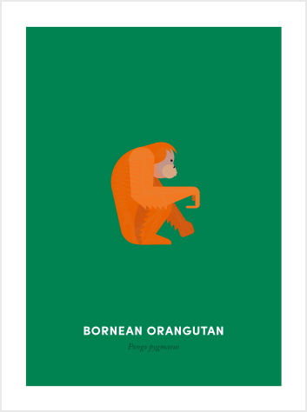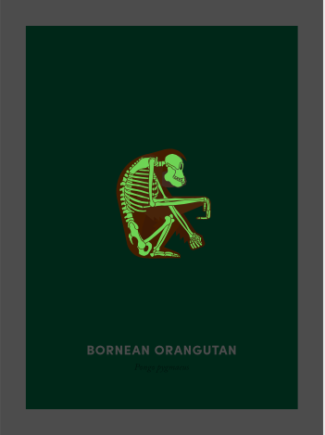
Figure 3 and 4 (Harrison, 2018).
Perception
Perception is derived from the Latin perceptionem, however was used more literally at the beginning of the 17th century meaning “the taking cognizance, of” (etymology dictionary, 2019) and is an important word when it comes to looking at the environment, design and sustainability.

Perception is essentially a mental impression that leaps beyond observation to judgement, ‘the way we see things is affected by what we know or what we believe’ (Berger 2008, p. 8). Subconsciously our minds already have pre-existing knowledge, anything new exposed to the mind is unknowingly being influenced by what an individual has seen or heard. This creates tainted perceptions of issues of the planet. This may manipulate and distort the truth creating new reality’s and possibly diminishing the seriousness of these issues, making them seem minimal and insignificant. Psychologically the human mind goes into denial when ‘the reality is too painful to bear, so you distort it until its bearable’ (Esanu, 2018). Perception is unique to every individual, causing misinterpretation of the size of problems to fit in with their own concepts, something large could be deemed very insignificant or alternatively something miniscule may seem momentous. Although the world is in crisis, the majority of the population only see this through media such as television and radio or design works such as posters and leaflets, so their perception of these issues are already tainted as all the information we receive is second hand knowledge. Perceptions are already modified creating a possible alternate version of reality by diminishing or intensifying problems. However, is there an argument that without all the information that the public receives from designers, advertisers, environmentalists and conservationists the environmental concerns could be disregarded. How important does that make these professions? Design plays a crucial role in awareness; it influences and educates perceptions subliminally as well as intentionally.

Perception plays a pivotal part in design works; the designer has a clear idea of what message they are portraying through their work, paradoxically though, the message may be completely misconstrued. It is critical that the correct message is conveyed. Lucienne Roberts, in her exhibition, has used lights and letters to create a clever dual meaning. The lights on the word “was” flicker on and off to create the word “is” creating the phrase “the future was here” to change to “the future is here” creating a different meaning. Done for design purposes, showing that design was and still is here forever changing and evolving. However, without context this can be perceived in many different ways. Daniel Chandler believes that ‘context influences perception, leading us to favour one interpretation over the other’ (Chandler 2007: 151). For example, if used in a different context such as the future of earth, the future of animals, or even the future of the human race, it can change not only the meaning behind the images but also the way the sign is perceived. Which one would you notice more? Do design works need to have context for the meaning to be explained?
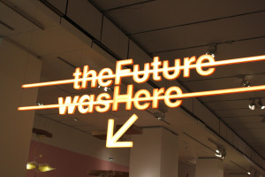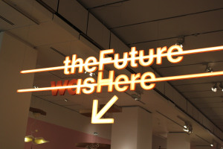
Figure 5 and 6 (Roberts, 2013).
Conclusion
After researching the three words in depth and exploring the environmental concerns and sustainable issues of the contemporary world it has led to explore in more depth how much impact a graphic designer can have in changing perceptions. How much of a role does a graphic designer really play in the way people perceive problems in the world? How much influence does a designer have on perceptions and decisions? Do graphic designers care, and of those who do care, are they even able to find the right jobs to make a difference? Should it be their responsibility? Although these issues are vast, the importance of them must now be a primary concern as it has become such a current issue. Having looked in more depth in areas such as, ethics of a graphic designer, sustainability and environmental concerns and through exploring theorists and books such as Good: an introduction to ethics in graphic design. This has led to a dissertation question of:

Do graphic designers have a responsibility to produce work that raises awareness for environmental concerns around the planet? Why does the responsibility lie with a graphic designer and can they change the perceptions of others through design?

Bibliography

Books:
Berger, J. (2008) Ways of Seeing. 01 Edition. London: Penguin Books Ltd.
Chandler, D. (2007) Semiotics the Basics. 2nd Edition. New York: Routledge.
Chermayeff, I. (2005) ‘discussion 9’, in Roberts, L. Drip-dry shirts: the evolution of the graphic designer. AVA Publishing: Switzerland.
Dougherty, B. (2008) Green Graphic Design. Allworth press: New York.
Roberts, L. (2006) Good:an introduction to ethics in graphic design. Lausanne: AVA Academia

Video:
Attenborough, D. (2019) Our Planet: David Attenborough speech at premiere [video]. Available at: https://www.youtube.com/watch?v=zlKkqQHCCCs (Accessed: 26 April 2019).

Websites:
Baker, K. (2018) Get Earthed. Available at: https://www.get-earthed.com/blog/2018/4/10/every-piece-of-plastic-ever-created-still-exists (Accessed: 9 April 2019).
Cowburn, A. (2019) MP’S make history by passing commons motion to declare”environment and climate change emergency”. Available at: https://www.independent.co.uk/news/uk/politics/climate-change-environment-emergency-commons-motion-mps-vote-latest-a8895456.html (Accessed: 7 May 2019).
Esanu, E. (2018) Designing Perceptions Instead of Solution’s. Available at: https://uxplanet.org/designing-perspectives-instead-of-solutions-6afb4b03c1a5 (Accessed: 7 May 2019).
Jordan, C. (2011) Chris Jordan. Photographic Arts. Available at: http://www.chrisjordan.com/gallery/rtn2/#gyre2 (Accessed: 9 April 2019).
Online etymology dictionary (2019) Design. Available at: https://www.etymonline.com/word/design#etymonline_v_46757 (Accessed: 26th March 2019).
Online etymology dictionary (2019) Environment. Available at: https://www.etymonline.com/word/environment#etymonline_v_8757 (Accessed: 26th March 2019).
Online etymology dictionary (2019) Perception. Available at: https://www.etymonline.com/word/perception#etymonline_v_12667 (Accessed: 26th March 2019).
Online etymology dictionary (2019) Sustainable. Available at: https://www.etymonline.com/word/sustainable (Accessed: 26th March 2019).
Sea Turtle Conservation Bonaire (2016) Are Sea Turtles Worth Saving? Available at: http://www.bonaireturtles.org/wp/explore/are-sea-turtles-worth-saving/ (Accessed: 22 April 2019).
Under the Skin (2019) Shining a light on extinction. Available at: https://undertheskin.co.uk/mission/ (Accessed: 22 April 2019).

Images:
Figure 1 and 2
Jordan, C. (2011) Gyre II. [Van Gogh painting recreated out of plastic cigarette lighters]. Available at: http://www.chrisjordan.com/gallery/rtn2/#gyre2 (Accessed: 2 April 2019).
Figure 3 and 4
Harrison, J and Harrison, E. (2018) Borneo Orangutan. [Screen print]. Available at: https://undertheskin.co.uk/shop/orangutan/ (Accessed: 2 April 2019).
Figure 5 and 6
Roberts, L. (2013) The future was here. [Installation]. Available at: https://katiemtownsend.wordpress.com/2013/09/08/shows-i-visited-in-summer-2013/ (Accessed: 2 April 2019)

