This essay will include three images of families who face poverty and are at severe risk of social exclusion due to how the group is depicted within society. The aim of this portfolio is to gain a deeper insight into how 21st century society views families in poverty through social media and newspapers. The Joseph Rowntree Foundation (2019) defines ‘poverty’ as
“not being able to heat your home, pay rent or buy the essentials for your children. It means waking up everyday facing insecurity, uncertainty and impossible decisions about money. It means facing marginalisation and discrimination because of your financial circumstances” (Joseph Rowntree Foundation, 2019).
This definition suggests that a family who face these everyday challenges are without the resources, money and opportunities to succeed and excel in life as much as a family in a better financial situation (Sen, 1992). Due to these financial uncertainties, a family may face challenges with housing, employment, education and being able to afford basic necessities in life. The definition of ‘poverty’ suggested by JRF (2019) suggests why families who face this are being excluded in society as they face an unequal and unfair chance in society which impacts their future. Families in poverty often face social exclusion as they may receive a lower educational attainment leading to the struggle to find employment and becoming excluded from the labour market. Families facing poverty also receive health problems and the risk of substance and alcohol misuse which can result in further exclusion (Tucker, 2018).
Social exclusion plays a risk factor for children who face poverty as research suggests children struggle in gaining qualification, skills and experience for future employment when in poverty as their families are unable to afford and support them as much as a family in a higher class (JRF Analysis Unit, 2017). This highlights the exclusion children may face when attending school, often this can lead to further exclusion as the individual enters the labour market. This is reinforced by Bynner (2019) who states an individual’s socio-economic status is one of the main reasons an individual is prevented to do well in life. Individuals are restricted to goods and opportunities that others in better positions and statuses can afford. These factors constitute towards an excluded future as it contributes to individuals in family having no job, insecure housing and low financial status.
The hardship families in poverty experience due to having insufficient funds to make ends meet impact their lives in many different ways. These include health, education, employment and social interaction which lead an individual to be eliminated from society (Joseph Rowntree Foundation, 2019). Children raised from a deprived family setting are more than likely to have poor school results, behavioural challenges and difficulty finding employment (Bovaird, Ferguson and Mueller, 2007). These obstacles will be furtherly discussed throughout this portfolio proposing how society plays an influential impact on the family becoming excluded.
The typical nuclear family which had once been considered the social norm for decades has now changed dramatically. A diverse family structure consisting of same sex marriages, step families, transgender families, single parent families now represent the 21st century family notion (Whitehead, 2008). Despite these diverse structures all play a role in the definition of family, for those families facing poverty who are eliminated in society due to their financial and social status are often underrepresented through the media and public eye (Mckendrick et al, 2008). Through media stories and reports, a typical representation of a criminal is portrayed though criminals and badly-behaved individuals (Gans, 1979).
As the Office for National Statistics (2012) suggests an increase in diverse, family structure has been presented over the decades enforcing the change in definition. Research by Ferri & Smith (2003) suggests step families are becoming increasingly popular in the 21st century. This research contributes to the term ‘social exclusion’ where over the decades step families were more probable to face poverty and live in more deprived areas. It can be argued that stereotypically single parent families who are represented in the media and soap opera are depicted as reliant on the welfare state and are often deviant or known trouble makers (Spicker, 2002). This depiction contributes to the idea of families in poverty being socially excluded as if they are recognised its due to their poor portrayal not their positive behaviour, nature or successfulness.
The Office of National Statistics (Knipe, 2017) defines a family as:
“either a couple, married, cohabiting, or in a civil partnership with or without children or a lone parent with one or more children, dependent or non-dependent”.
This definition suggests that society’s representation of a family involves two parents and does not seem to consider single parent families. This view gives readers an insight into how 21st century families are perceived. The research suggests society see families as having two generic parents and unless a family has both parents, the Government does not see this as a whole family.

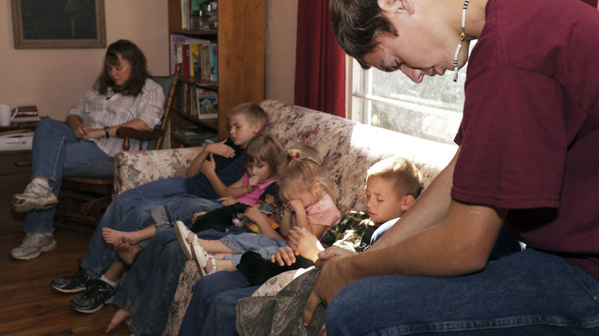
(Frank, 2016)
This image by Franks (2016) shows a family of four children and two parents sitting in a living room presenting sad and worrying facial expressions. The picture depicts the family from a low working-class background which is suggested by the home they live in, the way the individuals look and the concern on the parents face which suggests the family are struggling financially. Family poverty is a key factor of families at risk of exclusion which is presented through socio-economic factors such as wealth, income, social activity, where a family may live and what opportunities they have access to in life. Atkinson (1998) who studies social exclusion and the impact it has on families in poverty suggests there are economic indicators, cultural indicators and poverty indicators which result in families in poverty being excluded in modern day society. Suggested by Atkinson (1998) families of a low working class or whom may rely on solely welfare state are depreciated through the eyes of society. Due to families in poverty’s representation through the media, society devalues the group and discriminates them due to their financial status. Sen (1992) made some research into why families in poverty become at risk of social exclusion, his findings resulted in the group becoming denied access to ‘material, cultural and emotional resources’ (Bynner, 1996.) Sen’s research into the lack of resources presented to families in poverty suggests that often due to financial status families are unable to afford privileges that those from a higher class can afford. This picture depicts a family in poverty struggling to make ends meet and worrying about the upcoming struggles. This image represents societies perception on the group of family in poverty as it displays a negative representation of what the group feel and look like to the rest of society (Elliot, 2016).
Within the United Kingdom, the population of those families in poverty has largened widely throughout the 21st century, statistics presented by O’Leary (2019) show the family population in poverty has risen to 14.2 million people. The high demand of families in poverty creates media stories and news headlines resulting in society’s perception of this group becoming excluded and being treated like an outcast. The Joseph Rowntree Foundation (2008) states ‘Poverty in the UK is a marginal issue in mainstream media’. Although research suggests poverty was not previously reported to have been a news sensation in previous decades, the media acknowledged that by singling out families in poverty and presenting headlines which presented stories of those in poverty being far-reaching and momentous it would be successful in gaining more readers. Particularly as those in poverty represented a large majority of society, it gains readers attention. Often what is presented through media is incorrect information which is used to the media’s advantage to present insufficient truth which those in poverty are not in the position to challenge.
Research suggests those families in poverty are barely heard but often seen, in the 20th century, representations of families and children were presented through paintings, drawings and poetry as suggested by Ridge (2002) as the diverse change in family settings has changed massively over the decades, the voice of family settings has arisen and is more discussed than previous times, however those in poverty still remain the least significant and important to society resulting in the group being ignored.
Like demonstrated within this picture, the media and society’s interpretation of families in poverty suggest the group are not favourable in the public eye. Particularly when the media shapes the ‘at risk of exclusion’ group to resemble dole and benefit thieves. (Benedictis, Allen & Jensen, 2017). This stereotype causes further exclusion to the group as society starts to depict the families as delinquent. The impact of these negative representations results in mental health problems rising contributing to further pressures being faced by the family. Furthermore, with lack of financial status, this means the ability to seek help may be more difficult and can contribute to health and well-being which can continue in later life. Children may become resentful towards their parents in this situation as they are faced with financial uncertainties and are restricted to opportunities and resources (Ridge, 2009). A family’s safety and security may be imposed when lacking fundamental materials. Relationships amongst family members in poverty may be more hardened and children may have a more difficult time coping with a financial burden. From media representations, families in poverty are often displayed as poor and unfortunate, resulting in the children rebelling and deviant as they are often without the necessities, they need therefore turn to crime to make ends meet (McKendrick et al, 2008). However, because of these depictions from the media, society and viewers see families in poverty as a negative group when in reality, the true lives those families in poverty live are not often explored.
Sustainable communities and its impact on those families in poverty relates distinctively to the lack of employment in society, the trouble to gain skills and qualification through education is another factor which categorises in how poverty impacts the sustainable community. Often images are presented through the media of the low working class being unemployed and receiving benefits however this can often be exaggerated and played out by the media who seek those in poverty as a target to shape viewers and readers opinion of the socially excluded group. There are several disadvantages to families in poverty as presented by The Sustainable Development Goals, access to education, healthcare and adequate living conditions all impact an individual gaining employment (United Nations, 2019). By encouraging an inclusive, sustainable future for families in poverty, the likelihood individuals will receive more opportunities and a successful future.

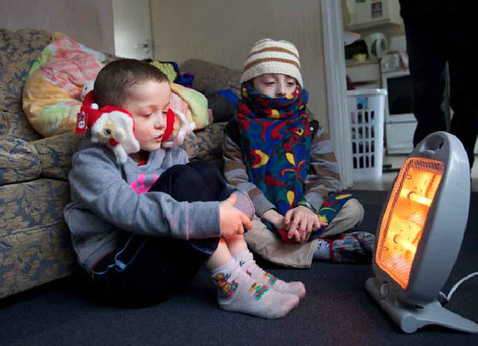
(End Fuel Poverty Coalition, 2019)

This second picture presents a sad and distressing image to viewers as the children try to keep themselves warm during winter, due to families unable to afford heating. The children are seen wearing layers of clothes and are situated in front of a mini heater to keep themselves heated. This image features two young boys facing poverty as the cost of heating is too expensive for the family to afford. This image creates a sad and pitiful representation to viewers as we recognise the struggle some families experience. In comparison to the usual images which are presented through the media, such as individuals on benefits, this image shows the true experience that those families in poverty go through to make ends meet and to protect their loved ones. In the 21st century, the gap between the rich and poor has become rather separated and distinguishing suggests Robson (2009.) Robson states
“Featuring the experiences of people living on low incomes can certainly bring a story alive and make it accessible. It can give a voice to people experiencing poverty, but it also carries risks for individuals and there is a significant danger of misrepresentation. Nevertheless, it is a real opportunity to get across messages that need to be heard.”
This suggests that today’s society is not as forthcoming or supporting to the idea of families struggling and being deprived of goods and resources. The representation of a family in the 21st century is presented very dissimilar to the normalised breadwinner father and stay at home mother. In fact, as suggested by the John Rowntree Foundation (Strelitz & Darton, 2003) both parents are likely to be in employment in the 21st century, with the quality of work being more significant than previous times. Families now face more pressures and stress alongside taking up employment, parenthood and managing to survive financially in day to day life. Childcare is expensive and when both parents are in employment, parents have no choice but to put children in creches and nurseries. However, for families in poverty who are unable to afford these necessities, they have no choice but to stop working which adds a further financial burden and risk of exclusion.

This image may impact social exclusion as viewers may take a negative approach to this type of image and link it with parents being unemployed, not earning enough money to care of their children and even consider this image with families relying on benefits. Viewers may see this as an opportunity for families to get others to feel sorry and pity for them and the life they live. As suggested by Chauhan & Foster (2014)
“Most media studies on poverty point in the direction of a recurring observation that usually the poor are presented in one of two contrasting frames: the ‘deserving poor’ and the ‘undeserving poor’. While the frame of deserving poor employs a sympathetic treatment of the poor, the frame of the undeserving poor is built upon the rhetoric of deficiency in individuals who are portrayed as a burden on the taxpayer due to their dependency on welfare policies”

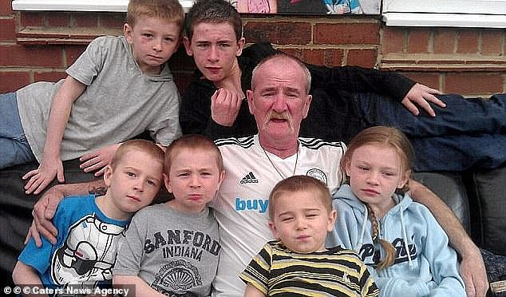
(Moseley, 2013)
This third image is a very dissimilar image presented of ‘family in poverty’ and contrasts the first two images due to the individual Mick Philpott who features in the photo. The source which presented this image was Daily Mail who aimed to depict this family as being reliant on the state with the headline of the newspaper quoting "Vile Product of Welfare UK” (Dolan & Bentley, 2013). This image symbolises a negative view of those relying on the state and facing poverty particularly as the older male in this newspaper is a British man who is currently in jail for manslaughter after his children were killed in a housefire he started (Dolan & Bentley, 2013). This image can contribute to individuals in poverty being despised and discriminated by the rest of society as readers may depict this 2017photo and associate this image with the rest of society who are struggling in poverty. This image demonstrates a typical example of how one image can gain bad press, negative views, opinions and how the media can influence society’s views (Tsfati & Cohen, 2013). This example suggests how families in poverty face social exclusion as identified in this coverage, the image solemnly focuses on a poor family with several children, parents who are unemployed and are ‘too lazy to work’ therefore rely on the benefit system to fund their lifestyle and housing (Bell, Baumberg & Gaffney, 2019). The Joseph Rowntree Foundation (2008) state “the tendency for negative reporting of poorer people, particularly in the tabloid press was a widely recognised feature of coverage.” Due to the large audience that newspapers and tabloids wish to gain, the more brutal and negative headlines and portrayals of those facing poverty can experience, the more viewers media gain. This leads to an injustice in society where families in poverty who already face challenges and barriers are further exploited by exclusion.

As seen in this image, the faces the young boys pull, the hand gesture a boy initiates behind his father and the sad expression displayed by the rest of the children all display presentations of what supposedly represents those in poverty. As suggested by Joseph Rowntree Foundation (2008), “the media influence public opinions about poverty” which as suggested by this image is accurate as viewers who see this image will associate other single parent families who are unemployed as negative and lazy resulting in social exclusion and labelling. Clawson & Trice (2000) suggest that the reason newspaper use pictures of parents with many children to represent families in poverty is due to the belief that the more children a family has the more money they will receive from the benefit system. This view reinforces societies view on those in poverty as it is filled with negativity and incorrect facts (Hall, Leavy & Greevy, 2014).

To conclude this portfolio, the three images displayed presented three different types of portrayals of families in poverty. The images used were representations from newspaper articles, magazines and online sources which suggests the impact images can have on excluding a group as they shape society’s view of the group. Due to the popularity of social media, TV, soap opera’s and newspapers, there is a constant view of family depictions particularly those from a low socio-economic background where for example demonstrated in EastEnders and Coronation Street represent deviant, desperate thieving characters who remain in the criminal justice system. The images presented suggest poverty is not often discussed and the reasons behind why those in poverty are in that situation are not explained through the media, therefore often individuals perceive the group as negative and blame the group for being in the situation they are in. The images used in this portfolio are all negative and give the view that families in poverty are deviant, poor and lazy, likewise the images all include the individuals looking sad, poor and unfortunate.

The concept of Sustainable Development is not adapted everywhere which makes the lives of families in poverty that much more challenging and secluded. As suggested within the main body, if access to education, housing, healthcare and employment were easier to achieve for families of a low class, then the individuals would have the ability to educate themselves, take part in more activities and opportunities and achieve employment and become financially stable. However, the reality is, as the labour market stands, to be successful in employment an individual has to have skills, qualifications and experience which for a family who does not have the opportunities and resources to meet these requirements, poverty will continue to exist.

References

Atkinson, Anthony B. and Hills, John (1998) Exclusion, employment and opportunity. CASEpaper, Atkinson, A. B. and Hills, John (eds.) (4). Centre for Analysis of Social Exclusion, London School of Economics and Political Science, London, UK.
Beaumont, J. (2011) Households and families: Social trends 41. Office for National Statistics
Bell, K., Baumberg, B. and Gaffney, D. (2019). Benefit system riddled with ‘stigma’ | Poverty and Social Exclusion. [online] Poverty.ac.uk. Available at: http://www.poverty.ac.uk/report-benefits-attitudes/benefit-system-riddled-%E2%80%98stigma%E2%80%99 [Accessed 17 Jul. 2019].
Benedictis, S., Allen, K. and Jensen, T. (2017). Portraying Poverty. [online] Eprints.whiterose.ac.uk. Available at: http://eprints.whiterose.ac.uk/118888/7/AllenPortraying%20Poverty%20AAM.pdf [Accessed 16 Jul. 2019].
Bovaird, S., Mueller, M and Ferguson, H. (2007). The impact of poverty on educational outcomes for children. [online] PubMed Central (PMC). Available at: https://www.ncbi.nlm.nih.gov/pmc/articles/PMC2528798/ [Accessed 16 Jul. 2019].
Bynner, J. (2019). RISKS AND OUTCOMES OF SOCIAL EXCLUSION INSIGHTS FROM LONGITUDINAL DATA. [online] Oecd.org. Available at: http://www.oecd.org/education/innovation-education/1855785.pdf [Accessed 16 Jul. 2019].
Bynner, J. (1998). USE OF LONGITUDINAL DATA IN THE STUDY OF SOCIAL EXCLUSION. [online] OECD.ORG. Available at: http://www.oecd.org/education/innovation-education/1856691.pdf [Accessed 16 Jul. 2019].
Chauhan, A. and Foster, J. (2014). Representations of poverty in British newspapers: a case of ‘othering’ the threat?. [online] Eprints.lse.ac.uk. Available at: http://eprints.lse.ac.uk/55289/1/Chauhan_Representations-of-poverty-in-British-newspapers_2014.pdf [Accessed 16 Jul. 2019].
Clawson, R., & Trice, R. (2000). Poverty as We Know It: Media Portrayals of the Poor. The Public Opinion Quarterly, 64(1), 53-64. Retrieved from http://www.jstor.org/stable/3078840
Cohen, J. and Tsfati, Y. (2013). Perceptions of Media and Media Eff ects. [online] Onlinelibrary.wiley.com. Available at: https://onlinelibrary.wiley.com/doi/pdf/10.1002/9781444361506.wbiems995 [Accessed 17 Jul. 2019].
Culliney, M., Haux, T. and Mckay, S. (2014). Family structure and poverty in the UK: An evidence and policy review. [online] Eprints.lincoln.ac.uk. Available at: http://eprints.lincoln.ac.uk/14958/1/Family_structure_report_Lincoln.pdf [Accessed 16 Jul. 2019].
Dolan, A. and Bentley, P. (2013). Vile product of Welfare UK. Daily Mail, [online] 127(4), p.1. Available at: http://www.dailymail.co.uk/news/article-2303120/Mick-Philpott-vile-product-Welfare-UK-Derby-man-bred-17-babies-milk-benefits-GUILTY-killing-six.html [Accessed 16 Jul. 2019].
Elliott, I. (June 2016) Poverty and Mental Health: A review to inform the Joseph Rowntree Foundation’s Anti-Poverty Strategy. London: Mental Health Foundation [Accessed 16 Jul. 2019]
Ferri, E. and Smith, K. (2003) Family Breakdown and Family Conflict: The NCDS cohort as parents. NCDS User Group Working Paper, P. 49
Ferguson, H., Bovaird, S., & Mueller, M. (2007). The impact of poverty on educational outcomes for children. Paediatrics & child health, 12(8), 701–706. doi:10.1093/pch/12.8.701
Frank, B. (2016). Middle Britain becomes the ‘new poor’ as poverty stalks the nation. [image] Available at: https://www.rt.com/uk/352083-middle-class-poverty-poor/ [Accessed 16 Jul. 2019].
Gans, H. (1979). Deciding what’s the news. New York: Pantheon Books.
Goodman, A. and Gregg, P. (2010). Poorer children’s educational attainment: how important are attitudes and behaviour?. [online] Jrf.org.uk. Available at: https://www.jrf.org.uk/sites/default/files/jrf/migrated/files/poorer-children-education-full.pdf [Accessed 16 Jul. 2019].
Hall, S., Leary, K. and Greevy, H. (2014). Public Attitudes to Poverty. [online] Jrf.org.uk. Available at: https://www.jrf.org.uk/sites/default/files/jrf/migrated/files/Attitudes_towards_poverty_full.pdf [Accessed 17 Jul. 2019].
Joseph Rowntree Foundation. (2017). UK Poverty 2017. [online] Jrf.org.uk. Available at: https://www.jrf.org.uk/sites/default/files/jrf/files-research/uk_poverty_2017.pdf [Accessed 16 Jul. 2019].
Joseph Rowntree Foundation. (2019). What is poverty?. [online] JRF. Available at: https://www.jrf.org.uk/our-work/what-is-poverty [Accessed 16 Jul. 2019].
Knipe, E. (2017). Families and Households - Office for National Statistics. [online] Ons.gov.uk. Available at: https://www.ons.gov.uk/peoplepopulationandcommunity/birthsdeathsandmarriages/families/bulletins/familiesandhouseholds/2017 [Accessed 16 Jul. 2019].
McKendrick, J., Sinclair, S., Irwin, A., O’Donnell, H., Scott, G. and Dobbie, L. (2008). The media, poverty and public opinion in the UK. [online] Spectacle.co.uk. Available at: http://www.www.spectacle.co.uk/uploads/other%20media/PovMMedia,%20poverty%20and%20public%20opinion%20FINAL.pdf [Accessed 16 Jul. 2019].
Mooney, A., Oliver, C. and Smith, M. (2009). Impact of Family Breakdown on Children’s Well-Being. [online] Pdfs.semanticscholar.org. Available at: https://pdfs.semanticscholar.org/ab35/024df163dce1857b188a8ea9d31a7a18b101.pdf [Accessed 16 Jul. 2019].
Parisi, P. (1998). A Sort of Compassion: The Washington Post Explains the Crisis in Urban America’. Howard Journal of Communications, 9, 187–203. DOI: 10.1080/106461798246989
Ridge, T. (2009). Living with poverty. [online] Bris.ac.uk. Available at: http://www.bris.ac.uk/poverty/downloads/keyofficialdocuments/Child%20Poverty%20lit%20review%20DWP.pdf [Accessed 16 Jul. 2019].
Sen, A. (1992) Poverty Re-examined. Cambridge (Mass):Harvard university Press
Spicker, P. (2002). Poverty and the Welfare State. [online] Rightsnet.org.uk. Available at: https://www.rightsnet.org.uk/pdfs/catalystaugust2002.pdf [Accessed 16 Jul. 2019].
Strelitz, J. and Darton, D. (2003). Tackling UK poverty and disadvantage in the twenty-first century. [online] Jrf.org.uk. Available at: https://www.jrf.org.uk/sites/default/files/jrf/migrated/files/1859350909.pdf [Accessed 16 Jul. 2019].
Tucker, J. (2018). The impact of poverty on child health. [online] RCPCH. Available at: https://www.rcpch.ac.uk/news-events/news/impact-poverty-child-health [Accessed 16 Jul. 2019].
United Nations (2019). Goal 1: End poverty in all its forms everywhere - United Nations Sustainable Development. [online] United Nations Sustainable Development. Available at: https://www.un.org/sustainabledevelopment/poverty/ [Accessed 16 Jul. 2019].
Whitehead, D. (2008). Historical Trends in Work-Family: The Evolution of Earning and Caring. [online] Sciencedirect.com. Available at: https://www.sciencedirect.com/topics/psychology/blended-family [Accessed 16 Jul. 2019].

Image Reference List
Chauhan, Apurv and Foster, Juliet (2014) Representations of poverty in British newspapers: a case of ‘othering’ the threat? Journal of Community and Applied Social Psychology, 24 (5). pp.390-405. ISSN 1052-9284 DOI: 10.1002/casp.2179
End Fuel Poverty Coalition. (2019). [image] Available at: http://www.endfuelpoverty.org.uk/ [Accessed 16 Jul. 2019].
Moseley, T. (2013). Vile Product of Welfare UK. [image] Available at: https://www.huffingtonpost.co.uk/2013/04/03/daily-mail-front-page-on-mick-philpott-provokes-online-storm_n_3003909.html?guccounter=1&guce_referrer=aHR0cHM6Ly93d3cuZ29vZ2xlLmNvbS8&guce_referrer_sig=AQAAAER_ynMJ1SPGKpq8pU6HUIGeyN-OChgtxXuoXBw8pfakXlLwyIcHrIYm9VSH4cn23n_7gA-_rY0C67yXCKh2bpvdOrQjVNqo2250-LOkVkjrs4yXq7iydxz4rb0lfzLgGAA80aI3AT0csngcB569mXL3_cZwW9IjMdlExu6V_CUm [Accessed 17 Jul. 2019].

