
Assessment component 2: Marketing Strategies Portfolio
Student ID: 2527935
Student Name: Krish Ghanshyambhai Sharma
Course Name :- Marketing Management (LCMB7024)
Lecturer Name :- Dr Muhammad Tariq
Term :- February 2026
Word Count :- 2568
Submission Deadline :- 1st May 2026

Table of Contents
Element 1: Poster 3
Element 2: Development of STPD analysis for the brand extension 4
Element 3: Marketing Mix 8
Element 4: Reflection 12
Reference list 14
Appendix: Poster 17

Element 1: Poster
Introduction to the brand extension of Dyson
Dyson, a UK-based home technology and engineering innovator, is fuelled by the demand for luxury appliances. The company announced more than £7.1 billion in revenues worldwide in 2024 (Dyson, 2025). Based on its experience in the field of air purification and acoustics, Dyson can introduce AirWave Pro. This product is a smart pair of headphones with an in-built personal air purification system to provide clean airflow and allow people to enjoy immersive noise-cancelling sound in the city.
Market appeal
The growing urban pollution and concern with personal health are predetermining consumer preference in protective technological products. It has been estimated that more than 90% of the global population inhales contaminated air, and therefore, innovation is of paramount importance (WHO, 2022). The USP of the AirWave Pro is that it is a device of high-fidelity audio with real-time air purification, which has two functions. This would attract commuters and professionals who want convenience, health protection, and high-quality lifestyle technology in one product.
Alignment with sustainability
The AirWave Pro complies with the sustainable engineering approach of Dyson, as it employs filtration systems that consume less energy and materials that can be recycled. Its modular structure and longevity are ensured by its robust design and less electronic waste. Dyson's vision has been described as a progressive, sustainability-focused technology (Dyson, 2024). Therefore, the AirWave Pro reduces the use of resources by combining two devices in one, and contributes to sustainability-based innovation.

Element 2: Development of STPD analysis for the brand extension
Segmentation
Geographic | - Urban cuties, including London, Birmingham and Manchester  - Areas with high pollution exposure and traffic congestion
Demographic | - Individuals between 25 and 45 years of age  - Middle to high-income professionals
Psychographic | - Eco-aware and health-conscious tech adopters  - Consumers who are influenced by wellness and sustainability trends
Behavioural | - Convenience seekers, frequent commuters and tech users  - Individuals who value multifunctional products
Table 1: Market segmentation
(Source: Self-created)
The UK Dyson AirWave Pro segmentation targets urban dwellers where there is an interplay of pollution and commuting. Air pollution continues to be a major concern for citizens, with transport and urban emissions being the major causes of air pollution. Additionally, air pollution in the UK is accelerating the onset of chronic diseases, which means consumer health awareness is increasing (Fuller, 2026). Geographical prioritisation of cities such as London and Birmingham is because of their large populations and exposure to pollutants. The 25-44 age group is well-suited, as it is the most active working population and the most likely to spend on high-quality technology.
Psychographically, the UK consumers are becoming more sustainability-oriented due to governmental policies. The imposition of the Environment Act (2021) and the rising awareness of environmental impact contribute to sustainability orientation (Legislation, 2021). Wearable technology is increasing in popularity, with an estimated 37% of consumers in the UK adopting it by 2025 (Mintel, 2023).
Targeting
Dyson will use a differentiated targeting strategy of a target market of urban professionals aged 25-44 in the UK, with a higher number of people commuting daily in major urban centres such as London. Simultaneously, the use of technology has been on the increase, with more than one-third of UK consumers owning it by 2025 (Mintel, 2025). This group is very topical because of long-term exposure to contaminated conditions and the great demand for high-quality and innovative products. Commuting is one of the most important features of urban life, as millions of people use the services of the transport system every day, exposing themselves to the impact of particulate matter and traffic pollutants (Rasca and Saeed, 2022). The targeting part helps Dyson to synchronise both the aspirational and practical consumer needs, ensuring brand cohesion and lucrative market penetration.
This population has also been found to have increased disposable income and is willing to invest in technology that improves lifestyle. Moreover, the growing interest in health risks, including respiratory diseases and conditions of pollution, stimulates a need for prevention measures (Shahriyari et al. 2022). It has been reported that air pollution is one of the causes of high health expenditure and low quality of life in the UK.
Positioning
Dyson AirWave Pro stands out in the UK market based on innovation in its category, excellence in engineering and integration of health. Dyson does not offer a product that competes with other audio devices like Sony or Bose, since they only emphasise the performance of audio but do not offer any personal air purification. Dyson’s unique filtration system provides the brand with a proposition that is not pertinent to its market competitors (Dyson, 2024). This is an innovative and relevant creation in the UK, as the growing pollution range is pertinent to severe health conditions. This problem is directly addressed by the fact that the product will be able to offer real-time filtered airflow during commuting.
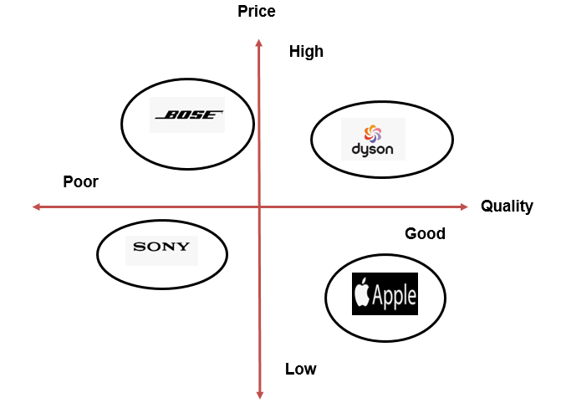
Figure 1: Positioning map
(Source: Self-created)
Also, it has a high-quality industrial design to support brand recognition and attract fashion-conscious consumers in the UK. Consumers and regulators in the UK continue to exert pressure to cut the amount of electronic waste (TechUK, 2025). The modular and robust design of AirWave Pro contributes to the ability to repair and durability. Between health, convenience, and high-performance audio, Dyson develops a distinct value that can hardly be replicated by competitors to position AirWave Pro as a functional need and a luxury lifestyle item.
Differentiation
Dyson AirWave Pro is poised to be a high-end, health-conscious wearable in the UK as a product aimed at urban workers who have to navigate polluted zones. The product is at the cross-section of individual well-being and cutting-edge consumer electronics, providing both security and functionality. Positioning builds on the brand name of Dyson as an engineering innovator, and is fitting with the growing UK consumer interest in air quality and health (Dyson, 2023). As pollution is correlated with the increase of medical problems and lowering the quality of life, AirWave Pro is not just a luxury, but a certain preventative style of life.
The product lies on a perceptual map, which represents a high-innovation and high-price product compared to conventional headphones and standalone air purifiers. Such positioning means that the AirWave Pro will attract status-conscious, health-conscious customers and the idea of Dyson as a technology-driven leader of the pack in its solutions to the demands of modern urban life.

Element 3: Marketing Mix
Product
The Dyson AirWave Pro is a premium wearable that will target urban contexts in the UK, which integrates advanced noise-cancelling headphones with in-built air purification. The product relies on the Dyson filtration system that helps reduce exposure to pollutants that could be abundant in UK cities, in particular, when commuting. It is also characterised as smart with features such as real-time air quality and connectivity with apps, which aligns with the growth of the use of connected devices in the UK. Modular design allows one to be environmentally friendly through repairing and minimising electronic waste (Ipaki and Hosseini, 2025). Dyson will be able to match the functional and aspirational values, securing high penetration in the market and brand identity.
Price
Dyson will use a premium pricing in the UK, which will reflect its high brand equity and high level of technology. The AirWave Pro will be placed among top-quality audio products, and will focus on consumers who are ready to spend on quality and innovation. Consumer perception that the high cost of a product is associated with high performance and durability favours premium pricing (Milios and Dalhammar, 2023). Also, the product is worth the price, given the dual functionality of the product, since it substitutes both headphones and portable air purifiers. This pricing model will help Dyson retain its luxury image, at the same time attracting professionals who will be interested in long-term health and lifestyle advantages.
Place
Dyson will implement an omnichannel distribution in the UK. AirWave Pro will be sold on the official AirWave website, in the flagship stores and through the upscale electronics outlets like Apple shops and at the high-end department stores like Selfridges. E-commerce is important as it indicates further development of online retail in the consumer electronics market (Orzoł and Szopik-Depczyńska, 2023). Furthermore, Dyson demo stores will offer experiential retailing services, where consumers can experience both audio and air purification systems. The key sites in key cities in the UK will mean that they are easily accessible to the target market, in addition to the premium positioning of the brand.
Promotion
Promotion will be important in informing potential consumers about the innovative value of the AirWave Pro product. The advertising plan will emphasise the use of online media since urban professionals read online media and technology materials on a regular basis. The behaviour of purchasing and attitude of consumer awareness in technology markets are affected by efficient strategies in digital marketing (Francis et al. 2023). The use of online campaigns will enable the brand to showcase product features using interesting visuals, videos and user experiences. This will assist the consumers in realising the synergy of audio technology and air purification features.
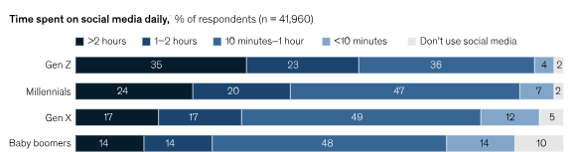
Figure 2: Time spent on social media
(Source: McKinsey, 2023)
Customers in the city will tend to use social media and online feedback to judge high-quality technology products. Approximately 75% of UK consumers of all age groups spend at least 10 minutes on social media platforms (McKinsey, 2023). It indicates the increased relevance of online promotional activities with consumers. Product demonstrations in the large cities will also be done as part of experiential marketing activities that will make consumers more engaged. Such measures will enhance the brand awareness and emphasise the innovation that AirWave Pro is based on.
People
The human element of the marketing mix will highlight how employees will be used to provide quality customer experiences. Employees who will be dealing with customers will need to have good product knowledge and communication to be able to justify why the AirWave Pro device is worth buying. The competence of employees and the quality of their services play a key role in customer satisfaction and brand perception (Putra and Dewi, 2023). Good staff training programmes will thus be required to make employees aware of the technological aspect of the product. This will assist customers in making informed decisions when making purchases.
When considering complex technology products, consumers will often use knowledgeable personnel to assess products. Organisations which invest in training and development programs for employees have a greater customer trust and loyalty (Sihombing and Dinus, 2024). Retail representatives will show the audio performance of the product and air purification. This will enable Dyson to provide a high-quality customer service experience.
Process
Process will be the way and mechanisms by which the product will be made available to the consumers efficiently. Properly designed service processes are going to make sure that customers are convenient and reliable during the purchasing process. Effective service operations enhance the performance of the operations and customer satisfaction (Harahap et al. 2024). The purchasing process will, thus, be geared towards making transactions easier and offering guidance on using the products. This will especially be significant in new products which involve high-technological capabilities.
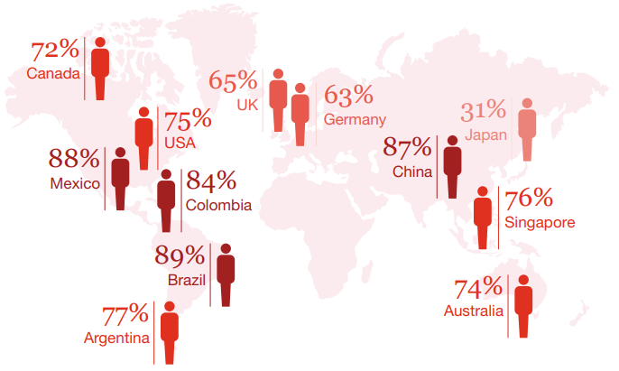
Figure 3: Consumer experience on buying behaviour
(Source: PwC, 2026)
Customers will demand more and more of hassle-free buying experiences, both online and in stores. Around 65% of UK consumers consider customer experience an important factor when choosing a brand (PwC, 2026). Effective delivery services and technical support will thus be important aspects of the strategy. These processes will uphold the high-quality image of Dyson.
Physical evidence
Physical evidence will be the material factors that will determine how consumers feel about the product quality and innovation. The design of products, packaging and presentation of the product in the retail outlets will hence be significant in supporting the high positioning of the AirWave Pro device. Aesthetic design has a strong impact on the consumer perception of electronic products (Sunstrum et al. 2024). The modernity and ergonomic look of the product will allow it to appear technologically advanced. The visual elements will be used to convey the messages of innovation and reliability to potential customers.
Customers will tend to equate high-quality materials and packaging with high performance of the product. Organisations that are focused on product design, especially those that are life-centric and maintain environmental and ethical norms, enjoy better customer interaction and financial results (Borthwick et al. 2022). In-store displays and product images on the internet will also emphasise product functionality. These factors will contribute to the fact that Dyson has a premium brand image.

Element 4: Reflection
The creation of the AirWave Pro brand extension was a valuable experience in using marketing theory in a practical business idea. The project involved consumer needs analysis, environmental issues, as well as technology potential, to come up with a realistic product concept. Effective brand extensions are based on the degree of fit between the parent brand and the new product category. Crisis response strategies are an important part of extension tactics that offer brand equity (Turan, 2022). This notion assisted in the creation of the proposed product by the company. This is because it guaranteed that it would be in line with the experience that Dyson already had in the field of engineering and air technology. This assignment allowed me to learn about the way in which organisations can introduce new products while still ensuring that their brand image remains intact.
I was able to understand the importance of certain marketing concepts such as segmentation, targeting and positioning, by applying myself to this task. This helped me organise my analysis and identify a target market for my product. Strategies of segmentation allow organisations to know their consumers well (Nur and Siregar, 2024). The use of these theoretical models assisted me in analysing the urban professionals as a significant consumer group since they face pollution, and they use technology in commuting. This exercise has improved my critical thinking abilities and proven that marketing concepts can be applied in strategic decision-making within business settings.
Another key learning experience with this project was preparing and presenting the poster. Selecting important pieces of information and systemising them ensures that it is accompanied by pictures, which ensures that people focus and comprehend difficult ideas during presentation (Hao et al. 2026). The poster design process thus prompted me to narrow the core ideas, but still convey the key points of the marketing strategy. The presentation also contributed to my building of confidence in presenting marketing concepts to a group of people in a clear and well-organised manner.
All in all, the project had a positive impact on my personal and professional growth as it enhanced my communication and strategic thinking skills, as well as my research. It was required to select legitimate sources and apply statistical figures in order to make decisions regarding marketing. Research-based analysis improves one's capacity for critical thinking and decision-making within the business environment (Dombrowski et al. 2022). This experience enhanced my skills in writing scholarly and structuring information. To improve my work in the future, I would strive to develop my project by performing a more profound competitor analysis. I will try to get more consumer insights to bolster better strategic suggestions. This would enable me to determine the more formidable competitive benefits and create a better marketing strategy. It would also assist in making sure that future product concepts would be more responsive to the changing consumer needs and market trends.

Reference list
Borthwick, M., Tomitsch, M. and Gaughwin, M., (2022). From human-centred to life-centred design: Considering environmental and ethical concerns in the design of interactive products. Journal of Responsible Technology, 10, p.100032.
Dombrowski, S.C., J. McGill, R., Farmer, R.L., Kranzler, J.H. and Canivez, G.L., (2022). Beyond the rhetoric of evidence-based assessment: A framework for critical thinking in clinical practice. School Psychology Review, 51(6), pp.771-784.
Dyson, (2023). Dyson United Kingdom. Available at: https://www.dyson.co.uk/discover/news/latest/dyson-connected-data-study [Accessed on 20.04.2026].
Dyson, (2024). Filtration at Dyson. Available at: https://www.dyson.co.uk/discover/archive/2021/filtration [Accessed on 20.04.2026].
Dyson, (2024). Sustainability at Dyson. Available at: https://www.dyson.com/sustainability [Accessed on 04.04.2026].
Dyson, (2025). DYSON 2024 RESULTS: Record volumes despite challenging conditions, setting the stage for more product launches in 2025 than ever before. Available at: https://www.dyson.co.uk/discover/news/press-releases/dyson-financial-results-2024 [Accessed on 04.04.2026].
Francis, U.O., Haque, R., Rahman, A., Al-Hunaiyyan, A., Al-Ainati, S., Lokman, F.Z.A. and Isa, M.B.M., (2023). The impact of digital marketing on consumer purchasing behaviour. International Journal of Operations and Quantitative Management, 29(2).
Fuller, G., (2026). Air pollution making people in UK get long-term illnesses earlier, study finds. Available at: https://www.theguardian.com/environment/2026/apr/17/air-pollution-making-people-in-uk-get-long-term-illnesses-earlier-study-finds [Accessed on 20.04.2026].
Hao, X., Valayakkad Manikandan, S., Demir, E. and Eyers, D., (2026). Visual narratives and audience engagement: edutainment interactive strategies with computer vision and natural language processing. Journal of Research in Interactive Marketing, 20(1), pp.68-90.
Harahap, A.T., Kadir, A.R., Nohong, M., Sobarsyah, M. and Sabbar, S.D., (2024). Impact of Service Digitalization on Operational Efficiency and Company Performance: Mediating Effect of Customer Satisfaction in Perumda Tirta Benteng. International Journal of Operations and Quantitative Management, 30(3), pp.36-60.
Ipaki, B. and Hosseini, Z., (2025). Repair-oriented design and manufacturing strategies for circular electronic products, from mass customization/standardization to scalable repair economy. Results in Engineering, 25, p.104169.
Legislation, (2021). Environment Act 2021 CHAPTER 30. Available at: https://www.legislation.gov.uk/ukpga/2021/30/pdfs/ukpga_20210030_en.pdf [Accessed on 20.04.2026].
McKinsey, (2023). Gen Z mental health: The impact of tech and social media. Available at: https://www.mckinsey.com/mhi/our-insights/gen-z-mental-health-the-impact-of-tech-and-social-media [Accessed on 20.04.2026].
Milios, L. and Dalhammar, C., (2023). Consumer perceptions of product lifetimes and labelling: implications for introducing a durability label. Journal of Circular Economy, 1(1).
Mintel, (2023). UK Smartwatches & Wearable Technology Market Report - Market Growth. Available at: https://store.mintel.com/report/uk-smartwatches-and-wearable-technology-market-report [Accessed on 20.04.2026].
Mintel, (2025). UK Technology Trends: Winter 2025 | Mintel Store. Available at: https://store.mintel.com/report/uk-technology-trends-winter-market-report [Accessed on 20.04.2026].
Nur, M.F. and Siregar, A., (2024). Exploring the use of cluster analysis in market segmentation for targeted advertising. IAIC Transactions on Sustainable Digital Innovation (ITSDI), 5(2), pp.158-168.
Orzoł, M. and Szopik-Depczyńska, K., (2023). Development trends in e-commerce sector. Procedia Computer Science, 225, pp.4157-4166.
Putra, M.A.A. and Dewi, L.K.C., (2023). The influence of customer relationship marketing and service quality on customer satisfaction with brand image as a mediating variable. Journal of Social Science, 4(5), pp.2215-2223.
PwC, (2026). Experience is everything: Here’s how to get it right. Available at: https://www.pwc.com/us/en/advisory-services/publications/consumer-intelligence-series/pwc-consumer-intelligence-series-customer-experience.pdf [Accessed on 20.04.2026].
Rasca, S. and Saeed, N., (2022). Exploring the factors influencing the use of public transport by commuters living in networks of small cities and towns. Travel Behaviour and Society, 28, pp.249-263.
Shahriyari, H.A., Nikmanesh, Y., Jalali, S., Tahery, N., Zhiani Fard, A., Hatamzadeh, N., Zarea, K., Cheraghi, M. and Mohammadi, M.J., (2022). Air pollution and human health risks: mechanisms and clinical manifestations of cardiovascular and respiratory diseases. Toxin Reviews, 41(2), pp.606-617.
Sihombing, L. and Dinus, H., (2024). Analysis of business development strategies in increasing customer trust. Journal on Economics, Management and Business Technology, 2(2), pp.84-92.
Sunstrum, F.N., Demirbilek, O., Gardner, N., Viengkham, C. and Spehar, B., (2024). Revealing the synergy between formal aesthetics and product semantics: Exploring the impact of visual form on product perception. International Journal of Industrial Ergonomics, 101, p.103593.
TechUK, (2025). The growing challenge of e-waste and the path toward a circular economy. Available at: https://www.techuk.org/resource/the-growing-challenge-of-e-waste-and-the-path-toward-a-circular-economy.html [Accessed on 20.04.2026].
Turan, C.P., (2022). Deal or deny: The effectiveness of crisis response strategies on brand equity of the focal brand in co-branding. Journal of Business Research, 149, pp.615-629.
WHO, (2022). Billions of people still breathe unhealthy air: New WHO data. Available at: https://www.who.int/news/item/04-04-2022-billions-of-people-still-breathe-unhealthy-air-new-who-data [Accessed on 04.04.2026].

Appendix: Poster
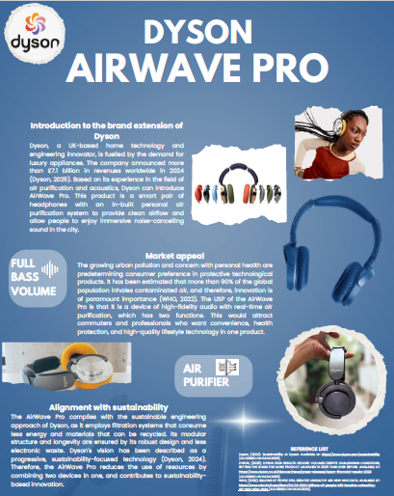
(Canva link: https://canva.link/0n0tefebirl4sy6 )

