

Skills for the Workplace
Module Assignment Submission
Student Name: | Holly Graham
Student Number: | 1910922
Module No: | BMSK4006
Module Title: | Managing Enterprise in the 21st Century  Part One

Statement of Confirmation of Authenticity
By the act of making this submission, the student declares that this is the work of the student named above. The work has not, in whole or in part, been knowingly presented elsewhere for assessment, or where assessment has been built on a previous assessment, this has been identified. Where materials have been used from other sources it has been properly acknowledged. If this statement is untrue, the student acknowledges that an assessment offence has been committed.
Attention is drawn to the plagiarism and unfair practice policies of both the University and of ILM.

Maison Grace Interiors
Business Plan

Holly Graham and Sophie Roberts

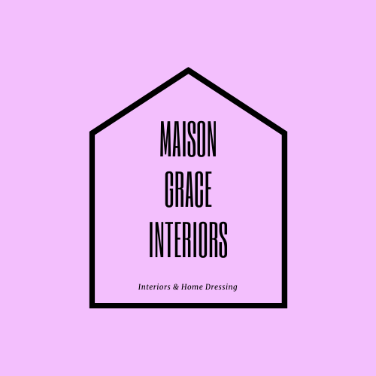

Table of Contents
Key Words 5
Executive Summary 5
Business Overview 5
Mission Statement 6
Client Perspective 7
Markets and Competition 7
Target Markets 7
Competition 7
Sales and Marketing 8
Product positioning 8
Marketing 9
Sales 9
Management 9
Key Personnel 9
Key advisors 10
Premises and Equipment 10
Suppliers and Subscriptions 11
Financial Forecast 11
Sales 11
Cashflow 11
Profitability 12
Financing 12
References 13
Bibliography 14
Appendix A 15
Management CV’s 15
Appendix B 18
Social Media interaction 18
Appendix C 19
Company Registration 19
Appendix D 19
Existing and Potential Clients 19
Appendix E 20
Insights 20
Appendix F 21
SWOT Analysis 21
Appendix G 22
Wave invoices 22
Appendix H 24
Supplier List 24
Appendix I 24
Business Insurance 24
Appendix J 25
Cashflow Projection 25
Appendix K 25
Profit and Loss 25
Appendix L 26
Cost of Goods 26
Appendix M 27
PEST 27
Appendix K 27
Cost of comparable refurbishment 27

Key Words
Directors- Relation of text to both Holly Graham and Sophie Roberts.
‘Instagramable’- Although not listed as an official word in the oxford dictionary, it is described by Jennings (2019) as a recognised word in social media marketing and defined on Urban Dictionary (2015) as a verb that describes a picture worth putting on Instagram.

Executive Summary
Maison Grace Interiors is a brand new interior design and sales company with a quirky, ‘instagramable’ approach. The company will be bringing a multi-channel service to their clients, offering bespoke interior styling for homes and small businesses in the local area of Cardiff and The Vale of Glamorgan and will seek to integrate national product sales of home interiors on expansion. Directors Holly and Sophie have previous experience in creative roles and management and each bring a unique set of skills to the business which are documented in Appendix A. Both Directors want to provide eye catching custom designs that provoke interaction on social media and this will be used as the main marketing tool in year 1. The business aims to turnover £38,264 in the first twelve months and there will be no requirement for external financing.
The demand for home interiors and refurbishments for new businesses is predicted to be consistent year on year with room for innovative thinkers and game changers. According to WalesStats (2019) Cardiff had 1,590 business births in 2018 with an average of 1,672 between 2016 and 2018. We would only need a to connect a project to 0.7% of these businesses to conduct 12 refurbishments in a normal year disregarding Covid-19. Despite current global uncertainty if businesses sell due to business failure, there will inevitably be buyers wishing to re-invent old projects. With more people spending time at home and investing in home projects we have seen the opportunity to include a second income stream in case businesses are slow to adapt to the easing of lockdown. Therefore we will still only need to complete five home projects in year one to make a profit, albeit small it would be a break even situation.

Business Overview
Both directors are opening because past interior design success, related to Holly’s other business and home, has prompted the directors to explore the possibility of bespoke projects. Maison Grace Interiors will provide small businesses with design projects as well as bespoke flower wall and neon installations. Two fully qualified and insured sub-contractors have been appointed to safely provide the labour to all interiors projects for both home and business.
The directors have an exciting and current approach to interior design, and it’s already admired by business and home owners via social media as seen in Appendix B. Our first post advertising our flower wall and neon installation generated 125 likes and 27 comments. (Kumar, Bezawada et al. 2016a) Agree that social media gives businesses an unprecedented reach in terms of communicating with their audience and discusses how social media can add value to a business. In an article by eMarketer (2019) it is considered that social media engagement does drive sales, albeit via paid advertising this can still be achieved at a cost that is reflective of your business.
We aim to create a social media brand that gets seen and creates interest by saturating social media with our quality images. Our Website and social media platforms will be colourful and visually pleasing, in line with recommended popular social media marketing advice. With a boutique feel applied across all current and future aspects of the business, we also aim to provide a personalised experience to our clients by focussing on one client project at a time, this will also reflect our manpower and current availability.
Instagram will be our main marketing tool, our fun and quirky décor will be a talking point and our clients will own businesses that people will want to be seen in. Instagram has changed many industries and catapulted small businesses into the spotlight, therefore we will use this platform continuously in our marketing strategies to generate interest and bookings to our website.
Maison Grace Interiors was established as a business with Companies house on the 18th of February 2020 under the trading name Maison Grace Interiors LTD (Appendix C). We have decided to operate as a Ltd company under the advice of our accountant in relation to our other businesses, both directors won’t take a wage in year one as they are financially stable, instead they will take dividends of the profits as they have a suitable income from their other businesses.
As current and successful business owners, part of the directors Business portfolio plans are to own multiple businesses that fit in with their schedules, to bring in a small income stream via each venture. Our goal is to employ 2 members of staff by the 31st of September 2022 to be fully trained by Holly and Sophie, so they can take over the directors roles full time and aid expansion. We look to end the first year on February 17th 2021 on £38264 and £7996 in profit, spending nothing on external marketing and staff in the first year.
To break even the company would only need one design project per year, or five flower wall installations. The amount of projects completed at one time are reflected by the directors availability and willingness to provide bespoke services and supported by the minimal risk in financing the business.
Our long term goal is to be running a fully functional and current interior design service that is known nationally and internationally due to our fun approach as well as our passion to add our own range of products when the company is ready for expansion. This is something we will be continuously monitoring and will launch at the correct time for our business.
The opportunity for this business is that there is already demand, there are currently no companies in Cardiff offering these services as a package, more details are available in the Competitor analysis.

Mission Statement
When discussing Habit two, Covey (2015, p176) talks about the importance of mission statements and how to apply them to organisations identifying that mission statements are vital to successful organisations. As a result of learning this directors agreed to make their own mission statement.

‘The team at Maison Grace Interiors work to produce bespoke designs to enhance clients homes and businesses. Our creative, modern and imaginative designs aim to bring value to our clients in the form of enjoyment and/or business growth. As a company and an employer we aim to adopt a principle-centred approach to our very core. Providing an exceptional level of standards to all key aspects of our business management.
We stand for Truth, Mental Health, Equality and diversity,’

This mission statement will be added to the website at the next web maintenance which is scheduled for August 20th 2020 and when we employ staff we will alter our statement to reflect their values to encourage their involvement in businesses development.

Client Perspective
As a flower wall client you would have come across one of our installations via social media or from visiting Holly’s business. The client would then contact the staff of social media pages for more information and an appointment would be arranged for one on the staff to measure up the space and talk about design ideas. The client will have a quote delivered to them by preferred contact withing 24 hours.
As a Company owner looking for a bespoke service to refurbish their business the Staff would attend the venue and discuss key points of design including the walls, flooring, safe spacing, colour scheme and budget. The client will be presented with a vision board within one week and an estimated quote for costs, this is then discussed and confirmed. Only small businesses are being considered at this time to reflect manpower.

Markets and Competition

Target Markets
Our target audience are small business owners that are either setting up or refurbishing and home owners that have the disposable income for interior projects. This is reflective of the projects we have already conducted and the interest we have received (Appendix D)
Through insight tracking, Instagram will predominantly determine our target market for the first year. Our current age reach is predominantly age 25-34 and 88% female, 12 % male Appendix E. This tool can be used to monitor interactions and enable us to reflect on results therefor publishing our content based on our audience. Initially we won’t have a marketing budget as we can rely on Sophies influencer account to divert traffic, as well as her connections with other influencers. We will however use profit from year 1 towards marketing in year 2 via different marketing approaches, such as paid adverts, banners, radio and this is encouraged by (Kumar, Bezawada et al. 2016b) who argue that although businesses are investing more in social media, email and television are also important channels to utilise when connecting with customers.
We are unaware of anyone offering this service to our local market and by starting to research further locations we have not found anyone to be offering these designs with fitting as an interior design company. However we are aware that florists have the creative advantage of working with faux flower installations and there is a threat of imitation and being undercut by cheaper products from China. Although we believe that if we penetrate the market first we will have an advantage point and can build our content and increase our client base rapidly and apply momentum.

Competition
When comparing data in accordance to Sources of information for competitor analysis (Davidson 1997) we collated our findings by using observable and opportunistic data. By using social media we have been able to analyse competitors social media presence and interactions with their audience, view their products and services and compare their services visually. We have also used social interactions with a number of the competitors to make a judgement on their business, for example we know through many conversations with AM Interior by Design that he serves wealthier clientele like footballers, refurbishes duplex apartments and larger businesses, although his work is very inspiring to our own vision.

Cardiff and the Vale of Glamorgan | Eden Wedding Design | VIP Event styling | The Flower Kitchen Cardiff | Di Oro interiors | Louise Misell Interiors | Am Interior by Design
Interior Design | X | X | X | YES | YES | YES
Flower Walls | YES | HIRE | YES | X | X | X
Neon lights | X | X | X | X | X | X
Product Sales | X | X | X | X | X | X
STRENGTHS | Creative and experienced in floral design | Creative and resourceful. | Creative, good social media interaction and consistent | Strong interior design knowledge, experienced. | Strong interior design knowledge, digital and visual planning. | Strong interior design knowledge and local presence. Experienced in home and business design for larger companies
WEAKNESSES | Low social media interaction  Doesn’t supply neon lights. | Low social media interaction, doesn’t supply neon lights and only hires flower walls. | Doesn’t supply neon lights. | Targets wealthier clientele, low social media interaction | Low social media interaction | Low social media interaction
Other notes |  |  |  | Targets wealthier clientele | Targets wealthier clientele | Targets wealthier clientele and larger businesses.

Sales and Marketing

Product positioning
Our USP is our flower wall installation and neon lighting, although many businesses have been able to replicate similar ideas, potential clients have still asked for information on who makes the designs that are showcased in Holly’s Business and Home (Appendix D). What sets us aside from competitors in our field is that we focus on giving every customer a 5* experience that makes them want to talk about us as if we were already a well-known brand, we are bringing something new to the local market. As you can see in the competitor analysis, interior designers in Cardiff tend to focus on high end jobs and Florists tend to focus on Floral installations. By meeting in the middle and noticing the weaknesses of other businesses we have been able to identify a gap where we can provide interior design advice to smaller businesses as well as provide bespoke floral and neon projects with or without fitting. Our products are also fire retardant, come with full supplier warranty and we are fully insured for our services. Holly’s Interior Design qualification has also enabled her to choose an influential colour palette for clients as recommended by the colour spectrum wheel for interior design. When comparing customer interest to our competitor analysis we can consider using a cost Differentiation pricing strategy.

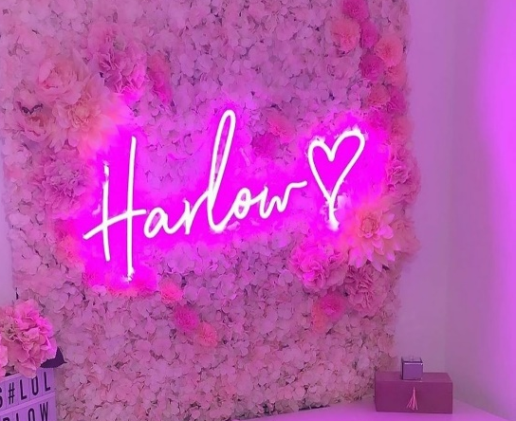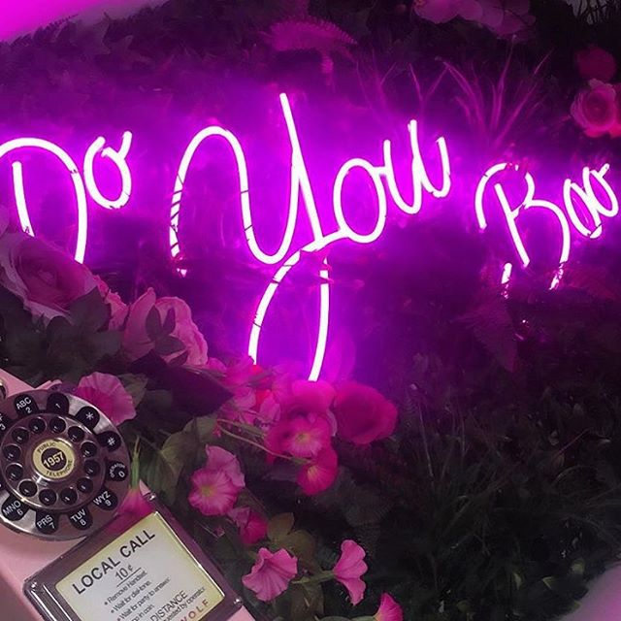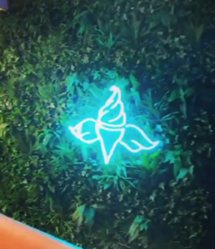

Marketing
We currently have 871 followers on Instagram, and as part of our weekly goals and business objectives, we aim to increase these numbers by 30 per week. This will Give us an extra 1560 extra followers by 7th July 2020. We will do this by following users that are interested in home interiors as well as small business owners which can be found using local hashtags such as #cardifflife #supportsmallbusinesses #supportlocalcardiff #cardiffsalon #cardiffrestaurant. By increasing momentum and diverting interest to our page using a range of marketing strategies we can also generate extra organic followers.
As previously mentioned social media will be our preferred marketing strategy for year one, the heart of our business model. It showcases our work and everything we do will have social media and reaching the thousands in mind. Our social media branding and advertising will be quirky, bright and eye catching and we aim to promote extensively using the free platforms Instagram and Facebook. Facebook automatically reflects anything we post on Instagram which is a benefit to our time management.

Sales
We will make our sales by networking, using social media to interact with businesses and increasing our audience and we will be relying on our online presence to convince potential customers that we are the correct candidates for their project and will be reliant on word by mouth for recommendations of future business. As mentioned previously we will be using cost differentiation to market our products to our audience as a bespoke service and we will use cost plus when calculating our pricing strategy. This remains a simple way to cover our costs but will need to be reconsidered if we get too close to the Vat threshold.

Management

Key Personnel
Initially we will work solely as a managing team, but have hired two fully qualified and insured contractors to carry out and specialist work we also aim to train two people by 31st September 2022, to take over the director roles on a full time basis with the possible need for more contractors.
We want to run this business because we both enjoy working for ourselves and love what we do. We both share the passion to succeed in business and we have the drive to fulfil our potentials. We also want to continue with the flexibility self-employment gives you, whilst maximising income. Eventually we seek to oversee a number of businesses and provide job opportunities to others.
Director Holly has been self-employed for over ten years and has previous experience with interior design sales at the beginning of her career, this included buying and selling on selling platforms such as eBay. Parenthood then lead to a number of small home businesses including a number of years catering to the wedding industry with creative backdrops. Holly has also previously worked for a makeup brand that uses excitement and visual tactics to increase footfall to the counter. With this experience as well as acting account manager on the counter, we believe this will help keep business exciting and financially stable. Holly also more recently opened a very successful Makeup and Blow dry Bar in Cardiff. It is during work on the Beauty salon that Holly became aware of the demand for some of her interior projects. Holly has GCSE level education, Interior design level 1 qualification, level 2 Hair & Beauty including application of number and welsh baccalaureate Pass * + other industry related qualifications. Holly is also working towards a Skills for the workplace Cert He at University of Carmarthen Trinity saint David.
Along with experience in the hospitality and marketing industry, Sophie has many skills that add value to the business, she has extensive customer service based skills and is dedicated to sales conversions. Sophie has also appeared on Reality Television and has gained a huge social following which has contributed to many of her business ventures. Sophie is a trendy and current individual who has a lot to bring to the branding and visual look of the company and provide knowledge to the social media and marketing fields. We have compared our strengths and weaknesses using a SWOT Analysis (Appendix F) which indicates how our individual skills complement each other.
Our business will strive because of our drive to succeed and make a solid name for ourselves not just locally but nationally. Both Holly and Sophie have a creative flair and passion to learn. Both are very proactive with social media and interested in sales figures and progression. We may experience weaknesses in areas of communication and delegation and sticking to the task in hand and We are not experienced to a high level of interior design however this isn’t related to the level of service we wish to provide. We want to focus on branding our business, with eye-catching décor that flows with our business ethos. External threats could be that someone else uses our ideas and imitates us, whilst there is room for healthy competition we want to lead this specialised market.

Key advisors
Holly is currently receiving help and support from university lectures to plan the business and look at all key aspects. Both directors also share an accountant who is experienced in small businesses and who has been an advisor to both for around 12 years. We also use a book keeping app called Wave, which is free and easy to use and helps us to raise invoices (Appendix G) and keep a record of all of our income and expenditure.

Premises and Equipment
The current structure of the business requires no business premises, so the directors have decided to work from home to carry out any admin work and will work on site to complete any quotes or manual work which is covered by insurance. Sophie will join Holly at her home every Monday and therefor Holly will claim a percentage of her household bills against the business. The directors also have the use of their mobiles and Laptops to conduct any work.

Suppliers and Subscriptions
We have a number of suppliers that are used for our design projects, (Appendix I) and we have trade accounts with all of the companies we use. We are also currently in talks with a local designer who may be able to bring the cost of our neon lights down.
Insurance quotes have been obtained by simply business and will cost £282 per year with Hiscox, this quote includes:- Public Liability up to One Million Pounds, Employers Liability up to Ten Million Pounds and Professional Indemnity up to Fifty Thousand Pounds (Appendix H). We have included employers liability as we have been instructed to cover our subcontractors under the Employers’ Liability (Compulsory Insurance) Act 1969.

Financial Forecast

Sales
For Business and Home designs we will calculate a 23% profit margin on all services. All of our services and sales will be using a cost plus strategy and we have decided to do this to remain a minimum risk company that provides a small income for directors. Therefor our average sale for design services includes a 23% charge and the remaining amount equals the cost of goods and all of our Jobs are paid upfront.
We will have two income streams in our first year, we aim to complete five small business designs totalling £34,940 and five flower wall installations totalling £3,000 resulting in £37,940 in sales and £7996 in profit after all deductions for the year. We have calculated our Interior design forecast by comparing Hollys salon refurbishment which totalled £7290+ 23% (Maison Grace Interiors charge) = £8967 to the first job completed by the company in month one which totalled £5668 including the companies charge. Considering these figures we have worked out the average of £7318 and applied this to our cashflow projection from month seven to twelve. Month two to six are reflective of government closure and month ten and eleven reflect a predicted seasonal decrease in refurbishments as businesses would need to be set up for Christmas revenue. Our Flower walls have been included from month seven and will yield a revenue of £600 every month until Month twelve which reflects a period of time where consumers may not have the disposable income. Our interior product sales that are planned for year two will be discussed when business planning for that venture, however it will be worth considering using a 28% profit margin to factor sales and offers.

Cashflow
Our cashflow takes into consideration the first job we did on starting the business, the following months are a true reflection of Covid-19 and its impact on the business. This business plan reflects the need to measure the business to ensure it is still viable and therefore the full year as it is documented refers to the tax year that we will need to process. (Appendix J)

Profitability
We will end the year with £7976 in profit (Appendix K)
A copy of the cost of goods can be found in Appendix L

Financing
Our start-up costs equal =£324 which is covered by the directors investments to cover initial set up and includes:
Companies House Registration = £12
Company Business Insurance = £282
Web URL and Hosting = £30
Ongoing Monthly costs from restarting the business year in August after five months of closure equal £48 and includes:
Website hosting £30
Electricity £6
Water £2
Telephone and Wi-Fi £10

References

Covey, S. (2015) The 7 habits of highly effective people. The interactive Ed. La Vergne : Mango Media Inc.

Davidson (1997) Sources of information for competitor analysis. [Table]. Available at: https://moodle.uwtsd.ac.uk/course/view.php?id=3927 [Log in required] (Accessed 15th June 2020)

eMarketer (2015) Social Network Ad Spending to Hit $23.68 Billion Worldwide in 2015. Available at: https://www.emarketer.com/Article/Social-Network-Ad-Spending-Hit-2368-Billion-Worldwide-2015/1012357 Accessed 11th July 2020

Jennings (2019) Should architects design provocatively ugly architecture that does not conform to Instagram’s aesthetic conventions? [online] Available at: https://www.dezeen.com/2019/09/05/anti-instagram-architecture-will-jennings/ (Accessed: 8th July 2020)

Kumar, A., Bezawada, R., Rishika, R., Janakiramna, R. and Kannan, P.K., (2016a) ‘From Social to Sale’ The Effects of Firm-Generated Content in Social Media on Customer Behavior. 80(1), pp. 7-25. 10.1509/jm.14.0249 (Accessed 10th July 2020)

Kumar, A., Bezawada, R., Rishika, R., Janakiramna, R. and Kannan, P.K., (2016ab ‘From Social to Sale’ The Effects of Firm-Generated Content in Social Media on Customer Behavior. 80(1), pp. 7-25. 10.1509/jm.14.0249 (Accessed 10th July 2020)

StatsWales (2019) Business births by area and year [online] Available at: https://statswales.gov.wales/Catalogue/Business-Economy-and-Labour-Market/Businesses/Business-Demography/businessbirths-by-area-year (Accessed: 11th July 2020)
Urban Dictionary (2015) Top Definition- Instagramable [online] Available at: https://www.urbandictionary.com/define.php?term=Instagramable (Accessed 8th July 2020)

Bibliography

Covey, S. (2015) The 7 habits of highly effective people. The interactive Ed. La Vergne : Mango Media Inc.

Davidson (1997) Sources of information for competitor analysis. [Table]. Available at: https://moodle.uwtsd.ac.uk/course/view.php?id=3927 [Log in required]

eMarketer (2015) Social Network Ad Spending to Hit $23.68 Billion Worldwide in 2015. Available at: https://www.emarketer.com/Article/Social-Network-Ad-Spending-Hit-2368-Billion-Worldwide-2015/1012357

Jennings (2019) Should architects design provocatively ugly architecture that does not conform to Instagrams aesthetic conventions? [online] Available at: https://www.dezeen.com/2019/09/05/anti-instagram-architecture-will-jennings/

Kumar, A., Bezawada, R., Rishika, R., Janakiramna, R. and Kannan, P.K., (2016a) ‘From Social to Sale’ The Effects of Firm-Generated Content in Social Media on Customer Behavior. 80(1), pp. 7-25. 10.1509/jm.14.0249

Kumar, A., Bezawada, R., Rishika, R., Janakiramna, R. and Kannan, P.K., (2016b) ‘From Social to Sale’ The Effects of Firm-Generated Content in Social Media on Customer Behavior. 80(1), pp. 7-25. 10.1509/jm.14.0249

StatsWales (2019) Business births by area and year [online] Available at: https://statswales.gov.wales/Catalogue/Business-Economy-and-Labour-Market/Businesses/Business-Demography/businessbirths-by-area-year

Urban Dictionary (2015) Top Definition- Instagramable [online] Available at: https://www.urbandictionary.com/define.php?term=Instagramable

Appendix A

Management CV’s
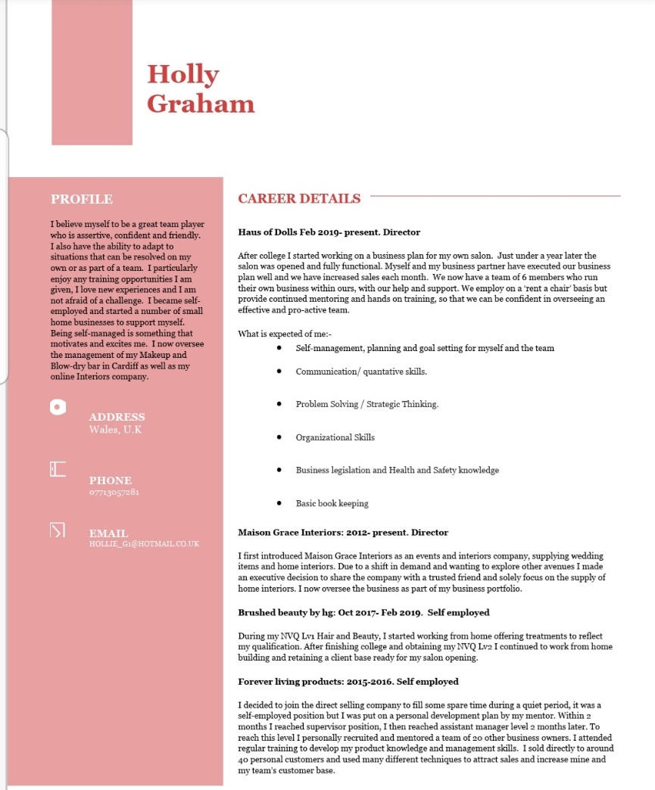

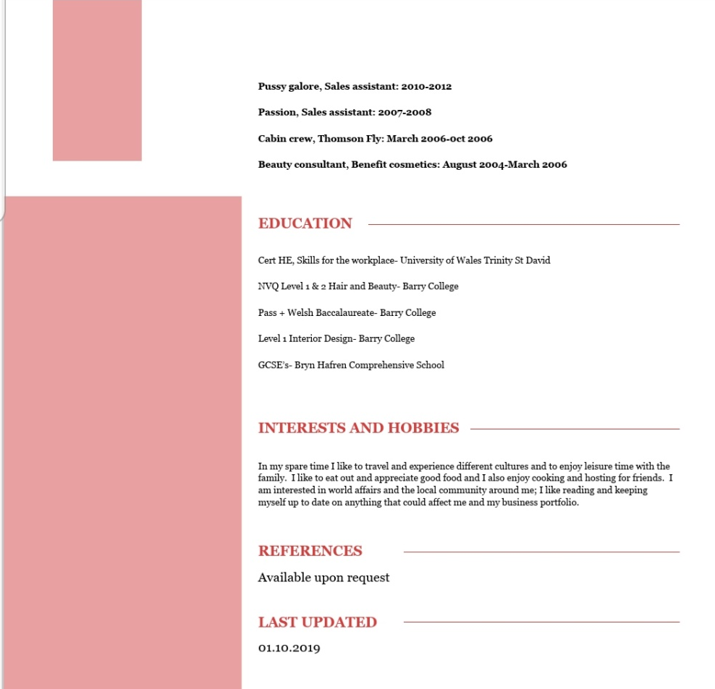
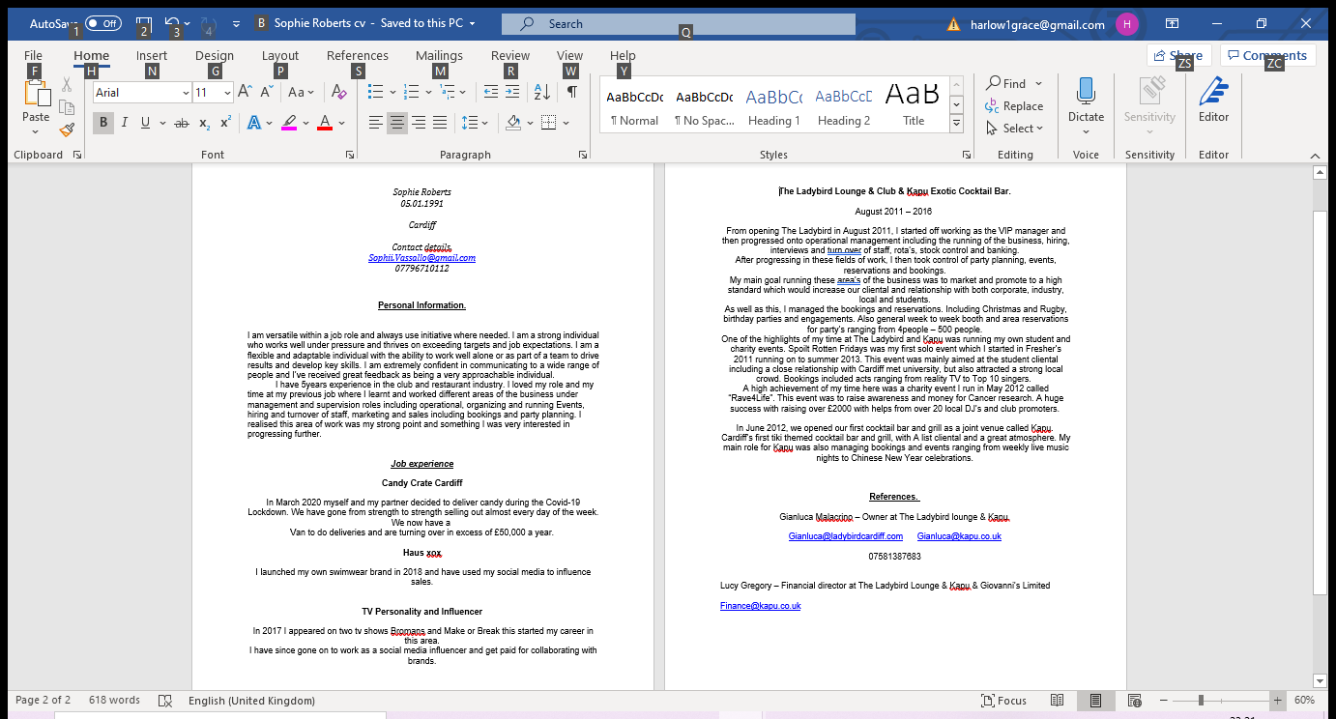

Appendix B

Social Media interaction

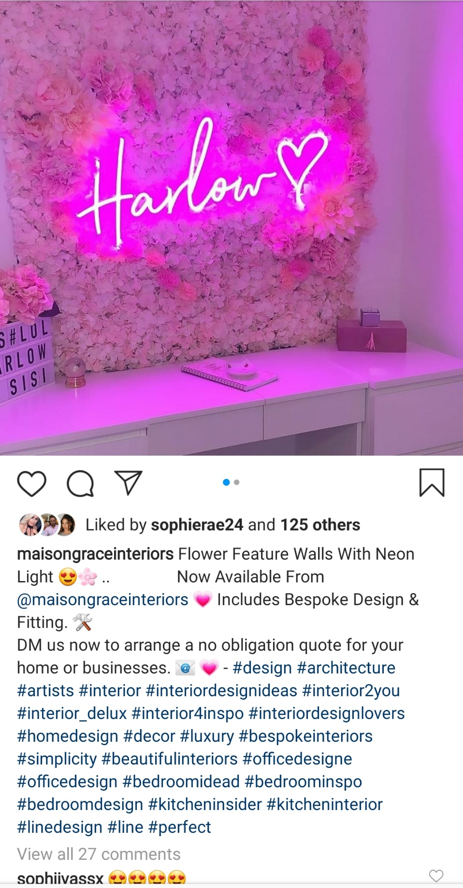

Appendix C

Company Registration
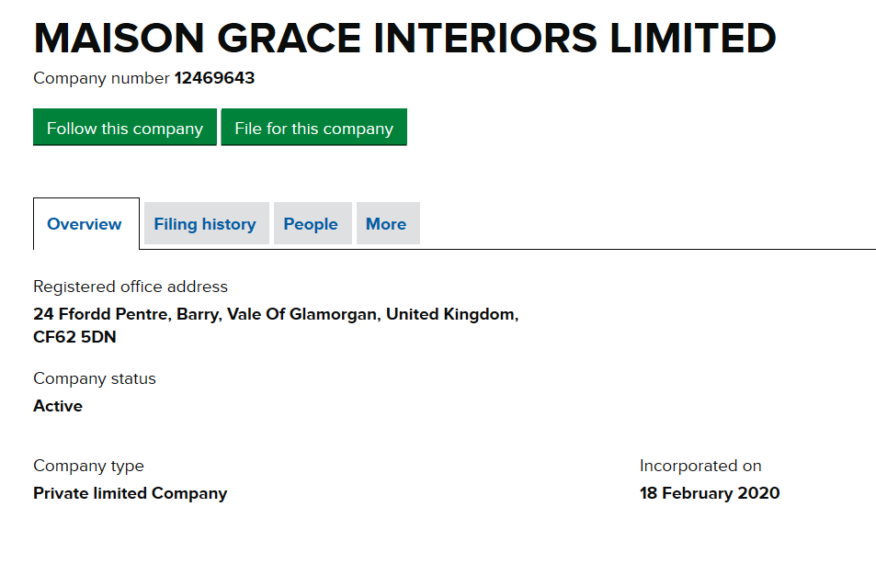

Appendix D

Existing and Potential Clients

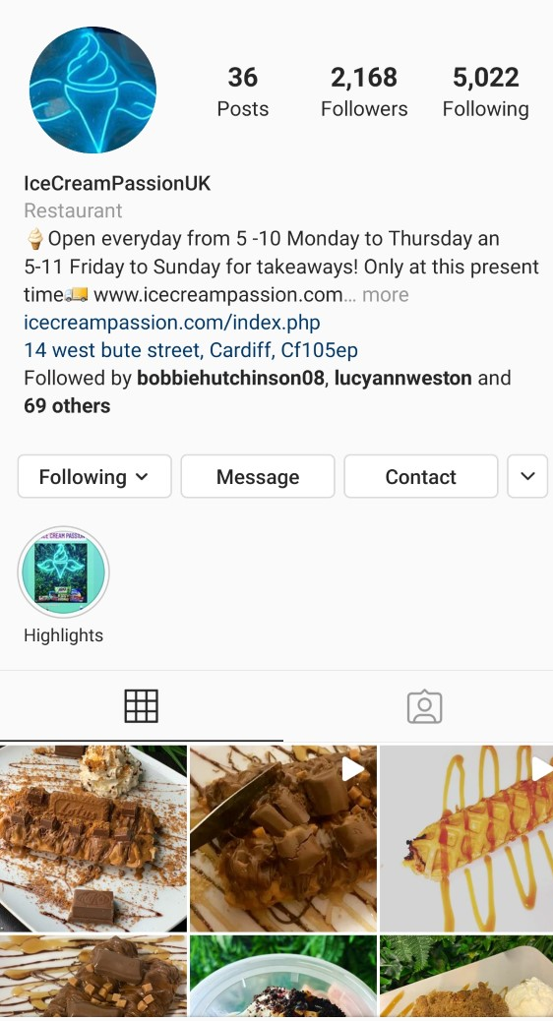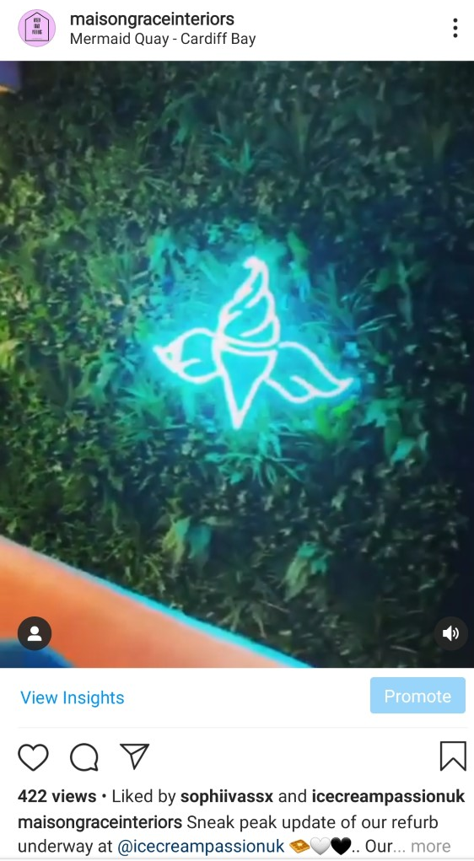
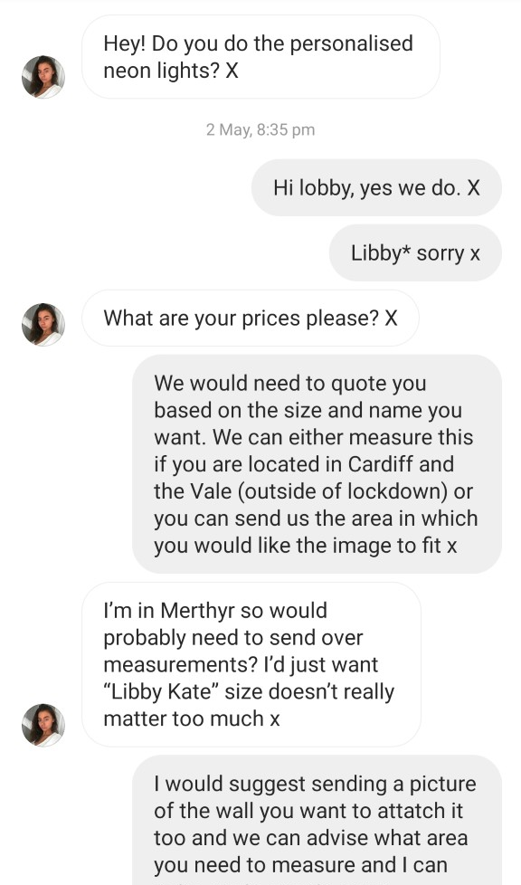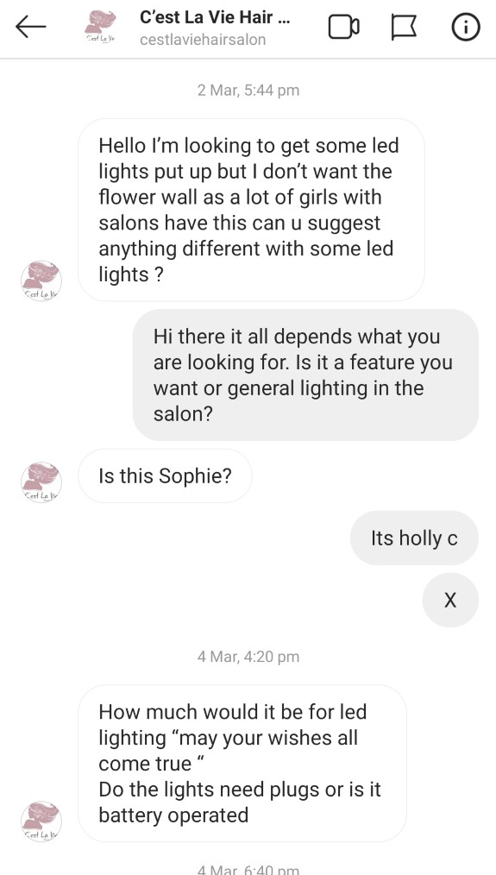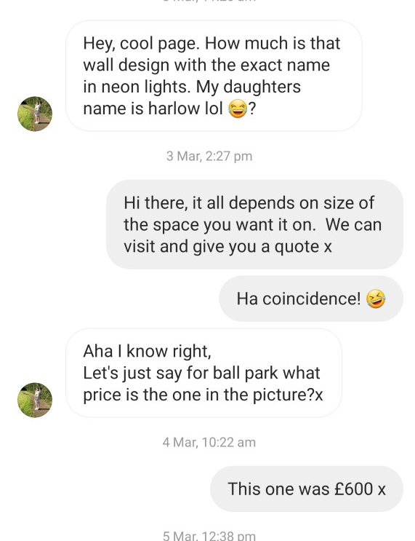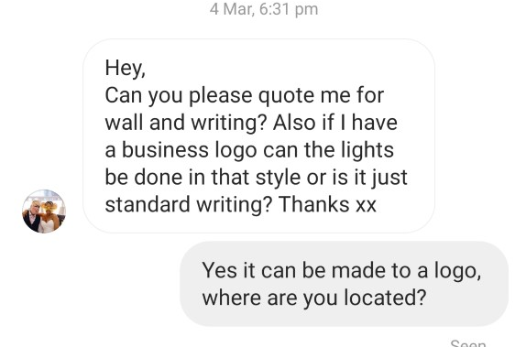

Appendix E

Insights
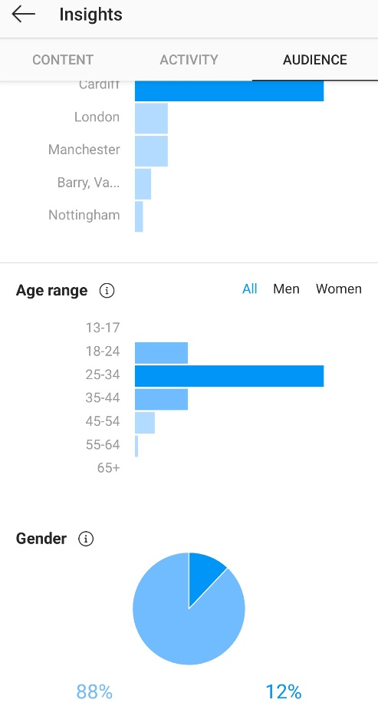

Appendix F

SWOT Analysis

Holly’s STRENGTHS  Motivation, confidence and positivity  Creativity  Leadership  Self-awareness  Resourceful  Experience  Networking  Presentation skills  Social networking  Working independently  Group working  Problem solving  Leadership | Holly’s WEAKNESSES  Time management  Communication  Emotional intelligence  Listening  Numeracy  Sticking to planning  Delegation
Sophie’s STRENGTHS  Networking  Social media  Resourceful  Creative  Conversion/leads to sales  Presentation skills  National reach | Sophie’s WEAKNESSES  Prioritising  Easily distracted  Take on too much  Always says yes  Professional communication  Separating work and friendship relationships
OPPORTUNITIES  Online selling  Personal webpage sales  Interior projects  Successful part time business  Recruitment of staff  Expansion  Overseeing the business | THREATS  Time management with other businesses  Legislation and legal restrictions

Appendix G

Wave invoices

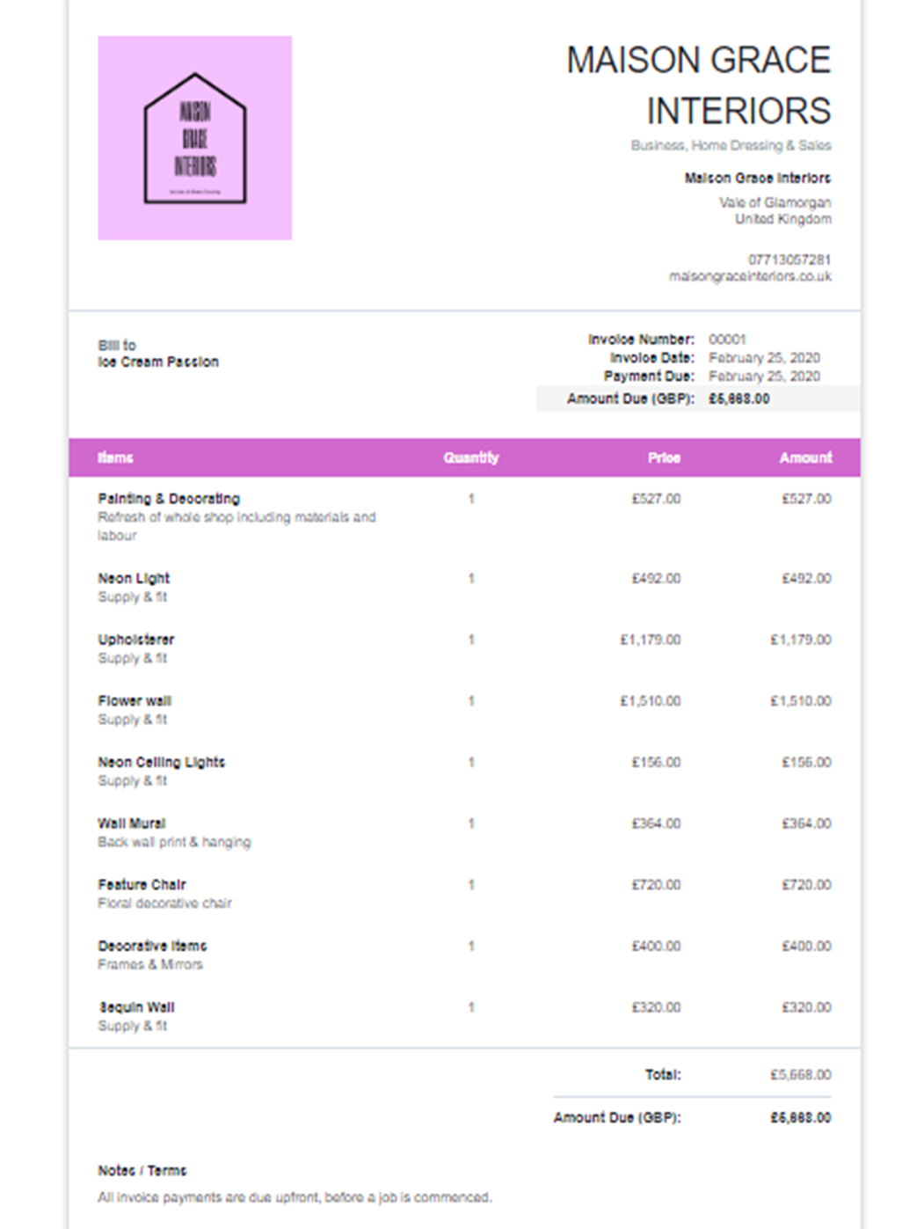

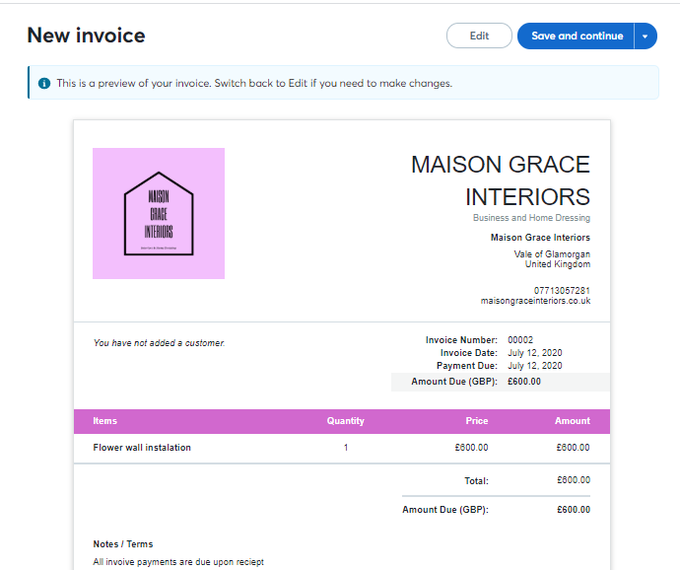

Appendix H

Supplier List
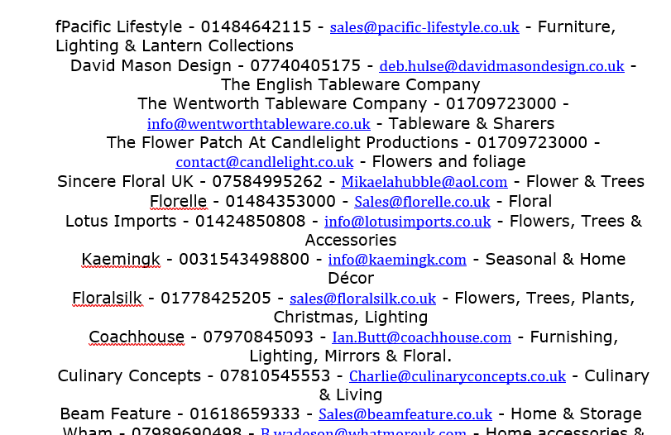

Appendix I

Business Insurance
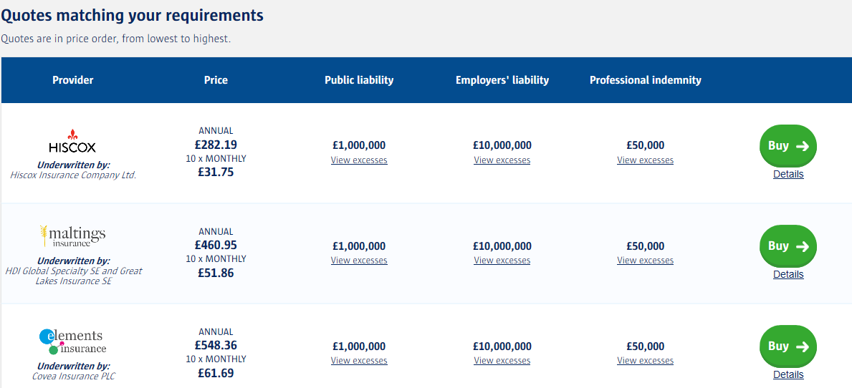

Appendix J

Cashflow Projection
CASHFLOW FORECAST YEAR 1.xlsx

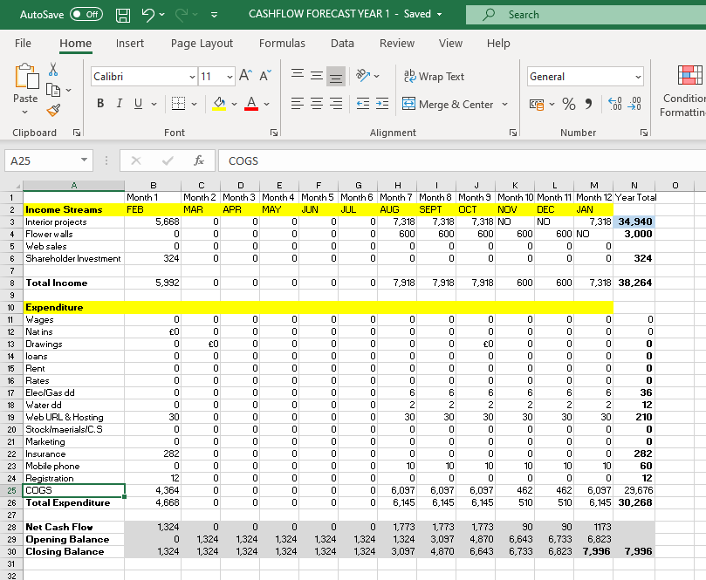

Appendix K

Profit and Loss

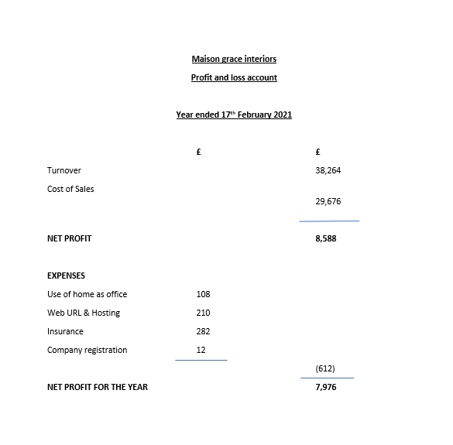

Appendix L

Cost of Goods

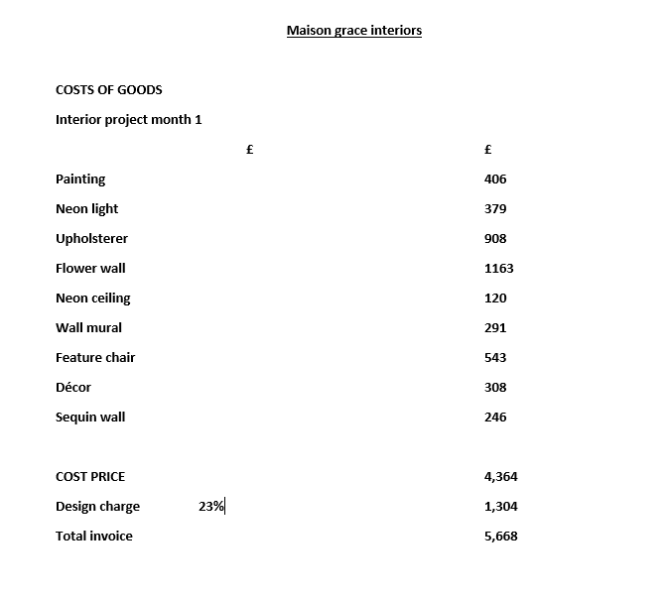

Appendix M

PEST
Political factors  Current Covid-19 circumstances can affects the other 3 factors including uncertainty on taxation.  Government is due a change.  Covid-19 has affected industry regulations and this can affect lead times and productivity due to increased safety precautions. | Economic factors  Economic uncertainty, unsure of Vat Rates, what further funding will become available and what tax implications there will be.  What stage is the business at compared to the offering during current? – due to being open in Feb 2020 without premises we didn’t get a grant but can get a BBL although this would put us in debt so it goes against our policies.
Social factors  Local population growth in Cardiff and the vale-  What is the gender and ethnicity in the area, does this have a reflection on businesses and sales? | Technological factors  Advancement of sales platforms  Weakness to other designers using graphic design technology that is learnt during degree levels.

Appendix K

Cost of comparable refurbishment



