

IMPACT OF AI IN TERMS OF HR DECISION-MAKING
Moodle Name: Research principles and philosophy (LCDB7007_BIRM)
Student Name: Farjana Akter Rimu
Student ID 2519813

[Articles were taken from Google Scholar, ScienceDirect, and UWTSD Library. Some are from ABS-ranked journal , but not all.]

1. Introduction
The use of Artificial Intelligence (AI) has continued to revolutionise Human Resource (HR) processes, especially in recruitment, performance analysis, and workforce analytics. The automation of candidate screening, forecasting employee performance, and data-driven insights to inform strategic decision-making are now popular automation systems based on AI. Such changes are part of a wider trend towards digitalisation and evidence-based management in organisations, in which data analytics helps optimise, improve consistency, and scalability of HR processes.
The increased use of AI in HR decision-making is noteworthy as it suggests that it is more objective, less erroneous, and efficient at the organisational level. Nevertheless, even with these benefits, there are severe issues that have been raised over algorithmic bias, lack of transparency, and ethical consequences. It has been found that AI systems can reproduce existing social biases within past data and thus casts doubt on the concept of fairness, accountability, and trust of automated judgment.
The purpose of this report is to critically examine the effect of AI on HR decision-making to identify the latest scholarly sources regarding this topic, particularly in terms of philosophical assumptions, ethics, and methods. The report is organised in the following way: the report starts with a critical literature review, proceeds to the development of a conceptual framework, explores the research philosophy, and evaluates methodological and ethical questions, finishing with a critical analysis of a particular research study and general conclusions.

2. Critical Literature Review

2.1 AI Technologies in the Recruitment and Selection Process
Artificial Intelligence (AI) has altered the recruitment and selection process to a great degree, including automation, predictive analytics, and data-driven decision-making tools. Intelligent recruitment systems employ algorithms, machine learning models, and natural language processing to filter resumes, find matches with job descriptions, and forecast candidate fit based on past trends in historical data. These systems strive to help increase efficiency, hiring time, and quality of talent acquisition decisions by reducing human intervention and subjectivity (Safshekan et al., 2026).
A number of studies note that AI recruitment models are based on structured and unstructured data, such as CVs, social media accounts, and behavioural analytics, to find patterns reflective of high-performing workers. They are commonly rolled in these models, making use of techniques of supervised learning and classification to rank the candidates and automate shortlisting. These methods can help organisations to handle volumes of applications throughputs and enhance scalability in recruitment practises (Murugesan et al., 2023).
AI Technology | Application in Recruitment | Impact on HR Decision-Making
Machine Learning Algorithms | Resume screening and candidate ranking | Improves efficiency and predictive accuracy
Natural Language Processing | CV parsing and chatbot-based candidate interaction | Enhances communication and candidate experience
Predictive Analytics | Forecasting candidate success and job fit | Supports data-driven and objective hiring decisions
Video Interview Analytics | Facial recognition and behaviour analysis during interviews | Assists in evaluating soft skills and personality traits
Chatbots | Automated responses and initial candidate screening | Reduces workload and speeds up the recruitment process
Deep Learning Models | Pattern recognition from large datasets (e.g., social profiles) | Enables advanced talent identification
Table 2.1: The Major AI Technologies in Recruitment and Selections
(Source: Self-Developed)
The table identifies major AI technologies that are reshaping the processes of recruitment and selection. It illustrates that machine learning, NLP, and predictive analytics allow becoming more efficient, accurate, and quality decision-makers. Thus, the use of these technologies requires that care is taken when considering the bias, transparency, and ethical implications within HR practises as well. However, in spite of these strengths, major issues have arisen on algorithmic bias and equity in AI-based recruitment systems. Algorithms that are trained on historical workplace data have a danger of reproducing already existing biases based on gender, ethnicity, or socio-economic status. This puts into doubt the objectiveness and neutrality of AI systems, specifically when biased datasets determine decision-making processes (Rigotti and Fosch-Villaronga, 2024).
According to further research, bias in AI recruitment systems is not purely technical but also cognitive, mirroring user biases during the system design and selection of data. This implies that AI systems are not autonomous decision-makers but human assumptions and organisational behaviours (Soleimani et al., 2021). Therefore, organisations need to adopt bias reduction models, such as diverse datasets, auditing algorithms, and fair decision-making models to maintain fairness and accountability (Sony et al., 2025).
Besides that, new studies have examined ways to solve bias in AI hiring, including incorporating explainable AI models and context-sensitive and ethically informed decision-making solutions. These methods focus on the power of human judgment and AI observations over total automation of the recruitment-based decisions (Soleimani et al., 2025). Altogether, AI boosts productivity and predictive quality in recruiting, but its use has complicated issues related to ethics, technology, and society.

2.2 AI Systems in Employee Performance Management Operation
AI has also become part and parcel of performance management systems to improve worker assessment, surveillance, and advancement. The AI-based performance management employs HR analytics, predictive modelling, and real-time data monitoring to evaluate the productivity, engagement, and behavioural patterns of employees. Such systems allow organisations to shift towards non-traditional, data-driven and ongoing performance appraisal systems (Madhuri and Kumar, 2025).
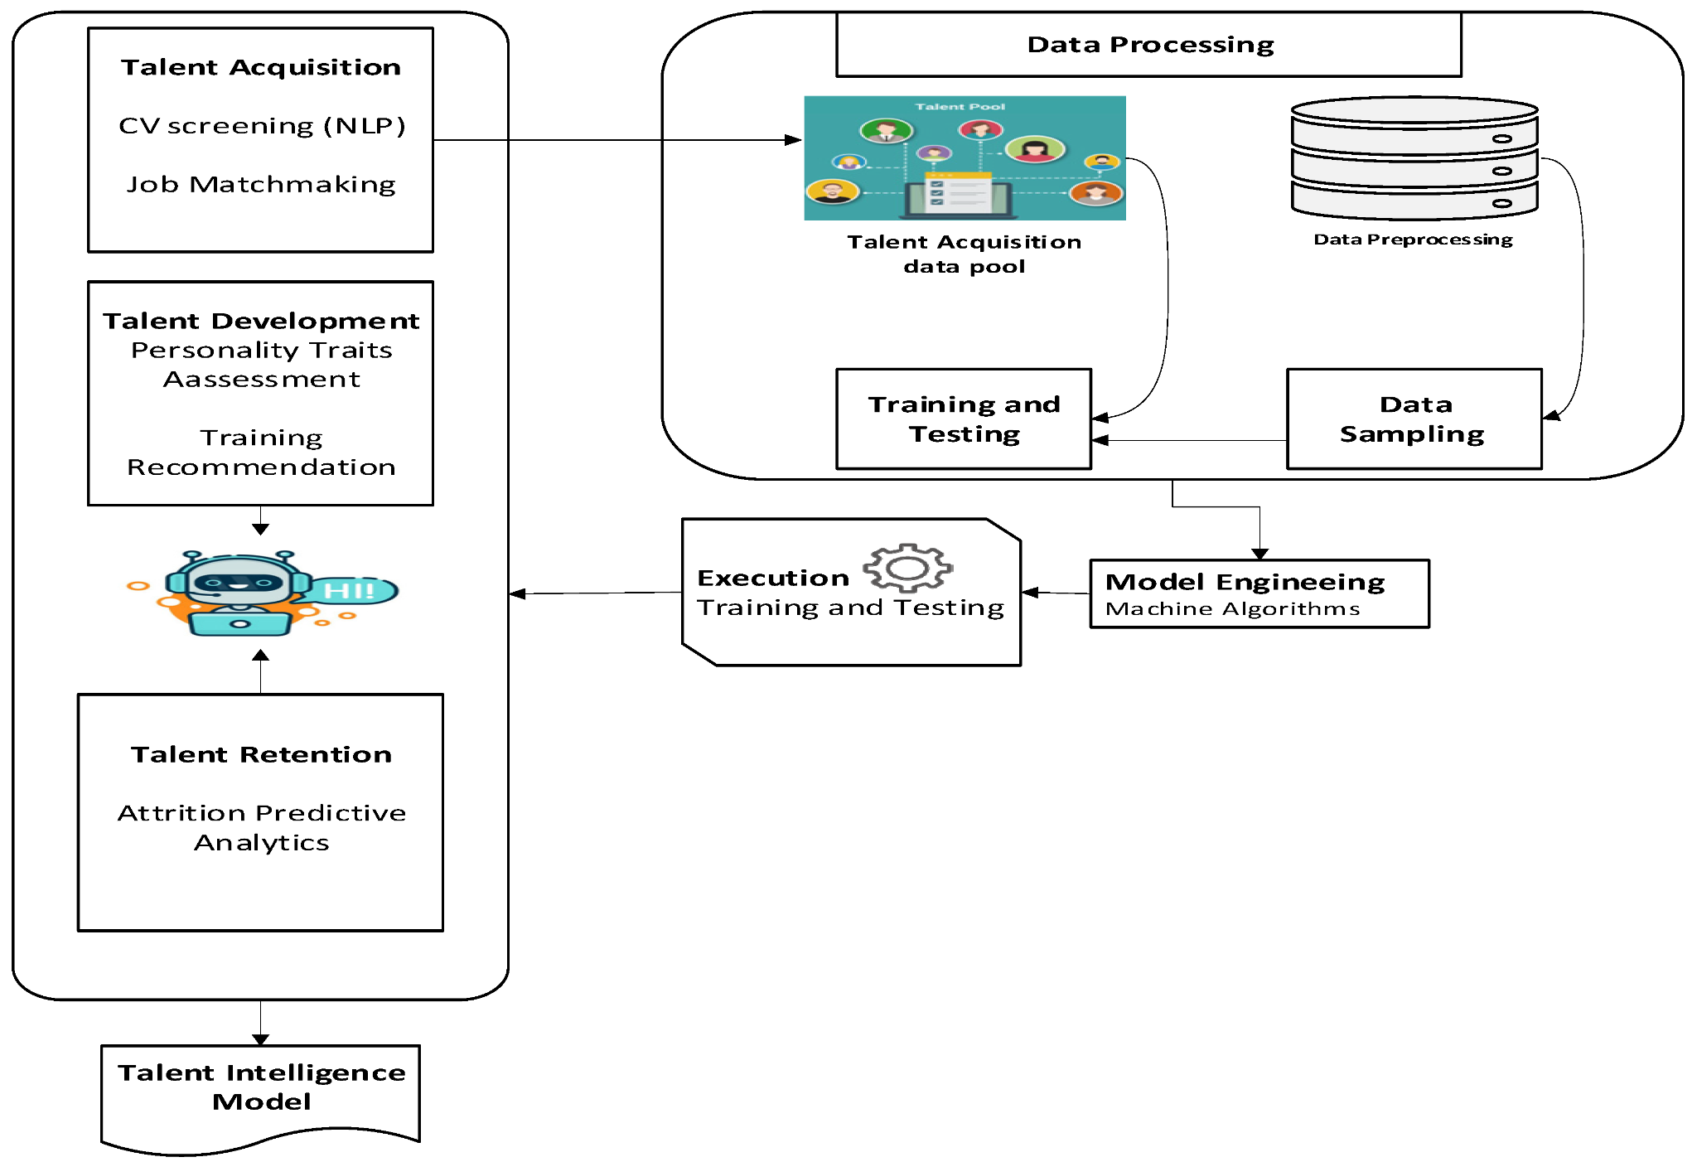
Figure 2.1: Employee Performance Management Systems with AI-Driven Talent Intelligence Model
(Source: Faqihi and Miah, 2023)
This number shows the integration of AI in performance management that includes processing data, predictive analytics, and talent intelligence to improve employee evaluation and decision-making (Faqihi and Miah, 2023). High-tech AI tools, including machine learning algorithms and big data analytics, enable companies to evaluate various performance parameters, including work output, collaboration, and feedback. By informing and guiding more objective decision-making in the performance management process, these models offer employees insight into areas of their strengths, weaknesses, and development (Ayanponle et al., 2022).
The use of AI in performance management will also facilitate individualised employee development by highlighting training requirements and proposing customised learning interventions. AI systems are able to process employee data and forecast future performance trends, and aid in strategic talent management decisions. This helps in increased organisational productivity and worker involvement (Ekuma, 2024).
Nonetheless, the application of AI in performance appraisal also provokes the issues of data privacy, monitoring, and employee autonomy. Monitoring employee activities continuously can foster a feeling of overcontrol and diminish trust in organisations. Moreover, focusing on quantitative measures can remove the qualitative part of performance, which can be creativity, teamwork, and emotional intelligence (Dima et al., 2024).
The second important constraint is that biased performance assessment may occur when AI models are based on incomplete or biased data. As an illustration, workers in varied jobs or settings might not be assessed equitably in case working metrics are uncustomised and shielded without background. This emphasises the need to have human judgement and contextual cognition in the systems of AI-based performance management. Altogether, although AI can improve the quality and efficacy of performance management, its application should consider ethical consequences, data quality, and organisational background to conduct fair and meaningful reviews.

2.3 AI in Strategic Human Resource Decision-Making Processes
AI is now an important tool of strategic human resource management because it allows making decisions on the basis of information and predictive analytics. AI systems complement strategic HR processes like workforce planning, talent management, and organisational development because they analyse large volumes of data and reveal patterns to guide long-term decision-making. Such a change can be interpreted as the increased significance of HR as a strategic ally of organisational success (Kim et al., 2025).
Artificial Intelligence-based HR analytics can enable organisations to predict workforce trends, detect skills gaps, and make optimal allocation of talent. Employee turnover, engagement rates, and performance data can be analysed prior to the decision-making using predictive models. These competencies make organisations more agile and allow HR professionals to align human capital plans with the business goals (Alabdali et al., 2024).
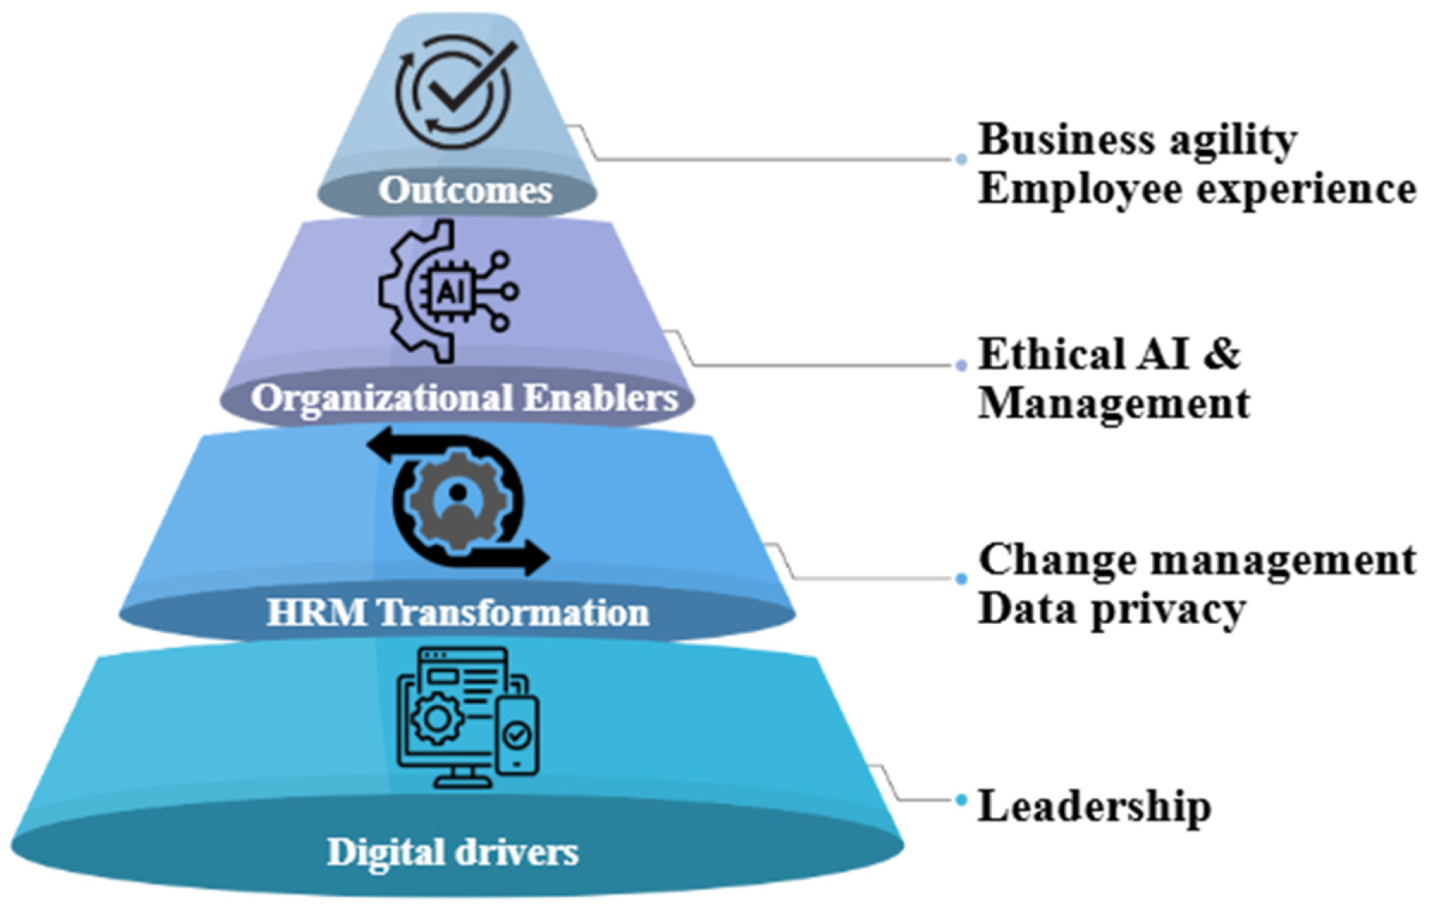
Figure 2.2: AI-Embarked HRM Change Model of Strategic Decision-Making
(Source: Khatoon et al., 2025)
This number depicts how AI can be used to revamp strategic human resource decision-making via a stratified frame. The so-called digital drivers facilitate the process of HRM transformation through leadership and change management, and considerations of data privacy. The success of the implementation is supported by organisational enablers such as ethical AI and management practises (Khatoon et al., 2025). The result of these processes is eventually agility in the business and improved employee experience. Evidence-based management is also promoted through the use of AI in strategic HR decision-making since it minimises intuition and subjective judgment. AI systems offer useful feedback to aid in decision-making in different HR processes, such as recruitment, training, and compensation management. It leads to enhanced organisational efficiency and competitive advantage (Úbeda-García et al., 2025).
Moreover, AI enhances employee lifecycle management by combining data on various HR procedures that allow managing the employees holistically. The use of AI systems can trace employee paths and career growth, and assist in succession planning, which leads to better organisational sustainability and long-term performance (Sharma et al., 2025).
Along with these advantages, there are a few challenges associated with the use of AI in strategic HR decision-making. Among the principal issues is that AI algorithms are not transparent, which is also known as the black box problem. This prevents HR professionals from interpreting and rationalising AI-based decisions, which might cause the loss of trust and accountability (Jiang et al., 2025).
Moreover, the application of AI into the strategic decision-making process can lead to a decrease in human agency and enhanced reliance on automated systems. This provokes the question of the place of human judgement in HR and the risks of excessive dependence on technology. Studies indicate that efficient HR decision-making must be based on a balance between AI and human intelligence (Taslim et al., 2025).
Generally, AI is a transformative factor in strategic HR decision-making, as it can improve the quality of data and organisational performance. Nevertheless, it cannot be successfully introduced without resolving issues associated with transparency, trust, and human-AI collaboration.

2.4 Ethical dilemmas, bias, and threats in AI-based HR systems
The use of AI in HR decision-making is linked to a variety of challenges and risks that are influential to organisations and employees. Algorithm bias is one of the most significant problems that occur when AI systems represent the existing disparities recorded in training data. It may result in inequitable recruitment, evaluation of performance, and promotions, which can affect fairness and diversity within organisations (Naoum et al., 2026).
Ethical issues are also central to AI-related HR practises. The aspects of data privacy, informed consent, and transparency are of specific concern to employee data. The application of AI systems often implies the utilisation of massive amounts of personal data and behavioural data, which makes the issue concerning the way this data is gathered, stored, and processed. These interests also demonstrate the necessity of strong ethical standards and processes of governance practice in AI consumption (Rodgers et al., 2023).
Issue | Description | Impact on HR Decision-Making
Algorithmic Bias | AI systems reflect biases from historical data and training models | Leads to unfair hiring, promotion, and evaluation outcomes
Lack of Transparency | “Black box” algorithms make decisions difficult to interpret | Reduces trust and accountability in HR processes
Data Privacy Concerns | Use of sensitive employee data without clear consent or protection | Risks, legal violations and employee dissatisfaction
Ethical Accountability | Unclear responsibility for AI-driven decisions | Challenges in assigning blame for incorrect decisions
Over-reliance on AI | Excessive dependence on automated systems over human judgment | Limits critical thinking and contextual decision-making
Discrimination Risks | AI may reinforce inequalities (gender, race, etc.) | Undermines diversity and inclusion initiatives
Table 2.2: Important Ethical Concerns, Bias, and Threats of AI-based HR Systems
(Source: Self-Developed)
The other major obstacle is that AI systems cannot be explained. Most AI models are irrelevant to interpret, and therefore difficult to comprehend how a decision was made; it may require an HR professional to seek a rationale behind the decision. Such non-transparency may decrease the level of trust displayed toward AI systems and can restrict the acceptance of AI systems in organisations (Sachan et al., 2024).
Another significant issue is the influence of AI on the working experience and organisational culture. As the application of automation and data-based decision-making grows, the focus on human interaction might decrease, and the perception of the impersonal approach to management practises may emerge. This may influence the involvement of employees, motivation, and faith in organisational procedures (ABUMERE, 2025).
Additionally, studies have noted that the use of AI in HR can intensify the levels of inequality, unless it is carefully implemented. To this end, AI recruitment systems have been found to be affected by gender bias, in which algorithms are likely to prioritise some groups of people above others. To resolve these issues, it is essential to involve an all-encompassing solution that will encompass ethical principles, regulatory provisions, and ongoing evaluation of AI systems (YU, 2025).
In spite of these dangers, AI has the opportunities of enhancing diversity, equity, and inclusion if it is applied in a responsible manner. Identifying and mitigating the role of biases in HR processes, AI can help to make judgments that are more just and bring more inclusive organisational practises. But this must be designed cautiously, ethically and be continually reviewed in regard to AI systems (Gupta, 2024). To sum up, even though AI has a tremendous potential to revolutionise HR decision-making, there are intricate issues of bias, ethics, and transparency that arise. The areas of concern should be addressed to have a positive impact of AI systems on organisational performance and employee welfare.

2.5 Literature Gap
Despite the extensive literature available on the topic of AI in HR decision-making, there are a number of critical gaps that must be addressed. The first weakness is that, to a large extent, the current literature attempts to investigate the effectiveness, degree of automation, and prediction accuracy of AI systems, which do not pay enough attention to the incorporation of ethical considerations in algorithmic decision-making. Even though the issue of bias, fairness, and transparency is often widely addressed, there is an empty sheet of formal and organised frameworks, which can help organisations to incorporate ethical accountability into the AI-mediated HR processes.
Moreover, most of the literature is overly focused on recruitment and selection with a fairly large amount of under-investigation in AI applications in performance management and strategic Hr decision-making, especially in practice. Also, most of the studies are theoretical without empirical confirmation, which limits their applicability and generalisability in practise.
The other important gap is the insufficient emphasis on human-AI interaction, particularly the aspect of automated decision-making versus human judgment. The impact of the organisational context, perception of employees, and preparedness to use AI is also inadequately studied. Consequently, next-generation studies ought to incorporate empirically valid and ethically-based and context-based models which combine technological and human factors in the AI-supported HR decision making.

3. Conceptual Framework
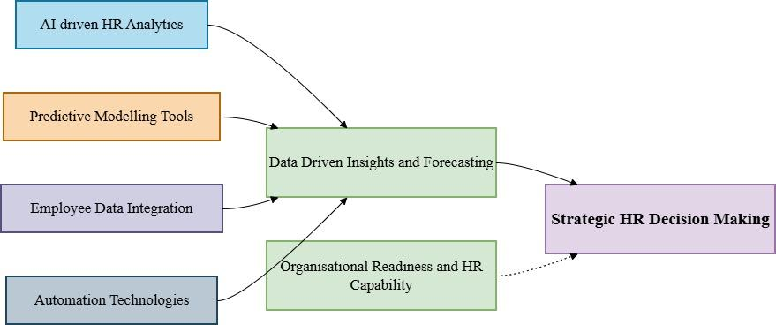
Figure 3.1: Conceptual Framework
(Source: Self-Developed)
The conceptual framework explains how AI technologies can affect the process of strategic HR decision-making in a systematic, data-driven manner. The inputs that will provide actionable insights are AI-driven HR analytics, predictive modelling, integration of employee data, and automation technologies. The data-driven processes which process these inputs to generate meaningful strategic information, like pattern recognition and forecasting, are the mediating variable which takes raw data and changes it into meaningful strategic information and strategic knowledge. This can help the HR professionals to make sound decisions that are based on workforce planning, talent management and organisational development.
Another moderating factor that the framework acknowledges is the level of organisational readiness in the form of technological capability and HR expertise, which dictates the success with which the AI insights are applied in decision-making activities. When considering the context of the research topic, this is an important point emphasising that AI does not expressly displace human judgement but complements strategic Hr functions through evidence-based decisions. Nevertheless, the success of AI-related integration will be defined by the competence of the organisation to exploit and utilise such insights in a responsible and ethical way.

4. Research Philosophy & Theoretical Foundations
The research philosophy is significant in influencing how the research on AI in HR decision-making is carried out. It assists the researcher to know what is considered as knowledge, the way reality is perceived, and what values are played into when determining the results of the research. These philosophical assumptions are particularly significant when it comes to the fields of AI and HR since the choices provided by AI systems directly impact employees, organisations, and society. Philosophy of research design has been mentioned as a guiding factor to the general design of the research, as is emphasised in the literature on research methods, to guarantee that the research is consistent throughout in terms of theory, methods, and interpretation
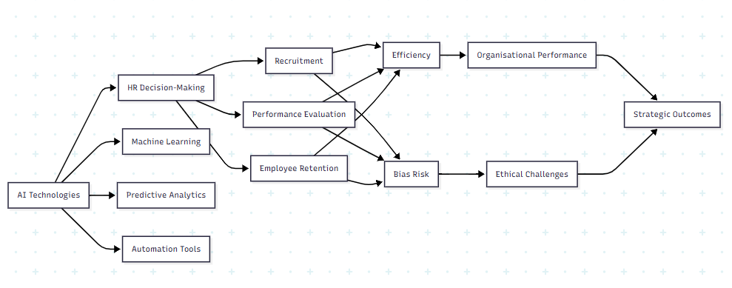
Figure 4.1: Conceptual Framework of AI Impact on HR Decision-Making
(Source: Author)

4.1 Epistemology
Epistemology is the origin of the knowledge that is valid knowledge. There are two epistemological approaches that are in common use in AI-HR research: positivism and interpretivism.
A significant number of recent AI uses in HR decision-making are positive, meaning that researchers are guided by quantitative data, such as the results of recruitment, the level of algorithm accuracy, and employee performance indicators (Rodgers et al. 2023). These studies presume that the objectivity of measuring knowledge with data and statistical analysis is possible. Indicatively, AI applications in the recruitment process are considered in terms of efficiency, reduction of bias, and predictability.
Nevertheless, this method has certain shortcomings. It tends to disregard the experiences and perceptions of human beings. The outputs of AI might seem objective, yet they might contain latent biases. Thus, interpretivism methodology is a faster growing method to comprehend the perceptions, trust, and equity of the AI system among the employees (Chatzichristos, 2025). These papers adopt interviews and qualitative research to understand the way people perceive AI-based HR decisions.
There is a growing trend of a balanced epistemological approach whereby researchers are implementing both quantitative and qualitative research designs. This interdisciplinary strategy will allow for a more comprehensive picture of AI in HR, including the measurable results and human experience.

4.2 Ontology
Ontology is concerned with reality. The central issue in AI-HR research entails whether the AI-made decisions on HR can be regarded as an objective reality or as something that is constructed socially.
According to the ontological view of realism, AI systems are considered objective instruments that manipulate the input of information and deliver impartial rulings. As an illustration, algorithmic hiring systems have frequently been introduced as more dependable than human decision-making since they are based on information as opposed to subjective influences (Kordzadeh and Ghasemaghaei, 2021).
Nevertheless, this assumption is questionable among numerous researchers. The constructivist viewpoint of AI systems is that the system is influenced by human contributions, organisational culture, and historical data. It implies that AI decisions are not objective, indeed, but mirror the prevailing social prejudices (Carnevale et al. 2024). Taking the example of historical hiring data, bias can be gender-based, and the AI systems can reproduce this discrimination.
This discussion points out that reality in the AI-HR research is not set in stone. Rather, it is impacted by the technological systems as well as social situations. Thus, a frequent position of many scholars is critical realist, admitting that even though AI systems are also real tools, their results depend on social and organisational characteristics.

4.3 Axiology
Axiology is a term that defines the role of values in research. Values are also an important consideration in AI-HR research since judgments have an impact on the fairness, equality, and well-being of employees.
Classical research was frequently supposed to be value-neutral. Nevertheless, full neutrality cannot exist in the case of AI-related research. Researchers come with personal notions of fairness, ethics and technology into their practice. Meanwhile, organisations that operate through AI also incorporate their values into the development of the algorithm (Rajagopal et al. 2022).
As an example, an organisation can focus on efficiency and not fairness, resulting in AI systems that will be efficient without considering the ethical factor. Alternatively, fairness researchers can point at the discrimination risks of AI systems.
Thus, the contemporary AI-HR studies realise the inevitability of values. Researchers are not supposed to put it aside; they are supposed to declare their assumptions and ethical standpoints. This is in line with the notion that research must not merely cognise the world, but it needs to make it better.

4.4 Theoretical Frameworks
There are various theoretical models of the study of AI in HR decision-making.
Another useful theory is the Algorithmic Decision-Making Theory that studies how AI operates to reach a decision-making conclusion and the effect of such a decision on individuals (Rodgers et al. 2022). This framework points to such issues as transparency, accountability and bias.
The next major framework is the Human Capital Theory, which focuses on how organisations apply AI to enhance the performance and productivity of employees (Manoj Kumar Behera et al. 2025). The use of AI tools is viewed as a means of maximising talent management and decision-making.
The Institutional Theory is also commonly applicable. It describes the mode through which organisations embrace AI as a result of external factors like competition, regulations, and the market trend (Rudko et al. 2024). This is one of the reasons why firms implement AI despite the ethical issues.
Lastly, Ethical AI Frameworks become more and more significant. These frameworks supply the idea of fairness, accountability, and transparency in the AI systems (Prem, 2023). They highlight the importance of creating AI systems, which are not only productive but also ethical.
Altogether, the integration of these frameworks will enable scholars to perceive AI in HR in a broader insight into how the field is viewed through the prism of numerous angles, such as technical, organisational, and ethical.

5. Positionality & Reflexivity
Positionality is the background, beliefs, or assumptions of the researcher, and this may affect the way the research is conducted and interpreted. Positionality is so critical, especially when it comes to AI in HR decision-making, since the issue at hand consists of a technology system and human results (Bankins et al. 2022). The researcher takes a moderate role in this research because he believes that AI has the potential to enhance efficiency and consistency in HR decision-making, and on the other hand, he plays down the issues surrounding bias, fairness, and transparency.
The view is informed by the recent debates within HR analytics and in digital transformation, where AI is being sold as a remedy to human constraints. Although it is also understood that such assertions can be exaggerated, particularly when algorithms are based on previous data, which can be an embodiment of existing disparities. Consequently, the researcher does not believe that AI is objectively inherent, however, he believes it to be a tool whose effects are conditional upon its design and implementation (Christou, 2023).
Reflexivity is the thinking of the way that such assumptions might affect the research process. The possible bias is the predilection to emphasise higher risks of AI, which are especially ethical issues, whereas underestimating the value of applying AI in practice (Hanna et al. 2024). To cope with this, extensive theoretical support and critical views on peer-reviewed literature are used in the study to create a more balanced analysis.
The use of secondary data is also another relevant factor of consideration. Although this enables one to reach through a variety of studies, it might hamper first-hand contact with organisational practices. Hence, choosing the sources to avoid losing credibility can be achieved by careful examination.
In general, reflexivity and the recognition of positionality make the research stronger as they develop the assumptions behind it (Jamieson et al. 2023). This openness improves the credibility and makes the inferences not sound like an utterly neutral statement, but rather a knowledgeable and doubtful one that has been thought from different perspectives.

6. Research Methods in Existing Studies
The research methods applied to AI in HR decision-making can demonstrate that there is a continuous conflict between rigour, realism, and practical relevance. Although the research has expanded so fast, it has yet to develop a unified and definitive methodological approach that integrates the multifaceted nature of the AI-based HR practices. Rather, the various approaches emphasise various aspects of the phenomenon, which tends to give partial, and even contradictory, understandings.
Quantitative methods are still the most popular method to be used, especially in research that addresses the issues of algorithmic performance, predictive accuracy and efficiency results. These works are based on statistical models, massive data sets, and machine learning to test the effectiveness with which the AI systems identify future hiring success or employee turnover, or performance levels (Ramachandran et al. 2021). The appeal of this method is that it generates objective, quantifiable, and generalisable results, which are of high importance to organisations that want to employ evidence-based decision-making. The limitation to this is, however, the critical fact that quantitative studies tend to assume that what can be measured is highly important. It can result in a false prioritisation of efficiency at the cost of less physical aspects like fairness, trust and perception among employees. Consequently, the performance of an algorithm can still yield a result that can be viewed as unfair or even unacceptable.
Qualitative designs seek to overcome these shortcomings by dealing with human experiences and organisational situations. Qualitative research investigates the perception employees and managers have towards the decisions made by AI using interviews, case studies, and thematic analysis (Hasija and Esper, 2022). These articles can contribute to the understanding of such issues as trust, transparency, and opposition to AI. Notably, they demonstrate that adequate technical accuracy does not imply acceptance and legitimacy. Nevertheless, qualitative research is commonly accused of having rather low generalisability and possible subjectivity of the researcher. The findings are usually industry-specific, and thus, it is challenging to generalise them into other sectors or companies.
The mixed methods research has been proposed as one method to overcome the quantitative/qualitative paradigm. Through a blend of statistical solutions and qualitative research, these studies have an opportunity to bring about a more all-encompassing perspective of AI in HR (P U Sivasubramaniyan, 2023). Theoretically, such a solution would be the best of both. Practically, however, it sets in new challenges. The problem, of course, is the failure to integrate the methods and be able to deliver quantitative and qualitative results separately, which are not meaningfully linked. It may lead to disjointed conclusions instead of a logical explanation of the research problem.
There are also experimental techniques, especially in the experimentation of algorithmic decision-making under controlled conditions. The research studies achieved high internal validity that enables researchers to control certain variables and determine cause-and-effect relationships. Brutal validity is, however, their major limitation. The AI systems that were tested in the laboratory environment might fail to operate in the same manner in the real organisational environment, where organisational culture, human behaviour, and ethical considerations tend to influence them greatly.
Another prevalent method is secondary data analysis, particularly when conducting large-scale research with organisational or publicly available data. Although this approach is effective and economical, it greatly relies on the completeness and quality of the data. Skewed datasets may cause false inferences, especially in AI studies where the algorithms are evaluated based on the data available.
All in all, the analysis of current techniques points to the fact that the methodological decisions are never impartial. Both strategies have a dominant focus on some part of AI in HR to the disadvantage of others. Thus, it is very important that researchers validate their methodological decisions in addition to becoming critical of their constraints so that they can produce a balanced and able analysis.

7. Ethical Considerations in AI-HR Research
Key issues with AI as it is applied to HR concept relate to ethical aspects since the systems directly affect the opportunities offered to people, their future growth in career, and experiences in the workplace. Such an application of AI in HR is in a very sensitive field, unlike various other applications of technology, whose decisions can impose protracted personal and social effects (Varma et al. 2023). Consequently, there is no periphery with regard to the ethical issues but rather a core aspect of the research process as well as the practical implications of the research.
Bias and discrimination have been one of the most popular ethical issues. The training of AI systems is usually based on historical organisational data, potentially containing historical inequalities in terms of gender, race, or age (among other aspects). These biases may be intentionally or accidentally recreated and even reinforced by algorithms that, in turn, give rise to discriminatory results, as emphasised by Kordzadeh and Ghasemaghaei (2021). Although organisations often choose to implement AI in hopes that it will help to lessen human bias, studies reveal that the assumption is too naive. As a matter of fact, algorithmic bias may be harder to identify since it is incorporated in the complicated data structures. It presents the researchers with an ethical dilemma as they need to critically assess not only the result of AI systems but also the data and design processes that lead to it (Kamila and Jasrotia, 2023).
The other important problem is transparency and explainability. Numerous artificial intelligence machines applied to HR-related decisions are black boxes, in which the logic of decisions cannot be accessed or comprehended easily (Rodgers et al. 2022). Such non-transparency casts grave ethical dilemmas, especially in matters relating to recruitment and promotion, where individuals can be influenced without having an idea of what influenced the results. Research-wise, this restricts determining the fairness and validity of AI systems in the most comprehensive manner. In addition, the lack of explainability may lessen the trust of the employees in the system, despite the technical correctness of such a system. Thus, research on ethics should not simply stop at testing performance but also look at the way the AI systems can be cognised and explainable to the people who suffer their impact.
Another important ethical issue is that of privacy and data protection. HR AI systems will be based on masses of data on individuals and even sensitive information, such as behavioural data, performance history, and even social media activity (Vishwanath and Vaddepalli, 2023). This makes one wonder about the data collection, storage, and its use. Researchers should make sure they are responsible when dealing with the data, and they should make sure that privacy rules and ethics are strictly followed. This is where informed consent is essential. Users' names should be time and again told about the usage of their data, particularly in cases where their data is used in making decisions regarding algorithms. Nonetheless, in reality, it can be complicated to have informed consent, since a person might lack full knowledge regarding the functioning of AI systems and data analysis.
The question of responsibility also makes ethical issues more complicated regarding AI-HR research. It is not always clear when AI systems make the decisions whose results take place. The responsibility can be distributed among the software developers, data scientists, HR professionals, and organisational leaders. Such spreading of responsibility complicates the situation of tackling mistakes, personal prejudice, or discriminatory judgment. As a research subject, this is a major question of how accountability can be defined and evaluated. Responsible research ought to thus seek to seek out bright edges of accountability and suggest frameworks of accountability in AI-driven research.
Besides these practical issues, there is a more profound ethical argument regarding the use of AI in defining the future of work. Although AI might enhance efficiency and consistency, it can increase a lack of human involvement in decision-making, which might involve empathy, judgment, and a globalised perception. This creates the issue of possible dehumanisation of the human resource practices, whereby people become data points instead of people. All these issues point out the need to have a balance between human values and technological efficiency.
One of the fundamental constraints of the present investigation is that few studies focus on the aspects of ethics despite their acknowledgment. Most research offers only issues, including bias and lack of openness, without proposing actual solutions. This implies that there is a difference in ethical knowledge and ethical action (Hofmann, 2022).
In order to deal with such issues, researchers are required to be proactive towards ethics. This involves the implementation of bias audit, transparency enhancement, effective data management, and well-spelled-out accountability arrangements. Ethical considerations must not be regarded as an epithet to the research design but rather as part of it. Finally, fairness, transparency, and respect for the individual should also be a core idea of responsible AI-HR research because it is not necessary to undermine ethical integrity to achieve technological progress.

8. Reliability, Validity & Bias
The most crucial aspects ensuring the quality, credibility, and utility of research can be reliability and validity, which are likely to ensure its high-quality level when discussing AI research in HR decision-making. Reliability can be described as the consistency of the results provided over time or in different situations, whereas validity can be said as the accuracy and truthfulness of the results that the research provides are true reflections of the phenomena in the real world. The concepts are especially applicable towards the area of AI-HR research because the findings of the research could directly influence the organisational practices, in the aspect of recruitment, promotion and rating of the staff.
Credibility of AI-based research is said to be high because a set of algorithms is developed to provide similar outputs with similar inputs. This does not though, make an assumption that can be depended on. The presence of discrepancy in data quality, system updates and contextual effects may result in inconsistency in results in the actual organisational environment. In the event that a similar AI recruiting tool is applied to different data or organisational contexts, a different recommendation may be suggested in regard to hiring. This is a connotation that technical consistency does not imply practices that are reliable. Reliability in qualitative studies is provided on a relational basis in that there is some concept dependability in which attention is given to the documentation and transparency, such that the given study can be recreated and read by the other participants to ascertain accuracy.
The case of AI-HR research is even more complex in terms of such notion as validity. The fact that, AI systems may depict high levels of predictive accuracy does not mean that it is warranted within the framework of reflecting the whole breadth of human behaviour and performance. An illustration is that an AI model can predict the turnover of employees correctly using previous data but when the data is biased or when the organisation has discriminatory policies against specific groups then the results will be aimed at supporting the discrimination rather than evaluating fairly. This introduces the construct validity problem whereby the variables used in the AI systems may not necessarily measure what they claim to measure. On top of this, external validity has a good deal of weaknesses since the findings of one organisation or data set are not necessarily replicable elsewhere.
Qualitative research methods have been criticised by researchers as not being reliable and valid because it is subjective. However, there are other criteria which are used in the determinants of quality, such as trustworthiness. Trustworthiness involves credibility, transferability, dependability and confirmability. Other strategies, such as triangulation, which entails the use of numerous data methods, lead to the fortification of results. Despite all these, qualitative research is a kind of study that is still anchored to the interpretation of the researcher, thus introducing an issue of bias.
Bias is one of the most critical concerns in the case of AI-HR research, and that directly affects both reliability and validity. Discrimination may be carried out on diverse levels. Data bias is the aspect that the past difference is contingent on the training data, i.e. gender or racial prejudice in the employment process. The model set up, e.g. variable selection and weights, may give rise to aggregate bias or bias in the algorithm. Also, the bias of the researcher may have some influence on the interpretation and presentation of the data, particularly in qualitative studies. The results of such kinds of bias can be tied to consistency (reliable) rather than unbiased (valid).
A summary of the key issues on AI-HR research regarding reliability, validity, and bias would be in the following table:
Problem | Statement | Background Sample in AI-HR | Reference
Reliability | Stability of result | Dissimilar AI tools offer divergent poor hiring results. | Rhea et al. 2022
Validity | Findings accuracy | AI produces incorrect predictions of performance | Sarstedt and Danks, 2021
Data Bias | Bias in training data | Historical gender bias in hiring | Chang, 2023
Algorithm Bias | Bias in an AI model | AI is favouring particular profiles | Nazer et al. 2023
Researcher Biasing | Personal influence | Selective interpretation of data | Jamieson, 2023
Measurement Error | Incorrect data entries | For employees, only some data is entered  Black-box algorithms: Lack of Transparency | Nakashima, 2022
Generalisability | Low industry applicability | The results are not applicable in other industries. | Heldal, 2024
To increase the reliability and invalidity, researchers possess several approaches, including several research approaches, clear and systematic documentation and transparent processes of analysis. Other approaches in AI research, such as bias audit, model checking and sensitivity analysis, are becoming more essential. It is worth mentioning, however, that the stereotype issue cannot be eliminated. Quite the contrary, scientists are required to be proactive in the identification, minimisation, and candidly acknowledge the presence of this.
On the whole, the three variables, reliability, validity, and bias, are closely associated with AI-HR research. In order to reach the quality of research, there is a need to ensure that it is technically rigorous and critically consider the sources of data, methodology and assumptions. This may be through prior concentration on transparency and ethical awareness of the researchers to enable the value and the soundness of their research to improve.

9. Critical Analysis of ONE Research Study
Rodgers et al. (2023) introduce a conceptual and theoretical format of ethical decision-making in AI-based human resource management (HRM). To describe the effect of algorithmic systems on HR decisions, the authors present a Throughput (TP) model that considers perception, information, judgment, and decision choice. The section is a strict critique of the study in terms of philosophical assumptions, methodology, ethical considerations, trustworthiness, bias and positionality.
Philosophical Foundations
The philosophical assumptions of this research is more pragmatism with aspects of interpretivism, so more pluralistic and applied. A pragmatist approach can be exemplified in practice by developing a practical ethical decision making structure on AI based HRM through integrating different theoretical perspectives (Rodgers et al. 2023). This connects with the pragmatist philosophy that seeks to provide solutions to practical problems in real life situations through integrating various perspectives (Saunders et al., 2019). An interpretivist approach can be achieved by assuming that decisions are made by humans perceptions, judgments and ethical consideration that reality is socially constructed by actors in a given situation (Crotty, 1998).
Ontologically, the study presupposes that HR decision-making is both an objective and subjective reality. Human perception and ethical reasoning are applied through the interpretation and application of decision-making by AI systems because objective data is processed by the system. Epistemologically, it is clear that both data-driven insights and human cognitions are used to create knowledge, meaning that it is a hybrid way. Axiologically, the paper is a firm supporter of values and ethics integration into AI systems, especially in the design of the algorithms and decision-making routes. This follows the lecture notes that research is not value-free and is influenced by the researcher and organisational beliefs.
Methodological Evaluation
This research is conceptually and theoretically based, not empirical. It integrates interdisciplinary research on HRM, ethics and artificial intelligence in forming the TP model. This method is suitable for the development of theories but restricts empirical testing.
The TP model is designed with four major parts, which include the perception, information, judgement, and decision choice. It also adds six moralization algorithms, such as utilitarian, deontology, and virtue ethics, to define how those ethical approaches can impact the results of decisions. The model offers a methodological structure for analysing AI-driven HR practises and is in line with the principles of research design that were emphasised in lectures.
However, the lack of primary data collection or testing weakens the findings. The paper lacks evidence of any practical use or validation of the model, which restricts its external validity. Also, the use of direct reference could draw interpretive bias during theory building.
Ethical Considerations
The interest of the study is ethics. The authors stress that AI systems are not necessarily neutral and may introduce biases by designing an algorithm. This paper identifies the critical nature of embedding the ethical framework within AI systems to promote fairness, accountability, and transparency in HR decision-making.
The TP model also integrates six theories of ethics, such as utilitarianism, deontology, relativism, virtue ethics and ethics of care, giving a holistic ethical model. This is in line with the lecture notes, which emphasise considerations and values of ethics (axiology) in research.
Among the ethical risks of the study, there are also issues such as algorithmic bias, lack of transparency, and problems with accountability. It states that ethical rules and audit systems in organisations should be developed to assess AI judgments. Nonetheless, although the research suggests the course of ethics, it lacks the development plans of practical implementation and necessary research on its viability.
Credibility and Reliability
Qualitatively, the study is credible and theoretically profound since it incorporates several fields and proven theories. The TP model is conceptually designed and gives a rational account of decision-making processes.
However, regarding dependability and confirmability, the study is weak. This fact cannot be an empirical validation of the consistency and reliability of the proposed framework. The aspect of testing and replicating the model in other organisational settings is also not explained much.
There is also limited transferability as the study is conceptual in nature, which makes the applicability of the concept based on organisational context and the particular design of AI systems. As strong as the framework is theoretically sound, its practical applicability still needs research based on empirical evidence.
Bias Analysis
The research is very critical in recognising the existence of algorithmic bias, especially on the issue of type 1 and type 2 errors in HR decision-making. It emphasises the fact that biases may be caused by data inputs, model design and human assumptions hidden in algorithms.
Nevertheless, theoretical bias could also be influencing the given study, which mostly dwells upon the TP model as its main paradigm. Other models or theories that contend with one another are not well studied, and the analysis might be restricted. The use of existing literature could also lead to selection bias, whereby some points of view can have a preference over others.
Another assumption related to the study is that ethical frameworks would actually curb bias, though it is not empirically tested. This brings the question of the real possibility of such frameworks being implemented in such complex organisational set-ups.
Positionality and Reflexivity
The authors take quite a stance, which highlights the relevance of moral responsibility in AI-based HR. Their view is a portrayal of an issue of weighing the efficiency of technology and human values, as well as the responsibility to organisations. This is true to the reflexivity principles, where researchers recognise the role played by their views in the research process.
The positionality of the authors and the possible bias are not explicitly stated in the study. There is very little consideration of how academic or professional backgrounds will affect how they view AI and ethics. Lecture notes state that reflexivity is the key to recognising the influence of the researcher, which is a weakness in the lack of it.
The Critical Evaluation and Contribution
The paper introduces a theoretical advancement in the field of ethical decision-making about artificial intelligence HRM as a structured concept to make a significant contribution. A combination of ethical theories and algorithmic paths gives a fresh look and solves a serious gap in the literature.
However, the study has weaknesses such as a conceptual nature, absence of empirical data, and discussion of how it could be implemented in practise. Although the TP model provides a holistic model, it is a complex model which can be utilised by HR practitioners when simplified or validated.
Related to the topic of the research, the study succeeds in outlining the duality of AI in improving the efficiency of decision-making, along with the ethical dangers. It strengthens the need to incorporate ethical concerns into AI systems to make ethical HR practises.
Conclusion of Analysis
In general, the research by Rodgers et al. (2023) offers an excellent theoretical reference to ethical AI in HR decisions. The study has a high degree of philosophical basis and concept clarity, but it is weakened by the fact that it lacks empirical validation and practical implementation. To improve the reliability, applicability, and impact of the TP model, future studies should attempt to apply the model to HR situations in reality.

10. Conclusion
The paper reviewed the effects of Artificial Intelligence on HR decision-making by synthesising literature findings, conceptual frameworks, research philosophy, and empirical criticism. The results reveal that AI has had a substantial impact on the HR functions, especially on recruitment, performance management, and strategic decision-making by allowing data-driven, efficient, and scalable processes. Machine learning and similar predictive analytics are AI technologies that help increase accuracy and organisational performance, as well as evidence-based HR practises.
However, the analysis also shows that AI is not a tool that is neutral tool. Such critical issues as algorithmic bias, transparency, ethical concerns, and exposure to data privacy issues are also major challenges. These concerns cast doubt on the impartiality and responsibility of AI-informed decisions and put a strong focus on the necessity to consider ethics frameworks and systems of checks and balances when addressing AI. The philosophical discussion also indicates that AI as an HR is applied both in objective and socially constructed reality, when human values, perceptions, and organisational settings are critical aspects.
Also, the analysis of the current methodologies and the critical analysis of Rodgers et al. (2023) prove that there is a disparity between the theoretical achievements and the practice. Conceptual models are important, but few empirical studies and real-life implementations have been established. To conclude, AI has a high possibility of revolutionising HR decision-making practises, yet its usefulness will rely on the attainment of a balance in technological effectiveness and ethical accountability, with the assistance of human assessment, openness, and constant review.

References

