Developing a Research Proposal
University of wales | Trinity Saint David
A Critical Evaluation of how managers motivate employees to increase productivity at work in tesco organisation
Anna Misiak-Ali (2311228)
2025

Contents
Research Title 2
I. Background, aims and objectives 2
Aim 3
Objectives 3
Research question 3
II. Literature review 3
III. Research methodology 7
IV. Limitation of the present research 8
V. References 10
VI. Gantt Chart 13

Research Title

To critically evaluate of how managers motivates employees to increase productivity at work in TESCO.

Background, aims and objectives

According to LSBF Staff (2024) employee motivation to work is an internal state of readiness to undertake and perform professional duties. It is the result of many different factors - both internal (age, self-esteem, life satisfaction, employee experience) and external (working conditions in the company). Simplilearn (2025) says about employee productivity as an evaluation of the actions, behaviours, results, and overall contribution of a particular employee to the organisation over a specified period. It is a measure of the efficiency, effectiveness, and quality of work performed by an employee in accordance with the goals, objectives, and expected standards of the company. In simple terms, employee performance is the ability of an employee to perform duties efficiently and effectively. This study seeks to investigate how managers motivate employees in TESCO stores. Conducting research on employee motivation is crucial for effective management of an organisation, because it allows to understand the factors that influence employee engagement and performance. This research provides valuable information that can be used to improve the atmosphere at work, increase productivity and achieve better business results. The subject of the study is important because it provides new knowledge, helps understand the world around us and can lead to specific solutions. Scientific research allows to distinguish facts from opinions, which is crucial for the development.

Aim
To critically evaluate how managers motivate employees to increase productivity in TESCO organisation.

Objectives
- To identify how managers motivate employees.
- To identify methods used by managers to increase productivity.
- To identify how motivation increase productivity.

Research question
- How managers motivate employees?
- What are the methods managers use?
- What motivates employees to increase productivity?

Literature review
Motivation is crucial for employees to increase productivity. There are many reasons why employees engage in a workplace. In 1943 an American psychologist Abraham Maslow introduced a theory of human motivation. Maslow’s theory presents a hierarchy of needs in the shape of a pyramid, with basic needs at the bottom of the pyramid and higher-order needs at the top. A person can only move on to satisfying higher-order needs once their basic needs have been adequately satisfied. McLeod (2025) explained the levels of pyramid with the lowest needs as a psychological need. The basic needs are essential for survival including food, sleep, water, shelter. When those needs are fulfilled employee can move to a higher rank which are the safety needs. In those cases, an individual seeks financial security, personal security, health and well-being. The third need is a love and belonging. In this group of needs a person is looking for friendship, belonging to the group and experience love. As for fourth esteem need an individual is seeking recognition from others, achievement, respect and self-esteem. At the very top of the pyramid is self-actualisation need. A person desire to fulfil one’s potential, to be creative and to experience personal growth.

Maslow's Hierarchy of Needs
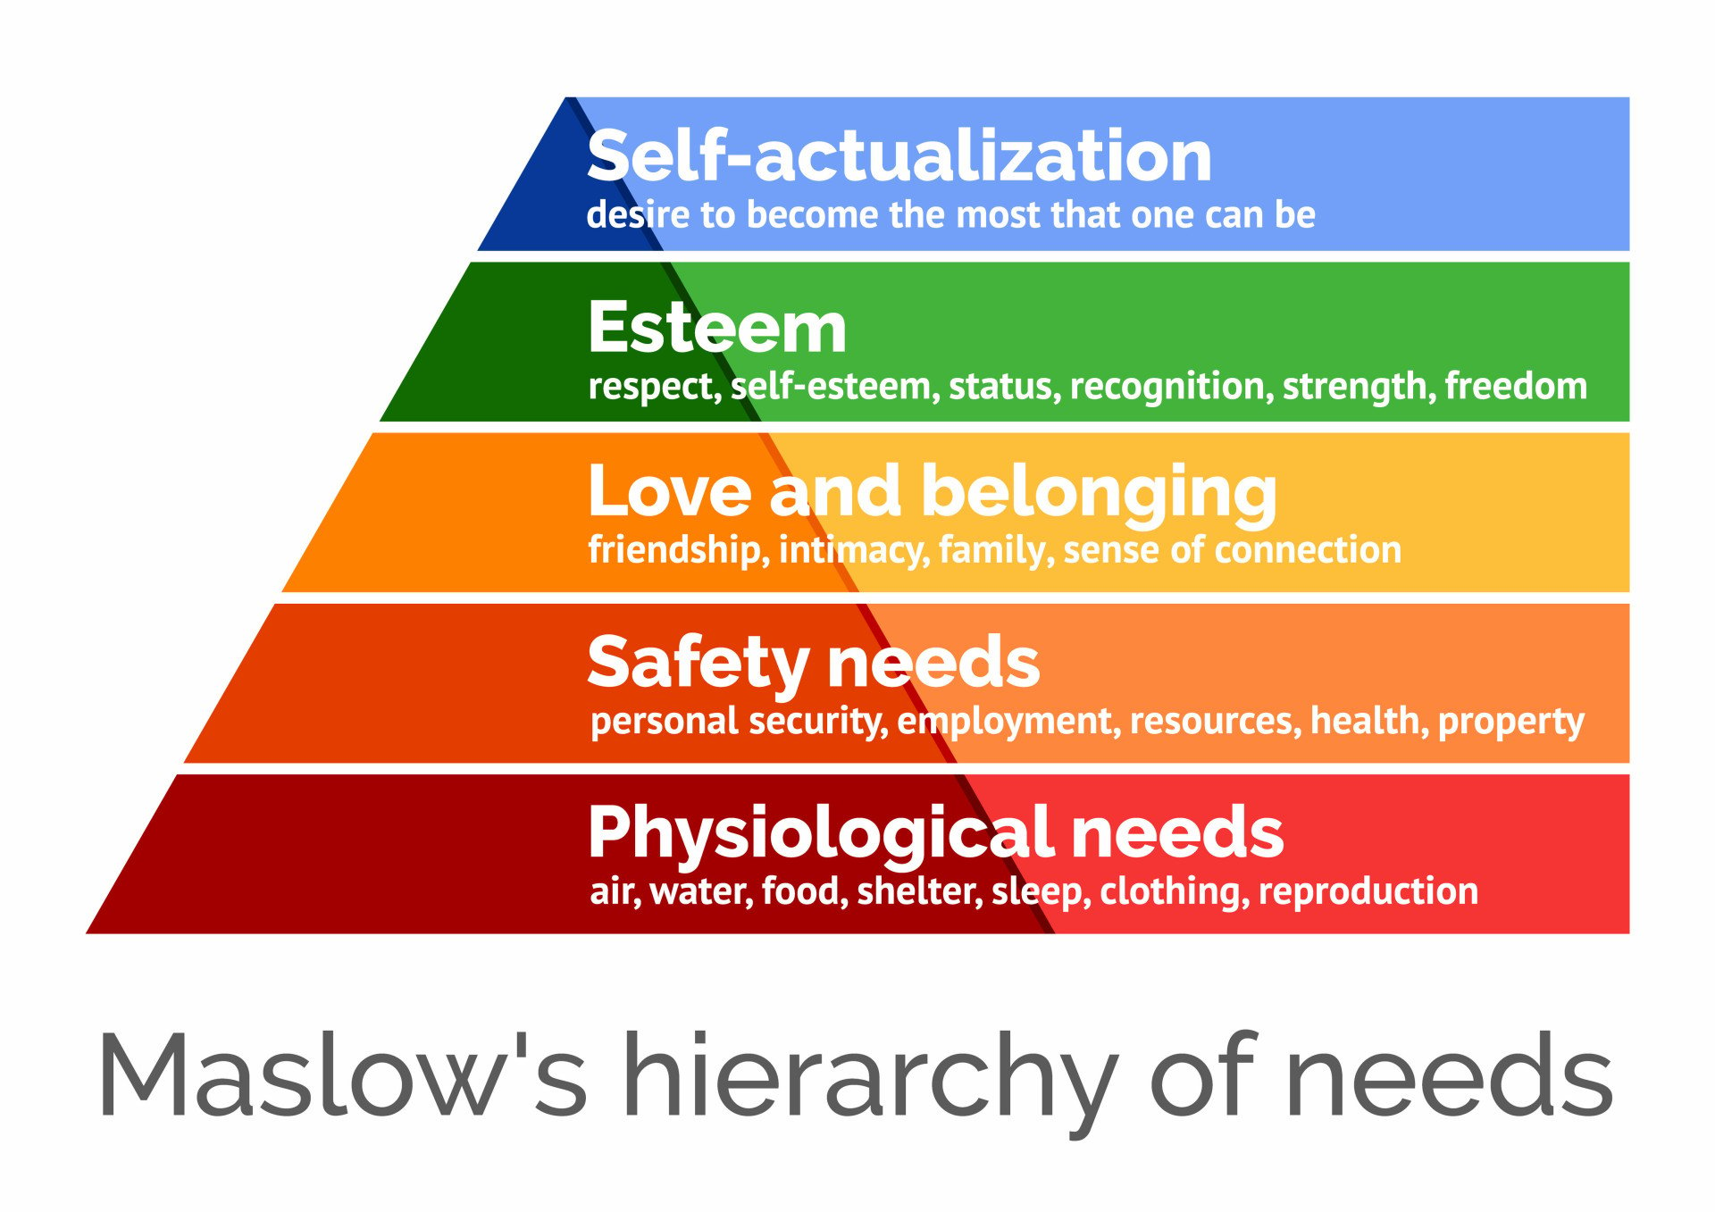
Source: Simply Psychology

However, Ghaleb (2024) argue that Maslow’s theory does not take into consideration fact that people come from different social and cultural backgrounds and that people can be motivated by internal rewards. Similar view of Maslow’s theory has Chavda (2024). He states that this theory does not take into consideration ,other motivating factors like expectations, experience and perception.’
Herzberg Two-Factors theory is a human resources management theory which says that employees are influenced by two types of factors: hygiene (for preservation) and motivational. As stated by Nickerson (2025) ,motivators, like recognition and achievement, lead to higher satisfaction and motivation.

Hygiene factors, such as salary and working conditions, prevent dissatisfaction but do not necessarily motivate.’ The two-factor theory assumes that the feeling of job satisfaction does not arise from removing sources of dissatisfaction, because the removal of factors causing a negative attitude towards work itself does not determine a positive attitude towards the job performance, but only reduces negative feelings. As explained by Mitsakis and Galanakis (2022) Herzberg Theory can be also used in retail setting. In organisational situation it has been reported that variables of achievement and recognition is valued in term of satisfaction and motivation.
Herzberg Two-Factors Theory
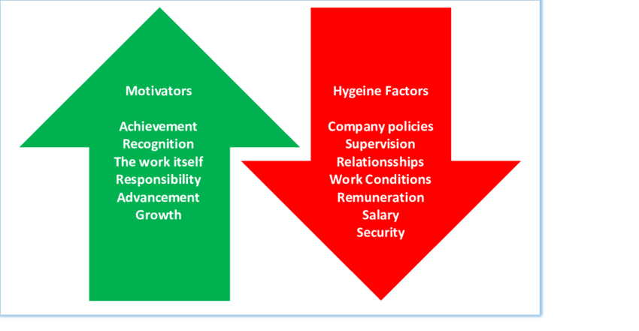
Source: Research Gate

The limitations of Herzberg Theory according to Chen (2024) are that employees feel obligated to like their job and as a result may increase work burnout and emotional exhaustion.
According to Parsons (2025) there are many leadership styles that can influence workplace, team wellbeing and company’s culture. The importance of understanding what type of leadership style is represented can increase the effectiveness in the workplace. In the autocratic leadership style, the person in charge is the one decision-making. It is efficient because decisions are made quickly but it discourage team discussion, and some information might be overlooked. Bureaucratic style is represented by hierarchical setups. It clearly defines responsibilities and duties. Clearly set goals allow transparency but discourage innovation and creativity. Coaching leadership style focuses on individual approach toward employee and focus on their unique strengths and weaknesses. Close connections with employees that requires time and energy investment. Democratic leadership style focuses on bringing team together, shared decision-making and bring talents and knowledge of an individual. This style tend to bring team together, employees are feeling valued, and it increase job satisfaction and productivity. Lack of decisions from leader can cause a slower decision-making.
In 1919 Jack Cohen began selling groceries in London. At the beginning the stock was dry good, mostly tea that was imported by T.E. Stockwell. The name TESCO came from combination of the words T.E.S. and surname of the owner CO (TESCO, 2019). TESCO is one of the biggest retail sellers in the UK with more than 300 000 employees. Managers at TESCO have many tools to motivate its employees. TESCO employs a variety of employee motivation methods, focusing on both financial and non-financial factors. These include competitive salaries, bonuses, rewards, career development programs, flexible working hours, a friendly atmosphere, and support for personal and professional development. Through diversity and inclusion, the workplace actively threat people with respect and allowing them to be themselves, celebrating cultures, personalities and preferences that help to build a strong business. The TESCO PLC board is committed to give opportunities to everyone that work at TESCO (TESCO PLC, 2024). Potential employees knowing the company’s policy are willing to work for TESCO due to recruitment policy that forbid harassment, bullying and any type of discrimination. The anti-harassment policy gives power and responsibility to all coworkers who witness harassment to raise complains to managers who will act responsibly to actively challenge those behaviours (TESCO PLC, 2024).
The methods use by managers to increase productivity is to be great leader and include everyone. The type of leadership which can help the business grow is a strategic hybrid between of two seemingly contradictory styles: transformational leadership and servant leadership (Quarter Deck, 2025). The democratic leadership is a foundation for employee empowerment that allows store managers and department heads to give significant autonomy in operational decisions. Due to this approach frontline employees have more possibilities to observe customer preferences and operational challenges. High efficiency in problem solving is observed due to feedback, surveys and regular consultation sessions (Quarter Deck, 2025).
The employee productivity is higher when jobs that are managed well gives fulfilment and happiness. Combination of factors that increase productivity is a positive work environment, recognition for their efforts, opportunities for growth and a sense of purpose in TESCO workplace. TESCO spent over £900 million since April 2022 to increase hourly wages for its employees to meet their needs with latest cost of living rise. Colleague discount package help to safe annually £2000 maximum but in 2025 the limit was lifted, and employees can use it freely, over 95% of workers use Colleague Clubcard (TESCO, 2025). A competitive pension scheme allows employees to safe for their retirement. Their benefits package attract and retain good employees. TESCO also offers an employee share scheme, allowing employees to become stakeholders in the company (TESCO, 2025).

Research methodology

In this research paper will be used qualitative research method. This approach is designed to understand how individuals think, feel or behave in particular situations, or in relations with others that develop over time (UK Research and Innovation, 2022). Qualitative research is a research approach that focuses on understanding the meanings, motivations, and context of human actions. Unlike quantitative methods, qualitative research is not based on numbers but on deep descriptive analysis, which allows for better capturing the details and nuances of a given phenomenon. Qualitative research asks questions like ,why?’ and ,how?’ to capture more in depth understanding of human nature said Tenny, Brannan and Brannan (2022).
The methods used in this research will allow readers to understand a point of view of an employees and experiences they have. Qualitative methods can bring more information about feeling, will give answers through mimics, gesture and tone of voice. Interview will allow to understand why employee behave in certain way and what push them to be more motivated. The interview will help to find new aspects of the problems that will help in the future research. The plan is to conduct a semi-structured interview with prepared guide but allow for free expression when needed to collect more information. Data collection will require to interview 15 participants from every shop with maximum of 3 shops. The interview will take place in a workplace after permission taken from management. Data analysis will be completed by looking for pattern and similarities from answers given by participants. Participation in research will be free and anonymous.

Limitation of the present research

In this document secondary data was used to collect and analyse the data. The goal of using secondary data is to collect sources from different research papers and to analyse them to find any gaps in the research (The library learning hub, 2025). According to Middleton (2022) validity refers to the extent to which a given measurement or tool actually measures what is intended to measure. Reliability refers to the consistency and repeatability of results. It checks if given measurements produce the same results when repeated multiple times under the same conditions. Chosen sources were conducted by TESCO itself and can be one sided. More data from different organisations and through interviews with employees can gives different more reliable insight of the problems and gaps in the research. The limitations of this research was time. Research took 7 weeks to complete.
Recommendations for future data collections is to interview employees of TESCO stores. Samples should be bigger and from different backgrounds. The idea is to collect more data and gather more information regarded employees motivation and productivity and what type of methods management use to fulfil needs of employees and work satisfaction.

References

Chavda, A.J. (2024) Maslow’s Hierarchy of Needs: A Critical Evaluation. International Journal of Social Impact. 9(3), p.1. [Online]. Available at: DOI: 10.25215/2455/0903012 (Accessed 8 July 2025).
Chen, Q. (2024) Critical Analysis of Motivation and Organizational Culture at Google: Balancing Innovation with Employee Autonomy. International Journal of Education and Humanities. 17(3), p.1.
Ghaleb, B.D.S. (2024) Towards A Dynamic Model of Human Needs: A Critical Analysis of Maslow's Hierarchy. International Journal of Multidisciplinary Approach Research and Science. 2(3), pp.1028-1046. (Online). Available at: https://doi.org/10.59653/ijmars.v2i03.674 (Accessed 8 July 2025).
LSBF Staff. (2024) What Role Does Motivation Play in Managing an Organisation? (Online). London School of Business £ Finance. Last Updated: 27 June 2024. Available at: https://www.lsbf.org.uk/blog/news/business-economy/what-role-does-motivation-play-in-managing-an-org (Accessed 3 July 2025).
McLeod, S. (2025) Maslow’s Hierarchy of Needs. (Online). Simply Psychology. Last Updated: 14 March 2025. Available at: https://www.simplypsychology.org/maslow.html (Accessed 7 July 2025).
Middleton, F. (2022) Reliability vs Validity in Research | Differences, Types & Examples. (Online). Scribbr. Last Updated: 10 October 2022. Available at: https://www.scribbr.co.uk/category/research-methods/ (Accessed 10 July 2025).
Mitsakis, M. and Galanakis, M. (2022) An Empirical Examination of Herzberg’s Theory in the 21st Century Workplace. Organizational Psychology Re-Examined. Scientific Research. 13(2), p.264-272. (Online). Available at: https://doi.org/10.4236/psych.2022.132015 (Accessed 8 July 2025).
Nickerson, Ch. (2025) Herzberg’s Two-Factor Theory of Motivation-Hygiene. (Online). Simply Psychology. Last Updated: 18 April 2025. Available at: https://www.simplypsychology.org/herzbergs-two-factor-theory.html (Accessed 7 July 2025).
Parsons, L. (2025) How to Determine What My Leadership Style Is. (Online). Harvard Division of Continuing Education. Last Updated: 19 February 2025. Available at: https://professional.dce.harvard.edu/blog/how-to-determine-what-my-leadership-style-is/#Why-You-Need (Accessed 9 July 2025).
Quarter Deck. (2025) What Leadership Style Does Tesco Use: Complete Analysis. (Online). Quarter Deck. Last Updated: 27 May 2025. Available at: https://quarterdeck.co.uk/articles/what-leadership-style-does-tesco-use (Accessed 9 July 2025).
Simplilearn. (2025) What is Productivity: Defining and Measuring Efficiency. (Online). Simplilearn. Last Updated: 9 June 2025. Available at: https://www.simplilearn.com/what-is-productivity-and-how-to-define-and-measure-it-article (Accessed 3 July 2025).
Tenny, S., Brannan, J.M. and Brannan, G.D. (2022). Qualitative study. (Online). National Library of Medicine. Last Updated: 18 September 2022. Available at: https://www.ncbi.nlm.nih.gov/books/NBK470395/ (Accessed 24 June 2025).
TESCO. (2019) Motivational theory in practice at Tesco. (Online). Business Case Studies. Last Updated: 20 September 2019. Available at: https://businesscasestudies.co.uk/motivational-theory-in-practice-at-tesco/ (Accessed 9 July 2025).
TESCO PLC. (2024) How we create an inclusive working environment. (Online). TESCO PLC. Last Updated: 23 July 2024. Available at: https://www.tescoplc.com/sustainability/documents/policies/how-we-create-an-inclusive-working-enviro (Accessed 9 July 2025).
TESCO. (2025) Our approach to Reward. (Online). TESCO PLC. Last Updated: 2025. Available at: https://www.tescoplc.com/sustainability/colleagues/reward-benefits (Accessed 9 July 2025).
The library learning hub. (2025) Introduction to secondary research. (Online). Teesside University. Last Updated: 16 June 2025. Available at: https://libguides.tees.ac.uk/researchmethods/secondary (Accessed 24 June 2025).
UK research and Innovation. (2022) What is social science? (Online). UK research and Innovation. Last Updated: 31 March 2022. Available at: https://www.ukri.org/who-we-are/esrc/what-is-social-science/qualitative-research/ (Accessed 24 June 2025).
Wietrak, E., Rousseau, D. and Barends, E. (2021) Work motivation: an evidence review. Scientific summary. London: Chartered Institute of Personnel and Development.

Gantt Chart



