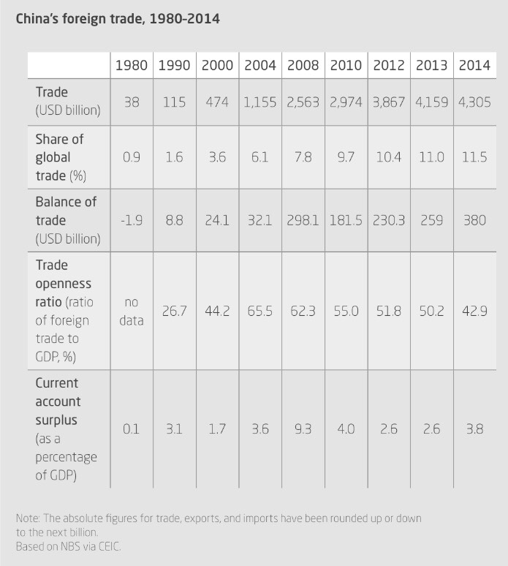
Morgan_1601543_HPCH6004_2
Data Analysis of the People’s Republic of China’s Trade from 1980-2014.
Sebastian Heilmann, China’s Political System, (London: Rowman & Littlefield, 2017), p.221.

In this data analysis I will be analysing and interpreting a table of numerical data concerning the clear trend toward growth in the foreign trade of the People’s Republic of China (PRC) from 1980 to 2014. The table shows five variables; the PRC’s annual trade, the share of global trade as a percentage for that year, the PRC’s balance of trade – in other words the difference between its net imports and net exports annually, the PRC’s trade openness ratio for that year, and the PRC’s current account surplus – this indicates that a country is a net lender to the rest of the world. All of these variables are rounded to the nearest billion USD. One of the interesting difficulties with analysing this table of trade related data is the time periods used. The table is sub-divided into two, decade long time periods from 1980 to 1990 and 1990 to 2000. It is then sub-divided into two, four-year-long time periods from 2000 to 2004 and 2004 to 2008. It is then sub-divided into two, two-year-long time periods from 2008 to 2010 and 2010 to 2012; before finally being sub-divided yet again into two, one-year-long time periods covering 2013 and 2014. I must make clear from the outset that my analysis and interpretation here is only an example of possible reasons for the trends uncovered in this table of data and is not intended to be perceived as the reason for any of the trends uncovered in the course of this analysis. In this data analysis I will analyse each time period and the numerical data for the five variables in that time period. The time periods will be 1980 to 2000, 2000 to 2008, 2008 to 2012, and 2012 to 2014.
As such let me begin with the data for the first time period beginning in 1980. During this time Deng Xiaoping was still relatively new to his position as paramount leader of the PRC, which he ascended to in 1978 following Mao’s death in 1976. Although the violence of the Cultural Revolution had abated by late 1968 many of its policies remained for years afterward. The simple fact was that the Cultural Revolution had severely damaged the PRC’s relations with more than 30 sovereign states. Red Guards had attacked foreign embassies and every single PRC Ambassador was recalled with the exception of the Ambassador in Cairo, Egypt. All of this chaos had consequences and as such it is no surprise that the PRC’s trade in 1980 only amounted to $38 billion, along with it’s very low 0.9% share of global trade, especially given its vast population of approximately 1 billion people at the time. The chaos of the Cultural Revolution and the persecution of intellectuals, scientists and academics could be a key reason for the complete lack of data on trade openness as a percentage of GDP; likely due to a lack of data collection by the National Bureau of Statistics (NBS). The aftereffects of the Cultural Revolution were also likely responsible for the fact that the PRC imported $1.9 billion more than it exported in 1980. This was despite managing to cling on to a 0.1% of GDP current account surplus.
However, by 1990 we see a significant increase of 0.7% in the global share of trade that the PRC possesses, alongside a jump in overall trade to $115 billion. The past decade had allowed the ‘Open Door to the West’ policy and market-based reforms put in place by Deng Xiaoping to take effect. According to Heilmann this was the result of four economic factors that allowed the rapid mobilization of capital, labour, and productivity throughout the 1980’s. Firstly, the previously centrally planned command economy was gradually phased out in favour of market-led forces, competition and an increasingly prevalent private sector. Secondly, the ‘Open Door’ policy mentioned above allowed an expansion of trade and foreign direct investment to the PRC, bringing with it technology and expertise. Thirdly, the migration of hundreds of millions of previously rural agricultural workers into the cities provided a constant flow of cheap labour to the metropolitan areas and finally the PRC’s state-led investments drove growth to a great extent via infrastructure projects and urban housing developments. These factors likely helped the PRC reach a turning point between 1980 and 1990, with it transforming from net importer to net exporter with its net exports at $8.8 billion in 1990, allowing it to achieve a healthy current account surplus of 3.1% of GDP. This was in large part due to the Special Economic Zones (SEZ’s), the first four of which – Shenzhen, Zhuhai, Shantou, and Xiamen – were set up under Deng Xiaoping and Zhao Ziyang in 1980. It is quite likely that these growth figures would have been higher however, were it not for the worst inflation in PRC History occurring in 1988 following the PRC’s experimentation with price reforms. That inflation was one of several issues that led to the Tiananmen Square protest and subsequent massacre on the 3rd-4th of June 1989. This led to a strong backlash from western nations, followed by sanctions on the PRC that severely curtailed economic growth and trade.
Having gone through the gradual introduction of market mechanisms into the PRC’s economy in the 1980’s growth began to really take off in a sustained and rapid manner after 1990. This transformation into a ‘socialist market economy’ created a new entrepreneurial class, further developing the market-economy characteristics of the PRC. As we can see this led to yet another significant increase in trade of $474 billion in the year 2000, and an increase in the PRC’s global share of trade to 3.6%. One important increase between 1980 and 2000 is the increase in the trade openness ratio – the ratio of foreign trade to GDP as a percentage – which rose from an unspecified amount in 1980 as there was no data available, to 26.7% in 1990 to 44.2% in 2000. This shows the rapid advance of China’s export-led growth and its transformation into the modern day ‘workshop of the world’. This may well have been in part due to the return of Hong Kong and Macau to the PRC in 1997 and 1999 respectively. Interestingly however, the PRC’s current account surplus dropped from 3.1% in 1990 to 1.7% in 2000. Since a current account surplus refers to the amount of goods and services being exported exceeding the amount being imported, that drop could be explained by the PRC’s use of its new found wealth to begin importing luxury western products and advanced technologies; an argument supported by the significant improvement in living standards.
Moving now to the period from 2000 to 2008 we see a massive expansion yet again in the PRC’s trade from $474 billion in 2000, to $1.155 trillion in 2004, and more than doubling yet again to $2.563 trillion in 2008. The primary factor for this massive expansion was likely the accession of the PRC to the World Trade Organisation (WTO) in 2001, its subsequent integration into the global economy and the deregulation and promotion of competition within its domestic market. This led to a 7.8% global share of trade by 2008 and a massive expansion of the PRC’s balance of trade from $32.1 billion in 2004 to $298.1 billion in 2008 following its deeper integration with the global economy. This period of rapid growth in trade also led to the PRC’s highest trade openness ratios of 65.5% and 62.3% in 2004 and 2008 respectively and a 9.3% of GDP current account surplus in 2008. However, things were about to change.
If the 2008 global financial crisis was an economic hurricane, the PRC was the relatively peaceful eye of the storm. It weathered the crisis relatively easily, sustaining an impressive GDP growth rate of 9.6% in 2008; at least according to the State Statistical Bureau. Other analyses by economists have taken a more sceptical view of the official figures questioning the reliability of official GDP statistics released by the PRC. One such analysis in China’s Political System by Sebastian Heilmann put the official figure for GDP growth in 2008 at 8.9% while the unofficial estimation put it closer to 5.8%. Despite this unreliability regarding analyses produced by the NBS it is clear that the PRC’s growth was still enviable at a time when virtually all the world’s developed economies were sliding into recession. The 2008 global financial crisis and subsequent 2010 European debt crisis clearly had an effect however. We can see this via the relatively slow growth in trade between 2008 and 2010 from $2.563 trillion to $2.974 trillion when compared with the explosive growth of 2004 to 2008. We also see the effect in the largest increase in the PRC’s share of global trade since the 1990’s, jumping from 7.8% to 9.7%. This was likely due to the contraction of the economies of most other developed trading nations. Another indication is the drop in the trade openness ratio from 62.3% to 55.0% between 2008 and 2010 and the significant drop in the current account surplus from 9.3% to 4.0% over the same time period. Likely due to a significant decrease in the importation of Chinese goods into developed nations affected by the 2008 global financial crisis and the 2010 European debt crisis, while the PRC maintained its level of importation from those nations of advanced technologies and luxury goods. The significant increase once again in 2012 of nearly a $1 trillion in trade is again explained by the resurgence of developed nations after the 2008 and 2010 financial crises and their greater ability to once again import Chinese goods. As such the PRC’s trade rose from $2.974 trillion in 2010 to £3.867 trillion in 2012.
Following the 2008 global financial crisis and the 2010 European debt crisis the new PRC leadership under President Xi Jinping decided the economy was overly dependent on investments and exports and insufficiently driven by domestic consumption. As such it determined it must decrease its reliance on, and exposure to, international financial markets. This is clear in the final time period of the table of data from 2012 to 2014. From President Xi’s accession to power in 2012 the PRC’s trade has continued to increase from $3.867 trillion in 2012 to $4.305 trillion in 2014 as has its global share of trade, up from 10.4% in 2012 to 11.5% in 2014. By 2014 the PRC also had a colossal $380 billion balance of trade. However, the interesting figures for this time period are the sharp decline in the trade openness ratio from 51.8% in 2012 to 42.9% in 2014, the lowest it has been since the 1990’s. This is in line with the move away from export-led growth to a more sustainable domestic consumption-based model under President Xi.
In conclusion then in have analysed this table of data concerning the PRC’s foreign trade from 1980 to 2014 and have found a number of trends in the data that match up well with domestic policy initiatives such as Deng Xiaoping’s liberalisation of the PRC’s post-Cultural Revolution command economy and its transformation into a ‘socialist market economy’; as well as President Xi’s more recent move away from export-led growth to an economic model based on domestic consumption. I have also shown that the data explains well the international economic factors, such as the PRC’s accession to the WTO in 2001 and its strong perseverance and subsequent expansion of trade after the financial crises of 2008 and 2010.

Word Count: 2,092

Bibliography
Cohn, T. H., Global Political Economy: Theory and Practice, 7th edn. (Oxford: Routledge, 2016).
Dreyer, J. T., China’s Political System: Modernization and Tradition, 10th edn. (New York: Routledge, 2019).
Heilmann, S., China’s Political System, (London: Rowman & Littlefield, 2017).
Saich, T., Governance and Politics of China, 4th edn. (London: Palgrave, 2015).

Sebastian Heilmann, China’s Political System, (London: Rowman & Littlefield, 2017), p.221.
June T. Dreyer, China’s Political System: Modernization and Tradition, 10th edn. (New York: Routledge, 2019), p.5.
Ibid., p.341.
Sebastian Heilmann, China’s Political System, (London: Rowman & Littlefield, 2017), p.245.
June T. Dreyer, China’s Political System: Modernization and Tradition, 10th edn. (New York: Routledge, 2019), p.5.
Sebastian Heilmann, China’s Political System, (London: Rowman & Littlefield, 2017), pp. 193-195.
Tony Saich, Governance and Politics of China, 4th edn. (London: Palgrave, 2015), p.24.
Ibid., p.52.
Ibid., p.329.
Sebastian Heilmann, China’s Political System, (London: Rowman & Littlefield, 2017), p.197.
Ibid., p.220.
June T. Dreyer, China’s Political System: Modernization and Tradition, 10th edn. (New York: Routledge, 2019), p.168.
Sebastian Heilmann, China’s Political System, (London: Rowman & Littlefield, 2017), p.197.
Ibid., p.198.
Theodore H. Cohn, Global Political Economy: Theory and Practice, 7th edn. (Oxford: Routledge, 2016), p.172.
June T. Dreyer, China’s Political System: Modernization and Tradition, 10th edn. (New York: Routledge, 2019), p.173.

