
Skills for the Workplace
Module Assignment Submission
Student Name: | Alana Quevedo Diaz
Student Number: | 2015376
Module No: | BMSK4002
Module Title: | Effective Team Working and Communication  Part 2

Statement of Confirmation of Authenticity
By the act of making this submission, the student declares that this is the work of the student named above. The work has not, in whole or in part, been knowingly presented elsewhere for assessment, or where assessment has been built on a previous assessment, this has been identified. Where materials have been used from other sources it has been properly acknowledged. If this statement is untrue, the student acknowledges that an assessment offence has been committed.
Attention is drawn to the plagiarism and unfair practice policies of both the University and of ILM.

Table of Contents
Part 2 Communication 3
1.0 3
Communication Cycle 3
2.0 4
Assessing Own Communication Skills as a Manager 4
Gap Analysis 4
PDP 4
Personal Development Plan to Improve own Communication Skills 5
References 6
Appendix A 6

Part 2, Communication

Communication can be defined as ‘The transmission or exchange of information, knowledge, or ideas, using speech, writing, mechanical or electronic media’ (Oxford English Dictionary, 2019).

Communication is one of the essential elements of our society. We need people to interact, and the ability to convey messages and understand each other is vital. The communication cycle indicates how the system of transmitting and understanding messages operates.

There is a relationship between effective communication and job satisfaction in a workplace environment to achieve higher success, where a good level of communication is essential. Clampit and Girard (1993) analysed communication satisfaction, explaining that their factors provide an effective way to differentiate between employees at the upper and lower parts of the range regarding both self estimates and job satisfaction for productivity.
Communication in organisations is essential, and it becomes effective when we have a clear idea of what is expected of us and how we can contribute in the workplace. We are likely to feel more satisfied. Communication in the workplace includes internal communication with staff and external communication with customers and suppliers.

4 Types of communication (Valamis.com)

Non-verbal, verbal, written and visual communication.
Communication is much more than just verbal transmission of information from one person to another.
Non-verbal is mainly facial expressions; for example, when we smile or raise eyebrows, it is essential in a conversation. We know how hard it is to talk to a stone-faced person.

Posture is how we position and angle ourselves if we are relaxed, leaning back or crossing arms or physically touching, maintaining or not eye contact. All these non-verbal actions are part of how we communicate.
Verbal is when we speak, we use tone and pitch; we are communicating much more than just word contents.
Our pitch may change the tone when we get emotionally involved and are angry, upset, or frustrated, or if we are content conveying to the listener that we are experiencing a strong emotion.
This is not necessarily a bad thing, but controlling it allows us to make sure that we are effectively communicating.
Written communication is more formal than verbal; leaving out slang and using punctuation and spelling are essential, especially in the digital era, where everything we write is there, even if we delete it. Knowing how to write is an essential skill. We clearly explain concepts and ideas, making sure that the reader understands, especially nowadays, that more people are working remotely and keeping in touch throughout different platforms, such as emails, Microsoft teams, Whatsapp messages, LinkedIn and others.
Visual communication is driven by social media, especially YouTube, and other platforms where we are video recordings, such as Microsoft teams, Zoom, Google Meet and others. We observe that more and more people and organisations are using these channels of communication.
Today we rely heavily on visual communication as visuals elevate our understanding of complex ideas.

Communication cycle
From source to the receiver

The Open University (2019) describes the communication cycle starting from the source, encoding, channelling, decoding and giving and receiving feedback.
Encoding is the building up of our message. Effective encoding will demonstrate clarity, and by using appropriate language, we reduce the risk of confusion. We must consider how the person who is reading or listening to our message will respond. If we are communicating our message to more than one person, each person may perceive it differently.
Channel is the form of communication, face to face, social media, video, written or spoken. We must consider the most appropriate channel to deliver a message. For example, sometimes written communication may be the best approach, but not always. Knowing and understanding the audience is vital in choosing the channel.
Decoding is the process that happens when the recipient receives the message. Effective decoding happens when we have written or spoken the message clearly, demonstrating an understanding of what the receiver should know already. This would support the receiver to interpret the message in the right way. Decoding will be an issue if we do not use appropriate language.
The receiver is the recipient of the message, and they will interpret the message accordingly. They could all agree or disagree depending on their point of view.
Feedback is essential because it helps us to judge whether our message has been received in the way we intended or another.

Communication Cycle
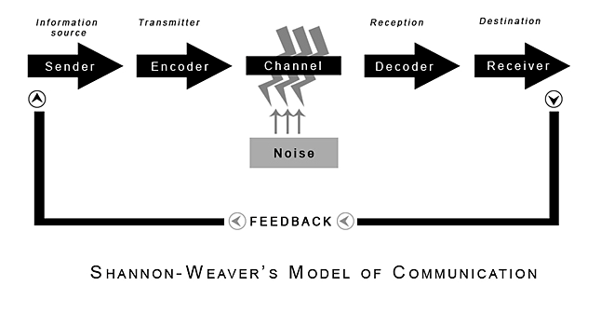

2.0
(Shannon and Weaver, 1949)

Claude Shannon was an American mathematician, Electronic engineer, and Warren Weaver was an American scientist. Both of them joined together to write an article in "Bell System Technical Journal" called "A Mathematical Theory of Communication" and also called the "Shannon-Weaver model of communication".
This model has been mainly created to develop efficient communication between sender and receiver. Also, they find factors that affect the communication process that is called "Noise". Initially, the model was created to improve technical communication. Later it was widely implemented in the field of communication.
The Shannon-Weaver model introduces Noise, which refers to anything that interferes in the channel stage of the model. For example, the background noise makes it hard for a receiver to hear a message, or maybe some distractions prevent them from concentrating on the communication. If we are talking to a customer who is at the same time receiving a phone call, or having physical pain, then the communication has been interfered with by Noise.
Other essential factors are not considered in the Shannon-Weaver model, such as language or cultural differences. Because it was initially designed for electronic communication, it does not focus on the additional human factors that could also influence how a receiver decodes their message.
Berlo's model of communication focuses on the emotional aspect of the message.

Berlo, Process of Communication

Berlo's model of communication operates on the SMCR model.
S - Source, M - Message, C - Channel, R - Receiver and S - Source
The source is the sender where the ideas originate, transferring the information to the receiver. It is done with the help of communication skills, attitude, knowledge, social system and culture.

The following characteristics are essential for Berlo's model of communication

Communication Skills
An individual should acquire excellent communication skills to make his communication efficient to impact among the listeners.
Attitude, having the right attitude can change the whole way of communicating.
Knowledge is the clarity of the information which the speaker wants to convey to the receiver. When communicating, we have to have in-depth knowledge of the subject and be prepared for questions that can pop up anytime.
Social System is knowing about the sentiments, cultural beliefs, religious feelings of the society we are referring to.
Culture is the background of the community or the listeners where the speaker is communicating or delivering his speech.

M - Message or encoding
When an individual converts his thoughts into words, a message is created.
Any message further comprises of the following elements.
Content is the matter or the script of the conversation. It is vital for the communicator to carefully choose the words and take good care of the content of the message. The content has to be crisp, sensible, accurate and related to the thought to impact the audience.
Element; Body language is the key as the speech must be coupled with lots of hand movements, gestures, postures, facial expressions, body movements to capture the listeners' attention.
Treatment; We need to understand the importance of the message and know how to handle it and present it so that it is conveyed in the most accurate form.
Structure
The message has to be conveyed in the most desired form.
Code
Codes in communication matters. Our body movements, language, expressions, gestures are the codes of the message and have to be accurate.
C - Channel
Channel: Channel refers to the intermediate how the information flows from the sender to the receiver. The five senses of the human being are the channels that are connecting us to the world.

R - Receiver
The receiver tries to understand the message and then responds accordingly; it is also called decoding.
For the flow of information, the receiver is on the same platform as the speaker, for good interaction and communication skills to understand what the speaker is trying to convey.

Assessing Own Communication Skills as a Manager

To evaluate my communication skills as a manager, I am referring to my presentation on effective teamwork. Having collected feedback from my fellow students, who acted as receivers of the message, they helped me understand my expertise in delivering an organised and knowledgeable speech. They gave me feedback that I was decoding to understand how I communicate. The purpose of my speech was to demonstrate an understanding of the main theories of effective teamwork, link it to team dynamics, and prove the importance of teamwork from an employment and management perspective. My goal was to describe the two leading theories of Belbin and Tuckman and describe my own teamwork experience. I talked about confidence, high-performance teams, role models in the workplace and team dynamics. I have analysed my workplace in terms of behavioural communication and have given examples of how good the workplace was. In this part of the presentation, due to Covid-19, we were unable to test our non-verbal communication ability. We showed our presentation online to the team. My presentation was between good and excellent. The feedback sheets from my fellow students said that they enjoyed the colours I chose for the slides and that my tone of voice was adequate. One of the criticisms I had, which I never had before, is that I spoke too fast, and maybe that was due to me thinking about finishing on time.
When thinking about my preparation, I believed that I researched it enough beforehand to be confident in the content and speaking ability. However, I did speak quite quickly, especially on the change from one slide to another. After reading over the feedback that I was given, I needed to take more time to let my audience absorb the information on every slide. In conclusion, if I had to do the presentation again, I would practise it with a broader group of people to get more feedback. Also, I would have practised pausing between slides and produced a sentence to link each slide to make the presentation flow and not lose my audience.
I felt that I included all the necessary information about effective teamwork. I had a good introduction, clear structure and reasonable explanation of examples from cruise ship work. Though some of these slides were a bit wordy, and I included a few images because I found it easy to relate to my content. On reflection, I could have used a more engaging presentation format. Nervousness is a significant obstacle for many people to speak in public. I was a little apprehensive during my presentation, and I thought it might have resulted in me leaving out parts of what I would say.
My voice could have been a little louder and possibly be more variant. The solution to this is to practice more when getting ready for the presentation. Furthermore, I will ensure that I continue developing my presentation skills and research to make a compelling slide presentation. Therefore through practice, I hope to have enough experience to be confident to give presentations effectively in the future.

Gap Analysis

Objective | Current Position | Deficiency | Action
What do I want to do? | What can I already do? | What am I lacking? | How do I fix this?
Listening Skills | Learn how to better support team conversations and how to listen to senior managers | I get distracted which sometimes leads to mistakes. | Attend leadership courses where I can improve these skills.  Which I am already doing with University.
Decision Making | I can make decisions sometimes, but I need more confidence. | When making decisions, clarity is essential throughout. how to make and stick to a decision | Learn from the course material and also learn from my coworkers and students.

PDP

Assessing Own Communication Skills as a Manager

Objectives | Tasks | Success Criteria | Time Frame | Resources
List your Goals | What do you need to do to achieve these goals? | How will you identify your success? | When do they need to be done by? | Who or what do you need to help you?
Improve communication skill | Plan and lead a team meeting | Monthly meeting with  my area manager to review my progress | 09/2021 | Approval from the manager to arrange a meeting at an approved time
Motivating a team | Outdoor team activities  1-2-1-team members or group setting | Improved engagement | 06/2021-ongoing | Away days/  outdoor activities
Improve presentation skills | By making presentation in a group and getting feedback | This goal is ongoing because I am still practising my presentation skills in front of family and coworkers. I am progressing; however, I will continue to work hard to achieve my goal . | 06/2021-ongoing | learn and observe from more experienced collegues

References

Berlo, D (1960) The Process of Communication [online] available at: https://www.communicationtheory.org/berlos-smcr-model-of-communication/ Accessed 18.05.21

Clampit and Girard (1993) Employee Perceptions of the Relationship Between Communication and Productivity: A Field Study [online] available at:
https://journals.sagepub.com/doi/10.1177/002194369303000101 Accessed 23.05.21

Oxford English Dictionary, 2019. Communication [online] available at: https://www.oxfordlearnersdictionaries.com/definition/american_english/communication Accessed 25.05.21

The Open University How does the communication process work? [online] available at: https://www.open.edu/openlearn/ocw/mod/oucontent/view.php?id=87012&section=4 Accessed 27.05.21

Valamis.com Types of communication [online] available at: https://www.valamis.com/hub/types-of-communication Accessed 28.05.21
Shannon, C. and Weaver, W. (1949) The Mathematical Theory of Communication. Urbana: University of Illinois Press.

Appendix A
Feedback 1
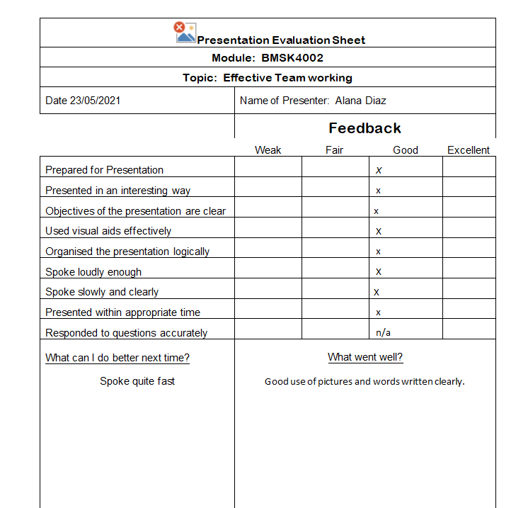
Feedback 2
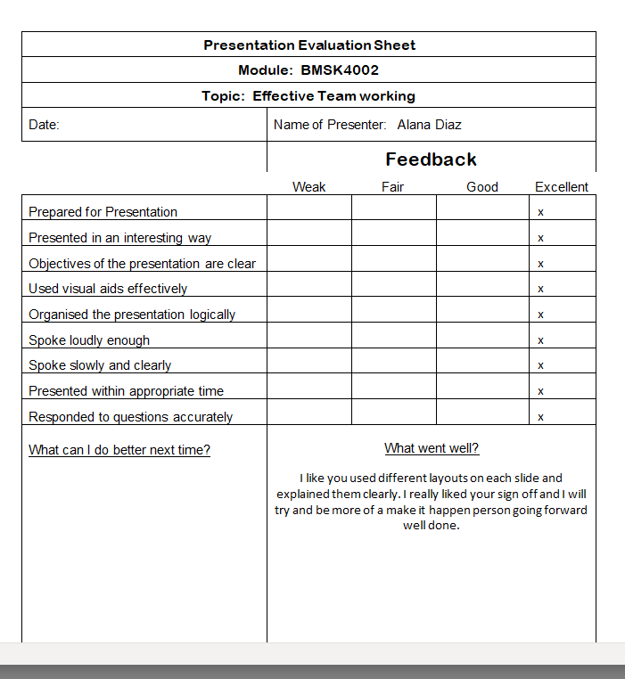

Feedback 3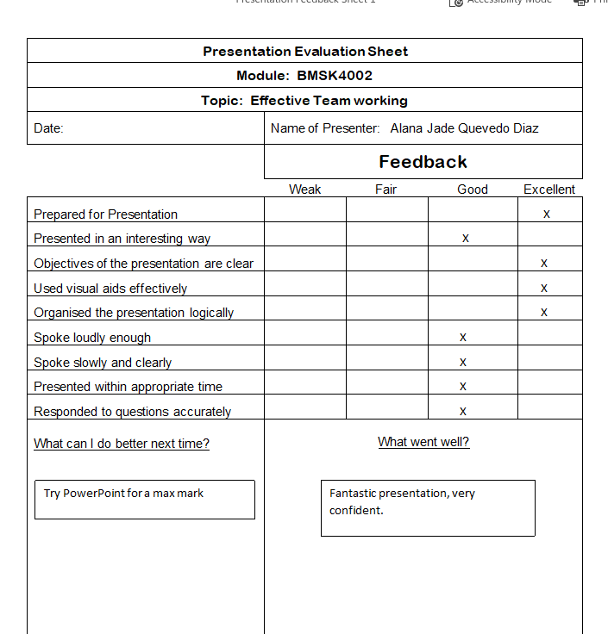

Feedback 3

