PROGRAMME: MBA – MASTER OF BUSINESS ADMINISTRATION
MODULE: BANKING FINANCIAL MANAGEMENT AND FINANCIAL MARKETS

Table of Contents
Introduction 3
1. Primary laws, regulations and contracts enacted post 2008 financial crisis 3
2. Contribution of reforms towards stabilisation of financial system and banking institutions post 2008 crises 7
3. Discussion and analysis of the reforms have had impacted the business model and level of compliance and non-compliance to these reforms 10
Conclusion 17
Reference List 19

Introduction
The following assignment is based on gaining comprehensive knowledge of “Banking Financial Management and Financial Markets”. This study will focus on two main learning outcomes that are to improve knowledge on demonstrating and understanding of the pricing of financial assets, the role and application of various financial theories and the operation of the financial markets. Along with that, to understand the bank performance criteria and valuation methods and assess a detailed understanding of contemporary issues that takes place in the banking management. The whole discussion is developed as per the financial crisis that took place in the year 2008. The financial crisis of 2008 has significantly affected the financial system of some of the developed economies (Goh et al. 2015). With real estate, the market started to collapse with the underlying issues in the management of the mortgage led to a serious recession. Several financial institutions collapsed completely with some getting assistance from banks and investors for their survival in the market. In regards to the above discussions on the financial crisis, several key aspects of banking management will be discussed in this following study and provide insights on how banking structure and operations have changed since the crisis.

1. Primary laws, regulations and contracts enacted post 2008 financial crisis
The “financial crisis”, illustrated the requirement for better supervision as well as regulation of the financial industry. The economic crisis in 2008 further prompted an immediate form of response by different governments for avoiding a collapse associated with financial and banking systems. The Eurozone crisis displayed vicious circle between sovereign and bank debt. The requirement for a better governed as well as a deeper economic union regarding single currency for working in prolonged period became precise. On 29th September 2010, EU presented legislative proposals associated with change in economic governance (Europa.eu, 2014).
It involved “reinforcing SGP”, through strengthening preventive form of arm and focusing more on “debt creation”. It included broadening surveillance and assuring more effective form of enforcement adequate incentives as well as early form of sanctions. At 11th March 2011 summit, EU leaders agreed to; potentially reinforce EFSF and allowed to intervene key debt market. The “EU Heads of State and Government”, committed to a proper banking union on June 2012 (Europa.eu, 2014). Their vision was further established in “European Commission’s blueprint for economic and monetary union”, in the month of November 2012 by issuing a “MEMO/12/909”. It contributed to a robust financial framework for single market in Europe (Europa.eu, 2014). Through this memo, EU created a strong financial framework for its 28 members, back in that time. In this context, the framework also comprehended to implementation of “G20 Commitments on financial regulation”, of EU (Europa.eu, 2014).

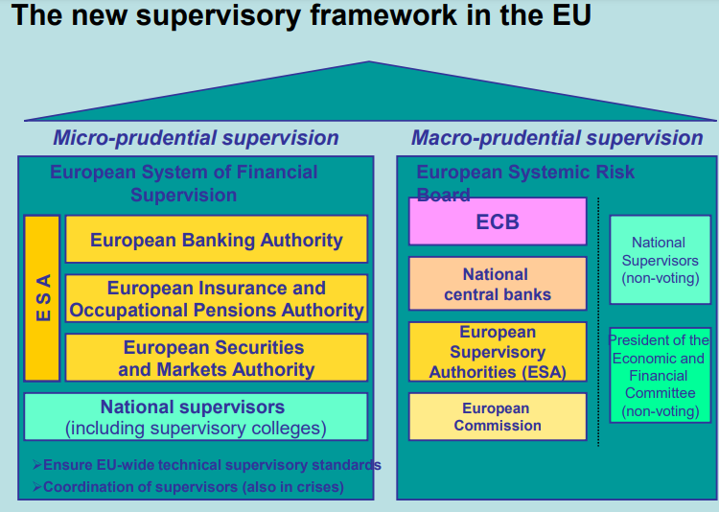
Figure 1: Improved supervisory framework in EU
(Source: Oecd.org, 2010)
EU also established “Three European Supervisory Authorities (ESAs)” on 1st January 2011, for launching a supervisory form of architecture ((MEMO/10/434). In this aspect, the “European Banking Authority (EBA)”, was set for dealing with supervision of banking institutions and it also involved supervision of bank recapitalisation aspects. Additionally, EU set up regulation bodies like “European Securities and Market Authority (ESMA)”, which dealt with monitoring of capital markets (Oecd.org, 2010). ESMA was also responsible for carrying out a direct form of monitoring with proper aspect to different credit-rating agencies along with different kinds of trade-repositories (Corpgov.law, 2010). Other regulation bodies included set up of “European Insurance and Occupational Pensions Authority (EIOPA)”, which dealt with supervision of insurance. Apart from these regulation bodies, the “European Systematic Risk Board (ESRB) was developed for assessing as well as supervising threats associated with financial form of stability , which raised due to the macro-economic establishments within potential financial system. The “European Council” in June 2009, had recommended development of a single form of rulebook that could be adhered by all financial institutions to operate in the single market (Europa.eu, 2014). It consisted approximately 8300 banks to adhere to the rulebook, for assuring good regulation everywhere and avoidance of any kind of loopholes. It worked as a major step in the field of banks and assured a “single market”, related to all kinds of financial services.
It is significant to note that the single rulebook was supported by “CRD IV (Capital Requirements Directive IV)”, which was incorporated through “Basel III agreement”, in EU legal framework. It came into force on 16th July 2013 (Cftc.gov, 2022). Apart from this, the “European Financial Stability Facility (EFSF)”, agreed on 10th may 2010, and held power for issuing bonds (Cftc.gov, 2022. It could be done utilising EA member stats guarantees to raise different funds associated with loans to individual EA countries during difficult financial times. However, the loans were subjected to strict terms and conditions and in conjunction with “International Monetary Fund (IMF)”. EFSF was further awarded an AAA rating, through S&P as well as Moody’s and Fitch (Cftc.gov, 2022). This policy was amended in 30th June 2013, in which no new lending facility was provided; however, EFSF held power to issue bonds as well as providing loans under existing programmes.
In US, following the economic crisis of 2008, the “Dodd-Frand Wall Street Reform and Consumer Protection Act”, took place that launched a set of measures that was further designed for regulating the financial sector activities and protect banking operations with their consumers. Another notable legislation would be “Emergency Economic Stabilisation Act, (EESA)”, that introduced “Troubled Asset Relief Program (TARF)”. The Dodd-Frank act was responsible for amending existing legislations and establishment of new stand-alone form of provisions. The “Emergency Economic Stabilisation Act”, in US delivered nearly $700 billion in terms of bailout relief (Forbes.com, 2020). The “Financial Stability Oversight Council (FSOC)” was created that concentrated on improvement of systematic risks of banking institutions (Forbes.com, 2020). The “Volcker Rule”, was further structured towards potentially limiting speculative form of investments in the country. A “Consumer Financial Protection Bureau”, was established by US government for overviewing all kinds of financial products as well as services and market regimes that were open to the consumers in US. The Treasury had further recovered $441.7 billion out of $426.4 billion from its investments in TARP funds (Cukierman, 2013). Finally, the “Federal Reserve”, in US took extra measures for supporting economy through lending to different industries and sectors in market.
In UK, “The Bank of England”, took major steps for increasing liquidity in banks and financial institutions. The design of “Credit Guarantee Scheme”, was enhanced for restoring confidence associated with the markets. This scheme further helped to guarantee specific forms of unsecured debts. “The Asset protection Scheme”, was another programme, that was made open to all banking institutions (Martin and Milas, 2013). The UK government would further insure up-to 90% of financial institution assets from losses and this helped banks to continue operations and facilitate responsible form of lending aspects. RBS, Northern Rock, Bingley and Lloyd Bank were key participants with other insolvent organisations, further receiving funds. Complex nature related to banking system in UK prior to the financial crisis times, further made it very difficult for recovery (Hodson and Mabbett, 2009). The causes associated with the crisis were well documented and demonstrated serious form of miscalculations through regulators regarding risk and reward policies that was endemic within the UK-banking-system. An initial strategy of UK government to recover from the crisis was to request “Northern Rock”, to reduce size associated with its loan book. It was opposite to requests made to other financial institutions that continued to lend to SME’s and other individuals.
The key difference have been emphasizing on lending to less-risky borrowers. The UK government further handled “bad book”, of mortgages within “Northern Rock”, from other banks differently than normal form of mortgages along with new businesses. UK government also took key measures such as “interest rate management”, along with “quantitative easing”.
Furthermore, the government enhanced fiscal stimulus in place for getting their economy recover from the crises (Farnsworth and Irving, 2015). The government of UK also placed various form of conditions and circumstances on financial institutions and banks that received public funds. It ensured that no form of competitive edge was nationalised for the banking sector. After attaining peak during FY2009, UK government scaled back support system and Northern Rock was further sold to “Virgin Money”, and shares of Lloyds’ were further sold (Hodson and Mabbett, 2009). Therefore, through enhancing proper support EU, US and UK government enhanced road to recovery from devastating form of credit crunch related to the financial crisis.

2. Contribution of reforms towards stabilisation of financial system and banking institutions post 2008 crises
As per reforms in US, the “Dodd-Frank”, could be regarded as a primary law enacted that has improved the stability as well as consumer protection in relation with financial institutions within post-crisis times. The “Dodd Frank Act”, reduced likelihood as well as magnitude of financial panics and allowed proper consumer protection (Dwyer and Lothian, 2012). Although critics argued that the act amounted to vast expansion associated with Government control on financial sector regardless of addressing real form of causes associated with financial panic (Congleton, 2009). Many argued that the act increased risks related to regulatory arbitrage as well as inefficiency. However, it resulted in different kind of fundamental changes to scope related to US financial regulation.
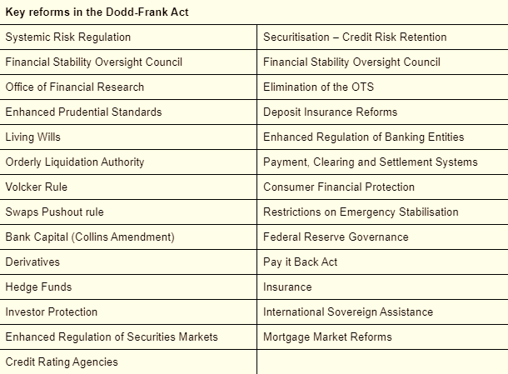
Figure 2: Primary reforms in Dodd-Frank Act
(Source: Corpgov.law, 2010)
The above Act, however, as per the above figure, enhanced systematic risk regulation, that was much required post-crises period. The Federal reserve further expanded power in relation with systematically significant bank-holding organisations along with non-bank financial organisations, which were designated as properly significant through the council. The laws and regulations in US, implemented by the government allowed regulation bodies like Federal Reserve to, systematically engage predominantly in financial activities. The Dodd-Frank Act, further delivered a stronger form of oversight associated with numerous form of financial as well as consumer markets (Corpgov.law, 2010). Although specific parts of its regulations have been restrictive, it must have been a necessary response in relation with the 2008 financial crisis. It helped to prevent another form of market meltdown in future aspects. It strengthened “Sarbanes-Oxley act”, while introduced concept of assessing risks through making it mandatory for hedge funds to deliver primary information regarding their trades as well as portfolios so overall risks could be assessed (Corpgov.law, 2010). Finally, the legislation is US post-2008 helped in monitoring every aspect related to insurance industry and overviewed credit ratings agencies such as “Standard & Poor’s and Moodys”. It helped in determination of credit ratings and allowed user protection as well as promoting accuracy in terms of credit ratings. Moreover, it allowed transparency in financial system, which helped to recover from the crisis.
Additionally, the government of UK, especially “Bank of England”, did not impose strict rules to small banks unlike EU or US (Bailey and Tomlinson, 2017). Rather swapping few mortgages helped in designing a proper Credit Guarantee Scheme for potentially restoring confidence associated with the markets.
- The scheme further guaranteed different kind of unsecured form of debts. Banks received direct as well as indirect form of support from different measures. Notable banks have been RBS, Bradford, Bingley, Lloyds and “Northern Rock” (Bailey and Tomlinson, 2017).
- The key difference have been emphasizing on lending to less-risky borrowers. In this context, one of the primary concerns associated with taxpayer is that if the money invested in banks will get paid back. Amount of income associated with investing in failing banks was significantly lower than expected income.
However, government overviewed this as a strategic approach that permitting an entire collapse of financial industry in UK. Therefore, government banking reforms and regulations could be justified as effective management regarding handling the financial crisis. Every reform and aforementioned legislation helped to maintain liquidity of financial institutions and banks so that money lending did not come to an halt. The government support allowed capital in banks at some level, which assured it does not fall into liquidation. Finally, without taking high form of risks, banks continued to lend to their borrowers and enhanced operations.

The rules and regulations through which EU had consistently presented themselves enhanced a global response in the crisis period for reshaping the global form of financial architecture. The European position associated with IMF governance allowed indication as a proper desire of maintaining framework related to the global form of financial system. The regulation bodies effectively dealt with monitoring of capital markets. ESMA was also responsible for carrying out a direct form of monitoring with proper aspect to different credit-rating agencies along with different kinds of trade-repositories. It contributed to a robust financial framework for single market in Europe (Burns and Tobin, 2016).
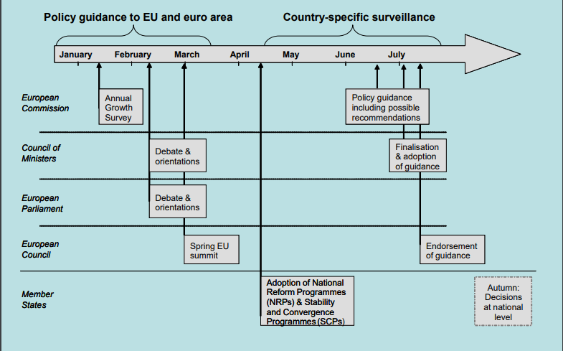
Figure 3: Steps taken for improving financial health of EU countries
(Source: Oecd.org, 2010)
The introduction of “single rulebook” enhanced that it should be adhered by all financial institutions to operate in the single market. It consisted approximately 8300 banks to adhere to the rulebook, for assuring good regulation everywhere and avoidance of any kind of loopholes, therefore enabling better legal compliance of the financial institution, which was necessary for avoiding any kind of financial misconduct in within the post-crises period. Finally, its commitment to official development assistance improved over the time (Durusoy et al. 2015). It assured designing of appropriate mechanisms for helping most vulnerable countries while allowing proper form of budget support to external countries, which have been hit through the crisis. EU council also developed several legislation bodies for maintaining regulation as well as assessing and supervising threats associated with financial form of stability, which raised due to the macro-economic establishments within potential financial system. Therefore, rules and regulations implemented by the EU also played an important part in recovering from the financial crisis.

3. Discussion and analysis of the reforms have had impacted the business model and level of compliance and non-compliance to these reforms
This part of this study discusses the various conditions and reforms that have affected the business model of HSBC bank. HSBC bank is a British multinational investment and financial services holding company. The company is regarded as the second-largest bank in the European market behind the BNP Paribas. The company holds over US 206,777 dollars of total equity and assets of US 2.958 trillion dollars (HSBC, 2021). The stock price of the company closed at 522.39 GBX (Yahoo Finance, 14th April 2022). HSBC has gone through several changes post-crisis in its operation that included macro-financial, regulatory and competitive developments. The post-crisis period was one of the considerable exuberance, primarily in the banking sector of some of the developed economies. It was recorded that, the banking sector has grown rapidly with increasing banking systems assets, credit and profits (Petria et al. 2015).
The reason for this booming profit generation from the banking companies was increasingly investing in risk-prone projects that offered high returns on short-term projects and sustainability for long-term projects. With credit standards relaxed, given the opportunity to developed banks like the HSBC to grow their business position (Naheem, 2016). However, the world economy has seen rapid growth in the recent past but still, a few risks is creeping back (mckinsey.com, 2018). It was seen that the road to recovery was a long one; the recovery from the crisis took almost eight full years to get back to a robust position for the banking industry. With several changes bringing in the banking sector in many developed countries, it has been seen that banks like the HSBC have worked in capitalizing their financial system, with that less money has been sloshing in the global financial system (Mckinsey.com, 2018).
The United States government passed the “Dodd – Frank Act” in the year 2010, this was primarily making the banks to holding significant amount of capital amount to US 50 million dollars either in assets or retained capitals and implement new liability standards and establishing restrictions in incentive compensation (investopedia.com, 2021). This legislation also created a separate body named “the Financial Stability Oversight Council” that provide provisions of the inclusion of Federal reserve bank and other government agencies in order to support and coordinate for better regulation (Dimitrov et al. 2015). Most importantly, this legislation was also passed to govern some of the important banks like the HSBC for minimizing the loss factor in case of any financial crisis in future. The legislation provided the council to take decision regarding any underperforming banks and break them into smaller groups that possess risk due to their sizes (investopedia.com, 2021). Along with this council establishment, efforts were also made for establishing orderly liquidation fund system that will allow in providing of financial assistance to the banks that may face fall in any financial crisis. However, many critics argued that the legislation, which was passed in 2010, is less effective and similar legislation was passed earlier that resulted in poor performance of the banking sector (Nwogugu, 2015).
It has been seen that this legislation has been compiled by the HSBC in their banking process. This has been done to improve the transparency in the banking process that mainly focuses on swap fund and hedge fund markets (Mckinsey.com, 2018). Since 2008, the HSBC Swiss private bank saw a steep fall in the profit generation and suffered losses in 2013; this showed that how various problems in the banking system has affected the business performance of HSBC and contributed declined in their brand image. In 2013, it was seen that HSBC has lost over US 291 million dollars and indulge in making scarp profit of only about US 14 million dollars in the first quarter on 2014. The bank did get criticism for not complying with the regulatory orders in Swiss private bank, where the ban was found to be involved in helping wealthy customers where millions of dollars of assets were involved. In order to improve their affected reputation in the market, HSBC tried to address the issues more strictly through removing the clients that did not meet the new standards and improve their spending on ensuring compliances instructed by the government should be addressed effectively (Hossain and Khan, 2016).
However, the HSBC chairperson commented that too many regulations has put burden on the banking operations. The increasing potential of hefty fines on the banks is making the banks more prone to risky situation (The global treasurer.com, 2014). He further added that, there has been some observation regarding the growing danger of “disproportionate risk aversion”. This was due to the covering up the compensation of the mistakes in the loan statement to the British customers, for this than needed to keep aside funds up to US 367 million dollars. In addition, the impacts of the reforms have felt in the other markets of the HSBC too. It was seen that due to growing criticism in lower implementation of regulatory in their business process has led to losing customers over the years. The company suffered loss of 12 per cent in the Asian market, from where the companies two – third profit are generated. The clarification on the fall in profits has been largely due to increasing regulatory fines and potential litigation. Some of the ;litigation cases involved the collapse of Bernie Madoff’s fraudulent investment made in 2008 and price fixing allegations in the currencies and precious metals (Quisenberry, 2017).
In order to assess the financial performance of the company in last two years to understand where the company needs to improve to make their financial system more effective and complies with the established reforms. The financial performance of the company is evaluated through ratio analysis to understand company’s ability and the impacts of reforms in making profits, controlling its liquidity position, providing investors with better returns, and comparing with its biggest competitor.
Liquidity ratios calculation
Formula for Current ratio = Current Asset / Current Liabilities
Current ratio of HSBC PLC and BNP Paribas for year 2020-21
= 300,605 / 176,001  = 1.7 | = 348,125 / 356,959  = 0.97
Current ratio of HSBC PLC and BNP Paribas for year 2019-20
= 225,740 / 158,233  = 1.43 | = 309,380 / 352,746  = 0.87
Current ratio of HSBC PLC and BNP Paribas for year 2018-19
= 120,064 / 176,153  = 0.68 | = 155,423 / 290,630  = 0.53
Current ratio of HSBC PLC and BNP Paribas for year 2017-18
= 160,560 / 196,274  = 0.81 | = 185,488 / 208,775  = 0.88

Formula for Acid Ratio/Quick Ratio = Current Asset- Inventories / Current Liabilities
Acid Ratio/Quick Ratio of HSBC PLC and BNP Paribas for year 2020-21
= 300,605 - 0 / 176,001  = 1.7 | = 348,125 - 0 / 356,959  = 0.97
Acid Ratio/Quick Ratio of HSBC PLC and BNP Paribas for year 2019-20
= 225,740 - 0 / 158,233  = 1.43 | = 309,380 - 0 / 352,746  = 0.87
Acid Ratio/Quick Ratio of HSBC PLC and BNP Paribas for year 2018-19
= 120,064 - 0 / 176,153  = 0.68 | = 155,423 - 0 / 290,630  = 0.53
Acid Ratio/Quick Ratio of HSBC PLC and BNP Paribas for year 2017-18
= 160,560 - 0 / 196,274  = 0.81 | = 185,488 - 0 / 208,775  = 0.88

From the liquidity calculation it can be determined that HSBC PLC has better liquidity policy in terms of managing its current assets and liabilities. Often it seen that investors looks for liquidity ability of a bank, bank that has the ability to meet cash and collateral obligations has significant chances of improving potential investment due to less risk involvement (Madushanka and Jathurika, 2018).
Profitability ratios calculation
Formula for Net profit margin = (Net profit / Total Revenue) X 100
Net profit margin of HSBC PLC and BNP Paribas for year 2020-21
= 19,260 / 26,313  = 0.73 X 100 = 73 percent | = 19,344 / 29,624  = 0.65 X 100 = 65 percent
Net profit margin of HSBC PLC and BNP Paribas for year 2019-20
= 21,506 / 32,562  = 0.66 X 100 = 66 percent | = 19,339 / 31,222  = 0.61 X 100 = 61 percent
Net profit margin of HSBC PLC and BNP Paribas for year 2018-19
= 23,878 / 42,873  = 0.55 X 100 = 55 percent | = 21,243 / 37,443  = 0.56 X 100 = 56 percent
Net profit margin of HSBC PLC and BNP Paribas for year 2017-18
= 22,922 / 37,261  = 0.61 X 100 =.61 percent | = 21,164 / 35,825  = 59 X 100 = 59 percent

Formula for Gross profit margin = (Total revenue – Cost) / Total Revenue)
Gross profit margin of HSBC PLC and BNP Paribas for year 2020-21
= (26,313 – 7,052) / 26,313  = 0.73 X 100 = 73 percent | = (29,624 – 10,280) / 29,624  = 0.65 X 100 = 65 percent
Gross profit margin of HSBC PLC and BNP Paribas for year 2019-20
= (32,562 – 11,056) / 32,562  = 0.66 X 100 = 66 percent | = (31,222 – 11,883) / 31,222  = 0.62 X 100 = 62 percent
Gross profit margin of HSBC PLC and BNP Paribas for year 2018-19
= (42,873 – 18,995) / 42,873  = 0.55 X 100 = 55 percent | = (37,443– 16,200) / 37,443  = 0.56 X 100 = 56 percent
Gross profit margin of HSBC PLC and BNP Paribas for year 2017-18
= (37,261– 14,339) / 37,261  = 0.37 X 100 = 37 percent | = (35,825– 14,661) / 35,825  = 0.59 X 100 = 59 percent

The profitability ratio of HSBC PLC shows that it has better profit making abilities then its competitor. This indicates that company has been complying with the regulations and policies more effectively now to reduce their expenses from fines and litigation that they faced after the financial crisis happened in 2008. The company was involved in various fraudulent situations that resulted in decreasing their profits in from 2012 to 2015. However, with the integration and adaptation of the financial policies and legislation prepared by the governing authorities has prepared for the banks.
Leverage ratios
Formula for Debt-to-Equity Ratio (D/E) = Total Debt / Total Equity
Debt-to-Equity Ratio of HSBC PLC and BNP Paribas for year 2020-21
= 291,959 / 136,117  = 2.14 | = 718,219 / 113,300  = 6.34
Debt-to-Equity Ratio of HSBC PLC and BNP Paribas for year 2019-20
= 277,166 / 133,568  = 2.07 | = 687,289 / 107,401  = 6.40
Debt-to-Equity Ratio of HSBC PLC and BNP Paribas for year 2018-19
= 296,189 / 129,683  = 2.28 | = 557,141 / 103,156  = 5.4
Debt-to-Equity Ratio of HSBC PLC and BNP Paribas for year 2017-18
= 304,821 / 134,958  = 2.2 | = 430,742 / 97,496  = 4.42

Formula for Return on Equity (ROE) = Net Income / Shareholder’s equity
Return on Equity ratio of HSBC PLC and BNP Paribas for year 2020-21
= 26,313 / 136,117  = 0.19 | = 29,624 / 113,300  = 0.26
Return on Equity ratio of HSBC PLC and BNP Paribas for year 2019-20
= 32,562 / 133,568  = 0.24 | = 31,222 / 107,401  = 0.29
Return on Equity ratio of HSBC PLC and BNP Paribas for year 2018-19
= 42,873 / 129,683  = 0.33 | = 37,443 / 103,156  = 0.36
Return on Equity ratio of HSBC PLC and BNP Paribas for year 2017-18
= 37,261 / 134,958  = 0.28 | = 35,825 / 97,496  = 0.36

The advantage ratios of HSBC PLC evaluates that the company has stable debt to equity ratio. For any banking company, stable debt to equity ratio should be between 2 and 2.5, however, the return on equity has been on lower side as per its competitor. Leverage ratio of both the companies establishes the ability the companies’ poses on the ability of shareholders equity to cover all the outstanding debts in case of any financial crisis.
Compliances in the banking industry plays a vital role and it becomes necessary for the authorities to ensure that legislation that are been enacted needs to be implemented by the parties in order to keep the economy in stable position and ensure growth. As the HSBC has grown over the years, it has become essential for the banking company to comply laws and regulations made by the government. This ensures that the bank does not come under unnecessary litigation cases, data theft or fines imposed by the government. Though, the bank has been involve in few cases and has been penalized by the authorities, the company is trying to improve their position (HSBC, 2022). Company has separate financial crime risk policies that focus on improving the ethical standards. These policies primarily implemented to remove the anti – laundering, sanctions and anti – bribery and corruption in order to improve their position in mitigating the risk more effectively (HSBC, 2022).
The Anti – laundering policy statement (AML) states that they are fully committed towards implementing effective control standards (O’Sullivan, 2017). The main aim of this policy statement is to identify the money laundering cases and protest HSBC, its stakeholders, customers, employees and communities they are serving. The policy is applied in developed countries like UK, US, European Union and Hong Kong (HSBC, 2022). Also complies with the sanctions policy made under the UK, UN, HK, US and EU regulatory bodies and ensures proper measures in financial crime concerns. It is mandatory for the bank to comply with the jurisdiction where they are operating and along with that, focuses also given on the local law effectively to manage with the compliances (Naheem, 2015). The sanctions policy statement stats the minimum standards they are required to meet in order to avoid penalties. For example, one of the sanctions the government needs to follow is the prohibiting direct funding to the government of Zimbabwe. Other restrictions like prohibiting customer relationships in places like Iran, North Korea and Syria (HSBC, 2022).

Conclusion
From the above study, a thorough understanding is developed of “Banking Financial Management and Financial Markets”. Discussion on various topics related to the banking sector and financial markets allowed in gaining the two main learning outcomes of this assignment that is based on improved knowledge on demonstrating and understanding of the pricing of financial assets, the role and application of various financial theory and operation of the financial markets. In addition, the studies also helped in understanding the bank performance criteria and valuation methods. With the evaluation of HSBC’s financial performance and compliances policies based on the various aspect of the global business environment, key knowledge is developed in financial markets and banking financial management.

Reference List
Books
Bailey, D., and Tomlinson, P. R. 2017. Back to the future? UK industrial policy after the great financial crisis. In Economic policies since the global financial crisis (pp. 221-263). Palgrave Macmillan, Cham.
Farnsworth, K., and Irving, Z. (Eds.). 2015. Social policy in times of austerity: Global economic crisis and the new politics of welfare. Policy Press.
Journals
Burns, C., and Tobin, P. 2016. The impact of the economic crisis on European Union environmental policy. JCMS: Journal of Common Market Studies, 54(6), 1485-1494.
Congleton, R. D. 2009. On the political economy of the financial crisis and bailout of 2008–2009. Public Choice, 140(3), 287-317.
Cukierman, A. 2013. Monetary policy and institutions before, during, and after the global financial crisis. Journal of Financial Stability, 9(3), 373-384.
Dimitrov, V., Palia, D. and Tang, L., 2015. Impact of the Dodd-Frank act on credit ratings. Journal of Financial Economics, 115(3), pp.505-520.
Durusoy, S., Sica, E., and Beyhan, Z. 2015. Economic crisis and protectionism policies: The case of the EU countries. International Journal of Humanities and Social Science, 5(6), 1.
Dwyer, G. P., and Lothian, J. R. 2012. International and historical dimensions of the financial crisis of 2007 and 2008. Journal of International Money and Finance, 31(1), 1-9.
Goh, B.W., Li, D., Ng, J. and Yong, K.O., 2015. Market pricing of banks’ fair value assets reported under SFAS 157 since the 2008 financial crisis. Journal of Accounting and Public Policy, 34(2), pp.129-145.
Hodson, D., and Mabbett, D. 2009. UK economic policy and the global financial crisis: paradigm lost?. JCMS: journal of common market studies, 47(5), 1041-1061.
Hossain, S. and Khan, M.R., 2016. Corporate Social Responsibility (CSR) in Banking Sector: An Empirical Study on the Hong Kong and Shanghai Banking Corporation (HSBC) Limited. IOSR Journal of Business and Management, 18(4), pp.53-61.
Madushanka, K.H.I. and Jathurika, M., 2018. The impact of liquidity ratios on profitability. International Research Journal of Advanced Engineering and Science, 3(4), pp.157-161.
Martin, C., and Milas, C. 2013. Financial crises and monetary policy: Evidence from the UK. Journal of Financial Stability, 9(4), 654-661.
Naheem, M.A., 2015. HSBC Swiss bank accounts-AML compliance and money laundering implications. Journal of Financial Regulation and Compliance.
Naheem, M.A., 2016. Risk of money laundering in the US: HSBC case study. Journal of Money Laundering Control.
Nwogugu, M.I., 2015. Failure of the Dodd-frank act. Journal of Financial Crime.
O’Sullivan, P.J., 2017. Regulatory relationships and incentives: from Riggs Bank to HSBC. International Journal of Law and Management.
Petria, N., Capraru, B. and Ihnatov, I., 2015. Determinants of banks’ profitability: evidence from EU 27 banking systems. Procedia economics and finance, 20, pp.518-524.
Quaglia, L., Eastwood, R., and Holmes, P. 2009. The Financial Turmoil and EU Policy Co‐operation in 2008. JCMS: Journal of Common Market Studies, 47, 63-87.
Quisenberry, W.L., 2017. Ponzi of all Ponzis: critical analysis of the Bernie Madoff scheme. International Journal of Econometrics and Financial Management, 5(1), pp.1-6.
Websites
Business today (2015). Retrieved from https://www.businesstoday.in/latest/economy-politics/story/hsbc-reforms-at-swiss-bank-cause-profit-to-fall-since-2008-143187-2015-02-12 . (Assessed on 16/04/2022)
Cftc.gov, 2022, DoddFrank Act Final Rules, Viewed on 16/04/2022 from https://www.cftc.gov/LawRegulation/DoddFrankAct/Dodd-FrankFinalRules/index.htm
Cftc.gov, 2022, Laws and Regulations, Viewed on 16/04/2022 from https://www.cftc.gov/LawRegulation/DoddFrankAct/Dodd-FrankFinalRules/index.htm
Corpgov.law, 2010, Financial panic of 2008, Viewed on 16/04/2022 from https://corpgov.law.harvard.edu/2010/11/20/the-financial-panic-of-2008-and-financial-regulatory-reform/
Europa.eu, 2014, Commission, Viewed on 16/04/2022 from https://ec.europa.eu/commission/presscorner/detail/fi/MEMO_14_244
Forbes.com, 2020, Investments and dodd frank, Viewed on 16/04/2022 from https://www.forbes.com/advisor/investing/dodd-frank-act/#:~:text=The%20Dodd%2DFrank%20Act%20was%20a%20law%20passed%20in%202010,by%20insurance%20companies%20and%20banks.
Hsbc (2022). Retrieved from https://www.hsbc.com/ . (Assessed on 16/04/2022)
Hsbc (2022). Retrieved from https://www.hsbc.com/who-we-are/esg-and-responsible-business/fighting-financial-crime/financial-crime-risk-policies . (Assessed on 16/04/2022)
Investopedia (2021). Retrieved from https://www.investopedia.com/ask/answers/033015/how-did-financial-crisis-affect-banking-sector.asp . (Assessed on 16/04/2022)
Mckinsey (2021). Retrieved from https://www.mckinsey.com/industries/financial-services/our-insights/a-decade-after-the-global-financial-crisis-what-has-and-hasnt-changed . (Assessed on 16/04/2022)
Oecd.org, 2010, Governance Budgeting, Viewed on 16/04/2022 from https://www.oecd.org/governance/budgeting/48871475.pdf
The global treasurer (2022).Retrieved from https://www.theglobaltreasurer.com/2014/08/04/hsbc-chairman-regulation-could-make-banks-totally-risk-averse/ . (Assessed on 16/04/2022)

