12/9/2021

Safiya Nanton
2114630
Assignment 1: Concrete and Steel Structures

ACBA4006 Materials and Building Servics
Table of Contents

Table of Figures………………………………………………………………………………2
Introduction…………………………………………………………………………..………3
Concrete Frame Structures………………………………………………………….………4
Steel Frame Structures………………………………………………………………………6
Comparing and contrasting…………………………………………………….…………..7
Conclusion……………………………………………………………………….…………..17
Bibliography………………………………………………………………………..……….18

Table of Figures

(Mahajan, n.d.)Figure 1: Components of Concrete 3
(Construction, 2019)Figure 2:Concrete Frame Building 4
(Angels, n.d.)Figure 3: The Cathedral of our Lady of the Angels, Los Angeles 5
(Construction, 2019)Figure 4: Close up of a Steel frame Structure 5
(foundation, 2019)Figure 5: The Eames House, Los Angeles 6
(Sadanand, 2021) Figure 6: Exposed Steel rebar in concrete affected by corrosion 7
(Ensor, 2018) Figure 7: Steel Frame Affected by Corrosion 7
(Charles, 2019)Figure 8: Concrete surface spalled, exposing steel rebar underneath 10
(Charles, 2019)Figure 9: An example of a concrete beam cracking due to a fire (External Cracking) 11
(Gillie, n.d.)Figure 10: Yield Strength Retention for Structural Steel at Elevated Temperatures 12
(Alnahhal, 2017)Figure 11: Displays the process of Recycling Concrete into Aggregate 13
(steelconstructioninfo, 2011)Figure 12: Graph showing Global scrap steel consumption vs. Global new steel production 14
Table 1: Comparing Concrete and Steel Structures 9
(Tech, 2018)Table 2: Natural Hazard Risk Rankings 15

Concrete and Steel Frame Structures

Introduction
The framing of a building is critical to its stability. It guarantees that your property is safe to live in and that it is constructed to withstand natural disasters (Architecture, n.d.). Buildings, like humans, require a skeleton for support and strength. There are several types of structural frames. However, I shall only be concentrating on concrete and steel frame structures. I'll also utilize two examples of these frames to help me better understand these framing systems. I selected a subtropical climate since it is hot and mostly dry all year. It would not be impacted by a snowy winter, but by severe rain. It is also vulnerable to a variety of other natural disasters, including wildfires, earthquakes, floods, and mudslides. I would also compare numerous additional similarities and variations between the structural frameworks.

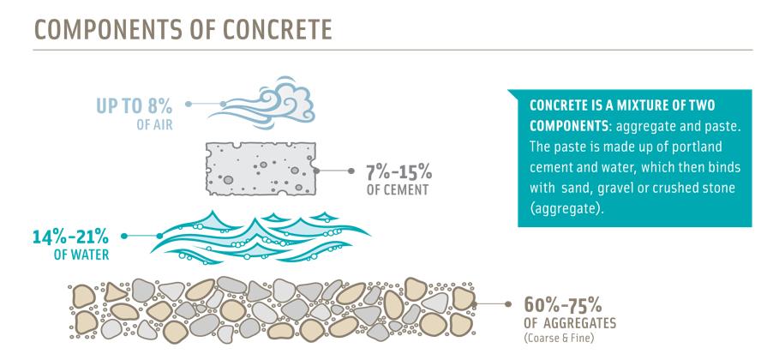
Concrete Frame Structures
Concrete frame construction is a building method that effectively transfers loads from the structure to the foundation using a network of columns and beams. It supports other components such as the floors, roof, walls, and claddings by acting as the building's structural backbone. Concrete is a structural material made up of a hard, chemically element called aggregate (typically sand and gravel) that is bound together with cement and water in the building industry (Britannica, 2018).
(Mahajan, n.d.)Figure 1: Components of Concrete
Concrete is the second most used building material after water because it is versatile, durable, easy to fabricate, and it can be molded into any shape. Plain cement concrete is made by blending cement, coarse aggregate (gravel), fine aggregate (sand), and water in the proportions specified by the architect. Reinforced concrete can be described as normal cement concrete reinforced with steel bars that enhance tensile strength. This is the most popular form of concrete used in construction, with uses ranging from buildings to structures such as water tanks. The benefits of using concrete frames in construction include low material costs, moldability to any shape, low labor costs, fire and water resistance, and high compression strength, which results in long-lasting building structures.

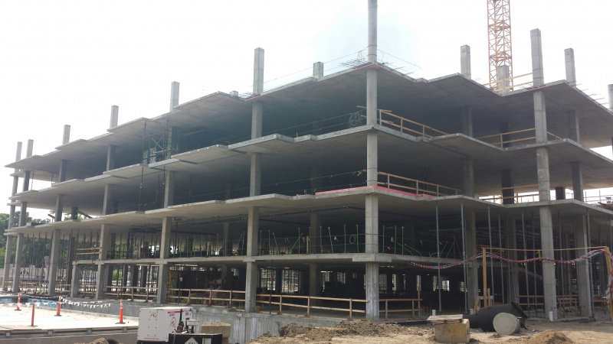
(Construction, 2019)Figure 2:Concrete Frame Building
The strength of concrete is affected by environmental variables, notably temperature and moisture. If it dries too rapidly, it may be subjected to unequal tensile stresses which it cannot withstand in its inadequately hardened state. Low temperatures can reduce its strength. Large concrete forms that cannot be adequately covered are not poured in cold conditions. Earthquakes, wildfires, floods, and mudslides are examples of environmental factors in Los Angeles that can have an impact on building strength.
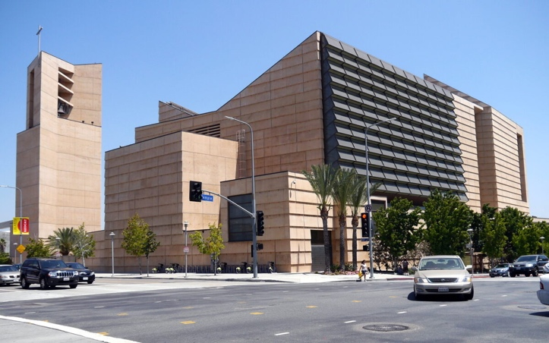
The Cathedral of Our Lady of the Angels in Los Angeles, California, is an example of a concrete-framed structure. The Cathedral is a 58,000-square-foot structure designed by Spanish architect Rafael Moneo (Cathedral, n.d.). The Cathedral, often known as the Los Angeles Cathedral, opened in 2002 to replace the Cathedral of Saint Vibiana, which was badly destroyed by the 1994 Northridge Earthquake. The cathedral was designed in a unique modernist architectural style using architectural concrete to create a limited display of straight angles, giving it the appearance of an imposing fortress rather than a pleasant place of prayer. Moneo included enormous windows made of Spanish alabaster into the interior with the ideas of "Light" and "Journey" in mind.
(Angels, n.d.)Figure 3: The Cathedral of our Lady of the Angels, Los Angeles
Steel Frame Structures
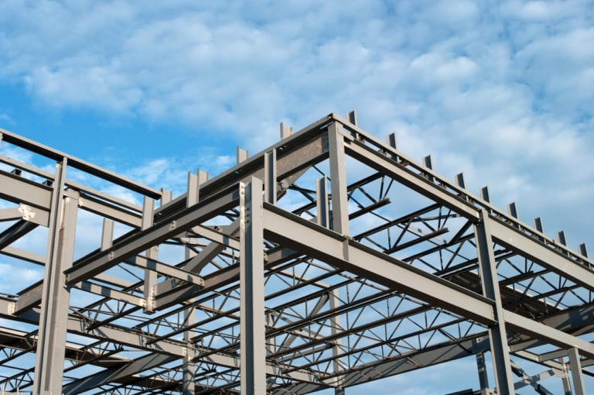
Steel structures are unique in both design and construction since it is a strong material with many various degrees of strength and parts. They must all be appropriately linked in order for a structure to be structurally sound (Ensor, 2018). Steel is a metal alloy composed of iron, carbon, and other elements. It is described as mild steel or high carbon steel based on its chemical composition. Most structural steel forms are elongated beams with a distinct cross section. The I-beam is the most common form, and it is highly stiff in terms of cross-sectional area. As a result, it can withstand heavy weights without distortion. On-site assembly of steel components into a frame constitutes structural steelwork erection. The methods entail raising and positioning components before putting them together. In most cases, this is accomplished by bolting, however on-site welding is also performed. It is critical to ensure that the foundations are appropriate and safe for installation to begin.
(Construction, 2019)Figure 4: Close up of a Steel frame Structure
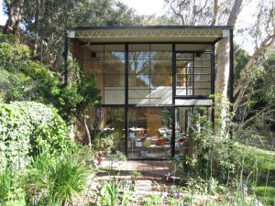
The Eames House, also well-known as Case Study House No. 8, is a mid-century modern architectural monument in Los Angeles' Pacific Palisades district. It was designed and built by the husband-and-wife team of Charles and Ray Eames in 1949 to serve as their house and studio. The Eames House is made up of two glass and steel rectangular boxes, one of which is a dwelling and the other a working studio. The Eames are well-known for their contributions to furniture and industrial design, films, exhibits, toys, and architecture. They treated problem solving as an adventure, combining dedication with a playful spirit.
(foundation, 2019)Figure 5: The Eames House, Los Angeles

Comparing and Contrasting
We must evaluate reinforced concrete and structural steel materials when comparing building frames since they have a similar component. Reinforced concrete, when properly prepared, can withstand chemicals, saltwater, moisture, and erosion. Concrete is resistant to pests since it is inorganic. It also doesn't burn or melt. However, despite its durability, reinforced concrete conceals a possible defect, from the corrosion-prone steel reinforcement that makes it stronger. Rusting rebar loses its bond with the surrounding concrete, releasing iron oxide, which expands and causes tensile strains and eventual corrosion (Nick, 2020). Although concrete decreases rebar corrosion, reinforced concrete exposed to seawater or huge amounts of salt may require further protection. For this purpose, epoxy-coated, stainless steel, or composite rebar works well. Structural steel, like rebar, is prone to corrosion and must be protected. Paint, powder coating, and corrosion inhibiting chemicals are all strategies for reducing or eliminating corrosive damage to structural steel.

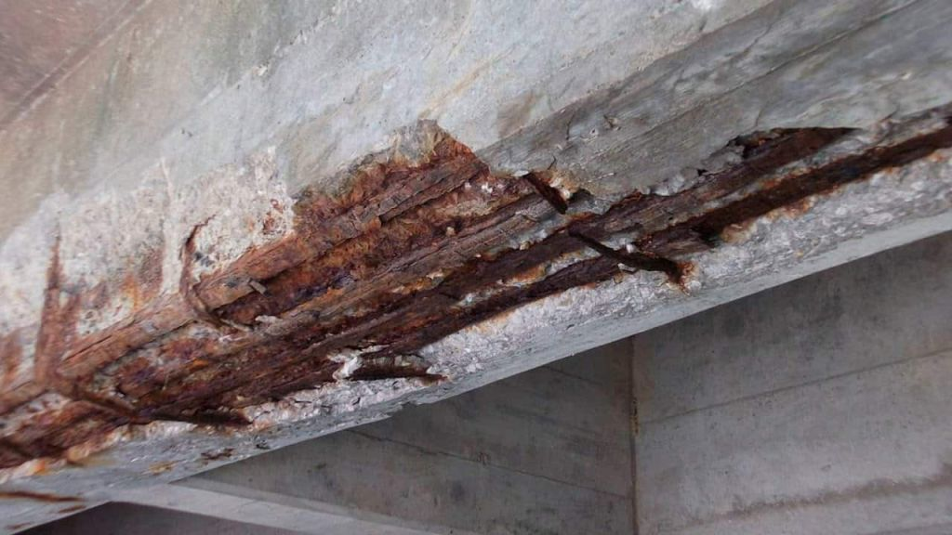
(Sadanand, 2021) Figure 6: Exposed Steel rebar in concrete affected by corrosion

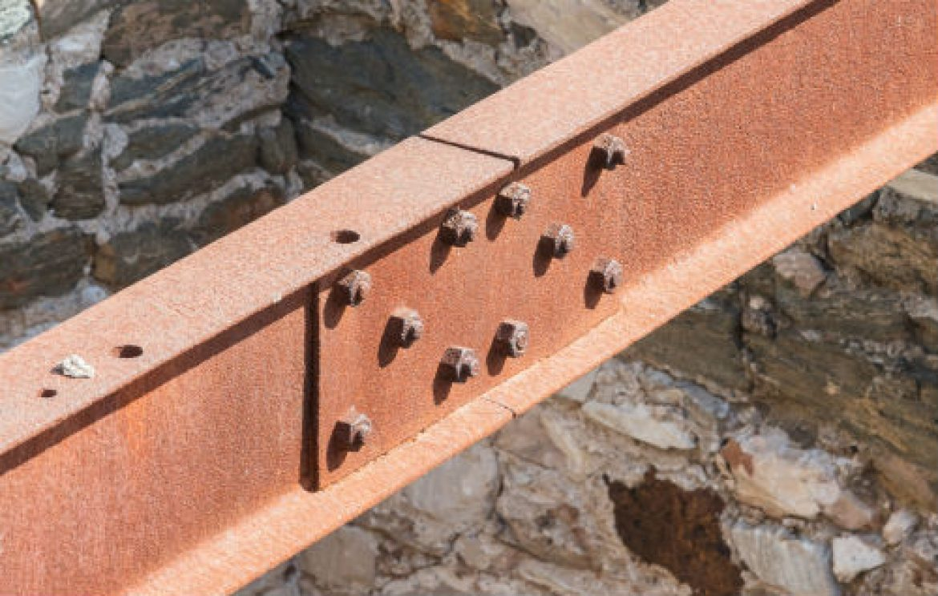
(Ensor, 2018) Figure 7: Steel Frame Affected by Corrosion

The Table Below compares Concrete and Steel Structures in a variety of categories. This shows that there are many similarities between them.
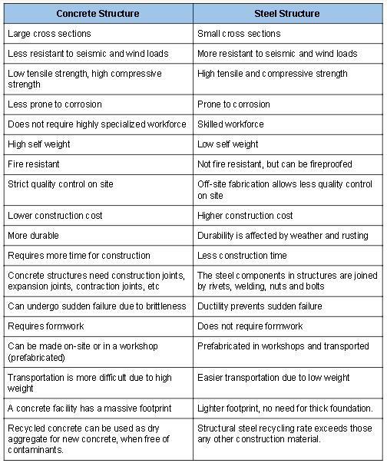
Table 1: Comparing Concrete and Steel Structures
Because of its composition, reinforced concrete is consequently noncombustible, and its low heat transfer rate prevents fire from spreading across places. However, when exposed to high temperatures for an extended period, both the concrete and the steel reinforcement might lose their strength. Reinforced concrete is more fire resistant than structural steel, but at high temperatures it begins to lose strength. Concrete exposed to the high temperatures of a fire can undergo both mechanical and chemical changes. Spalling is the displacement of concrete from the surface layer is an example of potential mechanical changes. another is External cracking, it’s the thermal expansion and dehydration of the concrete. Both can offer direct heating routes for exposed Reinforcing Steel (rebar). Rebar can become brittle at temperatures above 260°C (500°F) (a.k.a. "blue brittleness"). Rebar can lose 20% of its design strength at temperatures above 704°C (1300°F). When the effective tensile strength of steel reinforcement is diminished due to heating, structural collapse of reinforced concrete happens often (Charles, 2019).

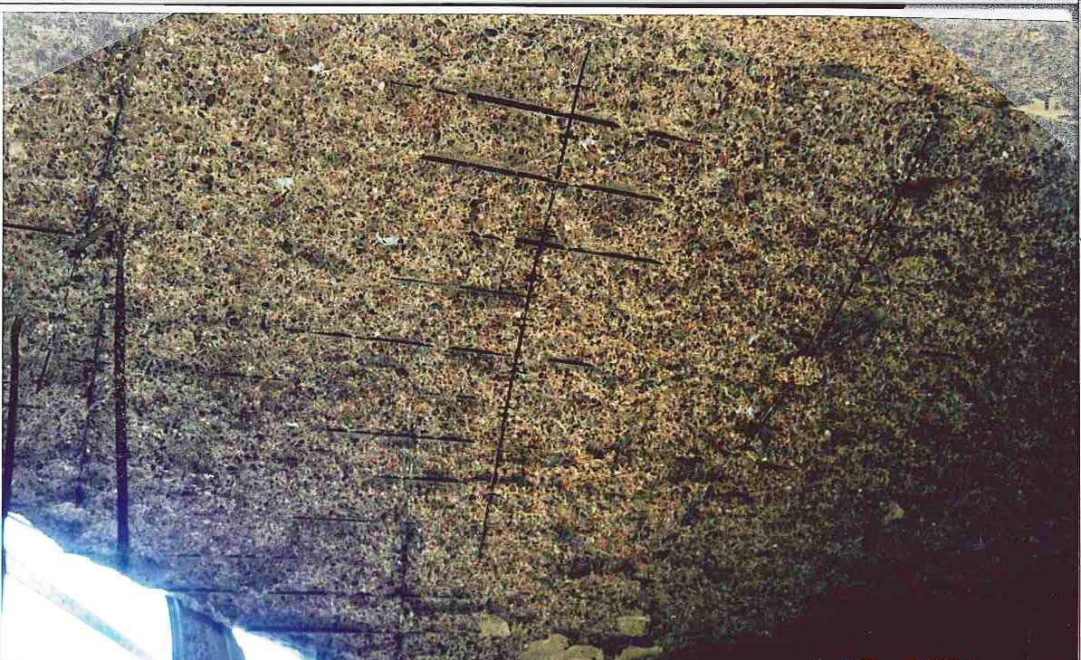
(Charles, 2019)Figure 8: Concrete surface spalled, exposing steel rebar underneath

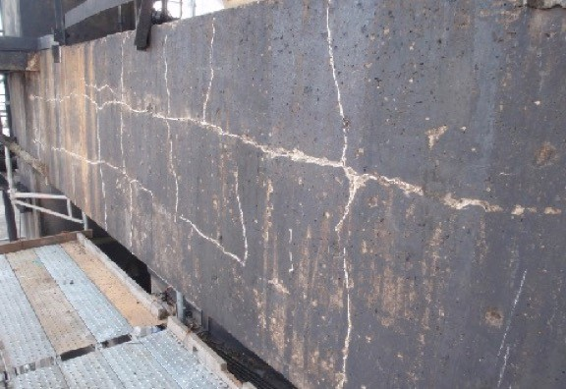
(Charles, 2019)Figure 9: An example of a concrete beam cracking due to a fire (External Cracking)
Steel's mechanical characteristics deteriorates duing higher temperatures during a fire incident. There may be a decrease in yield strength, stiffness, and modulus of elasticity. Steel member deformities and twisting can also occur. As a result, if not insulated, they are prone to rapidly heating up in flames. Because of these considerations, most key structural steel elements must be insulated (Gillie, n.d.). The rate of temperature increase in structural steel parts of a structure can be slowed using a variety of approaches.Coatings, barriers, cooling systems, concrete encasement, and active measures such as sprinklers are examples of these.
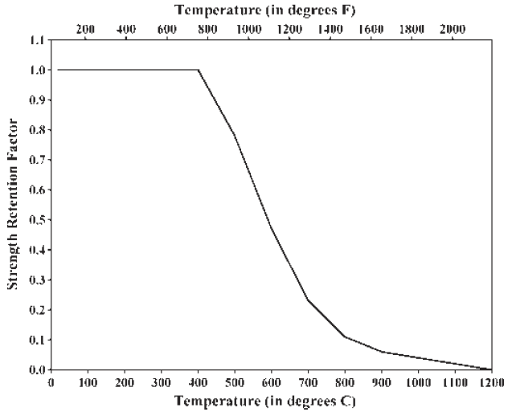
(Gillie, n.d.)Figure 10: Yield Strength Retention for Structural Steel at Elevated Temperatures

The graph in Figure 10 illustrates that the higher the temperature, the greater the stress retention on steel structures. The higher the temperature the lower the stress retention and the weaker the structures become. After the fire is quenched, the steel will either restore its pre-fire qualities or experience “permanent set” and will not return to its original shape. Longer exposures, on the other hand, will almost certainly result in annealing and a drop in yield strength. Due to heat expansion and probable deformations of the steel elements, connections may experience extra stresses during the fire. More material, such as angles, bolts, and plates, is typically present at connecting points. Connections are exposed to less heat from the fire than structural frame elements due to the extra material (Vertex, 2018).

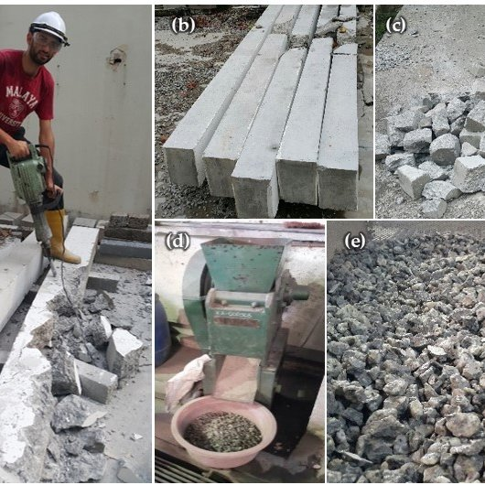
Buildings generate waste throughout construction and restoration, as well as when they are demolished or deconstructed, and material becomes accessible for recycling at each of these stages.When utilized in construction, both concrete and steel have environmental advantages. Concrete also has several environmentally friendly qualities. It can be recycled after demolition to make gravel, aggregate, or paving materials for use in road construction, erosion control, landscaping, marine reef restoration, and other projects. Concrete that is not polluted can be used as aggregate in fresh mixtures (Alnahhal, 2017). There are several environmental advantages to recycling concrete. It reduces building waste, keeps rubble out of landfills, and substitutes gravel and aggregates that would otherwise be mined and exported (Rodriguez, 2015).
(Alnahhal, 2017)Figure 11: Displays the process of Recycling Concrete into Aggregate
Approximately 85% of all steel used in the world is recycled at some point. Steel is the most ecologically friendly product since it is completely reusable. Steel recycling uses just a third of the energy used in steel manufacture, in addition to minimizing the demand for freshly mined resources. Steel is made by either using iron ore and combining generally 10% to 15% scrap steel or by using an electric arc furnace (EAF) and produced by 100% scrap steel (steelconstructioninfo, 2011). Although the quantity of scrap recycled is typically rising, scrap supply is bound by availability, and as demonstrated in the graph below, supply cannot currently fulfill global demand for new steel, necessitating primary steelmaking from iron ore. It has been highlighted that the largest demand is in developing nations where steel is utilized to create infrastructure and buildings. Steel demand and scrap supply are considerably more closely aligned in many industrialized economies (steelconstructioninfo, 2011).
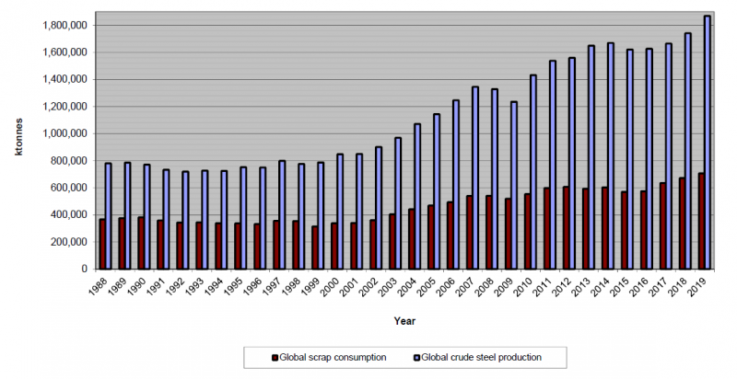
(steelconstructioninfo, 2011)Figure 12: Graph showing Global scrap steel consumption vs. Global new steel production

Steel manufacturing has become much greener over the decades, not only for environmental reasons, but also because using less energy and recycling typically saves money. Steelmakers have lowered the amount of energy required to create steel by one-third over the previous three decades, and virtually all the water used in its manufacturing (95 percent) is cleaned and reused (Biggs, 2020).
The climate in which a building is built has a huge impact on its overall structure. A structure must be planned effectively by taking certain significant variables into account while evaluating its surroundings. Among these elements but are not limited to, orientation, arrangement, shape, and materials. In contrast, in order to make optimal use of energy resources in a structure that uses an air conditioning system, the building must be able to save energy created in the field through the use of enough insulating material. As a result, the thickness, kind, and installation placement of such elements in the building envelope must be clearly stated. Thermal comfort is described as a state of mind expressing happiness with one's thermal surroundings. The following parameters have been established as thermal comfort standards in the building industry: air temperature, air humidity, rate of air movement, amount of radiation, and rate of heat production by the bodies of individuals in the building (Divsalar, 2010).
Humans are not reducing their emissions; instead, they are paving the way for a warmer future. Climate change has a variety of consequences on the structural stability of structures. While individuals are increasing the eco-consciousness of their on-site operations, it is critical to recognize a structure's long-term environmental implications. Buildings near the seaside are especially vulnerable because the chloride in salt water causes corrosion.
The City of Los Angeles has updated the 2018 Hazard Mitigation Plan (HMP) to reduce the City's vulnerability to disasters and demonstrate the City's commitment to mitigating natural-hazard risks. Conducting a thorough hazard risk analysis, establishing community disaster mitigation priorities, and devising subsequent mitigation plans and projects are all part of the planning process. They've also included a risk assessment in their plan, which is used to calculate the possible loss of life due to hazards. This is done to identify people's, infrastructure's, and buildings' vulnerabilities. In the table below, the Natural hazards risk are ranked in severity.
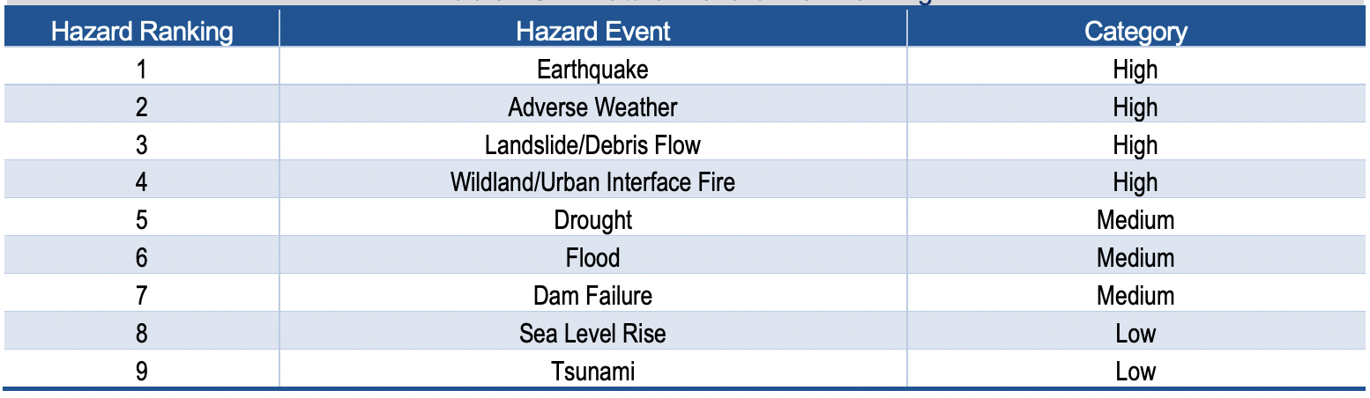
(Tech, 2018)Table 2: Natural Hazard Risk Rankings
The pace with which a structure is constructed is crucial. An office owner may begin renting a space sooner, and a factory owner can begin manufacturing a product sooner if a facility is occupied earlier. Fast construction also saves money on labor and costs for construction management services. Homes, buildings, and infrastructure must be rebuilt fast in the aftermath of natural disasters such as those listed above. Victims must not only deal with the loss of their homes, jobs, companies, and maybe family members and pets, but they must also attempt to rebuild. Finding strategies to strengthen damaged structures and reconstruct stronger structures in the aftermath of a natural disaster might be vital to their survival in future calamities (Fingland, n.d.). Earthquakes have the greatest level of danger in Los Angeles, according to the table above. There are still several structures with concrete and steel frames. Steel construction, on the other hand, is lighter in weight than concrete without sacrificing strength. It has less mass – and hence less force – to cause harm to itself during seismic shaking. It necessitates reduced seismic protection in the superstructure and base, potentially cutting construction costs as well (Arlinton, 2016).

Conclusion
To summarize, concrete and steel structure buildings are comparable in many aspects. They both can be impacted by fire, but the results are different. Concrete can withstand fire for a longer period and only fails when the concrete is spalled, and the rebar is exposed. Although they are both recyclable, steel has a longer lifespan than concrete since it can be reused numerous times and still function effectively. The climate also influences the type of building frame construction that is utilized. Steel Frame constructions are suitable in Los Angeles because they withstand seismic shocks during an earthquake.

Bibliography
Natsoulis, N., 2021. Comparing Steel Construction and Concrete Construction. [Online]
Available at: https://www.ny-engineers.com/blog/comparing-steel-construction-and-concrete-construction
[Accessed 1 December 2021].
Anon., n.d. Architect.. [Online]
Available at: https://www.olacathedral.org/architect
[Accessed 2 December 2021].
Anon., n.d. Cathedral of Our Lady of the Angels. [Online]
Available at: https://www.atlasobscura.com/places/cathedral-our-lady-angels
[Accessed 2 December 2021].
Designingbuildings.co.uk., 2020. Concrete frame. [Online]
Available at: https://www.designingbuildings.co.uk/wiki/Concrete_frame
[Accessed 1 December 2021].
Britannica, T. E. o. E., 2018. concrete | Definition, Composition, Uses, & Facts.. [Online]
Available at: https://www.britannica.com/technology/concrete-building-material.
[Accessed 1 December 2021].
Construction, U. B., 2019. Understand Building Construction.. [Online]
Available at: http://www.understandconstruction.com/steel-frame-structures.html.
[Accessed 1 December 2021].
Construction, U. B., 2019. Concrete Frame Structures. [Online]
Available at: http://www.understandconstruction.com/concrete-frame-structures.html
[Accessed 1 December 2021].
Divsalar, R., 2010. Building Problems in Hot Climates.. [Online]
Available at: http://i-rep.emu.edu.tr:8080/jspui/bitstream/11129/99/1/Divsalar.pdf.
[Accessed 2 December 2021].
Architecture, C., n.d. he Importance Of Good Structural Framing. [Online]
Available at: https://cumminshomedesign.com/blog/2018/6/22/the-importance-of-good-structural-framing
[Accessed 1 December 2021].
Mahajan, B., n.d. What Is Concrete | Ingredients Of Concrete | Concrete Test | Types Of Concrete. [Online]
Available at: https://civiconcepts.com/blog/concrete.
[Accessed 2 December 2021].
foundation, E., 2019. Eames House | Eames Foundation. [Online]
Available at: https://eamesfoundation.org/house/eames-house/.
[Accessed 3 December 2021].
ArchitectureAU, n.d. Sub-tropical Steel. [Online]
Available at: https://architectureau.com/articles/sub-tropical-steel/
[Accessed 3 December 2021].
Long, E., 2021. The Impact of Climate Change on Building Design. [Online]
Available at: https://www.construction21.org/articles/h/the-impact-of-climate-change-on-building-design.html
[Accessed 3 December 2021].
Tech, T., 2018. City of Los Angeles 2018 Local Hazard Mitigation Plan, California: Tetra Tech.
Vertex, 2018. Fire - How it Affects Structural Steel Framing.. [Online]
Available at: https://vertexeng.com/insights/fire-how-it-affects-structural-steel-framing/
[Accessed 3 December 2021].
Charles, E., 2019. Fire Effects on Concrete. [Online]
Available at: https://www.edtengineers.com/blog-post/fire-effects-concrete
[Accessed 3 December 2021].
Nick, P., 2020. Concrete vs Steel: What You Need to Know. [Online]
Available at: https://designeverest.com/lounge/article/concrete-vs-steel-what-you-need-to-know/
[Accessed 2 December 2021].
Gillie, M., n.d. Fire Resistance of Structures 5. [Online]
Available at: http://civil.iisc.ernet.in/~manohar/Fire/Part-23_Materials.pdf
[Accessed 3 December 2021].
Rodriguez, J., 2015. Save Money and Reduce Environmental Impact by Recycling Concretes.. [Online]
Available at: https://www.thebalancesmb.com/recycling-concrete-how-and-where-to-reuse-old-concrete-844944
[Accessed 1 December 2021].
Alnahhal, 2017. Evaluation of Industrial By-Products as Sustainable Pozzolanic Materials in Recycled Aggregate Concrete, s.l.: s.n.
Biggs, J., 2020. Steel Construction: Faster, Cheaper, and Greener. [Online]
Available at: https://www.procore.com/jobsite/steel-construction-faster-cheaper-and-greener/
[Accessed 3 December 2021].
steelconstructioninfo, 2011. Recycling and reuse. [Online]
Available at: https://www.steelconstruction.info/Recycling_and_reuse
[Accessed 2 December 2021].
Farrelly, L., 2009. Basic Architecture: Construction + Materiality. 5th Edition ed. Lausanne, Worthing: Ava Academia.
Fingland, J., n.d. The Role of Construction Before and After a Natural Disaster. [Online]
Available at: https://constructible.trimble.com/construction-industry/when-mother-nature-attacks-the-role-of-construction-before-and-after-a-natural-disaster
[Accessed 3 December 2021].
Arlinton, B., 2016. Ready for earthquakes?. [Online]
Available at: https://www.bdcnetwork.com/blog/ready-earthquakes
[Accessed 2 December 2021].
Sadanand, S., 2021. Corrosion in Reinforcement Steel. Causes and Remedial Measures. [Online]
Available at: https://omcon-om.com/corrosion-in-reinforcementm-steel-causes-and-remedial-messures/
[Accessed 3 December 2021].
Ensor, B. C., 2018. 3 Types of Failures in a Steel Structure. [Online]
Available at: https://www.bestructural.com/3-types-of-failures-in-a-steel-structure/
[Accessed 2 December 2021].

Word Count: 2441

