University of Wales Trinity Saint David

Wales Institute of Science & Art

BEng Manufacturing Systems Engineering

Module: Engineering Design (ACMA4008)
Assignment Title: Engineering Problem

Name: Grant Brooks
Student ID: 2514976
Date: January 2026

Abstract
This report investigates three safe solutions to come over an existing handling issue with an anodization process. The current stainless steel tank lid presents a manual handling risk due to its weight and requires a two-person operation. Following the product design cycle, three concepts have been developed and evaluated against safety, legislation, manufacturing constraints and cost. A final design has been produced using CAD with engineering drawings, supported by appropriate material selection and manufacturing processes, with the aim of improving operator safety and efficiency.

Contents
Abstract 2
Table of Figures 4
Table of Tables 4
Introduction 5
Problem Overview 5
Scope of the Project 5
Key Legislation Considerations 6
Health and Safety Legislation 6
Health and Safety at Work etc. Act 1974 6
Manual Handling Operations Regulations 1992 6
Provision and Use of Work Equipment Regulations 1998 (PUWER) 6
COSHH and Chemical Exposure Legislation 7
Chemical Exposure and Workplace Safety 7
Material Safety Considerations 8
Material Compatibility 8
Regulatory Compliance 8
Specifications 9
Operational Requirements 9
Design Limitations 9
Material and Safety Standards 9
Human Factors and Ergonomics 9
Time Plan for Producing the Product 10
Relevant Research 11
Material Selection 11
Stainless Steel 11
Fibre-reinforced plastic (FRP) composite 11
Thermoplastics 11
Design Concepts 12
Design Concept 1 – Hinged Split Lid 12
Design Concept 2 – Gas Strut Assisted One-Piece Lid 13
Design Concept 3 – Manually Operated Roll-Up Lid 14
Final Design Concept 15
Justification for Design Choice 15
Tank Assembly CAD Design 16
Technical Drawings 18
Parts list 20
Manufacturing Processes 21
Conclusion and Further Works 22
Bibliography 23

Table of Figures
Figure 1 - Gannt chart Timeline for design and manufacture of solution to the client’s brief 10
Figure 2 - Hinged Split Lid 12
Figure 3 - Gas Strut Assisted One-Piece Lid 13
Figure 4 - Manually Operated Roll-Up Lid 14
Figure 5 - Tank Assembly with 1 lid open 16
Figure 6 - Tank Assembly with both lids fully open 16
Figure 7 - Tank Assembly with lids fully shut 17
Figure 8 - Piano Hinge Technical Drawing 18
Figure 9 - Left Hand Lid Technical Drawing 18
Figure 10 - Right Hand Lid Technical Drawing 19
Figure 11 - Anodising Tank Technical Drawing 19
Figure 12 - Piano Hinge Technical Drawing (Essentracomponents.com, 2021) 20
Figure 13 - Hand Lay-up Manufacturing Method (www.sciencedirect.com, n.d.) 21
Figure 14 - Compression Moulding Manufacturing Method (Sciencedirect.com, 2016) 21

Table of Tables
Table 1 - Time Plan 10
Table 2 - Material Comparison 11

Introduction

Problem Overview
Stainless steel is essential in many production processes and is widely used in manufacturing due to its excellent mechanical properties. In this application, stainless steel is selected for its high corrosion resistance, which is provided by a natural chromium oxide layer that enables the material to withstand harsh chemical baths. One disadvantage of using stainless steel, particularly for the lid that requires manual operation, is its weight. The excessive weight presents a health and safety concern, and it necessitates a two-person lift. This requirement also reduces operational efficiency, as two operators are effectively performing a task that could otherwise be completed by one person. Consequently, this has a direct negative impact on the overall profitability of the anodised parts.

Scope of the Project
The scope of this project is to design a solution that enables safe, single-person operation while maintaining the existing tank dimensions and materials. All materials used must be suitable for the anodising environment and resistant to corrosion. The proposed design must be practical, cost-effective, and appropriate for low-volume production. In addition, the solution should reduce labour requirements by eliminating the need for two operators, providing long-term cost savings and a clear payback to the company through improved efficiency and reduced manual handling risks. The solution must remain compliant with relevant health and safety legislation.

Key Legislation Considerations

Health and Safety Legislation

Health and Safety at Work etc. Act 1974
he Health and Safety at Work etc. Act 1974 places a duty on employers to ensure, so far as is reasonably practicable, the health, safety, and welfare of employees. For this project, the Act reinforces the need to redesign the tank lid to reduce manual handling risks and provide a safer system of work through improved engineering controls. (HSE, 1974).

Manual Handling Operations Regulations 1992
The Manual Handling Operations Regulations 1992 require employers to avoid hazardous manual handling where possible and to reduce risk through redesign when avoidance is not feasible. The current stainless-steel lid exceeds safe lifting limits and requires a two-person lift. A lighter, single-operator lid directly supports compliance by reducing load weight, awkward postures, and the likelihood of musculoskeletal injury. (HSE, 1992).

Provision and Use of Work Equipment Regulations 1998 (PUWER)
PUWER applies to any equipment introduced into the workplace and requires it to be suitable, safe, and properly designed for its intended purpose. Any modified lid or assisting mechanism must not introduce new hazards and must allow safe operation, inspection, and maintenance throughout its service life (HSE, 1998).

COSHH and Chemical Exposure Legislation
COSHH applies due to the use of sulphuric acid in the anodising process. The redesigned lid must minimise exposure by preventing splashes, spills, and accidental contact. Material selection must ensure long-term resistance to acid degradation to maintain containment and prevent chemical release. (HSE, 2002).

Chemical Exposure and Workplace Safety
Equipment used in corrosive environments must be designed to prevent deterioration that could lead to leaks or structural failure. The lid must therefore withstand continuous exposure to heated sulphuric acid and allow easy cleaning and inspection to maintain safe operation. (HSE, 2013).

Material Safety Considerations

Material Compatibility
Materials selected for the redesigned lid must be compatible with sulphuric acid and capable of withstanding prolonged exposure at temperatures of 25°C. Corrosion resistance is essential to maintain structural integrity and prevent contamination of the anodising process. Suitable materials include corrosion-resistant stainless steels and polymers specifically rated for acidic environments.

Regulatory Compliance
All materials used must comply with REACH (Registration, Evaluation, Authorisation and Restriction of Chemicals) regulations, ensuring that substances used do not pose unacceptable risks to human health or the environment. Compliance supports safe material handling, long-term sustainability, and legal conformity within the European and UK regulatory framework (European Commission, 2023).

Specifications

Operational Requirements
The cover should be designed so that one individual can operate it safely without assistance. It must completely seal the tank opening to prevent accidental release of hazardous chemicals, which could result in severe injury. Additionally, sufficient overhead space must be maintained to allow the safe insertion and removal of metal components into the tank.

Design Limitations
The tank’s size, shape, and material must remain unchanged to ensure continued compatibility with current anodizing procedures. Only the cover is permitted to undergo modification. Consideration must be given to vertical clearance above the tank to facilitate safe handling of both liquids and metals.

Material and Safety Standards
The cover must exhibit excellent resistance to sulfuric acid to maintain structural integrity and ensure longevity. All components must be compliant and meet relevant regulatory safety standards. Because anodizing processes involves heating sulfuric acid to 25 degrees Celsius, thermal stability is also a critical factor in material selection.

Human Factors and Ergonomics
The cover should allow for effortless single-person operation. Ergonomic lifting aids, such as handles or support mechanisms, must be incorporated to reduce strain and prevent injury. Weight distribution should be balanced to avoid tipping and to minimize the physical effort required for lifting or positioning the cover.

Time Plan for Producing the Product
Table 1 - Time Plan
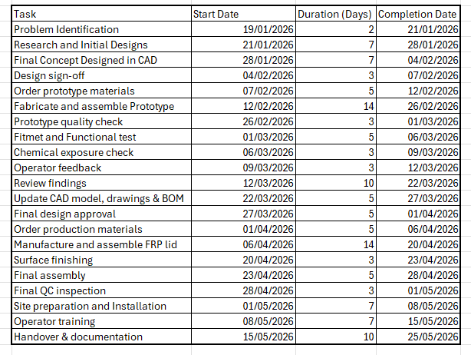
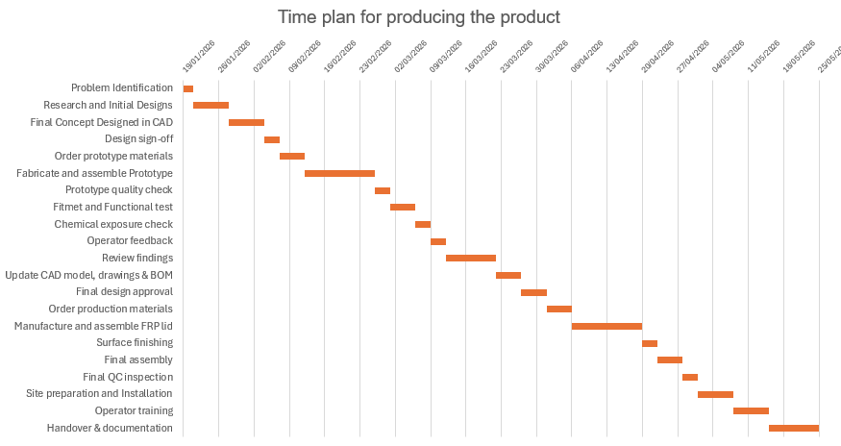
Figure 1 - Gannt chart Timeline for design and manufacture of solution to the client’s brief

Relevant Research

Material Selection

Stainless Steel
Stainless steel is a commonly considered material due to its high strength, durability, and widespread industrial use. It provides good mechanical performance and is resistant to many forms of corrosion; however, standard grades such as 304 offer limited resistance to sulfuric acid, particularly at higher temperatures. Higher grades like 316L improve corrosion resistance but are heavier and more expensive and still may degrade over long-term exposure to aggressive acids.

Fibre-reinforced plastic (FRP) composite
Widely used in chemical processing due to its excellent resistance to corrosive substances, including sulfuric acid. FRP composites are considerably lighter than metal alternatives, making them well suited for single-operator lids, and typically offer long service life when correctly specified. Their main limitation is lower structural strength compared to metals, often requiring additional reinforcement if large panels are required.

Thermoplastics
Thermoplastics such as HDPE and polypropylene are lightweight, low-cost materials that offer good resistance to corrosive chemicals. They are easy to manufacture and handle, making them suitable for manual operation. At an operating temperature of 25 °C, thermal resistance is not a limiting factor; however, their relatively low mechanical strength compared to metals and composites may still affect long-term durability if subjected repeated use.
Table 2 - Material Comparison
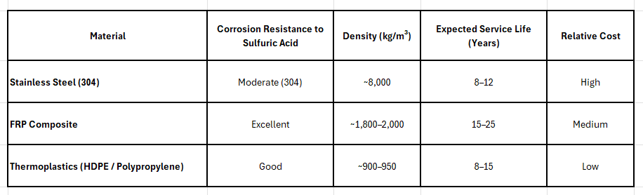
Based on corrosion resistance, weight, durability, and cost, FRP composite is the most appropriate material for the tank lid. Its low density supports safe single-person operation, while its chemical resistance ensures long-term performance in the anodising environment.

Design Concepts

Design Concept 1 – Hinged Split Lid
Two lightweight FRP panels, both bolted to the tank on three side hinges. Each panel lifts independently and folds down beside the tank. Handles on each section allow safe single-person operation, educing lifting effort.
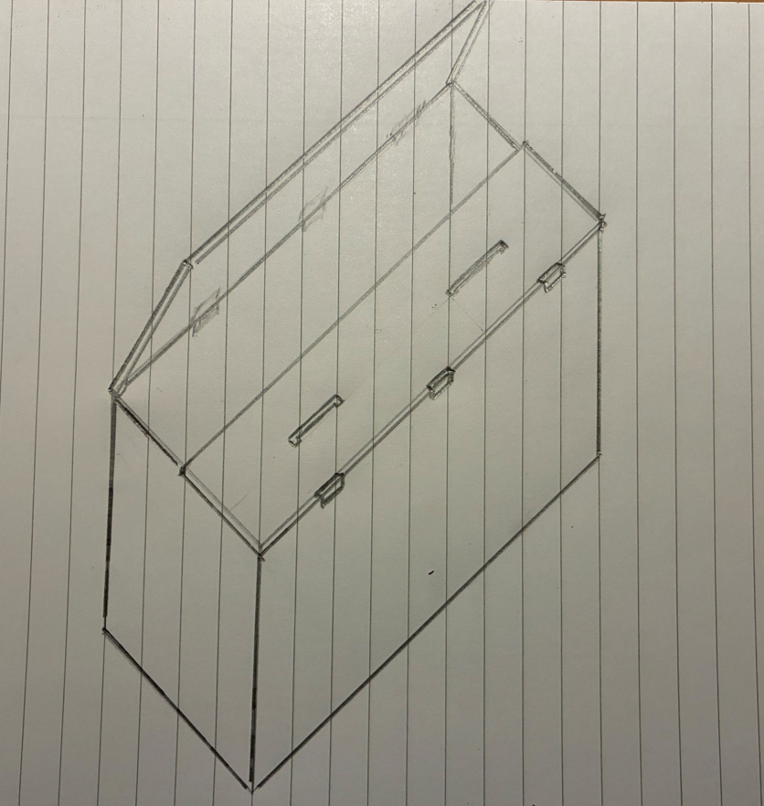
Figure 2 - Hinged Split Lid

Design Concept 2 – Gas Strut Assisted One-Piece Lid
A single light weight FRP lid supported by two hinges and gas struts. The struts provide lift assistance, allowing the operator to raise and lower the lid from one side. External mounts keep components clear of the acid environment. A handle is mounted at either side so the lid can be lifted & closed from either side.
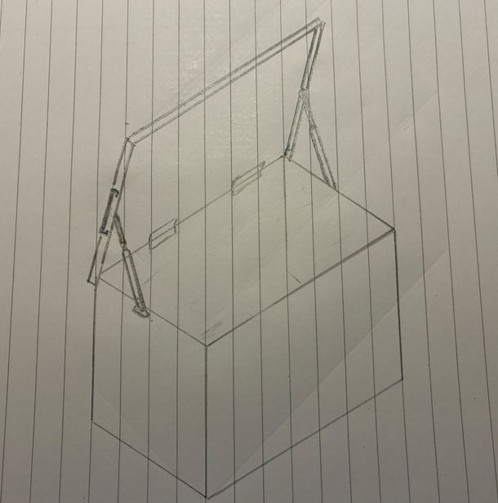
Figure 3 - Gas Strut Assisted One-Piece Lid

Design Concept 3 – Manually Operated Roll-Up Lid
A flexible lid that retracts into a housing using a manual crank. Guide tracks keep the lid aligned during movement. Operation requires no lifting and is a one-person task.
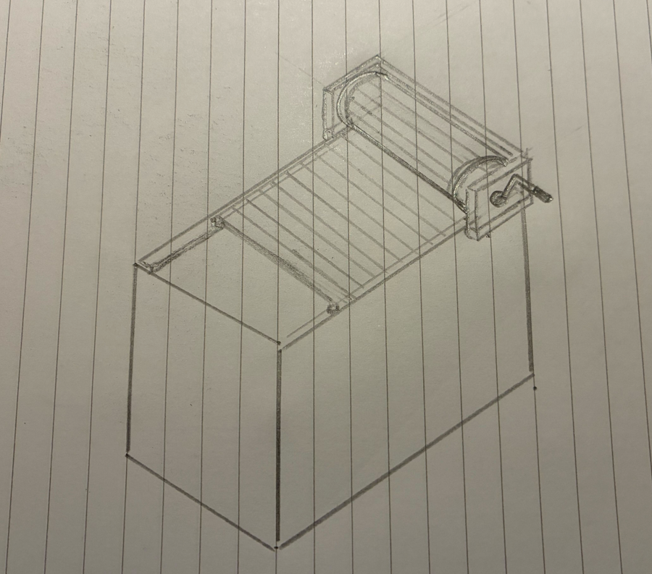
Figure 4 - Manually Operated Roll-Up Lid

Final Design Concept

Justification for Design Choice
The final design develops Concept 1 by using a two-piece FRP split lid mounted on piano hinges along the rear edge of each lid section. This maintains the benefits of the original split-lid arrangement while improving ergonomics, alignment, and load distribution.
FRP is selected for its low weight, excellent corrosion resistance, and long service life in sulphuric acid environments. Its reduced mass enables safe single-person operation and supports compliance with manual handling legislation, while still providing sufficient structural strength for repeated industrial use.
The piano hinges provide smooth, controlled movement and distribute loads evenly along the lid length, reducing stress on the FRP panels. Each lid section opens outward, with a small overlap ensuring correct alignment and a reliable seal when closed.
Integrated ergonomic handles are moulded into the FRP structure, eliminating the need for additional hardware and reducing the risk of leakage through drilled fixings. Their placement supports neutral lifting posture and minimises operator strain. The split-lid configuration further reduces lifting mass, improving safety and efficiency.
A downward-facing perimeter flange enhances chemical containment, and the sealed hinge interface prevents acid ingress. The design requires only minor modifications to the existing tank and uses minimal moving parts, reducing maintenance requirements and long-term cost.
Compared to Concepts 2 and 3, this solution is more cost-effective, simpler to manufacture, and easier to maintain. The lightweight FRP construction, split-lid layout, and robust hinge system provides a reliable, ergonomic, and durable solution for continuous industrial use.

Tank Assembly CAD Design
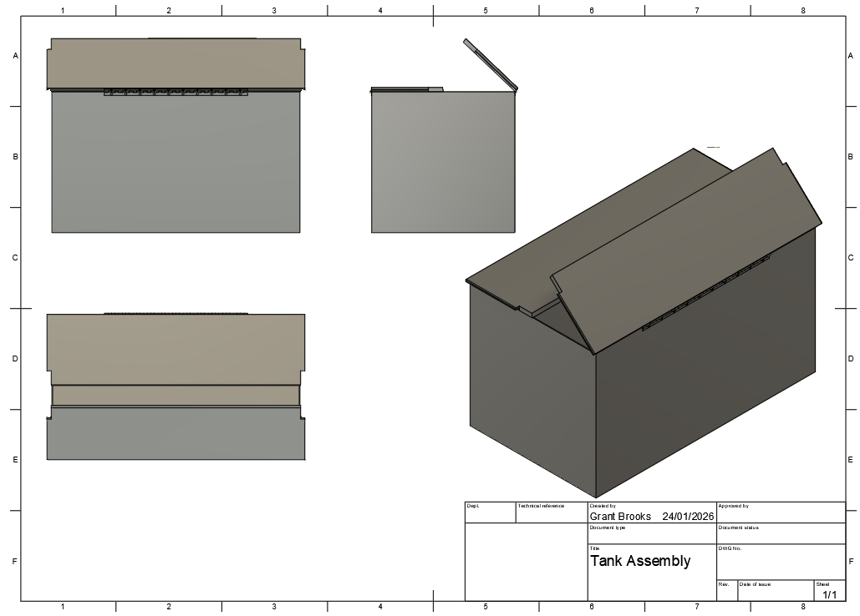
Figure 5 - Tank Assembly with 1 lid open
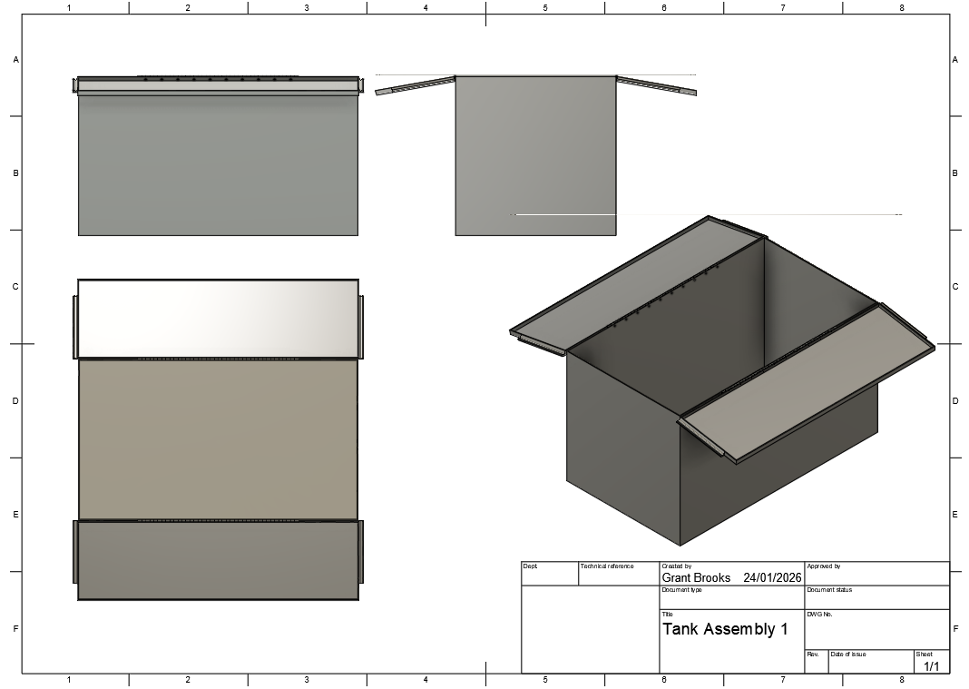
Figure 6 - Tank Assembly with both lids fully open
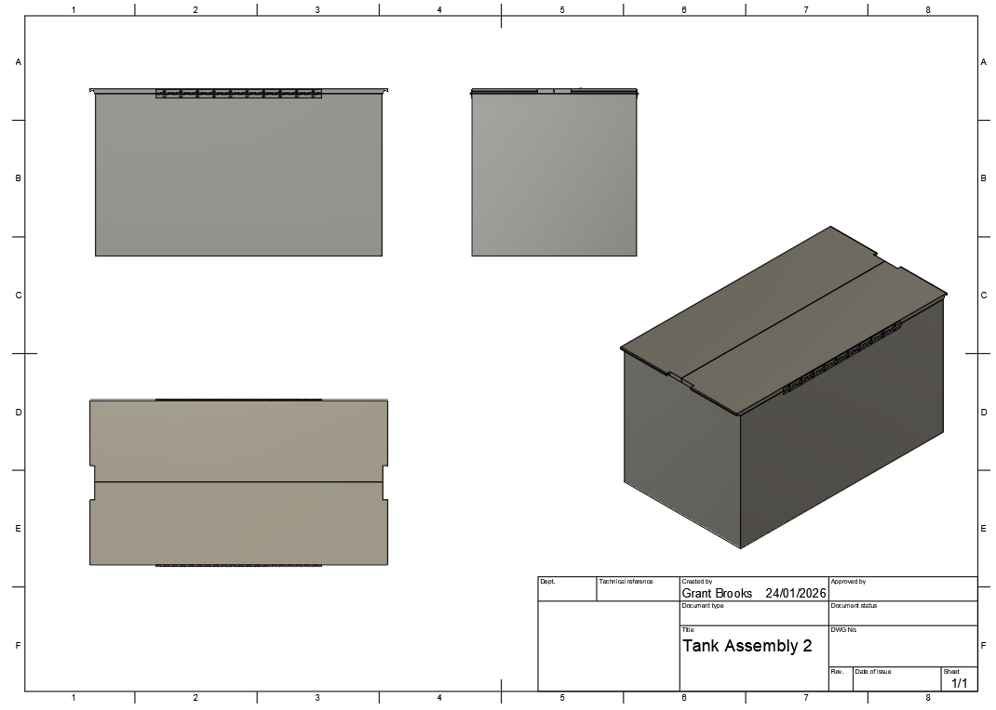
Figure 7 - Tank Assembly with lids fully shut

Technical Drawings
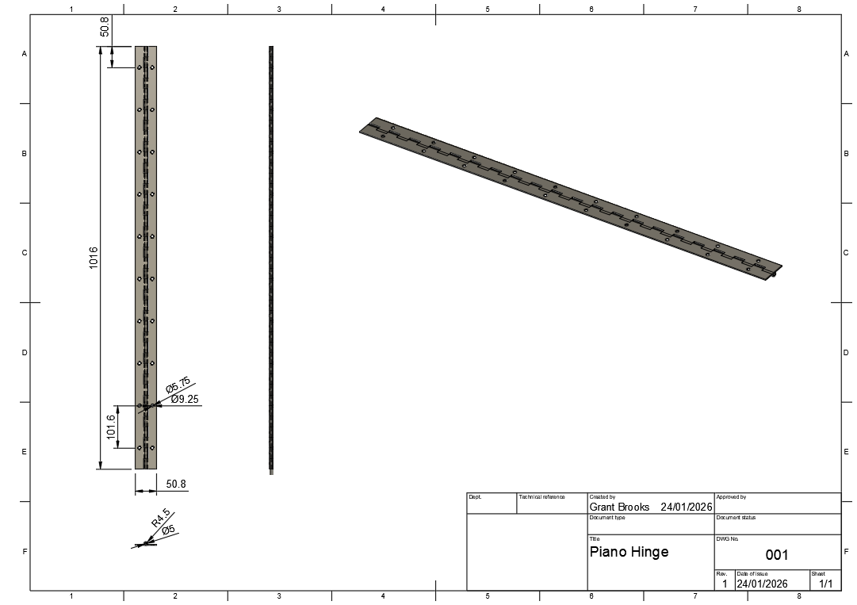
Figure 8 - Piano Hinge Technical Drawing
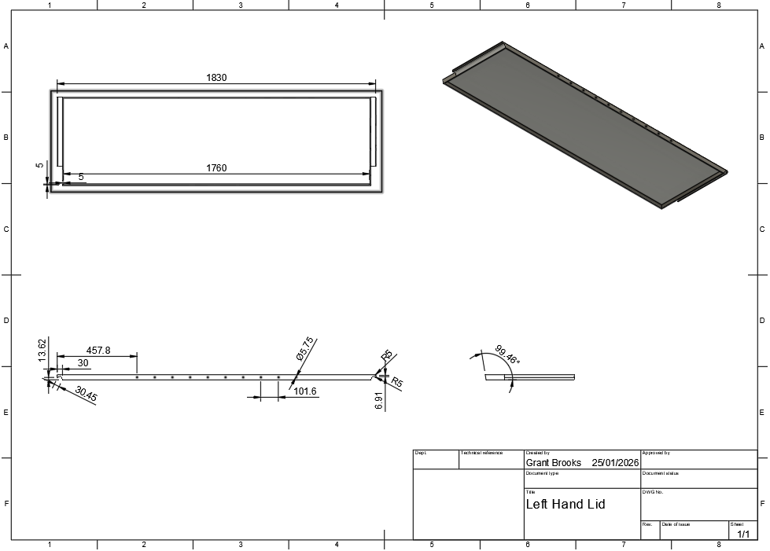
Figure 9 - Left Hand Lid Technical Drawing
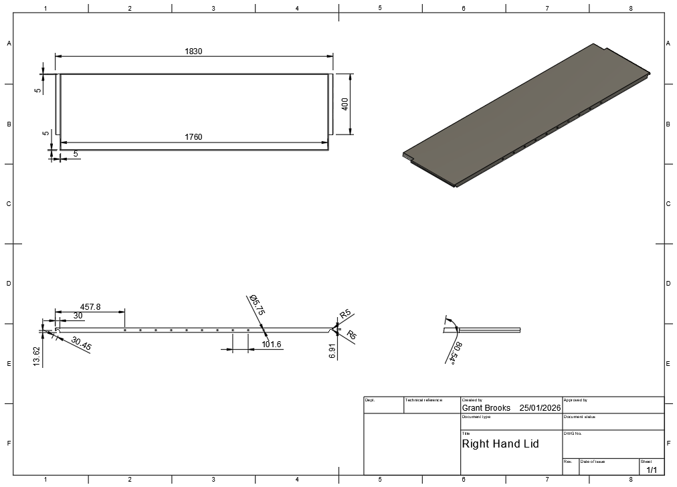
Figure 10 - Right Hand Lid Technical Drawing
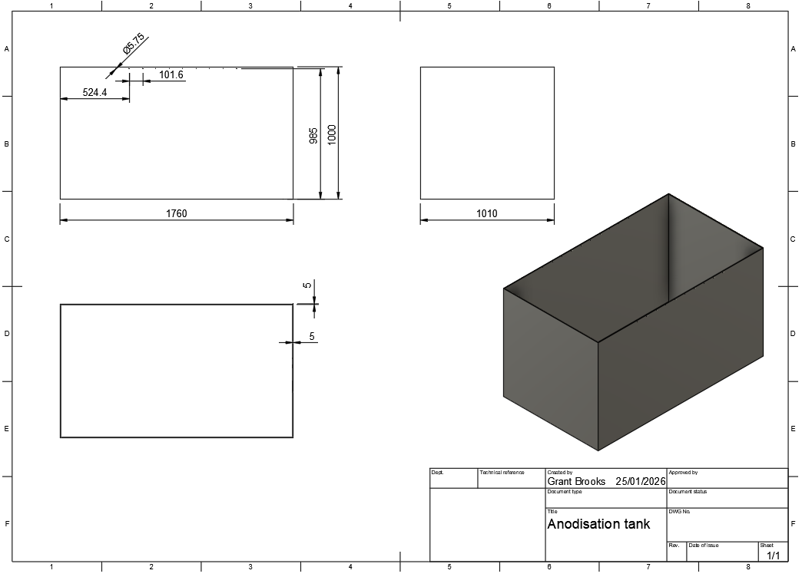
Figure 11 - Anodising Tank Technical Drawing

Parts list
2 x Piano Hinge Drilled Hinge 51.0 mm 1016.0 mm
https://www.essentracomponents.com/en-gb/p/continuous-hinges-metal/493552
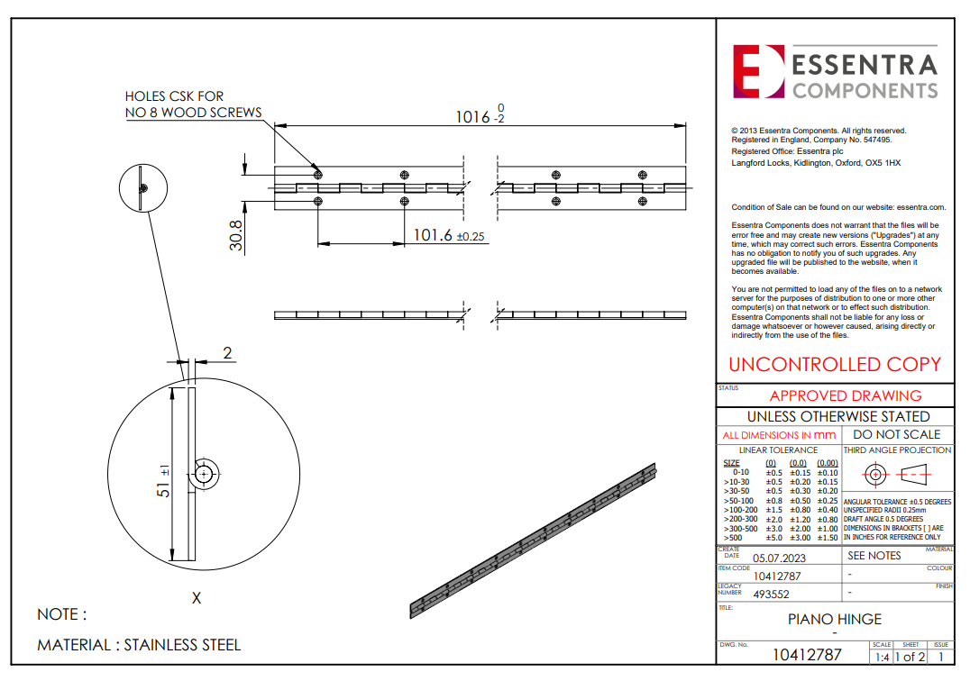
Figure 12 - Piano Hinge Technical Drawing (Essentracomponents.com, 2021)
20 x RS PRO Stainless Steel Hex Socket Countersunk Screw, ISO 10642, M5 x 16mm https://uk.rs-online.com/web/p/socket-screws/2328423?gb=a
20 x RS PRO A2 304 A2/304 Stainless Steel Plain Washers, M5, DIN 9021 https://uk.rs-online.com/web/p/washers/2874034?gb=a
20 x RS PRO Stainless Steel Lock Nut, DIN 985, M5 https://uk.rs-online.com/web/p/hex-nuts/0767826?gb=a
1 x Left hand lid (Figure 9)
1 x Right hand lid (Figure 10)

Manufacturing Processes
The initial manufacturing method for the anodising tank lid prototype would be hand lay-up using fibre-reinforced plastic (FRP). This manufacturing method is well suited to low production volumes due to its low tooling cost and design flexibility. A mould would be produced to define the lid geometry, into which layers of fibre reinforcement and chemical-resistant resin are manually applied to achieve a thickness of 5 mm. The laminate is then cured at ambient temperature before demoulding, allowing rapid prototyping and cost-effective small batch production.
For higher production volumes, manufacturing would transition to compression moulding. This process uses matched mould tools and controlled pressure and temperature during curing. Although the initial tooling cost is higher, compression moulding offers improved dimensional accuracy, surface finish, and lower unit costs compared to hand lay-up, making it more suitable for mass production once the design is finalised.
The lid uses a piano hinge, an off-the-shelf component available from Essentra Components. This hinge distributes load evenly along the lid length, reducing local stresses in the FRP and improving durability. Stainless steel is specified for the hinge material due to its good chemical resistance.
The handles are integrated into the lid structure rather than fitted as separate components. This increases stiffness, eliminates the need for additional drilled holes and extra hardware. This reduces the risk of acid leakage. Integrating the handles also improves overall robustness of the lid.
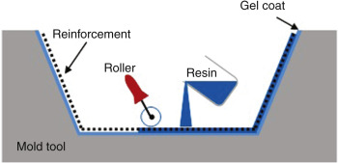
Figure 13 - Hand Lay-up Manufacturing Method (www.sciencedirect.com, n.d.)
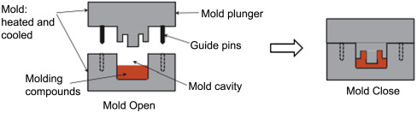
Figure 14 - Compression Moulding Manufacturing Method (Sciencedirect.com, 2016)

Conclusion and Further Works
The redesigned FRP split‑lid system successfully resolves the manual handling and safety issues associated with the original stainless-steel cover. By using lightweight FRP panels, full‑length piano hinges, and integrated ergonomic handles, the final design enables safe single‑person operation while maintaining durability and chemical resistance in the anodising environment. The solution meets all legislative requirements, improves operator ergonomics, and reduces long‑term maintenance costs due to fewer moving parts and corrosion‑resistant materials.
The design is simple to manufacture, compatible with the existing tank structure, and suitable for low‑to‑medium production volumes across multiple sites. Its combination of reduced weight, improved usability, and robust chemical containment makes it an effective and practical engineering solution.
Further development could include exploring semi‑automated or fully automated lid actuation to eliminate manual lifting entirely, as well as adding sensors to monitor lid position. These enhancements would further improve safety, efficiency, and process reliability in high‑volume anodising operations.
Semi‑automated actuation could be achieved by adding low‑force linear actuators or pneumatic cylinders to assist the operator during opening and closing. In this arrangement, the operator initiates movement using a button or lever, and the actuator provides the lifting force while the operator guides the lid. This reduces physical effort while maintaining simple, low‑cost operation.

Bibliography
Health and Safety Executive (HSE) (1974) Health and Safety at Work etc. Act 1974. London: HMSO. Available at: https://www.legislation.gov.uk/ukpga/1974/37/contents (Accessed: 20 January 2026).
Health and Safety Executive (HSE) (1992) Manual Handling Operations Regulations 1992. London: HMSO. Available at: https://www.legislation.gov.uk/uksi/1992/2793/contents (Accessed: 20 January 2026).
Health and Safety Executive (HSE) (1998) Provision and Use of Work Equipment Regulations 1998. London: HMSO. Available at: https://www.legislation.gov.uk/uksi/1998/2306/contents (Accessed: 20 January 2026).
Health and Safety Executive (HSE) (2002) Control of Substances Hazardous to Health Regulations 2002. London: HMSO. Available at: https://www.legislation.gov.uk/uksi/2002/2677/contents/made (Accessed: 20 January 2026).
Health and Safety Executive (HSE) (2013) Working with substances hazardous to health: A brief guide to COSHH. London: HSE. Available at: https://www.hse.gov.uk/pubns/indg136.pdf (Accessed: 20 January 2026).
European Commission (2023) REACH: Registration, Evaluation, Authorisation and Restriction of Chemicals. Available at: https://environment.ec.europa.eu/topics/chemicals/reach_en (Accessed: 20 January 2026).
Essentracomponents.com. (2021). Continuous Hinges - Metal - 10412787. [online] Available at: https://www.essentracomponents.com/en-gb/p/continuous-hinges-metal/493552 [Accessed 24 Jan. 2026].
www.sciencedirect.com. (n.d.). Hand Lay-up - an overview | ScienceDirect Topics. [online] Available at: https://www.sciencedirect.com/topics/engineering/hand-lay-up [Accessed 25 Jan. 2026].
Sciencedirect.com. (2016). Compression Molding - an overview | ScienceDirect Topics. [online] Available at: https://www.sciencedirect.com/topics/materials-science/compression-molding [Accessed 25 Jan. 2026].

