The best Bluetooth, AirPlay and wireless speakers for 2018
The best Bluetooth and wireless speakers CREDIT: UE
- Telegraph Reporters
22 DECEMBER 2017 • 3:15PM
If you're not happy with the noise from your current speaker set up then Christmas might be the time to invest in a wireless speaker system to make the most of the music collections on your phone, tablet or laptop. There are plenty of key points to look out for when buying a new wireless speaker. As well as the obvious point of sound quality, there are plenty of key features to consider when making a purchase.

What to look for in a wireless speaker
Portability can be a winner for many buyers. Some speakers are more versatile than others. Nifty speakers like the UE Roll 2 are light and portable. However, if you want a quality wireless home sound system you might want to look for a set of Sonos. Battery life is also an important for a portable speaker. Cheaper Bluetooth speakers may last ten hours or less, but pricier models can have seriously long lasting battery life. Other factors to consider include connectivity - checking you have the right ports and connections like Bluetooth; waterproofing if you want to take your speakers on holiday or to Glastonbury, and voice control.

What is the difference between Bluetooth, AirPlay and Wi-Fi speakers?
There are several different ways you can set up wireless speakers, but probably the most common is Bluetooth. Bluetooth has become the ubiquitous wireless speaker technology, simply pairing up a smartphone or tablet. Bluetooth speakers offer easy portability and simple connections, but can be interrupted by phone calls or notifications. Wi-Fi speakers from the likes of Sonos or the Amazon Echo set up their own mini Wi-Fi system, meaning they use internet connections rather than Bluetooth. This can be used for effectively setting up multi-room audio.
If you want a full breakdown of our favourite multi-room speakers you can find our guide here. Alternatively, if you want a multi-room system using a smart speaker check out our guide to all the best smart home devices such as the Amazon Echo and Google Home. Some speakers, from Apple and its preferred manufacturers, use their own AirPlay technology. This is used for iPhone, MacBook and iPad users and can also be used to transmit video.

How much should I pay for a wireless speaker?
You can pick up some very good portable Bluetooth speakers for under £150, from the budget-end Sumvision Psyc Monic to the JBL Charge 3. More advanced speakers will offer extra features, such as voice control, call answering or connectivity for a multi-room experience. Wi-Fi enabled speakers tend to be a little more expensive, but offer the ability to create a multi-room experience and are not affected by range. Larger and more powerful speakers will also cost more, and if you are paying much more than £250 you should be looking for a quality stand alone speaker system.

The best Bluetooth speakers

UE Boom 2
£92, Amazon
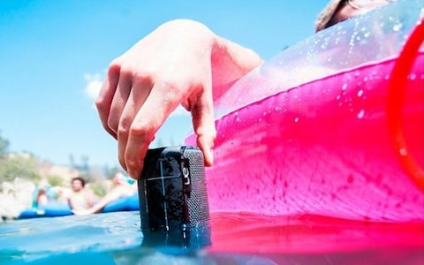
UE Boom 2, £92
These larger Ultimate Ears speakers offer 360-degree sound and enhanced battery life compared to its little brother the UE Roll. Coming in at seven inches tall, the UE Boom 2 is small and portable and has the water resistance and drop proofing that make it a perfect holiday or festival companion. Battery life is also impressive, clocking in at close to 15 hours with a two and a half hour charge time. You can also pair up to eight devices via Bluetooth with two sources connected simultaneously if you want to collaborate on your playlist. Not only that they sound brilliant and have become the go-to choice to portable music on the go. You can find them for under £100 on most online sellers.
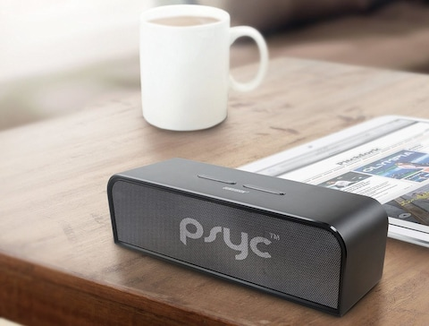
CREDIT: PSYCSOUND
One of the best-rated budget speakers, the Sumvision Psyc Monic combines small size with a mighty punch, delivering great audio quality for such a diminutive device. It is a little heavy, somewhat reducing the selling point of portability.
With a brushed aluminium design and dual 10-watt drivers powering its subwoofer, this Bluetooth speaker stands out from many other low-cost speakers. With around seven hours of playback time it has enough battery life to keep ticking over on a day out. For under £40 it's a great deal on a simple little speaker.
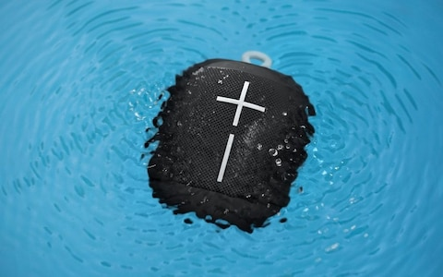
UE Wonderboom, £69 CREDIT: UE
If you want something stylish and portable that delivers a brilliant sound, the UE Wonderboom 2 is the tiny Bluetooth speaker that can be carried around with a finger or clipped onto a bag. It is also waterproof up to depths of one metre, meaning you can take it to the poolside or beach and not worry about damage.
Battery life is around 10 hours and it has punchy little speakers. It touts an effective Bluetooth range of up to 100 metres. It's durable and can be paired up with other UE speakers for a surround sound experience. Plus you can pick up a two pack for just over £100.

JBL Charge 3
£99, Currys
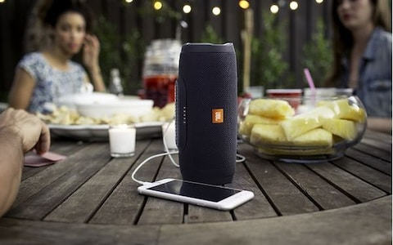
JBL Charge 3, £99 CREDIT: JBL
JBL's Charge 3 speaker is another great portable Bluetooth device. With 360-degree audio it offers great sound. The JBL also stands out for its epic battery life with a 20-hour charge for under £100 that offers fantastic value.
In fact the battery is so good on this portable speaker you can plug in your phone and charge from it. It comes in a range of fun colours and is waterproof even when submerged. Unlike some speakers at this price it also offers a touch activated speaker phone, and you can connect multiple JBL speakers to create a surround sound experience.

