A critical analysis of literacy, numeracy and digital competence as cross curricular responsibilities.

In response to Donaldson’s report Successful Futures (2015), the Welsh Government have found it essential that children are given the opportunities to learn essential skills that prepare them to move on ‘confidently in the modern world’ of work (DoE, 2017: p.2) with ‘a range of competencies and skills’ as foundations for learning in order to progress and move on with their learning (Donaldson, 2015: p.39). The Welsh Government set out in their plans for education that literacy and numeracy as a cross-curriculum responsibility will be a priority for all teachers (Welsh Government, 2017). A cross-curricular approach allows children opportunities to apply subject knowledge in other contexts whilst developing a high level of competency to consolidate understanding, skills and knowledge across the curriculum. This approach has been found to enhance teaching and learning through consolidating essential skills. Siraj-Blatchford (1998) supports this in arguing the importance of children requiring a ‘holistic curriculum’ through implementing a cross-curricular approach to teaching allowing children to gain a firm understanding through applying their knowledge and skills in other curriculum areas. Kerry (2015: p.213) argues that this will prepare learners for further education and ultimately, their working life as they will be used to applying skills to other areas. This view strongly supports Donaldson’s view of developing ‘citizens’ who are ‘ready to learn throughout their lives, leaving school with a sound command of literacy and numeracy skills’. Donaldson (2015) also advocates the importance of ensuring that learners leave school being both competent and confident in their use of skills in a range of settings and scenarios so that they can problem solve and live in the real world.
Whilst there has been a recent push by the Welsh Government to teach in a cross-curricular way, research has promoted these ideas for many years before Successful Futures (2015). Recent and former research agree that it is important for children to be taught how to use their skills in different ways and not just in set subjects. Morrison (1994: p.1) supports this in agreeing with the need for pupils to be ‘adaptable and flexible’ as we are in an era which is changing at a fast speed. For children to progress to a ‘successful future’, it is vital that they are taught adaptable, essential skills which can be used in various scenarios. Cross-curricular teaching allows children to learn skills which they then apply in other situations to deepen their understanding. Personal experience has demonstrated the benefits of teaching and learning in this way. In a recent observation of a year five class, pupils used skills learned in a previous geography lesson to enhance their knowledge in the history of Germany’s invasion route during World War Two (WW2). Pupils were provided with a blank map of Europe. The learners used an atlas to find out the names of the places. Having prior skills of using an atlas allowed children to independently complete this task whilst consolidating their skills of using an atlas. The learners then used a range of ICT including Chromebooks and iPads to research the route Germany took.During this activity, pupils used a range of reading techniques to research appropriate sources.This lesson combined history and geography skills predominately, whilst using digital and literacy skills to read and research information.
However, a cross-curricular style of teaching does have some implications. Alexander (cited in Pollard and Bourne, 1997: p.207) argues against cross-curricular learning; claiming that it may not give pupils equal opportunities in each area. In primary schools, one teacher delivers most subjects to their class; therefore, it is up to the teacher how much time is spent delivering each subject. Pollard and Bourne (1997) argue that this allows opportunites for favouritism and specialist subjects to receive more delivery time compared to other areas of the curriculum; thus, potentially leaving pupils less experienced in certain subjects. This could result in children missing out on certain areas which they may have thrived in if taught more often. Primary teachers are ‘highly flexible’ with what they teach on a day to day basis; whereas, in secondary school, a fixed and predictable timetable is followed where pupils receive the same delivery time in subjects fortnightly. However, on the other hand, it is also argued by Pollard and Bourne (1997) that cross-curricular teaching gives teachers opportunities to teach subjects more evenly as they can combine several subjects into one session. Therefore, allocating more time for the subject each week. Additionally, it allows teacher’s weaker subject areas to be integrated with an area they are complacent with; thus, developing both the teacher’s subject knowledge and competence in delivery whilst ensuring teachers have sufficient subject knowledge across the curriculum allowing pupil’s development of skills (Gulbenkian, 1982, cited in Pollard and Bourne, 1997).
Gorwood (undated, cited in Pollard and Bourne, 1997) suggests that the transition from primary to secondary is made more difficult due to extreme differences in delivery of subjects.Children transition from a single teacher delivering a mixture of subject areas within one lesson, to set subjects with individual subject teachers. However, this has also been identified by Donaldson (2015) who aims that a cross-curricular approach is implemented throughout primary and secondary education by all teachers which, in turn, will eradicate this issue.
Literacy is essential across the curriculum as speaking, writing and spelling are used in most subjects as well as the ‘fundamental role of language in thinking’ (Donaldson, 2015: p.40). However, children are being taught ‘the mechanics of writing’ and are expected to write about something in which they have no experience. For children to write about something to a high standard, they must have a personal or shared experience to write about. This links with Barnes’ (2015) multi-disciplinary cross-curricular learning. For children to learn how to write instructions, they must be given a meaningful opportunity such as following instructions to deepen their knowledge and understanding of what instructions look like and how they are set out in different contexts. This should be followed with the opportunity to present their understanding by writing instructions for another situation. However, it is important that the ‘mechanics of writing’ are still taught for children to progress in their writing abilities regardless of their previous experiences. If children are only given the opportunity to write about their experiences, they may not be able to write at a suitable level and will not become competent in their writing skills.
Literacy can be taught effectively in a ‘visual literacy’ cross-curricular skill which develops a ‘life skill of the highest order’ through developing digital competence in creation of a video presentation and photography (Kerry, 2015: p.215). This method allows children to deconstruct images they are using to have a reason for using the image giving them the opportunity to ‘explain thinking, explore and discuss ideas’ using language skills (Donaldson, 2015). Scorsese (2013, cited in Kelly, 2015) encourages children to deepen their knowledge of an image by distinguishing images that are ‘just telling them something’ and those that ‘engage their humanity and their intelligence’. This wider thinking develops thinking and reasoning skills. Therefore, pupils can express their process and ideas of what they have included in their writing giving pupils control of their writing.
Piaget (undated) advocates one way to enhance literacy and numeracy is to combine the two subjects using numerical literature. This cross-curricular style of teaching is useful in the Foundation Phase whilst children are beginning to link numbers to objects. There are many educational books that allow children to link the written figure of a number to the amount of that number in illustrated objects allowing them to develop both their numerical skills of numbers and counting in addition to their reading and comprehension skills (Cited in Ojose, 2008). Whilst many schools incorporate literacy and numeracy in other subjects, not many use multiple subjects to teach. This is visible in school literacy and numeracy approaches where literacy and numerical opportunities are set out individually to be incorporated into other subjects, but not into each other (Appendix 1).
Some theorists disagree with teaching through a cross-curricular approach as they argue it does not give children clear boundaries between individual subjects. It is argued that a cross-curricular approach does not ensure pupils receive regular opportunities to develop their skills in key subjects (Hayes, 2010). They believe that cross-curricular approaches allow children too much choice in their learning, therefore, they avoid subject areas they do not enjoy or find difficult. Consequently developing ‘poor work habits and attitudes’ towards certain areas. On the contrary, Rose (2009) disagrees with this lack of clear boundaries or children being given too much choice. It is the responsibility of the teacher to ensure clear boundaries are given to subjects even during cross-curricular lessons. This can be done by simply informing children of the core subjects being developed in a lesson and explaining the task. A beneficial strategy observed during teaching practice was that all new skills being introduced were shared with the class before the lesson.The teacher shared the ‘WALT’ (We Are Learning To…) with the class and ensured all learners were aware of what it meant.The children were then given an opportunity to discuss the subject areas they thought would be a focus in the lesson.It was surprising to see that most key stage two (KS2) children were aware that they were using numerous areas of learning in most lessons.The teacher encouraged the children to share their thoughts and ensured the numerous subjects and skills being covered in the lesson were explained.This approach was beneficial as it meant that the learners reflected on prior knowledge to aid them if they were struggling.Likewise, it is the teacher’s role to encourage pupils’ enjoyment and passion for all subjects and ensure that lessons are made enjoyable and engaging so that children do not feel they do not enjoy a certain subject.
Numeracy is becoming increasingly important within the curriculum looking at real-life situations being ‘essential for independent living and work’ (Donaldson, 2015: p.40). Skills taught in numeracy are often crucial to children’s progression in other areas of the curriculum requiring a certain degree of fluency in their skills to transcribe from numeracy to another area. Some critics believe that cross-curricular teaching is only beneficial with ‘soft’ subjects such as the humanities and drama and is not appropriate for subjects such as literacy and numeracy (Kerry, 2015). However, Ward-Penny (2011) and Barnes (2015) believe that numeracy enhances lessons in other subjects making them ‘more meaningful’ using numerical thinking and methods. Pupils are leaving school with a lack of awareness to importance of numerical skills in everyday life. This is because of the way it has been delivered in the past where pupils received mathematics and english lessons once a day in the morning, and then they would move onto their next subject area. Therefore, the skills they learned are not exercised in another situation until the next session. Cross-curricular teaching allows skills to be exercised whilst also developing other subject area skills. For example, in a mathematics lesson on coordinates, the teacher taught the skills of plotting and finding coordinates. Later that week, a geography lesson was taught where children were using maps to locate different settings through describing their positions compared to another place (e.g., the church is located North East of the post office). This was an opportunity that could have further developed children’s numerical coordinate skills using grid referencing and using coordinates to describe the position of a setting. Thus, not only would this have allowed children to describe the locations with accuracy, it would have allowed children to build upon their knowledge and deepen understanding of coordinates linking it with the geographical skill.
Additionally, numeracy skills develop to become more theoretical to real life situations in KS2. However, children are not given opportunities to use their skills in contexts which prepare them for working life. A cross-curricular approach to teaching real world numerical skills applying them to different contexts out of the numeracy lesson provides children a ‘high-quality mathematics education provid[ing] a foundation for understanding the world’ whilst also giving a sense of enjoyment and curiosity for the subject (DfE, 2018).
Ward-Penny (2011: p.127) discusses personal experience of teaching mathematics through a different language. The idea discusses problems faced from cross-curricular teaching being that subject knowledge must be strong in both areas before a teacher can be ‘comfortable delivering even the most straightforward’ of lessons without a secure understanding.It is argued that a lack in subject knowledge leads to a lack of cross-curricular lessons in higher years of education as pupils begin to work in a more sophisticated way.This can be overcome by focussing the main subject in an area that the teacher has a strength in. In personal experience in the classroom, it was evident that weaker subject areas were not delivered in a cross-curricular approach whilst stronger subject areas were. This was due to the confidence to deliver a lesson developing the skills and knowledge in two subject areas that have a deep understanding. However, when it came to teaching history, the lesson did not delve into other subject areas. History remained the focus and children only gained knowledge of the topic and did not develop skills from any other areas. On reflection for the next lesson, this could have been developed by integrating the weaker subject (history), with a stronger subject (mathematics) where children developed previous skills such as calculating areas, percentages and reading graphs to learn about the plague. Therefore, allowing pupils to secure mathematical skills and understanding whilst learning about the history of the plague, what it was, and the number of people affected by it.
Digital competency is one of Donaldson’s (2015) cross-curricular responsibilities. It sets out to apply digital skills to subject areas and scenarios relatable to children’s futures in work (Welsh Government, 2016). The world of work in which children will be entering ‘is dominated by new technologies’ (Barnes, 2015: p.286). With digital technologies becoming embedded in the world, children will leave school to apply and enter a world of jobs that do not yet even exist (Payton and Hughes, 2010 and UKCES, 2014). This increases the importance of digital competence skills being taught to children to give them skills they will require in the working world. It has been noticed that some teachers avoid delivering digital lessons as they ‘are not good with technology’. Advantage is taken of younger professionals in the school using them to deliver the subject. Whilst this may be an issue, it must be acknowledged that some teachers were not brought up with the vast amount of technology available today. Therefore, they are not familiar with the technology and how to use it. However, with such a speed of change in technology, it is important that children are given opportunities to advance their digital competencies regardless of the teacher’s capabilities as children are likely to be able to develop skills for themselves if given the opportunity (Rowley and Cooper, 2009).
Giving children the chance to show what they have learned by presenting findings through a PowerPoint or other technological methods allows children the chance to develop their digital competency skills whilst also making the work ‘more interesting for the children’ (Rowley and Cooper, 2009: p.87). Many argue that when children are interested in what they are learning, they are more likely to engage with it further, building upon their knowledge and skills in meaningful ways (Barnes, 2015, Donaldson, 2015, Kerry, 2015, Barnes and Shirley, 2007). By delivering a lesson that motivates learning, the lesson can be thought of as an efficient (Barnes, 2015). Donaldson (2015: p.10) states the importance of the curriculum being delivered in ways that ‘engage the interest of all children enabling them to achieve’.

To conclude, it is agreed with Donaldson that literacy, numeracy and digital competence should receive frequent opportunities to develop a high level of understanding across the curriculum. However, the use of a cross-curricular lesson should be relevant and should not be forced to become cross-curricular. Hayes (2010: p384) supports this view in that links between certain subject areas such as ‘music and geography are likely to be more difficult to create naturally than those between science and design and technology’. Therefore, if a lesson will have a bigger impact on children’s learning standing alone, then it is important not to force the lesson to include cross-curricular responsibilities. It is evident that in future practice, it is important to incorporate cross-curricular responsibilities that will have a positive impact on children’s learning and skills.
Word count: 2,746

Appendices
Appendix 1 – Literacy and Mathematics approach in school X.
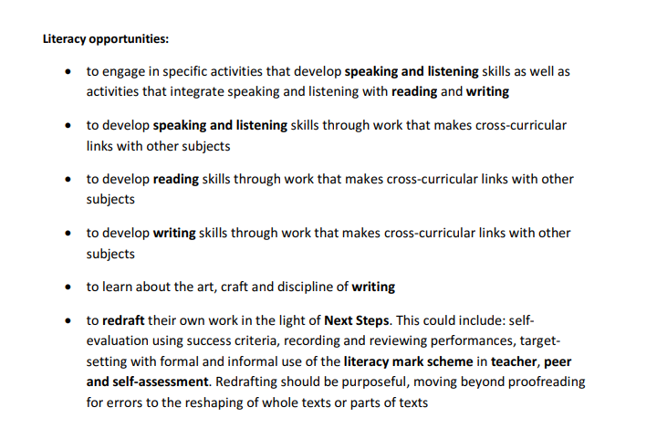
X Primary School (2017). Literacy and Mathematics Whole School Approach. [online] Available at: http://www.hollyfield.kingston.sch.uk/site/downloads/policies/literacyNumeracy.pdfhttp://www.hollyfield.kingston.sch.uk/site/downloads/policies/literacyNumeracy.pdf [Accessed 25 Nov. 2018].

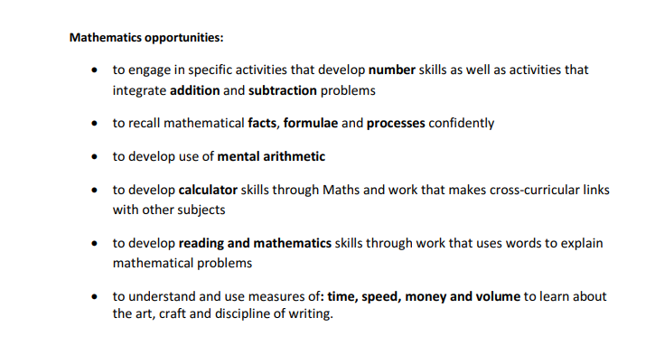

References
Barnes, J. and Shirley, I. (2007). Strangely familiar: cross-curricular and creative thinking in teacher education. Improving Schools, 10(2), pp.162-179.
Barnes, J. (2015). Cross-curricular learning 3-14. 3rd ed. London: Sage publications.

Department of Education (DoE) (2017). Cross-curriculum Responsibilities. January Report. [online] Cardiff. Available at: https://curriculumforwales.gov.wales/2017/03/07/cross-curriculum-responsibilities-findings-from-the-strategic-design-group/ [Accessed 23 Nov. 2018].
Department for Education (DfE) (2018). National curriculum in England: mathematics programmes of study. [online] GOV.UK. Available at: https://www.gov.uk/government/publications/national-curriculum-in-england-mathematics-programmes-of-study/national-curriculum-in-england-mathematics-programmes-of-study [Accessed 27 Nov. 2018].
Donaldson, G. (2015). Successful Futures. Independent Review of Curriculum and Assessment Arrangements in Wales. Cardiff: Crown.
Hayes, D. (2010). The seductive charms of a cross-curricular approach. Education 3-13, 38(4), pp.381-387.
Kerry, T. (2015). Cross-curricular teaching in the primary school. 2nd ed. London: Routledge.
Morrison, K. (1994). Implementing cross-curricular themes. London: David Fulton.
Ojose, B. (2008). Applying Piaget’s Theory of Cognitive Development to Mathematics Instruction. The Mathematics Educator, 18(1), pp.26-30.
Payton, S.and Hague, C. (2010). Digital literacy across the curriculum Bristol: Futurelab.
Rose, J. 2009. Independent review of the primary curriculum: Final report. London: DCSF Publications
Rowley, C. and Cooper, H. (2010). Cross-curricular approaches to teaching and learning. London: SAGE.
Siraj-Blatchford, I. and Siraj-Blatchford, J. (1995). Educating the whole child - Cross-curricular skills, themes and dimensions. Buchingham: Open University Press.
UK Commission for Employment and Skills (UKCES) (2014). Careers of the future. London: Crown.
Ward-Penny, R. (2011). Cross-curricular teaching and learning in the secondary school -- mathematics. London: Routledge.
Welsh Government (2016). Digital Competence Framework guidance. Cardiff: Crown.
Welsh Government (2017). Literacy and numeracy: Your questions answered. Cardiff: Crown.

