Morgan Hall



Contents
Evaluating the Effectiveness of Chosen Maintenance Strategies for Dedicated Equipment
BF Lower seal valve
Introduction…………………………………………………………………………………………1
Maintenance review……………………………………………………………………………….3
Maintenance evaluation…………………………………………………………………………..5
Cost…………………………………………………………………………………………………..6
Conclusion………………………………………………………………………………………….6
References………………………………………………………………………………………….6

Introduction
Due to the blast furnaces requirement of constant material input in order to continuously produce molten iron, there are obvious requirements for large valves that are used to control the flow of material into the furnace ensuring it is distributed within the furnace at its desired angle and flow rate. The furnace top or BLT (Bell Less Top) system named BLT from its previous design, features six valves in sequence that work together to ensure that material being charged to the blast furnace can be transferred from atmospheric pressure to furnace pressure (1.50 Bar maximum) efficiently while retain our stockline or material depth in the furnace which aids a smooth furnace process and good furnace health. Therefore, these valves that are on the furnace top are critical to the furnaces iron production and any issues with them can halt production for however long it may take to repair or in the worst case scenario, order a spare valve which could take up to forty-eight hours. This outlines our requirement as a business to maintain these valves to maintain our production and meet our targets set by the business.
The six valves in this sequences are placed around two hoppers, the receiving hopper and the material hopper. The receiving hopper receives material that is tipped by the skip, this can hold up to three batches of material which is three skips of material. After the receiving hopper has its full signal and the material hopper has depressurised through the use of the relief valve, the Upper Seal Valve unclamps and opens, the Upper Material Gate, that the material is sitting on in the Receiving Hopper and is above the Upper Seal Valve begins to open dropping the material in the Material Hopper that is currently as atmospheric pressure. Once the batches of material has discharged into the Material Hopper the Upper Material Gate will begin to close as there is no weight left to discharge in the Receiving Hopper. Once the UMG has its closed signal the Upper Seal Valve is able to close, this is reduce the chances of the Upper Seal Valve closing on material that could severely damage the valve. As the material is enclosed in the Material Hopper, the Equalising Valve opens allowing the Material Hopper to pressurise to the top pressure of the furnace which is as previously mentioned maximum of 1.50 Bar. The Equalising Valve will then close when the Material Hopper has reached the pressure of the furnace top, then the Lower Seal Valve will unclamp and open, only once it is open the Lower Material Gate is able to begin opening, the Lower Material Gate will open a specific amount depending on the distribution code which allows us to change the feed rate of material onto the rotating chute within the furnace that distributes the material evenly. Following the same process as the other valves, the LSV will close, then the LMG to prevent material blockage. The Material Hopper is then able to depressurise ready for the next batch of material that is waiting in the Receiving Hopper.
There is also a seventh valve called the Goggle Valve, this valve doesn’t operate in any sequence with the other valves and must be clamped open at all times, it is positioned below the LSV in the furnace top. It only ever used when work is being carried out on the furnace top system as an extra barrier of protection for the working party.
When comparing the Lower Seal Valve with the other five valves in this sequence, it is most important to understand that this valve is the most susceptible to wear, this is from dust and heat due to the valve being completely open to furnace pressure, therefore the LSV is nitrogen cooled allowing it to withstand the heat within the furnace, there is also a steam line to the LSV, the steam is used to ensure that there is no dust build up on the LSV, benefitting the operation of the valve and also prolonging the life of the valve by avoiding wear coming from dust particles within the furnace. Both of these ways of reducing wear and maintaining the valve must be maintained themselves due to the importance of this valve to furnace operation. It is critical that we maintain the valve itself and understand what components of the valve require changing when they do.
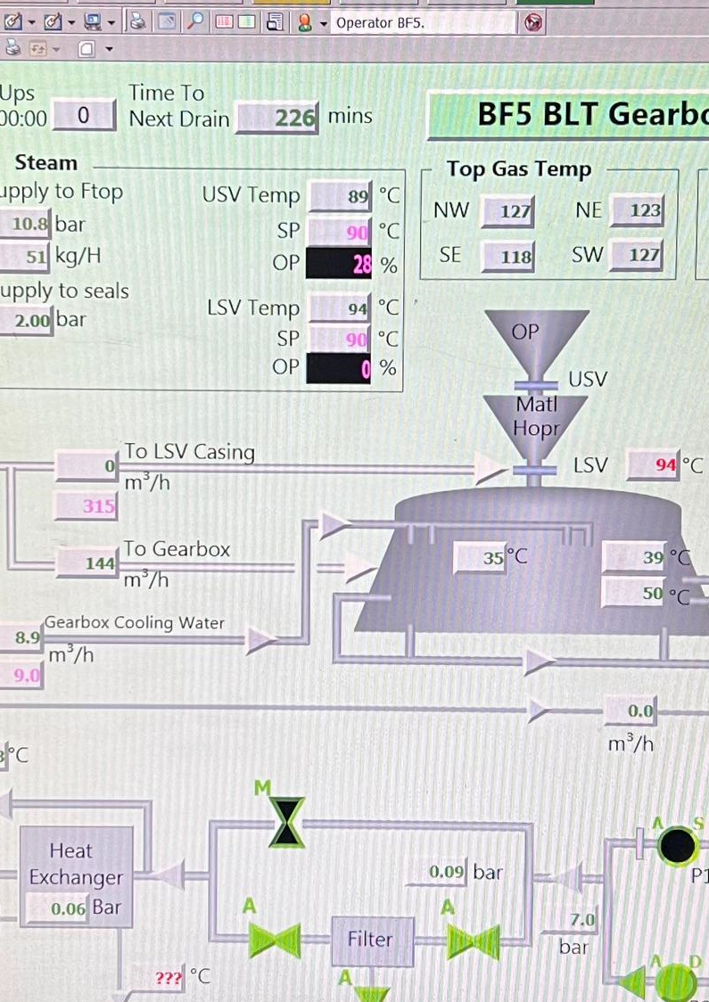
This image shows a screenshot of the Gearbox cooling operating screen on Blast Furnace 5. As seen in the screenshot, the USV and LSV are illustrated above and below the material hopper. On the left of the image, the nitrogen supply to the LSV casing is shown as ‘0’, this is because the temperature setpoint is set at ninety degrees Celsius, which it is slightly over (shown in red on right of image), once the temperature is five degrees over the desired temperature setpoint, the nitrogen will be introduced in order to cool the valve casing at a volume of three hundred and fifteen metres cubed per hour which can be altered by the operator on the left of the screen.
Maintenance Review
As previously explained, the Lower Seal Valve is internally cooled by nitrogen as way of preventing any damage that could occur from overheating of the valve, the continuous supply of steam is used to prevent corrosion of the section of valve that is open to the furnace. However, due to the use of this valve on the Blast Furnace, it is critical our maintenance engineers understand ways in which we can prolong the valves life cycle through preventative but also reactive forms of maintenance. This could include changes of components on the valve, lubrication and planned inspection.
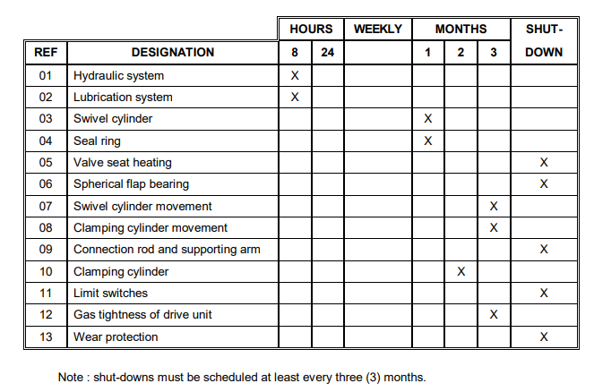
Ref 1

Based on the maintenance manual given to TATA Steel by Paul Wurth, the manufacturers of the Lower Seal Valve, this inspection plan must be followed by TATA to therefore prevent unknown faults with the valve. It shows each component of the Lower Seal Valve and how often maintenance engineers should inspect them for faults that could affect production. This therefore gives clear instruction on when to plan for certain inspections and also the timescale in which we will likely begin to notice wear on the valve.
Some key inspections that are outlines in the maintenance plan are that we must check all fittings and hoses on the lubrication and hydraulic system, this is to prevent leaks and also to maintain hydraulic pressure due to the risk of lost hydraulic pressure causing the inability to operate the LSV. Seal ring inspections must also take place to provide the valve with a secure seal in order prevent hydraulic and lubrication leaks onto other equipment on the furnace top. Maintenance engineers would also inspect the movement of the cylinder on the LSV to ensure it operates smoothly. Another critical planned inspection would be the checking of limit switches which would directly connect to the VDU screens in the control room on the SCADA system which allows the operators to see the movement of the valve and also the time in which the valve takes to open and close which can sometimes help with fault finding, therefore the maintenance and inspection of the limit switches to ensure they are positioned correctly, wiring and connections are in good condition and that the open and closed limits are displayed clearly in the control room is key. Finally, another example of inspections or preventative maintenance in which we carry out on the LSV would be the inspection of the wear protection condition. This would include the inspection of the steam supply system which as previously mentioned deters any dust build up which could corrode the valve. This would also be the inspection of the nitrogen supply lines to check for leaks, not only would this be due to the wear on the valve but due to the danger surrounding a potential release of an asphyxiant gas but also the cost of the nitrogen we are purchasing to cool the valve.
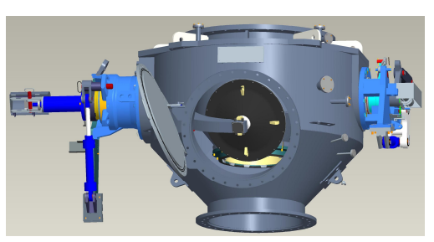

Ref 1

Due to the criticality to production this asset has on the blast furnace, there are never any planned changes to the components as this would halt production. Therefore, we rely on inspections in order to give us information on what changes are required on the valve when a planned furnace stop is occurring, although this obviously depends on the outcome of the inspection as more important aspects to the valves operation for example, the hydraulic system, that may require work will require a furnace stop instantly. Some examples of maintenance we would carry other than general inspections would be manual lubrication of joints on the valve, tightening of fittings on the hydraulic system and the change of hoses.
This method of maintenance has been chosen purely based on where the asset is in line with production. Due to this being essential to discharging material into the furnace this is the best type of maintenance. This is because ironmaking is dissimilar to other production methods where there may be a back up of a certain asset on the line which would not directly stop production if it is changed etc. Therefore, this method of maintenance that is chosen doesn’t effect production and if the asset requires work it can be carried out on an opportunity stop where other work can take place around the furnace. This chosen method is essentially breakdown and preventative maintenance, breakdown in terms of the valve itself that is open to the furnace being left until stop days to be inspected so if it were to fail when the furnace is on wind then we would have to stop production, however, in relation to preventative maintenance, the valve is inspected as per the inspection plan and any small changes like small leaks can be given a temporary fix until an opportunity stop.
Maintenance evaluation
On the one hand, using this method of preventive maintenance through the use of planned inspections and small fixes if required, we are able to maintain this asset and also maintain a good production rate, this enables us to acknowledge of failing parts and to plan to change them on a stop day, or if we are able to fix them with the furnace on we can. We can also use this method of maintenance in order to understand any patterns in failing parts, whether something in the production process is affecting the asset to point of continuous component failure due to having this fixed plan of inspections. Another benefit of our current method of maintenance is that by having preventive maintenance in place, we are able to stop any smaller engineering problems and fix them before they become large problems which can stop furnace production and most importantly have the potential to make an unsafe working environment, an example of this would be the prevention of smaller leaks on the hydraulic system which could lead to a loss in hydraulic pressure and therefore the inability to operate the Lower Seal Valve.
On the other hand, due to not being able to inspect the section of the valve that is open to the furnace, makes it difficult to understand how worn it is and how we can maintain the integrity of the valve as the only ongoing wear protection we have is the steam and nitrogen system to the valve. This could be seen as breakdown maintenance in terms of the section of the valve that is open to the furnace as we can only repair it on a stop day where we suspect it has failed.
An example of an improvement to our current maintenance would be how we can inspect the current state of the Lower Seal Valve. Temperature could be used as a sign to tell us if the LSV is worn, a thermocouple could be placed on the LMG (Lower Material Gate) which is above the LSV on the furnace top which could indicate that the LSV is letting more temperature through a worn section of the valve that is open to the furnace, this could also indicate that the nitrogen supply isn’t being supplied to that section of valve. This would give engineers an indication of how long we are able to use the valve prior to complete failure and requiring a shut down in order to fix it.
Another example of an improvement would be a change to the inspection plan, every shut down the valve should be opened and inspected for signs of wear, by inspecting the valve we are able to understand, as previously mentioned, if we aren’t supplying the correct amount of nitrogen or steam to the valve that is causing the wear. Other sections of the valve should also be changed during this period if they are showing signs of wear, rather than waiting for them to start affecting the valves movement for example, seals and gaskets, clamping and swivelling cylinder.
Cost
In regard to the potential cost of these parts, this could be expensive for the business however it would save more due to the less downtime in order to repair the valve. The first improvement would cost around £3000 to set up a thermocouple on the Lower Material Gate. This is based on the thermocouples cost which I have been quoted by the engineering department. The thermocouple would cost around £200 however we would then require a specialist contractor in order to fit it to the LMG.
The second improvement would mainly require time cost rather than monetary cost due to the manning required to change the valves components and fully inspect the interior of the valve. This could take up to twelve hours to complete with the furnace off wind, however, this type of work should be undertaken when there is larger work being carried out around the furnace which is keeping the furnace off rather than keep the furnace off for an inspection, which would not totally be required if the first improvement was implemented.
Conclusion
To conclude my findings on this assignment, after gaining information on how we maintain one of the most critical to production assets on site, I have gained an understanding that the majority of maintenance we carry out on this valve is preventive maintenance through the use of planned inspections and small fixes on the different components of the valve and on rare occasions we rely fully on breakdown maintenance in order repair the valve and restart production purely based on the application of the valve within the blast furnace.
From my improvements, they can be categorised into short term improvements, long term improvements and also medium term improvements. The long term improvement would be the installation of a thermocouple to the LMG which would give us understanding of the wear situation on the LSV, however this is a long term project and could take an extended period of time to plan on where to place this thermocouple. The short term recommendation would be the start of regular internal inspections of the Lower Seal Valve in order to prevent breakdown maintenance and loss of production. Then, the medium term improvement would be in the introduction of regular changes of the Lower Seal Valve’s components even they are not fully worn, again, to prevent the risk of required breakdown maintenance and shutdown. This is classed as a medium term in my opinion as management would require a full cost benefit analysis in order to understand whether this method of maintenance is beneficial to the business and the blast furnaces production.
References

- Paul Wurth Incorporation manual “Maintenance – Lower Seal Valve Type CF-LSV-SH-ND900”
- Christer, A.H. and Whitelaw, J., 1983. An operational research approach to breakdown maintenance: problem recognition. Journal of the Operational Research Society, 34(11), pp.1041-1052.
- Kajko-Mattsson, M., 2000, October. Preventive Maintenance! Do we know what it is?. In icsm (pp. 12-14).
- Dutta, S.K., Chokshi, Y.B., Dutta, S.K. and Chokshi, Y.B., 2020. Blast Furnace Process. Basic Concepts of Iron and Steel Making, pp.51-68.
- Sahu, M. and Shekhar, S., Sealing Valve Bell Less Top Blast Furnace Increasing Productivity.
- Swanson, E.B., 1976, October. The dimensions of maintenance. In Proceedings of the 2nd international conference on Software engineering (pp. 492-497).

