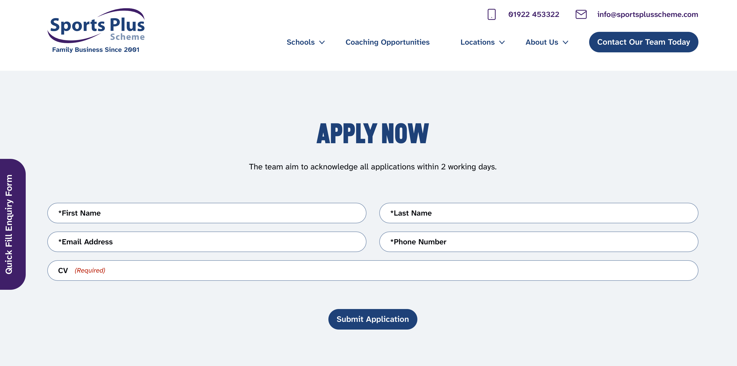

ROSHANE GORDON
Sports Coach Applicant | Dudley, West Midlands
Phone: 07… | Email: Roshanegordon60@gmail.com

Personal Profile
Highly motivated and enthusiastic aspiring sports coach with a keen interest in sport, exercise, and the development of people’s sporting ability. My goal is to run positive and safe sessions that allow participants to gain confidence, develop skills, and enjoy being physically active. I know the value of communication, preparation, teamwork, safeguarding, and modification of the activity for different levels of ability.

Key Skills
- Communication: explain activities clearly and listen to participants.
- Teamwork: work cooperatively with other coaches, teachers and staff.
- Organisation: prepare activities and equipment and manage time effectively.
- Motivation: encourage participation, effort and confidence.
- Safety awareness: check activity areas and equipment, follow instructions and report hazards.
- Adaptability and inclusion: adjust activities to suit different ages, needs and abilities.
- Athletics and sport: interest in developing fundamental movement skills and sports technique.

Education and Qualifications:
University Of Wales Trinity St Davis — Business Skills for Workplace
January 2026 – November 2026
Relevant study: GCSE Sport – Level 2 distinction, Level 1 Assistant Coaching
Coaching / first aid / safeguarding qualifications: Level 1 Assistant Coaching September 2026, First Aid Training August 2026 – August 2029, Willing to undertake relevant training.

Experience:
Junior Athletics Assistant coach — Wolverhampton and Bilston Athletics Club | August 2026-September 2026
- My role at this club was to organise and deliver activities/ drills to the children daily. I laid out cones and mini hurdles and explained clearly to them how to undergo the task, answering any questions they had. As they did the activity, I would express support and demonstrate if necessary.
- When the children did not fully understand the instructions given, I would explain again or maybe even demonstrate if they needed it. If some found it to challenging, I would slightly adjust the drill to. Beginner friendly version until they progressed.

COVER LETTER:
20 Monsal Avenue, Wolverhampton, West Midlands, WV10 FTD
Roshanegordon60@gmail.com | 07387523131
18.10.26
Recruitment Team
Sports Plus Scheme
Dear Recruitment Team,

I am writing to express my interest in the Sports Coach opportunity with Sports Plus Scheme in Dudley. I am enthusiastic about sport and athletics and would welcome the opportunity to help children enjoy physical activity, develop their skills and build confidence in a positive environment.

I believe an effective sports coach needs to be encouraging, organised, patient and clear when giving instructions. I would aim to make sessions enjoyable and inclusive, adapt activities to suit different abilities, and encourage every participant to take part and improve. I also understand that safety must come first: activities and equipment should be checked, instructions followed, and any concerns or hazards reported promptly.

Through my experience at Wolverhampton and Bilston Athletics Club, I have developed communication and leadership skills. For example, I instructed children in drills which they were able to execute with no issues. These skills would help me work constructively with children and colleagues. I am also willing to complete any relevant training required for the role and to follow the organisation’s safeguarding procedures.

I would appreciate the opportunity to discuss how my enthusiasm, willingness to learn and commitment to safe, inclusive sport could contribute to Sports Plus Scheme. Thank you for considering my application.

Yours faithfully,
Roshane Gordon.

