Problem Solving and Decision Making

Student name | Miloud Dguigou
Student no | 1814060
Module title | Problem Solving and Decision Making
Module code | BMSK4004_LON
Lecturer Name | Afzal Munna

Table of Contents
Introduction 3
What is favoritism 4
My experience of Favoritism at workplace 5
Scope of the problem 5
Impact of the issue 6
Analysis on the problem 6
Steps to problem solving 7
The decision making process 9
Types of decision 10
Factors affecting decision making 12
Ingredients of good decision making 13
Fishbone analysis 13
The solutions 14
Evaluation 14
Plan for implementing the solution to the issue 15
Monitoring the implementation of the plan to solve the problem 16
Conclusion 17
Reference 18

Introduction
The business organizations face a lot of challenges. These challenges are often related with the business operations rather than being an issue that is connected with external sources. But whether it’s an internal or external issue, a problem is always something that organizations have to solve no matter where it comes from, in order to balance the organizational activities so that the organization can maintain its performance and does not fall behind in the competition. But this does not mean solving a problem related to organization is easy. In any kinds of problems, the management of the organization has to look really close into a problem and then come up with various alternatives to solutions in order to find the most appropriate strategy that eliminate the issue from the workplace. So this means that the management has to make use of relevant tools in order to achieve this. With enough analysis on the problem and its causes, the management can solve any issue within or outside of the organization. This report will discuss about the specific problem within Oktra, an office interior designer service in the United Kingdom which is the organization where I work as an executive. The main issue that Oktra is facing is favoritism which leads to employee dissatisfaction and performance issue, therefore, this report will explain the issue in details in order to analyze the problem and then identify range of solutions that can be implemented in order to improve the performance of the staffs in workplace.

What is favoritism
The term favoritism refers to the behavior of giving benefits to an individual or groups while ignoring others who also have the right to receive the benefits as well. In other words, the favoritism can occur in workplace when an individual, for instance, decides to do favors for someone based on things such as their relationship, characteristics etc. instead of favoring someone else in workplace who probably meet the same qualifications or even exceeds, but is not liked by the individual. This type of attitude in workplace is known to cause a lot of issue such as employee dissatisfaction which affects their performance (Graetz et al., 2011).
Advantages of favoritism
- It can motivate employees to show better work so they could gain more favors
- It can help individuals with their career development.
Disadvantages of favoritism
- It creates an unfair environment in workplace
- It causes conflicts between individuals in workplace
- It neglects talent and causes talented individuals working for the organization to become unhappy, thus affecting their performance
- It hinders organizations to promote career development for other employees who are not under the favors of management (Hermitage, 2018).
- It can cause turnover for organizations due to continuous unfair treatment in workplace (Dundoon et al., 2007).
- It promotes negative politics in workplace.
Resolving favoritism
Favoritism can be resolved in workplace through different ways. These strategies are as follows:
- Before accusing someone, management should look into evidences
- Confirming speculations in workplace
- Ignoring rumors and implementing policies to stop employees from creating rumors in workplace (Johnson et al., 1998).
- Being fair with every individual based on their performance, skill, and knowledge; while ignoring any relationship in workplace.

My experience of Favoritism at workplace
Any organization involved in business rely on performance. Whether it is the performance happening inside the organization or related to activities such as marketing that is external activity of the organization, any activity related to a business organization means there are staffs involved and staff performance is connected with the operations of the organization in the market (Freeman, 1984). Usually organizations set a goal for each operation that the staffs working for their department has to fulfill in order to reach the organizational goals. Every time staffs perform their jobs properly; the outcomes bring the expected profit to the company. However, when the performances are not good for any reason, this can significantly affect the result of the operations of the company, which can also negatively impact on the goals and objectives that management has set for the staffs in workplace. Performance issues, if not maintained well enough, can lead to serious damage to the reputation of the company. Also, continuous lack of performance means there are likely serious causes behind this in the workplace which can slowly bring new problems such as employees leaving the job, resisting any change, conflicts and many other issues. One of these issues is the Favoritism.
In Oktra, I work as a Supervisor, so based on my experience, the company has been recently facing a lot of performance issue. And the major cause behind this is the favoritism in workplace. The company has the service of designing office interiors for other companies, therefore, meeting client expectations is important. However, the company is facing some issue in terms of the performance from the staffs and this is causing the company to lose some clients due to poor service. And the major reason behind this was found to be the favoritism that takes place between some of the employees and management or team supervisors. It has been affecting the sales of the company, thus an immediate solution to this is required.

Scope of the problem
The main issue here is that there is a culture of favoritism that has been developed in the workplace of Oktra which is the reason employees are giving some negative performances. This is happening for various reasons. The main issue that the staffs have complained about is the lack of organizational culture, and negative use of politics. There are also issues related to employees not having the mentality to work as a team when they are put into a group for relevant projects that require teamwork. They are engaging in conflicts or are not listening to their supervisors because of the favoritism from supervisors towards some of the staffs while the supervisors tend to not listen much to other members.

Impact of the issue
The issues that have been mentioned seem to be slowly affecting the performance of the staffs. The absence or number of leaves of the employees have increased. Some employees have also quit the job. So the organization is losing workforce and this is affecting its performance. The company has made poor sales from its service due to staffs not working properly to meet the client expectations. The office interior design requires creative approaches, but there is hardly any creativity being implemented by the creative department of the company and clients are looking towards other similar companies that provide such service due to not being able to get suitable ideas from staffs working here. The favoritism in workplace has caused performance issues which in turn have affected the service in ways that it led to company getting some negative reviews.

Analysis on the problem
When companies have a situation within or outside of the organization that is affecting its business in the market, it’s important for the management to identify the issues behind the main problem in order to analyze the issues for getting ideas on how these issues could be solve through necessary strategies (Schriek et al., 2017). The strategies essentially are used by the management to make effective approaches. Without analyzing the issues, strategies cannot be formed due to management not being able to make decisions simply from observation on the issues. That is why management at Oktra has to look into the issue in details.
The main issue at the moment is the favoritism among employers and employees at Oktra which is affecting the performance of the staffs and there are couple of other issues that seem to be the cause behind this. First of all, it has been previously mentioned that the workplace of Oktra do not maintain a specific culture that is positive and there seem to be use of politics in the workplace. This means staffs are likely in disadvantages and are facing issues in setting the mindset to work with others willingly, which leads to the issue of not being able to work as a team, therefore, conflicts are always there. The supervisors are the ones who seem to be using their power to force staffs to work and only listen to people whom they are in good terms with, and this is causing other staffs working in the group to not listen to what the supervisor orders them to do as the supervisor also seem to ignore them when they want to share their ideas or opinions. All of these issues that are causing the negativity among staffs in workplace have been further reinforced by the lack of care that has been given to maintain the office of Oktra. So these are causing the employees to be not feeling motivated to perform well in workplace as they do not value the organizational goals and objectives. There are careless attitude and it is the reason for the company to be facing poor sales in the market as the company kept losing its client.
In order to combat such issues, the management at Oktra has to work to develop strategies that can eliminate the favoritism practice in workplace and could possibly improve the motivation of the employees, as their performance seems to be not going well due to lack of motivation that is been caused by favoritism towards some of the staffs in workplace. So there are couple of solutions that can be implemented by the management to improve the performance of the staffs in workplace.

Steps to problem solving
When there is a problem, there are ways to solve the issue as well (Neely et al., 2002). And this applies to the workplace scenario as well and that means Oktra can make use of problem solving steps to eliminate the issue of the favoritism in workplace to improve the performance of their employees and create a positive work culture where everyone gets fair treatment based on their performance and contribution; not because of their relationship with individuals working for the company. The problem solving steps consists of the following steps:

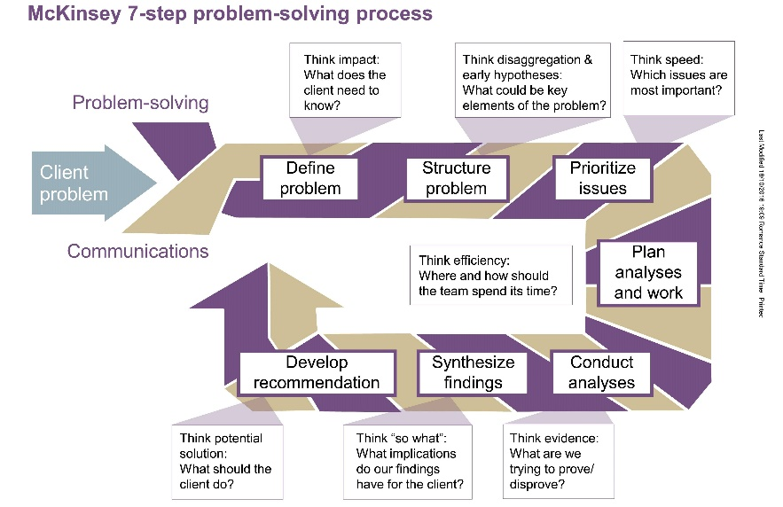
Figure: Problem solving process
The above figure from McKinsey’s model shows the steps to problem solving. It starts with defining the problem which indicates the main issue. In case of Oktra it would be the favoritism in workplace. Then it is important to structure problem where the issues behind the main problem could be identified. After that, management can prioritize issues that are most important or relevant to the major problem and then plan analyses and work initiates where management can plan possible actions to combat such issues based on their evaluation of the issue (Morgan, 2016). Then the management will have to again conduct analyses of the evidences at hand related to the issue and then they need to synthesize findings to evaluate their findings comparing with the possible solutions that management thought of before and then recommendation on the solutions that are most suitable for solving the problem. This way the management at Oktra can solve their issue which is the favoritism n workplace.

The decision making process
The decision making process is a term that indicates actions involving plans for solving certain issues. In terms of organizations, the management is responsible for such actions and their decisions allow them to manage any situation that is affecting the activities of the organization. In order to effectively make decisions, there are a couple of tools that help the management to identify what they are good at and what their limitations are (Weber et al., 2010).
Below is a SWOT analysis for Oktra that shows their strengths, weaknesses, opportunities and threats in terms of the performance issues. The SWOT analysis is one of the problem solving tools that can be used to analyze the position of the company that can help management to see what they need to be doing and how they can do it. It has been used for Oktra as well in order to understand their issue.
Strength | Weakness
- The company has a good reputation as office interior designer because of their previous records of quality service from creative staffs  - The company has good number of employees who have the right skills and competencies to fulfill the job requirements | - There isn’t enough motivation among staff due to favoritism in workplace which has been affecting their performance  - The workplace has poor office environment  - There are complaints on politics among staffs  - Supervisors in teams have shown some negative behaviors towards people who they do not favor which is causing conflicts  - There is no motivation to work as teams in the organization
Opportunity | Threat
- The management have number of solutions that can be implemented to solve the issues  - Most of the issues can be solved by taking actions that can promote fair treatment in workplace which can help management to ensure the motivation of the staffs and by doing so the management can retain the expected performance | - The company is losing valuable staff due to the issues happing in workplace and the existing staffs are not performing well, leading to the organization getting really bad results from their operations  - The performance at the moment is not good which is the reason clients are looking towards other companies in the market.

Types of decision
So the company has to make necessary decisions. The solutions have already been proposed. However, it is up to the management to use the best solution that fits with their current issue. Oktra can take decisions based on two forms of decision making processes. These are known as rational or creative.
The rational decision making involves evaluating a problem by defining the issue, gathering relevant data, generate, evaluate and choose options and then implemented the most appropriate option. The creative decision making involves taking decisions using less structure way and can often be used for finding better solutions. However, for the case of Oktra, the rational decision making would be appropriate as often times following structured decision making seems to work for companies and Oktra at this moment depends on rational decisions to solve the performance issue rather than using creative approaches to come up with solution.
However, aside from rational and creative decisions, there are major three types of decisions that also come into play. These are routine decision, adaptive decision, and innovative decision.
Routine decision would be applicable when companies face a common issue that can be solved with the most common strategies. This is the simple decision to implement and is pretty common that companies almost always go through this decision in workplace. The adaptive decision is applicable when a problem is uncommon and the solution is uncommon as well, but are not something new for management to not understand it completely. This kind of situation occurs for organizations few times. The innovative decision is where the management might be completely unclear of the problem, therefore, the solution to such issues might have to be formed through creative approach as well. This kind of situation can occur rarely, but it can sometimes pose serious issues for companies and might not be solved through usual strategies for most of the common problems.

Factors affecting decision making
When it comes to decision-making, there are some common factors that can affect the decision phase of the management. These include experiences and knowledge. Past experiences of the management and their knowledge in workplace can affect the decision of the situation.
Creativity also comes into play when a decision is required for taking creative approach to solution.
Stress can affect the decision. Most of the time negatively. If there is a time limit for making decision, it can affect the decision of the management as they could have time to take a decision based on a lot of analysis and evidences while not being able to analyze anything out of rush if they are on a time limit for the decision. Other aspects could affect decision either way:
Financial aspects can positively or negatively affect the decision.
People involved in the decision also have the energy to make effective decision.
Risks associated with the decision can affect it as well.
Organizational values can also affect the decision.
Availability of data can also affect how good the decision would be.
Necessary support from stakeholders and other parties can also result in taking good decisions. Lack of support means company might have to choose options that could not be netting the expected outcome.

Ingredients of good decision making
Usually a good decision consists of some ingredients that make it viable for management when they consider implementing the decision within the organization which include –
- Following the basic systematic process of problem solving
- Making sure that there are multiple people working as a team to make the decision
- Delegation within the decision such as routine decision
- A lot of brainstorming for finding alternatives
- Taking creative approaches rather than going with usual strategies just to avoid the stress
- Being objective when taking a decision and not focusing on showing emotions when taking the decision. It is crucial to focus on the main problem and how to get rid of the issue

Fishbone analysis
The fishbone analysis is a tool, relevant to the cause and effect diagram, that allows management to identify the main issue, which is considered as the effect, and then look into the causes behind the effect that they have identified. The effect is pointed out with a straight arrow and then from this arrow, multiple branches are formed that represents the main cases behind the effect. Each cause also comes with its sub-causes that further explains the occurrence of the major causes behind the effect shown in the diagram by the management (Wren et al., 2005).
The fishbone analysis for Oktra in terms of their issue with favoritism would look like the following –
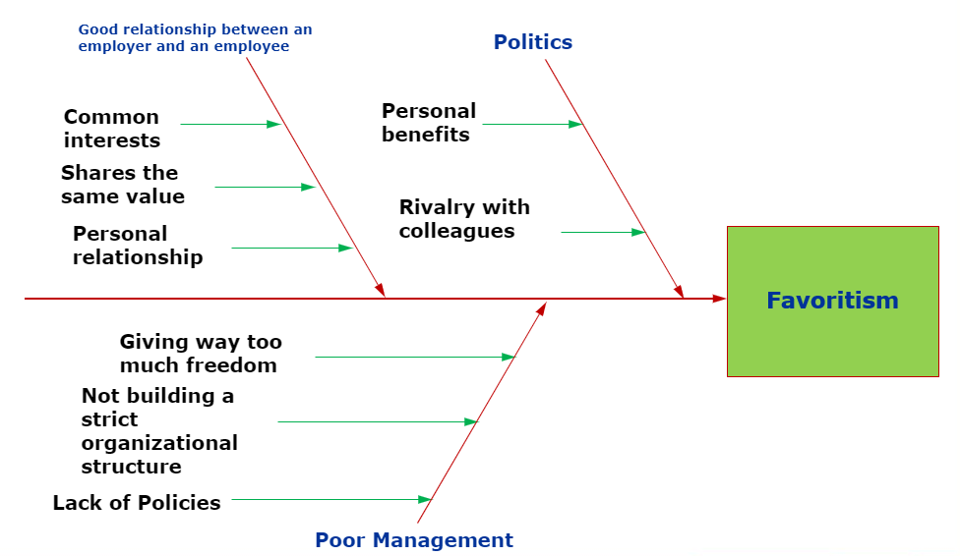
Figure: Fishbone analysis of Oktra

The solutions
The following solutions can be considered by the management to help them with their decision making process so they could identify the best alternative solution that can be taken to improve the performance of the staffs working at the Oktra.
- Implementing a performance management software that can keep records of the staffs in the workplace. Each team working at the company has to submit the report of their tasks everyday by using the software. The supervisors assigned to the various team can be given this duty. By doing so, management can identify which employees are performing the worst and can communicate with that employee to talk about what issues they are having.
- Set strict policies to free the workplace from politics. Staffs can be supported to report any behavior when they see it and the management should inform the staffs as well as supervisors working with the work teams about the actions against such behaviors in workplace.

Evaluation
The first solution that was suggested was that management needs to be implementing a performance management software for keeping records of the tasks of the employees. Most employees feel that their performance isn’t being reviewed properly due to the favoritism among the supervisors and even in the management. So in this case, the application of a performance management software for record keeping can be viable for maintaining an unbiased work culture where every performance of each individual in workplace would be based on the records in this software that have been inputted but the employees themselves. However, management does have to assign a reliable manager to manage the software and its records who would be responsible for keeping it private so that no modifications can be done to the records.
Another solution that can be taken is rather simple but can be very effective which is to change the organizational policies that specifically promotes the withdrawal of favoritism in workplace. If the management can set some serious penalties for people who conducts this attitude even after the implementation of the policy, then this can set examples for people working for Oktra to see that the top management of the company would not tolerate such attitude no matter what position they have in the company.

Plan for implementing the solution to the issue
Among the solutions that have been proposed to the top management of the organization the most relevant would be changing the existing company regulations of the firm to have some policies against the favoritism within the workplace and applying serious penalties if anyone found guilty with this.
So now that the main solution has been chosen, it now has to be applied using the implementation plan. This term indicates the process that consists of stages to go through that would allow the strategic plan to be implemented in action so that the objectives can be achieved with this. There is no specific way of implementation plan. The implementation plan can vary depending on the strategy and the objectives that the strategies would try to achieve though the plan. An implementation plan would be necessary for Oktra. This is because without an implementation plan the company will not be able to reach their objective. So if Oktra wants to eliminate favoritism from the office, then it has to form an implementation plan to apply their strategy which is to reform their policies and set penalties for such behaviors in workplace.
Below is the implementation plan for the chosen strategy that would be applied by the top management at Oktra.
Figure: Gantt Chart of implementing reformed policies to stop favoritism
The Gantt Chart is a tool that allows management to break down entire larger task to form smaller tasks that can be helpful to prioritize on what tasks need to be completed first and then putting each task in separate time limit in order to ensure that the entire task could be completed and the management could reach their objective with this (Radwan, 2000). In this case, the Gantt Chart has been used for implementing the plan. The Gantt Chart shows that it would take 10 weeks to fully implement the plan.

Monitoring the implementation of the plan to solve the problem
The Gantt Chart shown above gives a good idea of how the plan will be implemented in the workplace. This chart will also be used for monitoring the progress of the project. The chart shows that it should take 10 weeks for Oktra to implement their reformed policies to prevent favoritism in the workplace. So based on the chart, the management will maintain the time limit of each task mentioned in the chart so that they could maintain the tasks and complete the implementation plan within the time limit while also communicating with the stakeholders (Greenwood, 2001). This is because they are also responsible for supporting the company, therefore, the management has to also notify them about the changes. If any issue occurs after the implementation of the plan, then the management will have to further make changes until at least within three weeks after the implementation of the plan the issue could be mostly resolved. Punishments would have to be discussed with stakeholders as well and need to be implemented if anyone fails to comply with the new policies within the monitoring of the management. If the plan goes successful, the top management will have to continue monitoring the policy so that favoritism could be completely removed from the workplace culture.

Conclusion
The workplace culture should be free of favors as this can hurt the motivation of the employees and can cause the organization some serious issues with the performance. The favoritism is a common aspect in almost any organization, therefore, there are solutions to prevent such issues occurring in workplace as well. However, solutions tend to vary depending on the organization. And for an organization like Oktra which is involved with creative interior designing for other companies, not every solution would be viable due to the costs. This is why the suggested plan for the company is likely going to be successful and the company should be able to mitigate the favoritism from the workplace. There are many other things that can be done to prevent such issues, but sometimes the simple rational decisions can help companies to tackle issues like this. So this is applicable for Oktra if they could maintain it. This way they would be able to improve the workplace for the employees where the workplace culture would be free of favors and would rely on the contribution of employees.

Reference
Freeman, R. (1984). Strategic management: A Stakeholder Approach. p.25.
Graetz, F., Rimmer, M., Smith, A. and Lawrence, A. (2011). Managing Organisational Change. 3rd ed. Brisbane: John Wiley and Sons Australia, Ltd.
Greenwood, M. (2001). The Importance of Stakeholders According to Business Leaders. Business and Society Review, 106(1), pp.29-49.
Hermitage, S. (2018). Quality Management IBA 305. Unpublished Manuscript: Griffith University, pp.13, 14.
Johnson, G. and Scholes, K. (1998). Exploring corporate strategy. Hemel Hempstead: Prentice Hall, p.155.
Maund, A. Schriek, M. and Tinkler, P. (2017). Certificate in Higher Education: Skills for the Workplace Student Yearbook. Sage Publications
Mills, J., Neely, A., Bourne, M., Richards, H. and Platts, K. (2002). Strategy and performance. Cambridge: Cambridge University Press, p.1.
Morgan, P. (2016). The Business Student’s Guide to Study and Employability. Sage Publications
Polo, E. and Weber, W. (2010). Competitive Generic Strategies Evolution and the Importance of Michael E. Porter. Revista de Gestão, 17(1), pp.99-117.
Radwan, A. (2000). Computerised dynamic Gantt-chart for maintenance scheduling and management. International Journal of Computer Applications in Technology, 13(3/4/5), p.251.
Rollinson, D. and Dundoon, T. (2007). Employee relations. Maidenhead: McGraw-Hill Education.
Wren, D. and Wren, D. (2005). The history of management thought. Hoboken, N.J.: Wiley.

