Knowledge and Information

Management Skills for the Workplace

STUDENT NAME: ALINA NICOLETA MACARIE
STUDENT ID: 1713499@studentuwtsd.co.uk
MODULE: BMSW5006_LON
LECTURER: TANJA NATHAN

Table of Contents

Introduction: 1
1. Evaluating the concept and importance of knowledge management in terms of an organization’s knowledge assets and their management: 2
2. Understanding the key knowledge management processes required for organizational development: 9
3. Developing a framework for establishing a knowledge management culture: 13
Conclusion: 17
Reference: 18

TABLE OF FIGURES
Figure 1: Knowledge assets 3
Figure 2: Relationship among data, information, knowledge and wisdom 5
Figure 3: DIKW Model 6
Figure 4: The Graphic Map of Knowledge Management 9
Figure 5:Knowledge Management Process 11
Figure 6: Information Life Cycle 13

Introduction:
The world is now running depending on information and whoever possesses the most information nowadays always has the chance to dominate the specific sector regarding that information (Vellai, 2019). People are now living inside a pond of information where it is making life easier and competitive day by day. This also happens for the business industry as well and this report will demonstrate the importance and concept of knowledge management regarding a specific business organization. For analysing and explaining different factors of knowledge management and knowledge assets, Aston Martin is undertaken to be the relevant organization and each discussion regarding knowledge and information management skills for the workplace is also interpreted on the context of Aston Martin also. Aston Martin is a public limited company which started its activities in 1913 in the UK. Total revenue for the company in the year 2018 was £1,096.5 million and operating income was £146.9 million respectively (Surbakti, 2019). The company also maintain two brand names and those Aston Martin and Lagonda.

1. Evaluating the concept and importance of knowledge management in terms of an organization’s knowledge assets and their management:
Organizations respective to every business industry are now much more dependent on knowledge and information than any other external factors. The importance and concept of knowledge management and the proper utilization of knowledge assets is the key factor for any organization to gain long term success and competitive advantage. Knowledge assets are the intellectual resources, information, other elements that are possessed and exercised by the employees and other stakeholders of an organization (Valentine, 2019). The importance and concept of knowledge management are supposed to be discussed in term of Aston Martin’s knowledge assets and management. It can be concluded that Aston Martin is a very well-known and luxury brand of the UK which is conducting their business across the whole world and the company is highly dependent on its knowledge assets and their management for achieving success for the last couple of decades.
The term knowledge assets are the combination of a variety of assets, factors and elements what help and coordinate other things with the working process of business such as workforce, database, documents, guides, policies, software, hardware, data and information, patent etc. Knowledge assets are basically the “know how” that is used and exercised by organizations and the term also attains the necessary elements which are available to use, to invest and to grow organizational activities in broader perspective with the proper knowledge management practices (Surbakti, 2019). Proper knowledge asset management is necessary for organizations in a specific industry. As, Aston Martin is one of the most luxurious car manufacturers in the world along with the UK, proper knowledge asset management is very necessary for the organization to meet stakeholders’ interest and organize the key components of the organization for creating values. Thus, knowledge assets and its management are required for the organization and the organization also needs to evaluate the components of knowledge assets for sustaining long term competitiveness and organizational success.
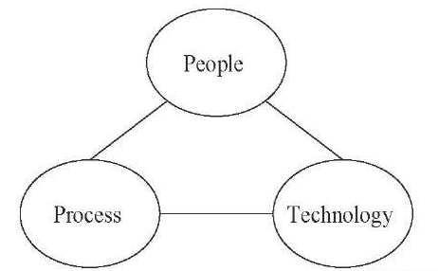
Figure 1: Knowledge assets
Source: (Surbakti, 2019)
The factors of knowledge assets and its management are the combination of different organizational elements such as workforce, database, documents, guides, policies and procedures etc. But the deeper perspective of knowledge assets defines the intellectual properties or resources of an organization which are also controlled and maintained by a very specific method called knowledge management process (Surbakti, 2019). For Aston Martin, it is required to maintain such assets and gain a competitive advantage in the car manufacturing industry. Thus, the organization can introduce and divide the knowledge assets into three parts such as people, process and technology. The proper and effective combination of these asset elements or intellectual resources creates a channel for organizing different knowledge factors and bring organizational success for short and long period. These three elements always help Aston Martin to facilitate huge knowledge creation by using internal and external resources and intellectual properties. Parsons (2017) also claims that there are four different independent variables of knowledge assets which act as an indispensable part of exercising knowledge management in an organization. Those independent properties can be described on the context of Aston Martin and those are experiential, conceptual, systematic and routine knowledge assets.
The experiential and conceptual knowledge assets of Aston Martin are the most experienced and valuable employees of the organization. Experienced employees always have an outstanding impact on the organization for creating policies, formulating strategies and assisting the organization for taking decisions effectively and efficiently (Valentine, 2019). Different types of technologies which are being used by Aston Martin over the course of time are considered as the systematic knowledge variables Basically these technologies always assist the experienced employees to implement their strategies and tasks as well as formulate plans. Routine knowledge assets are another dimension of different processes relevant to knowledge management practices. Basically, this is the part where organizations may get the result of previous knowledge asset experiences which has been done on the context of having and applying conceptual, experiential and systematic knowledge management variables.
The importance and concept of knowing knowledge management has become a key issue for organizations conducting businesses in various industries and segments (Davenport, 2015). The whole process related to knowledge assets and its management are discussed in this report on the context of Aston Martin. Here, it will also provide knowledge management concept, importance and other necessity of it according to the systematic way of practicing knowledge management for organizational context. Knowledge management implies the scientific and systematic process of managing different types of organizational data, information and knowledge and uses those elements for increasing the value of the organization by covering different strategies and policies (Parsons, 2017). The knowledge management practice of Aston Martin demands to include different types of activities and initiatives including initiation, processing, creation, goal setting, strategy making, systematic approach, transmission and demolition of knowledge.
Knowledge assets and its management help Aston Martin in many ways by increasing the understanding level of knowledge for its employee. For example, a proper understanding of the knowledge management increases the efficiency level of the employees of Aston Martin thus they can work more cooperatively for the company and create more values for the organization as well as experience their personal development. For understanding knowledge management, it is required for the employees of an organization to know the primary relationship among data, information, wisdom and knowledge (Valentine, 2019). This is also important for Aston Martin through which the organization will be able to evaluate different information sources perfectly and capture information from different sources continuously.
Tom Davenport (2015) was the first person who introduced the idea and concept of knowledge management in the late 90s. According to Tom Davenport, knowledge management implies the relationship among organizational goals, strategies and managements which help to set up future for implementing new and innovative actions for achieving long term success for the company.
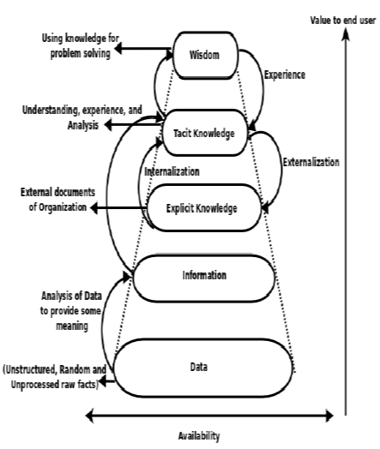
Figure 2: Relationship among data, information, knowledge and wisdom
Source: (Valentine, 2019)
The human mind has a lot of conscious and subconscious variables and these contents can be divided into four different parts such as data, information, wisdom and knowledge (Oz, 2019). Russel Ackoff (2005) was the first one to introduce such differentiations of the human mind in 2005. There are some basic differences among these variables or contents and those differences provide a clear understanding of each content according to their legitimacy inside an organization such as Aston Martin. Different types of random, unstructured and un-purified raw facts are considered as data for Aston Martin. On the other hand, if any data provide any meaning to the organization when it is necessary is regarded as information. If collected data or raw facts provide some meaning or necessity for Aston Martin, it will be recognized as information for the organization. The difference among these factors can be provided with a specific example of Aston Martin such as there is a raw material for the company stored in the storehouse and it is counted as one hundred units after the calculation. The raw material which was laid in the storehouse without counting can be regarded as data and after the calculation the same raw material becomes information.
Knowledge is the bunch of thoughts and rationalisms possessed by specific individuals through personal and professional experiences and wisdom the highest form of intellectuality and knowledge (Surbakti, 2019). Knowledge is the ability to observe things meticulously and draw a decision based on the observation when it is needed. The employees of Aston Martin have different types of knowledge which continuously help them to take the proper decision for the company when it is necessary. Thus, the company also becomes able to take any decision more meticulously than the competitors and gain a competitive advantage soon over the rivals. Wisdom is the last stage of knowledge experience and very few employees of an organization may possess wisdom for using those in term of the betterment for the organization (Liebowitz and Frank, 2011). A DIKW model can be explained on the context of providing the importance of wisdom, knowledge, information and data for interpreting knowledge assets and its management.
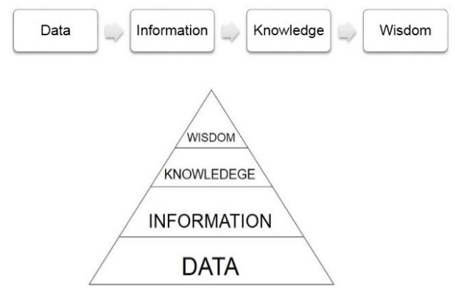
Figure 3: DIKW Model
Source: (Subrakti, 2019)
The formulation of bonding between organizational goals and strategies is very important and it is properly exerted with the implication of knowledge management which also helps the organization to create unbound value for business also (Liebowitz and Frank, 2011). Aston Martin can easily exercise knowledge management practice and properly handle the factors of knowledge assets by setting up standard and benchmark for the organization. The organization may have different sources of information and data to build up proper knowledge management for itself. Aston Martin needs to be very specific about the source of information which also enables the organization to evaluate the dependable source of information and data. For this reason, the company can divide the source of capturing information and data into two parts such as primary and secondary. All the primary and secondary sources of data are dependent on another source such as internal and external sources. Primary sources or internal sources of information and data are the direct sources and flows of information which is experienced and derived by the organization. For Aston Martin, the primary sources of information or data are different proofs of business transactions such as invoice notes, documents, written agreements, sales bills, buying bills, checks received or provided etc.
The secondary source of information and data for Aston Martin is the indirect source such as information which is derived without the intimacy of the organization. The secondary source of data is developed and provided to the company by the third party or second hands such as bank statement, survey data and poll results (Kendrick, 2014). Properly evaluating the different sources of information and data is very essential for companies who are conducting business activities in the same industries because this also facilitates the flow of information and evaluate information and data properly. Knowledge management also helps and enables Aston Martin to exercise proper and relevant knowledge inside it at the same time increasing the understanding level of the employees as well. There are bunches of information for manufacturing companies inside and outside of organizational context, but each information or data may not be equally important (Kendrick, 2014). The importance and concept of knowledge management let the companies know about what important information is and what is not. So, it is highly important for Aston Martin to evaluate information and data properly for using those in an organizational context. The management and policy maker of Aston Martin needs to implement proper knowledge management practices for evaluating information and data.
When organizations can differentiate between important and less important information or data, it becomes easy for those organizations to utilize various information properly according to the need of the organization (Koenig, 2019). This also increases the capacity of knowledge assets of the organization by assembling various knowledge and information from the business surroundings. So, it is very important for Aston Martin to capture and evaluate the most important information, knowledge and data for the company to increase the knowledge assets for the company as well. The company’s several strategy setting and decision-making process is mainly constituted of having several information, data and knowledge. Depending on the collected data, information and knowledge the company becomes able to take a decision which is effective for the organization context (Joyce and Woods, 2011). After discussing and evaluating different facts regarding knowledge assets and knowledge management, it can be concluded that the main objective of knowledge management is to ensure various knowledge assets for the organizations and its employees thus they can ultimately increase the value of the organization.

2. Understanding the key knowledge management processes required for organizational development:
Organizational development is dependent on different factors among those proper knowledge management practice is very important. Knowledge management process is the way through which organizations gather and distribute knowledge for increasing the intellectual property of the organization (Hawarden, et.al., 2018). Aston Martin is a very well-known car manufacturer in the world, its development depends on several factors and knowledge management practice is one of those. According to Hawamdeh (2018), knowledge management is not a single approach or process for collecting, analysing and disbursing information rather it’s a bunch of activities which are required to be accomplished collectively by the management and employees of an organization. The key knowledge management process can be discussed on the context of Aston Martin and it could be worth to say that each component of knowledge management is very necessary to evaluate and analyse for organizational development.
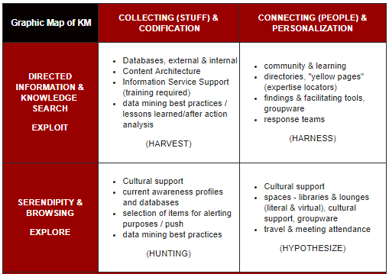
Figure 4: The Graphic Map of Knowledge Management
Source: (Ducker and Maciariello, 2019)
The most important reason for exercising knowledge management practice inside an organization is to provide open communication for all stakeholders (Griffin, 2019). Different analysts, researcher and business persons provide different statements about the knowledge management process but the main objective of the process remains the same and which is to ensure organizational development. According to the given graphic map, how knowledge management work for an organization can be understood in the context of Aston Martin. The given graph is divided into four parts and each part has its own implication which literally leads the company to organizational development. The first implication of graphical knowledge management process was developed by IBM in 1996 and after that, it grabbed the attention of other companies (Drucker and Maciariello, 2019). The components of the knowledge management process can be described considering the graphic map which is done for Aston Martin.
According to the graph, the key components are divided into four parts and those are content management, expertise location, lessons learned and communities of practice. For collecting and assessing the information for inside and outside environment of business, content management is very necessary. It mainly focuses on how the inside and outside environment of an organization formulate the knowledge management process and enhance its activities to a broader perspective. The content management also ensures that intellectual resources such as data, information and knowledge must flow incessantly among the employees of the organization (Dooley, 2019). With the implication of key knowledge management practices, Aston Martin becomes able to ensure that information inside the organization flow continuously which is recognized as enterprise content management. On the other hand, expertise location dictates that the company can collect information beyond its present location and geographic position. It also enables the employees of Aston martin to derive knowledge by discussing with others. Thus, the company becomes efficient in knowledge management practices and ensures the best knowledge practice and knowledge asset for the organization.
It is very common among organizations belonging to the same industry that the best strategy for them may be the same and may be different based on the information and data collected and analysed. For implementing organizational development, the key factors or component of the knowledge management process is interpreted as follows in the context of Aston martin:
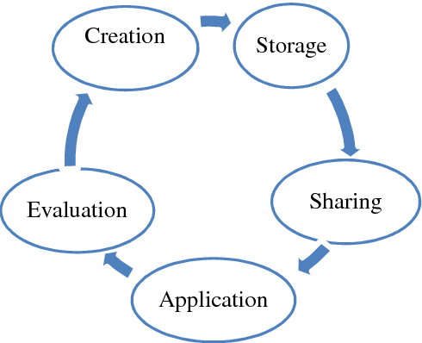
Figure 5:Knowledge Management Process
Source: (Dooley, 2019)
Creation: The first and most important stage of the knowledge management process is to determine how data, information or knowledge of an organization is found or derived from other sources. There are various sources of data and information what business organization can use for having relevant data that has access to business information and requires for development (Beal, 2019). The creation or discovery stage of knowledge also helps the employees and staffs of Aston Martin to understand the necessity of the flow of different knowledge within the organizational context.
Storage: Storing information, data or knowledge dictate the procedure of saving those properties safely and securely for the future purpose (Vellai, 2019). The procedure implies that Aston Martin must contain a proper system of collecting data and information which also facilitates the organizational structure for capturing and assessing data and empowering the knowledge management process. For this purpose, Aston Martin can have both written and stored documents or database.
Evaluation: Evaluation is the process through which the credibility of data and information is assessed to ensure the best utility of differentiated thoughts, ideas and concepts (Parsons, 2017). If any information is discovered in Aston Martin, it will not be concluded as to use for the final purpose rather the different perspective of data and information will be evaluated to sort data according to the importance for specific utility.
Sharing: Knowledge is increased if it is properly shared and nurtured under the proper environment (Oz, 2019). For sharing information and knowledge inside Aston Martin, the organization also needs to adopt different strategies and procedures which will facilitate the free flow of information among the employees and other managerial bodies. To implement the proper sharing of different information and knowledge, Aston Martin also can run different discussion period and session between the employees and the management bodies.
Application: The most important duty of a business organization is to implement the predetermined goals and objectives through which the organization becomes able to increase its value and achieve competitive advantage (Surbakti, 2019). Without the proper implication of the key factors of the knowledge management process, Aston Martin will not be able to meet up its goals and objectives. Thus, the organization needs to implement all the key elements of the knowledge management process. Application is the stage where Aston Martin gets the opportunity to utilize all the relevant information and data accurately and improve organizational development as well.

3. Developing a framework for establishing a knowledge management culture:
The most fundamental requirement of organizational success is to nurture a knowledge management culture inside the company which bring success and development by achieving huge values to the respective industries (Liebowitz and Frank, 2011). It is not enough to know different components of knowledge management without implementing those to an organizational perspective. For this reason, Aston Martin is required to cultivate a culture of proper knowledge management practice. The organization in this context can develop a proper framework which ultimately supports the knowledge management culture. Before making a framework of knowledge management culture, it is necessary for Aston Martin to know several facts regarding knowledge and information management process such as information life cycle, information risk and management, external factors of information management etc.
The information life cycle is the process or method through which proper information is collected and analysed for implementing knowledge management process for organizational development (Navoni, 2019). Aston Martin can use the information life cycle efficiently from the creation of the data to the destruction of the data. There are different stages of the information life cycle which can be discussed in the context of Aston Martin.

Figure 6: Information Life Cycle
Source: (Navoni, 2019)
The first stage of the information life cycle is the creation or acquisition of data and evaluate the proper source of the data effectively. Data can be collected for organizations from different sectors such as it can come from an internal source or external source (Kendrick, 2014). For evaluating the necessity and importance of data or information, it is required for companies to have the proper source of data which can be created or collected. The next stage is the publication of data which dictates the competency or necessity of data for having the relevancy to use for organizational development. Data also needs to be published or shared with others for increasing the credibility of data and the publication of data provides such credibility to the organizations for acquiring different types of information and data simultaneously. The next phase of the life cycle of data is to retain data or information and remove the data after having the proper utility of it from an organizational perspective. As, Aston Martin belongs to the car manufacturing industry, so it is required for the organization to manage data properly and erase the date for not transferring to a bad hand. Organizations must retain data and delete data in time after using and utilizing it for a specific purpose because if any necessary data can go to a wrong hand it can bring harmful consequences for the organization (Kendrick, 2014). Basically, these are three stages of the life cycle of data which is implemented quite properly inside Aston Martin and thus the company is stable to create a strong position in the respective industry as well.
By having the proper understanding of the life cycle of data, organizations become able to mitigate the different risk of information and data by engaging several safety and precautionary measures. In this context, Aston Martin can adopt different initiatives which enable the company to establish a framework for knowledge management culture. Some important parts for incorporating such initiative is demonstrated as followed:
Know the worth of knowledge management and accept it as a strategic initiative:
Incorporating standard knowledge management must be an initiative which can support overall organizational development by engaging all the stakeholder into centre point to the organization (Joyce and Woods, 2011). Knowing the actual value and worth of knowledge management is also very necessary for the employees and management bodies of an organization which are conducting business in the manufacturing industry such as Aston Martin. Knowledge management is not only a process of engaging employees to different knowledge related tasks but also it requires cooperation from the management and other stakeholders also. The proper implication of knowledge management sometime requires a big structural change to an organization. For example, when Aston Martin started working in a combined culture in 2001, the corporate structure of the company was changed drastically. So, this will also be the same for Aston Martin when the organization turns to its activities to a culture of knowledge management and this demands the organization to set up several block initiative according to the structural change and organizational development. Apart from that, there are also differentiated initiatives which can be undertaken by organizations like Aston Martin. For example, some initiatives can be written, and some can be discussed orally. It is also important for the management and employees of the organization to let the change regarding knowledge management culture know other stakeholders. Thus, the other stakeholders will be known to the upcoming change or initiative and can be self-motivated to be part of the initiative.
Undertaking a life cycle approach to implementation:
It is suggested for the organizations to take or accept the life cycle approach as a long-term objective rather take it as a short-term obligation (Hajric, 2019). For cultivating and developing a cultural sense of knowledge management, differentiated and sundry knowledge becomes a very important part of the development process for Aston Martin which requires the company to implement the activity inside the organization to draw support from other stakeholders. The implementation process of the life cycle strategy starts with the establishment of management cultures with the help of service strategy (Hawamdeh, et.al., 2018). A service strategy is a procedure through which the employees are known and introduced to the upcoming change about the workplace regarding knowledge management culture. After that service design comes which demands the organizations to adopt different tools and strategies for implementing the management practices by supporting tools, systems, methods, metrics and opportunities. The last part is the service operation for implementing life cycle strategy to the organizational development context. It enables Aston Martin to undertake and establish a long-lasting knowledge management culture for organizational development.
Realizing that there are silos to overcome:
The IT department of every organization has different lines and silos which needs to be evaluated and analysed carefully by the management and other technicians (Griffin, 2019). There may have different management teams for supporting the technological advancement of an organization and these team also may provide supports in different segments such as planning, data transitioning, operational support etc. Each team can provide different support to the organization thus there may create chaos inside the decision-making process of the company which is also regarded as the silos of the company. For overcoming these limitations, Aston martin needs to evaluate each teams support and dedication according to the given standard or criteria. Thus, the employees and other service providers start to realize how important these silos for protecting daily conflicts of knowledge management and they become very careful about their specific task and the knowledge management culture is established for organizational development.
Focus on the strategy first, not the KM tools:
There is a mismatch observed in the understanding of proper knowledge management culture and the mismatch arises from the focusing point between the strategy and tool of knowledge management. For incorporating a knowledge management culture, an organization must investigate the strategy of organizational support first not to look into the tools of knowledge management (Drucker and Maciariello, 2019). Aston Martin first let the employees and other related parties know to the strategy about knowledge management and focus on the strategy first for formulating a knowledge management culture. It is suggested to the company not to give excess priority or create a dependency on the knowledge management tools rather giving importance to the stagey.

Conclusion:
The present business world is supremely dependent on various information and data facts for achieving long term competency in specific industries. For managing the proper workplace, organizations require to implement proper knowledge and management skills for the employees and management bodies. After evaluating and assessing the whole report, it is hoped that students and related parties will be able to know the worth of having proper implementation of knowledge and management skills for the workplace. The importance and concept of knowledge management are interpreted on the context of Aston Martin which is a renowned luxury car manufacturer in the world. Although the whole discussion can’t provide a detail explanation regarding knowledge management in the workplace, some important facts of knowledge management are discussed elaborately on the context of organizational development. It is expected that, after working on this module, students will have a proper understanding of knowledge management practice for organizational development and how an organizational knowledge management culture can be developed for achieving organizational success also.

Reference:
Beal, V. (2019). [online] Available at: https://www.webopedia.com/TERM/I/ILM.html [Accessed 7 Aug. 2019].
Dooley,P.(2019).[online]Thinkhdi.com.Availableat:https://www.thinkhdi.com/library/supportworld/2016/6-steps-build-knowledge-management-culture.aspx [Accessed 7 Aug. 2019].
Drucker, P. and Maciariello, J. (2019). Management. London: Collins.
Elearn. (2019). Information and Knowledge Management Revised Edition. Burlington: Elsevier.
Emil, B. (2019). Knowledge Management Processes. [online] Knowledge-management-tools.net. Availableat:https://www.knowledge-management-tools.net/knowledge-management-processes.php [Accessed 7 Aug. 2019].
Griffin, L. (2019). Valuable Information in Business: Characteristics & Examples | Study.com. [online] Study.com. Available at: https://study.com/academy/lesson/valuable-information-in-business-characteristics-examples.html [Accessed 7 Aug. 2019].
Hajric, E. (2019). Knowledge Management Definition. [online] Knowledge-management-tools.net. Available at: http://www.knowledge-management-tools.net/knowledge-management-definition.html [Accessed 7 Aug. 2019].
Hawamdeh, S., Stauss, K. and Barachini, F. (2018). Knowledge Management. Singapore: World Scientific Publishing Company.
Joyce, P. and Woods, A. (2011). Strategic management. London: Kogan Page.
Kendrick, T. (2014). The project management tool kit. New York: AMACOM.
Koenig, M. (2019). What is KM? Knowledge Management Explained. [online] Kmworld.com. Available at: http://www.kmworld.com/Articles/Editorial/What-Is/What-is-KM-Knowledge-Management-Explained-122649.aspx [Accessed 7 Aug. 2019].
Liebowitz, J. and Frank, M. (2011). Knowledge management and e-learning. Boca Raton: CRC Press.
Navoni, L. (2019). About Data, Information, Knowledge Relationships and their representation. [online] Medium. Available at: https://medium.com/@lorisnavoni/about-data-information-knowledge-relationships-and-their-representation-b1599f70130b [Accessed 7 Aug. 2019].
Oz, E. (2019). Management informmation systems. Australia: Course Technology.
Parsons, M. (2017). Effective knowledge management for law firms.
Surbakti, H. (2019). [online] Available at: https://www.researchgate.net/figure/Relationship-among-Data-Information-Knowledge-and-Wisdom-Except-these-several_fig1_273676506 [Accessed 7 Aug. 2019].
Valentine, K. (2019). Knowledge Management Process: 4 Key Steps | NJIT Online. [online] NJIT Online. Available at: https://graduatedegrees.online.njit.edu/blog/knowledge-management-process-4-key-steps/ [Accessed 7 Aug. 2019].
Vellai, K. (2019). Sources of Information. [online] Jhigh.co.uk. Available at: http://www.jhigh.co.uk/Intermediate2/Using%20Information/4_sources_of_information.html [Accessed 7 Aug. 2019].

