1.Utilising your own research, select a concrete framed building from anywhere within the UK, or from an international location, and report on the elements of its original design and the method of its construction. (25 marks)
For this question I have chosen the Barbican estate found in central London with around 2000 flats, maisonettes, and houses. Originally built as a rental housing for middle class professionals and remains an upmarket residential estate. Built between 1965 and 1976 and designed by architects Chamberlin, Powell and Bon.

Original Design Elements
The Barbican Estate is based on a reinforced concrete frame consisting of columns, beams, and floor slabs. This structural system supports all loads, allowing the external walls to be non-loadbearing. The use of concrete in compression and steel reinforcement in tension provides strength, durability, and structural continuity. It also allows flexibility in the internal layout, as partitions are not required to support loads the design uses a regular structural grid, with columns arranged at consistent intervals. This creates repetitive floor layouts, particularly in the residential towers, improving construction efficiency and simplifying load transfer.
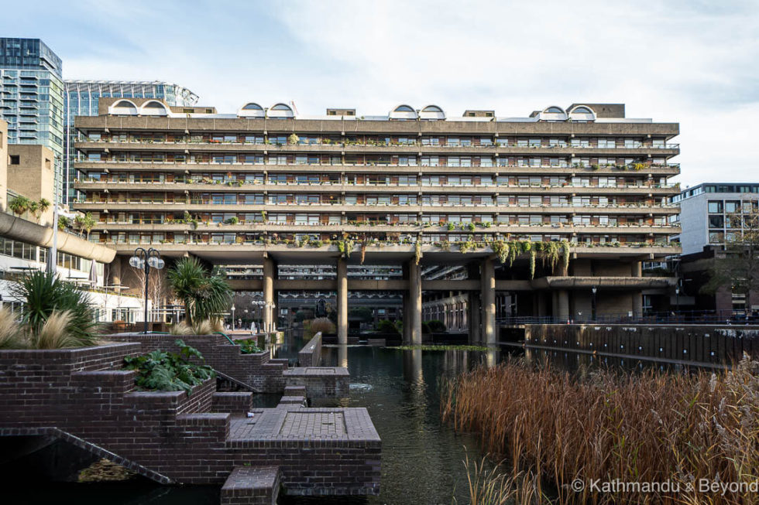
The Barbican is a key example of Brutalist architecture, where the concrete frame is exposed rather than hidden. The surfaces are textured using techniques such as bush-hammering, and structural elements like beams and columns are clearly visible. This reflects a design approach that emphasises honesty in materials and construction, making the structure part of the building’s visual identity. A raised podium separates pedestrian and vehicle movement, with walkways above and roads below. This required the use of transfer structures, such as large, reinforced slabs and beams, to redistribute loads from the towers to different column layouts at lower levels. This design responds to post-war planning ideas focused on safety and functional zoning. Building services, including ventilation, plumbing, and electrical systems, are integrated within floor zones and vertical cores. The reinforced concrete frame allows internal walls to remain non-loadbearing, making it easier to coordinate and install these services without affecting the structural system.

Method of Construction
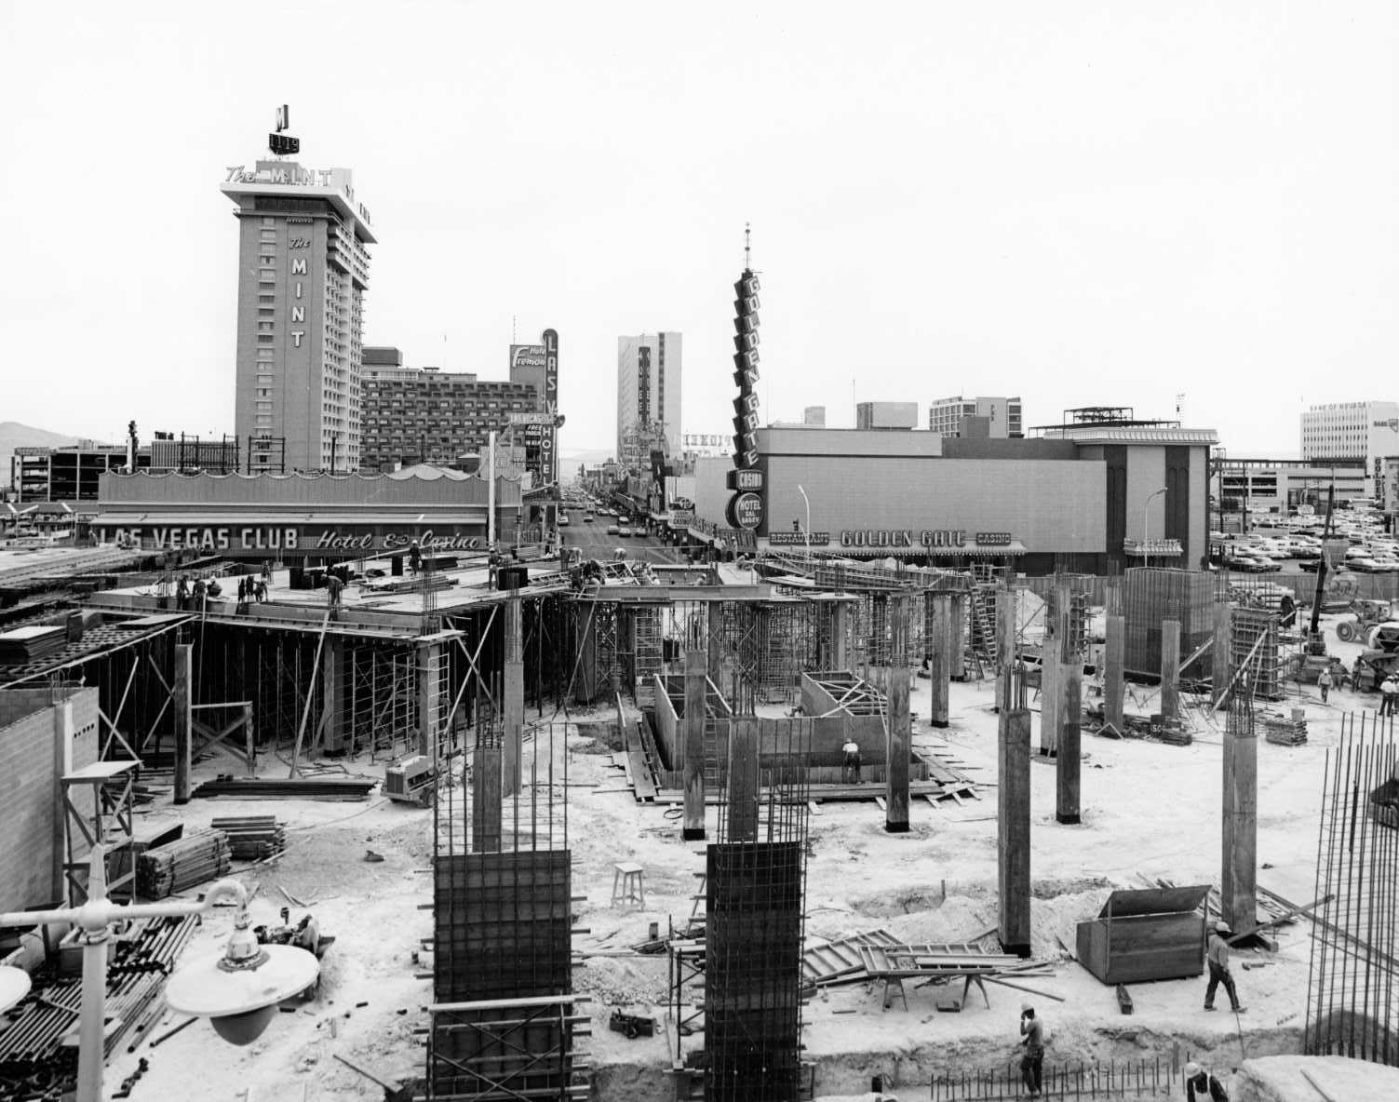
The Barbican was constructed using reinforced tooled concrete. This involved assembling formwork on site, placing steel reinforcement, and pouring concrete into the moulds. After curing, the formwork was removed. This method creates a continuous, monolithic structure and allows for complex architectural forms. The building uses floor systems such as flat slabs and slab-and-beam arrangements, which transfer loads directly to columns. These systems simplify construction and reduce structural depth but require careful design to ensure adequate strength and performance during both construction and use. Transfer structures are used at podium level to manage changes in column alignment. These heavily reinforced elements redistribute loads from the upper structure to the supporting columns below. They are critical to the stability of the building and require detailed structural analysis. Construction followed a sequential, storey-by-storey process. Structural cores and columns were typically built first to provide stability, followed by floor slabs. Engineers needed to consider temporary load conditions, as the structure behaves differently during construction compared to its final state. The reinforced concrete frame also acts as the finished façade, reducing the need for additional cladding. Non-loadbearing infill panels are placed between structural elements. The exposed concrete was carefully finished to achieve the desired appearance, making structure and aesthetics closely linked. While the Barbican relied on in-situ construction, modern concrete frame buildings often use precast or hybrid systems to improve speed and quality. However, the fundamental principles of load transfer, structural framing, and service integration remain largely unchanged.
References
- CROSS (2022) Concern over modelling of concrete frame building for construction stage. Available at: Concern over modelling of concrete frame building for construction stage | CROSS Accessed: March 2026).
- Building Engineer (2022) Concern over construction sequence of concrete frame. Available at: Search | Chartered Association of Building Engineers
- Tabasum, M.H. et al. (2022) A short overview of reinforced concrete frame structure design methodology and problems. Available at: ResearchGate.
- FP McCann (2025) Precast concrete building frames. Available at: https://fpmccann.co.uk Precast concrete building frames | FP McCann
- The Concrete Centre (2016) Concrete framed buildings: a guide to design and construction.

2). Analyse the framing material in the following specific areas, utilising these as your sub-titles:

A. The framing materials strength, durability and climatic resistance, given the environmental conditions it is exposed to at the site of the build.

The Barbican Estate uses a reinforced concrete frame, which provides high compressive strength, embedded steel reinforcement and adequate tensile capacity. This makes it suitable for high-rise residential construction, where structural stability and load-bearing capacity are critical. The monolithic nature of in-situ concrete also improves stiffness and resistance to progressive collapse. Steel

In terms of durability, reinforced concrete performs well in the UK’s temperate maritime climate, characterised by regular rainfall, moderate humidity, and occasional freeze–thaw conditions. Concrete inherently resists weathering, but long-term exposure can lead to carbonation and moisture ingress, which may cause corrosion of the steel reinforcement if not properly detailed. At the Barbican, exposed concrete required high-quality finishes and sufficient cover to reinforcement to limit deterioration. While generally durable, the structure requires ongoing maintenance to address surface wear and cracking over time.

b. Time, Labour, Programme and Cost when compared to steel framing. .

In-situ reinforced concrete construction is typically slower than steel framing due to the sequential nature of the process. Activities such as erecting formwork, placing reinforcement, pouring concrete, and allowing time for curing all extend the construction programme. This also increases on-site labour requirements, as multiple trades are needed throughout each stage.
However, concrete can be more economical in material cost, particularly in the UK where raw materials are readily available. It also provides inherent fire resistance, reducing the need for additional fire protection measures that are required in steel structures. Steel framing, by contrast, benefits from off-site prefabrication, allowing rapid assembly and shorter construction programmes with reduced labour on site. Despite this, for large-scale developments like the Barbican, concrete offered a cost-effective solution at the time due to its dual role as both structure and finish.

c. The frames ease of assembly and the potential ease of its adaptation to different building shape and building use, within the life cycle of the building.

Reinforced concrete frames are complex to assemble because they rely on in-situ processes. The need for formwork, reinforcement placement, and curing makes construction slower and less flexible compared to steel frames, which can be quickly erected from prefabricated components.

In terms of adaptability, RC frames allow internal spaces to be reconfigured since internal walls are non-load bearing. However, altering the structural frame itself is difficult due to its monolithic construction. Removing or changing columns and slabs requires significant intervention and is often not practical. As a result, while the building can accommodate changes in layout and use, it is less adaptable than steel-framed structures over its full life cycle.

d. The problems faced by the integration of services provision, and how these problems are overcome.

It can be difficult to install building services (such as pipes, ventilation, and electrical cables) in reinforced concrete frames because the material is solid and hard to cut through. Unlike steel frames, where holes can be easily included for services, concrete requires these spaces to be planned. If changes are needed later, drilling or cutting into the concrete can be slow, expensive, and may weaken the structure if not done carefully.

At the Barbican, this problem was managed by planning service routes early in the design. Vertical service cores were used to carry major systems like lifts, pipes, and cables, while smaller services were run through designated spaces in floors and ceilings. Suspended ceilings and service voids also helped hide and organise these systems without affecting the main structure.

e. The specific challenges faced at the point of the building’s potential demolition, at end of life.
Reinforced concrete buildings like the Barbican are difficult to demolish because the material is very strong and heavy. Unlike steel buildings, which can often be taken apart piece by piece, concrete usually has to be broken up using large machines. This makes the process slower, noisier, and more expensive.
Another issue is recycling. The steel inside the concrete is mixed in, so the concrete must be crushed to separate it. While some of the crushed concrete can be reused, it is not as high quality as new material. Demolition also creates a lot of dust and waste, which can impact the environment.

3). Discuss the negative impact of the concrete production process,
in terms of ccommunity and the environment.
Environmental
The concreting process has a significant impact on the environment, particularly due to the production of cement. Manufacturing cement requires heating limestone to extremely high temperatures, which releases large amounts of carbon dioxide. As a result, the cement industry is responsible for around 7–8% of global CO₂ emissions, contributing heavily to climate change. In addition, the extraction of raw materials such as sand and gravel leads to environmental degradation, including habitat destruction and loss of biodiversity. Quarrying and sand mining can damage rivers and landscapes, while also reducing natural resources.

Concrete production and use also contribute to pollution. Dust from cement plants and construction sites can reduce air quality, affecting both humans and wildlife. Water pollution can occur when wet concrete or waste materials enter waterways, harming aquatic ecosystems. Noise pollution from heavy machinery further disrupts both local communities and wildlife. Another environmental issue is the urban heat island effect, where concrete surfaces absorb and retain heat, making cities warmer and increasing the need for energy-intensive cooling systems.

Community

Despite its environmental drawbacks, concrete plays a crucial role in supporting communities. It is a fundamental material for building infrastructure such as roads, bridges, schools, hospitals, and housing. This infrastructure improves accessibility, safety, and overall quality of life, while also supporting economic growth. The construction industry also creates employment opportunities, benefiting local economies through job creation in manufacturing, transportation, and building.
However, there are also negative impacts on communities. People living near cement plants or construction sites may experience health issues, particularly respiratory problems caused by dust and emissions. Noise and increased traffic from construction activities can disrupt daily life and reduce the quality of living. Furthermore, excessive use of concrete in urban areas can lead to overcrowded environments with limited green space, sometimes referred to as “concrete jungles.” This can negatively affect mental wellbeing and reduce opportunities for recreation.
Overall
Overall, the concreting process has both positive and negative impacts on the environment and communities. While it is essential for modern development and provides many social and economic benefits, it also contributes significantly to environmental damage and health concerns. Moving forward, adopting more sustainable practices—such as using recycled materials, reducing emissions, and incorporating green spaces into urban design—can help balance these impacts and make concrete use more environmentally and socially responsible.

4)
Sieve Size (mm) | Mass(g) | % on sieve | % Passing
125 | 0 | 0 | 100
75 | 0 | 0 | 100
63 | 0 | 0 | 100
37.5 | 120 | 9.6 | 90.4
20 | 137 | 10.96 | 79.44
10 | 143 | 11.44 | 68
6.3 | 105 | 8.4 | 59.6
3.35 | 45 | 3.6 | 56
2 | 130 | 10.4 | 45.6
1.18 | 63 | 5.04 | 40.56
0.6 | 105 | 8.4 | 32.16
0.3 | 102 | 8.16 | 24
0.212 | 109 | 8.72 | 15.28
0.15 | 98 | 7.84 | 7.44
0.063 | 55 | 4.44 | 3.04

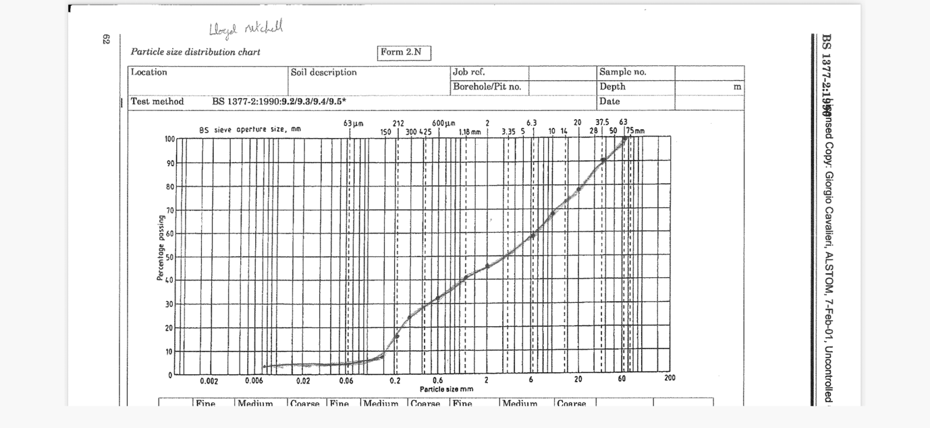
Coarse aggregate= 40.4%Fine aggregate= 56.56%

