

Student Name: Asmabanu khojbariya
Student ID: 2227851
LCMB7004: Entrepreneurship

ASSESSMENT 1: ESSAY
Lecturer: Vasilios Tavlaridis

Contents
Proposed Business Idea (Solar-Chargeable Phone) 3
Gap in the Market and Unique Selling Point (USP) 3
Unique Selling Point (USP): 4
Proposed Business Location and Legal Entity 5
Location: 5
Legal Entity: 5
Insurance: 6
Licensing: 6
Patents: 6
Logo: 6
SWOT Analysis of the Business 7
Strength 7
Weakness 7
Opportunity 7
Threats 8
Target Market strategies 8
Target Market 8
Sales and Pricing 8
Operations and Logistics 9
Webpage, Online Store, Visibility, and Social Media 9
Financial Budgeting 9
Data Input 9
Cash Budget 10
Profit and Loss 10
External sources of Funding 11
References: 11

Proposed Business Idea (Solar-Chargeable Phone)
The proposed business concept involves the development of a solar-powered mobile phone targeted toward the Generation Z demographic. The innovative device utilizes solar energy as a means of recharging its batteries, thereby offering a sustainable and convenient alternative for power provision. The incorporation of solar panels for charging purposes will be seamlessly integrated into the phone's design. This design characteristic mitigates the need for traditional charging methods and encourages environmentally conscious behaviors.
Key Features | Description
Solar Panels Integration | The mobile device's design will integrate solar panels. Solar panels will be strategically placed to maximize solar energy absorption without compromising phone functionality or aesthetics (Sadhu et al., 2015).
Sustainable Power Solution | The phone's solar power charging mechanism is eco-friendly. Recharging mobile devices with renewable solar energy reduces fossil fuel use and carbon emissions (Russel, 2023).
Seamless Design | The phone's solar panels will be integrated in a way that's attractive and ergonomic. The integration's sleek and attractive design will improve the phone's visual and touch experience.
Battery Management System | A smart battery management system will improve charging efficiency and battery life in the mobile device. Regulated charging will prevent overcharging and ensure energy storage safety and efficiency.
Efficient Solar Energy Conversion | Solar panels will be designed to efficiently absorb sunlight and generate electricity. High-efficiency solar cells will be used to optimize charging performance (Veiga, 2022).
Convenience and Portability | Sunlight will allow people to charge their phones anywhere, eliminating the need for cables or outlets. This capability is useful in outdoor or power-constrained settings.
Integration with Traditional Charging | The phone uses solar charging but also supports USB charging. When solar charging is not possible, users can charge their phones using standard methods.
Eco-Friendly Manufacturing: | The phone will employ ecologically friendly materials and processes to reduce its environmental impact. Sustainable production includes waste reduction, energy efficiency improvement, and ethical material sourcing.

Gap in the Market and Unique Selling Point (USP)
There is currently a dearth of comprehensive solar charging solutions for mobile phones in the market. Solar-powered chargers are frequently standalone devices that may not offer a fully integrated charging solution (Lieang, 2021). Solar-powered mobile phones often compromise aesthetics and user satisfaction in order to integrate solar technology.
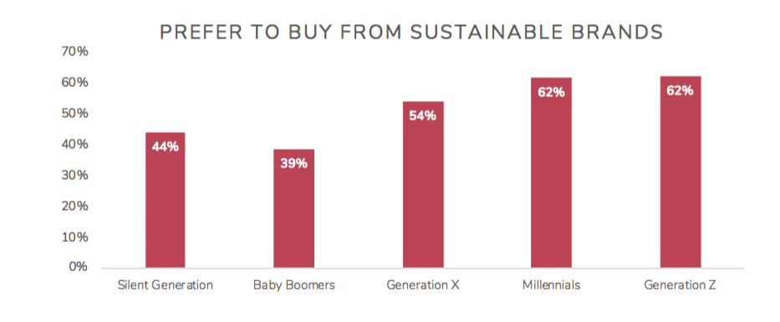
A study conducted by Oliver Wyman in 2023, it was revealed that a significant proportion, specifically 40%, of individuals belonging to Generation Z exhibit a preference for brands that prioritize and emphasize sustainability as a core value (Wyman, 2023). Based on the findings of the report, it can be inferred that Generation Z holds the belief that companies should adopt environmentally responsible practices. there is a growing consciousness within this particular demographic regarding the environmental consequences associated with their decision-making processes. Consequently, they actively pursue products that are in line with their personal values.
Figure 1 Buying from sustainable brands (Carufel, 2020)
Nevertheless, the limited adoption of solar-powered mobile phones can be attributed to issues related to inadequate integration and compromised aesthetics. According to Market Research Future, there is an anticipated growth of 8.5% in the global solar-powered phone market between the years 2021 and 2026. The growth rate serves as an indicator of the potential within the market for solar-powered phones (Fehske et al., 2011).
Unique Selling Point (USP): The solar-chargeable phone seamlessly incorporates solar panels into its design, maintaining both its aesthetic appeal and ease of use. The unique selling proposition (USP) of our product appeals to environmentally conscious customers seeking a power solution that is both sustainable and aesthetically pleasing.
We collaborated with reowned industrial designers to accomplish this objective. This strategic alliance guarantees that our solar-powered mobile device aligns with the aesthetic preferences of our intended consumer base. The incorporation of solar panels into the phone's structure is achieved through the utilization of advanced materials and technology, resulting in a sleek aesthetic and a superior tactile experience.
Multiple empirical studies have provided evidence that mobile devices have the capability to utilize solar panels. According to a study conducted by researchers at the Massachusetts Institute of Technology (MIT), the integration of solar technology in mobile devices has the potential to enhance battery life and decrease dependence on traditional charging methods (Mohsan et al., 2022).
Another study conducted by Greenpeace, a significant majority of consumers expressed their willingness to purchase a solar-powered mobile device if it offers a satisfactory user experience and aligns with their design preferences (Jacobson, 2007).

Proposed Business Location and Legal Entity
Solar-powered smartphones enable convenient and environmentally friendly charging on the go. Integrated solar panels are capable of absorbing solar radiation and converting it into electricity, thereby serving as a substitute for traditional charging methods and contributing to a reduction in environmental harm (Sansaniwal, Sharma and Mathur, 2018).The provision of a product that is in accordance with the values and preferences of consumers possesses the potential to leverage the increasing desire for ecologically sustainable technologies, thereby yielding advantages for both the market and the environment.
Location: Our business stands to gain advantages from the UK's robust market, strong dedication to sustainability and renewable energy, and technologically sophisticated customer base. Statista reports that the United Kingdom exhibits the highest levels of smartphone penetration and internet usage among European countries. UK mobile internet users reached 63.2 million in 2022. The nation's population is estimated at 93% (Statista, 2023). This particular market presents an opportune environment for the promotion and sale of our solar-chargeable mobile devices.
The United Kingdom government actively advocates for the adoption of renewable energy sources and the implementation of environmentally sustainable practices. The Climate Change Act of 2008 imposes requirements for the reduction of carbon emissions (Climate Change Committee, 2008). The Feed-in Tariff and Renewable Heat Incentive serve as effective mechanisms for promoting the utilization of renewable energy sources (Connor et al., 2015). These variables contribute to the establishment of a corporate environment that aligns with our mission of promoting sustainable technological solutions.
Legal Entity: Our intention is to establish a UK Limited company. This legal entity offers startups the advantage of limited liability protection and the opportunity to secure equity investment (Crail, Haskins and Watts, 2022b). Based on statistical data from the British Business Bank, it can be observed that a significant majority, approximately 96%, of newly established businesses in the United Kingdom adopt the legal structure of private limited companies (British Business Bank , 2019).
In the capacity of a privately held corporation, we possess the ability to provide reassurance to investors, suppliers, and customers. The legal framework serves to establish a clear delineation between personal assets and business obligations, thereby safeguarding the financial interests of both our founders and stockholders (Manne, 1967).
Insurance: Our business operations will encompass the provision of insurance services aimed at mitigating potential risks and hazards. The implementation of general liability insurance will serve as a safeguard for our business against potential legal claims arising from property damage or personal injury incurred throughout the various stages of the manufacturing, distribution, and utilisation processes associated with our solar-chargeable phone(Abraham, 1988). To ensure sufficient protection, we will collaborate with established providers of technology and product liability insurance.
Licensing: We will acquire the necessary authorizations and licenses to conduct operations within the United Kingdom. The inclusion of safety, importing, and production licenses is a possibility. In order to maintain regulatory compliance in our operations, it is imperative that we conduct thorough research and adhere to industry-specific licensing regulations.
Patents: The integration of our groundbreaking solar technology holds significant importance. Consequently, we will initiate the process of filing patent applications to safeguard our intellectual assets. The efficacy of our solar charging technology will undergo evaluation by patent attorneys, accompanied by a comprehensive examination of the prior art. Patents serve as a means of safeguarding our distinctive design, thereby establishing a barrier against competitors and maintaining our competitive edge in the market (Mansfield, 1986).
Logo: The logo will serve as a visual representation of our brand and its commitment to environmental sustainability. Our enterprise will collaborate with proficient designers to develop a visually captivating and distinctive logo that effectively appeals to our designated target demographic. The logo design will encompass the principles of sustainability, the utilization of solar energy, and the integration of contemporary technological advancements. Our objective is to enhance brand recognition and market presence by means of a visually captivating and easily memorable logo. This strategy will distinguish us from others.

SWOT Analysis of the Business
The SWOT analysis is a strategic management tool utilized by companies to identify and evaluate their primary challenges. This evaluation considers both the internal and external factors affecting the business (Gurel and Tat, 2017).

Strength
- Unique and Innovative Product Offering: Our solar-powered mobile device attracts eco-conscious customers. Deloitte found that consumer interest in sustainable products is rising. Our unique products meet market demand.
- Growing Demand for Eco-Friendly Technology: Sustainable technological solutions are being recognized worldwide. Grand View Research predicts rapid growth in the solar-powered device sector (Devabhaktuni et al., 2013). Our solar-chargeable phone's market potential looks good.
- Strong Emphasis on Sustainability: Our business benefits from the UK government's sustainability efforts and consumers' growing interest in eco-friendly products. Accenture found that nearly two-third of consumers consider sustainability when buying (Accenture, 2021).

Weakness
- High Initial R&D and Manufacturing Costs: Solar phone integration requires extensive R&D. Our design may increase production costs compared to typical mobile phones.
- Market Competition: Established companies dominate the mobile phone sector, which is very competitive. Competing with established companies might hinder market access and brand visibility. In 2022, Apple held over 50% of the UK mobile device market. Samsung was second with almost 30% of the UK market. Both major UK mobile device vendors were far ahead of Huawei, which placed third with around five percent of the market share, down from prior years (Statista, 2022).
- Limited Awareness of Solar-Phones: Despite consumer interest in eco-friendly items, solar-powered phones are unknown. By promoting its advantages, our solar-powered mobile device will sell.

Opportunity
- Increasing Sustainability Awareness: With the growing worldwide focus on sustainability, environmentally friendly technologies could benefit from growing awareness and excitement. Partnerships with environmental organizations and sustainability efforts can boost our product's visibility.
- Growing Mobile Phone Market: Emerging players have opportunities in the growing mobile phone market. IDC predicts 1.38 billion smartphone shipments worldwide by 2023(Scarsella, 2022). This growth can help us gain market share.
- Collaborations with Eco-Conscious Brands: Collaborating with well-known eco-friendly brands could boost our brand's reputation and market share. Joint marketing efforts, co-branded product creation, and distribution agreements enable access to pre-existing client segments.

Threats
- Rapid Technological Advancements: Our product may be threatened by new technology, which is changing rapidly. We must innovate and incorporate new technology and features into our products to be competitive.
- Economic Volatility: Economic uncertainty affects consumer spending. During economic downturns, people may choose necessities over luxury items like our solar-powered phone.
- Intellectual Property Infringement: We must protect our IP from competitors. Unauthorized replication or imitation of our solar charging technology in the rapidly evolving tech industry could hurt our market position and competitiveness.

Target Market strategies

Target Market
Our study targets Generation Z (Gen-Z), born between the mid-1990s and early 2000s. Numerous studies have shown that Generation Z members are tech-savvy and quick to adopt new gadgets. According to a Pew Research Centre survey, 95% of Generation Zers use smartphones, demonstrating their affinity for mobile technology. Generation Z is environmentally sensitive and seeks sustainable products. McKinsey found that 70% of Generation Z consumers are willing to pay more for products that reflect their beliefs, including sustainability (Katz et al., 2022). Our phone's solar-charging capability aligns with Generation Z's value system by providing a sustainable and convenient power alternative. Generation Z also leads a mobile lifestyle and relies on smartphones for communication, entertainment, and productivity. By targeting this population, we can meet their needs for a reliable and eco-friendly mobile device.

Sales and Pricing
Our sales approach will prioritize online sales through our exclusive website and renowned e-commerce platforms. Generation Z prefers online retail; therefore, this technique targets our major demographic. SEO and social media advertising will be used to increase traffic to our e-commerce platform. We plan to explore partnerships with cell carriers and merchants to broaden our distribution and consumer base.
Our pricing plan will include market demand, production costs, and the value added by sustainable technology. Pricing research and analysis will help determine client segment-specific price points. Our organization will offer multiple pricing tiers to meet Gen-Z consumers' budgetary needs and make our products more affordable. We'll also offer installment plans and subscriptions.

Operations and Logistics
Our company will partner with top electronics manufacturers to ensure high production standards and growth. We can leverage their expertise, production capacity, and supply chain management through these partnerships. Outsourcing manufacturing lets companies focus on product creation, marketing, and distribution. This reduces capital costs and production risks. We will streamline operations and work with reliable shipping and logistics companies to distribute products and fulfill customer orders. Customers will receive goods and services on time and be more satisfied.

Webpage, Online Store, Visibility, and Social Media
Our team wants to create an attractive, easy-to-use website that highlights our solar-powered mobile device's features and environmental friendliness. Product data, consumer feedback, and several payment choices will make e-commerce easier and safer. A well-planned social media strategy will increase visibility and audience engagement. We create compelling content and market on Instagram, Facebook, and Twitter. Influencer and eco-friendly brand partnerships will improve our brand messaging and product excitement. Communication, promotions, and social media client contact can develop brand loyalty and advocacy.We target Generation Z with competitive pricing, efficient operations and logistics, digital platforms, and social media to gain market share and create our brand as a leader in sustainable and innovative mobile phone technology.

Financial Budgeting

Data Input
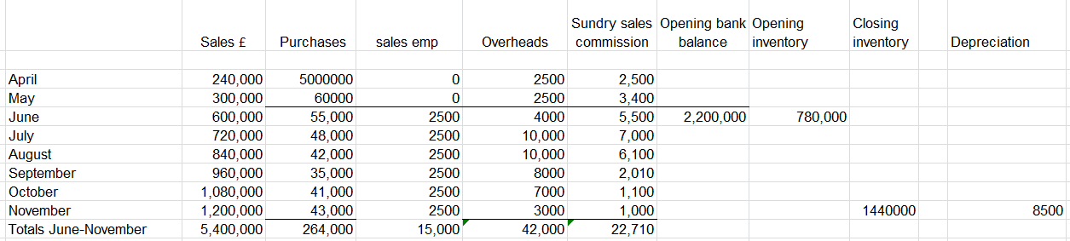

Cash Budget
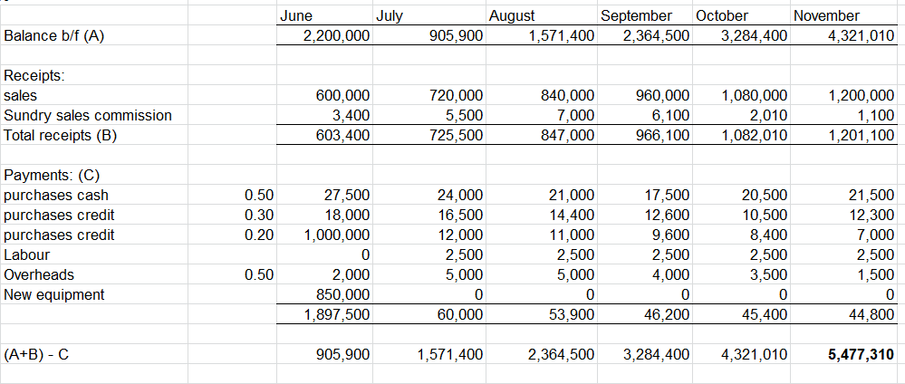

Profit and Loss
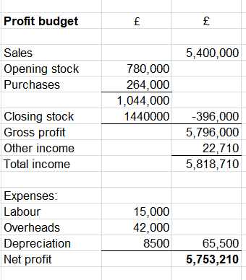
Our mobile phone R&D budget will focus on solar panel development and integration. We control batteries and energy conversion efficiency. Hire skilled engineers, research, prototype, and test. R&D will cost £500,000. We will cooperate with electronics manufacturers to create our solar-powered mobile device. Materials, infrastructure, assembly, quality assurance, and packaging require money. Manufacturing and production receive £1,000,000 initially. Our budget will raise brand awareness and consumer interest in our products. Social media advertising, influencer collaborations, website design, and content creation are included. Data shows a £300,000 marketing and promotional investment. E-commerce platform setup, customer support, and administrative fees. Operations and logistics require £200,000 upfront.
Our solar charging solution will be patented and protected. Patent attorneys, prior art searches, and submitting patent applications in relevant jurisdictions are required. We estimate £100,000 for IP protection. The budget covers administrative expenses, office rental, power, legal fees, insurance premiums, and more. The first £100,000 should cover administrative and overhead costs.
This totals £2,200,000.

External sources of Funding
Bank Loan: Private limited liability companies borrow from banks. A business plan including financial forecasts and collateral can help the company get bank financing. The company owns and repays with this choice.
Equity Investors: Equity investors can fund and staff a company. Angel investors, venture capital firms, and others can fund private limited enterprises' vision and growth. Investors can advise and connect while receiving funding without financial obligations.
Given the present focus on renewable energy and sustainability, government grants and funding programmes are advantageous. Several UK government programmes fund research in these areas. Showing how the solar-chargeable phone endeavor supports government goals may help the organization gain more funding.

References:

Abraham, K.S. (1988). Environmental Liability and the Limits of Insurance. Columbia Law Review, [online] 88, p.942. Available at: https://heinonline.org/HOL/LandingPage?handle=hein.journals/clr88&div=47&id=&page=.
Accenture (2021). Two-Thirds of Consumers are ‘Sustainability-Minded Drivers,’ Accenture Report Finds. [online] newsroom.accenture.com. Available at: https://newsroom.accenture.com/news/two-thirds-of-consumers-are-sustainability-minded-drivers-accenture-report-finds.htm.
British business bank (2019). ENABLING SMALLER BUSINESSES TO GROW AND PROSPER Annual Report and Accounts 2019. [online] Available at: https://www.british-business-bank.co.uk/wp-content/uploads/2020/09/BBB_Annual_Report_2019-tagged.pdf [Accessed 5 Jul. 2023].
Carufel, R. (2020). Sustainable retail expectations on the rise with Gen Z shoppers. [online] Agility PR Solutions. Available at: https://www.agilitypr.com/pr-news/public-relations/sustainable-retail-expectations-on-the-rise-with-gen-z-shoppers/.
Climate Change Committee (2008). A legal duty to act. [online] Climate Change Committee. Available at: https://www.theccc.org.uk/what-is-climate-change/a-legal-duty-to-act/#:~:text=The%20Climate%20Change%20Act%202008.
Connor, P.M., Xie, L., Lowes, R., Britton, J. and Richardson, T. (2015). The development of renewable heating policy in the United Kingdom. Renewable Energy, 75, pp.733–744. doi:https://doi.org/10.1016/j.renene.2014.10.056.
Crail, C., Haskins, J. and Watts, R. (2022a). What Is A Limited Liability Company (LLC)? Definition, Pros & Cons. [online] Forbes Advisor. Available at: https://www.forbes.com/advisor/business/what-is-an-llc/.
Crail, C., Haskins, J. and Watts, R. (2022b). What Is A Limited Liability Company (LLC)? Definition, Pros & Cons. [online] Forbes Advisor. Available at: https://www.forbes.com/advisor/business/what-is-an-llc/.
Devabhaktuni, V., Alam, M., Shekara Sreenadh Reddy Depuru, S., Green, R.C., Nims, D. and Near, C. (2013). Solar energy: Trends and enabling technologies. Renewable and Sustainable Energy Reviews, [online] 19, pp.555–564. doi:https://doi.org/10.1016/j.rser.2012.11.024.
Fehske, A., Fettweis, G., Malmodin, J. and Biczok, G. (2011). The global footprint of mobile communications: The ecological and economic perspective. IEEE Communications Magazine, 49(8), pp.55–62. doi:https://doi.org/10.1109/mcom.2011.5978416.
Gurel, E. and Tat, M. (2017). SWOT analysis: a Theoretical Review. Journal of International Social Research, [online] 10(51), pp.994–1006. doi:http://dx.doi.org/10.17719/jisr.2017.1832.
Jacobson, A. (2007). Connective Power: Solar Electrification and Social Change in Kenya. World Development, 35(1), pp.144–162. doi:https://doi.org/10.1016/j.worlddev.2006.10.001.
Katz, R., Ogilvie, S., Shaw, J. and Woodhead, L. (2022). GEN Z, EXPLAINED : the Art of Living in a Digital age. S.L.: Univ Of Chicago Press.
Lieang, J. (2021). Solar chargers Advantages & Disadvantages. [online] www.linkedin.com. Available at: https://www.linkedin.com/pulse/solar-chargers-advantages-disadvantages-joy.
Manne, H.G. (1967). Our Two Corporation Systems: Law and Economics. Virginia Law Review, 53(2), p.259. doi:https://doi.org/10.2307/1071435.
Mansfield, E. (1986). Patents and Innovation: An Empirical Study. Management Science, 32(2), pp.173–181. doi:https://doi.org/10.1287/mnsc.32.2.173.
Mohsan, S.A.H., Othman, N.Q.H., Khan, M.A., Amjad, H. and Żywiołek, J. (2022). A Comprehensive Review of Micro UAV Charging Techniques. Micromachines, 13(6), p.977. doi:https://doi.org/10.3390/mi13060977.
Russel, S. (2023). Making the Switch to Solar: Saving Money and Reducing Your Carbon Footprint with a Solar Charging Station. [online] Evcharging Energy5. Available at: https://energy5.com/making-the-switch-to-solar-saving-money-and-reducing-your-carbon-footprint-with-a-solar-charging-station [Accessed 5 Jul. 2023].
Sadhu, M., Chakraborty, S., Das, N. and Sadhu, P.K. (2015). Role of Solar Power in Sustainable Development of India. TELKOMNIKA Indonesian Journal of Electrical Engineering, [online] 14(1), pp.34–41. Available at: http://journal.esperg.com/index.php/tijee/article/view/1445 [Accessed 17 Dec. 2022].
Sansaniwal, S.K., Sharma, V. and Mathur, J. (2018). Energy and exergy analyses of various typical solar energy applications: A comprehensive review. Renewable and Sustainable Energy Reviews, 82, pp.1576–1601. doi:https://doi.org/10.1016/j.rser.2017.07.003.
Scarsella, A. (2022). Worldwide Smartphone Forecast, 2022–2026. [online] IDC: The premier global market intelligence company. Available at: https://www.idc.com/getdoc.jsp?containerId=US48936022.
Shaw, J. (2023). Why Gen Z Values Sustainability: Tips for Marketing to the Eco-Conscious Generation. [online] Kadence. Available at: https://kadence.com/why-gen-z-values-sustainability-tips-for-marketing-to-the-eco-conscious-generation/.
Statista (2022). UK: smartphone market share 2010-2018 | Statista. [online] Statista. Available at: https://www.statista.com/statistics/487780/market-share-of-mobile-device-vendors-uk/.
Statista (2023). Topic: Mobile internet usage in the United Kingdom (UK). [online] Statista. Available at: https://www.statista.com/topics/8904/mobile-internet-usage-in-the-united-kingdom-uk/#topicOverview.
Veiga, A. (2022). Solar cell efficiency and how to improve it — RatedPower. [online] ratedpower.com. Available at: https://ratedpower.com/blog/solar-cell-efficiency-improve/.
Wyman, O. (2023). What Business Needs To Know About The Generation Changing Everything Click. [online] Available at: https://www.oliverwymanforum.com/content/dam/oliver-wyman/ow-forum/template-scripts/a-gen-z/pdf/A-Gen-Z-Report.pdf.

