

Module: Entrepreneurship
Module code: LCBB5001
Lecturer: Vasilios Tavlaridis

Component 1: Written Report (Business Plan)

Name: Marco Guarracino
Student Number: 2114886

Table of Contents
1. Introduction 3
2. Overview of the business idea and its products/services 3
3. Legal format of the company 5
4. Management of the company 6
5. Evaluation of the business idea (SWOT) 8
6. Marketing Mix 10
7. Cash flow forecast 12
8. Conclusion 14
References 16

1. Introduction
This project is based on the scenario of the organisational development of Angelic Beauty line, which is to be introduced in UK as the beauty line that offers blemish free skin with an angel like glow. The project further covers the ideas and the use of business models that can help in developing the progress of the marketing plan proposed for the company. Attainment of SWOT analysis and Marketing Mix helps in developing the progressive plan of the business idea that further helps in taking over the market gap in the UK.

2. Overview of the business idea and its products/services
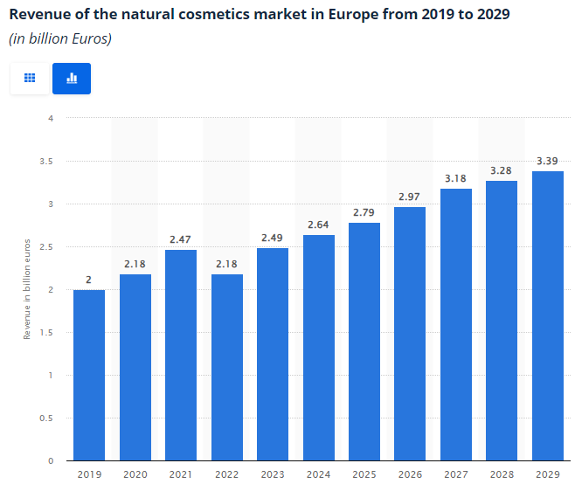
Figure 1: Natural cosmetics market revenue in Europe
(Source: Statista, 2024)
The UK’s beauty industry is a thriving market, especially within the clean beauty segment. According to a report published by Statista (2024), in the 'Natural Cosmetics' segment of the European Beauty & Personal Care Market, revenues are expected to grow between 2024 and 2029 by a total of €0.8 billion (+30.3%). After the seventh successive rising year, it is expected to reach €3.39 billion and thus a new high in 2029 (Statista, 2024). This trend is driven by an increased consumer focus on health, wellness, and environmental impact. Additionally, it has been found that half of UK consumers aged 16-24 prefer green beauty products and are willing to pay a premium for such products (Gomes, Lopes, and Nogueira, 2023).
Considering the above statistical information, a business idea has been generated:
Product
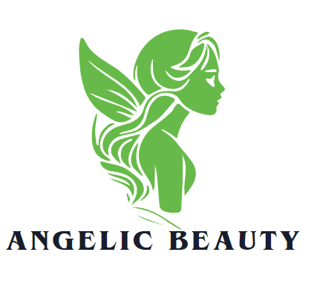
Figure 2: Logo of the brand
(Source: Created by the author)
This proposed venture is set to unveil a premium skincare line named Angelic Beauty Line to capture the growing UK for clean, natural beauty products. It promises a brand that will focus on the highest quality plant-based facial serums, cleansers, and moisturizers, all designed to pump up hydration, combat ageing, and bring radiant beauty to the skin.
Packaging
The products will be packaged sustainably, building on the growing awareness of consumers for ethical and environmental practices.
Target Audience
The millennial and Gen Z consumer base would predominantly be the target for this new product range, as they are more sensitive to their use of products and remain concerned about the transparency and sustainability involved in the brands that they follow. This younger consumer base is known for seeking out skincare products that align with their ethical standards, including clean ingredients and eco-friendly packaging (Gomes, Lopes and Nogueira, 2023).
Distribution
The e-commerce boom in the UK opens up an opportunity for the brand to access direct-to-consumer sales, which increased at a very high rate during the pandemic and is now forecasted to grow at 3.8% till 2028 (Statista, 2022). Partnership with select boutiques will further offer physical touchpoints to raise customer experience as well as make the brand more visible.

3. Legal format of the company
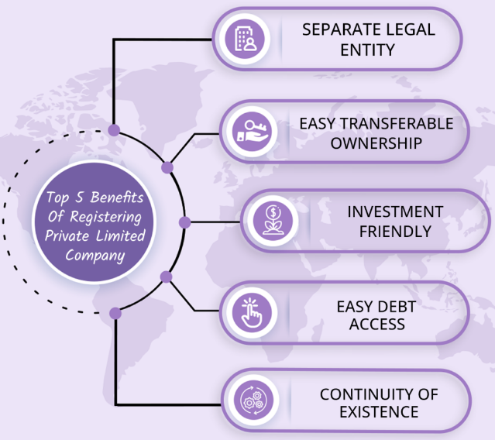
Figure 3: Benefits of registering a Private Limited Company
(Source: Sharma, 2022)
The new skincare company, titled Angelic Beauty, will be launched in the UK as a Private Limited Company (Ltd). Freedman (2020) has stated that this structure is deemed perfect for start-ups and small businesses because of its flexibility, limited liability, and professional credibility. The most apparent reason for selecting a Private Limited Company is the limited liability it offers to the founders. In such a structure, personal assets are protected because the company is recognised as a separate legal entity (Sharma, 2022). This is particularly important in a high-investment, product-based business where potential risks, such as product liability or customer disputes, could arise.
Additionally, Acharya (2022) has noted that an Ltd company allows more control for the founders as the shares can be privately owned and can be transferred without losing complete decision-making authority and without public interference. This structure will also make it easier to raise funds later since equity can be sold to investors without jeopardising the founders' control (Freedman, 2020) Further, for a Private Limited Company, it is easier to gain credibility and trust among customers and suppliers and even potential investors. Finally, an Ltd has beneficial tax treatment because corporate tax rates are often much lower than personal income tax rates, allowing the business to retain more profits for reinvestment (Acharya, 2022).

4. Management of the company
The skincare business will be a sole proprietorship at the start, which will mean ownership and control over the development, marketing, and running of operations. The background of the owner should be sound in the skincare or natural beauty space to understand market trends and consumer needs well. As the company builds further, it will begin to employ and entrust certain core roles as it grows to build the brand further.
Employees:
The company will apply a lean team at the initial stage with extreme flexibility to develop high flexibility within all departments (McKinsey, 2020). There will be a part-time marketing assistant to support the management of social media, production of content, and integration. A sales coordinator will support e-commerce operations and boutique partnerships. More customer service representatives and inventory managers will be recruited in due course depending on the brand's growth (Business Queensland, 2022).
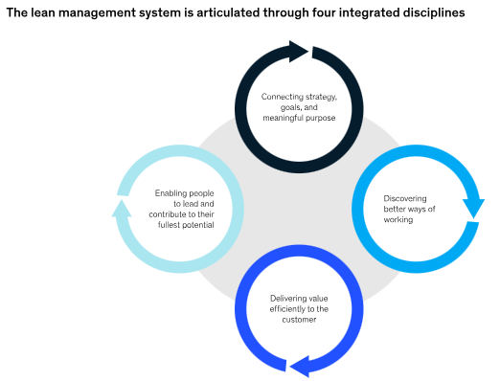
Figure 4: Four disciplines of Lean management system
(Source: McKinsey, 2020)
External Professional Services:
For advancement and quality standards, the firm will recruit external specialists for specific tasks.
Product Formulation Specialist: Recruitment of an experienced cosmetic chemist to come up with a safe, effective, and quality skincare formula that fits into the brand's natural ethos (Business Queensland, 2022).
Graphic Designer: Recruit a designer to prepare packaging, branding material, and website visuals to look attractive and professional and resonate with target customers (Yanir and Narkhede, 2023).
Digital Marketing Consultant: The first £25,000 will be spent on the optimisation of paid social ads, online search terms, and influencer collaborations by consulting a digital marketing specialist.
Legal Services: A cosmetic-specific attorney will be contacted to assist in understanding the requirements and regulations regarding product safety, labelling, and trademark registrations.
This kind of lean management approach will bring scalable growth, while strategic use of professional services ensures to maintenance of high standards by the brand in the emerging skincare market (Slattery et al., 2022).

5. Evaluation of the business idea (SWOT)
Strengths  - Strong alignment with current consumer trends, clean natural beauty and sustainable packaging appeal to the UK market (Sharma, 2021)  - Targeting millennial and Gen Z, who prioritise ethical and cruelty-free products  - Use of plant-based ingredients supports eco-friendly positioning. | Weakness  - Limited initial investment (£25,000), potentially restricting product development and marketing reach.  - Lack of brand recognition, making it difficult to compete with established skincare brands  - Dependence on a small product range may limit market appeal initially
Opportunities  - Growing demand for natural and sustainable beauty products in the UK  - Expansion into the new product lines such as body care or haircare products, once brands gains tractions (Azzahrah, Rakib and Jufri, 2023)  - Establishing partnership with influencers and eco-friendly retailers can help in developing brand visibility. | Threats  - Highly competitive market with major players existing (Lin and Wang, 2024)  - Fluctuations in the availability of the raw material can affect the supply chain causing disruption  - Regulatory changes could increase compliance costs (Moosivand, Ghatari and Rasekh, 2019)
Table 1: SWOT analysis
Analysis of the above SWOT table:
Because it falls within the category of natural, ethical, and sustainable beauty products currently in demand by consumers, the brand has very promising potential (Sharma, 2021). This business is also set to tap into the millennial and Gen Z, a huge market of consumers whose philosophies, such as transparency and an eco-friendly decision, have affected purchases. At the seed capital of £25,000, the only feasible options are basic product development and marketing, but this alone would not be enough to face established brands with more advanced funds.
In its effort to alleviate these weaknesses, the business should emphasize brand awareness using digital marketing strategies and activities, such as creating social media campaigns and signing influencer partnerships. Having a diversified product mix in the future will increase demand in the market and help attract new customers (Azzahrah, Rakib and Jufri, 2023).
Han, Lin and Wang (2024) stated that threats include stiff competition, as well as potential changing dynamics of the laws and regulatory mechanisms influencing the brand. The company has to be flexible in its pricing plans to stabilise fluctuations in the supply chain and must be aware of such legal regulations as pertain to products to avoid improper compliance (Moosivand, Ghatari and Rasekh, 2019). However, through the opportunities for extension and strategic partnerships, businesses can appropriately expand and establish themselves within the market.

6. Marketing Mix
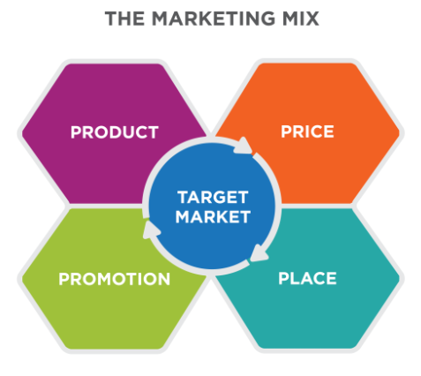
Figure 5: 4Ps of marketing mix
(Source: (\Niosi, 2020)
According to Niosi (2020), a marketing mix is defined as a set of tools and strategies applied by a company for designing its marketing plan. The four fundamental elements of a marketing mix are commonly referred to as the '4 Ps' that represent product, price, place, and promotion (Niosi, 2020). A marketing mix for Angelic Beauty is as follows:
Product
Angelic Beauty will be a premium skincare line designed to meet the growing demand for clean, plant-based beauty products. The product line will include facial serums, cleansers, and moisturisers developed to target specific skin-related concerns, such as hydration, anti-ageing, and glow. The brand’s unique selling proposition (USP) lies in its all-natural and cruelty-free products, along with overall eco-friendly and sustainable packaging, which appeals to conscious consumers. Products will target millennials and Gen Z, and every product will not only state transparency over its formulations but will also be scientifically backed in production, formulating without harming chemicals making them safe and effective.
Price
The price point for Angelic Beauty will be premium because of the use of high-quality ingredients, in addition to natural ones, and sustainable packaging. The prices will be similar within the premium natural skin care segment between £20 and £60 per product. The pricing strategy will align with the purchasing behaviour of millennials and Gen Z, which include paying a premium for sustainable and ethical products (Gomes, Lopes and Nogueira, 2023). Introductory offers, bundles, and loyalty programs will be introduced to encourage sales at the beginning, reward repeat purchases, and create brand loyalty (Manel and Feyrouz, 2020).
Place
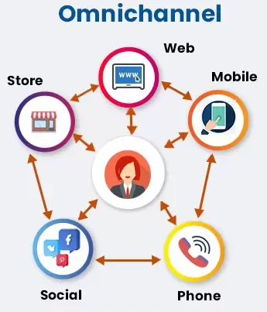
Figure 6: Omnichannel strategy
(Source: iTech, 2022)
Angel Beauty will apply an omnichannel marketing strategy selling through both the offline and online modes (iTech, 2022). First, the products would be sold through e-commerce using a website and various other online marketplaces, including Amazon and beauty-focused platforms such as LookFantastic. This maximises the audience, especially the technologically advanced millennials and Generation Z, who are more accustomed to buying products online (Chevalier, 2024). Secondly, the company will also collaborate with selected high-end boutiques and speciality beauty stores throughout the UK to provide a physical touch point for customers who prefer to try products in-store The combination of both online and offline distribution channels ensures that the brand can engage with the widest demographic (Shankar and Kushwaha, 2020).
Promotion
Angelic Beauty will focus heavily on digital marketing as its promotional strategy. Primary awareness will be driven through social media, including Instagram, TikTok, and Pinterest, using influencers and user-generated content that will create trust and authenticity. The visibility and traffic for the e-commerce website will be created through paid social media advertising, Google advertising, and paid YouTube ads. A focus on content marketing, such as skincare tips, tutorials, and ingredient highlights, would make Angelic Beauty an expert in clean skincare. Together, these tactics would lead to increased brand visibility, trust, and customer engagement, leading to higher sales and market share growth (Veleva and Tsvetanova, 2020).

7. Cash flow forecast
Months | Cash flow in £ | Cash outflow in £ | Net cash flow (£) | Cumulative cash balance (£)
1 | 0 | - Product development – 5000  - Branding and packaging- 2500  - Legal and licensing- 1000  - Marketing- 1500  - Website development - 2000 | -12,000 | 13,000
2 | 0 | - Marketing- 1000  - Inventory purchase- 3000  - Rent and utilities- 500 | -4,500 | 8,500
3 | 2000 | - Marketing- 1000  - Rent and utilities- 500  - Wages- 1000 | -500 | 8,000
4 | 3000 | - Marketing- 1000  - Rent and utilities- 500  - Wages- 1000 | 500 | 8,500
5 | 4000 | - Marketing- 1200  - Rent and utilities- 500  - Wages- 1200  - Additional Inventory- 2000 | -900 | 7,600
6 | 5000 | - Marketing- 1200  - Rent and utilities- 500  - Wages- 1200 | 2,100 | 9,700
7 | 6000 | - Marketing- 1500  - Rent and utilities- 500  - Wages- 1500  - Inventory restocking- 2000 | 1,500 | 11,200
8 | 7000 | - Marketing- 1500  - Rent and utilities- 500  - Wages- 1500 | 3,500 | 14,700
9 | 8000 | - Marketing- 2000  - Rent and utilities- 500  - Wages- 2000 | 3,500 | 18,200
10 | 10,000 | - Marketing- 2000  - Rent and utilities- 500  - Wages- 2500  - Inventory- 3000 | 2,500 | 20,700
11 | 12,000 | - Marketing- 2500  - Rent and utilities- 500  - Wages- 3000 | 6,000 | 26,700
12 | 14,000 | - Marketing- 3000  - Rent and utilities- 500  - Wages- 3,500 | 7,000 | 33,700
Table 2: Cash flow chart
Assumptions:
- Cash Inflows: Sales start in Month 3 and grow over time as the brand name gains popularity and the distribution channel is expanded.
- Marketing Cost: The first few months are high to establish the brand name, and then stretched out to maintain the upward trajectory.
- Wages: Employees increase gradually with the growth of operations. Salaries will increment as operations expand.
- Inventory Costs: Periodic restocking as sales expand
- Other Costs: Rent, utilities, and legal/licensing fees are kept low to maintain lean operations.
The forecast indicates that there is a positive cash flow from Month 3. This forecasting result finally shows a cumulative balance of £33,700 by Month 12, so it has sustainable growth potential.

8. Conclusion
Concisely, Angelic Beauty possesses a wonderful business plan that offers bright new opportunities for a new line of skincare that will appease the rising demands for green and sustainable beauty products within the UK market. With the three important aspects of plant-based ingredients, ethical practices, and environmentally friendly packaging, the brand is well defined to draw conscious consumers, such as millennial and Gen Z. However, the first hurdles are lack of funding and competition from huge brands, proper management through lean management, digital marketing, and suitable partnership will help enhance further development. The cash flow forecast may reveal a positive trajectory. Therefore, further development sustainability is achievable in this new skincare industry.

References
Acharya, M. (2022) Advantages and Disadvantages of Private Limited Company, cleartax.in. Available at: https://cleartax.in/s/advantages-and-disadvantages-private-limited-company (Accessed: 24 October 2024).
Azzahrah, A.A., Rakib, M. and Jufri, M. (2023) ‘Product Diversification to Increase Consumer Satisfaction: A Development Research Study’, International Journal of Current Science Research and Review, 06(11). Available at: https://doi.org/10.47191/ijcsrr/v6-i11-33.
Business Queensland (2022) Improving your customer service, www.business.qld.gov.au. Available at: https://www.business.qld.gov.au/running-business/marketing-sales/customer-service/improving (Accessed: 24 October 2024).
Chevalier, S. (2024) Topic: Gen Z online shopping behavior, Statista. Available at: https://www.statista.com/topics/11087/gen-z-online-shopping-behavior/#topicOverview (Accessed: 24 October 2024).
Freedman, J. (2020) ‘Limited Liability: Large Company Theory and Small Firms’, Modern Law Review, 63(3), pp. 317–354. Available at: https://doi.org/10.1111/1468-2230.00267.
Gomes, S., Lopes, J.M. and Nogueira, S. (2023) ‘Willingness to pay more for green products: A critical challenge for Gen Z’, Journal of Cleaner Production, 390(136092). Available at: https://doi.org/10.1016/j.jclepro.2023.136092.
Han, X., Lin, T.X. and Wang, X. (2024) ‘Mitigate cross-market competition caused by the risk of uncertainty and improve firm performance through business intelligence’, Heliyon, 10(14), pp. e34542–e34542. Available at: https://doi.org/10.1016/j.heliyon.2024.e34542.
iTech (2022) Omnichannel Marketing vs Multichannel Marketing: Why It’s Important - iTech, iTech. Available at: https://itechindia.co/article/multichannel-marketing-vs-omnichannel-marketing/ (Accessed: 24 October 2024).
Manel, H. and Feyrouz, S. (2020) DEMOCRATIC AND POPULAR REPUBLIC OF ALGERIA MINISTRY OF HIGHER EDUCATION AND SCIENTIFIC RESEARCH Ecole Supérieure de Commerce Effects of Sales Promotions on Consumers’ Brand Preference Case of Promotions on Home Appliances A Paper Submitted in Partial Fulfillment of the Requirements for Masters’ Degree in Commercial Sciences Major: Distribution Management. Available at: http://dspace.esc-alger.dz:8080/xmlui/bitstream/handle/123456789/168/Manel%20Haddadi-Dissertation.pdf?sequence=3 (Accessed: 24 October 2024).
McKinsey (2020) Lean management or agile? The right answer may be both | McKinsey, www.mckinsey.com. Available at: https://www.mckinsey.com/capabilities/operations/our-insights/lean-management-or-agile-the-right-answer-may-be-both (Accessed: 24 October 2024).
Moosivand, A., Ghatari, A.R. and Rasekh, H.R. (2019) ‘Supply Chain Challenges in Pharmaceutical Manufacturing Companies: Using Qualitative System Dynamics Methodology’, Iranian Journal of Pharmaceutical Research : IJPR, 18(2), pp. 1103–1116. Available at: https://doi.org/10.22037/ijpr.2019.2389.
Niosi, A. (2020) ‘Reading: Defining the Marketing Mix’, ecampusontario.pressbooks.pub [Preprint]. Available at: https://ecampusontario.pressbooks.pub/pr72250/chapter/outcome-marketing-mix/ (Accessed: 24 October 2024).
Shankar, V. and Kushwaha, T. (2020) ‘Omnichannel Marketing: Are Cross-Channel Effects Symmetric?’, International Journal of Research in Marketing, 38(2). Available at: https://doi.org/10.1016/j.ijresmar.2020.09.001.
Sharma, V. (2022) 5 Reasons to Register Private Limited Company - Filemydoc.com, Filemydoc.com. Available at: https://filemydoc.com/blog/featured/5-reasons-to-register-private-limited-company/ (Accessed: 24 October 2024).
Sharma, D.V. (2021) The Rising Demand for Sustainable Beauty Brands, Indian Retailer. Available at: https://www.indianretailer.com/article/retail-people/sustainability/the-rising-demand-for-sustainable-beauty-brands.a7328 (Accessed: 24 October 2024).
Slattery, O., Trubetskaya, A., Moore, S. and McDermott, O. (2022) ‘A Review of Lean Methodology Application and Its Integration in Medical Device New Product Introduction Processes’, Processes, 10(10), p. 2005. Available at: https://doi.org/10.3390/pr10102005.
Statista (2022) UK: retail e-commerce sales growth 2020-2026, Statista. Available at: https://www.statista.com/statistics/1401033/e-commerce-retail-salesgrowth-in-the-united-kingdom-uk/ (Accessed: 24 October 2024).
Statista (2024) Natural cosmetics revenue Europe 2012-2025, Statista. Available at: https://www.statista.com/forecasts/1221138/europe-revenue-natural-cosmetics-market (Accessed: 24 October 2024).
Veleva, S.S. and Tsvetanova, A.I. (2020) ‘Characteristics of the Digital Marketing Advantages and Disadvantages’, IOP Conference Series: Materials Science and Engineering, 940(1), p. 012065. Available at: https://doi.org/10.1088/1757-899X/940/1/012065.
Yanir, B. and Narkhede, P. (PD) (2023) How can your packaging design align with your brand identity?, www.linkedin.com. Available at: https://www.linkedin.com/advice/0/how-can-your-packaging-design-align-brand-identity-1enbf (Accessed: 24 October 2024).

