1.Mnist
The Mnist dataset is a collection of handwritten digital images. Mnist is one of the best-known datasets in the field of machine learning, used in everything from simple experiments to published research papers. The Mnist dataset is composed of digital images ranging from 0 to 9, with 60,000 training images and 10,000 test images, which can be used for learning and reasoning.

MNIST data sets are from the National Institute of Standards and Technology (NIST). The training set consists of handwritten numbers from 250 different people, 50 percent high school students and 50 percent workers at the Census Bureau. The test set is the same proportion of handwritten numeric data.

MNIST data sets are generally used to learn with training images and then correctly classify test images with the learned models.

The MNIST data set can be downloaded in two ways: MNIST Handwritten Database, Yann LeCun, Corinna Cortes and Chris Burges
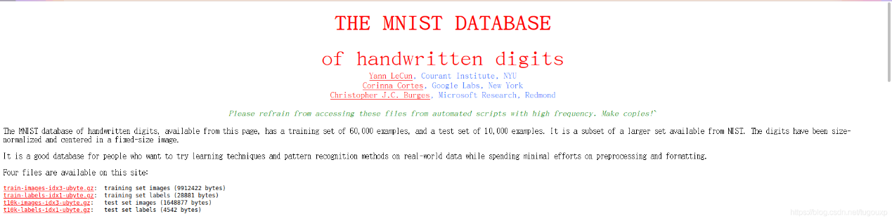

The downloaded MNIST contains the following files

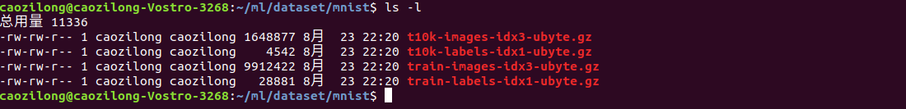

The functions of each file are explained as follows:

T10k-images-idx3-ubyte. gz, 1.6m in size, containing 10,000 samples.
T10k-labelages-idx1-ubyte. gz, size 4.5K, containing 10,000 labels.
Train-images-idx3-ubyte. gz, 9.5m in size, containing 60,000 samples.
Train-allelages-idx1-ubyte. gz, 29K in size, containing 60,000 labels.
After decompression, the pure data file is shown as follows:

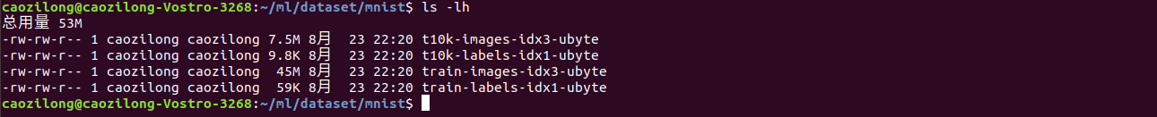

The total amount 53M
-rw-rw-r-- 1 caozilong caozilong 7.5M 23 22:20 t10k-images-idx3-ubyte
-rw-rw-r-- 1 caozilong caozilong 9.8K 23 22:20 t10k-labels-idx1-ubyte
-rw-rw-r-- 1 caozilong caozilong 45M 23 22:20 train-images-idx3-ubyte
-rw-rw-r-- 1 caozilong caozilong 59K 23 22:20 train-labels-idx1-ubyte

2. SVM
Support Vector Machines (SVM) is a dichotomous model that maps the feature vectors of an instance to points in a space. The purpose of THE SVM is to draw a line that "best" distinguishes the two types of points, so that if a new point comes along in the future, the line will also do a good job of classification. SVM is suitable for small and medium-sized data samples, nonlinear, high-dimensional classification problems.
SVM was first proposed by Vladimir N. Vapnik and Alexey Ya. Chervonenkis in 1963, and the current version (soft Margin) was proposed by Corinna Cortes and Vapnik in 1993. And it was published in 1995. Before the emergence of deep learning (2012), SVM was considered to be the most successful and best-performing algorithm in machine learning in recent decades.
1.1 Basic concepts of SVM
Map the eigenvectors of the instance (taking two dimensions as an example) to some points in the space, solid points and hollow points in the figure below, which belong to two different categories. The purpose of SVM is to draw a line that "best" distinguishes the two types of points, so that if a new point comes along in the future, the line will also do a good job of classification.
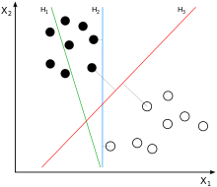
Q1: How many lines can you draw to distinguish sample points?
A: There are an infinite number of lines that can be drawn. The difference is how well they work. Each line can be called a partition hyperplane. For example, the green line above is not good, the blue line is ok, and the red line looks better. The line we hope to find that works best is a partition hyperplane with maximum spacing.
Q2: Why is it called a hyperplane?
A: Because the characteristics of the sample are likely to be higher dimensional, the division of the sample space is not a line.
Q3: What are the criteria for drawing lines? / What makes this line work well? / What's good?
A: SVM will look for partition hyperplanes that can distinguish between the two categories and maximize the margin. When the sample is locally disturbed, it has the least influence on the hyperplane, the classification result is the most robust, and the generalization ability is the strongest for the unknown example.
Q4: What is margin?
A: For any hyperplane, there is a minimum distance (vertical distance) between the data points on both sides of the hyperplane. The sum of these two minimum distances is the interval. For example, the strip area formed by two dotted lines in the figure below is the margin. The dotted line is determined by the two points closest to the central solid line (that is, determined by the support vector). But now the margin is relatively small. If we draw it in the second way, the margin is obviously larger and closer to our target.
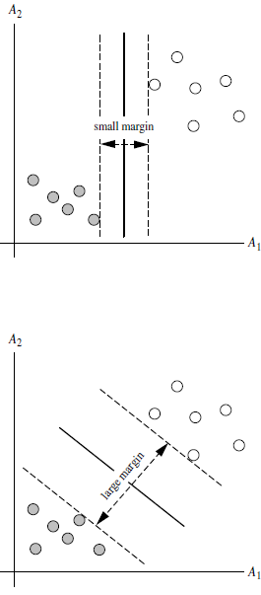
Q5: Why make margin as big as possible?
A: Because big margins are less likely to make mistakes, so they're more robust.
Q6: What are support vectors?
A: As can be seen from the figure above, all the points on the dotted line are the same distance from the partition hyperplane. In fact, only these points together determine the position of the hyperplane, so they are called "Support vectors", hence the "Support vector machine".

1.2 hard-margin SVM
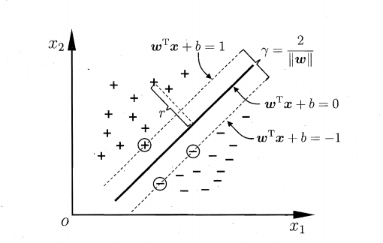

2. The kernel method
Motivation for using nuclear methods
ϕ(X) \phi(X)ϕ(X) is a nonlinear mapping function that transforms vector points in the training set into higher-dimensional ones. Because the algorithmic complexity of the inner product is very large, So we use kernel functions instead of calculating inner products of nonlinear mapping functions.
In the?
How to solve the problem of high algorithm complexity when calculating inner product?
: Using kernel trick
SVM can be extended to multiple classification problems
SVM extension can solve multiple category classification problems:
For each class, there is a binary classifier for the current class and other classes (one-VS-REST)
The multi-classification problem is transformed into n dichotomous problems, where n is the number of categories.
Features of SVM algorithm
The algorithm complexity of the trained model is determined by the number of support vectors, not by the dimension of data. Therefore, SVM is not prone to overfitting.
The model trained by SVM is completely dependent on support vector. Even if all non-support vector points in the training set are removed and the training process is repeated, the exact same model will still be obtained.
If the number of support vectors obtained by a SVM training is relatively small, then the model trained by SVM is easier to be generalized.
3. Bayes
The Bayesian method is actually something that we've been exposed to since high school, and probability in high school is mostly about the Bayesian method.

In fact, before the Bayesian method was really accepted, the frequency school was the rule of probability, so if you had a bag of balls, and you had a bunch of red balls and black balls, before Bayes you could ask anybody what the probability of picking up a red ball was, they would say 50%. Hey! Meng force? How do you know the number of red balls without the number of black balls 50%, the way you think about it in the frequency school is whether red balls are black balls, so 50%.

3.1 Bayes method is proposed
When Thomas Bayes (1702-1763) was alive, he was not well known to the people of his time. He seldom published papers or books, and communicated very little with the academic circles of his time. In today's terms, Bayes was a real folk academic diaos. However, the diaosi finally published An essay titled "An essay Towards Solving a problem in the doctrine of Chances", which translates as: a solution to a problem in the theory of chance. You might think I'm saying: the publication of this paper created a random sensation that cemented Bayes' place in academic history.

First of all, the probability is really an uncertain value, because since it is called probability, there is an element of luck. Suppose that a friend starts a business, there are no more than two outcomes: success or failure. According to the frequency theory, his success is 50%. But you know how he is, he has ideas, he has ideas, he has perseverance, so you might think he has a 70% chance of success, and that's the way Bayes thinks. He differs from the black and white of the traditional frequency school by adding premises.

Now let's take a closer look at the Bayesian approach

Bayes treats it as a random variable and then computes the distribution, which requires us to understand the original distribution.

For example, if you throw a dime on the table, do you know where it will land? If I throw it randomly, then maybe it will land anywhere, that is, the probability that it will land anywhere on the table is uniformly distributed, and this basic premise before the experiment is called the prior distribution.

So we have a formula

Prior distribution + posterior distribution of sample information

Familiar? When you look at the formula for the posterior distribution, isn't that conditional probability in high school?
2.2 Bayes' theorem
Before WE talk about Bayes' theorem, let me introduce a few definitions

1) (A posteriori probability) is the conditional probability events in another event B has occurred under the condition of probability, the formula is expressed as P (A | B), pronounced "under the condition of B A probability".

2) Joint probability means the probability of two things happening together. The joint probability of A and B is equal to or.

3) Edge probability (also known as prior probability) is the probability of an event happening. The edge probability is obtained as follows: In joint probability, it is called marginalization to eliminate the unnecessary events in the final result by merging them into their full probability (the total probability is obtained by summing discrete random variables and the total probability is obtained by integrating continuous random variables). For example, the edge probability of A is expressed as P(A). The edge probability of B is represented by P(B).
Bayesian network, also known as reliability network, is an extension of Bayes method and one of the most effective theoretical models in the field of uncertain knowledge representation and inference. Since it was proposed by Pearl in 1988, it has become a research hotspot in recent years. A Bayesian network is an Directed Acyclic Graph (DAG) consisting of nodes representing variables and Directed edges connecting them. Nodes represent random variables, and directed edges between nodes represent the relationship between nodes (from parent node to child node). Conditional probability is used to express relationship strength, and prior probability is used to express information without parent node. Node variables can be abstractions of any problem, such as: test values, observed phenomena, consultation, etc. It is suitable for expressing and analyzing uncertain and probabilistic events, for making decisions conditionally dependent on multiple control factors, and for making inferences from incomplete, inaccurate or uncertain knowledge or information.

In fact, Bayesian network is a kind of uncertainty processing model that simulates causality in human reasoning process, and its network topology is a directed acyclic graph (DAG). Nodes in directed acyclic graphs of Bayesian networks represent random variables, which can be observed variables, hidden variables, unknown parameters, etc. Variables or propositions that are considered causal (or not conditionally independent) are linked by arrows. If two nodes are connected by a single arrow, indicating that one node is "parents" and the other is "children", the two nodes will generate a conditional probability value.

In general, the arrows connecting the two nodes indicate that the two random variables are causal or not conditionally independent.

For example, assume that node H E will directly affect the node, the E and H, use the arrow from E to H the nodes E to establish H directed arc (E, H), weight (that is, the connection strength) with conditional probability P (H | E).
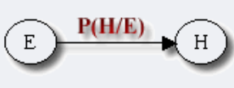

Now I'm going to introduce a very important formula, which is the basic formula that you use when you apply naive Bayes classification. And this formula is calculating the joint probability, in my personal understanding, of the Bayesian network that you're building, the probability that this Bayesian network will happen.

Let G = (I,E) represent a directed acyclic graph (DAG), where I represents the set of all nodes in the graph and E represents the set of directed connected line segments, and let X = (Xi) I ∈ I be the random variable represented by a node I in its directed acyclic graph. If the joint probability of node X can be expressed as:
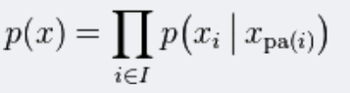

This symbol is similar to the summation symbol, and its actual meaning is multiplication. We extend this formula to obtain:

Everyone here may have strong doubt, why is this, I'll explain it simply, a moment to look at the sample, you will understand, it's actually and bayesian network diagram has the close relation, because in the network diagram, a node may lead to another node, so after expansion is of this type. I'll give you an example, and you'll get the idea.

Here is one of the simplest Bayesian grids
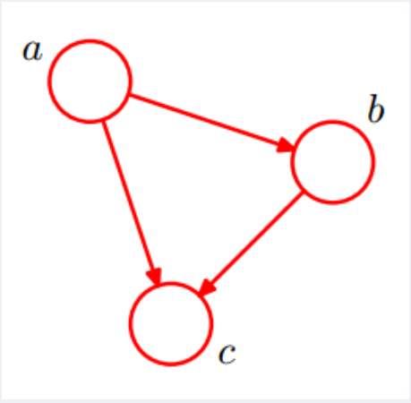

A leads to B, and B and A lead to C

p(a,b,c)=p(c|a,b)p(b|a)p(a)

And you can see from this formula, you're just multiplying the probabilities of each event, and b and C are conditional, so I'm going to write them in terms of conditional probabilities.

Now let's look at a more complex Bayesian network diagram.
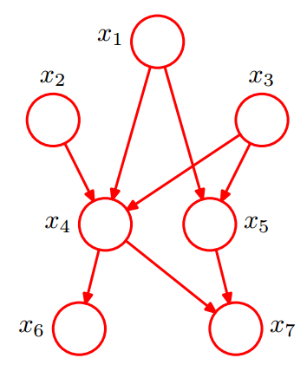

This Bayesian network diagram is also multiplying them one by one, and the joint distribution of these seven nodes is zero

I'm just multiplying the probabilities of each point.

3.2 Structural form of Bayesian network

The structural form of Bayesian network may be considered superfluous when people have no hands-on application, but it is one of the essential foundations in the actual construction of Bayesian network. I'll give you a brief introduction to three forms of Bayesian grid.

Head to head
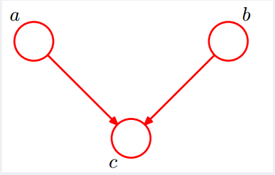

Here we can get the P (a, b, c) = P (a) * P (b) * P (c | a, b) was established, we simplify

Because P (c | a, b) = P (a, b, c)/P (a, b) P (a, b, c), and then we get the P (a, b) = P (a) * P (b)

Therefore, it is concluded that A and B are blocked in the unknown condition of C, which is called head-to-head conditional independence.

The second is tail-to-tail

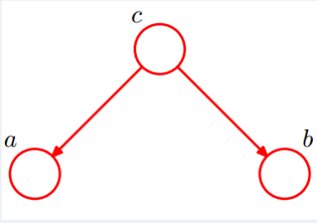

Consider that C is unknown, and c is given these two cases:

1. When c is unknown, there are: P (a, b, c) = P (c) * P (a | c) * P (b | c), at this point, can't it is concluded that P (a, b) = P (a) P (b), c is unknown, a and b is not independent.
2. When c is known, there are: P (a, b | c) = P (a, b, c)/P (c), then P (a, b, c) = P (c) * P (a | c) * P (b | c) into the formula, are: P (a, b | c) = P (a, b, c)/P (c) = P (c) * P (a | c) * P (b | c)/P (c) = P (a | c) * P (b | c), is known as c, a and b independent.
Therefore, under the given condition of C, A and B are blocked and are independent, which is called tail-to-tail condition independence.

The third type: head-to-tail

This form is already spawned an algorithm for the more complex, markov chain model, markov chain model is to I've markov chain model combined with grey model, markov chain model as the authentication model, to verify the accuracy of the gray model, will be dedicated the combination of the two.
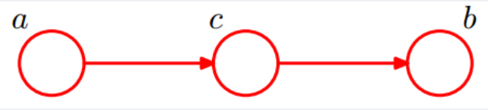
So let's say we have c unknown and WE have C and we have these two cases:

C is unknown, there are: P (a, b, c) = P (a) * P (c | a) * P (b | c), but can't launch P (a, b) = P (a) P (b), c is unknown, a and b is not independent.

C is known, there are: P (a, b | c) = P (a, b, c)/P (c), and according to the P (a, c) = P (a) * P (c | a) = P (c) * P (a | c), can be obtained in:

p(a,b|c)

=p(a,b,c)/p(c)

=p(a)*p(c|a)*p(b|c)/p(c)

=p(a,c)*p(b|c)/p(c)

=p(a|c)*p(b|c)

Therefore, under the given condition of C, A and B are blocked and are independent, which is called head-to-tail condition independence.

3.3 Naive Bayes model

Now that you're ready to get your hands dirty, this is the simplest classification model of Bayesian, as you can see from the name, the naive Bayesian model, and a little bit more complicated is the application of Bayesian grids.
The following content is reproduced in a public account found in the naive Bayes model of the detailed explanation

So what is the core algorithm of naive Bayes classification?
Is the following Bayes' formula:

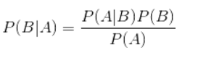

4. The implementation

Mnist-image's handwritten digital data has 70,000 image data (60,000 training data + 10,000 test data), and each image data is 20px * 20px.
What does the data look like?
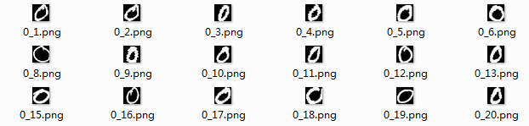

Above is part of the image data of the handwritten number '0'.
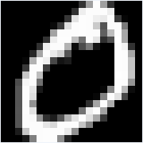

This is the 0_1.png zoom, 20px by 20px.
A: what happened?
What do we do with the data?
1. Transform image data into vectors
Numpy vector is used to represent image data.
The image data is grayed first, and then stored in numPY array. At this time, the value range of each element is 0~255. Then, we perform grayscale transformation on it, map it to the range of 0~1, and round each element to 0 or 1, and finally transform it into a binary matrix. Finally, the 20 * 20 binary matrix is transformed into a 1 * 400 vector.
Convert the 20px by 20px image data into a 1 by 400 NUMPY vector
ImgFile -- the image name is 0_1.png
# return: 1*400 numpy vector
def img2vector(imgFile):
Img = Image. Open (imgFile). The convert (' L ')
Img_arr = np.array(img, 'I ') # 20px * 20px grayscale image
Img_normlization = Np. round(img_arr/255) # Normalize the gray values
Img_arr2 = Np.0 0 (IMg_normlization, (1,-1)) # 1 * 400 matrix
Return img_arr2
2. Read all instances of each number and convert them to a matrix
Then we need to convert all instances of each number to a 1 * 400 vector and convert them to a matrix of N * 400 (N is the number of instances).
Read all the data for a category and convert it to a matrix
# parameters:
# basePath: The basic path where the image data resides
# Mnist - image/train /
# Mnist - image/test /
# clA: category name
# 0,... 9,
# Return: all data for a certain category ----[sample size *(image width x image height)] matrix and label vector
def read_and_convert(imgFileList):
DataLabel = [] #
DataNum = len (imgFileList)
Zeros ((dataNum, 400)) # dataNum * 400
For I in range (dataNum) :
ImgNameStr = imgFileList [I]
ImgName = get_img_name_str(imgNameStr) # get number_instance number.png
# print (" imgName: {} ". The format (imgName))
ClassTag imgName = split (". ") [0]. The split (" _ ") [0] # get class label (digital)
# print (" classTag: {} ". The format (classTag))
DataLabel. Append (classTag)
DataMat [I:] = img2vector (imgNameStr)
return dataMat, dataLabel
3. Integrate training data
Read all instances of all numbers and consolidate them into a very large 60,000-by-400 matrix.
Read training data
def read_all_data():
cName = ['1', '2', '3', '4', '5', '6', '7', '8', '9']
train_data_path = "Mnist-image\\train\\0"
flist = get_file_list(train_data_path)
dataMat, dataLabel = read_and_convert(flist)
for c in cName:
train_data_path_ = "Mnist-image\\train\\" + c
flist_ = get_file_list(train_data_path_)
dataMat_, dataLabel_ = read_and_convert(flist_)
dataMat = np.concatenate((dataMat, dataMat_), axis=0)
dataLabel = np.concatenate((dataLabel, dataLabel_), axis=0)
print(dataMat.shape)
print(len(dataLabel))
return dataMat, dataLabel
At this point our training data is ready.
After loading the data, let's look at this matrix
：
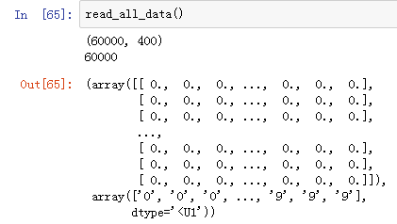

The above array is the 60000 * 400 training data, and the following array is the 1 * 60000 class tag data.
4. Construct SVM model
SVM can be used for both classification and regression tasks. If SVM is not modified, it can only be used to deal with dichotomies.
Handwriting digital font recognition is obviously a multi-category classification problem. For multi-classification problems, the basic idea to solve is "splitting method", that is, several dichotomous problems are split into several ten-classification tasks for solving. Specifically, the problem is first split, and then a classifier is trained for each of the removed ten classification tasks. During the test, the results of these two classifiers are integrated to obtain the final multi-classification result. The splitting strategies are as follows:
OvO (one - v - one)
The idea of this solution is: for any task with N categories, pair the N categories to produce N(n-1)/2 dichotomous tasks. In the test phase, new samples are submitted to all classifiers at the same time, so that N(n-1)/2 classification results can be obtained, and the final result can be voted: that is, the most predicted category is the final classification result.
OvR (one - v - rest)
The idea is to train N classifiers one class at a time as positive examples and all other classes as negative examples. During the test, if only one classifier is predicted to be positive, the corresponding category will be marked as the final classification result.
Comparison of the two strategies:
Obviously, OvR only needs to train N classifiers, while OvO needs to train N(n-1)/2 classifiers, so OvO's storage overhead and test time overhead are generally higher than OvR's. But for training, OvR uses all of the training samples for each classifier, whereas OvO uses only two classes for each classifier. As a result, when there are many classes, OvO's training time overhead is typically smaller than OvR's.As for performance, depending on the specific data distribution, most of the time the two are about the same.
# create model
def create_svm(dataMat, dataLabel, decision='ovr'):
clf = svm.SVC(decision_function_shape=decision)
clf.fit(dataMat, dataLabel)
return clf

SVC parameters:
SVC (C = 1.0, cache_size = 200, class_weight = None, coef0 = 0.0,
Decision_function_shape = 'ovr, degree = 3, gamma =' auto ', the kernel = 'RBF',
Max_iter = 1, aim-listed probability = False, random_state = None, shrinking = True,
Tol = 0.001, verbose = False)
5. Categorization tests
Read the test data and integrate it into a matrix
# Categorize 10 numbers
def main():
tbasePath = "Mnist-image\\test\\"
tcName = ['0', '1', '2', '3', '4', '5', '6', '7', '8', '9']
tst = time.clock()
allErrCount = 0
allErrorRate = 0.0
allScore = 0.0
for tcn in tcName:
testPath = "Mnist-image\\test\\" + tcn
#print("class " + tcn + " path is: {}.".format(testPath))
tflist = get_file_list(testPath)
#tflist
tdataMat, tdataLabel = read_and_convert(tflist)
print("test dataMat shape: {0}, test dataLabel len: {1} ".format(tdataMat.shape, len(tdataLabel)))

#print("test dataLabel: {}".format(len(tdataLabel)))
pre_st = time.clock()
preResult = clf.predict(tdataMat)
pre_et = time.clock()
print("Recognition " + tcn + " spent {:.4f}s.".format((pre_et-pre_st)))
#print("predict result: {}".format(len(preResult)))
errCount = len([x for x in preResult if x!=tcn])
print("errorCount: {}.".format(errCount))
allErrCount += errCount
score_st = time.clock()
score = clf.score(tdataMat, tdataLabel)
score_et = time.clock()
print("computing score spent {:.6f}s.".format(score_et-score_st))
allScore += score
print("score: {:.6f}.".format(score))
print("error rate is {:.6f}.".format((1-score)))
print("---------------------------------------------------------")

tet = time.clock()
print("Testing All class total spent {:.6f}s.".format(tet-tst))
print("All error Count is: {}.".format(allErrCount))
avgAccuracy = allScore/10.0
print("Average accuracy is: {:.6f}.".format(avgAccuracy))
print("Average error rate is: {:.6f}.".format(1-avgScore))
Classification results:
test dataMat shape: (980, 400), test dataLabel len: 980
Recognition 0 spent 9.5305s.
errorCount: 11.
computing score spent 9.693493s.
score: 0.988776.
error rate is 0.011224.
---------------------------------------------------------
test dataMat shape: (1135, 400), test dataLabel len: 1135
Recognition 1 spent 10.7278s.
errorCount: 11.
computing score spent 10.832672s.
score: 0.990308.
error rate is 0.009692.
---------------------------------------------------------
test dataMat shape: (1032, 400), test dataLabel len: 1032
Recognition 2 spent 9.7781s.
errorCount: 57.
computing score spent 9.973572s.
score: 0.944767.
error rate is 0.055233.
---------------------------------------------------------
test dataMat shape: (1010, 400), test dataLabel len: 1010
Recognition 3 spent 9.6072s.
errorCount: 55.
computing score spent 10.072705s.
score: 0.945545.
error rate is 0.054455.
---------------------------------------------------------
test dataMat shape: (982, 400), test dataLabel len: 982
Recognition 4 spent 9.4975s.
errorCount: 44.
computing score spent 9.271692s.
score: 0.955193.
error rate is 0.044807.
---------------------------------------------------------
test dataMat shape: (892, 400), test dataLabel len: 892
Recognition 5 spent 8.4760s.
errorCount: 70.
computing score spent 8.578377s.
score: 0.921525.
error rate is 0.078475.
---------------------------------------------------------
test dataMat shape: (958, 400), test dataLabel len: 958
Recognition 6 spent 9.0267s.
errorCount: 27.
computing score spent 9.043633s.
score: 0.971816.
error rate is 0.028184.
---------------------------------------------------------
test dataMat shape: (1028, 400), test dataLabel len: 1028
Recognition 7 spent 9.8431s.
errorCount: 66.
computing score spent 9.765103s.
score: 0.935798.
error rate is 0.064202.
---------------------------------------------------------
test dataMat shape: (974, 400), test dataLabel len: 974
Recognition 8 spent 9.3546s.
errorCount: 75.
computing score spent 9.849029s.
score: 0.922998.
error rate is 0.077002.
---------------------------------------------------------
test dataMat shape: (1009, 400), test dataLabel len: 1009
Recognition 9 spent 9.6555s.
errorCount: 79.
computing score spent 9.595665s.
score: 0.921705.
error rate is 0.078295.
---------------------------------------------------------
Testing All class total spent 196.587770s.
All error Count is: 495.
Average accuracy is: 0.949843.
Average error rate is: 0.050157.
6. Result analysis
It can be seen from the above results that the accuracy of SVM for handwritten digital font recognition is relatively high, 94.9%. In this example, when the gray value is normalized, one digit after the decimal point is cut off, and then rounded to 0 or 1, and the binary matrix 0-1 is obtained. If different processing methods are adopted to obtain different binary matrices, that is, different eigenmatrices, the classification results will be different.
subsequent
This paper briefly introduces the use of machine learning SVM model for handwritten digital font recognition, handwritten digital font data set is MNIST-Image. In the next chapter, we will use the deep learning framework TensorFlow to construct a neural network to identify this data set.

