

Module Code: ECAD5015

Assignment Title: Deepening Practice
ALN – Part 1 Journal
Student Name: Stella Griffiths
Student Number: 2305515
BA Primary Education (QTS)

AI Acknowledgement

I confirm that I have not used any AI tools in the research and creation of this assignment.
I confirm that I have not presented any AI generated materials as my own work.
I confirm that I have copies of my drafts, notes, and other resources I used, which I may be asked to provide in evidence.

Target | How I have addressed it in this work
1. I appreciate you are working on your targets of deepening critical engagement and synthesis of literature. Continue to develop these skills. | I have deepened critical engagement and synthesise in my work by engaging to essential literature and theorists. I have summarised my reading and expanded by linking to literature together.
2. Develop your paragraph structure to make more persuasive arguments. Look for opportunities to refer back to literature and link to theory where possible. | I have structured my paragraphs by starting with a statement, literature to back the statement, a critical view and then how to overcome the barrier.

Inclusive practice in education is an approach that removes potential barriers to learning and participation for all students, especially students with additional learning needs (ALN). An inclusive education practice focuses on equality for all learners regardless of their abilities in mainstream educational settings. An inclusive classroom involves differentiation depending on each child needs and abilities, numerous teaching strategies and providing specific support to every learner (Booth and Ainscow, 2002). The social model of disability outlines the barriers within society and the environment have an impact on levels of participation in learning rather than ALN (Shakespeare, 2006). Policy development in Wales has drastically developed for students with ALN due to this model. A positive outcome of the policy development is the Additional Learning Needs and Educational Tribunal (Wales) Act 2018. This legislation supports the collaboration for learners and families in education, health, and social care (Welsh Government, 2023).

A theoretical framework that aligns with the act is Vygotsky’s Sociocultural Theory (1978), that indicates that social interaction highly influences the outcomes of learning. Vygotsky’s (1978) Zone of Proximal Development emphasises that through cognitive development, students learning outcomes develop further due to interaction with advanced intellectual others. This suggest that inside an inclusive classroom, learners with ALN thrive through collaboration and interactive environments that influence support rather than being taken out of mainstream. Additionally, Bronfenbrenner’s (1979) ecological systems theory also highlights the importance of supportive peers and staff around the learner to ensure they feel comfortable within their environment.


Contrastingly, several challenges have been apparent throughout the introduction to the ALN and Education Tribunal (Wales) Act 2018. Schools have faced limitations when implementing the policy into practice although the highlighted theorical basis in inclusive practice. Estyn (2023) indicate that limited resources and trained staff effect the delivery of the new act which has negatively impacted the quality of ALN provision.
(Tallett, 2024)

The case study by Harris and Goodall (2021) expands on these challenges. The case study in schools in Wales took a whole-school approach to inclusion by working with local services and families. This approach influenced an increased outcome for the learners by creating a collaborative approach. The study highlights several limitations to implementation of inclusive education reforms in Wales. Schools that effectively implemented inclusive education had more access to resources and trained staff. However, many schools struggled with funding which effected the implementation. These schools were located in economically disadvantaged areas. This had an impact on the ability to implement the support required.

The importance of an inclusive environment as highlighted during my placement in a Welsh urban primary school. The importance of an inclusive environment became apparent through the process of creating Individual Development Plans (IDPs). Children with ALN require IDPs to ensure all teachers are aware of how to support their needs and the outcome that child wants to receive. I observed the process of conducting an IDP, where the teacher, child and family collaboratively contributed. Throughout the process, it was apparent that a person-centred approach was considered throughout by the child actively taking part in the process. The child’s opinion was the main concern which aligns with the United Nations Convention on the right of the child to express their views (UNIEF, 1989). The process has drawn attention to the importance of a person-centred approach by allowing the child to voice their opinions on their own learning to support the child in creating their best outcome. Throughout my teaching practice, I have started to implement inclusive strategies into my teaching which include visual timetables, timers and countdowns and emotional check-in.

Visual timetables are recognisably seen as an effective inclusive teaching strategy that promotes structure and independence for all learner, specifically ALN learners. Visual timetables represent the routine of the day through pictures or symbols to identify what lessons and activities are going to happen in an order (Council for Disabled Children, 2024). Visual timetables with support learners with autism spectrum disorder (ASD), speech, language, and communication needs (SLCN) social, emotional, and behavioural difficulties (SEBD) because they may require a daily routine (Cooper and Jacob, 2011).
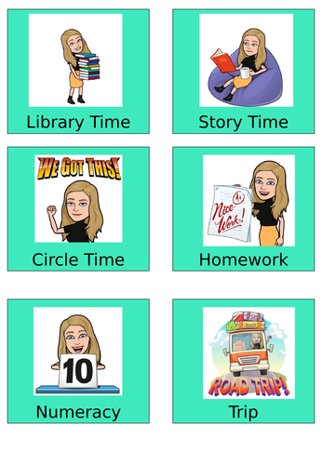
During my teaching practice, it was evident that a visual timetable had an impact on learns that required a routine daily. Before the timetable was implemented, one pupil was experiencing behavioural problems regularly which included not being able to settle down to complete work. When the visual timetable was introduced, their behaviour changed, and they were able to regulate their emotions throughout the day. The child shared their views on the strategy, and it became apparent that the child struggled with not knowing what was happening throughout the day. After seeing the impact on that student, I also started to include the timetable into my teaching where at the beginning of the day a student would place the pictures in order of what was happening through the day. The timetable also supported my time management by referring to through the day.
(Miss Hayward’s Shop, 2021)

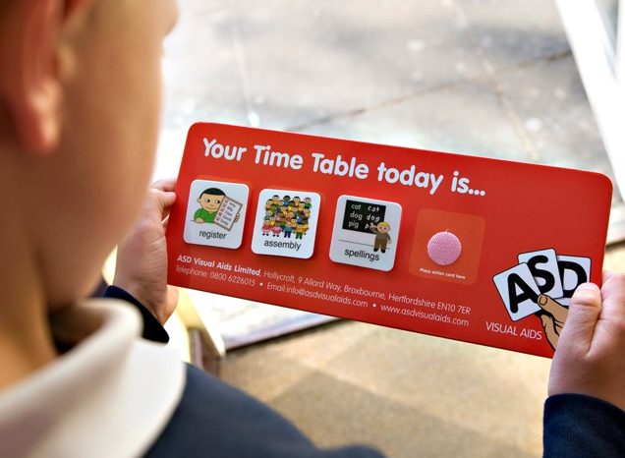
Contrastingly, there are several negatives to the use of visual timetables. According to Mesibov et al (2006) the timetables do not allow unexpected change in routine. A change in routine can increase anxiety and behavioural challenges in ALN learners. When facing this challenge, the teacher can address the change to the learner before changing the timetable so that the individual is aware of the change before it is changed. Additionally, an inclusive classroom required cognitive, language and sensory needs. A visual timetable format may not support each learners needs. Some children may find it difficult to read each lesson card, whereas some students may find images too abstract (Beukelman and Mirenda, 2013). To overcome this limitation, the teacher can create numerous visual timetables that could include pictures of actions, words, and symbols. They can be displayed in different areas of the classroom and each learner can choose one to refer too. However, this can also be time consuming for planning.
(Sense Toys, 2025)
In conclusion, visual timetables are an effective strategy for an inclusive environment depending on the implementation and adaptations to their specific needs.

An additional strategy is emotional check-ins. Emotional check-ins are carried out at the beginning of the day in numerous ways such as verbally and visual symbols. Learners must communicate their feelings by choosing an emotion to support their emotional well-being. Emotional check-ins allow students to develop an understanding of their emotions and how to express them (Twinkl, 2025).

Throughout placement, I observed the use of emotional check-ins on a daily basis. The children took part at the beginning of the day which allowed the children to become more aware of identifying and expressing their emotions. The strategy helped the teacher address negative emotions at the start of the day to prevent any behavioural problems throughout the day. For instance, a child with ASD had chosen an angry symbol. The teacher took time to ask the child how they felt. Then the child shared that they had issues at home and the class teacher then suggested emotional literacy support assistants (ELSA) interventions that allowed the child to express their feelings while receiving support.
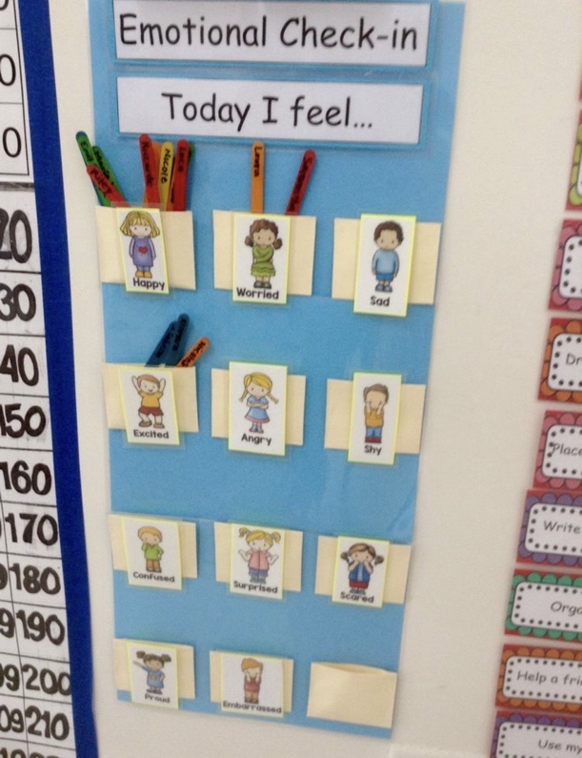
(Taylor, 2023)
Despite the positive benefits to emotional check-ins. There are various challenges to the effectiveness of the strategy. While the check-ins can support emotional regulation. Learners with social, emotional, and mental health needs can influence emotional distress through bringing up trauma and anxiety (Rivers et al., 2013). To prevent distress, staff can offer the learners to share their emotions privately to prevent embarrassment through public sharing. The staff can also remind children that the check-ins are voluntarily, so the child has the choice to share their feelings. Furthermore, visual check-ins can oversimplify emotions. ALN learners may have limited emotional vocabulary and choose an emotion they are familiar with but not because it reflects their emotions (Lisa Feldman Barrett, 2017). This could confuse both the learner and staff with identifying their emotions. To overcome this limitation, the staff can give the children the opportunity to add an emotion to the check-in if they are feeling different to the options given. This will help the staff identify the specific emotion the learner is feeling to correctly support the need.

Emotional check-ins are a valuable tool for creating an inclusive environment where all learners feel supported and emotionally safe (Rivers et al., 2013). Check-ins regularly allow learners to recognise and express their feelings to influence emotional regulation. Encouraging an inclusive environment through emotional regulation can build stronger relations and prevent behavioural problems. However, to effectively support inclusion the check-ins must respectful and voluntary. Emotional check-ins support a rights-based environment where every child can thrive (UNICEF, 1989).

The theories and research discussed link to the teaching standards by highlighting the importance of inclusive environments and person-centred approach which align with the Curriculum for Wales. The standards emphasise the need for supporting ALN learners (Welsh Government, 2023). I have developed an increase understanding of creating an inclusive environment through visual timetables and emotional check-ins to promote continuous development.

Reference list

Beukelman, D.R. and Mirenda, P. (2013) Augmentative and alternative communication: supporting children and adults with complex communication needs. Baltimore: Paul H. Brookes Pub.

Booth, T. and Ainscow, M. (2002) Index for inclusion: developing learning and participation in schools. 3rd edn. Bristol: Centre For Studies on Inclusive Education.

Bronfenbrenner, U. (1979) The Ecology of Human development: Experiments by Nature and design. Cambridge: Harvard University Press.

Cooper, P. and Jacobs, B. (2011) From Inclusion to Engagement. Chichester: Wiley-Blackwell.

Council for Disabled Children (2024) What is a visual timetable? Available at: https://councilfordisabledchildren.org.uk/sites/default/files/uploads/attachments/Visual%20Timetables%20Resource.I%20CAN.FINAL_.pdf (Accessed: 5th May 2025).

Estyn (2023) Thematic Report: Implementation of ALN Reform in Schools. Available at: https://estyn.gov.wales/ (Accessed: 12th May 2025).

Mesibov, G.B., Shea, V., Schopler, E. and Al, E. (2006) The TEACCH approach to autism spectrum disorders. New York: Springer.

Miss Hayward’s Shop (2021) Bitmoji Visual Timetable. [image]. Available at: https://www.tes.com/teaching-resource/bitmoji-visual-timetable-12563993 (Accessed: 18th May 2025).

Lisa Feldman Barrett (2017) How emotions are made the secret life of the brain. Boston: Mariner Books.

Rivers, S.E., Brackett, M.A., Omori, M., Sickler, C., Bertoli, M.C. and Salovey, P. (2013) Emotion Skills as a Protective Factor for Risky Behaviors Among College Students. Journal of College Student Development, 54(2), pp.172–183.

Sense Toys (2025) Visual Timetable Board. [image]. Available at: https://sensetoys.com/products/visual-timetable-board (Accessed: 18th May 2025).

Shakespeare, T. (2006) Disability Rights and Wrongs. London: Routledge.

Tallett, A. (2024) Understanding and improving person centred care for children and young people. [image]. Available at: https://picker.org/research_insights/understanding-and-improving-person-centred-care-for-children-and-young-people/ (Accessed: 18th May 2025).

Taylor, H. (2023) Emotional Check-in. [image]. Available at: https://inside.ewu.edu/managementtoolbox/emotional-check-in/ (Accessed: 18th May 2025).

Twinkl (2025) Emotions Check-in. Available at: https://www.twinkl.co.uk/resource/cfe-p-308-emotions-check-in-resource-pack (Accessed: 5th May 2025).

UNICEF (1989) How we Protect Children’s Rights. Available at: https://www.unicef.org.uk/what-we-do/un-convention-child-rights/ (Accessed: 5th May 2025).

Vygotsky, L. (1978) Mind in society: The development of higher psychological processes. Cambridge: Harvard University Press.

Welsh Government (2023) Additional Learning Needs and Education Tribunal (Wales) Act 2018. Available at: https://law.gov.wales/additional-learning-needs-and-education-tribunal-wales-act-2018 (Accessed: 5th May 2025).

