NAME: Prasanna Dhakal
STUDENT NUMBER:2131567
MODULE: LCMB7006
LECTURER: Tushara Balendran
COURSE: Master’s in business administration
SUBMISSION DATE:13/01/2023
TITLE: International marketing

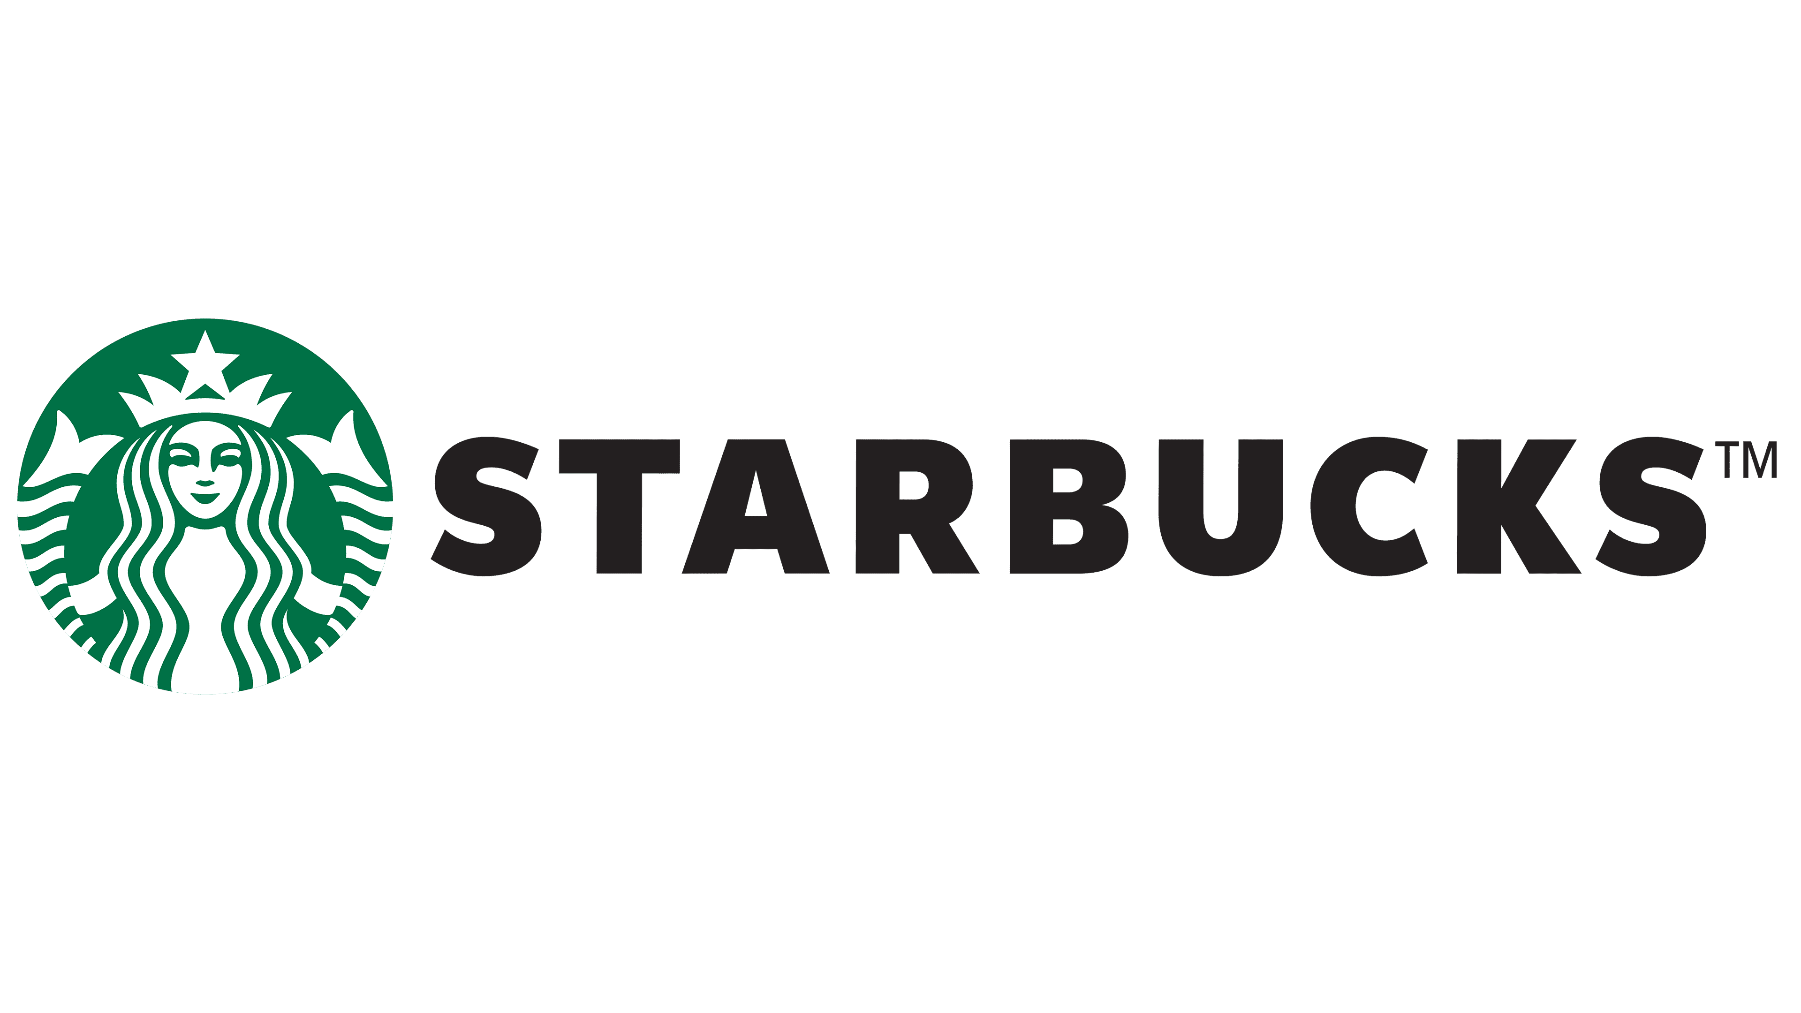

Table of Contents
Introduction:…………………………………………………………………………………...4
Background: 4
Macro-Environmental Analysis of Starbucks in USA and UK: 4
Porter five forces of Model of Starbucks for USA and UK: 8
SWOT Analysis of Starbucks Company for USA and UK: 11
Advantages and Disadvantages of SWOT analysis model: 13
Relation to STP of Starbucks in UK and USA: 13
Marketing Mix for USA and UK: 15
Market Entry Strategy of Starbucks: 17
Ansoff Matrix analysis of Starbucks for USA and UK: 20
BCG Matrix analysis of Starbucks for USA and UK: 22
Product Life cycle model of Starbucks: 24
Product Life cycle strategies of Starbucks for USA and UK: 25
Defence strategies for Pioneers in the Growth stage of the PLC for USA and UK: 25
Attack strategies for Followers in the Growth stage of the PLC for USA and UK: 26
Strategies in the Maturity stage of the PLC for USA and UK: 26
Recommendation:…………………………………………………………………………….27
TOWS matrix for USA and UK:……………………………………………………………..28
Conclusion:…………………………………………………………………………………...28
References: 29

Introduction:
When a company practises "global marketing," it tailors its approach to the preferences of customers in different parts of the world. The goal of global marketing is to bring in more customers outside of a company's current home market.
Large companies that do business all over the world tend to standardise their products and use economies of scale to cut costs. A high level of local responsiveness, on the other hand, suggests that a company would make its products fit the needs of customers in a certain area. Because of these two factors, many different strategies have come about, such as multi-national, multinational, and transnational initiatives.
Starbucks has a multi-domestic approach in its global expansion. It has a fast response time but weak integration. As a result, the corporation tailors its wares to the tastes of local customers. As a result of the lack of a centralised decision-making structure, different branches of the company are given discretionary authority to make decisions.

Background:
The first of what would become many Starbucks coffee shops opened in 1971 in Settle, Washington. The success of the company comes from the high quality of its coffee and the hard work of its employees. Starbucks' "one person, one cup, one neighbourhood at a time" marketing campaign has changed the American coffee industry and made Western coffee culture known around the world. More than 100 million people will frequent the world's 33,832 Starbucks locations annually by 2022 (Environments, no date).

Macro-Environmental Analysis of Starbucks in USA and UK:
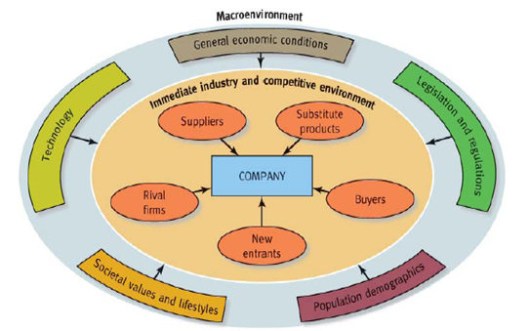
Fig.1: Starbucks Macro-environment analysis
Source: https://ivypanda.com/essays/macro-environmental-factors-of-starbucks/
- Political Factors:
- Brown (19) thinks that the coffee industry is exposed to a lot of political pressures from the macro environment (Lingley, 2009). This means that businesses like Starbucks need to keep an eye on political disturbances and policy changes, like the decision to take the assets of a foreign corporation.
- The problem is made worse by the fact that American regulations put limits on the market. Multi-national corporations with U.S. headquarters are now subject to more regulation than ever before. Furthermore, the company should monitor the political situation in the nation. Additional factors to consider:
  - Funding Government Spending
  - Employment law
- Another aspect of politics that might have an impact on global trade is tax policy. As of 2015, it was revealed that from 2003, when Starbucks first opened there, until 2015, the company has paid no corporate tax in the United Kingdom (Kim and Park, 2021). The corporation may find success by focusing more on the British market.
- Economic Factors:
- Starbucks' primary external economic driver is the current global economic slowdown. As I've previously said, this element harmed Starbucks' bottom line. As a result, consumers have been opting for less expensive options. Given that they have continued to purchase coffee, this may be a promising market for Starbucks. Both wages and other business expenses are on the rise in the United States, causing problems for the organisation. There is a great deal of anxiety due to the inflationary climate and the decline in profits.
The following economic factors may also have an impact on Starbucks:
  - The current exchange rates of the local currency
  - Economies in many regions throughout the world
  - Degree of taxation
- The high demand for high-end coffee and snacks in the UK could be caused by a number of things, such as people having more money to spend and the price of coffee changing around the world. The recession of 2008–2009 had a significant negative impact on Starbucks' bottom line. By March of 2008, Starbucks' sales had declined 28% as a result of the recession's effect on customers' discretionary spending in the face of growing unemployment and stagnant incomes, resulting to the closure of almost 900 stores and the layoff of 6,700 staff (Tsai et al., 2020). Starbucks' primary raw material is coffee beans; hence the company's costs and profits are very sensitive to the shifting prices of coffee beans on the international market. Profits rise as the cost of coffee beans falls below their market value.
- Social Factors:
- Starbuck's might have trouble if more and more Americans who care about their health start to avoid the company's more indulgent products. Demand may be affected by changes in the population, such as a drop or rise in the median age. The majority of Starbucks' customers are middle-aged adults (25-45), including men and women. A more costly brand may appeal to consumers who have more discretionary income to spend. It seems to reason that the demand for Starbucks drinks has an effect on customers' disposable earnings since both have changed over time.
- Brown (19) says that Starbucks' CAFE mission was made to calm the fears of the CSR industry and protect the livelihood of coffee-bean growers in UK, who could become an industry standard in the future (Fabiana Meijon Fadul, 2019). The company now often buys non-fat milk in order to meet the needs of its growing number of health-conscious customers.
- Technological Factors:
- Starbucks is well positioned to take advantage of the growing mobile market in the USA. They are riding the mobile wave to success because of their connection with Starbucks, which provides subsidised software. The availability of wireless internet access through Wi-Fi has long been a standard feature in today's retail locations. Customers place a high premium on having an Internet connection. Now that they have Wi-Fi, they can get their job done at Starbucks. To restate the point, the company's overall reputation benefits from this. This agreement is beneficial for both the business and the customer. Mobile payment options are now available at Starbucks as well. In the United States, they are conducting pilot tests.
- Starbucks' state-of-the-art IT infrastructure in the UK includes Wi-Fi internet access, coffee bean roasting and brewing equipment, and more.
- Legal Factors:
- In order to be in accordance with numerous regulations in the United States, this corporation pays an extra $250,000,000 on health-insurance and $225,000 USD to handle Consumer Protection lawsuit for gift card breaches (‘the Chinese Attitude To Foreign Brands in the Case’, no date). Employment rules (including maximum hours worked and minimum wages) and health and safety regulations also fall under this category (which includes customer safety legislation).
- If Starbucks has been so successful in the UK, it may be because it has followed all laws and regulations to the letter. For as long as anybody can remember, Starbucks has been synonymous with delicious coffee and tasty treats. Starbucks' brand recognition increased from 52nd to 52nd in 2018. " (Starbucks, 2020) The organisation is not only a "wonderful place to work" and winner of 2014 Employer of the Year, but also received a perfect score of 100 on the disability equality index.
- Environmental Factors:
- Some of the measures taken by the company to ensure a sustainable production process in the USA include: in-store recycling, reusing cups, composting used coffee grounds, purchasing renewable-energy, designing to verify retail outlets and retail archetypes, cutting power usage by 25%, implementing a climate change policy, focusing on energy conservation, and so on (Musonera, 2021).
- In 2014, Starbucks bought about 5% of all the coffee beans that were needed in the UK. The resulting figure is 442.8 million tonnes (Khanum et al., 2018). Because of the effects of climate change on coffee bean cultivation, Starbucks' supply chain and future profits are in jeopardy. If the weather continues to become hotter, coffee producers may witness decreased yields and worse quality in their harvests.
- Cultural Factors:
We learned that Starbucks would be increasing the size of their online store and making other changes to their online presence in the United States and the United Kingdom to entice customers to visit a physical location, such as making it easier for users to find the "in store" icon button on every product page. When product, pricing, and packaging information is obscured in favour of the high-context "come to the shop" strategy, it makes navigation, search queries, and information acquisition more challenging. While we understand the commercial rationale, we believe that Starbucks' website should be updated to once again include the missing information, this time with more robust mechanisms to account for external restrictions (such as pricing variations between states) to minimise the inconvenience to customers.
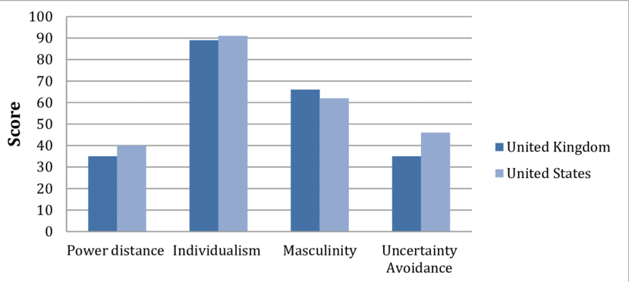
Fig.2: Hofstede's Cultural Dimensions for U.S. versus U.K.
Source: https://www.researchgate.net/figure/Hofstedes-Cultural-Dimensions-for-US-versus-UK_fig2_336409478

Porter five forces of Model of Starbucks for USA and UK:
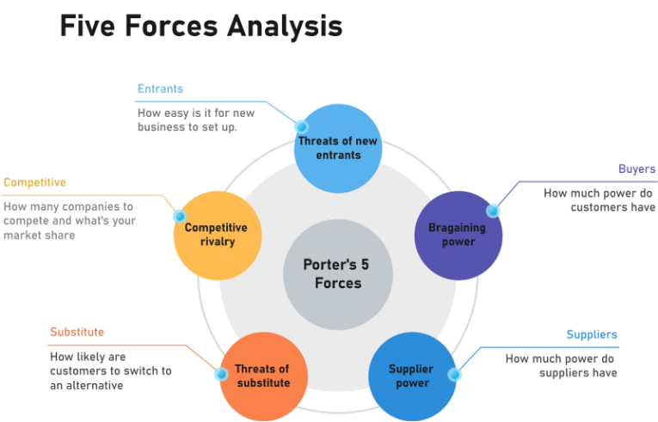
Fig.3: Starbucks porter five forces of model
Source: https://www.edrawmax.com/article/starbucks-porters-five-forces-analysis.html
- Industry Competition:
When there is more competition in the same market, prices drop and profits go down. Starbucks is always facing new competitors because the restaurant business is very competitive and there aren't many barriers to getting in or getting out. Starbucks has a bigger share of the U.S. market than its competitors because of the high quality and uniqueness of its products. The level of competitiveness in this industry is high due to a number of variables, including;
- There are a lot of businesses in this industry since the barriers to entry and departure are low.
- The average number of businesses has a satisfactory effect on the economy.
- One motivation is the lessened burden of making a new decision.
As Starbucks expands, it confronts stiffer competition in the UK. The possibility that competitors would aggressively lower prices, launch similar products, or increase output in order to gain market share. Eventually, Starbucks' rivals were able to catch up to the company because of the company's innovative products. The primary competitor of Starbucks has a far easier job maintaining steady fixed costs.
- Bargaining Power of Buyers:
Starbucks is a good example of how consumers can make a big difference even in a very competitive and diverse economy like the U.S. and UK Customers that care about price are more likely to spend a considerable amount (Jun, Ma and Lee, 2019). Because preferences change often, particularly in response to suggestions from loved ones, switching is free of any hidden fees.
Consumer demand is likely to be high if a number of conditions are met. When a UK buyer has a high level of awareness, routinely makes large purchases, the supplying industry has many small operators, there are alternative sources of supply, the cost of the component or material accounts for a sizable portion of the total cost, and the cost of switching suppliers is low or involves little risk, backward integration by the buyer is always a possibility.
- Threat of New Entrants:
A potential threat to Starbucks in the United States is the emergence of new competitors who, via efficiencies and breakthroughs in the industry, may undercut Starbucks' prices. However, it's not even a significant contender in the industry. There are few obstacles to opening and running a coffee business like this one. This suggests that small businesses in the area may challenge established chains like Starbucks. By looking at Starbucks as an example, we can see how the company's strong brand recognition, loyal customer base, and market dominance help to reduce this risk. It has boosted output, improved product quality, and bolstered its infrastructure greatly in response to this challenge. Since its competitors can't match Starbucks' access to ingredients and suppliers (Lee, 2020), Starbucks is in a particularly advantageous position to compete.
By allowing new entrants, the competition in the UK market will increase. This shouldn't be too much of a worry, given Starbucks' already substantial market dominance in the coffee business. It's a direct challenge to the newcomers. The more volume an established company does, the more at risk a new entry is because of the superior knowledge and resources available to the incumbent.
- Bargaining Power of Suppliers:
The relationship between Starbucks and its American suppliers is intricate and interesting. It has its own supplier diversity policy since it uses so many suppliers from different parts of the globe. Due to Starbucks' massive order volume, the corporation is important to individual suppliers. It's also working with regional farmers to strengthen its position in the food supply.
In the United Kingdom, power was rationed to suppliers. Their coffee bean demands may have dropped, but with $9.8 billion in sales in 2009 and growing, Starbucks is still "the most famous specialty coffee shop company in the world" (Qianru, Xinbei and Minghua, 2021). The degree of reliance that Starbucks' vendors have on the coffee chain should be comparable to, if not higher than, that of the company itself.
- Threat of Buyers Opting for Substitute Products:
There is a lot of rivalry between Starbucks and other coffee companies in the United States and UK. Several other drinks and coffee brands may serve as suitable substitutes for Starbucks coffee. The transition will incur little expense. However, this impact may be somewhat counteracted by great quality and brand loyalty.
Starbucks' popularity in the UK would increase if consumers could trade their coffee for tea, iced coffee, or juice.

SWOT Analysis of Starbucks Company for USA and UK:
- Strength:
For the twelve months ended September 30, 2022, Starbucks' annual sales in the United States were $32.250 billion, an increase of 10.98% from the previous year. In 2022, Starbucks' annual sales were $32.25 billion, an increase of 10.98 percent over the previous year.
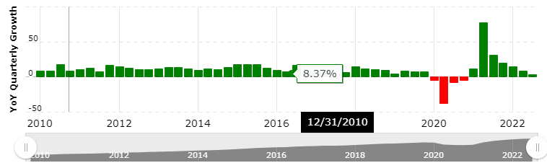
Fig.4: Starbucks revenue in USA till 2022
Source: https://www.macrotrends.net/stocks/charts/SBUX/starbucks/revenue
Due in large part to the company's phenomenal success in the United States, Starbucks is now the world leader in the coffee and beverage retail market. The company's over $4 billion value gives it a significant advantage over its competitors.
It is well-known in the UK for its activism, moral rectitude, and commitment to environmental protection. Considering its position in the Top 100, it was attractive to a large number of potential employees in 2005 (Wang, 2021). The Starbucks Card, Starbucks Gift Card, and Starbucks Reward Program Workers in this organisation are respected, given ample opportunities for professional development, and generously rewarded for their efforts.
- Weaknesses:
Profitability in the United States and the United Kingdom is very sensitive to changes in the price of coffee beans, the company's primary input. Starbucks seems to be too vulnerable to swings in the price of coffee beans; the company would do well to diversify its product offering to reduce this exposure.
More than 75% of its shops are located in the United States, making it the undisputed leader in the retail sector there. Risks to the business may be minimised by growth (Haskova, 2015).
Because the company's products are priced in the high and medium ranges, middle-class workers in the UK cannot afford to buy them.
- Opportunities:
The expansion of the company's network of US suppliers might make it less reliant on a select set of suppliers, making it more robust in the face of economic volatility. This would increase the firm's safety net against disruptions in its supply chain and make it more resilient to fluctuations in the price of coffee beans.
The firm would do well to increase its retail footprint in key American and Britain cities in order to attract a wider audience and capture a larger portion of the market. This opening is a good fit for the company's goals of expanding its product line, its customer base, and its presence in both domestic and international markets.
To be competitive in the growing British market against fast food giants like McDonald's and Burger King, Starbucks may do well to broaden the selection of food and drink it now offers.
- Threats:
The rising cost of coffee beans and the attendant disruptions in the supply chain have presented difficulties for the company in the United States. The growing price of dairy products poses a risk to the company's bottom line.
Local coffeeshops and specialty stores provide stiff competition to the global company, which is trying to attract the same customers. This suggests that small businesses, especially those whose customers are brand-agnostic, represent a serious danger to the company's bottom line.
As a result of its success, several imitators have emerged, and they pose a threat to its growth in the UK market. It's possible that if the cost of things like coffee and milk goes up, Starbucks' profit margin would too. Farmers are often portrayed negatively in the media of supply countries.

Advantages and Disadvantages of SWOT analysis model:
Some brainstorming sessions might benefit from using the SWOT approach because of its many features, such as the fact that it can be applied to a wide range of business problems. One of the tool's drawbacks is that it relies on a subjective evaluation of the problem, which may be off-putting to certain users.

Relation to STP of Starbucks in UK and USA:
- Segmentation:
During its early years, Starbucks focused on serving Americans from the upper middle class and the professional and administrative classes. Even so, they thought there would be growth opportunities in the market and made plans to attract a bigger customer base (Shim et al., 2021).
When Starbucks originally started in the United Kingdom, their clientele consisted mostly of well-to-do professionals in search of a quiet area to sip a latte during their lunch break. Starbucks was able to divide his customers even more by opening stores in places where recent college graduates and coffee lovers lived.
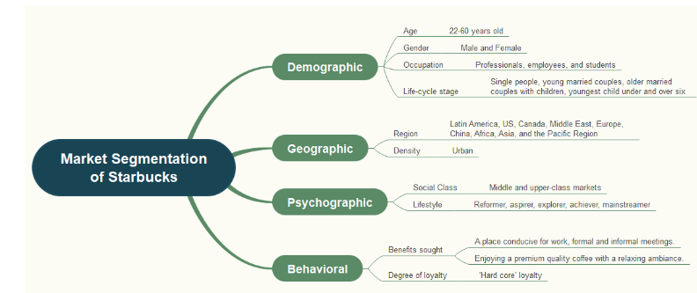
Fig.5: Segmentation variables of Starbucks in USA and Uk
Source: https://www.edrawmind.com/article/starbucks-market-segmentation-targeting-and-positioning.html
- Targeting:
In both the United States and the United Kingdom, middle-class and affluent professionals make up the bulk of Starbucks' customer base. Starbucks is a global coffee chain that listens to its customers to figure out how to make its signature drinks work best in each area it serves (Dwipamurti, Mawardi and Nuralam, 2018). If a country has a Starbucks, then foreigners may eat among locals and get a flavour of the culture.
Starbucks wants to attract customers who want to eat better and more sustainably by putting nutrition information about its drinks and food on its website in Uk. This information will include the number of calories, the amount of fiber, the amount of salt, and the amount of protein. Customers who are trying to reduce their caloric intake may appreciate this information.
- Positioning:
For example, Starbucks has created a unique market position to set itself apart from competitors in the U.S. and other key areas. The emphasis of the business strategy is on consistently exceeding consumer expectations. The firm has earned rave reviews from its core clients thanks to its dedication to environmental sustainability, its aim to improve customers' lives, and the welcoming atmosphere of its retail shops (Shim et al., 2021). Thanks to Starbucks' beneficial impact, the Starbucks brand is safe for consumers to buy.
Starbucks' positioning strategy in the United Kingdom is based on their promise to give great customer service. This will help spread the word about their name and products. Starbucks has taken over a large part of the coffee shop business, from design to sound systems, thanks to its customer-focused business model and high-quality facilities. Employees at Starbucks are treated like partners in the firm since they have a say in the company's destiny and are guaranteed a stable income.
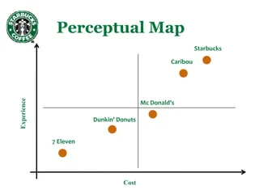
Fig.6: Perceptual Map of Starbucks in USA and Uk
Source: https://www.slideshare.net/puneetarora369/starbucks-final-ppt

Marketing Mix for USA and UK:
- Product:
Before the introduction of non-fat milk and cold blended beverages, coffee was the only thing that Starbucks sold in the United States and UK both. I went on to describe a few of the sweets and pastries available, as well as a few of the seasonal drinks like strawberry and cream Frappuccino’s and gingerbread lattes. Starbucks polled customers to see whether they were interested in trying out its new products.
Starbucks is well-known in the US due to the high quality of its coffee, and the chain's fame has recently moved over the Atlantic to the UK. Most of the more than a thousand choices are different kinds of coffee, smoothies, biscuits, tea, muffins, pastries, doughnuts, fresh fruit juice, blended drinks, and a lot more. Customers' names are written by hand on their own Starbucks coffee cups, making them an instantly recognisable symbol of the company's dedication to product design and a fan favourite.
- Price:
Even though it has higher prices than its competitors, Starbucks has devoted customers in the United States and the United Kingdom. Starbucks' prices are higher than those of its competitors, but the higher quality of their products and the many free extras they offer more than make up for the difference.

Fig.7: pricing strategy of Starbuck
Source: https://iide.co/case-studies/marketing-mix-of-starbucks/
- Place:
In 2022, Starbucks own and run 9,265 stores in the U.S., and another 6,608 stores are owned and run under licence by the world-famous coffeehouse business (Lombardi, Chidiac and Record, 2021).
In 2022, there are 1,156 Starbucks locations in the UK.

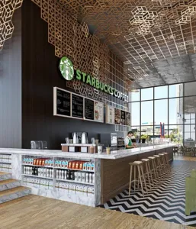
Fig.8: Starbuck store place
Source: https://iide.co/case-studies/marketing-mix-of-starbucks/

Market Entry Strategy of Starbucks:
USA:
Starbucks creates companies that it owns outright, enters into strategic partnerships, and gets licences to do business in new countries. Businesses usually set up wholly-owned subsidiaries in areas where they already have a lot of knowledge. This is true in particular for the American market.
UK:
Starbucks grew in Asia and (eventually) the Middle East through partnerships, but they chose to buy their way into the United Kingdom.
- Promotion:
In the United States and UK, commercials for Starbucks may be seen on television and in internet forums, among other places. Their success depends on how well they can keep their brand voice the same across all of their marketing efforts. Large advertising budgets almost always fail to generate a profit.

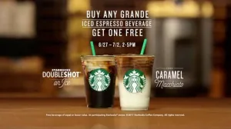
Fig.9: Starbucks Print Ad
Source: https://iide.co/case-studies/marketing-mix-of-starbucks/
- People:
Customers who have had a great experience with Starbucks products in the United States are more inclined to recommend the company to their friends and family. The abundance of taste discussion around Starbucks amounts to free promotion for the company.
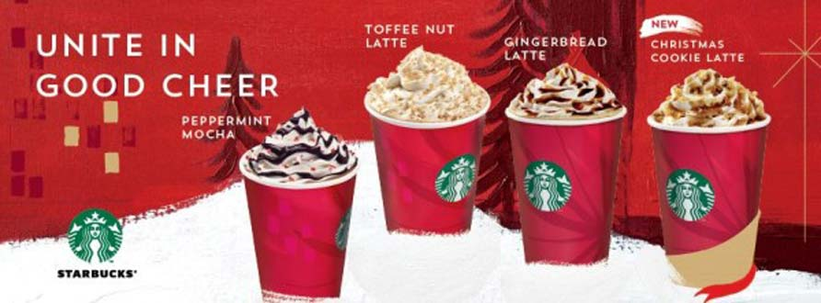
Fig.10: Starbuck’s advertising campaign is built in part on the back of satisfied consumers' comments. Cult of Mac is the image's source (2017).
Source: https://mavsocial.com/starbucks-christmas-social-campaign/
Starbucks' reputation in the United Kingdom as an employer that values its staff has been earned. The goal of the Barista Basics Training programme is to equip newly hired baristas with the conceptual framework and practical abilities they'll need to do a good job. Providing excellent service to customers is a top priority for Starbucks.
- Process:
Starbuck’s customer service in the US is accessible via a variety of mediums. Customers who need service for their Starbucks products can choose to receive a phone call, start a conversation, or go to a Starbucks Retail Store.
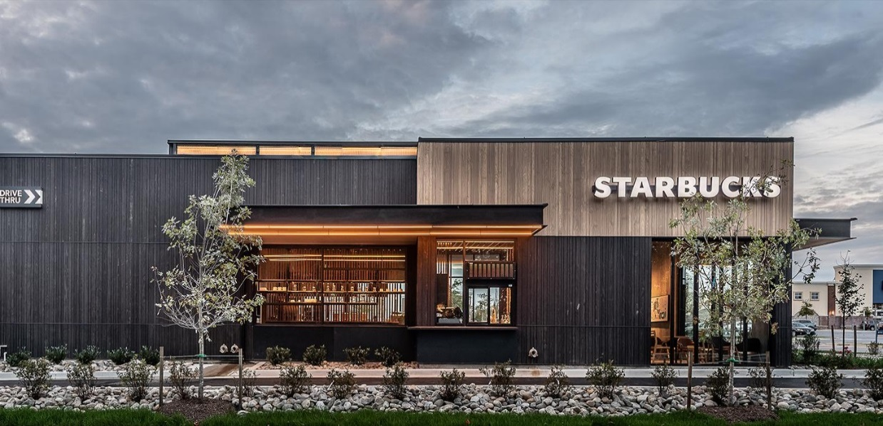
Fig.11: Starbucks retail store.
Source: https://stories.starbucks.com/press/2020/starbucks-to-transform-us-store-portfolio-by-building-on-the-strength-of-digital-customer-relationships/
Customers in the United Kingdom have access to Starbuck’s expert and free technical support staff at any of the company's retail locations or online (Shailza, 2020).
- Physical Evidence:
Starbucks has taken a unique approach to designing the inside of its cafes by asking local artists and designers to create a unique atmosphere for each one.
In 2011, Starbucks released a smartphone app for its consumers. Customers have been able to make purchases inside the store and have them delivered to the curbside or drive-thru window ever since (Rayie, 2021).
71% of app users visited Starbucks at least once per week as of March 2019 (Rayie, 2021). Provider of market analytics and consumer insights, Numerator, compiled this information.

Ansoff Matrix analysis of Starbucks for USA and UK:
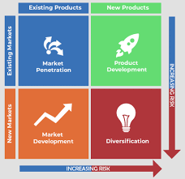
Fig.12: Starbucks Ansoff Matrix
Source: https://heartofcodes.com/ansoff-matrix-of-starbucks/
Starbucks employs four distinct growth methods within the context of the Ansoff Matrix:
- Market Penetration:
Market penetration refers to the practise of selling into an existing market. In the eyes of Starbucks' core demographic in the United States, no other coffee shop comes close. The largest coffee company in the United States is using an integrated marketing strategy to attract new customers and increase sales. One Seattle cafe advertises itself as a halfway house between the monotony of work and the comfort of home.
If Starbucks' low sales in the United Kingdom's Tier 2 and Tier 3 locations are due to their high pricing, the company may want to consider cutting prices there. Starbucks is thinking about starting a programme that would give rewards to loyal customers who bring in new customers (Osiyo and Semuel, 2018). This new system would supplement Starbucks' existing Rewards programme. Starbucks may attempt discounting its products on certain days as part of a larger promotional effort if they want to increase sales even more.
- Product Development:
In Ansoff's view, new product development is a key factor in the expansion of any business. According to the matrix, the corporation should introduce new products into the existing market. Increasing the selection of available products is another name for this tactic. The company might launch an all-new product, update and relaunch an old one, or do nothing at all. The Starbucks card and the Starbucks VIA Ready brew, both of which have been successful in the United States and the United Kingdom, are examples of Starbucks' use of this strategy. To put it another way, it gave people a chance to spice up their coffee with all sorts of unique flavours (Areiza-Padilla, Cervera-Taulet and Puertas, 2020). In an effort to increase interest in Starbucks' new food and beverage offerings, the company's marketers may use several techniques.
- Market Development:
Making new points of sale is a crucial aspect of any strategy to break into a new market. For the Starbucks Corporation, this is a vital growth strategy. The company opened its first coffee shop in Seattle's Pike Place in 1971 and has since expanded to manage 171,133 shops and licence another 167,000 around the country. In the not-too-distant future, they want to expand their store presence throughout the country and beyond the world (Grandelli, 2019).
- Diversification:
If you're from the US or the UK, you've undoubtedly heard of McDonald's McCafé. Due to McCafé and its extensive menu of coffees and smoothies, McDonald's has a leg up on the competition. To be successful, Starbucks needs a diversified approach like this. They are losing out on a significant market segment by not offering breakfast, lunch, and dinner. Starbucks' potential entry into the healthy food business has been speculated about in response to rising consumer demand (Fischer and Roy, 2019).

BCG Matrix analysis of Starbucks for USA and UK:
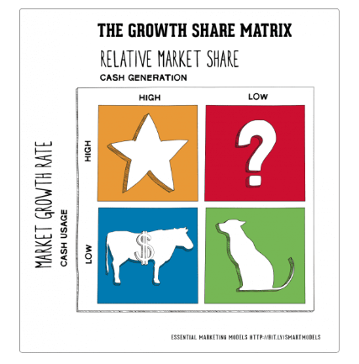
Fig.15: Starbucks BCG Matrix
Source: https://heartofcodes.com/bcg-matrix-of-starbucks/
- Question Mark:
Most of the Tumblers, Mugs, T-Shirts, etc., that Starbucks sells to consumers in the United States are limited edition, seasonal items that sell out quickly. People who go to Starbuck's think it's a badge of honour to be seen in public wearing any of the company's products.
A vast variety of mugs, cups, t-shirts, and other items may be purchased as official Starbucks gear. Whether they're limited edition or seasonal, they usually don't last long on store shelves until they're gone. Customers of Starbucks are proud to show off their purchases because the company cares about quality and the Starbucks name is well-known.
Rare designs, particularly those that have done well in the United Kingdom, are the exclusive focus of certain websites, who then resell and transport them to eager customers all over the world.
Starbucks still has a way to go before it can be considered a major player in the UK's clothes and general retail industries. This being the case, your Starbucks orders should be placed in the question mark.
- Stars:
The United States supermarket market is the most important since it accounts for around 25% of overall revenue. In order to boost food sales by 2021, the company is looking into new food products and alternatives. The warm breakfast sandwiches are a great touch, and there's a good selection of coffees to choose from.
High-protein, low-fat snack sales of Sous Vide Egg Bites, which hit the UK market in January 2017, are rising 60% year over year (Rayie, 2021).
- Cash Cows:
The United States and the United Kingdom are ideal locations for a Starbucks franchise because of the rising demand for coffee in both nations. Accelerated growth in the coffee business, which has been a money maker for the company from the start, has helped it reach levels of success that were previously unimaginable.
Even though Barista, Cafe Coffee Day, Costa Coffee, and many other coffee shops are strong competitors, Starbucks has built a loyal customer base.
This organisation stands out from the competition because of the superior quality of the coffee they sell. The way people thought about coffee and how they drank it changed dramatically when the first Starbucks opened in 1971 (Haskova, 2015).
- Poor Dogs:
Using the BCG matrix as a yardstick, Starbucks' plastic bags strategic business unit in the US is doing badly. Five years ago, this crucial division started losing money and hasn't stopped since. The market it formerly serviced is decreasing as more individuals become aware of and concerned about environmental problems. To maximise revenues, Starbucks could consider spinning off or selling its most successful product line.
According to BCG's matrix, Starbucks' UK No. 5 brand strategic business unit is doing poorly. Over the last five years, this industry has shown nothing but declining trends. Even this crucial division is exacerbating the company's financial problems. However, developments in the global economy are forecast to drive the industry's continued growth. Starbucks has to make a substantial investment if it wants to turn a profit. As the economy recovers, Starbucks will benefit greatly.

Product Life cycle model of Starbucks:
USA:
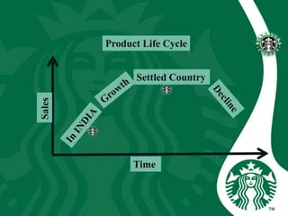
Fig.16: Starbucks product life cycle model in USA
Source: https://www.slideshare.net/GirishJadhwani/starbucks-coffee-66643401
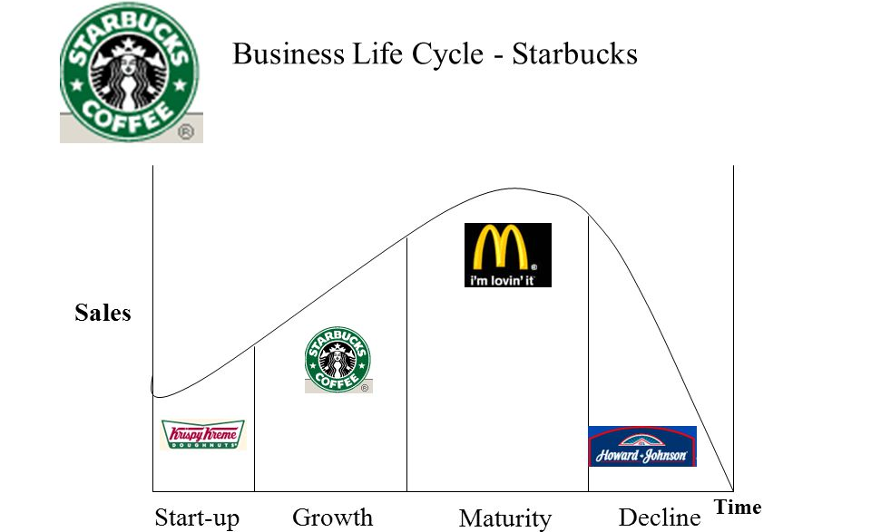
Fig.17: Starbucks product lifecycle model in UK
Source: https://slideplayer.com/slide/3801409/

Product Life cycle strategies of Starbucks for USA and UK:
- Introduction Strategies:
- Develop its distinct brand identity.
- Find the best people to help spread the word about their product's launch.
- To charge a price that is not terribly inflated.
- Growth Strategies:
- Increasing their market share by developing and releasing novel product features and supporting services
- getting into new niches of the market.
- Increase the segmentation of markets.
- Should increase their distribution channels in UK.
- Maturity Strategies:
- To shift one's market strategy so as to steal market share from rivals.
- For the purpose of enhancing and introducing new features to their products.
- Establishing a price for all products and setting it apart from competitors in the market
- Decline Strategies:
- They need to cut back on the money they're spending on product promotion.
- Find a different application for the item.
- To withdraw the service or product after it has reached its full potential.

Defence strategies for Pioneers in the Growth stage of the PLC for USA and UK:
- Fortress or position defence strategy:
Although its competitors have decreased the prices in their products, Starbucks has shown no interest in doing the same for their special items in USA and UK.
- Flanker strategy:
In USA and UK, to cover the gap of premium prices and incompatibility with its rivals, Starbucks normally manufactures high quality and unique features-based products.
- Confrontation strategy:
In the European countries, if Starbucks rivals launch new product, Starbucks will not quickly follow that approach by releasing its own new product.
- Market expansion strategy:
In USA and UK, Starbucks is deciding to increase the further new number of shops outsides the cities to facilitate the travellers.

Attack strategies for Followers in the Growth stage of the PLC for USA and UK:
- Frontal Attack strategy:
In European countries, Starbucks, McDonald and Whitebread have been at frontal attack with each other for the past many decades.
- Leapfrog strategy:
Starbucks store and their side products are extra-ordinary which makes them unique and different in USA and UK against their competitors.
- Flank Attack:
Starbuck's ecosystem gives it unmatched market resilience against their competitors in USA. And that’s how it attacks on its competitors weak spots.
In the UK, Starbucks has highlighted its innovation and user privacy, emphasising the Fresh-brewed coffee customer satisfaction, ease of taste. Starbucks has ignored the interim report and refused to consider ecosystem changes.
- Encirclement strategy:
Starbucks has launched multiple products variants with varied prices in the US and UK markets to outsell competitors.

Strategies in the Maturity stage of the PLC for USA and UK:
- Increased Penetration Strategy:
In the United States, Starbucks has 6,608 physical stores. Starbucks will also expand its market in the future to increase its marketing. As well as They are also thinking to increase its ecommerce market strength.
Starbucks or authorised franchises sell UK products. Unauthorized Starbucks franchises sell it and expand market share. The company sells online. After launching the product, the corporation offers discounts to acquire market share.
- Extended User Strategy:
In the USA and UK and many other countries, Starbucks employs "high prices" to convince customers that popular products are available in short term basis in a day. Because they don’t compromise on the quality of their products.
- Global Market Expansion Strategy:
The core of Starbucks differentiation strategy is the development of new goods and services that help deliver outstanding value to customers. creating a strong consumer base and boosting the business's visibility overseas (Rayie, 2021).
Recommendation:

TOWS matrix for USA and UK:
USA:
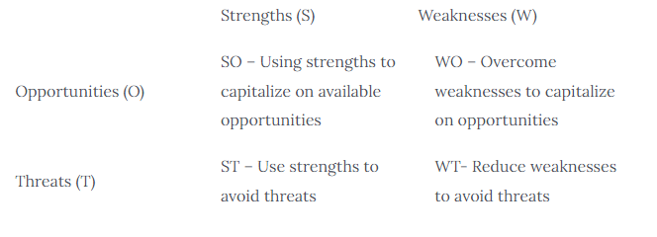
Fig.13: TOW analysis table of Starbucks for USA
Source: https://www.notesmatic.com/tows-matrix-for-starbucks/
UK:
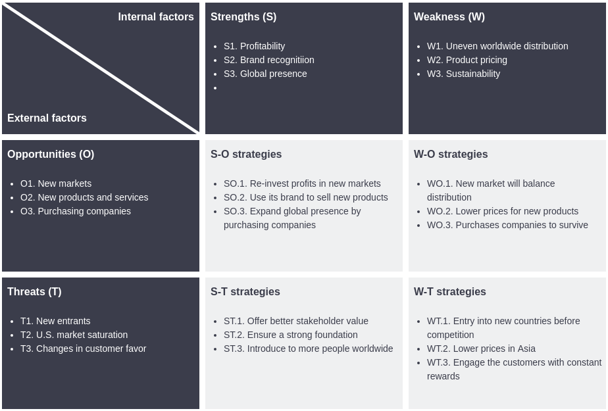

Fig.14: TOWS analysis table of Starbucks for UK
Source: https://online.visual-paradigm.com/diagrams/templates/tows-analysis/starbucks-coffee-tows-matrix/

Conclusion:
Instead of spending a lot of money on ads that don't help people, Starbucks has come up with a marketing plan that focuses on its customers and good business practices. The success of the cafe might be due to the fact that it is in a busy area with a lot of foot traffic. Keeping this client and encouraging repeat business is a formidable task.
The "experimental" 18–40-year-old age group is a common customer demographic for the firm. The café offers expensive coffee to its wealthy regulars and unique drinks to its younger, trendier audience so that it may maintain its posh reputation. Not only are Starbucks' drinks delicious, but the chain's decor and vibe are also highly sought after.
CSR plays an important role in Starbucks. The company places a high priority on the welfare of its coffee and tea farmers, and it is also helping the environment by establishing eco-friendly retail locations, decreasing its water use, and providing its coffee in recyclable cups. In addition, they use the utilisation of social media into their marketing approach to keep in regular contact with their customers. A number of customer-facing initiatives are planned, and suggestions for enhancements are solicited, with the eventual goal of achieving this.

References:
- Areiza-padilla, j.a., cervera-taulet, a. And puertas, m.a.m. (2020) ‘ethnocentrism at the coffee shop industry: a study of starbucks in developing countries’, journal of open innovation: technology, market, and complexity, 6(4), pp. 1–20. Available at: https://doi.org/10.3390/joitmc6040164.
- Dwipamurti, i.g.a.n., mawardi, m.k. and nuralam, i.p. (2018) ‘the effect of green marketing on brand image and purchase decision (study on consumer of starbucks café ubud, gianyar bali)’, jurnal administrasi bisnis (jab), 61(3), pp. 57–64. Available at: www.starbucks.com.
- Environments, m. (no date) ‘contemporary marketing assignment no . 1 starbucks an analysis of the micro and macro environments’, (1).
- Fabiana meijon fadul (2019) ‘済無no title no title no title’.
- Fischer, d. And roy, k. (2019) ‘market entry in india: the curious case of starbucks’, rutgers business review, 4(2), pp. 124–139.
- Grandelli, k. (2019) ‘a cup of colonialism : a qualitative analysis of starbucks and fair trade coffee’. Available at: https://digitalcommons.hollins.edu/researchawards/46/.
- Haskova, k. (2015) ‘starbucks marketing analysis’, cris - bulletin of the centre for research and interdisciplinary study, 2015(1), pp. 11–29. Available at: https://doi.org/10.1515/cris-2015-0002.
- Jun, y., ma, y. And lee, h. (2019) ‘empirical study of space localization approach on brand attitude: the case of starbucks in south korea’, archives of design research, 32(4), pp. 27–37. Available at: https://doi.org/10.15187/adr.2019.11.32.4.27.
- Kee, d.m.h. et al. (2021) ‘how starbucks maintain its competitive edge? – the secret of its success’, journal of the community development in asia, 4(2), pp. 34–43.
- Khanum, s. Et al. (2018) ‘starbucks market segmentation and targeting’, international journal of business and management invention (ijbmi) issn, 7(5), pp. 44–45. Available at: www.ijbmi.org44%7cpage.
- Kim, j.e. and park, e.s. (2021) ‘the spatial design marketing strategy of global franchises that take into consideration the characteristics of modern consumers—a study involving the global coffee companies of starbucks and blue bottle’, land, 10(7). Available at: https://doi.org/10.3390/land10070716.
- Lee, s.-y. (2020) ‘study on digital transformation strategies: starbucks case study’, journal of digital contents society, 21(10), pp. 1809–1816. Available at: https://doi.org/10.9728/dcs.2020.21.10.1809.
- Lingley, r. (2009) ‘marketing strategy and alliances analysis of starbucks corporation’, liberty university, p. 10. Available at: http://digitalcommons.liberty.edu/busi_fac_pubs/10.
- Lombardi, c. V., chidiac, n.t. and record, b.c. (2021) ‘starbucks coffee corporation’s marketing response to the covid-19 pandemic’, innovative marketing, 17(2), pp. 177–188. Available at: https://doi.org/10.21511/im.17(2).2021.16.
- Musonera, e. (2021) ‘strategic marketing case analysis: starbucks’, journal of business and social science review issue, 2(11), pp. 12–22. Available at: https://doi.org/10.48150/jbssr.v2no11.2021.a2.
- Osiyo, a.k.m. and semuel, h. (2018) ‘pengaruh green marketing terhadap green brand image dan purchase intention pelanggan pada starbucks coffee malang’, jurnal strategi pemasaran, 5(2), pp. 1–9.
- Qianru, x., xinbei, p. And minghua, c. (2021) ‘research on transnational marketing strategies of new-style tea in china -- based on the case of overseas marketing of starbucks’, proceedings of the 2021 6th international conference on social sciences and economic development (icssed 2021), 543(icssed), pp. 698–701. Available at: https://doi.org/10.2991/assehr.k.210407.132.
- Rayie, t. (2021) ‘improving the quality of processed apple products through the home industry food permit (pirt) to encourage marketing development in batu district, batu city’, business and management research, 193(bistic), pp. 138–142.
- Shailza, s. (2020) ‘prospects of custard apple value chain development in rajasthan’, economic affairs, 65(2), pp. 117–123. Available at: https://doi.org/10.46852/0424-2513.2.2020.11.
- Shim, j. Et al. (2021) ‘antecedents of purchase intention at starbucks in the context of covid-19 pandemic’, sustainability (switzerland), 13(4), pp. 1–14. Available at: https://doi.org/10.3390/su13041758.
- Starbucks, c.: (2020) ‘chau nguyen sustainability marketing concept’, (december).
- ‘the chinese attitude to foreign brands in the case’ (no date), pp. 607–610.
- Tsai, p.h. et al. (2020) ‘exploring the effect of starbucks’ green marketing on consumers’ purchase decisions from consumers’ perspective’, journal of retailing and consumer services, 56(march), p. 102162. Available at: https://doi.org/10.1016/j.jretconser.2020.102162.
- Wang, s. (2021) ‘different marketing strategies between starbucks and luckin coffee and the impact of the epidemic’, proceedings of the 2021 international conference on enterprise management and economic development (icemed 2021), 178(icemed), pp. 1–5. Available at: https://doi.org/10.2991/aebmr.k.210601.001.

