
Discover North Wales
Website Design and Development Report


Name : Rike Raranti Siska
Student Number: 2531290
Module Code : ACCA4023
Lecture Name : Suresh Shanmugasundaram
Date : 14th August 2026

Table of Contents

Website Design and Development Report 2
1. Introduction 2
2. Requirements 2
3. Implementation 2
3.1 Website Development 2
4. Evaluation 10
4.1 Website Usability 10
4.2 Website Accessibility 10
4.4 Evaluation of the Completed Website 10
5. Compare two live websites 10
5.1. Introduction 10
5.2. Usability Comparison 10
5.3. Accessibility Comparison 14
5.4 SEO Comparison 14
5.5. Mobile Friendliness 18
6. Conclusion 20
7. References 20
8. Appendices 20

Website Design and Development Report

1. Introduction
This report outlines the design, development, implementation, and evaluation of the Discover North Wales website. Created to offer visitors clear and useful information about North Wales, it highlights main destinations and activities. The project showcases the use of HTML for structuring content and CSS for styling and layout. It covers the website’s requirements, purpose, target audience, development process, and HTML/CSS validation. Additionally, it assesses key web development principles such as usability, accessibility, and SEO, while highlighting the site's strengths and areas for improvement.

2. Requirements
The main goal of this project was to develop a straightforward, accessible tourism website about North Wales that offers valuable information and simple navigation. The site features key sections: Home, Destination, and Things to Do. The Home page introduces North Wales, while the Destination page showcases popular spots like Anglesey, Beaumaris, Betws-Y-Coed, Caernarfon, and Snowdonia. The Things to Do page emphasizes activities and attractions for visitors. Designed to be visually attractive and easy to read, the website uses appropriate images, headings, colours, and clear navigation. Content is structured with HTML, and CSS manages the layout and style. Navigational links are included for easy page movement. A gallery could be added later to display more photos of North Wales.

3. Implementation

3.1 Website Development
The website was built with HTML and CSS in Notepad++. HTML provided the core structure and content for each page, while CSS enhanced the visual design, including layout, spacing, colours, images, the navigation menu, and text alignment. The development process was incremental, beginning with a navigation menu to facilitate movement between pages. Images of North Wales locations were added to make the site more appealing and informative. CSS styling-controlled image sizes, centred headings, organised content into sections, and maintained a uniform look throughout. Regular testing in a web browser during development helped identify issues such as oversized images, misaligned headings, and broken links. These problems were resolved by reviewing and modifying the HTML and CSS code[1]

3.2 Completed Website Pages
The North Wales tourism website now includes several pages filled with helpful visitor information. Important pages are Home, Destination, and Things to Do. The Home page introduces North Wales with a clear heading, images, and a summary of the site. The Destination page highlights popular locations like Anglesey, Beaumaris, Betws-y-Coed, Caernarfon, and Snowdonia, with relevant images and short descriptions. The Things to Do page features activities and attractions, all presented with a consistent design and straightforward navigation.

3.3 HTML and CSS Validation
After completing the website development, the HTML and CSS code was checked using the W3C Markup Validator and W3C CSS Validator. These tools detect coding issues such as missing tags, incorrect attributes, and invalid CSS rules. All errors and warnings were examined and corrected as needed. Validation enhances code quality, ensures adherence to web standards, and promotes consistent display across various browsers. Screenshots of the validation results are provided as proof that the testing was performed[2].

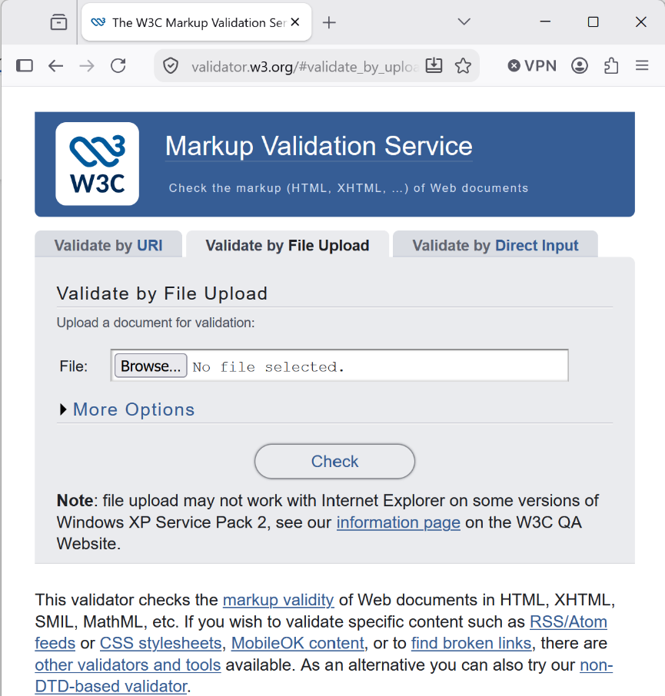
Figure 1
Shows the W3C HTML Validator, where the “Validate by file Upload” option was selected to check the website’s HTML code.

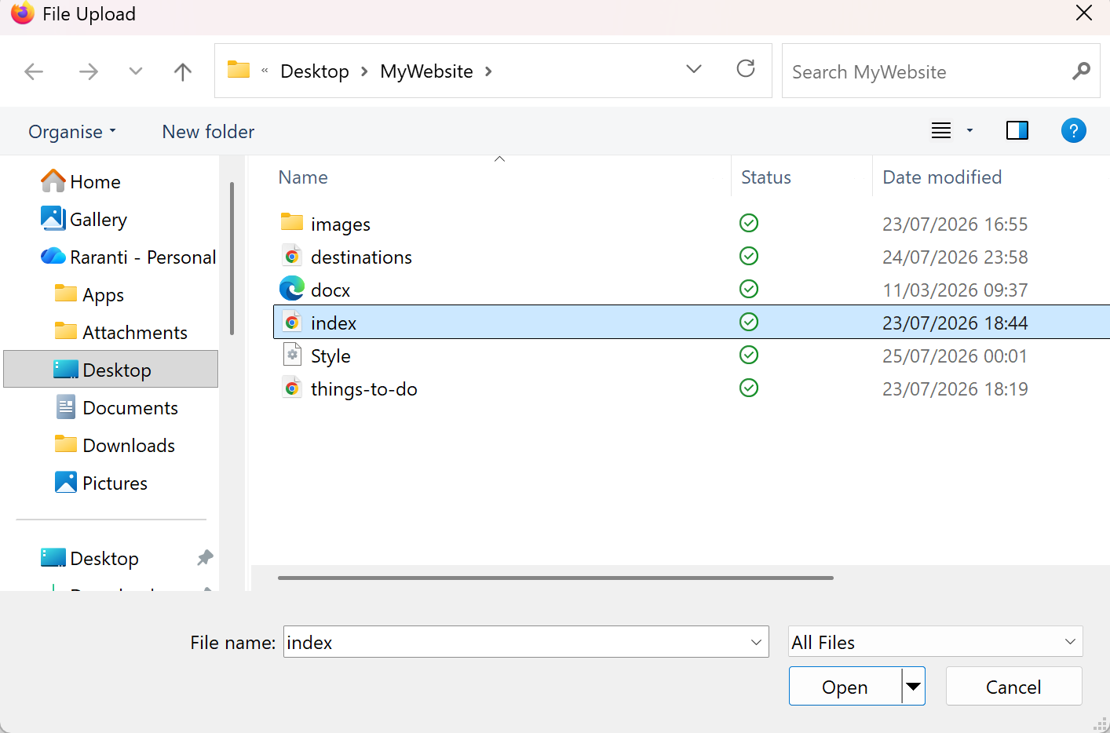
Figure 2
Shows the index.html file being selected from the website folder and uploaded to the W3C Validator for validation.

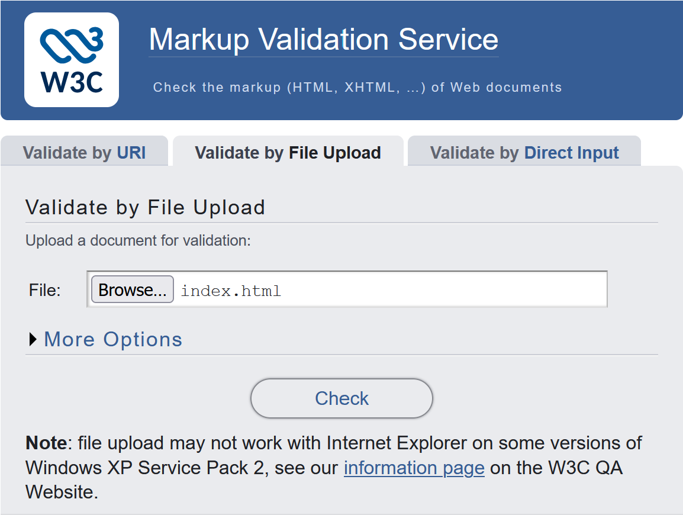
Figure 3
Shows the index.html file being uploaded to the W3C Markup Validation Service. The Check button starts the HTML validation process.

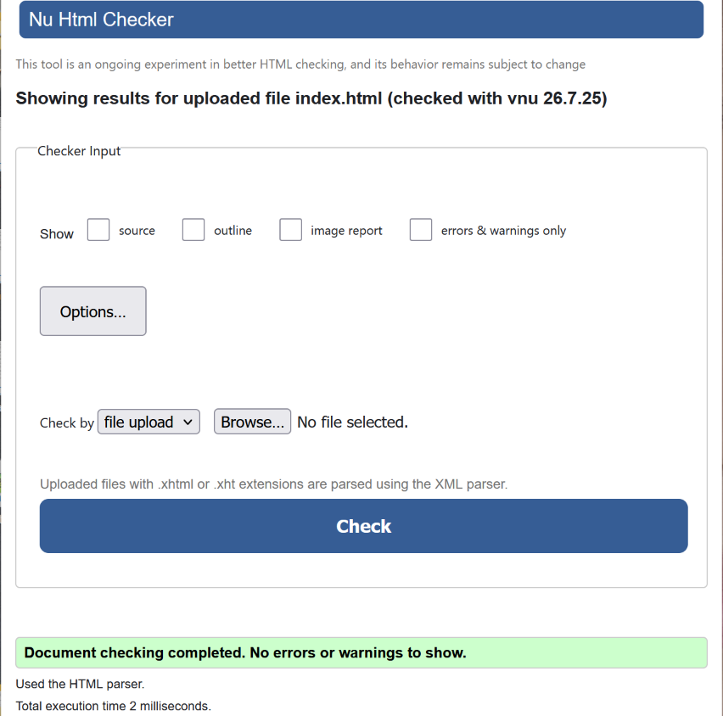
Figure 4
Shows the validation result for index.html. The check completed successfully with no errors or warnings, confirming that the HTML code complies with web standards.

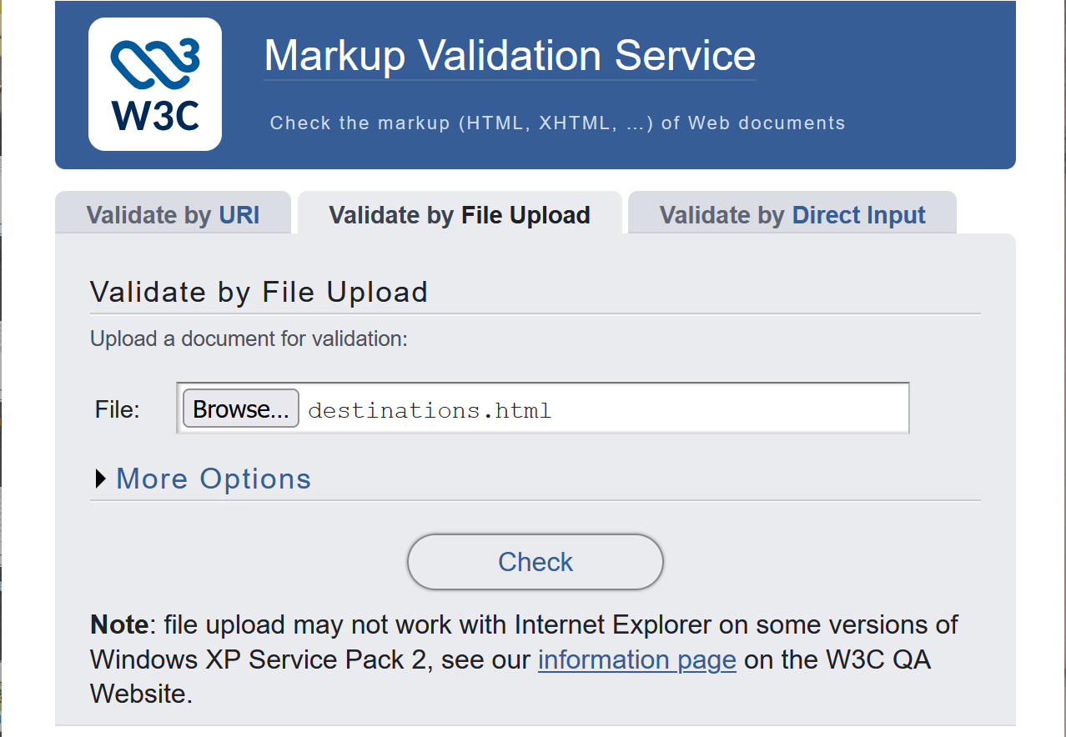
Figure 5
Shows the destination.html file being uploaded to the W3C Markup Validation service to check the HTML code for errors.

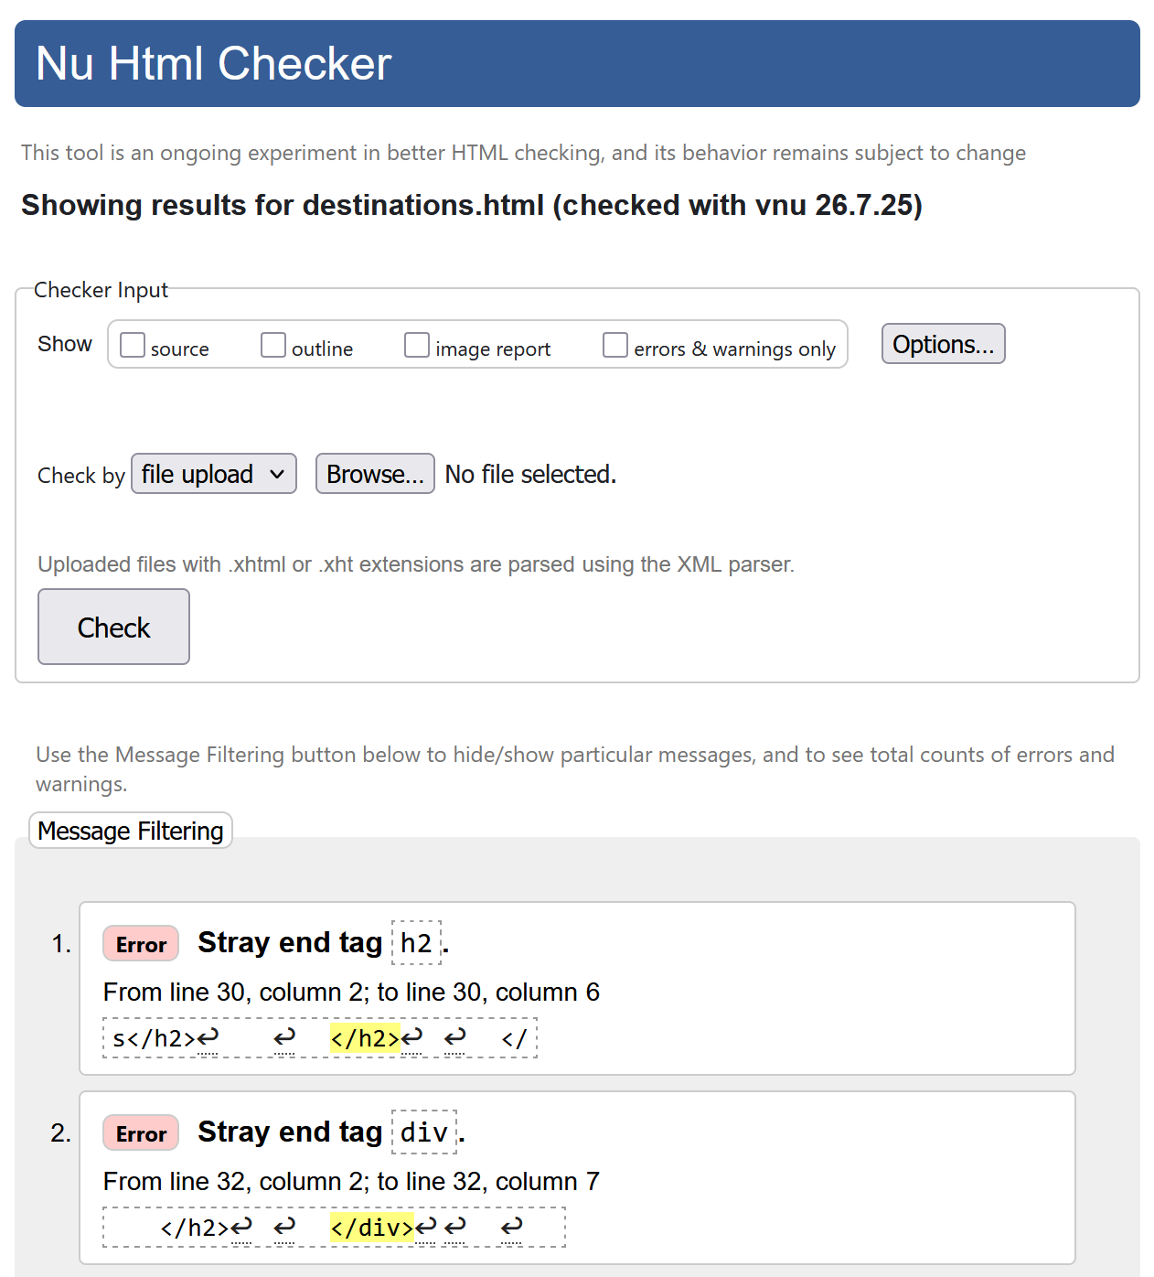

Figure 6
Shows that the validator detected two HTML errors in destination.html. The errors were caused by incorrectly closing </h2> and </div> tags, which needed to be corrected.

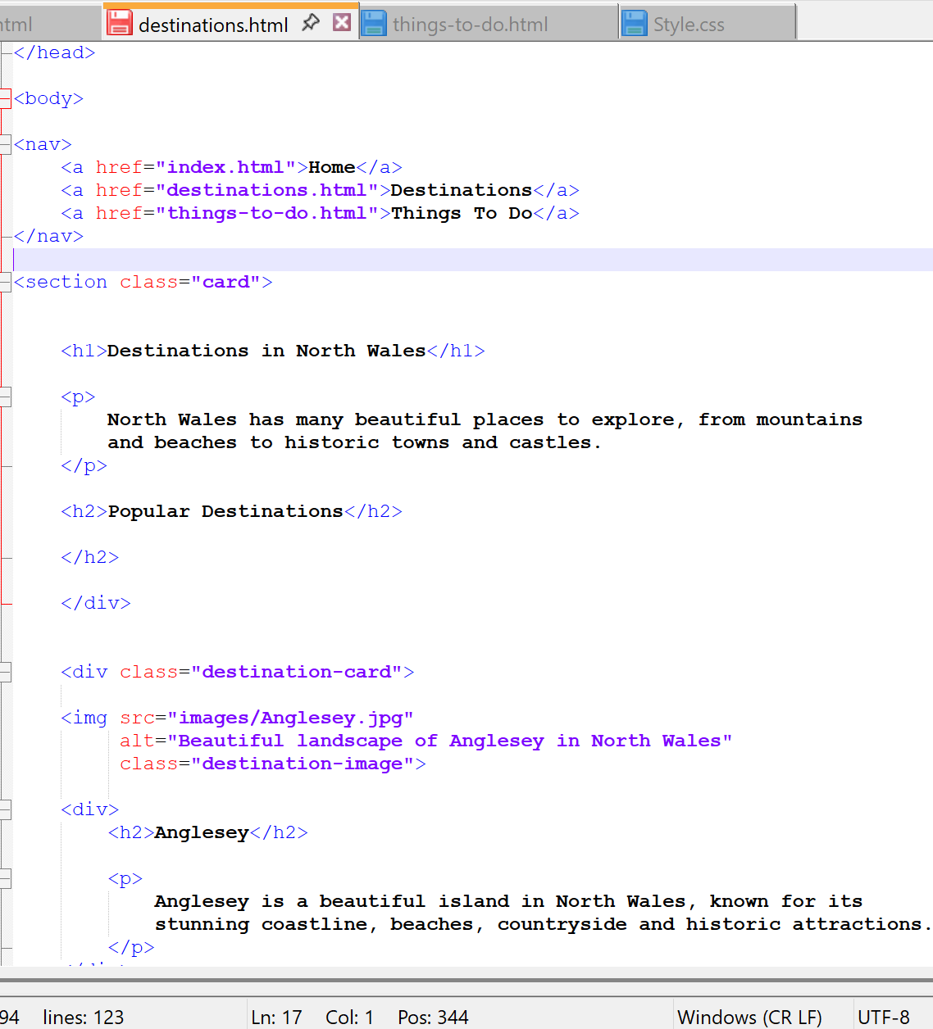
Figure 7
Shows the errors identified in destination.html. The extra </h2> and </div> closing tags were identified and removed to correct the HTML structure before revalidation.

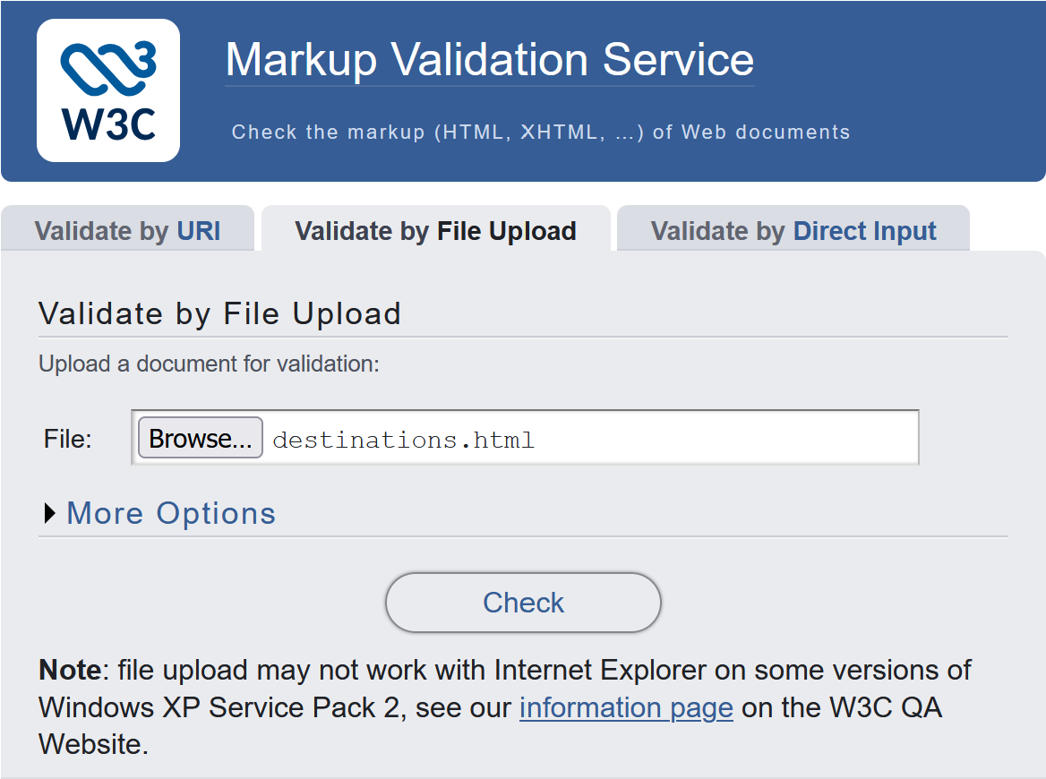
Figure 8
Shows the corrected destination.html file being uploaded again to the W3C Markup Validation Service to check whether the previous HTML errors have been fixed.

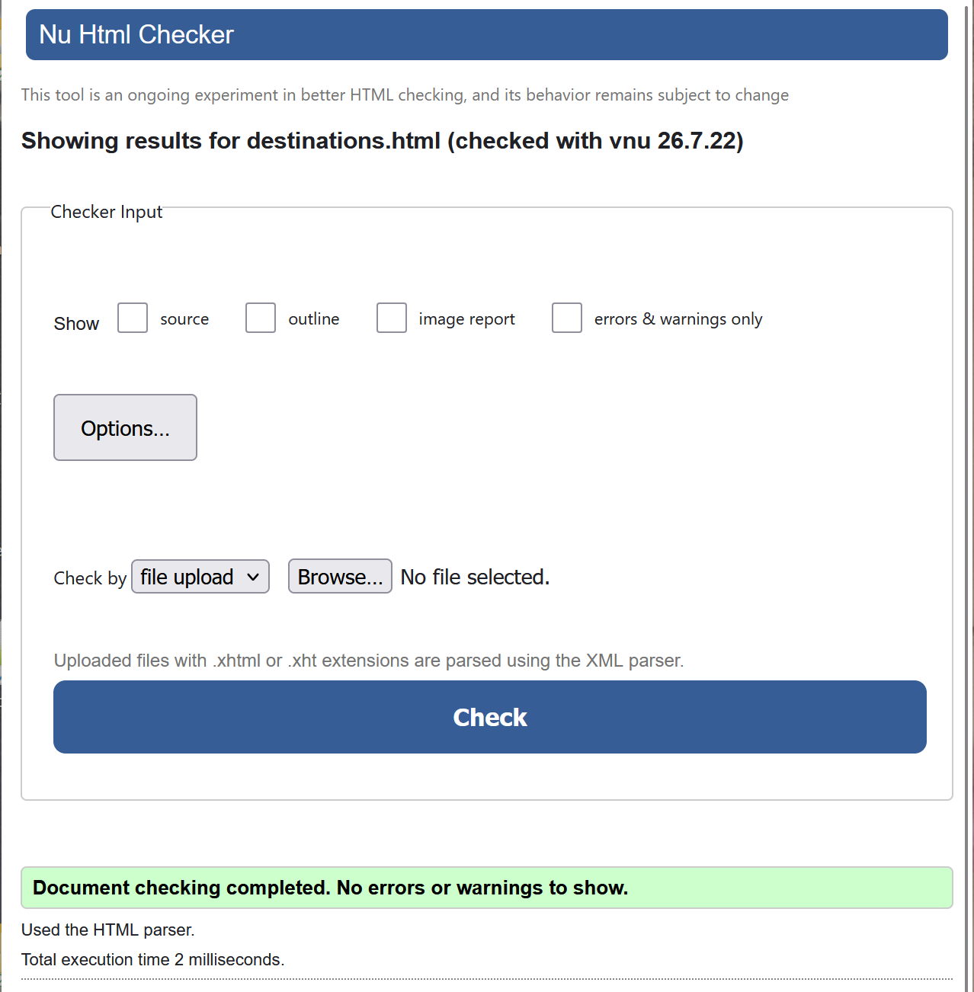
Figure 8
Shows the final validation result for destination.html after the errors were corrected. The W3C Markup Validator confirms that no errors or warnings were found, indicating that the page now follows valid HTML standards.

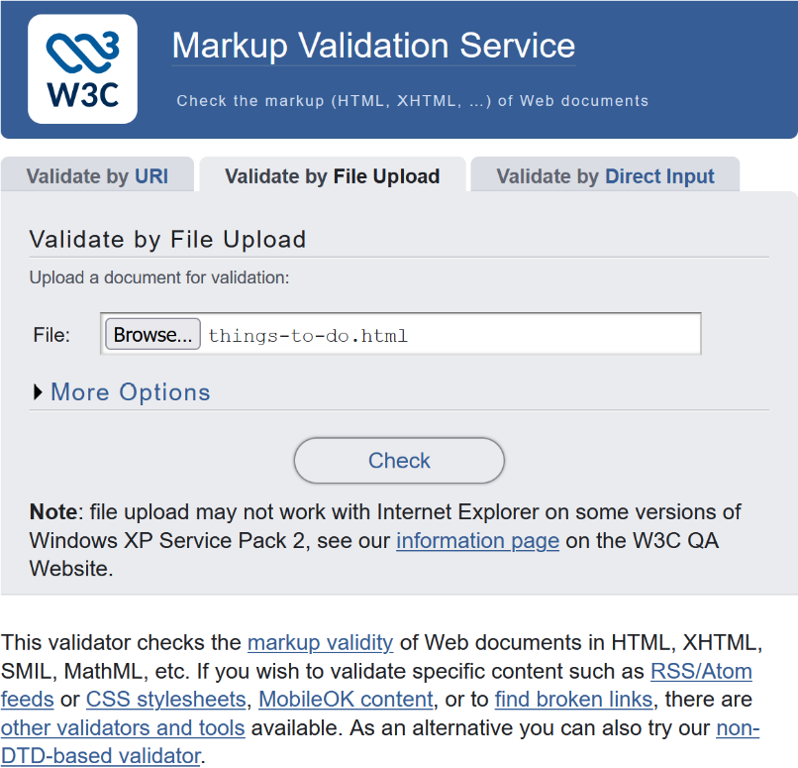
Figure 9
Shows the things-to-do.html file being uploaded to the W3C Markup Validation Service. The Check button starts validation and identifies any HTML errors or warnings.

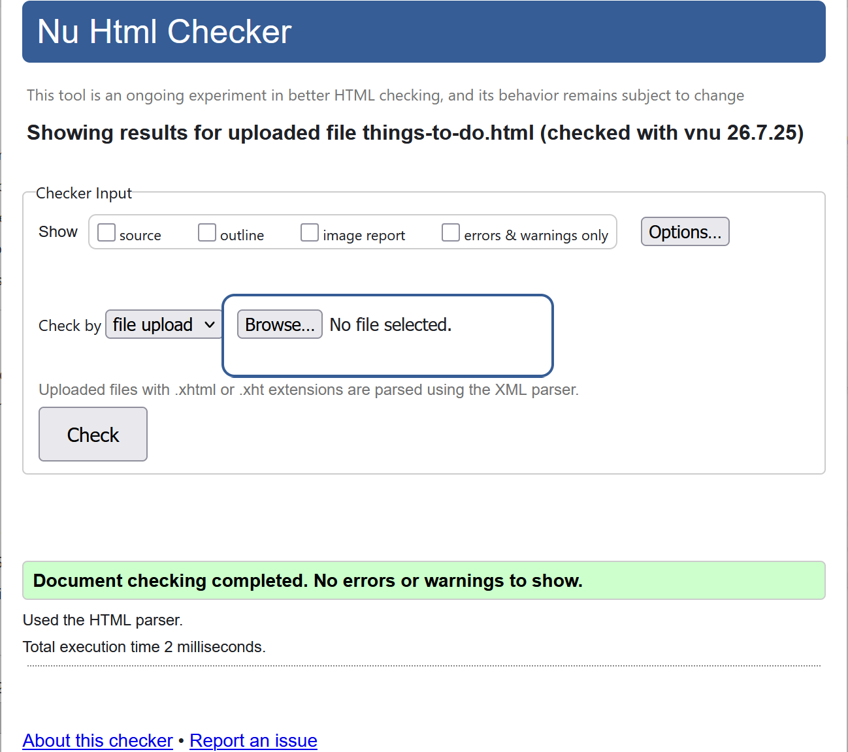
Figure 10
Shows the validation result for things-to-do.html. The W3C Markup Validator found no errors or warnings, confirming that the HTML code is valid and follows web standards.

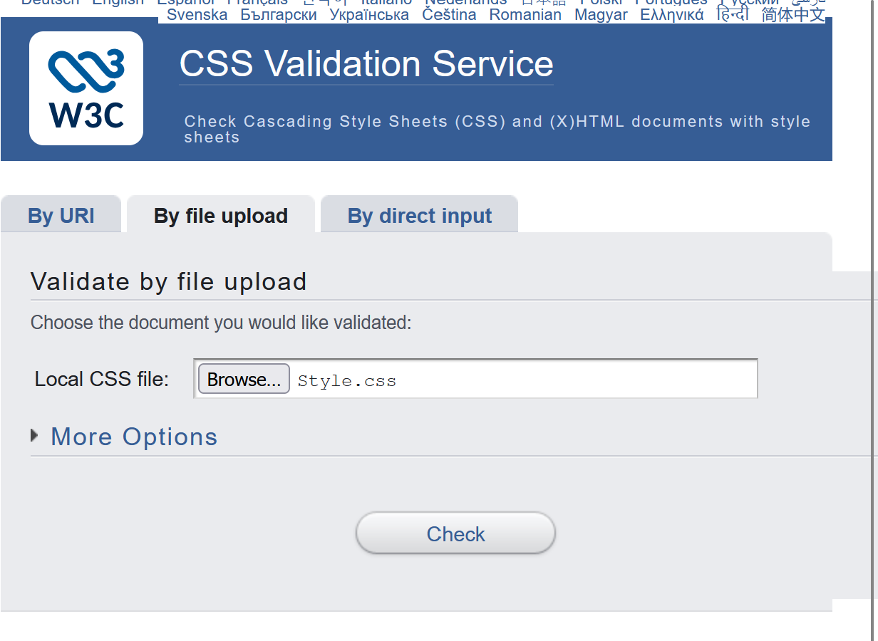
Figure 11
Shows the Style.css file being uploaded to the W3C Markup Validator. The Check button validates the CSS code and identifies any errors or warnings.

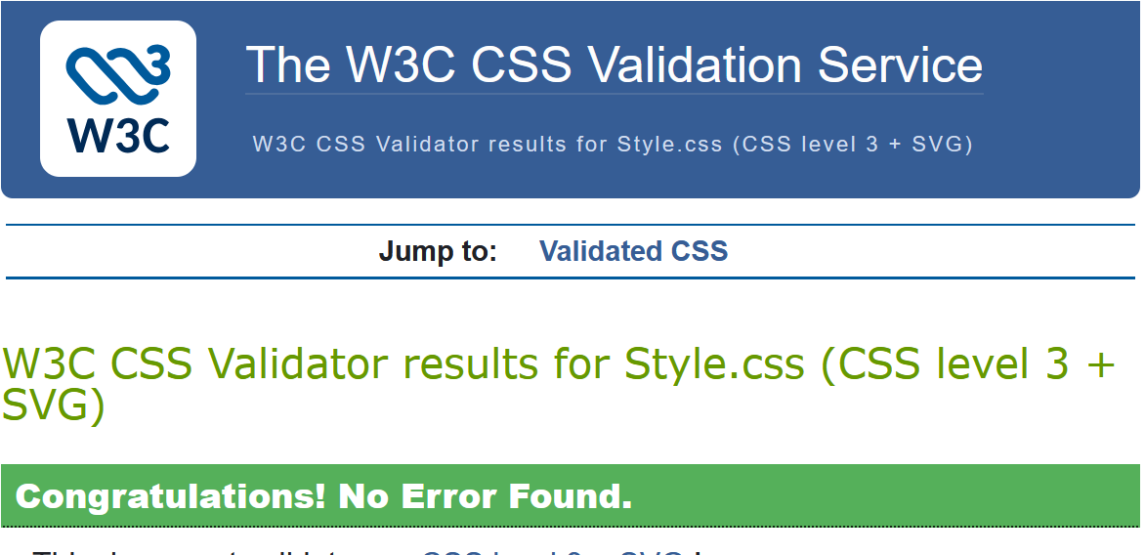
Figure 12
Shows the validation result for Style.css. The W3C CSS Validator found no errors, confirming that the CSS code is valid and follows web standards.

4. Evaluation

4.1 Website Usability
The Discover North Wales website is designed for simplicity and ease of use. Its navigation menu enables smooth movement between the Home, Destination, and Things to Do pages. Clear headings and organized content allow visitors to find information quickly. The site maintains a consistent navigation layout, colour scheme, and design across all pages, enhancing user experience and making information retrieval easier. Overall, the website offers good usability for a tourism platform. Future enhancements could include adding more interactive features and optimising the site for various screen sizes.[3]

4.2 Website Accessibility
Accessibility was central to creating the North Wales tourism site, designed to cater to a diverse range of visitors. It incorporates clear headings, readable text, a simple layout, and alt text for images to assist users utilizing screen readers. Following WCAG guidelines, providing text alternatives for key non-text elements is advised. The site also features intuitive navigation and easy-to-read content to boost accessibility. Future updates could include checking colour contrast, improving keyboard navigation, and testing compatibility with various assistive technologies.

4.3 Search Engine Optimisation (SEO)

During the development of the North Wales tourism website, Search Engine Optimisation (SEO) was integrated to improve its search visibility. The site features straightforward page titles, headings, relevant content, and descriptive image names with alternative text. Google recommends using descriptive page titles and clear headings to help both users and search engines understand the page. While the current SEO practices are basic, future enhancements might include adding meta descriptions, further optimising images, and publishing more targeted content[4]

4.4 Evaluation of the Completed Website
The North Wales tourism website effectively achieves its primary goal of offering visitors clear information on destinations and activities. It has a straightforward, uniform layout featuring easy navigation, headings, and images that enhance content clarity. HTML and CSS validation helped improve the site’s quality by pinpointing and fixing coding errors. Future updates might involve adding more destinations, boosting mobile responsiveness, and performing further accessibility testing. Overall, the project successfully showcases how HTML and CSS can be utilised to build a functional and organised tourism website.

5. Compare two live websites

5.1. Introduction
This section assesses the BBC and Sky News websites by examining their usability, accessibility, SEO, and mobile responsiveness. The goal is to highlight each site's strengths and weaknesses and compare the overall user experience.

5.2. Usability Comparison
Feature | BBC | Sky News
Layout | Clean and well-organised with a simple design. | Modern layout with larger images and more visual content.
Navigation | Clear, easy-to-use menu. | Easy navigation with more menu options.
Readability | Uses clear fonts and consistent colour. | Large headings but busier pages.
User experience | Fast and easy to use. | Engaging but slightly crowded.

Discussion
Both BBC and Sky News deliver a positive user experience, featuring straightforward navigation and frequently updated news. BBC's straightforward, well-structured layout simplifies information retrieval, while Sky News emphasises a more visual approach with larger images and live updates. However, its homepage may appear busier and might need more scrolling.
No.1
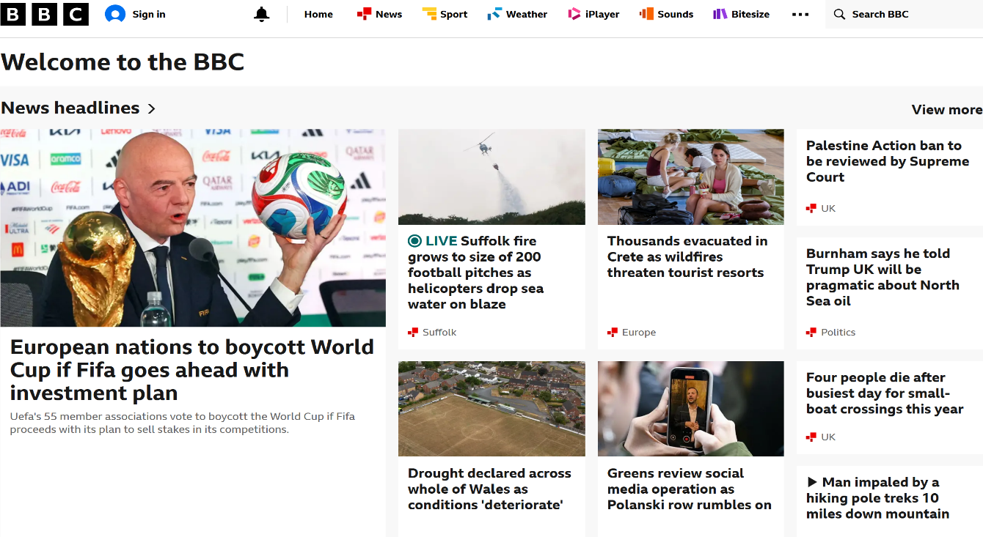
Figure 1
BBC homepage showing a clean, well-organised layout with clear navigation, featured news stories, and a user-friendly interface.

No.2

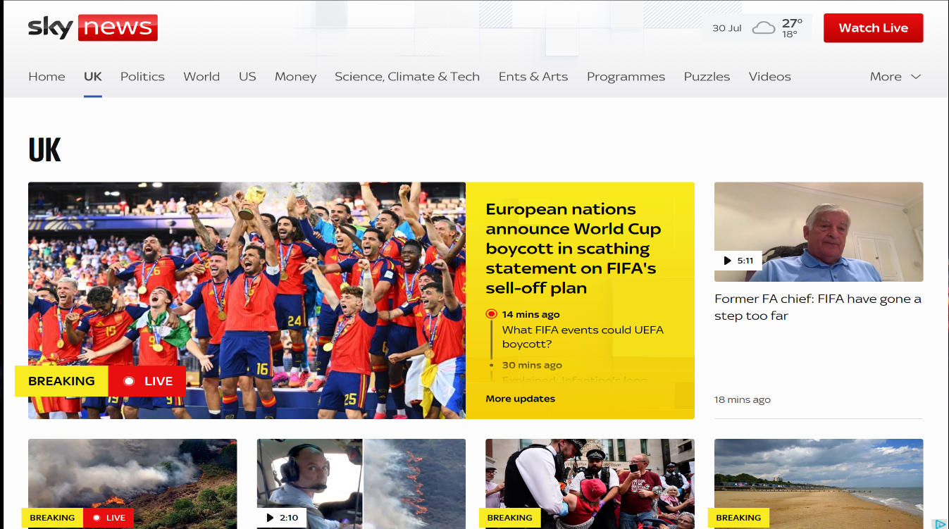
Figure 2
Sky News homepage displaying a modern interface with prominent news headlines, multimedia content, and easy access to different news categories.

Figure 3
BBC navigation menu showing clearly labelled sections, including Home, News, Sport, Weather, iPlayer, Sounds, and Bitesize. The simple menu structure makes it easy for users to navigate the website.

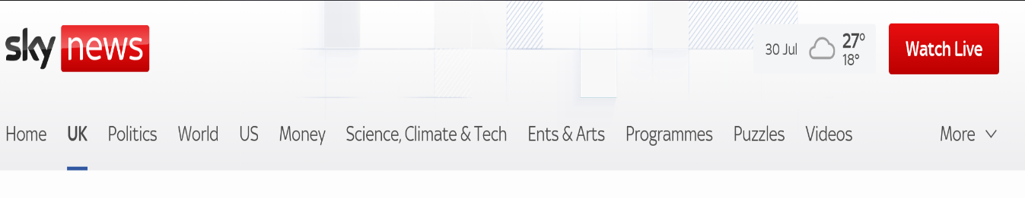
Figure 4
Sky News navigation menu displaying a wide range of news categories, including UK, Politics, World, US, Money, and Science. The menu provides quick access to sections and live news.

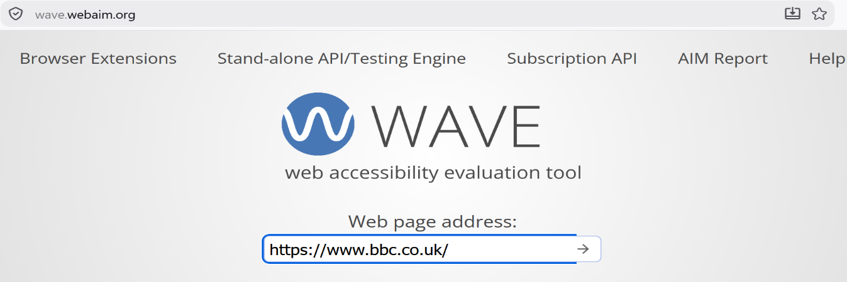
Figure 5
Opened the WAVE Web Accessibility Evaluation Tool, entered the BBC website URL, then clicked the arrow to evaluate.

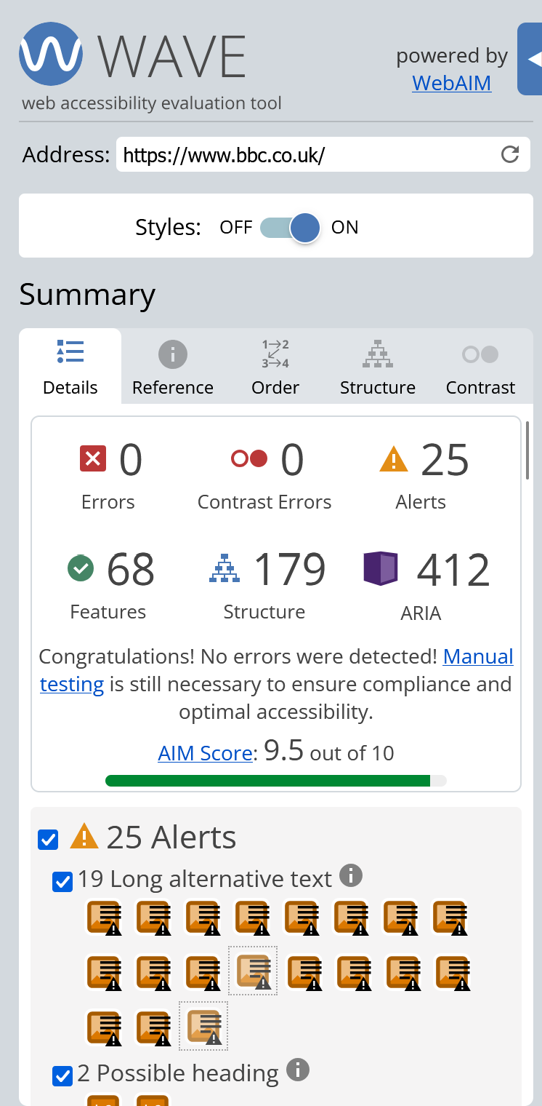
Figure 6
Wave accessibility evaluation of the BBC website shows no accessibility or contrast errors, with an AIM score of 9.5 out of 10, indicating strong compliance with WCAG 2.1 accessibility guidelines.

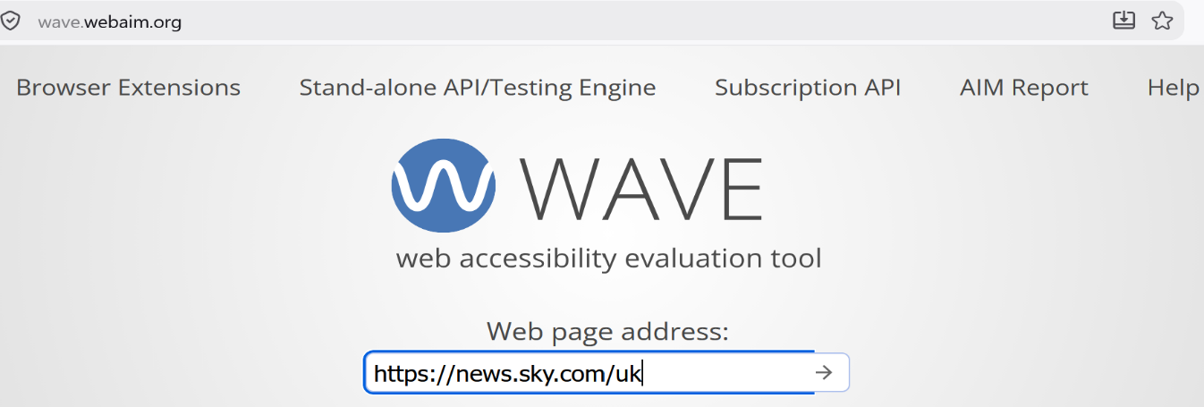
Figure 7
Opened the WAVE Web Accessibility Evaluation Tool, entered the Sky News website URL, then clicked the arrow to evaluate.

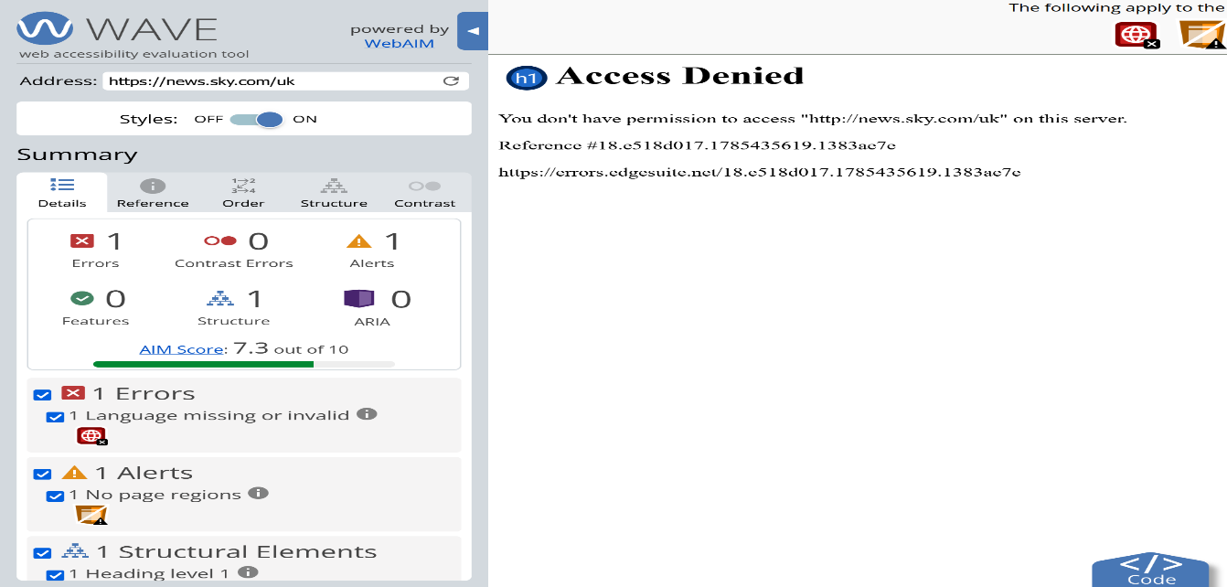
Figure 8
WAVE accessibility evaluation of the Sky News website. The evaluation could not be completed because the website returned an “Access Denied” message, preventing the accessibility tool from analysing the page.

5.3. Accessibility Comparison

The WAVE evaluation showed that the BBC website has excellent accessibility, with no errors or contrast issues, and an AIM score of 9.5 out of 10, demonstrating strong compliance with many WCAG 2.1 standards. In contrast, Sky News could not be fully evaluated because its security system blocked WAVE from accessing the homepage, limiting the assessment. Based on the data available, the BBC displayed superior accessibility through thorough testing and the absence of errors. Although Sky News may have effective accessibility features, these could not be verified with WAVE[5].

5.4 SEO Comparison
SEO Feature | BBC | Sky News
Page Title | Uses a clear and descriptive page title that reflects the website content | Uses a descriptive page title related to current news and headlines.
Meta Description | Includes a relevant meta description that helps search engines understand the page. | Provides a meta description describing the latest news and featured stories.
Heading Structure | Uses a logical heading hierarchy (H1, H2, H3) to organise content. | Also uses structured headings, although more headings are used because of the large amount of new content.
Image Alt Text | Images include alternative text to improve accessibility and SEO | Images generally include alternative text to describe news images for search engines and screen readers.

Discussion

Both BBC and Sky News employ effective SEO strategies, such as descriptive page titles, clear headings, and alternative text for images, enhancing search visibility and accessibility. BBC features a more organised heading structure, whereas Sky News adopts similar SEO practices but has a more intricate homepage. Overall, both sites exhibit strong SEO, with BBC offering a slightly clearer layout.

1. BBC Lighthouse reports

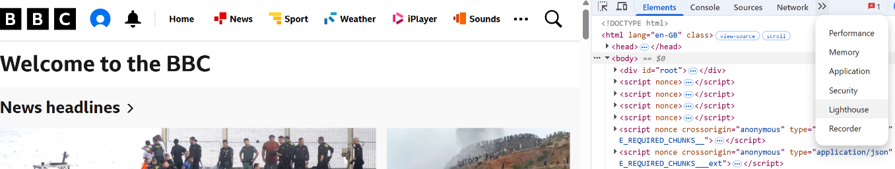
Figure 9
Open the BBC website, press FN+F12 to open Developer Tools, then click the double arrow >> and click Lighthouse.

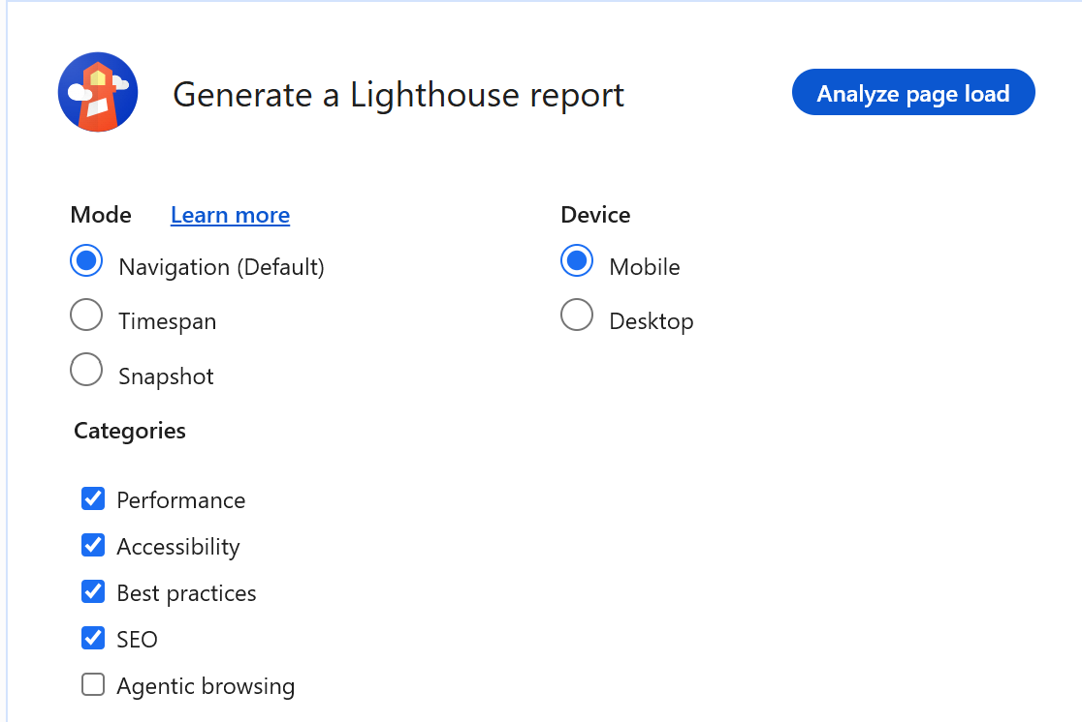
Figure 10
Once Developer Tools is open, look across the top for tabs such as Performance, Accessibility, Best Practice, SEO, and Mobile. Then click Analyze page load.

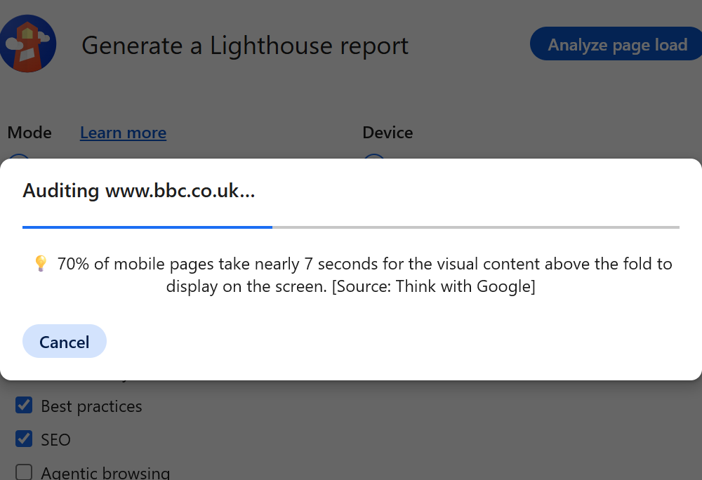
Figure 11
This is a processing analysis of the page load.

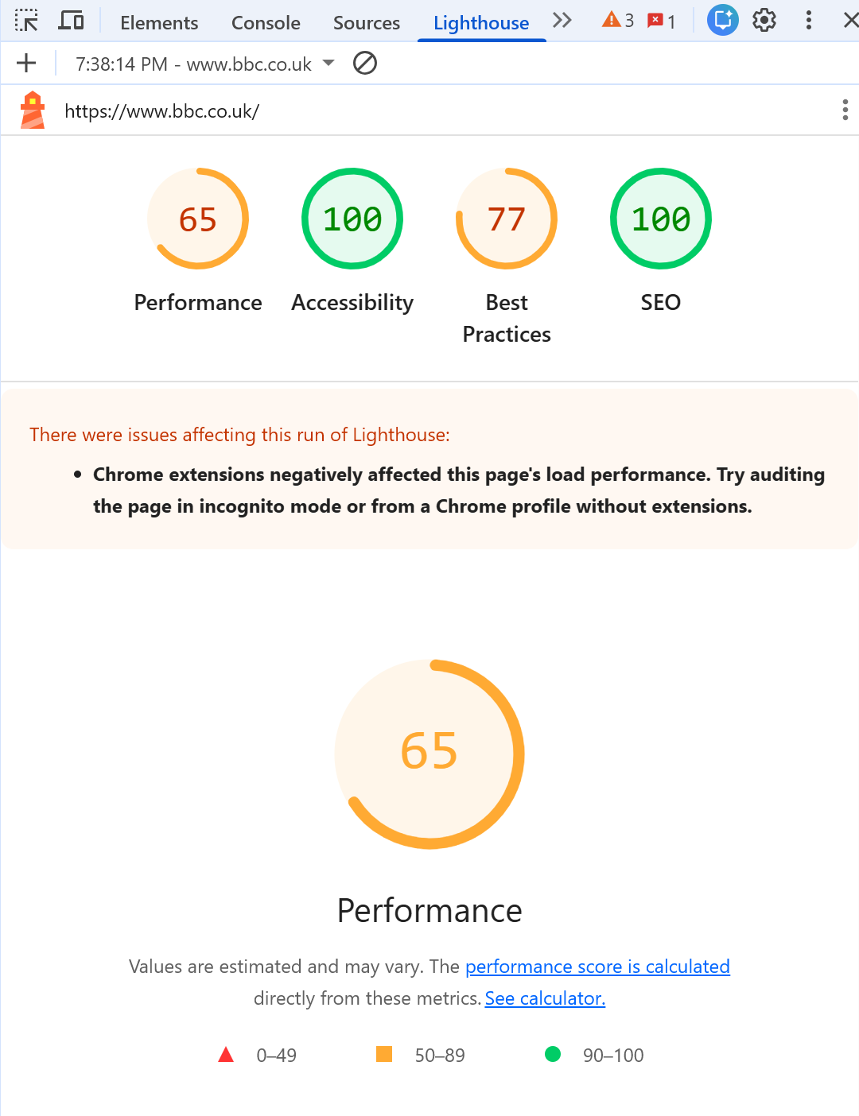
Figure 12
Google Chrome Lighthouse report for the BBC website showing excellent SEO (100) and accessibility (100) scores, indicating strong optimisation for search engines and accessible web design.

2. Sky News Lighthouse reports

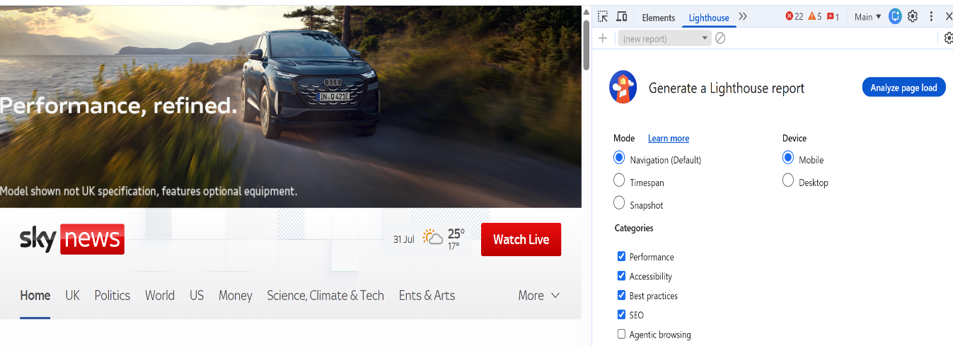
Figure 13
Open the Sky News website; press FN+F12 to open Developer Tools. Look across the top for tabs such as Performance, Accessibility, Best Practice, SEO, and Mobile. Then click Analyze page load.

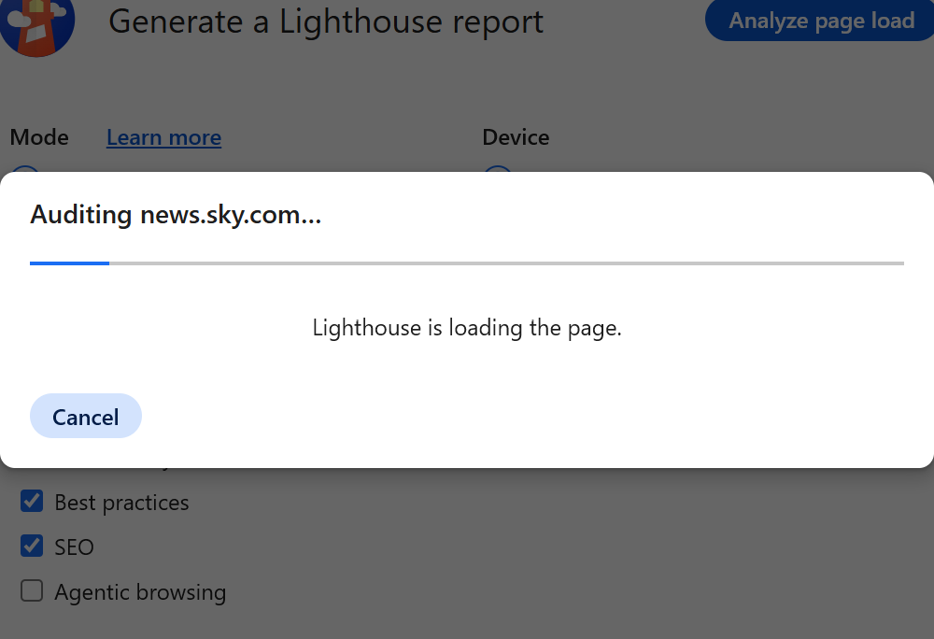
Figure 14
Sky News Analysing page load processing

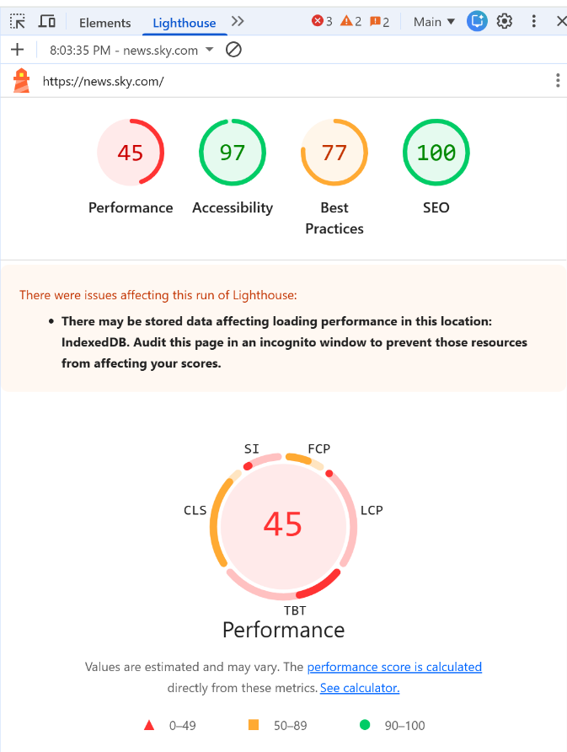
Figure 15
Google Chrome Lighthouse report for the Sky News website, showing a performance score of 45, an accessibility score of 97, a best practices score of 77, and an SEO score of 100.

5.5. Mobile Friendliness

Comparison Table

Feature | BBC | Sky News
Responsive Design | Adapts well to different screen sizes. | Adapts well to mobile devices with a responsive layout.
Navigation | Menu remains clear and easy to access on mobile devices. | Mobile menu is easy to use but contains more navigation options.
Readability | Text remains clear with appropriate font size and spacing. | Headlines are easy to read, although pages contain more images and content.
User Experience | Fast and simple mobile browsing experience. | Good mobile experience, but a lower performance score may affect loading speed.

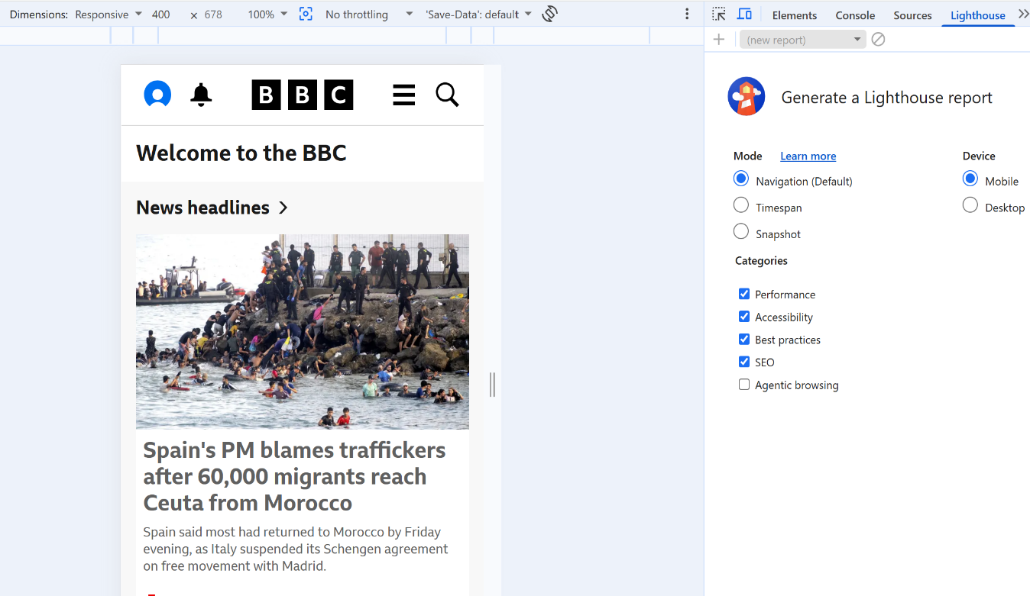
Figure 16
BBC website displayed in Chrome’s mobile device emulator, showing a responsive layout that automatically adapts to a smartphone screen while maintaining clear navigation and readable content.

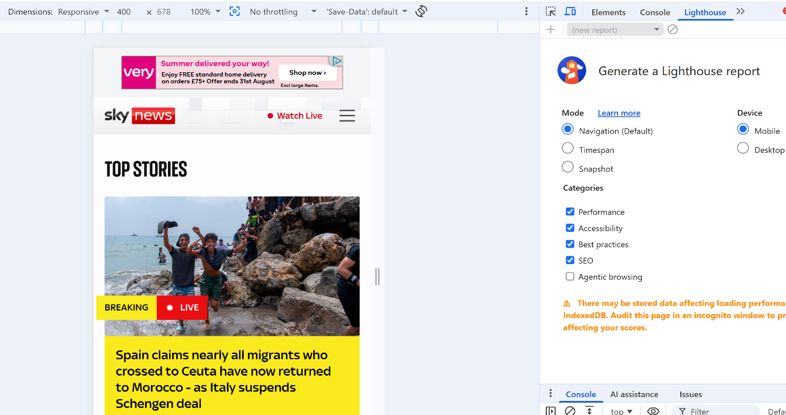
Figure 17
The Sky News website displayed in Chrome’s mobile device emulator, showing a responsive layout that adapts to smaller screens while maintaining navigation, headlines, and readable content.

6. Conclusion
This report evaluates the BBC and Sky News websites based on usability, accessibility, SEO, and mobile-friendliness. Both sites offer high-quality user experiences and follow established web development standards. Overall, the BBC website performs marginally better due to its straightforward navigation, superior accessibility, and enhanced mobile performance. While Sky News features engaging multimedia content, the BBC delivers a more consistent and user-friendly experience.

7. References
References
[1] S. Kumar, J. Shree DV and P. Biswas, "Comparing ten WCAG tools for accessibility evaluation of websites," vol. 33, no. 3, pp.163–185, 2021,
[2] Y. Lee and K. A. Kozar, "Understanding of website usability: Specifying and measuring constructs and their relationships," Decis.Support Syst., vol. 52, no. 2, pp.450–463, 2012,
[3] F. Almukhtar, N. Mahmoodd and S. Kareem, "Search engine optimization: a review," vol. 17, no. 1, pp.70–80, 2021,
[4] A. W. West, "Validation," in Practical HTML5 Projects, Springer, pp. 399–413.
[5] D. DuRocher, HTML & CSS QuickStart Guide: The Simplified Beginners Guide to Developing a Strong Coding Foundation, Building Responsive Websites, and Mastering the Fundamentals of Modern Web Design, ClydeBank Media LLC, 2021.

8. Appendices

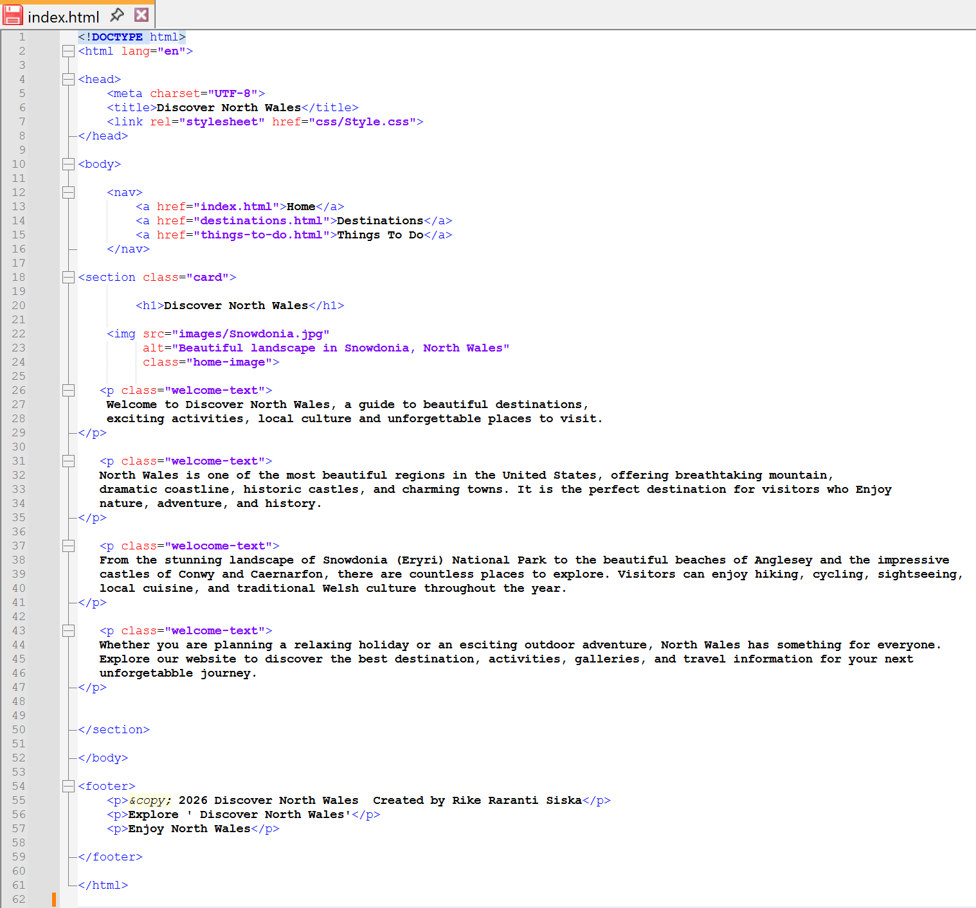
Notepad++ - Index HTML table

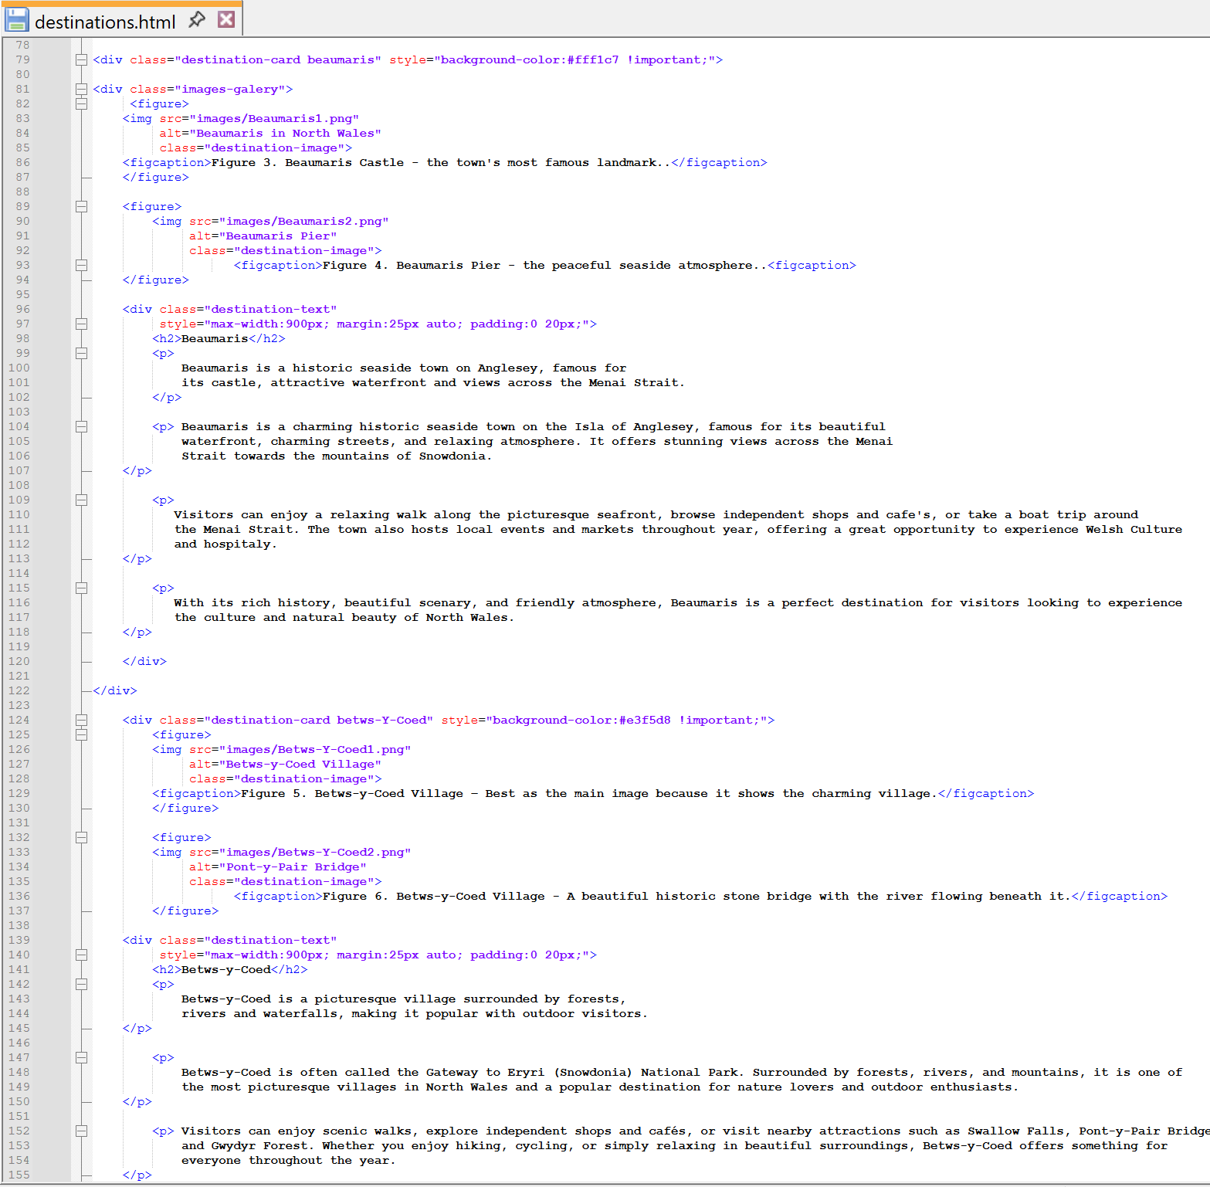
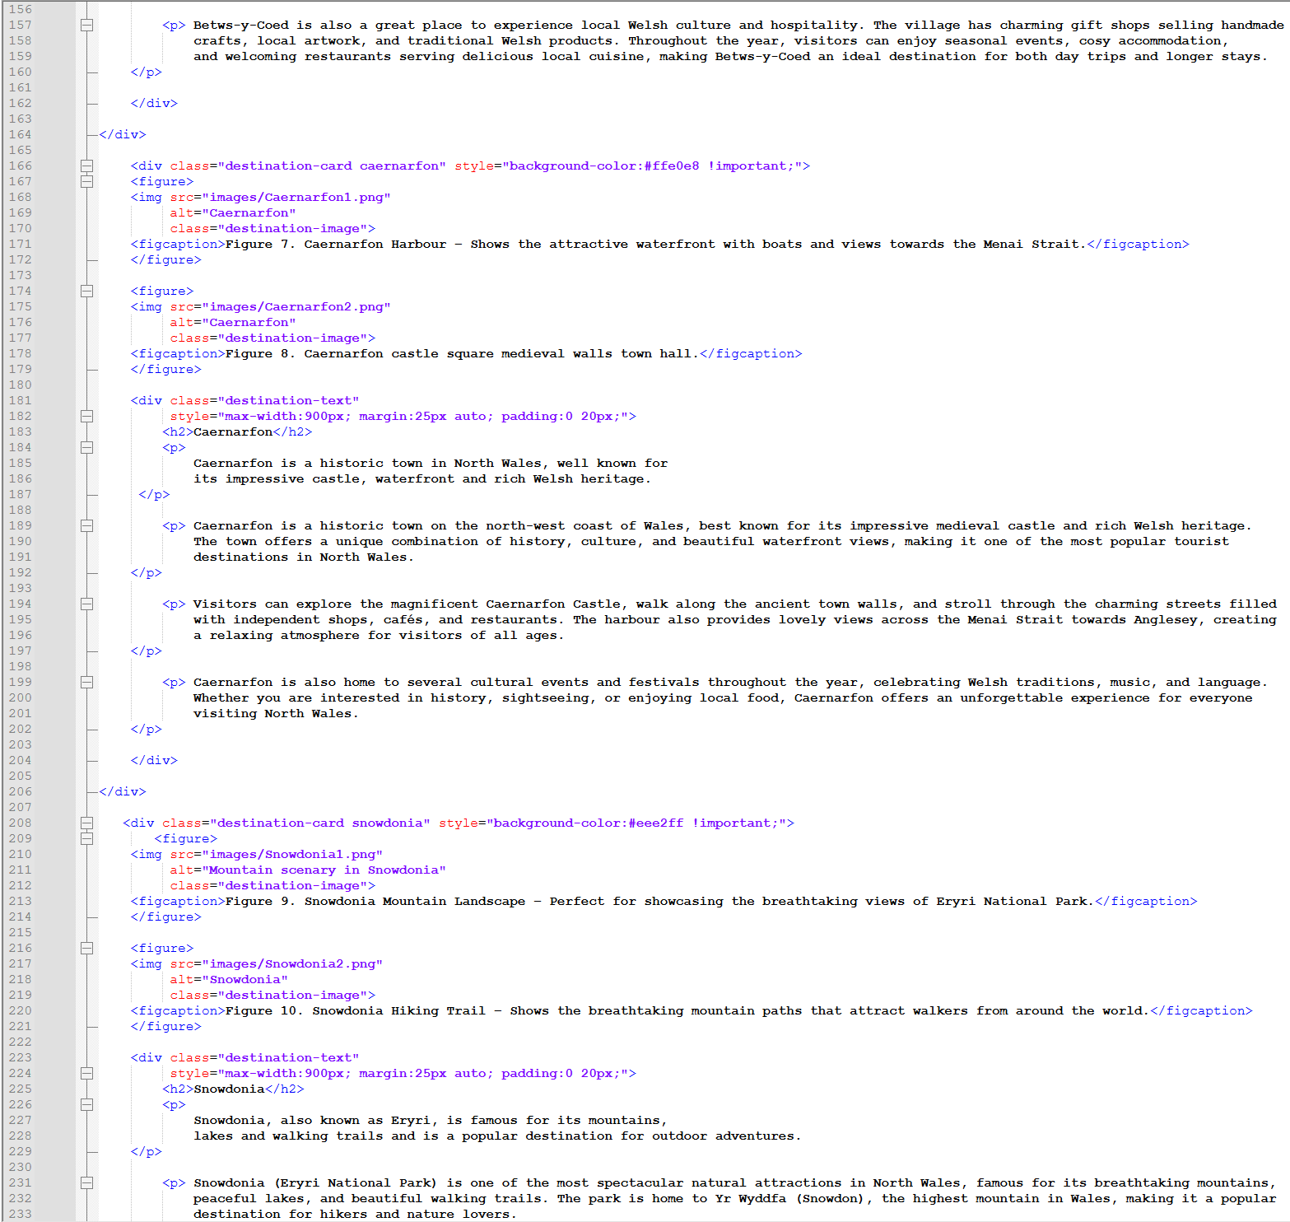
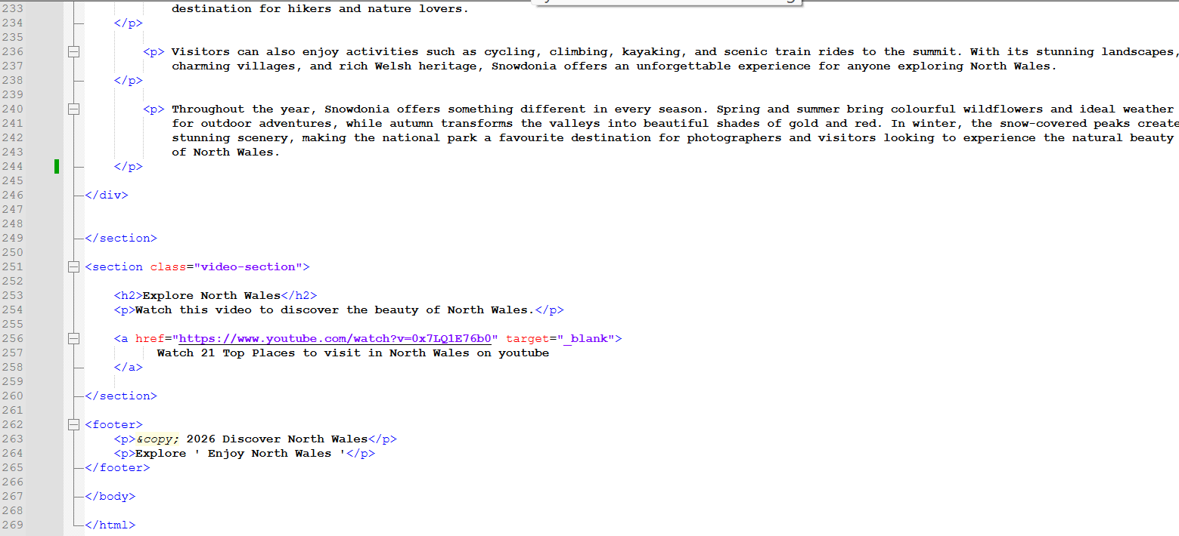
Notepad++ - Destination HTML table

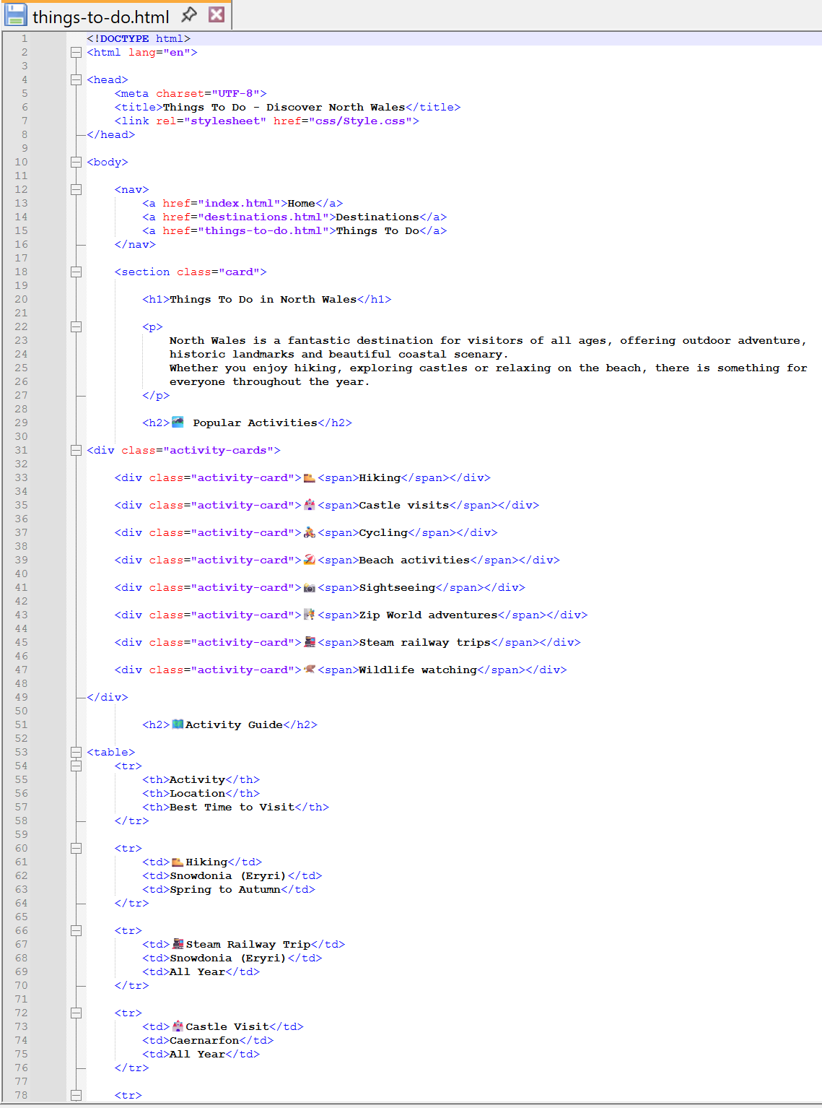

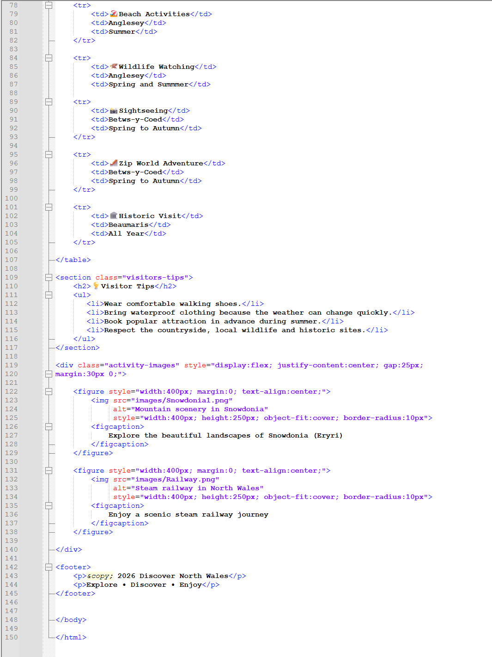
Notepad++ - Things to-Do HTML table

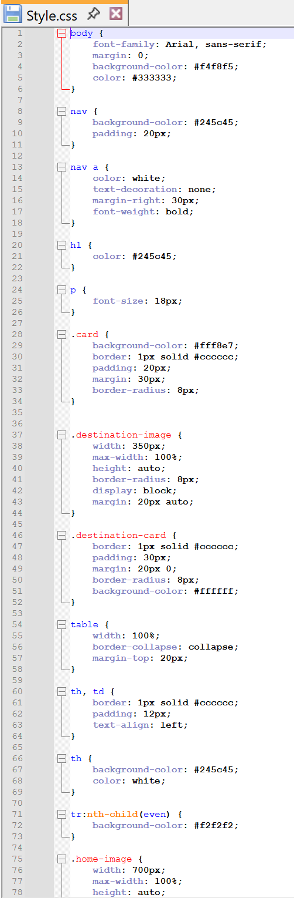 | 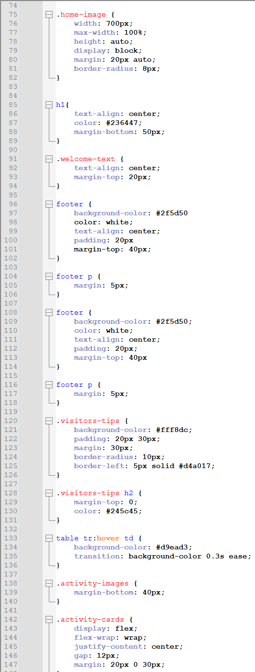
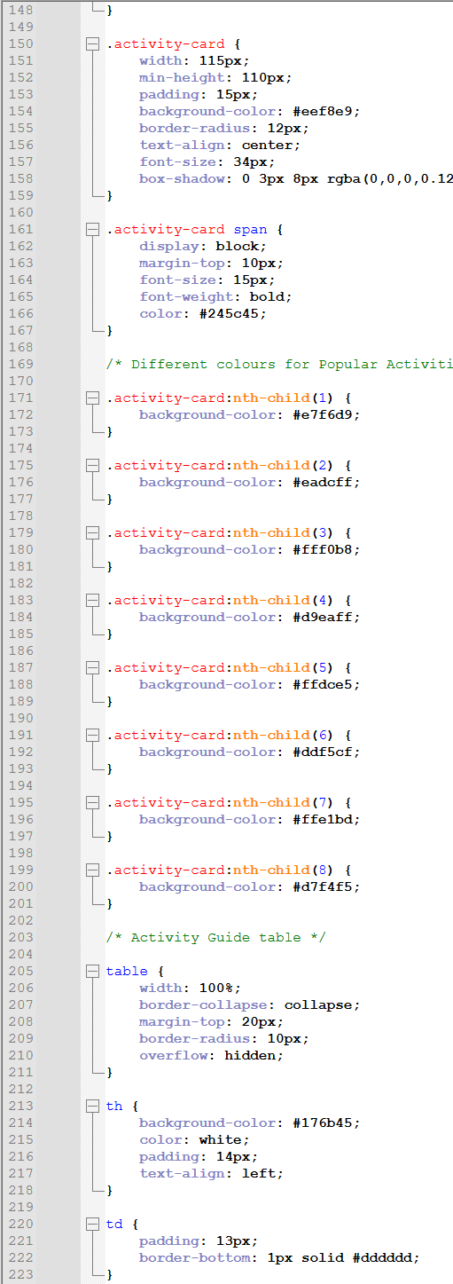 | 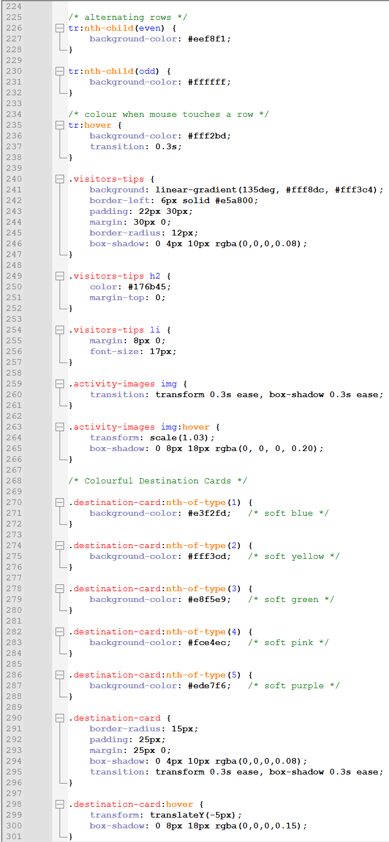

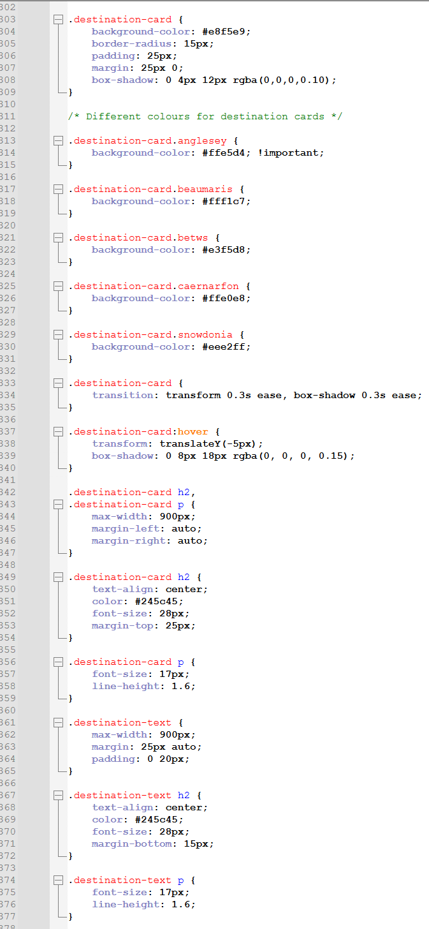 | 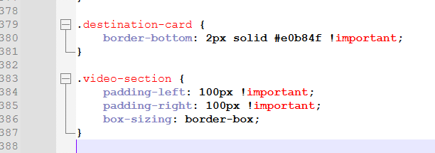
Notepad++ - CSS table

