

Block Two

1st Film location questions

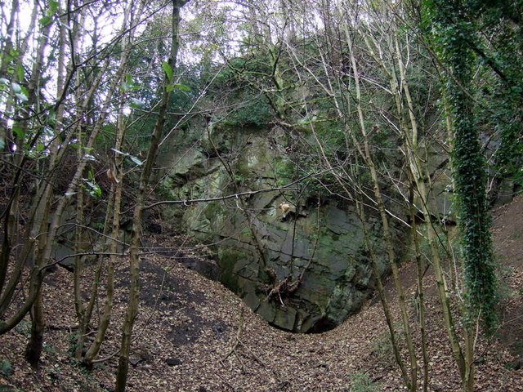

- What specialist skills did you test Friday?
- How will you know if you have met or failed to meet them?
- What were you expecting to struggle with on Friday?
- As Friday was still a testing of your skills, what did you need to learn that day to ensure you have got right before you turn to your own projects?
- Did you spent too much on Friday’s shoot?
- Where could you have saved/spent more?
- How much time did you spend in the location prior? Was that enough? If so, how do you know that is the case?
- Were the roles allocated according to technical, artistic, professional or personality?
- Which of the following can be said to characterise your approach on Friday?
- “Plans are of little importance, but planning is essential.”
- “Everything is an experiment.”
- “I am not certain whether I ever believed in the City of the Immortals; I think the task of finding it was enough for me.”
- “Mathematics is life: the workings (process) is more important than the answer (proof/product). A wrong process cannot make a right product.”

- What aspect of story did you test?
- If you authored any aspect of the film, how would you say you responded to the challenge?
- Identify 3 reflection quotes to summarise your work on Friday?
- How does all the above considerations feed in to this Friday? (Has it made you think about a change in your approach, has it made you think you need to do more research, etc.)

