What is a skill? “A generic definition of skill is “the level of proficiency on a specific task or group of tasks. The development of a given skill or proficiency on a given task is predicated in part on the possession of relevant basic abilities” (Fleishman & Quaintance, 1984, p. 163).” [1].
Essential skills for study and employment are the critical foundations to enable the capability for study and later in to employment. Ravenscroft [2] lists eight essential skills as matched pairs that loosely feed in to the higher academic classifications that the University of Cambridge highlights as the intellectual skills of analysis and problem-solving, communication skills, interpersonal skills and organisational skills:


- Listening and Presenting as the component parts of effective communication.


- Teamwork and Leadership as the two sides of interpersonal skills.

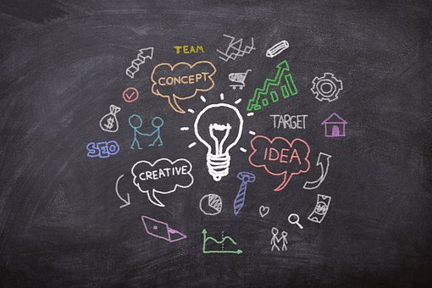
- Creativity and Problem-Solving to help create and manage new ideas.


- Aiming High and Staying Positive as the two dimensions of setting clear goals and plans.

Missing from this list are the fundamental skills such literacy and numeracy. “A significant number of employers say graduates lack basic skills in numeracy and literacy. A weakness in basic skills can affect performance in everyday tasks” [3]
As well as numeracy and literacy, digital skills need to be considered part of the ‘essential skills’. “Deloitte’s new research points towards a fundamental shift in the balance of skills, knowledge and abilities in the UK’s workforce as organisations adapt their operations to suit an increasingly global and digital world.” [4]

[1] J. Burrus, K. D. Mattern, B. D. Naemi, R. D. Roberts, “Building Better Students: Preparation for the Workforce”, Oxford Scholarship Online, 2017, p36.
[2] T. Ravenscroft, "The Essential Skills That Education Mustn’t Forget", Academy Magazine, vol. 7, pp. 10, 2017. [Online] Available: https://www-proquest-com.ezproxy.uwtsd.ac.uk/docview/1949508426?accountid=130472. [Accessed Nov. 26, 2020]
[3] UCAS, “What skills are employers looking for?”, UCAS, No date, [Online] Available: https://www.ucas.com/careers/getting-job/what-are-employers-looking. [Accessed Nov. 27, 2020]
[4] “Talent for survival: Essential skills for humans working in the machine age,” Deloitte, London, 2016. [Online] Available:https://www2.deloitte.com/content/dam/Deloitte/uk/Documents/Growth/deloitte-uk-talent-for-survival-report.pdf [Accessed Nov. 27, 2020].
All images used are copyright free from www.unsplash.com and https://pixabay.com/

