Greenwashing in the Hospitality Industry

Laurentiu-Costel Popa
2126893
BMIH5006
Kathryn Roberts
Word Count: 1912
Table of Contents

- Introduction.
- Definition of Greenwashing.
- History of Greenwashing.
- Greenwashing in the hotel industry.
- Study case: Marriot Hotels.
- Impact of Greenwashing on Marriot's Reputation.
- Greenwashing Strategies in the Marriot International.
- Other examples of Greenwashing in the hotel industry.
- Whitewashing, green hushing.
- Alternatives to self-evaluation practices in Greenwashing.
- Conclusion.
- References.

- Introduction
This report stands for the study of greenwashing within the hospitality industry. It reflects the need for greenwashing in the new era, as the trend of becoming sustainable by implementing greenwashing is growing. As the global environment is increasingly fragile and human society is decreasing its value or examples of natural disasters or wars, the need for sustainability is growing globally. Humans are greedy and destroying is a word that defines human society, as trends like being, acting, showing, or having something unique, go beyond imagination. There are factors that also are part of this disaster called extinction like mass media, which has a substantial influence on human behaviour. Also, in the last decades, even though the process of extinction has grown, still making societies sustainable is a slow process and becoming green is extremely far away from reality.

- Definition of greenwashing
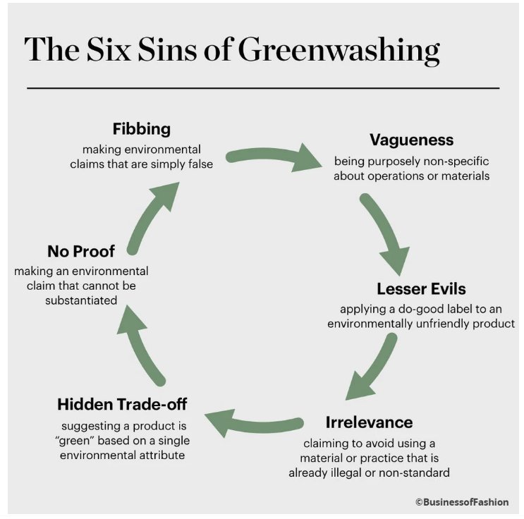
Chen(2019) states that greenwashing refers to the activities and strategies that companies use to give the incorrect impression to the clients that they are being friendly to the surroundings.
In marketing practices over the years, greenwashing has become a slogan inside and outside of the marketing industry. The emerging reputation of eco-friendly merchandise and inexperienced and sustainable life amongst clients supply a big motivation for companies to encourage greenwashing. On the other hand, regardless of the rising difficulty over inexperienced merchandise claims that are not rational, the phenomenon is still continuously prevalent and well-favoured amongst companies in green promoting and advertising.

- History of greenwashing
With a history of more than seventy years, the word “Greenwashing” started to be found in the Oxford English dictionary around 1999th year ( Wikipedia.com). The background started in the mid-fifties as the corporate responsibility to go green became a trend and did gain momentum in the hotel industry.
However, there are substantial differences in implementing and marketing sustainable operations and options to go green, and the need for the existence of green hotel certifications in the future is complicated. It is hard to define a green hotel nowadays, but there are programs of self-evaluation that will help them gain satisfaction and trust from consumers.
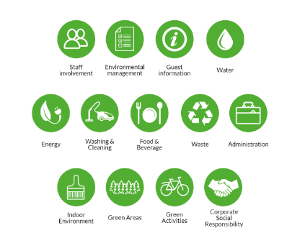
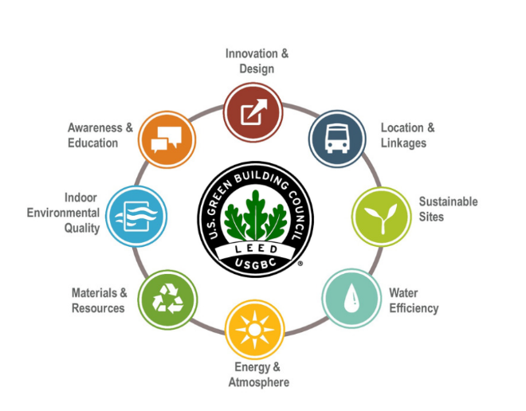
Leadership in Energy and Environmental Design or LEED, is an independent verification program that shows environmental performance measures over the time of a hotel for energy and water consumption (USGBC, 2020). As the growth in human belief in green buildings is rising, companies are using the LEED tool in media to reduce the negative impact on consumers to gain trust (Gauthier, 2012).
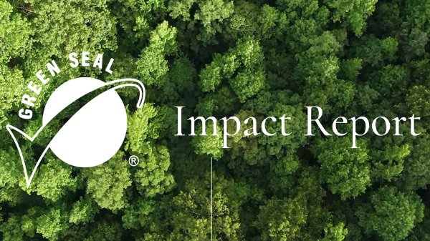
Another industry-recognized certification is the Green Key Eco-Friendly initiative, which stands for the commitment of businesses to respect the criteria of the Foundation for Environmental Education (Green Key, n.d.).This program has since grown from 80 members in the inaugural year to over 2,900 members from countries around the world, and it ranges from lodging and meeting facilities to certifying operations.
On the other hand, single attribute programs include certification such as Green Seal that is shown to consumers who wish to actively support the environment by choosing goods or facilities that are in line with the premise of the green certification (Green Seal Impact Report, n.d.). Such labels that are federally trademarked countries globally include those within the EU or the United States.

- Greenwashing in the hotel industry
The hotel industry is often accused of greenwashing. This means that customers are being deceived into thinking that a particular business is doing more to protect the environment than it is (Alyahia, 2024). However, more people believe that greenwashing in the hotel industry is general. This may be because there are so many ways in which a hotel can claim to be working in an environmentally friendly way that it is difficult to know whether those claims are true. For example, a hotel might claim that it is helping the environment because it gives guests the possibility not to have their towels and bed linen washed every day (Rahman, 2015).
However, Menn(2010) states "Is it to save the environment or just to cut costs?", so it is questionable how these hotel operators take their commitment to the environment seriously.
There are so many different ways in which a hotel can claim to be going green, such as reducing plastic waste, reducing water waste, having electric car charging points or even just adding a few pot plants to the reception area, that it can be hard as a customer to work out if a business is legitimately trying to help the world or doing very little at all. This means that there has not been regulation created to deal with accusations of greenwashing in the hotel industry, although new rules are starting to come in to try and protect customers.
The UK's Competition and Markets Authority published guidance for businesses in January 2020 to help them understand what greenwashing is and what they should do to make sure that their practices follow the law (Consumer protection: enforcement guidance, n.d.). However, the guidance does not go so far as to set out specific remedies or penalties for businesses found to be greenwashing and it is not the case that hotels are the only businesses in the leisure industry which have been accused of trying to take advantage of the public's concern for the environment.

- Study case: Marriot Hotels
Marriot International is a multinational company with more than eight thousand properties worldwide that is the largest chain hotel in the world.
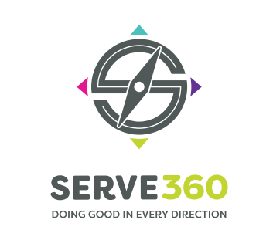
Marriott has made various sustainability commitments and initiatives, such as reducing carbon emissions, water conservation efforts, and implementing eco-friendly practices in their hotels through their programme SERVE360. However, whether these efforts are genuinely impactful and transparent or if they are used primarily for marketing purposes would require a deeper examination of their practices, disclosures, and overall commitment to sustainability. It is essential to look at specific actions, certifications, and transparency in reporting to assess whether a company engages in greenwashing or is genuinely committed to sustainable practices.
As an example, the influence of the COVID-19 virus on the hospitality industry was too big and tourism was close to collapse. Therefore, Marriot International had to shut down a program called “Make a Green Choice”, which allowed customers to choose whether or not to have housekeeping in the rooms, and if they were to choose every two days, they were going to get five hundred points through their Bonvoy Membership (One Mile at a Time, 2020). Even though the program was built to help hotels reduce water and energy waste, after and during the pandemic, the need and demand for sanitising according to health and care rules and regulations was huge. Hotels, such as Marriott International, were forced to use more energy, more water, and more resources to keep the customers safe, including reducing occupancy rate during the COVID-19 pandemic, meaning that in case of emergency, sustainability is more likely to be not practicable (Seric, 2021).
Because competition in the hospitality industry is growing, Marriot International announced that by 2025, all their properties will have LEED certification or equivalent to gain an advantage for long-term success (Bianco, 2023).
With high demand in customer expectations about sustainability challenges, tourists are willing to pay for these certifications according to Nelson(2021).

- Impact of Greenwashing on Marriot's Reputation and CSR
The existence of Greenwashing in the Marriott Group has affected the reputation of the company. Ever since the revelation of the Green Choice program, Marriott received negative publicity from a survey that was conducted among their housekeeping employees in various groups in the country (Marriott’s Dirty Choice, n.d.). Therefore, the malpractices and people affect the credibility of the company and are not able to trust the commitments and policies of the company towards the environment and the societies in which they use.
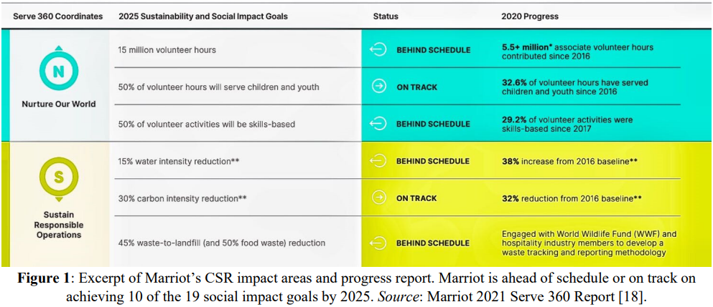
Society also loses confidence in the major steps taken by the company to engage and deliver in line with Corporate Social Responsibility actively and effectively. The criticism is too much, and the company needs to invest heavily in rebranding and public relations in damage control programs.
Even though the company is behind their goals by 2025, through their program, its CSR has managed to start rebuilding its brand by investing a couple of millions in programs to help youth, women and others develop hospitality skills (Xie, 2022).

- Greenwashing Strategies in the Marriot International
Hotels may highlight green building features such as LEED certification or sustainable materials to prove their commitment to environmental stewardship. While these features can reduce the environmental footprint of a hotel, they may not offset other unsustainable practices within the hotel's operations.
However, the Geneva Marriot Hotel managed to receive a High-Performance Energy certificate (HPE) by achieving energy savings of 10% to 20% (SageGlass, n.d.).

- Other examples of Greenwashing in the hotel industry
Nowadays, green hotels are in deep search when it comes to people’s destinations, no matter the type of tourism that they are looking for. However, to be green is a huge work, which requires investment constantly, to be in trend with new regulations regarding Greenwashing. Thus, trust is the correct word in the Greenwashing process and hotels need to have green transparency (Gao, 2014).
ACOR’s Group commitment to sustainability shows huge improvements in energy saving and low carbon emissions, by implementing a new system to reduce energy consumption by 40% (Group.accor.com, n.a.). Having more than five thousand properties around the world, ACCOR Group has mitigated sustainability in the last decade by reducing carbon emissions, and food and plastic waste, which made the group achieve the Marie Claire award for "Best Sustainable Hotel" (Hospitality Net, n.d.).

- Whitewashing, green hushing
To find new ways of financial benefit, people are willing to do anything, regardless of the impact on the environment, the local economy or even the health and safety regulations (Garau-Vadell, 2018).
Whitewashing over tourism is quite common nowadays, as can be seen in destinations that are overpopulated, meaning that there is a low quality of life or products (Goodwin, 2013). As an example, destinations like Amsterdam, Barcelona, Lanzarote, and Thailand have developed programs to control the number of tourists that are coming to avoid over-tourism, such as targeting disrupting visitors, searching for higher quality visitors, banning tourists to rent motorbikes or to initiate ticketing system.
Green hushing is a strategy developed during the process of sustainability, where people are making claims because companies do not meet their expectations, as they are paying for green hotel services (Rittenhouse, 2022). Having this problem, companies do not want transparency on their long-term sustainability process and do not want to publish their annual reports regarding the sustainability efforts.

- Alternatives to self-evaluation practices in Greenwashing
Sustainable Development Goals or SGD is a tool used in Sustainability Development that measures poverty, inequality and climate change founded in United Nation’s Global Goals (Bandola-Gil, 2022).
Therefore, according to Zumente (2022), within regions and countries, to avoid greenwashing within sustainability development companies need to use the key factors for performance like Environmental, Social and Governance Policies or ESG.
- Conclusion

This report shows that Greenwashing in hospitality plays a huge role in hospitality, as the keyword for sustainability is “trust”.
To avoid Greenwashing, companies need to have transparent communication when speaking about their evolution regarding environmental efforts.
Also, they need to avoid exaggerations, by ensuring that all statements are accurate and reflect the real practices used in the sustainability process.
Lately, they need to focus on continuous improvement by updating sustainability initiatives, based on feedback, practices or measurements regarding sustainability.

- REFERENCES
Accor Group (2021) Accor reaffirms its net-zero commitment and signs two new initiatives. group.accor.com. Available at: https://group.accor.com/en/Actualites/2021/11/net-zero-commitment (Accessed: 28 February 2024)
Alyahia, M. et al. (2024) ‘Greenwashing Behavior in Hotels Industry: The Role of Green Transparency and Green Authenticity’. Sustainability (Basel, Switzerland), 16(3), 1050-. Available at: https://doi.org/10.3390/su16031050
Bandola-Gill, J. et al. (2022) Governing the Sustainable Development Goals : Quantification in Global Public Policy. Springer Nature.
Bianco, S. et al. (2023) ‘The impact of sustainability certifications on performance and competitive action in hotels’, International Journal of Hospitality Management, 108, 103379-. Available at: https://doi.org/10.1016/j.ijhm.2022.103379
BLANC (no date) ‘What Is Greenwashing and How To Stop It’, blancliving.co. Available at: https://blancliving.co/blogs/news/what-is-greenwashing-and-how-to-stop-it (Accessed: 20 February 2024).
Chen, H. et al. (2019) ‘Greenwashing in hotels: A structural model of trust and behavioral intentions’, Journal of Cleaner Production, 206, 326–335. Available at: https://doi.org/10.1016/j.jclepro.2018.09.168
Competition & Markets Authority (2016) Consumer protection: enforcement guidance. Available at: https://assets.publishing.service.gov.uk/media/5a7f59f6ed915d74e6229eee/cma58-consumer-protection-enforcement-guidance.pdf (Accessed: 20 February 2024).
de Grosbois, D. and Fennell, D. A. (2022) ‘Determinants of climate change disclosure practices of global hotel companies: Application of institutional and stakeholder theories’, Tourism Management (1982), 88, 104404-. Available at: https://doi.org/10.1016/j.tourman.2021.104404
Gao, Y. (Lisa), and Mattila, A. S. (2014) ‘Improving consumer satisfaction in green hotels: The roles of perceived warmth, perceived competence, and CSR motive’, International Journal of Hospitality Management, 42, 20–31. Available at: https://doi.org/10.1016/j.ijhm.2014.06.003
Garau-Vadell, J. B. et al. (2018) ‘Economic crisis and residents’ perception of the impacts of tourism in mass tourism destinations’, Journal of Destination Marketing & Management, 7, 68–75. Available at: https://doi.org/10.1016/j.jdmm.2016.08.008
Gauthier, J. and Wooldridge, B. (2012) ‘Influences on Sustainable Innovation Adoption: Evidence from Leadership in Energy and Environmental Design’, Business Strategy and the Environment, 21(2), 98–110. Available at: https://doi.org/10.1002/bse.716
Goodwin, H. (2023) Whitewashing overtourism. Travel Tomorrow. Available at: https://traveltomorrow.com/whitewashing-overtourism/ (Accessed: 20 February 2024).
Green Key (no date) Green Key — Green Key programme. Available at: https://www.greenkey.global/our-programme (Accessed: 20 February 2024).
Green Seal Impact Report (2023) Green Seal’s 2023 Impact Report. Available at: https://impact.greenseal.org/ (Accessed: 20 February 2024).
HospitalityNet (2022) Accor wins Marie Claire Award for Best Global Sustainable Hotel Group. hospitalitynet.org. Available at: https://www.hospitalitynet.org/news/4111593.html (Accessed: 20 February 2024).
Malik, G. et al. (2022) ‘Do Green Attributes of Destination Matter? The Effect on Green Trust and Destination Brand Equity’, Event Management, 26(4), 775–792. Available at: https://doi.org/10.3727/152599521X16367300695799
Menn, M. (2010) ‘Greenwashing -- Say it Ain’t So’, In Qualified remodeler (Vol. 36, Issue 7, pp. 24-). SOLA Group. Available at: Greenwashing - Say it Ain't So! - ProQuest (Accessed: 20 February 2024).
Nelson, K. M. et al. (2021) Tourist willingness to pay for local green hotel certification. PloS.org. Available at: https://doi.org/10.1371/journal.pone.0245953
Rahman, I. et al. (2015) ‘Consequences of “greenwashing”’, International Journal of Contemporary Hospitality Management, 27(6), 1054–1081. Available at: https://doi.org/10.1108/IJCHM-04-2014-0202
Rittenhouse, L. (2022) ‘“Green hushing” explained--why brands are cutting back on sustainability marketing; Greenwashing concerns are forcing brands to do more sustainability work under the radar’, Advertising Age, 93(18), pp. 3. Available at: https://www.proquest.com/trade-journals/green-hushing-explained-why-brands-are-cutting/docview/2756732757/se-2?accountid=130472 (Accessed: 20 February 2024).
SageGlass (no date) Geneva Marriott Hotel - Case Study. SageGlass.com. Available at: https://www.sageglass.com/en-gb/case-studies/geneva-marriott-hotel (Accessed: 20 February 2024).
Schlappig, B. (2020) Marriott Eliminates ‘Make A Green Choice’ Program. onemileatatime.com. Available at: https://onemileatatime.com/marriott-eliminates-make-a-green-choice/ (Accessed: 10 February 2024).
Šerić, M. and Šerić, M. (2021) ‘Sustainability in Hospitality Marketing during the COVID-19 Pandemic. Content Analysis of Consumer Empirical Research’, Sustainability (Basel, Switzerland), 13(18), 10456-. Available at: https://doi.org/10.3390/su131810456 (Accessed: 20 February 2024).
Unite Here (2018) Marriott’s Dirty Choice. unitehere100.org. Available at: https://www.unitehere100.org/wp-content/uploads/MakeABetterChoiceReportFinal.pdf (Accessed: 20 February 2024).
USGBC (2020) LEED Rating System. usgbc.org. Available at: https://www.usgbc.org/leed (Accessed: 20 February 2024).
Xie, Y. (2022) Corporate Social Responsibility: Concept and Cases. Proceedings of the 2022 7th International Conference on Social Sciences and Economic Development (ICSSED 2022). Available at: https://doi.org/10.2991/aebmr.k.220405.232
Zumente, I. et al. (2022) ‘ENVIRONMENTAL, SOCIAL, AND GOVERNANCE POLICY INTEGRATION AND IMPLEMENTATION FROM THE PERSPECTIVE OF CORPORATIONS’, Intelektine Ekonomika, 16(1). Available at: ENVIRONMENTAL, SOCIAL, AND GOVERNANCE POLICY INTEGRATION AND IMPLEMENTATION FROM THE PERSPECTIVE OF CORPORATIONS - ProQuest (Accessed: 20 February 2024).

