

Can FEA replace physical testing?
Advanced Stress Analysis and FEA (M6X00420)
Student: Alex Oke (P151012)
Lecturer: Kelvin Lake
Due Date: 26/04/2020
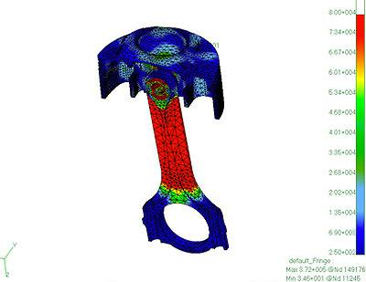

Table of Figures
Figure 1 The Altair Design Approach compared to The Traditional Design Process 4
Figure 2 Crank Mechanism Diagram (Patidar, Penn State University, 2017) 5
Figure 3 4-Stroke Combustion Engine Cycle 5
Figure 4 CP Carrillo Connecting Rod FEA Example (CP Carrillo, 2019) 6
Figure 5 Tensile test machine schematic diagram (Chellamuthu, 2012) 7
Figure 6 Strain gauge schematic diagram (Vignesh, 2018) 8
Figure 7 Connecting Rod with strain gauge attached to I-beam shank section (Micro-Measurements, 2018) 8
Figure 8 Brittle lacquer crack pattern showing the stress concentrations on an engine block (Magnaflux Corporation) 8
Figure 9 Three stress areas of definition (Palas, 2015) 9

Table of Equations
Equation 1 Inertia Force 5
Equation 2 Gas Force 5

Table of Contents
Table of Figures i
Table of Equations i
Table of Tables i
Table of Graphs i
1 Introduction 4
1.1 Aims of this report 4
2 4-Stroke Combustion Engine Connecting Rod Case Study 5
2.1 Brief Description 5
2.2 Connecting Rod Loading Scenarios 5
2.3 Errors During Load Calculations 6
2.4 CP Carrillo & PANKL 6
2.5 Physical Testing Correlated to FEA 7
3 Finite Element Mesh Influence on Correlation 9
4 FEA Without Physical Testing 10
4.1 Feasibility 10
4.2 Positives 10
4.3 Negatives 10
5 Conclusion 11
6 References 12

Introduction
Finite Element Analysis (FEA) is the simulation of any physical objects operating scenarios using a method called the Finite Element Method (FEM). This is a numerical technique used by engineers in order to reduce the number of iterations during prototyping, accelerate the design process and improve the quality of the final product in a shorter time span.
To understand any physical object scenario, mathematical processes such as Partial Differential Equations are used to quantify all forms of structural, thermal or fluid behaviour during simulations. Over the last two decades, the FEA has become the primary numerical technique for allowing computers to solve these equations efficiently. These equations are also used to solve the physics applied and engineering phenomena occurring during all types of different load scenarios, thus enabling a fast computation of stresses and strains.
The solution provided from FEA approximates the real result which is given by physical testing. This approximation allows for engineers to identify stress concentrations, areas of the design which are failing due to object geometry and areas which have excess material thus allowing for design and mass optimisation in the context of a reciprocating engine connecting rod as a case study.
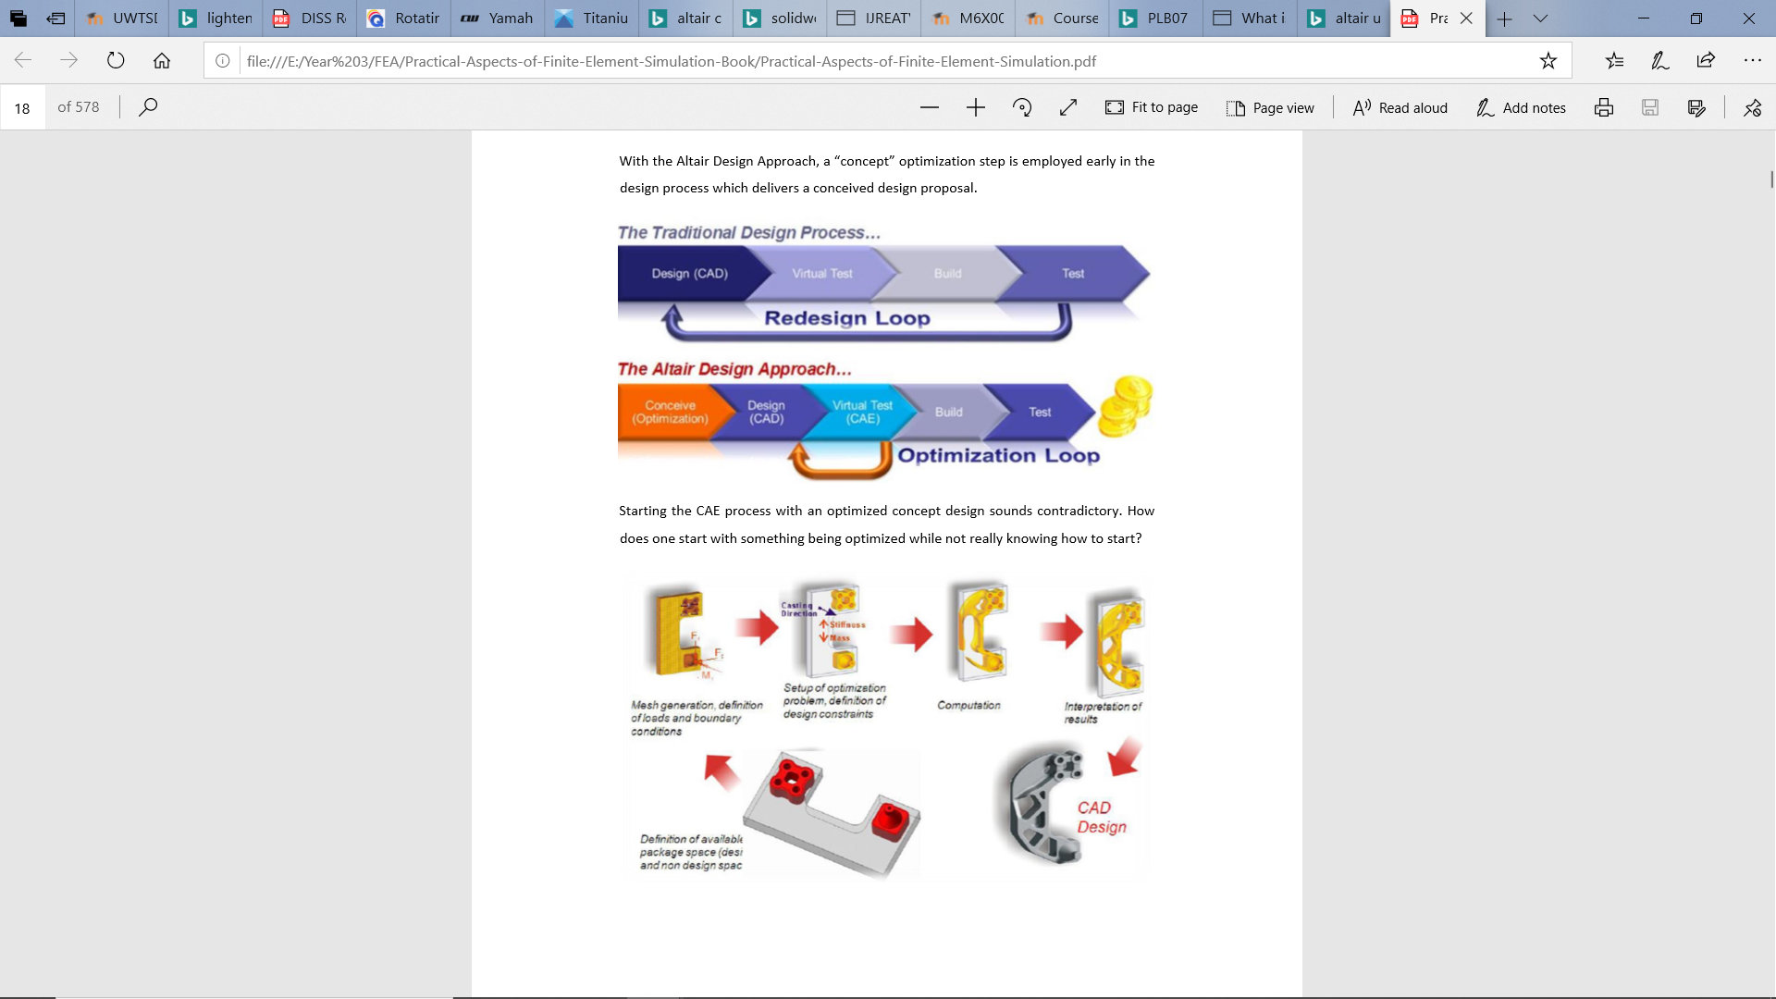
In Altair’s Design Approach, a product concept optimisation step is implemented prior to the initial CAD design, thus allowing for a conceived design to be proposed early on in the design process.
Figure 1 The Altair Design Approach compared to The Traditional Design Process

Aims of this report
- To show why companies carry out FE analysis alongside physical testing.
- Explain how physical testing is correlated to an FE model.
- Discuss the feasibility, positives and negatives of FEA completion with no physical testing.

4-Stroke Combustion Engine Connecting Rod Case Study

Brief Description
A combustion engine with a reciprocating piston and that is part of the full crank mechanism is shown in Figure 2. The prominent component converting reciprocating to rotational motion is the connecting rod attached at one end to the piston and at the opposite end the crankshaft.
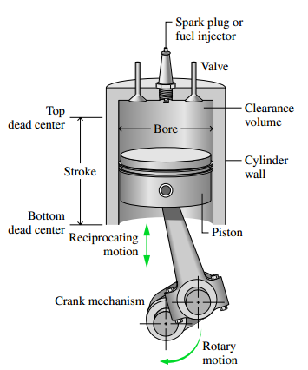
Figure 2 Crank Mechanism Diagram (Patidar, Penn State University, 2017)

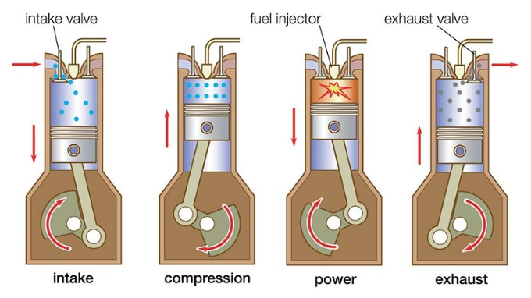
Figure 3 4-Stroke Combustion Engine Cycle

Connecting Rod Loading Scenarios
Throughout 720° of crank rotation which represents a complete 4-stroke cycle in a combustion engine, there are 2 extreme load cases which are considered during the design process. The 4-stroke cycle is illustrated in Figure 3. During the power stroke, peak cylinder pressure occurs from combustion thus putting the connecting rod under a compressive load. The extreme second load case is a tensile load which the rod experiences when the reciprocating assembly’s mass is trying to stretch the rod at exhaust top dead centre. To calculate these loads, see Equation 1 and Equation 2 below:

Inertia force causing tension in rod
Equation 1 Inertia Force
$$Inertia Force=Reciprocating Mass∙Piston Acceleration$$

Gas Force causing compression in rod
Equation 2 Gas Force
$$Gas Force=Cylinder Pressure∙\left(\frac{π∙{Cylinder Bore}^{2}}{4}\right)$$

Errors During Load Calculations
Gas force can be incorrect from a cylinder pressure sensor which may not be correctly calibrated or not correctly installed, therefore resulting in a cylinder pressure being too high or low, causing the compressive force applied in an FEA model to be too high or low. Using a force which is too low for the connecting rod will result in a cross-sectional area in the shank of a connecting rod which buckles under the combustion pressure, if the force is too high then the connecting rod will be over engineered with too much re-enforcement and mass.
Whilst defining the maximum Inertia force, the kinematic formulation of the crank mechanism is considered and used to calculate piston acceleration. The mass of the reciprocating assembly must be measured accurately otherwise this force will not be represented correctly as piston acceleration and reciprocating mass are the only two inputs possible of introducing errors.

CP Carrillo & PANKL
CP Carrillo are a connecting rod and piston design and manufacturing company operating in the USA since 1963. Finding their process of designing using FEA correlated with real testing has proved something of a challenge for the author as this is a well-guarded secret. An example of the full FE model used with a stress plot is illustrated in Figure 4.
The parent company of CP is PANKL Racing Systems situated in Austria who specialise in developing and manufacturing engine and drivetrain components such as connecting rods and piston for race cars, motorcycles and various high-performance vehicles including the aerospace industry. Both CP and PANKL rely heavily on computer generated models of their components to ascertain the stress, strain and displacement.
Figure 4 CP Carrillo Connecting Rod FEA Example (CP Carrillo, 2019)

“An essential part of the development process is the Finite Element Analysis of our components, for which PANKL Racing uses a proprietary method. By fine-tuning the individual components, we are able to guarantee an optimised result with regard to performance characteristics and reliability” (PANKL, 2019). This statement given on their website informs the author they are using FEA to develop their product further to enhance vehicle performance as opposed to the financial benefit the majority of the automotive industry is targeting.
PANKL state that to provide preliminary results to the customer during the development process, they utilise state of the art physical testing in the form of tensile, compression and ovalisation test beds. This testing is to provide early results of design iterations along with fatigue and friction analysis which they carry out on all components before signing off.
According to Brett Becker who discusses the new 2000hp capable BoostLine connecting rods manufactured by Wiseco in a blog on Speed News, “the company performed significant testing of the finished product, but also initially through finite element analysis” (Becker B, 2007). Brett goes on to say that when designing a connecting rod for a new application requiring a heavier or lower load than a current design, they can make small adjustments to the FEA simulation to enable the delivery of a conceived idea early on.

Physical Testing Correlated to FEA
A study carried out by Matthew Powell exploring connecting rod design using composite materials, states that Matthew modelled the rod in Solidworks and completed an FEA in Siemens FEmap with loads calculated from the extreme load cases stated in section 2.2. To ensure the material properties used in the FEA are correct and accurate to yield useful results, carbon fibre coupons were tested in a Denison test machine. Without testing the exact material being used the FEA results will vary from what the author is expecting from hand calculation for stress, strain and displacement.

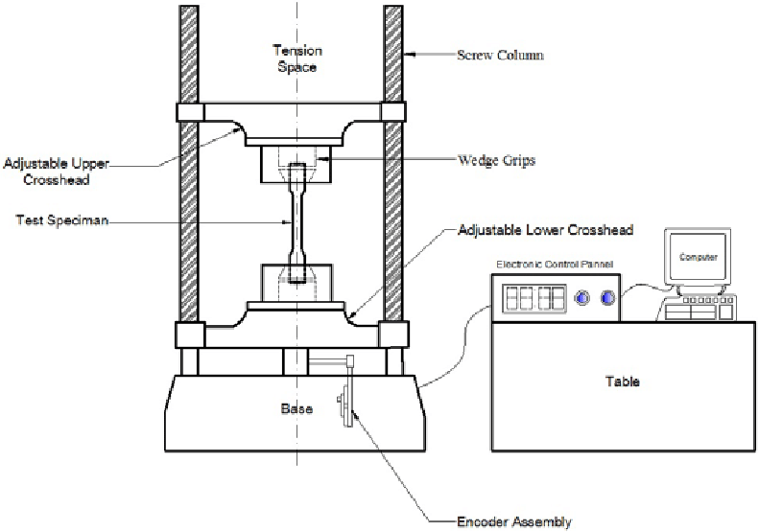
Figure 5 Tensile test machine schematic diagram (Chellamuthu, 2012)

To validate a tensile FEA scenario for the connecting rod, a Tensometer as illustrated in Figure 5 is used to examine the rod shank displacement in the Y-axis. This test is carried out using the same force applied in the FE model for continuity. For validation of the compressive FEA test, the same process is used as the tensile test but with the machine in compressive direction using a sensor to record the force applied, a DTI gauge for the displacement of the rod and a strain gauge for the strain.
As stated by E.J. Hearn in his 2nd book on Mechanics and Materials, the use of FEM and mathematically calculated stresses is acceptable for an engineer to adopt when working with materials and components that are the regular output of that manufacturer, however, when a new material or object geometry is required, this no longer allows the engineer to rely on past knowledge of solutions and therefore requires a new approach by using a set of already established physical validation techniques used to this day. These techniques used as opposed to the theoretical procedures FEA is governed by include brittle lacquer and strain gauges.
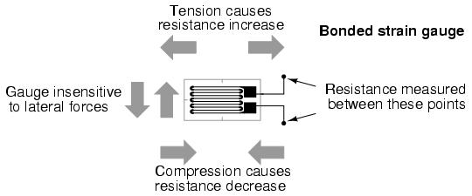
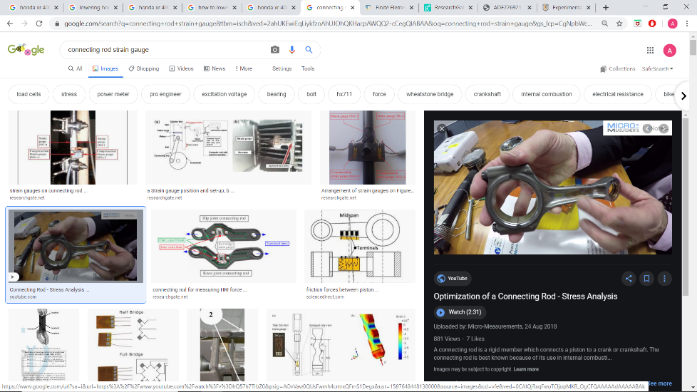
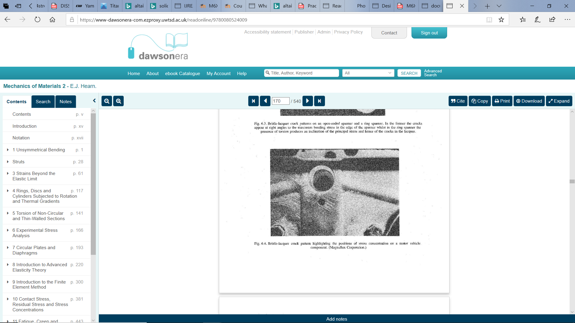
In a paper published by Sourabh Jain and many other available literature sources to the reader documenting the methods used to validate computational methods, the comparison of results from FEA with hand calculations and strain gauges are the predominant way of correlating a physical test to the computational methods used. The author has not come across any available literature suggesting brittle lacquers are used in the correlation to this day, however as mentioned in section 2.4, these are well guarded trade secrets.
Figure 6 Strain gauge schematic diagram (Vignesh, 2018)
Figure 7 Connecting Rod with strain gauge attached to I-beam shank section (Micro-Measurements, 2018)
Figure 8 Brittle lacquer crack pattern showing the stress concentrations on an engine block (Magnaflux Corporation)

Finite Element Mesh Influence on Correlation
From the authors experience from a previous study there are factors of meshing which can have a large impact on how the results compare with physical testing outcomes. The number of elements which are being used must following a simple rule to enable the true behaviour of a part with complicated geometry through its neutral axis. This rule is to have at least 3 elements across a face on the objects geometry to obtain a compressive and tensile force either side of the neutral axis as displayed in
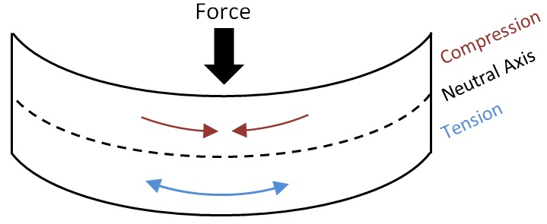
Figure 9 Three stress areas of definition (Palas, 2015)

In Altair’s guide to the practical aspects of FEA, it is noted that the size of mesh elements can be selected by many different contributing factors dependant on the scenario, object geometry and its boundary conditions.
Element size selection can be governed by one or a combination of the following constraints presented to the engineer:
- Based on previous experience (Where good correlation has been found with same type of FEA scenario simulation and FEM used)
- Time limited (With less time available to the design engineer, the mesh size may need to be smaller in order to reduce computing tie and effort)
- Hardware limited (This is at the discretion of the engineer to understand the element node quality and size which can be used within their means)
- Type of analysis (If only deflection/displacement is being studied and not the stress so importantly, then a lower element size can be used for a beam of rectangular section)
These constraints when choosing an element solution to go with can effect also the results which the engineer yields to compare and correlate with real results therefore this is paramount it must be understood prior to attempting multiple FEA’s and time consuming iterative changes to the FEM used if the correlation is not within a permitted acceptable error percentage.

FEA Without Physical Testing

Feasibility
To complete an FEA without correlating the results to a physical test can be done, however the implications of this can be costly further down the line, this can be simply put into perspective by referring to the original design process in Figure 1 which consists of a repeated loop of iterations until the component is correct. In the context of a connecting rod, the physical testing can be neglected when the engineer has many years of experience in FEA of a specific type of connecting rod for only a specific type of application, the engineer must also know which FEM to use and how to set-up the model with the correct mesh and boundary constraints. Only when the engineer in question has completed and successfully manufactured connecting rods for a specific purpose can they neglect the physical testing correlation, thus assuming their FEA is correct.
In the event of a different material being selected for the connecting-rod, which is a common reason for new designs, the engineer will need to adapt his FEA model and the objects geometry will undoubtedly change therefore yielding naturally different results. With a different material used, the Young’s Modulus of the material will most likely change as observed in multiple pieces of literature. Therefore, the change in elastic material properties will result in a varied displacement result for the shank of a connecting rod which will not correlate with previous experiments, thus requiring physical testing to be completed for FEA validation.
Taking into consideration the connecting rod is not under a specified load in all engines from varying combustion pressures and engine rotational speeds, the load which these rods will change depending on application therefore resulting in a different set of results for a higher or lower load applied.

Positives
- Some physical testing can be destructive therefore an initial cost reduction.
- If only FEA is used as a virtual testing method, it can reduce time spent on physical testing.
- For the shank of the connecting rod it can be assumed that the results yielded are most likely to be acceptable.

Negatives
- Can lead to the end product not completing its duty life cycle due to inaccurate un-correlated FEA results.
- Propagation of cracks in the connecting rod without an adequate physical test to correlate with is going to cause time lost in re-iterative designing the component and running FEA tests which in itself cost time for an employer or self-employed engineer.

Conclusion
To conclude this research report discussing whether FEA should replace physical testing, the author would like to re-iterate that removing the physical testing can be done to a certain extent, but it is highly dependant on the many different forms of product design the FEA will be used for.
In the context once again of a connecting rod, the loading which the connecting rod is subject to is changing depending on its application, this is the primary reason for changing the connecting rod in the first place, therefore it cannot be removed in the sense of critical engine components which will cost the customer a lot in repairs. Not only limited to the loading, the material properties may change in order to reduce the mass of the rod or in the event of a connecting rod requiring a higher Young’s Modulus in order to reduce rod shank displacement causing catastrophic engine component contact. Any of these changes to the design must be physically tested as this will logically change the results produced by any FEM used.
The costs of completing FEA without correlation can far outweigh those which are saved in negating the physical tests. Therefore, in the opinion of the author the discussion brings the final outcome that physical testing is currently necessary in the development and design of high-end connecting rods and in general any critical engine part which could cause such damage as it would.
In other applications of product design such as in the context of a chair leg, there are lots of previous studies to suggest that this is not as critical as such engine components. Therefore, it can be completed using FEA with no correlation as long as the engineer designing the chair leg has completed a correlated FEA before and uses the same finite element method as previously used.

References
Carrillo, C., 2018. Finite Element Analysis FEA. [Online]
Available at: https://www.cp-carrillo.com/gi-256136-finite-element-analysis-fea.html
[Accessed 12 March 2020].
Hearn, E. J., 1997. Mechanics of Materials 1. Third Edition ed. Oxford: Butterworth-Heinemann.
Hearn, E. J., 1997. Mechanics of Materials 2. Third Edition ed. Oxford: Butterworth-Heinemann.
Heywood, J. B., 1988. Internal Combustion Engine Fundamentals. USA: Library of Congress Cataloging-in-Publication Data.
Palas, P., 2015. Strain Gauges.
Shaari, R. M. N. M. K. K. A. K., 2010. Design Of Connecting Rod Of Internal Combustion Engine: A Topology Optimization Approach. Pahang, Universiti Malaysia Pahang.
Systems, P. R., 2019. [Online].
Systems, T. Q., 2019. FEA and Simulation Validation, Pennsylvania: Trilion.
University, A., 2019. Practical Aspects of Finite Element Analysis. 5th ed. Detroit: Altair.
Vignesh, M., 2018. What is a strain gauge and how does it work?, s.l.: Instrumentation Forum.

