

University of Wales Trinity Saint David (UWTSD)
Module Name: Employability and Career Development
Module code: LCLM 4005
Assessment Title: Mock Interview

CertHE Business Skills for the Workplace
Submitted by:
Dean Kiran
Student ID:
Lecturer: David Oyebisi
Submission Date: 19/10/2026
Word count: 725

Customer Service Analys:
IT Service Desk in Oldbury (B69) | Pimlico Banks Recruitment

(Accessed 15.10.2026)

https://www.totaljobs.com/job/it-service-desk-analyst/pimlico-banks-recruitment-job108111560?rltr=2_2_25_seorl_s_0_0_0_0_0_0

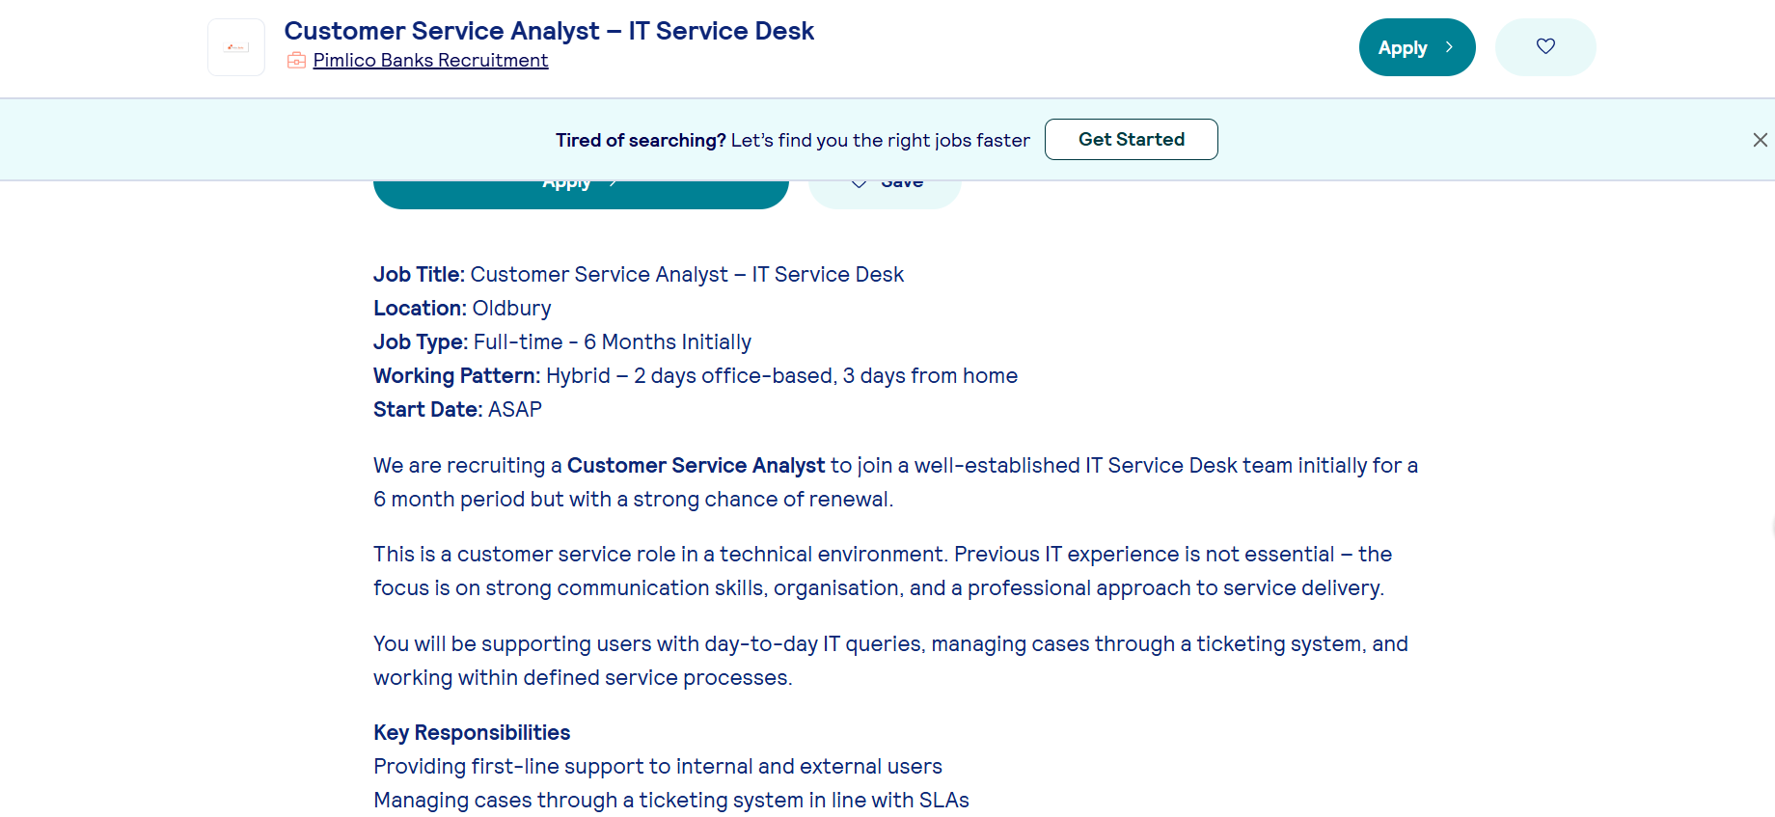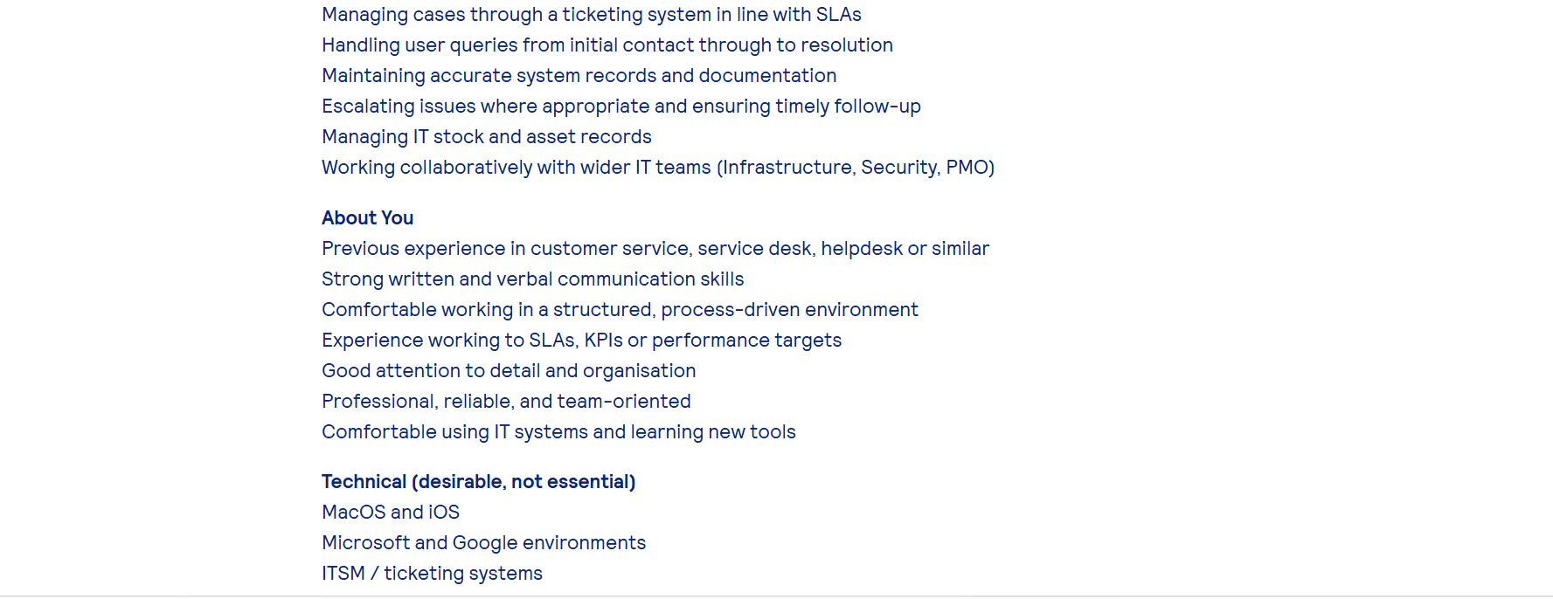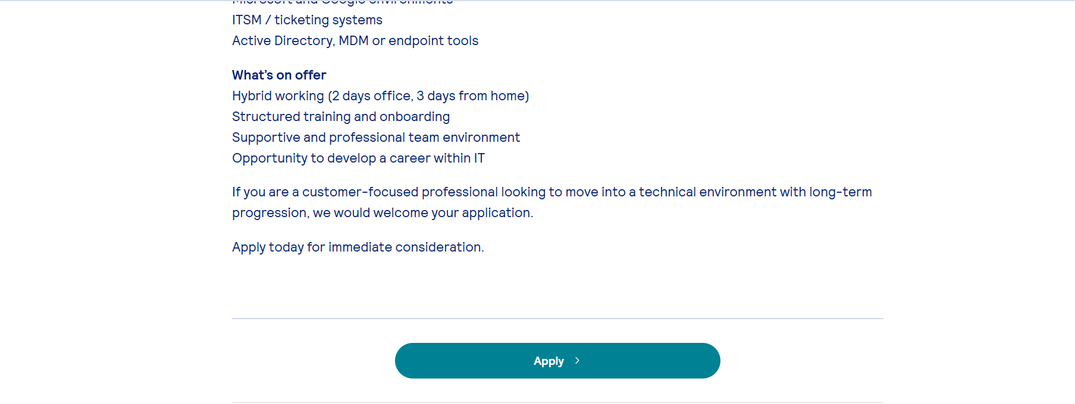

Dean Kiran

Pimlico Banks Recruitment,
Oldbury B69 4HE

18.10.2026

Dear Hiring Manager,

I wish to apply for the role of Customer Service Analyst – IT Service Desk, currently being advertised. Please find enclosed my CV for your consideration.

As you can see from my attached CV, I have over 15 years’ experience in customer service and account management, and I believe my track record in support, following SLAs, and maintaining accurate records makes me the perfect candidate.

In my current role as Remote Account Manager at Bupa UK, I act as main contact for clients, resolve enquiries from start to finish, manage cases in CRM systems, escalate issues appropriately, and consistently meet service targets.
I have developed strong communication skills, organisation, and the ability to learn new IT tools quickly. I work well in structured teams and take pride in reliable, high-quality support.

All of this, plus my ICT Networking qualifications and enthusiasm to build a career in IT, has helped me deliver excellent service and achieve 100% call quality ratings.
I am confident I can bring this success to your team and help your IT Service Desk build on its reputation for excellent user support. I will make a positive, reliable contribution from day one.

Thank you for considering my application. I look forward to discussing how I can support your team.

Yours sincerely,

Dean Kiran

Dean Kiran

Tel: 07865 528 242 | Email: DLKK2012@live.com,
LinkedIn: https://uk.linkedin.com/in/dean-kiran-343a623b5

Address: 1122 Fabrick Square, 1 Lombard Street, Digbeth, Birmingham, B12 0AA

Professional Summary

With over 15 years in customer service and B2B support, I’m building my career in IT service support. I communicate well, help people, follow processes, and meet targets. Organised and quick to learn new tools, I deliver clear, friendly, efficient service every time. I work independently or in teams, and I’m eager to grow within a technical environment.

Work Experience

Remote Account Manager – Bupa Health Insurance
01/03/2020 – Present

- Manage a portfolio of Bupa UK client accounts, acting as the primary point of contact for ongoing support and service delivery.
- Build and maintain strong, professional relationships with Bupa stakeholders, ensuring clear communication and alignment with service level agreements.
- Process and track customer enquiries, authorisations, and referrals accurately and efficiently using SWIFT CRM and OneView, adhering to data protection and GDPR standards.
- Monitor performance against targets and provide regular updates on key metrics, trends, and opportunities for improvement.
- Collaborate with internal teams and Bupa partners to streamline processes and ensure a consistent, high-quality service experience.

Customer Support Advisor / Advisor — Alliance Health Group Corporate
08/06/2017 – 02/03/2020

- Began in the Referrals team on the Vitality Health insurance campaign; promoted within one year to the Corporate Accounts team supporting key clients including Rolls-Royce, Northumbrian Water, and Anglian Water.
- Used CRM and Maise systems to log, schedule follow-ups, Managed shared email inboxes, updated patient records, and processed claims received by post and digitally maintaining Service Level Agreement (SLA) compliance.
- Achieved 100% call quality ratings and ‘Lead Booker’ status; promoted to handle complex corporate claims, ensuring invoices were processed and paid correctly and on time.

Birmingham City Council — Council tax and Housing Officer
08/06/2006 – 02/03/2016

- Customer service, query handling, payment enquiries, complaints
- Created an internal system called “Sheldon” to support over 400 agents, was in charge of the training and roll out over many departments
Central Peripherals Ltd — Printer Technician
(Work Experience)
2003 – 3 months

- Fix and refurbish old and new printers, replacing old cartridges and rollers
- Updating firmware, testing on different types of paper
- Warehouse management, updating stock, organising transport of goods using CRM.

Education & Qualifications

Dates | Institution | Qualification
2020 – Present | University of Wales Trinity Saint David | Level 4 Business in the Workplace
2006–2007 | University of Central England, Birmingham | BTEC PDC: Information and Communication Technology
2004–2006 | City College | BCS Level 2 IT Users · ECDL · OCR Level 2 ICT System Support
1998–2003 | Hamstead Hall  School | 8 GCSEs Grades A–D (English, Maths, Science) · GNVQ Leisure & Tourism (Pass)

Additional Information

- Took part in the Prince’s Trust Film Live programme, working with Channel 4 producers to create a short film.
- Previously worked in hospitality, progressing from kitchen porter to assistant chef through training and dedication.
- Enjoys learning new skills, travelling, music, and helping others. Keen interest in design and mechanical problem solving.
- Reliable, punctual, and willing to take on new responsibilities.

Referees Available upon request.

