

Assessment 1
Title: The Influence Of National And International Labour Markets On HRM And IHRM Strategies

Name: Chetnaben Anilbhai Fadke
Student ID: 2430959
Module Name: Human Capital Management
Module Code: LCMB7023_LON
Lecturer’s Name: Dr Gladius Kulothungan
Word Count: 2500

Term 1

Table of Contents
1. Introduction 4
2. Technological Advancements in the Labor Market for HRM and IHRM strategies 4
3. Market Segmentation and Its Challenges for HR Professionals 6
4. Addressing Skill Gaps and Talent Shortages in Critical Sectors Through Strategic HRM 7
5. Reflective Report 9
6. Conclusion 11
Reference 13

1. Introduction
“Human Resource Management”, or HRM, is the process of utilising various strategies to manage an organisation to help the employees achieve maximum performance in their workflow, and align their goals with the company. It emphasises the employees and refers to them as the assets of the business (Barney, 2023). Several factors help HR professionals with the operations of a company, such as recruitment, training, benefits, performance management, employee retention, and more. If companies want to achieve proper management of Human Resources, they need to follow some basic principles, such as human capital, strategic partner, and establishment of an employee-centric environment.
Meanwhile, “International Human Resource Management”, or IHRM, is the practice of managing human resources on a global level. IHR professionals need to follow some significant considerations to achieve management in a global sector, including cultural diversity, legal differences, balancing global needs, and others. IHRM professionals use the IHRM model to ensure a seamless process and manage resources in a multinational sector (alp consulting, 2023). However, while managing the resources in a company, HR and IHR professionals face several difficulties in their operations. This study evaluates the various challenges the professionals face while implementing HRM and IHRM strategies.

2. Technological Advancements in the Labor Market for HRM and IHRM strategies
HR and IHR professionals are becoming more aware of the implementations of various technologies, such as AI, automation, digital platforms, and more. These technologies can reshape the labor market and shift administrative functions to a strategic business partnership. Today, the technological sector is implementing artificial intelligence in its business operations to create a fundamental relationship between employees and the companies (Vrontis et al. 2021). However, contemporary developments are providing alternatives to human resources in functions to require human interaction and communication, and bringing a change to the organisational structure. Automating technologies to create routine tasks can lead to a high demand for skilled workers for the management of tasks and technologies.
The collection and analysis of vast amounts of employee data can allow for predictive analytics while enabling organizations to forecast talent needs. They can also identify turnover risks and develop targeted strategies based on evidence rather than intuition. For International professionals, they can focus on talent acquisition and recruitment with the help of analytical technologies. AI technologies can be used for automated resume screening and conducting interviews through a chatbot. Performance management can become real-time-based for providing continuous feedback. The professionals can follow a strategic HR management for issues regarding management, policies, and operations (Patrick, Jha, and Sharma, 2022). These professionals deal with various complexities in management to implement strategies in the global workforce, and still benefit from the use of technologies.
The Management of sensitive employee data across borders can present significant challenges regarding data privacy and security. IHRM strategies need to prioritize better cybersecurity measures to navigate varying international data protection laws and mitigate data breaches to maintain trust. After the “Fourth Industrial Revolution”, there has been an immense increase in the use of technologies, including AI, automation, and more (Budhwar et al. 2022). Thus, these technologies not only create challenges but also opportunities that they can achieve in the global industry. With its implementation, the professionals can achieve cross-cultural communication and collaboration with other companies and sectors by breaking the language barrier. Cloud-based system can enable a seamless process for global operations. This technology facilitates the seamless acquisition and management of international talent and allows IHRM to create a diverse global talent pool regardless of location. The technologies can enhance the experience of employees through various platforms and apps, including self-service portals, wellness apps, and internal social media platforms. E-learning platforms, virtual reality (VR), and augmented reality (AR) can offer personalized, on-demand training experiences that can be customised based on individual skill gaps and career goals.

3. Market Segmentation and Its Challenges for HR Professionals
“Market Segmentation” is the process used by HR to divide the workforce into groups within an organisation. In the labor market, the focus is on aging and declining working-age populations, as life expectancy has increased and birth rates have declined. This can lead to a skill mismatch in the older employees (OBSERVER RESEARCH FOUNDATION, 2025). On the other hand, the low-income economies can have a large population of young employees who can drive the economic growth of the labor market. However, this requires proper training and job creation for it to come to fruition. Migration and urbanisation are other factors that can be a significant source for the development of nations and fulfilling gaps in the skills of the employees.
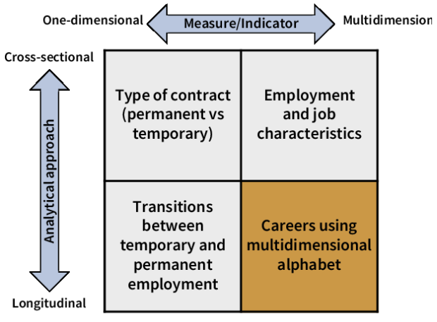
Figure 1: Market Segmentation in the Labor Industry
(Source: Cruz et al. 2020)
Geopolitical factors are also crucial, as they can present the HR professionals with significant challenges. One of the most influential factors in the employment and labor market is the fragmentation of geoeconomics. An increase in geopolitical tension can lead to trade disputes, sanctions, causing disruption in the management of the supply chains. In modern business, the intersection between HR and marketing strategies is crucial; however, its competencies can be underpinned by human capital for organisational success (Judijanto, Puspitarini, and Zulfikri, 2024). Marketing strategies are designed to determine the distribution of price, product, and satisfaction to the consumers. Therefore, it plays a pivotal role in the development of the product and the evaluation of financial performance.
The professionals in this sector face several challenges in the implementation of new strategies. One of the significant challenges in the industry is exclusivity doubts. Consumers can exhibit preferences that can span multiple segments, which makes it difficult to assign a task to any one of the employees. Therefore, companies need to focus on a budget-friendly option to create a correlation between the segments (SLM, 2024). There is always the concern of data collection and privacy concerns, as gathering unnecessary data of the employees can lead to concerns about safety and security. Managing multiple programs can also become complex as it needs to maintain a balance between personalised options and consistency across the organisation. The impending retirement of large cohorts of experienced employees can lead HR to prioritize effective succession planning and knowledge transfer programs, which can ensure leadership continuity while preventing significant loss of knowledge. The professionals need innovative strategies for talent acquisition to mitigate labor shortages and resignation of employees. It can involve a process of competitiveness, while providing benefits and arrangements for work to appeal to the demographic of the employees.

4. Addressing Skill Gaps and Talent Shortages in Critical Sectors Through Strategic HRM
“Strategic Human Resource Management”, or SHRM, is the process of aligning the goals and values of a company with the HR strategies to achieve an enhanced business goal. The processes can include hiring, promoting, and rewarding the employees based on their performance. Noticing and bridging the gaps can help to upskill and reskill the existing employees of an organisation (Vulpen, 2020). The professionals need to conduct a thorough analysis of the existing skills of the employees and the areas where they are lacking. They need to compare the current workforce and upskill according to it. They need to collaborate with external partners to gain access to other skills and train their employees in them. This can include working with universities to shape curriculum and partnering with industry associations to find specialized talent. Using advanced technologies, such as AI and automation, HR professionals can automate processes, personalize learning, and upskill employees.
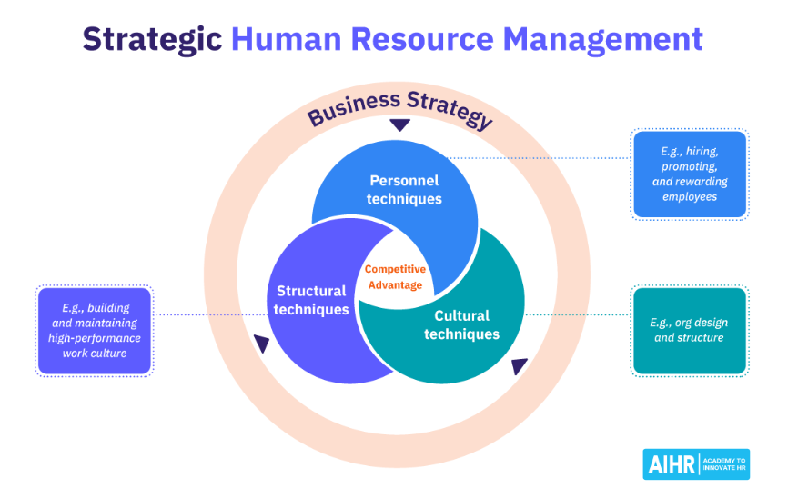
Figure 2: Strategic Human Resource Management
(Source: Vulpen, 2020)
The topic of skill gap in employees is relatively new, and thus, it needs an in-depth understanding of the concept to actually implement it in business operations. It is mentioned by Shah (2023) that skill gaps can be considered as resource-based or market-oriented. The decision of the stakeholders, therefore, can affect the interests, which can lead to the employees having skill gaps. In the technological sector, advancements can cause skill gaps in the workers, which in turn leads to enabling training sessions. Emphasizing continuous upskilling and reskilling programs can be done through e-learning platforms and simulations. In the healthcare sector, skill gaps can lead to staff shortages and neglect in patient care (Vandy, 2023). However, utilising HR strategies can help the employees to streamline tasks and use various initiatives for patient care. In the hospitality sector, opting for performance-based incentives can increase the satisfaction of the guests while also increasing employee loyalty.
The professionals can create an environment where the employees can foster learning and development, while being involved in training to bridge skill gaps, and align themselves with the goals and values of the company. With recognition, achievement, and rewards, professionals can encourage employees to learn new skills. Another important factor in addressing skill gaps and talent shortages is the management of the public sector. In this sector, several concerns are in play, such as policymakers, researchers, and practitioners (Rikala et al. 2024). One of the major gaps in this industry is the issues faced during leadership and management, which makes the organisation suffer from a lack of leadership and successful plans. The public sector is connected to the application of human resources. Therefore, misuse of the management processes can lead to failed opportunities and employee turnover.

5. Reflective Report
This study focuses on the application of HR strategies in both local and international contexts, while also focusing on the challenges faced by them. In today's globalised workplace, every employee must be equipped to perform effectively in an international environment. Moreover, given the extremely fast changing technologies, the continuous adaptation and innovation of a person gains more and more significance to help him/her take advantage of all the new opportunities that appear along the way (University of Cambridge, 2023).
The purpose of my attempted study was to assess the HR strategies considering factors like technological progress in the labour market to HRM and IHRM, market classes and obstacles to market segmentation, and closing skills gaps and talent shortages in vital sectors using strategic HRM.
This reflection is written to present my view on my present abilities as an international employee. This experience has made me understand that technology, innovation, and resources are important elements in any organisation as they allow the organisation to operate effectively and be strategically aligned. It has also become clear to me that the process of communication and collaboration cannot be done without the efficient HR management since the professionals should be able to listen to the employees and implement their feedback.
Strengths
In the course of the research, I have learned that various personal strengths helped me to learn and develop professionally:
Pressure working: I have been shown to be stable and concentrate despite deadlines as I have demonstrated that I am able to work under pressure.
Adaptability and learning attitude: I could adapt fast to new academic demands and get acquainted with new HR concepts, in particular, technological integration in HRM.
Skills in analytical and critical thinking: I was able to assess the strategies via the HR and relate the theoretical principles to the practical business problem.
Commitment and motivation: I remained resolute to deliver the report within the time limit and in quality even though there were setbacks at the beginning.
Knowledge of technological influence: I gained a clear picture of the ways in which AI, automation, and digital platforms may be applied to improve HR practices, especially recruitment, data management, and employee engagement (Zhang and Chen, 2023).
Weaknesses
In the process of completing this assignment, I also noted some weaknesses that influenced my performance and the quality of my work, in general:
Ineffective time management: I was unable to organize my schedule on how to research and write, which resulted in time pressure at the last minute and lack of time to revise my work.
Insufficient research depth: I lacked information on how to find enough academic sources and this influenced the quality of my evidence-based analysis.
Poor communication skills: I had a problem in her complicated expression of ideas in a scholarly manner.
Lack of attention to leadership and teamwork models: I came to the understanding that my analysis might have been more detailed by introducing models associated with leadership and collaboration.
Excessive dependence on theoretical material: I was inclined to explain theories rather than use real life examples or case studies to make them more realistic.
Reflections and Future Development.
I have come to know that these are my strengths and weaknesses which have influenced my learning experience. To enhance my time management skills in future assignments, I will develop a timetable of work and do my initial research. I would also apply my academic workshops and constant feedback to improve my communication and writing skills. Besides, I hope to incorporate leadership and teamwork theories in order to have a more holistic view of the HR strategies.
On the whole, this reflection has allowed me to get to know not only about the concepts of HRM and IHRM but also about my personal growth as a learner and potential practitioner. By understanding my weaknesses and strengths, I will be able to work better both academically and in an organisation in the future. I have to say I have found my strengths and weaknesses while answering the queries. I have found out that I have not done enough research to provide concrete evidence for the factors; however, I have found reasonable insights regarding technological advancements and skill gaps. Therefore, I have to say that for future research, I have to make a clearer aim for my study to assess it. I have come to the conclusion that market segmentation is a prominent factor in the assessment of HR strategies for an organisation. The segmentation primarily focuses on the demographics and the geopolitical factors that influence the strategies. Fragmentation of geoeconomics can lead to geopolitical tension can lead to trade disputes, sanctions, and disrupt the management of the supply chains. Data collection and privacy are other concerns, as gathering unnecessary data of the employees can lead to concerns about safety and security. Skill Gaps and Talent Shortages are significant challenges when it comes to the implementation of new strategies and technologies (Next Innovation Asia, 2024). Through the use of Strategic Human Resource Management, a company can not only enhance its business, but also focus on hiring new workers and promoting its business. Putting emphasis on continuous upskilling and reskilling programs can be done through e-learning platforms and simulations.

6. Conclusion
To conclude, this study focuses on the challenges faced by HR professionals while implementing strategies to enhance business. This study focuses on various factors important for the implementation process, most importantly technological advancements, market segmentation, skill gaps, and talent issues in employees. All these factors have a significant effect on the business operations of a company. There are several factors that help HR professionals with the operations of a company, such as recruitment, training, benefits, performance management, employee retention, and more. If companies want to achieve proper management of Human Resources, they need to follow some basic principles, such as human capital, strategic partner, and establishment of an employee-centric environment.
The reflective report states the limitations of this study and what can be done for future researchers. It also provides insights into the three factors discussed in the study to further emphasise the strategies and their impact on business operations. There are several differences between HRM and IHRM. Most importantly, HRM focuses on a single country and provides legal laws based on domestic rules; meanwhile, IHRM focuses on international management and utilises global resources for business operations. Thus, it can be concluded that both processes provide influential factors for the sectors to care for.

Reference
alp consulting (2023). What is International Human Resource Management? Alp Consulting. [online] 21 Dec. Available at: https://alp.consulting/what-is-international-human-resource-management/ [Accessed 7 Nov. 2025].
Barney, N. (2023). What Is Human Resource Management (HRM)? [online] TechTarget. Available at: https://www.techtarget.com/searchhrsoftware/definition/human-resource-management-HRM [Accessed 7 Nov. 2025].
Budhwar, P., Malik, A., De Silva, M.T.T. and Thevisuthan, P. (2022). Artificial Intelligence – Challenges and Opportunities for International HRM: a Review and Research Agenda. The International Journal of Human Resource Management, [online] 33(6), pp.1065–1097. Available at: https://www.tandfonline.com/doi/full/10.1080/09585192.2022.2035161.
Cruz, I., Molina, O., Paulauskaitė, E., Tursa, A., Recotillet, I., Schmidt, T., Tomlinson, M. and Wessling, K. (2020). Labour market segmentation: Piloting new empirical and policy analyses. [online] Available at: https://www.semanticscholar.org/paper/Labour-market-segmentation%3A-Piloting-new-empirical-Cruz-Molina/94832a247e548bd69fbe92bf07902a369cfe9837/figure/3 [Accessed 7 Nov. 2025].
Judijanto, L., Puspitarini, E.W. and Zulfikri, A. (2024). HR Competency Challenges in Developing Marketing Strategies: A Bibliometric Review. West Science Interdisciplinary Studies, [online] 2(03), pp.656–663. doi:https://doi.org/10.58812/wsis.v2i03.746.
Next Innovation Asia (2024). HRM Strategies for Addressing skill shortages |. [online] NIA Blog. Available at: https://nextinnovationasia.com/blog/hrm-strategies-for-addressing-skill-shortages/ [Accessed 7 Nov. 2025].
OBSERVER RESEARCH FOUNDATION (2025). Making the case for global workforce migration: A strategic blueprint to harness India’s demographic dividend. [online] orfonline.org. Available at: https://www.orfonline.org/research/making-the-case-for-global-workforce-migration-a-strategic-blueprint-to-harness-india-s-demographic-dividend [Accessed 7 Nov. 2025].
Patrick, W.S., Jha, J.K. and Sharma, K.G. (2022). Strategic International Human Resource Management (SIHRM) framework: an Integrated Review and Directions for Future Research. Journal of Global Mobility: The Home of Expatriate Management Research, 11(2). doi:https://doi.org/10.1108/jgm-08-2022-0039.
Qualtrics (2024). Market Segmentation: Everything to Know in 2022. [online] Qualtrics. Available at: https://www.qualtrics.com/en-au/experience-management/brand/what-is-market-segmentation/ [Accessed 7 Nov. 2025].
Rikala, P., Braun, G., Järvinen, M., Stahre, J. and Hämäläinen, R. (2024). Understanding and measuring skill gaps in Industry 4.0 — A review. Technological Forecasting and Social Change, [online] 201(123206), pp.123206–123206. doi:https://doi.org/10.1016/j.techfore.2024.123206.
Shah, N. (2023). Leadership Strategies to Closing the Critical Skills Gap: A Review. International Journal Of Scientific Advances, [online] 4(5). doi:https://doi.org/10.51542/ijscia.v4i5.10.
SLM. (2024). Market Segmentation: Benefits and Challenges • SLM (Self Learning Material) for MBA. [online] Available at: https://slm.mba/mmpc-006/market-segmentation-benefits-challenges/ [Accessed 7 Nov. 2025].
University of Cambridge (2023). LibGuides: Reflective Practice Toolkit: Reflective writing. [online] Cam.ac.uk. Available at: https://libguides.cam.ac.uk/reflectivepracticetoolkit/reflectivewriting [Accessed 7 Nov. 2025].
Vandy, J.F. (2023). Bridging the Gap for Effective Public Sector Management – Reviewing the Critical Role of Strategic Human Resource Management. International Journal of Research Publication and Reviews, 4(4), pp.769–774. doi:https://doi.org/10.55248/gengpi.2023.4.4.34741.
Vrontis, D., Christofi, M., Pereira, V., Tarba, S., Makrides, A. and Trichina, E. (2021). Artificial intelligence, robotics, Advanced Technologies and Human Resource management: a Systematic Review. The International Journal of Human Resource Management, 33(6), pp.1–30. doi:https://doi.org/10.1080/09585192.2020.1871398.
Vulpen, E. van (2020). Strategic Human Resource Management: The Basics. [online] AIHR. Available at: https://www.aihr.com/blog/strategic-human-resource-management [Accessed 7 Nov. 2025].
Zhang, J. and Chen, Z. (2023). Exploring Human Resource Management Digital Transformation in the Digital Age. Journal of the Knowledge Economy, [online] 15(1). Available at: https://link.springer.com/article/10.1007/s13132-023-01214-y [Accessed 7 Nov. 2025].

