

MODULE CODE: BMSK4003
DIGITAL SKILLS AND RESEARCH METHODS
NAME: MARIAN-BOGDAN ISACESCU
ID: 1812780

TOPIC: EXPIRED FOOD IN CORNER SHOPS
Executive Summary
The assignment is aimed at the study of the expired products that are being sold by these corner shops. Problems of the sellers in selling the expired foods and the consequences of the consumption of expired foods of the customer are discussed. The scope of the research is related to the enquiry of the selling of the corner shop and the daily consumption of expired food from the shops by the consumers. The selling of the expiry foods can significantly impact the profit of the retailer or the sellers of particular shops. The sale of the expired food is directly dependent upon the selling of the fresh products. In order to avoid the sale of the expired foods, the shopkeeper sells the products prior to the use by dates or by selling them at lower cost. If the sales rate of the shop is higher, then the stocks in the shop are cleared and no other foods in the store remain. Whereas, if the stocks of the shops is not cleared prior to the expiry date, then the foods are remained unsold and eventually kept in the shop for further period of time ready to be sold.

Table of Contents
Introduction 4
Research objectives 4
Research questions 4
Literature review 5
Introduction 5
Critically describing expired food 5
Critically demonstrating condition of sellers in corner shops 5
Critically illustrating impact of expired food on corner shops 5
Critically describing the issues related to expired foods 6
Critically describing theory related to food safety 6
Gap in literature 6
Primary research 6
Methodology 6
Research philosophy 6
Research method 7
Sampling method 7
Survey questionnaire 7
Ethical consideration 8
Limitation of the study 8
Results 8
Analysis 12
Conclusion 12
Reference List 14
Appendix: Expired Food Issues 15

Introduction
The expired foods are the foods that have crossed their date of use. Every food has certain endurance and it may become contaminated in due course of time. Foods that are packaged sufficiently can also be proved to be toxic to health if it becomes expired. The selling of the expiry foods can significantly impact the profit of the retailer or the sellers of particular shops.
The grocery and corner shops in the UK became the first major sellers to sell food past its date. In the year 2017, the groceries that are located about 125 locations throughout the East Anglia have started down marketing some foods to a lower cost to encourage the customers to buy the expired items. The prices that are reduced are only applicable to the foods that are not perishable such as snacks, canned goods, pastas as well as rice. This down marketing lasted for about at least one month until the stocks were cleared enough to avoid further losses (treehugger.com, (2019). The aim of the report is to find out expired foods in corner shops.
The assignment is aimed at the study of the expired products that are being sold by these corner shops. Problems of the sellers in selling the expired foods and the consequences of the consumption of expired foods of the customer are discussed. The scope of the research is related to the enquiry of the selling of the corner shop and the daily consumption of expired food from the shops by the consumers.

Research objectives
- To find out the reason behind expired foods and its numbers
- To determine the condition of corner shops
- To evaluate the impact of issues related to expired foods and its condition in corner shops
- To recommend strategies for mitigating issues related to expired foods

Research questions
Q1. What are the reasons for expiration of foods?
Q2. What are the conditions of the corner shops when the foods in the shops are expired?
Q3. What are the impacts of expired foods on the sellers of the corner shops?
Q4. What can be strategies for mitigating issues related to the expiration of foods?

Literature review

Introduction
This chapter discusses expired food and its consequences in corner shops. Expired foods have been discussed in this study Along with severe issues related with this case.

Critically describing expired food
The expired foods are the foods that have crossed their date of use. As mentioned by Principato et al. (2015), every food has certain endurance and it may become contaminated in due course of time. On the other hand, Aschemann-Witzel et al. (2015) commented that the foods that are packaged sufficiently can also be proved to be toxic to health if it becomes expired. On the contrary it can be put forward that the consumption every food has their own expiry dates irrespective of their packaging method and can be harmful to the health if consumed

Critically demonstrating condition of sellers in corner shops
The corner shops are the small retail shops where different kinds of items can be found. They are found in almost every corner of the streets. According to Cadle et al. (2014), the threat of substitution is faced by the shopkeeper as a significant number of competitors in an area is increased. Therefore, it results in a decrease of sell and increase of stocks in the stores. On the other hand Heimeshoff and Klein (2014) argued that the demand of the shop can be critically reduced if there are increased numbers of options to the customers. Thus, the selling of a shop can be noticeably low whereas the other shop’s sale can be high.

Critically illustrating impact of expired food on corner shops
The selling of the expiry foods can significantly impact the profit of the retailer or the sellers of particular shops. As opined by Jedermann et al. (2014), the sale of the expired food is directly dependent upon the selling of the fresh products. On the other hand Principato et al. (2015) mentioned that, in order to avoid the sale of the expired foods, the shopkeeper sells the products prior to the use by dates or by selling them at lower cost. Therefore, it can be said that when the selling of shopkeeper is low then it is more likely to have increased number of expired products in the shops. Thus, salesman and the shopkeeper suffer a significant amount of loss on their part.

Critically describing the issues related to expired foods
The expired food can cause a severe effect on the consumers as well the sellers. As discussed by Aschemann-Witzel et al. (2015), when the sale of the shop is critically reduced, the products remains in the store for a longer period of time even after their expiry. On the other hand Kimani-Murage et al. (2014). commented that the consumer of the expired product can be severely affected by the consumption of toxic contamination that are being produced inside the product. This can cause several diseases to the customers such as diarrhoea and dysentery as well as other food poisoning diseases. On the contrary, the effect of the expired foods is correlated with both the profit of the seller and the health of the customer. (Refer to appendix)

Critically describing theory related to food safety
As per the principle of safety and issues related to expired food, consideration of daily basis checking content and quality of ingredients of foods are necessary to ensure the safety of people. Based on best quality ingredients, increased rate of expired food in corner shops can be reduced significantly.

Gap in literature
The expired foods are the foods that have crossed their date of use. Every food has certain endurance and it may become contaminated in due course of time. Foods that are packaged sufficiently can also be proved to be toxic to health if it becomes expired. However, person-centred activities regarding safety for food products and the way of avoiding expired foods in corner shops have not been discussed in this study. Thus, it creates a gap in the literature.

Primary research

Methodology

Research philosophy
Positivism type of philosophy is the way of gathering evidence based and real world data from severe available options. As mentioned by Saunders et al. (2009), positivism type of philosophy is the way of gathering exact and positive data based on specific information. In this research, the researcher has followed positivism type of philosophy because of gathering most suitable and positive data related to expired foods and its consequences in corner shops.

Research method
Primary type of research method is the way of collecting new and severe opinion by considering qualitative along with quantitative research method. As opined by Kothari (2004), conducting interviews among group of managers is the way of gathering exact data related to influencing factors and its effect on certain factor. In this research, the researcher has followed primary qualitative along with quantitative research methods due to which accurate reasons behind the expired foods in corner shops and related issues have been included in the research. Along with primary quantitative type of research method has been followed for conducting surveys by implementing questionnaire. Survey has been taken among 55 existing and new customers and sellers of Corner shops in the UK.
Regular basis observation technique has been considered by the researcher to ensure issues from expired foods and its impact on condition of sellers of corner shops.

Sampling method
A sampling method is required for proper survey of a subjected enquiry. This can be described as a method of gathering sample members form the population for certain questionnaire regarding the objective related to the survey. There can be different approach in the sampling methods, differentiated on the basis of elimination of bias as well as cost and effort reduction. The most common method of sampling can be named as the Random sampling where some completely random members are selected from the population for further procedure. The Systematic sampling is another way of sampling method where the population are ordered according to the subject and questioned at regular intervals. Lastly, Stratified sampling, where the population is split into categories and members are selected from each category randomly for questioning. In this research, random sampling method has been followed for avoiding biases in the research.

Survey questionnaire
Q1. Do you believe that checking the date of expiry of the product is mandatory before buying them?
Q2. Do you believe that the expired foods that are sold in the corner shops at a low price is the correct choice?
Q3. Do you believe that the corner shops are worried about their profits over the health of the customers?
Q4. Do you think a legal action must be taken by the Government against corner shops for selling expired product to the customers?

Ethical consideration
As per guidelines of legislations related to Data protection 1998, protection of significant information and avoidance of data theft are major consideration of ensuring effectiveness of research on specific topic (legislation.gov.uk, 2019). In this research, researcher has stored all important data related to expired foods and corner shops through strong database for avoiding data theft. All participants participated in the survey has provided their opinion as their own wish without forced by members of the research team.

Limitation of the study
Limited time and shortage of cash have been major limitations of this research. Due to limited time, researcher has not been able to include important information regarding the condition of sellers due to expired foods into the research. Along with, shortage of cash has been a key issue at the time of researching due to which maximum opinion from severe people have not been gathered. Thus, it has impacted slightly on the research in a negative way.

Results
Q1. Do you believe that checking the date of expiry of the product is mandatory before buying them?
Factors | Total number of participants | Total number of respondents | Percentage of respondents
Strongly agree | 55 | 22 | 40
Agree | 55 | 14 | 25
Neutral | 55 | 2 | 3
Disagree | 55 | 12 | 22
Strongly disagree | 55 | 5 | 9
Table 1: response related of checking product expiry date

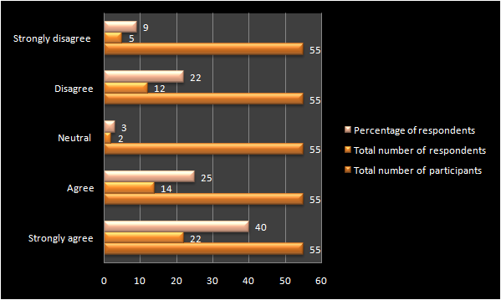

Figure 1: : response related of checking product expiry date

Q2. Do you believe that the expired foods that are sold in the corner shops at a low price is the correct choice?
Factors | Total number of participants | Total number of respondents | Percentage of respondents
Strongly agree | 55 | 5 | 9
Agree | 55 | 14 | 25
Neutral | 55 | 2 | 3
Disagree | 55 | 12 | 22
Strongly disagree | 55 | 22 | 40
Table 2: response of customers towards lower price of the expired products

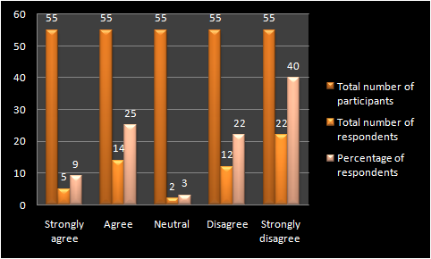
Figure 2: response of customers towards lower price of the expired products

Q3. Do you believe that the corner shops are worried about their profits over the health of the customers?

Factors | Total number of participants | Total number of respondents | Percentage of respondents
Strongly agree | 55 | 21 | 38
Agree | 55 | 12 | 21
Neutral | 55 | 10 | 18
Disagree | 55 | 8 | 14
Strongly disagree | 55 | 4 | 7
Table 3: response related to profit of customers vs health of customers
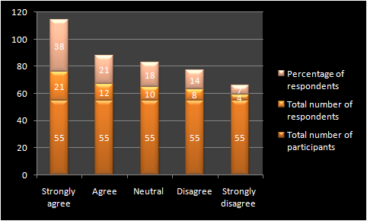
Figure 3: response related to profit of customers vs health of customers

Q4. Do you think a legal action must be taken by the Government against corner shops for selling expired product to the customers?
Factors | Total number of participants | Total number of respondents | Percentage of respondents
Strongly agree | 55 | 25 | 45
Agree | 55 | 11 | 20
Neutral | 55 | 10 | 18
Disagree | 55 | 5 | 9
Strongly disagree | 55 | 4 | 7
Table 4: response of the customer regarding the legal actions to be taken
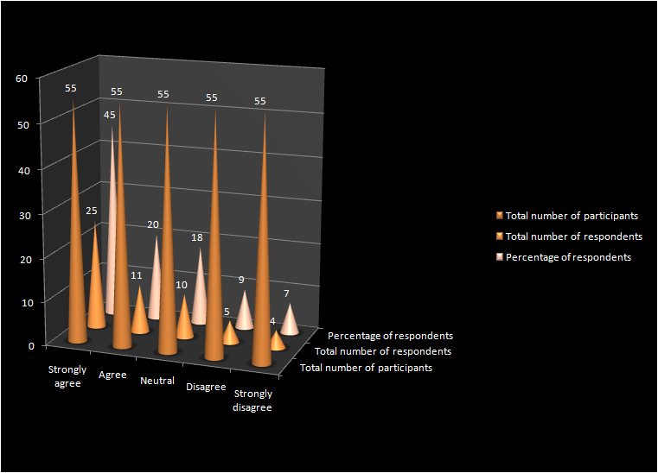
Figure 4: response of the customer regarding the legal actions to be taken

Analysis
It clear from all the respondents that respondents are aware about expiry date of product as 65% of respondent has given agreement with this question. Most of the respondent are not satisfied with the fact expired food in corner shops are good for selling at low price rate. Government officials can take strict legal steps for authority of corner shops who has been dealing in expired food products by selling it at low price range

Conclusion
Thus, it can be concluded that the expiration of the food is directly related to the sales of a shop. If the sales rate of the shop is higher, then the stocks in the shop are cleared and no other foods in the store remain. Whereas, if the stocks of the shops is not cleared prior to the expiry date, then the foods are remained unsold and eventually kept in the shop for further period of time ready to be sold. The expired are sold to the customers at a lower price to gain profit and clear their stocks. This affects the customer physically through severe diseases. The expired foods if not sold, are disposed off the environment creating a hazard and polluting the environment. This can cause a critical and harmful effect to the environment as the expired foods can spread pathogenic and infections such as illness, malaria dengue as well as other harmful diseases.

Reference List

Aschemann-Witzel, J., De Hooge, I., Amani, P., Bech-Larsen, T. and Oostindjer, M., 2015. Consumer-related food waste: Causes and potential for action. Sustainability, 7(6), pp.6457-6477.
Cadle, J., Paul, D. and Turner, P., 2014. Business analysis techniques. Chartered Institute for IT: Wimbledon
Fabbri, D. and Klapper, L.F., 2016. Bargaining power and trade credit. Journal of corporate finance, 41, pp.66-80..
Harum, N. and Bernardus, D., CREATING CUSTOMER ADVOCACY TOWARDS CUSTOMER of LALA GROUP BABY SHOP. In Welcome to the 5th International Conference on Entrepreneurship, 12(3), pp. 73-103.
Jedermann, R., Nicometo, M., Uysal, I. and Lang, W., 2014. Reducing food losses by intelligent food logistics. 13(4), pp.23-39.
Kimani-Murage, E.W., Schofield, L., Wekesah, F., Mohamed, S., Mberu, B., Ettarh, R., Egondi, T., Kyobutungi, C. and Ezeh, A., 2014. Vulnerability to food insecurity in urban slums: experiences from Nairobi, Kenya. Journal of Urban Health, 91(6), pp.1098-1113.
Kothari, C. R. (2004). Research methodology: Methods and techniques. New Age International: California.
legislation.gov.uk. (2019). Data Protection Act 1998. Available at: https://www.legislation.gov.uk/ukpga/1998/29/contents [Accessed on: 09/07/19]
Principato, L., Secondi, L. and Pratesi, C.A., 2015. Reducing food waste: an investigation on the behaviour of Italian youths. British Food Journal, 117(2), pp.731-748.
Saunders, M.N.K., Thornhill, A. & Lewis, P. (2009). Research Methods for Business Students, 5th edition. Pearson education: New York City, New York, United States
treehugger.com, (2019) UK grocer sells food past 'best before' date, Available at:https://www.treehugger.com/green-food/uk-grocer-sells-food-past-best-date.html [Accessed on: 12/08/2019]

Appendix: Expired Food Issues
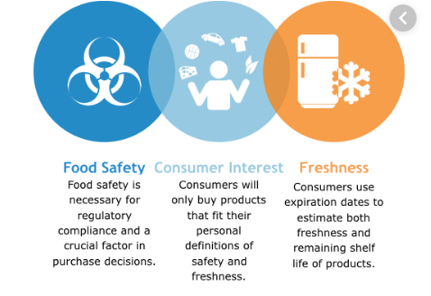
(Source: https://www.softwareadvice.com/resources/fefo-warehouse-software-food-distribution/)

