Portfolio of work

Student name: Aya Janagap
Student number: 2020123
Module code: BMSW 4005
Lecturer’s name: Olubukola Adegbite

Table of Contents
Introduction 1
SWOT and Personal Development Plan 2
SMART Goals 4
Skills of an effective Manager 4
Gibbs Cycle 7
UK employment 8
Learning Theories 8
Feedback Interview: 9
Self -awareness and Conclusion 9
References: 10

Introduction

With completing this module, Professional and Career development. I have learnt that being an aspiring Registered Manager in a Healthcare industry necessitates a wide range of information and abilities. It is, of course, required for us to advance professionally. I have used matrices to assist me visualise my abilities and properly describe my realisations so that I can recognise my skill set.

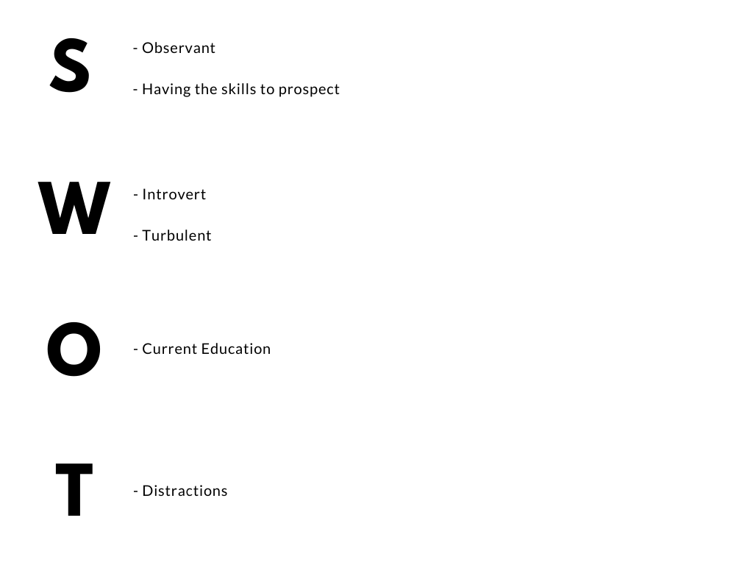

SWOT and Personal Development Plan

SWOT analysis, Personal Development Plan, and SMART Goals are structured matrices that assist an individual to recognise their strengths, weaknesses, opportunities, and threats while also their skills and goals to be attained. After utilising the said matrices, I was able to know my strengths and that includes being observant and having the skills to prospect. I consider these two as strengths for these can help me generate deeper insights and ideas. Having these skills also improves the thoroughness in completing work by caring about all aspects considered. My weaknesses, on the other hand, include being an introvert and being turbulent. I acknowledge that I sometimes prefer to be independent rather than communicate with others. I am self-conscious at times, which disrupts my inner peace. I tend to be self-conscious about my successes and to become a perfectionist.

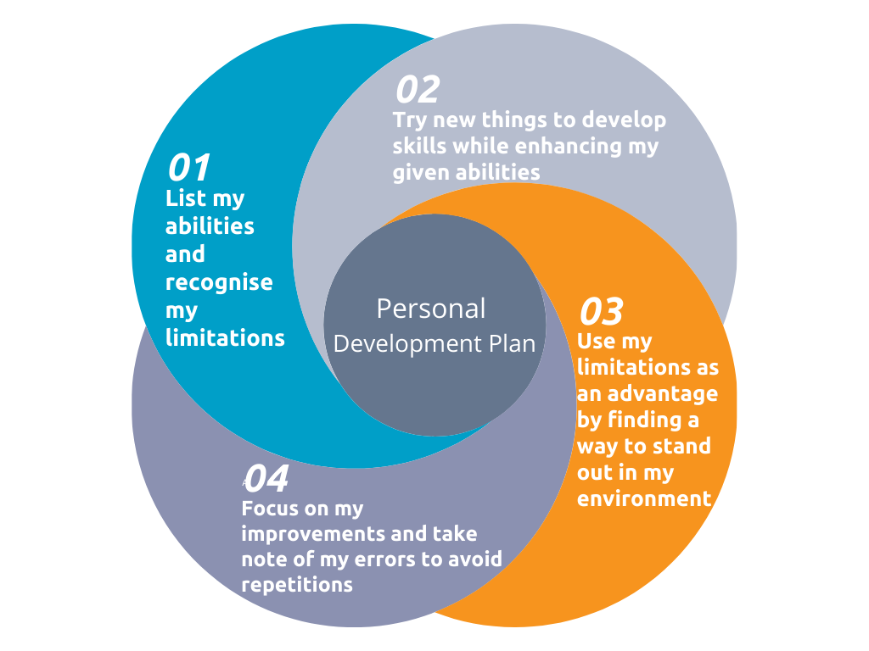

These are, without a question, not ideal, but via personal development planning, I have devised an organised approach to address these deficiencies and transform them into desired talents. To begin, I will try to be open-minded and gradually connect with people. To avoid becoming turbulent, I will strive to recognise my strengths and grow without putting too much pressure on myself. This degree that I am pursuing is one of the opportunities that I currently have. This is an opportunity for me since it will provide me with appropriate knowledge and skills that will be useful in the industry that I will be entering. The distractions in the environment are the threats that I address. Distractions cause me to lose concentration when working on a task. But I can remove as many excuses and distractions as I can so you can bring my full attention to one task at a time -- no multitasking. (Patel,2018) This distraction, however, may be converted into an opportunity only if I allow myself to be distracted by those "distractions" that are advantageous.
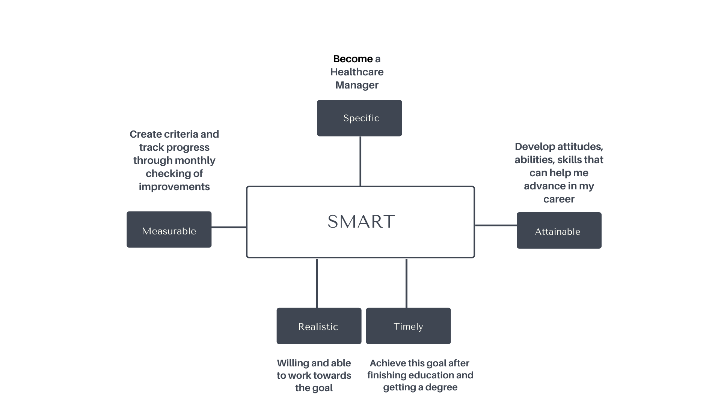

SMART Goals

These goals of mine, of course, are connected to my other goal which is to become a healthcare manager. To be organised and fully understood, I have used SMART Goals. This way I can visualise and acknowledge both my achievements and errors while in the journey of achieving my goals.

Skills of an effective Manager

Clearly, the main objective of hospitals is to deliver exceptional health care. However, hospitals are wide organisations that are handled in the same way that any other company does. As a result, competent hospital administrators must integrate their management expertise with a strong concern for the welfare of their patients. If I become a manager, I will have various duties and obligations as part of my work. In this essay, I will be enumerating skills that I believe are needed to become an effective healthcare manager in NHS hospitals

First, enough knowledge and education. If I will be a manager someday, I need to understand that applicants with certification have polished their talents, obtained a great education, and established all the necessary relationships in the industry.

Next, Responsible and Formal. To create a trusting relationship, I, as an aspiring manager, must be open, candid, and never conceal any objectives or suggestions. I will also be made responsible for any improper policy choices or blunders that my employees will commit so as early as now I should practice being responsible and formal.

Another is Organisational skills. Although the main obligation of mine, If I will be a manager, is to regulate all hospital activities, it is difficult to do so individually. This is because I, as a manager, must rely on other executives to carry out their responsibilities effectively.

Problem-solving skills. There will always be a new task or difficulty for me as manager to address in the hospitals. Because managers can be confronted with a few challenges, I need to be able to solve them quickly. I as a healthcare manager should think articulately about an issue and come up with a way that is acceptable to everybody.

Advantages- A hospital manager profession allows them to make a significant difference in the lives of patients. Hospital management are constantly striving to provide affordable healthcare for all demographics. Managing a hospital is the ideal challenge for forward-thinking executives who are passionate about providing high-quality healthcare and ensuring patient safety.

Disadvantages- A healthcare manager cannot rest at times because of rising healthcare expenditures, staff shortages, critical equipment demands, and diminishing income. They are under a lot of pressure to keep expenses down without endangering patient safety or destroying employee morale by announcing layoffs. Another source of anxiety is the plethora of complex government laws that, if broken, can result in severe penalties and even prosecution of hospital employees.

Nursing home manager positions offer interesting and creative chances to deliver high-quality patient care and a good working culture for employees. If I will be a nursing home manager, I must possess a varied range of talents to execute the requirements of this position. The skills that I believe are needed for a managing position in nursing homes are the following:

First, Skills in Human Resources. As a nursing home manager, I must be experienced in recruiting and hiring procedures, as well as informed about the nursing home's employment regulations and criteria for each job. I must also be aware of labour law and assure that the nursing home does not prejudice employees or candidates and that all parts of employment law are followed.

Next, Communication Skills. The most valued skills in the “contemporary job market” are communication skills. (Curtis, 1988). As a nursing home manager, I have the obligation to contact medical experts regarding patient wellness and situation, resolve any issues with employees, and speak with clients within the nursing facility. I also supervise patient admittance and engage with present and future patients' relatives.

Skills in decision-making and critical thinking should also be considered. If I will be a manager, I must also analyse rules and create choices to resolve issues with employees and patients. Critical thinking is a universal human phenomenon and is improving (Simpson, 2002).

However, after years of experience, nurse managers are frequently promoted into more senior administrative positions. As a nurse manager, you will be exposed to a variety of departments within your hospital, giving you plenty of opportunities to dazzle. The finest nurse managers know how to turn their bosses' heads, which can lead to yet another favourable promotion.

As you begin your career in management, you will probably encounter a few unfavourable circumstances. For managers in nursing homes, this typically manifests as a reduction in day-to-day patient care duties. Many nurses select this profession because they wish to work directly with patients who want assistance. While you will still have a significant impact on many patients' quality of life, your position will be more peripheral than you are likely used to.

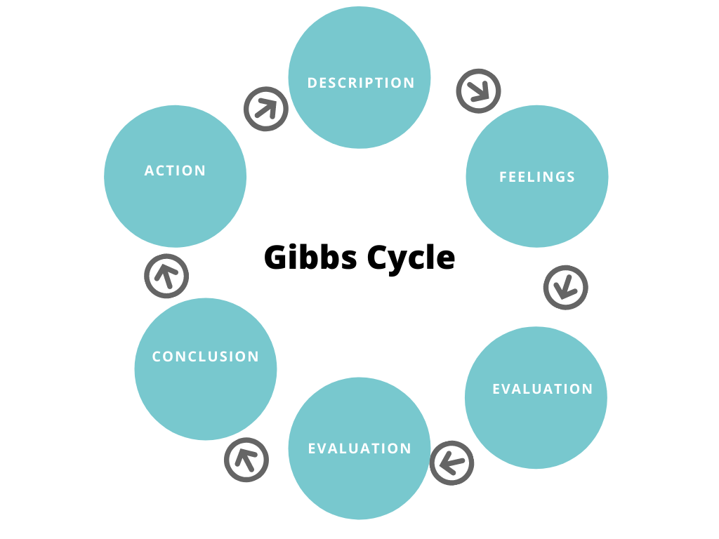

Gibbs Cycle

In this module, I have learned several concepts that are beneficial to my current situation and future career. I used the Gibbs Cycle as a model to thoroughly discuss my reflections. First, I learned the concept of SMART goals and objectives. Peter Drucker's Management by Objectives approach is usually credited with the requirement of a SMART Goal. However, Drucker never made a direct reference to a SMART acronym in his book (Morrison, 2010) By making goals specific, measurable, achievable, realistic, and timely, SMART goals prepare an individual up to lead. I discovered the relevance of this concept for making SMART Goals since it enables me to articulate my notions and concentrate my work, allowing me to manage my resources in the most efficient and effective way possible. It also eliminates the potential of overlooking important or trivial facts that will aid or obstruct my attempts to achieve my objectives. SMART Goals are an excellent approach for me to prepare for what is next. I will be more engaged and conscious of moments when my interest should be directed elsewhere as I gain a better understanding of what actually matters.

UK employment

The other concept that was discussed on this module is the UK Employment law and why it matters to my future career. The partnership between employers and employees is governed by employment law. It establishes what companies can demand from employees, as well as what employers can request them to do and their fair working conditions. According to the ukrules.co, Employment in the United Kingdom is defined as "a contract of employment." It is a contract in which both the employer and the employee have commitments. An employment contract gives the employer the authority to decide when and how the task is accomplished. At first look, employment law may appear confusing and varied, particularly for a student like me who must learn about UK employment law while continuing to study other courses and operations. Furthermore, employment laws of which there are numerous exist to safeguard organisations, defining their responsibility to their employees as well as their rights as employers. They are also helpful to maintain a fair working relationship for both sides.

Learning Theories

This module also tackled Learning Theories. Through frameworks, learning theory guides the implementation of active learning. According to Harasim (2017), states that “a theory is an explanation for why something occurs or how it occurs” Learning theory, according to her, is one that seeks to “to help us to understand both how knowledge is created and how people learn”. Learning theories provide contexts for comprehending how information is used, understanding is formed, and individuals learn. Learning strategists can use these concepts to tailor educational methods to specific learning and participant objectives, allowing them to make better knowledgeable decisions. I frequently find myself in rhetoric over the essence of understanding theories. This module reinforced my understanding that theories give a foundation for understanding how people learn as well to explain, characterise, evaluate, and anticipate learning. In this way, a theory aids us in making more informed judgments about understanding methods, growth, and presentation. This module also enlightened me. There is no such thing as a "perfect" learning theory because each one presents a different perspective on learning and the components that make it possible. Different theories lend credence for learning, consolidated level, and instructional techniques, all of which have significance for instructional design and delivery. Furthermore, some theories are better suited to various learning objectives and learners' characteristics. Because each theory is made up of data and hypotheses, seeking the most appropriate learning method must start by determining the learning aim and then selecting the best conceptual basis for implementing those learning results.

Feedback Interview:

During the interview, the interviewers gave me a reasonable score under the first impression. Based on the scores they have given; I have made a good first impression. Under the verbal behaviours category, I have received mixed scores. There were good scores like demonstrated knowledge about the company and understood position/ pointed out work related skills but there were also poor skills like in referenced specific items on resume and asked appropriate questions of the interviewer. These scores and feedback helped me recognise the skills that I should maintain and those that I should work on. Overall, I received a score of 63 out of a 100. Personally, I think that is a decent score.

Self -awareness and Conclusion

Lastly, this module brought a lot of valuable insights into self-awareness methods. One of the first aspects of the self-concept to arise is self-awareness. While self-awareness is an important aspect of who you are, it is not something you are keenly aware of at all times of the day. Self-awareness, on the other hand, becomes an intimate part of who you are, emerging at varying periods situationally and your character. Weisinger (1998) wrote that high self-awareness enables individuals to observe and monitor their behaviour. It is critical to good on-the-job productivity, according to him, since it allows people to respond effectively to the wide spectrum of interpersonal encounters that might occur in the workplace, such as irate clients, dishonest co-workers, and pushy supervisors. My key takeaways while learning this module revolves around the importance of self-awareness and methods. I actualised that self-awareness also aids in self-reflection or reflecting about what went wrong in order to figure out how to fix things and do better next time. Another realisation of mine is that people that are self-aware are knowledgeable of their own talents and weaknesses, as well as what enables them to flourish. They also recognise that their perceptions of themselves may vary from those of others. It is simpler for people to develop high self-esteem when they have a better understanding of themselves. This is especially true for those who learn and think differently, as well as those who have difficulty with specific skills and jobs.

References:

Cardon, M., Thorgren, S., & Murnieks, C. (2021). Passion. Available at: https://www.oxfordbibliographies.com/view/document/obo-9780199846740/obo-9780199846740-0086.xml
(Accessed: November 27 2021).

Dao-anis, C. (2018). Raise Your Speaking Skill, Raise Your Income. Available at: https://www.baguioheraldexpressonline.com/raise-your-speaking-skill-raise-your-income/
(Access November 27 2021)

Employment Rules and Regulations. (n.d.). Www.Theukrules.co.uk Available at: https://www.theukrules.co.uk/rules/employment/index.html
(Accessed November 26 2021)

Goldman, R. (2020). Self-Awareness Development and Types. Available at: https://www.verywellmind.com/what-is-self-awareness-2795023
(Accessed November 27 2020)

Patel, D. (2018, December 12). 7 Proven Strategies for Overcoming Distractions. Available at: from https://www.entrepreneur.com/article/324560
(Accessed November 26 2018)

Taboli, H., & Gohargazy, M. H. (2017). The importance of critical thinking in management. The Importance of Critical Thinking in Management, 3(1), 24–29. Available at: https://sciarena.com/storage/models/article/6t53cQRQvai8snF0XS7X4Q9HuoOUOMaVQ1Uzz4Q8MnjF0NwWkUpKcnwGNF3b/the-importance-of-critical-thinking-in-management.pdf (Accessed November 26 2021)

Thomas, H. (2020, October 1). What are learning theories and why are they important for learning design? Available at: https://www.mybrainisopen.net/learning-theories-and-learning-design/ (Accessed November 26 2021)

