Holly Williams
Confirmative Praxis report

Introduction
Scientifically its proven as humans we have five senses, and vision has long dominated in western civilisation. Touch borders all senses, skin is the body’s largest organ which connects and flows from the outside to every point of entry: the eyes, the mouth, the ears and the nose. The connections in our brains to our senses is a gift that we often forget about, this is because it’s in our subconscious, and the senses care constantly chatting to one another, whether we realise or not this does take serious mental effort to divide our sensations apart. My Octopus analogy came from the fact that Octopi can interpret and understand their world around them through their sense of touch, they do this with eight brains and millions of suckers. I envy the Octopi because as a neurodivergent individual, my brain has executive disfunction. Individuals with ADHD and ASD are hyper sensitive, whether it be difficulty regulating emotions due to a bright light triggering me, or a dull distant repetitive noise or responding to something they’ve smelt that may be uneasy and overwhelming. Although having a sensory disorder is a struggle to live with, there is something unique about how we see the world.
“Autism and sensory issues often go together. Almost everybody with autism has some degree of sensory issues. My sensory issues have always been auditory and touch. When I was little, I couldn’t tolerate being hugged. It felt like a tidal wave of stimulation washing over me. Then gradually, I got to where I could tolerate hugging. That’s been desensitized, but I still have problems with scratchy clothes. The worst sounds when I was a child were balloons popping, school bell ringing, and firecrackers, things like that, really sudden loud noises. It was like a little pain down my ear, it really hurt. Other people have described, maybe a sound of rain on a tin roof would just sound, one boy described that as bullets because it was so loud that it hurt his ears. There are other individuals that have visual sensitivity problems. They can see the flicker of fluorescent lights. And it’s flashing on and off like a strobe light. For some people, where their hearing and the visual systems are just giving you a jumble of information, so, you know, riding in a car might be like sort of like looking through a kaleidoscope of things, where hearing’s cutting in and out like a bad cell phone. The visual system’s pixelating and breaking up like a satellite dish that’s shaking, and so, you really are concentrating on what the vibration of the car, and what it feels like, because that’s still giving you accurate information, and these problems are not in the eye. You can go check the eye out at the eye doctor. That’s all fine. See, the back of your brain, there’s circuits for shape, colour, motion, and texture, and those circuits have to work together to form a graphics file. Sensory issues are on a continuum. They can vary from little nuisances to being absolutely, totally debilitating, and it’s one of the areas autism really needs to be researched. I’d put it on the top of my research agenda.” (Grandin, 2011)
My aim is to portray and highlight how different our senses are to neurotypical people, and give an insight to the neurodivergent brain through the medium of texture, applique, embroidery and fabric manipulation. In juxtaposition of the Octopi’s eight remarkable functioning brains, I plan to create eight pieces of work that I intend to emphasise on my personal sensory issues, ADHD and ASD traits and inviting the neurotypical through Phenomenology into my world.

Research
From the moment we are born, as babies we yearn the touch of our mother, the practice of touch creates a bond and emotional connection with one another, it’s our basic human need and provides mental, emotional and physical benefits. As we grow older and develop, as children we learn the difference between solids and hot and cold, this is known as tactile stimulation. A historic educator and founder of the importance of play for young children is German pedagogue Friedrich Fröbel. In 1837, Fröbel recognised that the first three years of a child’s life is significant to their brain development. He researched and developed a program what we would know these days as ‘nursery’. The idea behind his programme was that he believed that play is the natural way for a young child to explore and make sense of the world, he felt it was a holistic and meaningful way for a child to develop their skills, creativity and social interactions through their own independent learning. Fröbel encouraged a space for children to engage in self-direct learning allowing them to develop at their own pace and one their own terms. “One of Fröbel’s momentous contributions to early childhood education was the theory of introducing play as a means of involving children in self-activity for the purpose of externalizing their inner nature. Fröbel understanding of the play is characterized by free play which solicits all of the child’s imaginative powers, thought, and physical movements by symbolising in a satisfying form his own descriptions and education interests. It was continued by indicating that play designates a child’s mental attitude and should not be identified with anything performed externally. A child should be given complete liberation from the prerequisite in playful self-activity.” (Manan, 2015). I am a practical and visual learner so Fröbel’s ideology resonates with me. I like to touch and feel textures, edges and shapes to allow me to gain a greater understand of something. Frobel emphasises on the value of play and utilizes an education through using our sense, especially touch. His ideals recognises the early childhood cognitive growth and explores the early stages of development in which a child can thrive in their own time at their own pace. For myself, an individual with delays in learning this sort of education would have allowed me to develop and flourish in my own way, without the input of my parents, the expectations and pressure in the education and learning environments. “A child is free is a free entity and must be given a right to develop according to his or her own pace and interests. It is very important to provide a free and student friendly atmosphere in all education set-ups.” (Manan, 2015).
During my childhood, especially in primary I struggled in class, I remember daydreaming and zoning out, purely because I would become overwhelmed with letters and numbers. “Children using all their senses in the process of exploration, especially the sense of touch; offering plenty of opportunity to mould and manipulate materials; and not having a focus on making or producing something. Though a staple in UK early childhood provision, there has been limited research into the theoretical underpinning and value of messy play. We know that sensory stimulation is a key part of how young children learn about themselves and the world around them and material encounters provide a particularly rich vein for cognitive disequilibrium, as well as providing an insight into the child’s understanding of the world. Messy play is part of children’s need for close contact with different substances, for creative experiments that involve learning through chaos’ (Szekely, 2015: 42) and it is this sense of chaos that gives children opportunities to explore containment, control and transformation, as well as testing adult’s resolve!” (Gascoyne, First edition; 2018). Fröbel’s approach emphasises the importance of a hands-on, playful and practical experience on learning and I believe that can absolutely help foster a child’s emotional, physical and intellectual growth. “Play is the highest expression of human development in childhood for it alone is the free expression of what is in the child’s soul.” (Trust, 2023).
Gardening and being amongst nature was another approach Fröbel encouraged through the early stages of childhood development. He believed that building a connection between plants and animals and their environment shared knowledge on their lives and how they share food, water and sources. There’s been a greater research into how spending time in nature and how it can have a positive effect on your mental well-being, mental disorders and reducing stress. I think as an example of this could be shown through the pandemic where we weren’t able to leave our homes for long periods of time. “The evidence amassing for the negative impact of lockdowns on mental health problems in children and adolescents is now incontrovertible, and suicide ideation increased significantly over the first six weeks of the first UK lockdown in 2020. There was a worrying signal that suicides in young people increased during this lockdown.. Key risk factors for suicide include lacking a sense of belonging, feeling defeated, trapped and hopeless – lockdowns have undoubtedly increased these feelings in many people.” (Townsend, 2021). Being in nature is a multisensory experience, not only do we benefit from visual stimuli but we also benefit from auditory e.g. the sound of birds chirping, tactile e.g. the wind which can also result in the olfactory e.g. different smells from the environment. It’s important to point out that senses are unique to every person, because of physical sensory or intellectual disabilities there is a percentage of people who have not had the same opportunities to explore and develop in their environments.
The senses also connect and stimulate the part of the brain that produces emotional response. The sensory-emotion pathways respond to stimuli through the sensory cortex which the responders direct the appropriate emotion to the correct regions in the brain, this allows the brain to determine if the stimuli is pleasant or unpleasant. Those with Autism and ADHD may develop a trait known as sensory processing disorder which is a condition where the brain doesn’t process the appropriate response to demands of the environment. For example, clothing tags or seams can cause unbearable distress or that of someone eating loudly can trigger outbursts of overwhelm and emotion known as hyperresponsiveness. On the other hand, there are multiple things that can evoke a positive reaction such as listening to music and eating chocolate, this is because these things have been proven to stimulate neurotransmitters like dopamine, serotonin and endorphins.

Exhibits and Artists
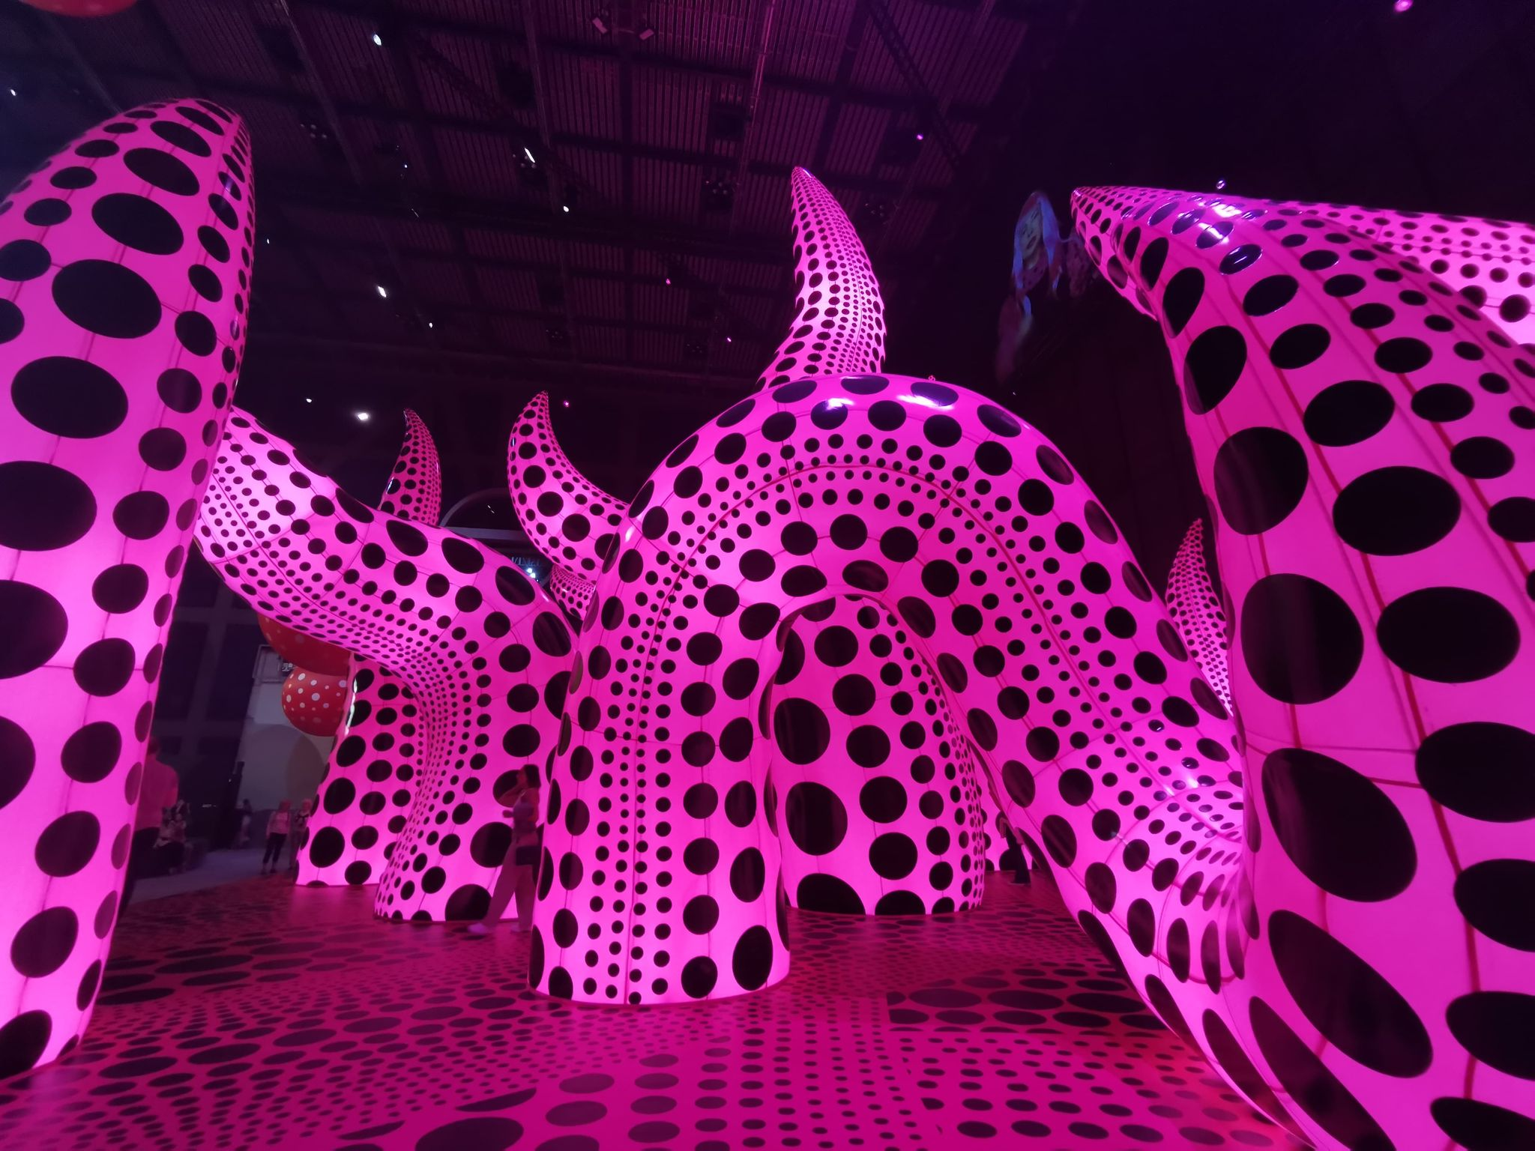
“I fight pain, anxiety, and fear every day, and the only method I have found that relieves my illness is to keep creating art. I followed the thread of art and somehow discovered a path that would allow me to live.” (Kusama, 2021). During my research I felt it was important for me to visit some exhibitions so I could gain some inspiration from how different work can be displayed and how artists portray their work in a professional setting. I was lucky enough see Yayoi Kusama’s exhibition ‘You, me and the ballons’ in Manchester, which allowed me to see, interact and experience Kusama’s work in person. The exhibition was such a surreal experience, being a fan of Kusama’s work for so many years and then to experience it first hand was truly something special. An aspect of her work was interactive but included these large sculptural tentacles please see figure 1, this work in particular inspired me due to the association with an Octopus but it allowed me to appreciate the polka dots and Kusama’s perspective in her work in the flesh.
Figure 1.

During a holiday to Mexico I visited an incredible one of a kind underwater museum just off the Isla Mujeres. Built by an artist called Jason Decaires Taylor who created sculptures of women, men and children and fixed them to the sea bed. The exhibition ‘Silent Evolution’ now sits amongst other artists and was originally built to help promote and support local sea life. This exhibition was inspiring to me for many reasons, it was immersive, very unique and the way the textures of the coral and sea life moved under water was nothing you would be able to experience anywhere else in person. Many of my designs are inspired by the shapes and textures from this particular exhibition, please see figure 2.


Over the years my work has very much evolved, I once wanted to make pretty things with flowers and colour, and over the years I have developed more of an appreciation for where our fabrics come from, what fabrics they are and how much do they impact our planet. This has also trickled into my style of clothing and how I buy and make clothing for myself to help with my own carbon footprint. Embroidery and embellishment is something I have always enjoyed and am very skilled in I use a lot of unusual materials like plastics, metals, sequins and beads, which may seem like a contradiction. When it comes to sewing by machine, I enjoyed the structure and pace of a running stitch, it’s almost like second nature, like riding a bike. With each stitch I sit in suspense and excitement waiting to see how the final outcome is, this doesn’t always end with success which may lead to dismembering each stitch back to its restored form. But that’s the point, its about playing and changing a piece of fabric into something else. Hand sewing is a state of euphoria. A place where my intrusive thoughts are quieter than normal. The process is more personal, you slowly see your design develop. I enjoy hand sewing beads and sequins, it’s almost adding a layer of personality or elevating the fabric to whole new garment, my grandmother used to say I was like a magpie and shiny things. I came across a beautiful book called A philosophy of Textiles: Between Practice and Theory and I found this quote I feel resonates with my perspective on sewing. “The simple utilitarian straight stitch can be used to patch, repair, connect and hold fabric pieces together, the needle passing back and forth between them. This term ‘back and forth’ indicates a mutual exchange brought about by the action of needle and thread, suggesting openness and engagement between pieces. Back and forth implies repetition and rhythm, notions that are most commonly associated with a sense of well-being, perhaps even a meditative state. What I want to focus upon here is the balance between what stitching does and what stitching can become as a productive or metaphoric element in the joining together of pieces: the passage between. I want to explore ways in which this stitching between, both by hand and machine, joins and connects pieces and fragments together, to create new, expanded pieces. This is not a linear model, but rather a process that champions differences and fragmented paths.” (Dormor, A Philosophy of Textiles: Between Practice and Theory, 2022). As this chapter comes to a close, I’d like to emphasise that the rest of my research of exhibitions and artists in a separate document, please refer back to this for further information and research.
Figure 2.

Body of work
Through my research of the Octopi and the ability it holds with its 8 tentacles and millions of sucker to process multiple bits of information at the same time. I decided to create 8 pieces of work creating a metaphoric juxtaposition of the 8 tentacles, portraying what I perceive as the hardest traits to cope with as a neurodivergent individual. I wanted to create the emphasis on what it’s like to feel all these things at once and being unable to regulate them. The pieces are of various sizes to portray how some traits may magnify and over power the other in certain situations. Combining the idea of creating 8 pieces and the idea of the viewer being able to interact, play and get up close to each piece, I hoped that I could successfully show as an artists and a neurodivergent, how I perceive and understand the world. For further information on how I created each piece and the process of work my please refer to the sample directory.

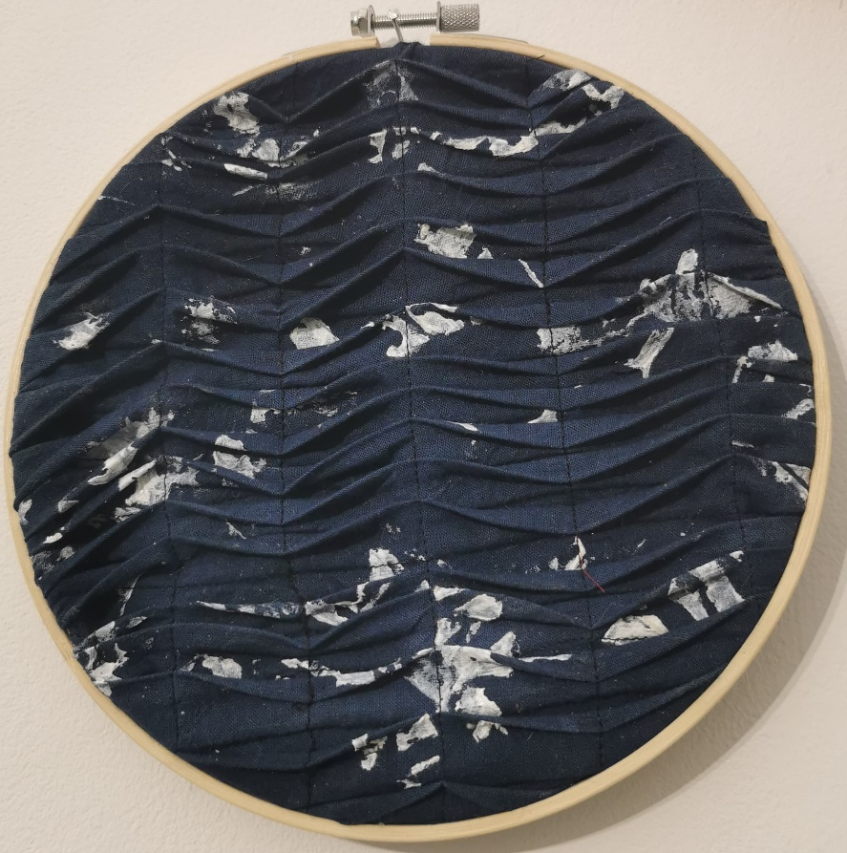
Emotional Dysregulation
The first piece I’d like to discuss is my portrayal of Emotional Dysregulation. This is a common trait that presents itself in individuals with ADHD and ASD. For me Emotional Dysregulation impairs my life, it causes me to react impulsively and often leaves me feeling in limbo. On occasions I could feel happy and my mood could be mellow, and within seconds my mood can change and I can become tearful or angry. This may be caused by something so minor and can last minutes, but it causes much anxiety and unpredictability that I often feel like I’m constantly living in an heightened state. Going to the seaside is something I associate with feeling calm, and I often sit and watch the waves roll in and out. I think focusing on the unpredictability in the direction of the waves resonates with me, feeling like my emotions go in every direction, are being pulled back and forth. As seen in figure 3, the dark inky blue represents the murky waters of uncertainty in my emotions and the white bursts of colour represent the angry outbursts. A problem that arose was once under the sewing machine the folds were difficult to navigate due to the thickness of the fabric and the hardness of the white paint. I eventually realised the imperfections are just a metaphor for having such a dysfunctional and unpredictable trait. This piece I feel is a great representation of how I feel when experiencing Emotional Dysregulation
Figure 3.

Stimming
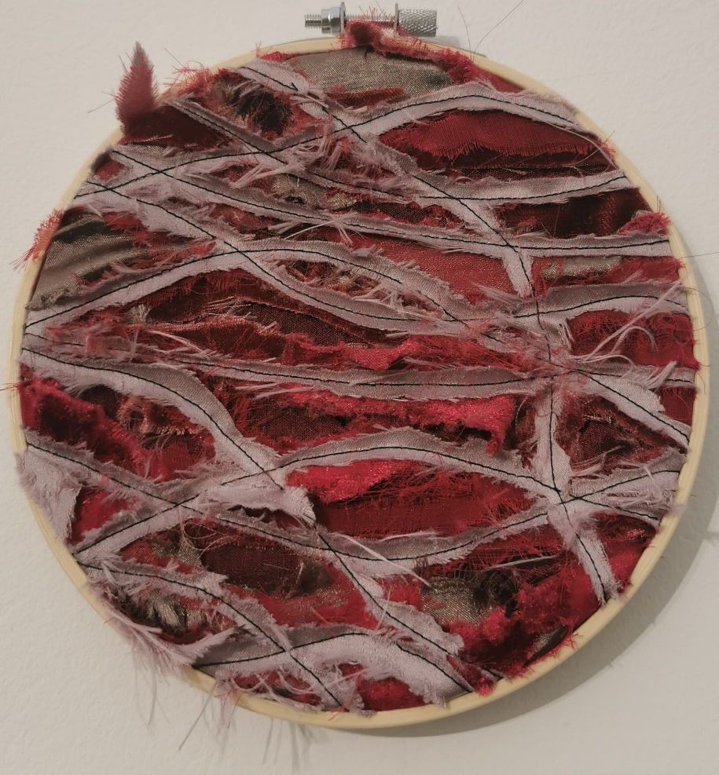
For as long as I can remember I have stimmed, however since my diagnosis I was unbeknown to the fact it was a stim. Stimming is a form of repetitive performance of a vocalization or movement. This is a common trait in a person with autism. Based on psychiatrist research its claimed this type of function is a protective response, it helps calm, and is a self-stimulatory behaviour. Some individuals find rocking back and forth, flapping hands, twirling hair or drumming fingers a calming response, however the stim I have adapted from a young age is that of biting the skin around my fingernails. I do this subconsciously, and it’s something I can admit does calm my nerves but unfortunately causes a lot of self-inflicted pain. It’s a trait I am unable to control, when I am anxious I will bite, pick and pull at the skin, sometimes I will do this so much that it draws blood. Figure 4 is my response to what my stim visually looks like, the layers of colours of browns, reds and pinks are a literal representation of how my skin looks. I feel the layering has effectively portrayed the texture and colour, I used a black thread to create the cutting shapes to allow the colour and the frayed fabrics to stand out. I didn’t want a specific structure to the piece because when I do stim there is no accurate shape or outline I create. In one of Dormor’s chapters she discusses the role of fraying, “Claire Pajaczkowska, in her essay ‘Making Known: the textiles toolbox – psychoanalysis of nine types of textile thinking’ (in Jefferies et al. 2016: 72–92), takes up these ideas to consider ways in which making with textiles is simultaneously making the self and making society. She suggests that this implicates the role of empathy, which both Winnicott’s and Klein’s objects require for their potency. Pajaczkowska also points to the role of violence and destruction in the ontology of the artefact (82) which overcomes romanticized approaches, but offers a means for thinking through the role of fraying within textile practice. In this sense, she sets making as praxis, but it is a praxis with something of the undisciplined through its relational foundations. Without the selvedge, cloth frays and deconstructs itself, returning to its material elements” (Dormor, 2020). Dormor’s words resonate with me in response to my piece on stimming. The notion of fraying fabric can be deconstructed, almost stripped back to the original weave, and this is how I portrayed my piece on stimming through fraying, I wanted the fabric to represent the performance in which I bite and rip and strip my skin back down to my original form under my skin, my muscles and tendons.
Figure 4.
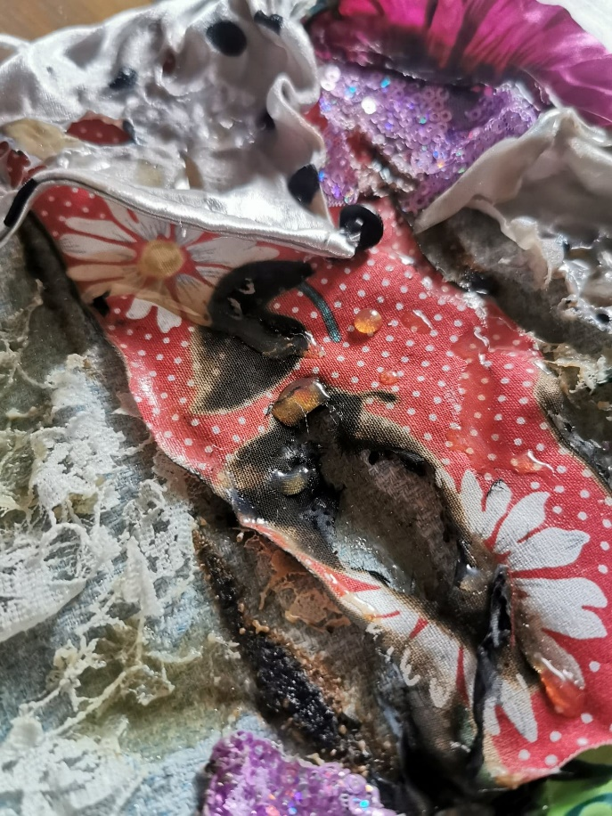
Anxiety
“Anxiety is another co-occurring condition that has been proposed as being relevant to both problem behaviours and sensory over-responsivity. According to a review regarding the comorbid psychiatric symptoms of ASD, anxiety disorders are the most detected disorders in individuals with ASD, with the rates of 5–35% generalized anxiety reported in previous studies.²⁹ Studies have shown that individuals with ASD who have higher levels of anxiety symptoms will also experience greater levels of difficulty with over-responsivity.” (Suy, Huang, Wang, Chang, & Lin, 2020)
Anxiety is something I remember experiencing as young as 5 years old. I never understood what the tingling pain in my stomach was until I grew into my teens. As an adult I unfortunately have developed different side effects with my anxiety and the symptoms that impair my life the most are sweating, feeling overheated and acid reflux. Figure 5 is s literal response to the burning sensation, I used various old clothing and burning through them to create dark, crispy circles. I used latex to create droplets to represent beads of sweat on the surface of the fabric this allowed the fabric to look wet and imitate sweat effectively. I then used latex again to create longer wet marks emerging from the fabrics to represent the idea of oozing and frothing of the acid in my stomach. As I was building my pieces I was cross-examining the narrative between memory, textiles collage and sculpture, by using upcycled materials I was reclaiming the seams of abandoned fabrics. Changing their shape, colour and texture, which reflects the feelings I have when my anxiety is at its worst.
Figure 5.

Sensory Dysphoria
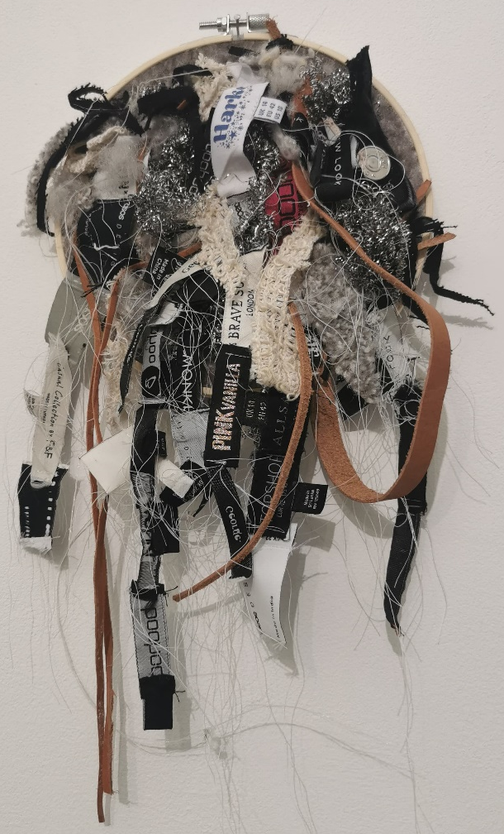
This piece of work I wanted to really emphasize on what it’s like to experience sensory dysphoria. I wanted the portray the surfaces and materials that cause me most discomfort and display them in a chaotic, jumbles form to represents the cross-wiring and chaos our brain goes into when our touch receptors can’t filter themselves appropriately. Figure 6 is a configuration of multi-materials all of which I discuss their purpose in the sample directory. I’m pleased with the results of this piece of work, I like the 3D form, the colour combinations and the chaotic structure, as the viewer you gain a greater understanding from each material just by touch. I feel its an effective representation of what I wanted to portray, and even the frayed threads and edges dangling below portray the idea that the receptors are broken and the connection is lost.

Figure 6.

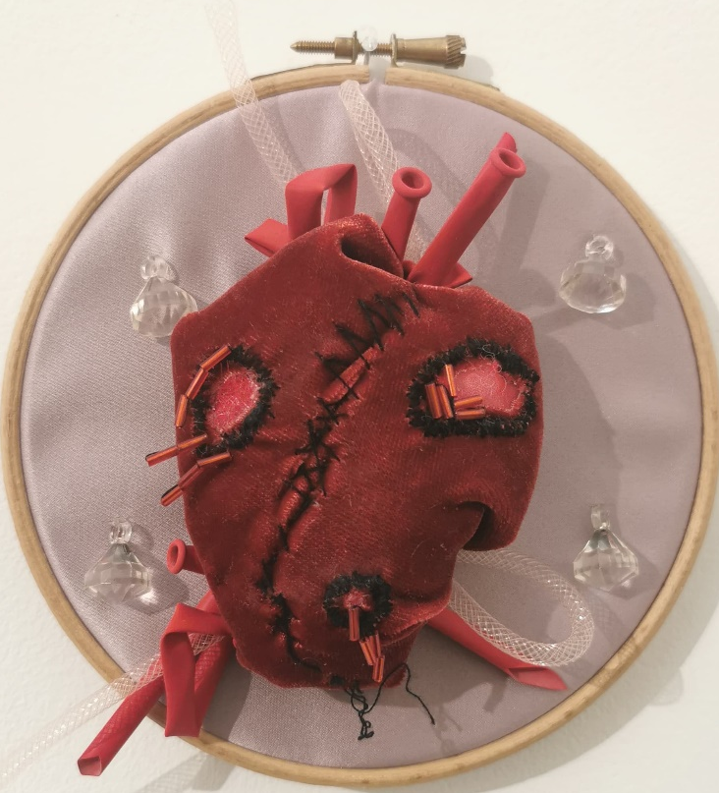
Rejection Sensitivity Dysphoria
Figure 7.
Rejection Sensitivity Dysphoria isn’t a trait that all individuals with ADHD experience, the disorder is described as the inability to regulate your response or emotions to feelings of rejection or failure. For me this disorder has affected my self-confidence in all types of settings. It also has very painful side effects for example I experience physical chest pain, as though my heart is going to burst into a million pieces, and figure 7 is a response to my experience. As stated in my sample directory this piece was one I played with for hours, manipulating and changing the shapes but also ensuring it was obvious that it’s a heart that my work was centred around. This was an emotional piece to create as the whole piece was hand stitched, and hand sewing is a very visually ‘close up’ technique. A juxtaposition of creating something dark, emotional and uncomfortable, using a technique I find therapeutic and calming. I really thought about the positioning and shape of the heart and the rest was a play on utilizing the small space to create something that I feel like could burst off the fabric. “The artist Ann Hamilton writes: My first hand is my sewing hand. A line of thread drawn up and down through cloth influences how I think about the confluence and rhythms of space and time.” (Dormor, A Philosophy of Textiles: Between Practice and Theory, 2022).

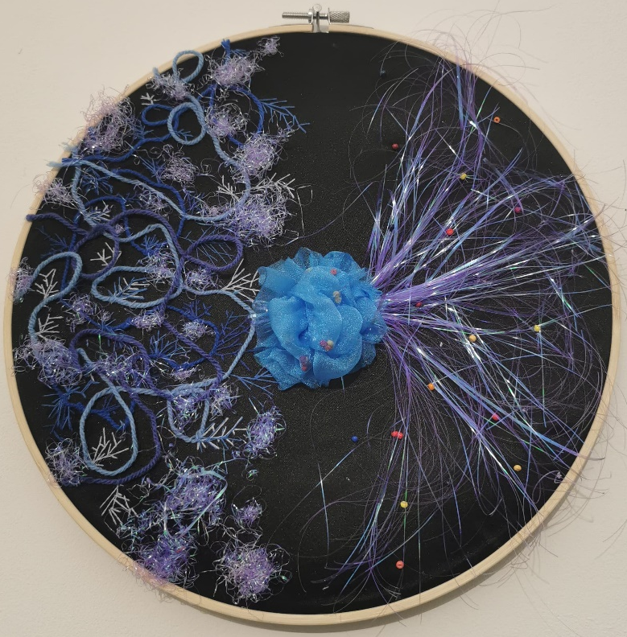
Executive Dysfunction
Figure 8 is my interpretation of what Executive Dysfunction could look like. The different circuits portray different thoughts and receptors attempting to successfully navigate to the correct area of the brain. I wanted this piece to embody electric connections and waves and I think the combination of colour choice and the Angelina fibre does successfully portray that. However, reflecting on my work I feel this one could have been bolder, I do feel in presentation, possibly because of the black background it didn’t stand out as much as the other pieces. If I were to change anything I would have gone into further detail and created a larger scale piece.

Figure 8.

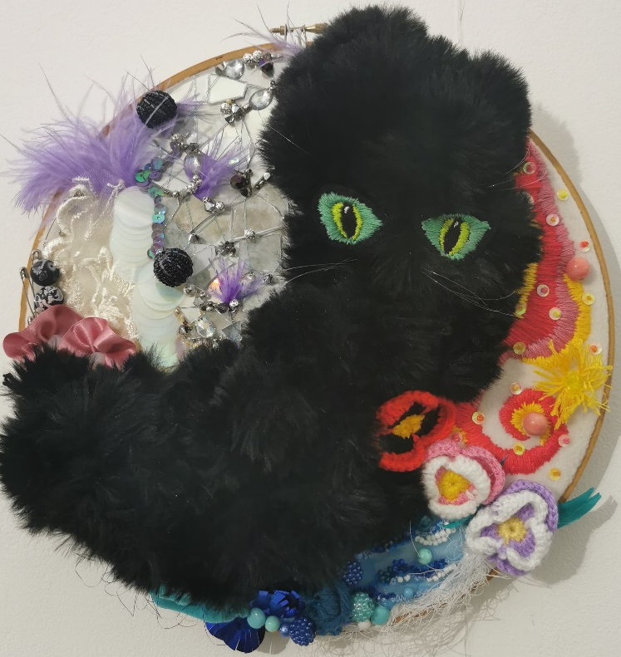
Dopamine
Figure 9.
“Dopamine is a critical modulator of both learning and motivation. This presents a problem: how can target cells know whether increased dopamine is a signal to learn or to move? It is often presumed that motivation involves slow (‘tonic’) dopamine changes, while fast (‘phasic’) dopamine fluctuations convey reward prediction errors for learning. Yet recent studies have shown that dopamine conveys motivational value and promotes movement even on sub second timescales. Here I describe an alternative account of how dopamine regulates ongoing behaviour. Dopamine release related to motivation is rapidly and locally sculpted by receptors on dopamine terminals, independently from dopamine cell firing. Target neurons abruptly switch between learning and performance modes, with striatal cholinergic interneurons providing one candidate switch mechanism. The behavioural impact of dopamine varies by subregion, but in each case dopamine provides a dynamic estimate of whether it is worth expending a limited internal resource, such as energy, attention, or time. “ (Berke, 2018). Dopamine is a chemical that individuals with ADHD lack, for me I get a high of energy from sewing and working with my hands, and I wanted to portray that through my passion for embroidery and embellishment. Figure 9 is my interpretation of Dopamine. I wanted to create something that people would be lured to and want to touch, something bold and something that portrays my personality and as chaotic this piece may seem I think it definitely shows bursts of energy. From the whole collection, this is my favourite piece of work, upcycling materials I paid ode to my late grandmother, some past work and memories of music and an old pet. I think the contrast of the harsh strong edges towards the top of the pieces and the softness and the flow of the bottom of the piece is eye catching and allows the viewer to really dive into distinctive details. Figure 10 and 11 are images of visitors interacting with my work.
Figure 10.
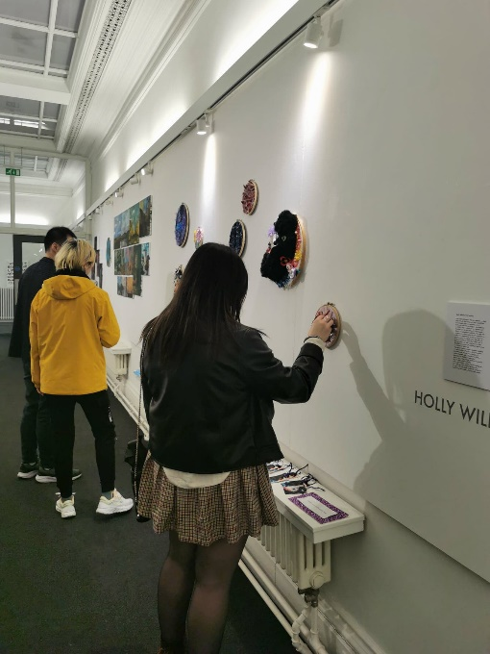
Figure 11.

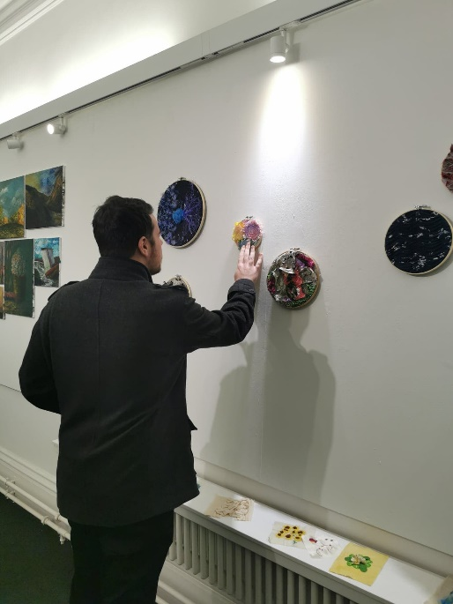

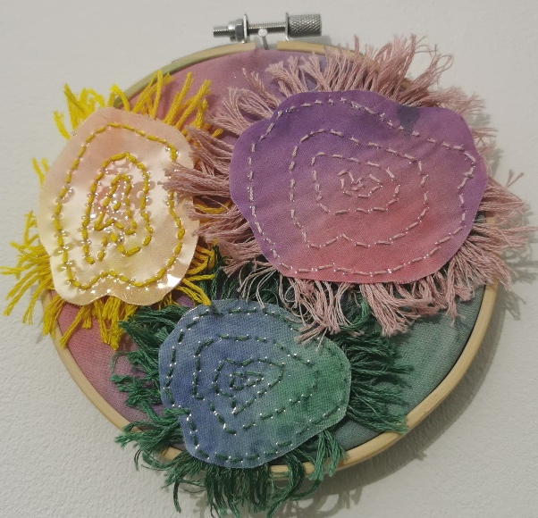
Daydreaming/Zoning Out
To capture a trait that is a state that I myself struggle to describe was very hard to portray. This was the last piece of work I made, mainly because I struggled to think of a way to portray what it is I see when I daydream. It’s almost like drops of water zooming into one direction, moving and flowing and turning. Sometimes I see colour and other times there’s a glow around these shapes. Using the plastic and a play on the light allowed me to emphasise the movement, it also helped the colours and shapes stand out and helped create a 3D piece that created an illusion of these things moving towards the viewer. Hand stitching through laminated thick plastic was difficult, navigating stitches in to the correct position was time consuming, however it expanded my skills and knowledge with different material, it felt with every poke and pull, I was giving birth to a new form.
Figure 12.
“Thinking in terms of the passage of needle and thread, the space of hand seaming offers a form of meaning-making that is about access and egress. For Irigaray, this notion of a passage between echoes the process of birthing and giving birth, that inextricable link between mother and child. Existence, then, begins with encounter: two before one. A form of seaming.” (Dormor, A Philosophy of Textiles: Between Practice and Theory, 2022)

Conclusion
As a thirty year old woman, being recently diagnosed with ADHD and ASD I have gone through a lot of emotions, it completely turned my life upside down. I have spent a lot of time self-reflecting on my life through my childhood, education and teens and even my early adult life and overplaying scenarios of how I could have changed things if I had known that I had a processing disorder. I focused my project on this matter to allow myself to learn and research more into both deficiencies, and in a way this project has helped me to understand myself better, although its caused a lot of anxiety, sleepless nights and upset, it’s almost been like therapy. Along with having counselling to establish my traits and how I can manage and navigate through stressful times, this project has had such a positive impact on me in so many ways.
In reflecting on my practical work, I am pleased with the outcome and I feel I’ve produced 8 very personal pieces of work which allowed the viewer to experience and touch, in order to allow them to understand how I interpret the world as a neurodivergent person. I feel my work was a labour of love, as an unmedicated ADHD individual I did find difficulty to find the motivation to start my final idea. I think this was due to feeling overwhelmed and lacking in confidence. Throughout the process of creating samples I was slowly finding my ideas evolving but struggled to make decisions and as time was creeping towards the deadline I found myself not being able to sleep, procrastinating, feeling guilty, not feeling good enough and I was unable to regulate my emotions. How I worked and created my pieces I felt was very intimate, I worked closely with multiple medias of materials and each piece took more than a week to make mainly by hand. This process revived my love for hand sewing, something I began doing as young as 10 years old. I found my love for embroidery and embellishment again, which I felt I’d lost. There’s a quote I came across by Tracey Emmin which I felt deeply resonated with me. In an interview discussing her most recent exhibition ‘Lovers Grave’ in New York, Emmin explains (White Cube, 2024)
One negative thing I wish I could change regarding my practical work (which I think is probably a common factor for many artist) is not being able to financially fund my supplies. Due to the lack of finances I felt I had limitations with what I could produce and this effected the development of my work and how far I could have pushed it. On the other hand I will admit I did originally outline I hoped to re-use and upcycle from my won clothing, materials, this has been a joy amidst the financial strain, as its allowed me to revisit old clothing, fabrics, materials and even source from older projects of mine. It’s also allowed me to stick to my pledge in reducing my carbon footprint.
My intensions were to bring viewers into my neurodivergent world, and although some parts are negative I’ll end this report with an incredible quote from another neurodivergent individual;
“Autistic people are taught from very early that their way of seeing things is wrong. They’re taught to doubt themselves. Autism is not a disorder. It’s not a way of being broken. I have a unique way of seeing things, like every other autistic person. I have a unique set of perceptions. I’ve learned to listen to my intuition, about how to move, about what I’m seeing. And there’s a very deep level of empathy and perception that’s there if one learns to listen to it, and trust it, and that’s just a matter of reclaiming one’s confidence. I’ve reclaimed my ability to move like an autistic person, and to be an autistic person, and to live as an autistic person, needs to live to thrive. And so, I’m thriving.” (Jones & Walker, 2023).

