Student Name: Silvia Alina Canalos  Student ID: 2233691  Module Title: Foreign Languages and Cultural  Awareness  Module Code: BMIH5003  Lecturer: Heidi Prosser  Date:09.02.2024 | 
ASSIGNMENT 1: PORTFOLIO
(4 Components)

Component 1: Professional Reflection (500 words +/- 10%)

Weighting: 25%
The ERA Cycle is a straightforward framework for reflection forming three distinct phases: Experience, Reflection, and Action. According to this theory, learning commences with an encounter, which may be completely foreign or familiar to the learner. The individual reflects on what happened subsequent to the occurrence, taking into account both the event itself and their reaction to it. The phase of reflection eases a comprehension of the experience and its ramifications (Seaman, 2008). The final phase, Action, consists of finding what modifications or actions to implement in light of the reflection. This cycle points out the ongoing nature of acquiring knowledge from one's experiences through diligent reflection and the implementation of newly acquired insights into subsequent endeavours. This model will be utilized to reflect on my personal occurrence at the Ibis London Stratford Hotel, specifically during a breakfast service.
Experience: The incident entailed a visitor originating from Japan, a nation renowned for its commitment to detail and accuracy, and a colleague operating in accordance with the more conventional and relaxed British hospitality standards. The guest paused as they considered the variety of alternatives, seeking advice on breakfast etiquette in this unfamiliar context. My colleague, anxious to help but unfamiliar with the guest's cultural background, waved broadly towards the food menu and quickly said, "Help yourself, everything's available!". The resultant cultural collision caused the guest distress, as they perceived my colleague's approach to service as surprisingly impersonal. This particular incident served as an important reminder of the deep effect that cultural norms and expectations can have on the experiences of customers within the hospitality sector.
Reflection: Considering this incident, I have come to understand the impact that cultural subtleties can have on the dynamics of interactions. My colleague and I were initially ignorant of the fact that the guest's influence on the service manner was based on their cultural heritage. This instance of cultural dissonance revealed a lack of cultural sensitivity and awareness on the part of both myself and my colleague. As suggested by Hamden-Turner and Trompenaars (2020). the consequences of cultural diversity in professional environments highlights the intricacy of managing cultural disparities and the imperative of resolving cultural dilemmas in order to facilitate effective communication. In order to prevent misunderstandings and increase visitor satisfaction, it is clear that our actions and service provision must be guided by an improved understanding of cultural expectations.
Action: As a result, it is imperative that we proceed with a dedication to the enhancement of our cultural competence. This entails proactively participating in cultural sensitivity training, acquiring information regarding the varied cultural heritages of our clientele, and cultivating a team atmosphere that promotes candid dialogue. It is vital to implement these modifications in order to foster an environment that is inclusive and welcoming to all visitors. Understanding national cultural dimensions is crucial for reducing the likelihood of cultural misunderstandings and enhancing intercultural cooperation, as suggested by Hofstede, Hofstede and Minkov, (2012). By demonstrating this dedication to action, we will not only proactively avert forthcoming cultural misinterpretations but also bolster our ability to provide service that values and honours cultural diversity.

References:
Hampden-Turner, C. and Trompenaars, F. (2020) Riding the Waves of Culture. 4th Ed. London: John Murray Press.
Hofstede, G., Hofstede, G.J. and Minkov, M. (2010) Cultures and organizations: software of the mind. 3rd Ed. New York: McGraw-Hill.
Seaman, J. (2008). Experience, Reflect, Critique: The End of the ‘Learning Cycles’ Era. Journal of Experiential Education, [online] 31(1), pp.3–18. doi:https://doi.org/10.1177/105382590803100103.

Component 2: Training Plan (500 words +/- 10%)

Weighting: 25%

Identified cultural misunderstanding (in a few words) :
The informal breakfast service approach adopted by a British employee caused unease for a Japanese visitor, revealing a disparity in communication and service expectations between the two cultures.
Training plan (Why/What//Who/Where/When):
Why: The occurrence at the Ibis London Stratford Hotel highlights a substantial cultural misinterpretation that has the potential to negatively impact both the contentment of guests and the reputation of the hotel. Cultural competence is not just an asset; it is a vital requirement in the hospitality industry. As a result of the globalisation of travel, hotel personnel must be adept at navigating cultural differences in order to provide each visitor with personalised, considerate service (Abramson and Moran, 2019). By providing employees with cultural competence and sensitivity training, they will be better equipped to address the varied requirements of guests from diverse cultural backgrounds. As a result, the establishment will provide an environment that is inclusive and improves the overall guest experience.
What: The training is built upon Geert Hofstede's Cultural Dimensions Theory. Hofstede delineates six cultural dimensions that serve as a framework for cross-cultural comparisons: Masculinity versus Femininity, Long-Term Orientation versus Short-Term Normative Orientation, Individualism versus Collectivism, and Indulgence versus Restraint. This theory clarify the rationale behind the Japanese guests' anticipation for meticulous and exact service, given Japan's propensity for high Uncertainty Avoidance scores(92), which signifies a preference for unambiguous regulations and expectations (Hofstede Insights, 2023). By comprehending these dimensions, personnel are able to predict and provide superior service to the diverse expectations of visitors hailing from various cultural origins. Also, according to Deresky (2017), high-context cultures, such as Japan, place significant emphasis on contextual factors, including non-verbal indicators and the physical environment, to convey meaning. Conversely, low-context cultures, like the United Kingdom, prioritise explicit communication through verbal interaction. This theory emphasises the significance of comprehending and modifying communication styles in accordance with the guest's cultural environment. By providing staff with training on how to identify and adapt to high-context and low-context communication preferences, interactions with guests can be vastly improved, resulting in decreased misunderstandings and increased guest satisfaction.
Who: The training programme will involve the entire hotel staff, comprising front desk personnel, maintenance staff, restaurant and breakfast service staff, and management. In consideration of the fact that each staff member contributes to the formation of visitor experiences, it is vital that the entire group establishes a strong groundwork in cultural sensitivity and competence.
Where: The training sessions will be carried out within the hotel premises in order to provide convenient access for all personnel. Furthermore, this process permits the customisation of the training programme to precisely fit the hotel's atmosphere and the commonplace situations that its staff might confront. The incorporation of practical situations and illustrations will boost the practicality and pertinence of the instructional material.
When: The training programme is scheduled to be implemented gradually over the course of three months. Every month, a fresh section will be introduced, providing the staff with a gradual opportunity to assimilate and implement the knowledge gained. In addition, this phased approach enables continuous evaluation and modification of the training material in response to feedback and observed results. To provide ample time for preparation and strategizing, the first lesson will commence at the start of the subsequent quarter.

References:
Abramson, N.R. and Moran, R. (2018) Managing Cultural Differences: Global Leadership for the 21st Century. 10th Ed. Abingdon: Routledge.
Deresky, H. (2017) International Management: Managing Across Borders and Cultures: Text and Cases. 9th Ed. Harlow: Pearson Education Ltd

Hofstede Insights (2023). Country comparison tool. [online] www.hofstede-insights.com. Available at: https://www.hofstede-insights.com/country-comparison-tool?countries=japan%2Cunited+kingdom.
‌

Component 3: Student Self-Reflection (500 words +/- 10%)

Weighting: 25%
As I reflected on my journey in order to comprehend cultural sensitivity in the hospitality industry, I utilised Gibbs' Reflective Cycle as the conceptual structure for my analysis. This reflective piece explores my personal growth and development of perspectives, resulting in a significant recognition of the critical role of cultural sensitivity in providing exceptional hospitality services.
Description: A major turning point in my reflective voyage occurred at the IBIS Hotel Stratford, where our team's deficiency in cultural awareness was brought to light through a cultural misunderstanding between a colleague and a Japanese guest. This incident, characterised by its simplicity and significance, served as proof of the critical interrelationship between cultural sensitivity and the provision of services.
Feelings: Upon witnessing the guest's disbelief and unease, I was initially overcome with a mixture of embarrassment and disappointment. Sadness at our failure to anticipate this event and irritation at the obvious deficiency in our preparation. My significant emotional distress stimulated a desire for transformation, motivating me to further my comprehension of cultural subtleties.
Evaluation: The incident exposed a harsh truth. Cultural sensitivity is intricately linked to the provision of exceptional service in the hospitality industry. Consideration must be given to the manner in which amenities are provided, taking into account the cultural heritage of every visitor (Christiansen, Branch and Karmowska, 2020). Significantly demonstrating the necessity for a more inclusive approach to hospitality management, this realisation marked a turning point.
Analysis: In order achieve a full grasp of this matter, I consulted scholarly literature. Hofstede's seminal research on cultural dimensions established a solid theoretical framework, explaining how customers originating from high power distance cultures might anticipate more formal exchanges, whereas those from individualistic societies might place a premium on autonomy and personal preference in their service encounters (Hofstede, Hofstede, and Minkov, 2010). Additional research directed me to the study by Hampden-Turner and Trompenaars (2020) concerning the resolution of cultural dilemmas, which provided valuable perspectives on effectively managing cultural disparities. he practical implications of their notion of reconciling cultural dilemmas, including variations in contract negotiation and emotional expression across cultures, resulted in the customisation of visitor interactions. For example, an individual visiting from a particularistic culture may prioritise personal connections and adaptability over rigid compliance with regulations, which could impact their evaluation of the standard of service.
Conclusion: In short, I can assert that my viewpoint regarding cultural awareness has experienced a substantial shift. It has evolved from an aspect of guest service that was neglected to become an essential component of my professional mindset. This transition encompasses more than just modifying service provision; it also entails cultivating an atmosphere that ensures every customer feels esteemed and comprehended, irrespective of their cultural heritage.
Action Plan: In the future, I am fully dedicated to incorporating cultural sensitivity into every aspect of hospitality management. This encompasses the promotion of ongoing education regarding cultural diversity, the facilitation of candid dialogues regarding cultural sensitivity within my team, and the endorsement of routine cultural awareness training initiatives. My objective is to establish cultural sensitivity as an inherent component of our commitment to service.
This thoughtful journey has been crucial for a multitude of reasons. By highlighting the significance of cultural sensitivity in improving the overall experience of guests, it made a valuable contribution to the wider dialogue surrounding diversity and inclusion in the hospitality sector. Furthermore, it facilitated individual development, looking for a more detailed and empathetic approach to the provision of services.

References:

Christiansen, B., Branch, J.D. and Karmowska, J. (2020) Cultural Factors and Performance in 21st Century Businesses. Hershey : IGI Global
Hampden-Turner, C. and Trompenaars, F. (2020) Riding the Waves of Culture. 4th Ed. London: John Murray Press.
Hofstede, G., Hofstede, G.J. and Minkov, M. (2010) Cultures and organizations: software of the mind. 3rd Ed. New York: McGraw-Hill.

Component 4: Training Presentation (6 Slides)

Weighting: 25%
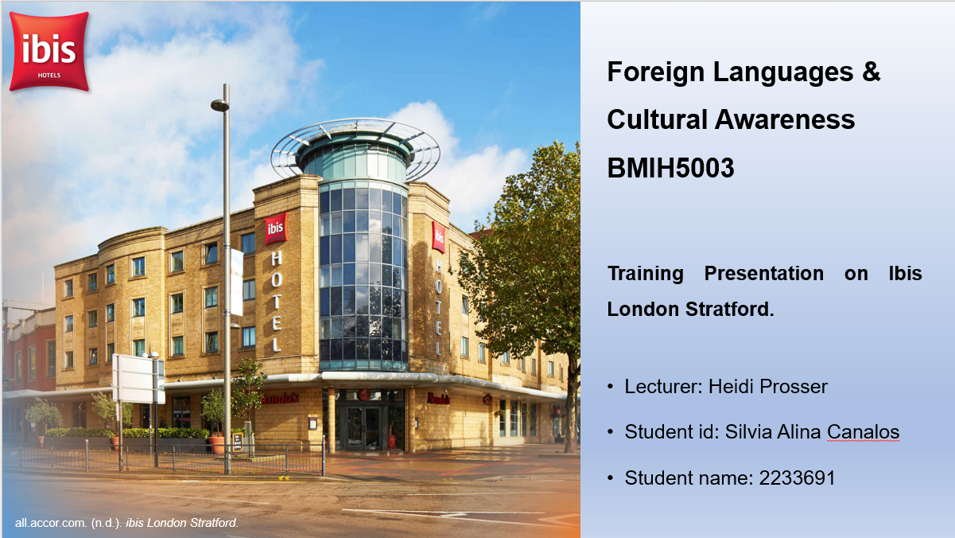
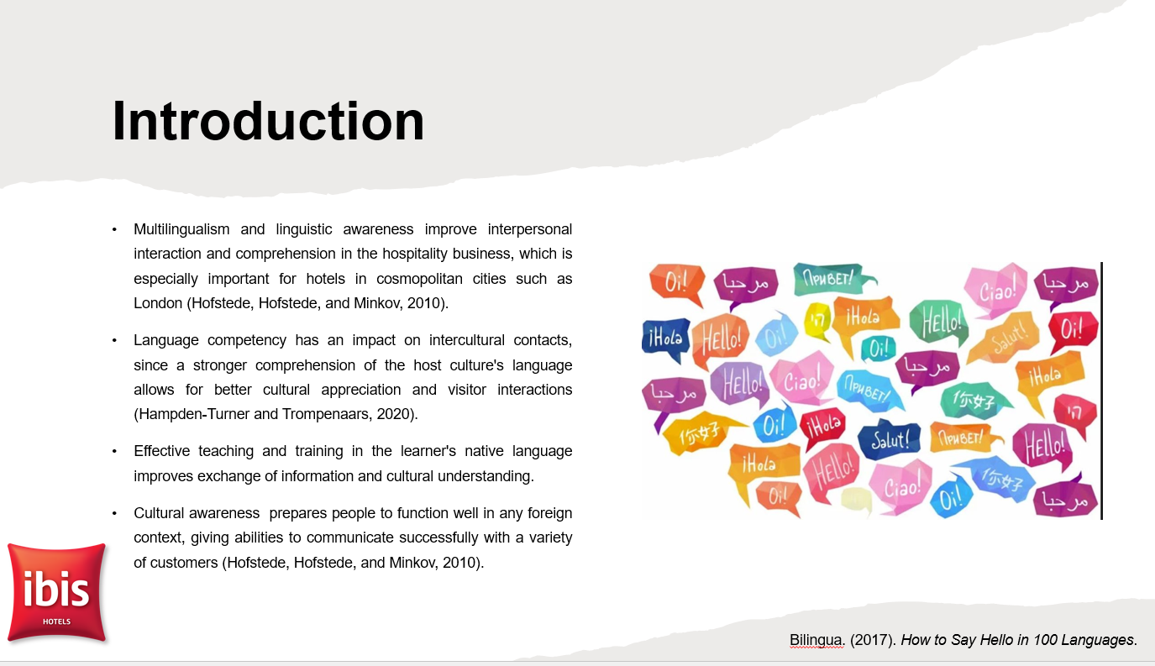
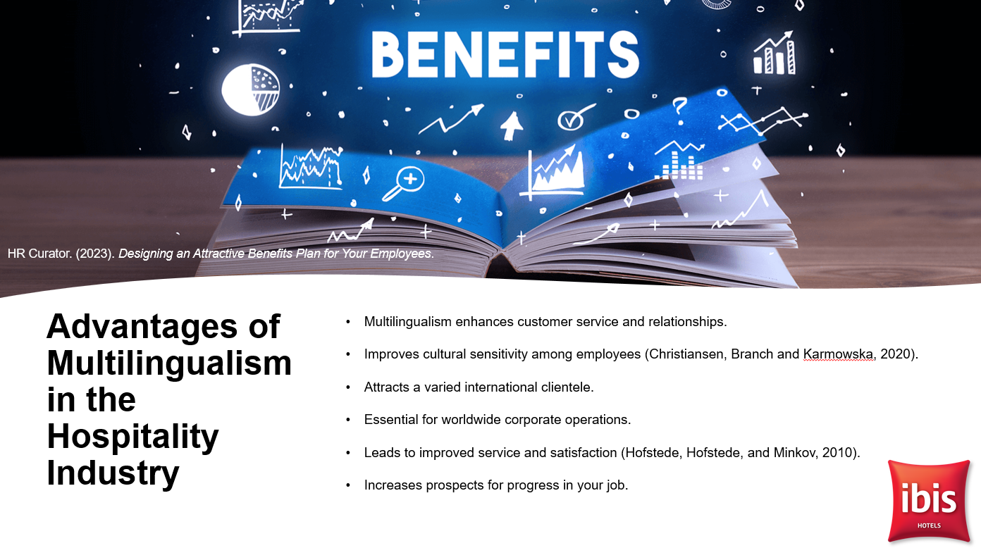
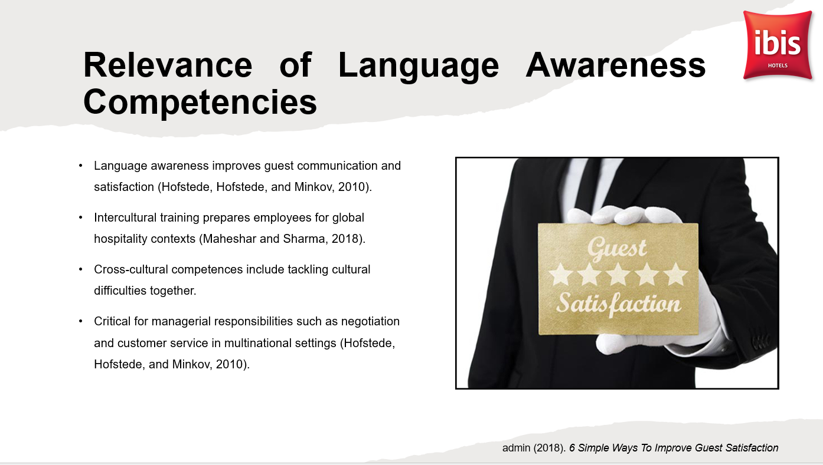
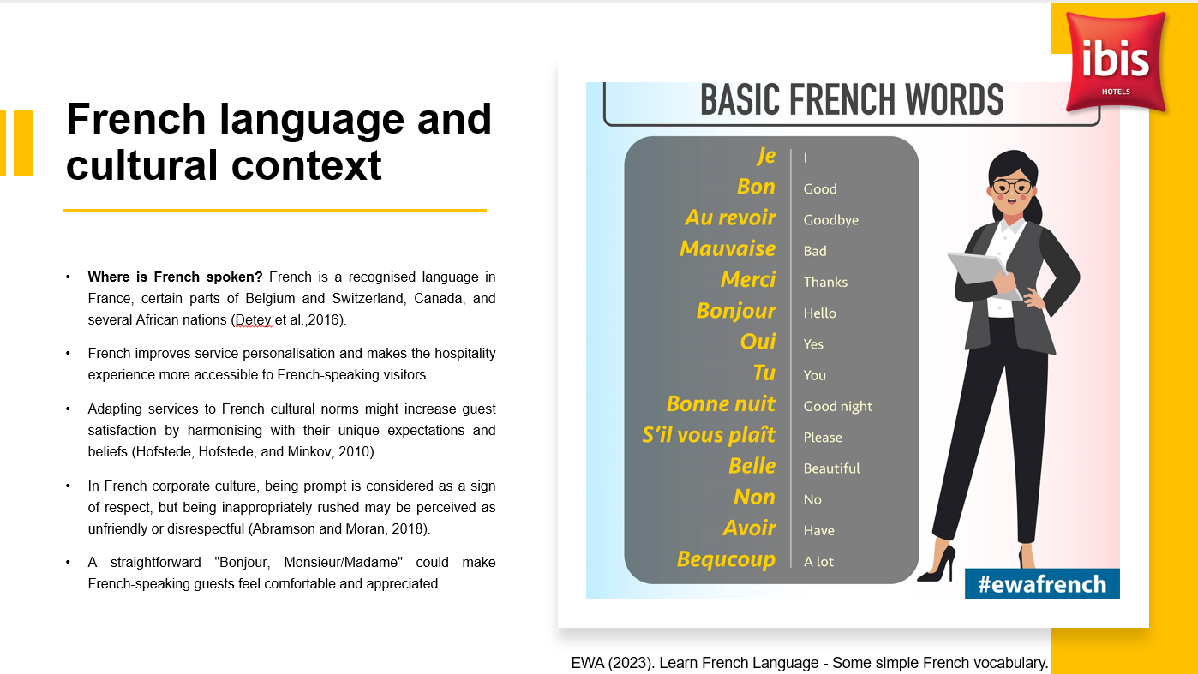
References:
- Abramson, N.R. and Moran, R. (2018) Managing Cultural Differences: Global Leadership for the 21st Century. 10th Ed. Abingdon: Routledge.
- Christiansen, B., Branch, J.D. and Karmowska, J. (2020) Cultural Factors and Performance in 21st Century Businesses. Hershey : IGI Global
- Detey, S., Durand, J., Laks, B. and Lyche, C. (2016). Varieties of Spoken French. [online] Google Books. Oxford University Press. Available at: https://www.google.co.uk/books/edition/Varieties_of_Spoken_French/i0q1DAAAQBAJ?hl=en&gbpv=1&dq=Where+is+French+spoken%3F+French+is+a+recognised+language+in+France [Accessed 22 Jan. 2024].
- Hampden-Turner, C. and Trompenaars, F. (2020) Riding the Waves of Culture. 4th Ed. London: John Murray Press
- Hofstede, G., Hofstede, G.J. and Minkov, M. (2010) Cultures and organizations: software of the mind. 3rd Ed. New York: McGraw-Hill.
- Maheshkar, C. and Sharma, V. (2018) Handbook of Research on Cross-Cultural Business Education. Hershey: IGI Global.

