Module Assignment Submission
Cover Page

Student Name: | Mayesha Choudhury
Student Number: | 1811545
Module No: | BMSK6002
Module Title: | Developing Innovation and Creativity for Business Advantage

Date submitted: | 15/01/2022
Time submitted: | 23:00
Statement of Confirmation of Authenticity
By the act of making this submission, the student declares that this is the work of the student named above. Where materials have been used from other sources it has been properly acknowledged. If this statement is untrue, the student acknowledges that an assessment offence has been committed. Proven incidents of plagiarism, collusion or cheating can result in a learner being withdrawn from a
qualification.
Attention is drawn to the Plagiarism, Collusion and Cheating Policy and Unfair Practice policies of the University and ILM.
Permission for ILM to use this script
ILM uses learners’ submissions – on an anonymous basis – for assessment standardisation. By submitting, both the centre and the learner agree that ILM may use this script on condition that identifying information is removed. However, if you are unwilling to allow ILM use this script, please refuse by ticking the box: □

Table of Contents
1.0 Introduction 3
2.0 – Innovation in the organisation & its’ ability to innovate effectively 4
Innovation Model – Stage-Gate Process 5
Innovation Model – Open Innovation 6
3.0 - Evaluate an organisations’ ability to harness creativity and foster a creative culture in the workplace 8
Creativity 8
Creativity and Culture 10
4.0 Conclusion 12
References 13
Appendix A 19
The Innovation Matrix 19
Appendix B 20
Stage-Gate Process Model 20
Appendix C 21
Innovation funnel diagram / Open innovation 21
Appendix D 22
Three components of creativity 22

Introduction
Every striving enterprise should comprehend what innovation is, its significance and how it may be utilised to benefit their business as innovation stands as the core of all successful business (Hamel, 2006). In today’s corporate environment, organisations thrive and succeed for a variety of reasons (Purcell, 2019). Many are recognised for their merchandise, whereas others are renowned for their qualities like strong customer loyalty or engaging marketing efforts. However, if one browses through businesses that are current leaders in their fields, it’s apparent that they all have a common characteristic, they all value and welcome innovation. For example, young companies like Amazon & Uber which challenged and disrupted the current systems by changing methods at the centre of their sectors. Along with committed organisations like Apple and Microsoft which have been in the industry for a while credit continuing success to persistence innovation and reinvention. Regardless of sector, a company can’t anticipate sustaining a competitive advantage if innovation isn’t included in its organisation strategy (Chatzoglou and Chatzoudes, 2017)

This report will focus on innovation and creativity in the workplace and its different theories. The chosen organisation will be the students place of work which is the telecommunication company Three in which they work at retail.

2.0 – Innovation in the organisation & its’ ability to innovate effectively
The understanding of the concept of innovation can vary from sector to sector. In the business industry, innovation can be defined as the creative process of successfully developing and applying new or enhanced proposals in order to achieve useful and practical results (Seaden & Manseau, 2001). Similarly, other academics identify innovation as a procedure that involves several stages which organisations develop ideas into new value-added merchandise, service or practices to succeed in the marketplace: by advancing, competing and differentiating themselves from competitors (Baregheh, Rowley, Sambrook, 2009). Both definitions have similarities and suggest that innovation involves:

- Producing favourable outputs, such as tangible measures, establishment of a new industry or a strategic edge against others
- The acts necessary to generate this value must be new to the organisation.

Innovation shouldn’t be confused with invention, as they can often mistakenly be used interchangeably. Invention is to do with discovering something entirely new whereas innovation is to use ideas to create new procedures or services that can contribute to an organisation’s success (Herbet, 2016). The globally recognised and popular company Netflix can be used as an example of successful innovation in the entertainment sector. As they transformed the delivery of DVDs and film rentals by introducing a digital streaming service where customers have a monthly subscription and they’re provided a library of new and old movies, tv shows and documentaries etc.

So, what role does innovation play in an organisation? Well, according to a survey conducted by Mckinsey (2010) of more than 2,000 executives from around the world, 84% of the senior manager respondents agreed innovation is a critical component in an organisation’s growth strategy. Likewise, in another report by PA Consultancy in 2019, 66% of the UK corporate leaders stated that innovation was fundamental to their companies’ success. These figures indicate that for organisations to be successful, the impact of innovation is a necessary element. As the results stated, innovation can help grow organisations which can result in adding value to the organisation which can enhance profitability and revenue (Tidd, 2001). There are more competitors than ever before due to globalisation and a constant changing market, therefore it’s important to keep up with demands of the consumers and the marketplace. Having an innovative organisation can help, it can support the business to stay ahead of the competition and assist in anticipating economic and industry trends whilst meeting customers’ requirements (Allen and Henn, 2007). As consequences of not having an innovative organisation will lead to the organisation struggling to stay relevant as other companies who have integrated innovation will constantly be bringing new concepts to the market. Overall, Innovation allows businesses to differentiate themselves amongst others, because executing something differently from what others are doing in your field is what innovation is about.

Often, individuals have the assumption that companies can be labelled as being either innovative or not. This perspective overlooks the reality that a business can embrace a variety of different styles of innovation, and that there is no right approach to innovate. Each organisation will adopt a different style of innovation to suit its situation as there are many different categories of innovation. One method to classify innovation is to look at it from two aspects: the technology it employs and the economy in which it operates that can be displayed in the innovation matrix (See Appendix A). The main recognised styles of innovation are:
- Incremental Innovation – the process of constantly improving current products or services to acquire additional value to an existing industry and maintain a competitive edge. Most innovations are incremental due to them typically being the most cost-effective and simplest to adopt. While this type of innovation doesn’t generate new markets and technology, it can entice higher paying consumers by meeting their demands as determined by their reviews or conduct (Pieroni, McAloone and Pigosso, 2019)
- Architectural Innovation –is to do with modifying current solutions to fulfil the requirements of a completely new marketplace. It looks at altering a product’s structure by combining pre-existing elements in creative new ways in order to increase the flow of new customers.
- Disruptive Innovation – this approach that was first put forward by Clayton Christensen in 1995, which he described as a concept, product or service that generates a new value system via disrupting an established industry or by developing an entirely new marketplace (Christensen, Raynor and McDonald, 2013).
- Radical Innovation – this is like disruptive innovation as it takes some time to destroy existing systems and processes in replacing it with something completely new; it uses new advanced technologies to create a new business model (Afuah, 2014). Therefore, radical innovation is rare as they transform the manner the world functions and works. Examples of radical innovation in the past is things like, computers, internet and cars.

Innovation Model – Stage-Gate Process
Over the years, there has been many approaches on how to carry out and manage the innovation process which led to several different models. One common model is the Stage-Gate process that was developed by Robert Cooper (1990). [See Appendix B for diagram]. It’s a value-generating procedure that helps turn a company’s ideas into successful new products in a rapid and profitable manner (Cooper, 2008). The model can be seen as a roadmap for optimizing the effectiveness and efficiency of the new product development process. The stage-gate model breaks down a large project into a series of more manageable stages with gates between them which are considered as the decision-making stations; where leaders must decide whether to move onto the next stage. This allows managers to review and evaluate their position at each stage, checking if everything is good before moving onto the next stage – it minimise risks and issues whilst saving time, resources and money which can be seen as an advantage to this model. As, should a problem arise at one stage, they will be able to look back and either solve or pivot the project accordingly. Evidence have supported this as it has concluded that projects need some sort of reviewing policy throughout procedure because otherwise it could be at risk of overruns or failure (Hong, et al., 2011). Cooper (2008) added that innovation starts with an idea and finishes once the production has been launched into the marketplace. The model consists of five stages, which are:

- Scoping – the initial low-cost research and scoping of the proposal.
- Build a business case – the thorough examination including primary studies that results to a business plan. This typically covers the understanding of the proposal and product as well as the project rationale and the intended development strategy.
- Development – this stage is to do with the precise in-depth construct and advancement of the new good or service along with the layouts of the operational process that will be needed for large production in the future.
- Testing and validation – stage four is all about trialling and testing the proposed new products or services as well as the marketing and procedures plans to ensure they are assessed and qualified for the last stage.
- Launch – the final stage which is the launch of the product/service – it is the start of the extensive manufacturing, advertising, distributing and sales activities (Edgett, 2015).

In addition to these stages, there is a start and end activity too. Before one starts with the scoping stage, there needs to be some pre-work focused on identifying and uncovering commercial prospects and generating fresh concepts which can be classed as a pre-step known as discovery (Cooper, 2014). Moreover, after launching there should be a post launch review which consists of an overall reflection and evaluation of the process and operations. The advantage of this model is that it enables management to begin with a variety of ideas that reduces in number by each stage until they are left with the most appropriate and appealing idea; one that is most probable to be successful and receive larger investments further down the line. In addition, it allows leaders to reach clear and concise decisions that will prevent projects from failing and wasting resources (Sommer, et al., 2015)
On the other hand, some academics points out that there are some weaknesses to this model. For example, the model is linear and fails to consider errors, repetitions and diversions that occur in real-world innovation. Moreover, if the organisations have too many stakeholders at every decision-making stage, then the process can end up being more of a chore rather than a strategy as every stakeholder will have their own opinion that can sometimes be conflicting and can stifle the creative flow (Chesbrough, 2010).

Innovation Model – Open Innovation
Another popular framework of innovation is the ‘Open Innovation model’ coined by Chesbrough in 2003. Open innovation is built on the concept that organisations can utilise and employ knowledge via a variety of external source as well as their internal domains to increase and accelerate innovation, resulting in providing greater value to its consumers (Brant and Lohse, 2014). This approach of innovation is the contrast to closed innovation, which was the traditional method organisations practised innovation in past centuries – most companies would, and still do perform innovation internally, without the input of any external businesses or people i.e., closed innovation. Open innovation is predicated on premises that businesses understand that they don’t hold all the knowledgeable and skilled employees required for their success, that they’re aware that there are more creative, experienced and competent individuals that exist outside of the organisation that could help the business achieve its strategic objectives and innovate more effectively (Benezech, 2012). This allows organisations to adopt new ideas and technologies that may not been introduced before, giving an insight into research and development without comprising their own resources – this can save businesses a lot of money, time and effort. The effort made by a corporation to harness the value of its innovation is an important aspect of open innovation; therefore, organisations who embrace open innovation must participate in proactive intellectual property management to be able to strategically leverage their own and other organisations innovation and knowledge (Herzog, 2008). Integrating open innovation techniques necessitates expertise of a variety of skill; for example, seeking prospects, analysing ideas, sourcing potential collaborators, generating value via commercialisation and expanding the innovation portfolio (Grönlund, Sjödinand and Frishammar, 2010). Open innovation is often portrayed as a funnel model [See Appendix C].
The advantage of the model is that the utilization of ideas can help businesses to improve cost and risk management as well as speed up technological developments. Furthermore, corporations can engage a wide spectrum of innovators globally by using open methods like crowdsourcing. In addition, due to the broader base of ideas and learning capacity from this style, it can allow organisations to develop their performance and gain a competitive advantage (Lichtenthaler and Ernst 2010; Carlsson et al. 2009). Gassmann, Enkel and Chesbrough, (2010) claim that open innovation can boost a corporation’s ability to innovate and becoming profitable by embracing external streams of creativity and knowledge as well as exploiting the external possibilities for commercialization of new products and services. Contrarily, many academics are critical of the open innovation mechanism as they question if the framework is truly innovative, as evidenced by the fact that its concepts have been identified already in the past (Trott and Hartmann, 2009). Moreover, scholars Christensen, Olesen and Kiaer (2005) argued that an issue with the open innovation model is the potential administrative expenses that can occur from engaging external parties in the process as a result of contractual discussions for the exchange of information and knowledge. Another limitation of the model is that it has a strong dependency on external knowledge which means organisations cannot work independently; the model insists on external knowledge. Lastly, there’s a potential risk of confidential information being leaked in the process which can harm the organisation and cause inconveniences (West and Gallagher, 2006).
Although it is apparent there are some limitations to the open innovation model, there are several strengths that the student believes outweighs the cons. For example, organisations can use non-own intellectual property and pose it as a strategic asset which can increase the competitive advantage without using the company’s resources or funds. Also, the collaboration with external parties can expand market opportunities and new solutions, ideas and technology.
The two models of innovations have both been popular in the business industry, although they take two different approaches to the innovation process, there are similarities that one can gather. For example, both models possess an evaluation aspect to its process. One differentiation is that the internal external channels to market are rigorously analysed in the open innovation paradigm for the export of know-how and technology, whereas only the internal routes to markets are assessed in the stage-gate model. Moreover, the open innovation enables a continuous assessment and evaluations of the organisations core abilities whilst the stage gate is fit between the new product development project and current core capabilities.

Although innovation models can help manage the process of innovation, there are several other factors that are required to successfully innovate. One of the crucial factors that contribute to having an innovative organisation is the organisations culture. The culture of a corporation can have a significant impact on the success of innovation. Culture needs to have that innovated and growth mindset for innovation. This requires characteristics of trust, open-mindedness, creativity, encouragement, confidence, engagement, communication, shared vision. Which ultimately is influenced by management and leaders, so leadership style also plays an important role (this will be discussed further in section 3.0).

Three is an innovative organisation, in the higher roles in head office, there are teams dedicated to innovation and product/service development. For example, in the retail stores after 12 years of the same design, the company finally rebranded and redesigned its entire organisation, including a whole remap of its retail stores called ‘stores of the future’. The new design incorporated an open plan setting with a completely new design to entice customers and keep the employees in refreshed environment. In addition, the new refurbished stores were in line with the rebranding of the company with new colour themes, goals and products. Moreover, to stay in line with the market and competitors, they are constantly developing their services and products such as introducing 5G spectrum and expanding it along with introducing 5G devices, broadband and E-sims. In fact, Three owns most of the UKs 5G spectrum (Beckett, 2021). The organisation follows a more open method of innovation, they maximise external sources as well as their internal to innovate effectively.

3.0 - Evaluate an organisations’ ability to harness creativity and foster a creative culture in the workplace

Creativity
So now the concept of innovation has been understood, this section will look at what creativity is, how it links with innovation and where it differs. Many people tend to associate innovation with creativity because it’s like innovation in that it’s to do with new ideas, discoveries and its use. Creativity is not as simple to define because there are many perspectives to the concept of creativity in different industries. For example, some see creativity to solve dilemmas, others see it as a transition from an idea to a reality, or new concepts arising from experimentation (Styhre, 2005). In addition, what can be classed a creative for one, may not be seen as creative for another. According to the Cambridge dictionary (2021), creativity can be defined as the capability to generate and deploy unique and uncommon ideas. Academics, Runco and Jaeger (2012) agreed with this notion and concluded that creativity has two components, originality and effectiveness. Thus, for Belussi and Staber (2012), creativity is part of a broader journey leading to innovation, in which the initial steps are the generation of ideas I.e., creativity. So, creativity can be seen as the thought procedure, creating something out of nothing whereas innovation is to do with putting those ideas into practise.

In recent years, the skill of being creative has made it to one of the most top desired and required skills for most organisations (Hart, 2021). In fact, various sources have revealed that creativity is the most valued skill to employers; the Institute for Business Value (2010) survey results implied 60% of the CEO candidates identified creativity as the most crucial leadership trait, in comparison with integrity. Another annual census by Boston Consulting group (Lister, 2018), scored creativity and innovation as the top strategic imperatives for the seven out of eight years they have conducted the survey. Moreover, LinkedIn has rated creativity as the most in-demand skill globally for businesses (Petrone, 2018).

A justification of this is that creativity has a favourable impact on the return of investment, as individuals that can think creatively and outside the norm have a better incline to developing distinctive and new approaches to challenges that can arise with in the business; it allows individuals to question norms or old modes of thought. These behaviours can assist organisations in developing items, services and other offers that distinguish them from the competition. The drive to resolve difficulties can contribute to new strategic methods of completing activities, resulting in more efficient business operations (Chen, 2006). Creativity enables organisations to evolve and grow with the application of fresh unique concepts and innovation. Although many unique discoveries originate from a single individual, they require to be shaped by a group to become fully developed. Therefore, creativity can promote and encourage employees to work and collaborate with one another as a team which builds better teamwork and productivity because employees that can work together, can achieve business targets and goals more effectively (Gloor, 2006). Academics, Gilson et al., (2005) agreed with this as their research correlated high-performing teams with their aptitude to deliver creative solutions. Furthermore, when staff are empowered to be creative, they are more satisfied with their position and are more dedicated to staying with the organisation in the long run. So, creativity can enhance the ability to attract and retain staff, which can save the organisations a lot of time, effort, resources and money. Businesses can continue to think of new, enhanced and innovative proposals that satisfy their customers current and future demands by applying creative thinking techniques (Andriopoulos, 2001).
There are many factors that contribute to creativity in an organisation. According to Amabile, (2011) there are three key components of creativity: expertise, creative thinking skills and motivation (See Appendix D for the componential model). Her model proposed that there’s a logic governing how the three components intersect, and that leaders should exploit the diagram to anticipate the level of creativity predicted in each workplace. Amabile (2011) hypothesises that people that possess all three traits of the model are more inclined to being highly creative. Likewise, individuals that have domain and thinking skills but lack motivation wouldn’t be as creative as those who do. Hence, the mix and interplay of these factors influence the levels of creativity that is likely to emerge in the workplace.
Other academics (Kim and Lee, 2008; Fejes and Nicoll, 2008) listed motivation as one of the main contributors of creativity, in particular intrinsic motivation. Singh (2016) supported this as his studies of motivation depicted that intrinsic motivation is stronger and successful than extrinsic motivation and that leaders should be working towards encouraging their employees to be more intrinsically motivated rather than extrinsically. This is because when individuals are predominately driven by their interest, delight, challenge and fulfilment, they are then the most creative (King and Teo, 2012). Herzberg’s (2017) two factor theory emphasises this as his motivating factors that include achievement and fascination are necessary elements for employee satisfaction and productivity. Motivated individuals tend to search for alternative effective and quality techniques to execute tasks and are generally much more productive than those who aren’t motivated (Deci and Ryan, 2014). So, stimulating motivated creativity can optimise the quality of the organisation’s operation and performance. Intrinsic motivation for creativity also requires traits such as inspiration, influence, ambition and support. Therefore, leadership has an important role in fostering creativity, as leaders need to be able to encourage and guide their subordinates to being inspired and influenced so they can be motivated to be creative and innovate successfully. The role of leadership will be discussed in depth further in the report.
Moreover, Clarkson (2005) recorded those traits such as divergent thinking, confidence, risk-taking and behaviour flexibility are linked to creativity. Studies carried out by Beghetto, (2021) indicated risk-taking is a crucial element of creativity. Risk-taking involves having confidence to take that step to act creatively and innovate. In the workplace, this involves getting the team out of their comfort zones to exploit their full potential. As having a creative team is crucial for business success. Individuals who are prepared to undertake intellectual risks are more prone to believing in their potential to be creative and therefore more inclined to interact in creative activities on a frequent scale; developing greater creative accomplishments than those who didn’t take risks (Oliva and Kallenberg, 2003). Another trait related to creativity is being open minded, creative individuals need to have open mindset and flexibility to allow new and different ideas and thoughts to occur. Bearing an open mind is essential for unlocking creativity as it enables one to have dual perception of the surroundings, allowing for a clear awareness of how things are whilst simultaneously envisioning how they could be (Bowes, 2021). In addition, management need to carry this trait in order to promote and encourage creativity from their team – they need to be open minded to the unique suggestions and concepts from their subordinates. The open mind extends out to even being welcoming to criticism and the potential that their ideas or thinking may not always be the one. They should be open to constructive criticism that can be used as feedback to refine and develop their concepts and grow.

Creativity and Culture
It’s apparent utilising both creativity and innovation in organisations can have a positive impact on business performance, but to do this organisation must firstly create room for both to occur. This comes from organisations culture; the culture of the organisation has an influence on the creativity of individuals, successfulness of innovations and the business. This is because culture is the core of any business and it heavily influences the way it works, the success of it and profitability falls back onto its culture (Santagata, 2010). Culture is understood as a system of shared knowledge, values, norms, attitudes and beliefs that bind a group of people together (Chiu and Hong, 2013); it governs cognition and motivation, as well as the interactions and activities (Leung and Morris, 2011).

Organisation cultures need to encourage their employees think and act creatively by steering their values, attitudes and behaviours towards this mindset. Leadership is critical in building and maintaining a culture of creativity and innovations because leaders dictate how their team operate and works (Reiter-Palmon, and Illies, 2004). The style of leadership will determine the shape of the organisations culture and team, so to promote a creative culture, leaders need to seek a supportive style of leadership to inspire, encourage and motivate their team. For example, democratic style of leadership focuses on consulting with the subordinates and involving them in the decision-making process. This open approach will help foster enthusiasm in people and empower them to share their ideas. In this style, management share the responsibility with the team, taking their suggestions on board which can make the team feel like they are in open forum, where their thoughts feel safe and welcomed. Shin (2015) underlined that democratic style of leadership leads to higher motivated employees with improved morale that contributes to overall improvement in job performance. Other advantages include increased cooperation and teamwork. Leaders taking this supportive approach must be able to allow room for mistakes and risk taking and remove fear of failure so that employees won’t feel afraid to put their say in (Moos, 2015).

In contrast, leaderships styles that endorse tight rules and guidelines like autocratic leadership will fail to foster creativity in their team. This is because they tend to stick to what they know, taking full authority and responsibility, making decisions on their own initiative without engaging the staff. Autocratic leadership connotates negativity, as it’s a very clear-cut, authoritarian-style management where subordinates do as their leader commands with no input for suggestion or influence (Bosiok, 2013). Employees are in these cases micromanaged which can cause frustration and stress amongst them that can often lead to quitting their jobs (Northouse, 2021). Because of this, such leadership technique has fewer chances of being effective and creativity as staff will do all that is required of them to avoid any sanctions without question. Moreover, another con of this leadership style is that the new generation are more self-reliant, less obedient and are resistant to strict supervision like so.
Thus, once again leadership has an important role in moulding the culture and setting the scene for employees; leaders should depict style that employs a supportive system, where employees are valued and feel appreciated which can increase their confidence levels and stimulate other creative avenues (Chua, Roth, and Lemoine, 2015). Edgar Schien (2010) touched on this, as he highlighted those underlying beliefs of subordinates are the strongest indicators of an organisations culture as he believes they mirror how the company operates on the inside. Suggesting that the employees must have the belief that their leaders have trust and care for their opinions and ideas and that they’re valued in order to bring about creativeness. In addition to leadership styles, infrastructures and the environment are linked with culture which ultimately determines creativity. Values and beliefs are also a fundamental part of culture – a group must share some commonality amongst values and beliefs.

In the students’ workplace, Three, the organisation itself has a dedicated department for mainstream creativity which is centred in head office. However, in the retail sector in which the student works, creativity is channelled to an extent in store. As discussed earlier on, the management style has an impact on exploiting creativity, so over the years the dynamic and culture has differed depending on who was manager and running the store. Therefore, there had been cases in the past where creativity was fostered and encouraged more than others. In the past, the previous manger in store had trust in their team and left the staff to it if they were compliant in line with the organisation and reaching their targets. During this period, there were less employees leaving and the culture and dynamic of the workplace felt alive and well. The assistant managers under this style of management would channel creativity and encourage it from the team too as they’d be creative with their daily briefings; holding store incentives that were fun allowing the team to come up with the reward and sanctions – this allowed the team to feel more relaxed and trusted which evidently was captured in our sales, as targets were overachieved.
In the present moment, the management style currently adopted in the workplace is more towards micromanagement for employees; it is very military style with how they work which creates a sense of lack of trust from management to their staff as they’re always being carefully watched and given scripts to follow which fails to promote creativity in people.
Creativity in its literal ways is apparent, as for marketing and advertising purposes, the team do hold some power and freedom in the choices for promotion and design for things like the outdoor chalkboard, deciding what they think as a team what will attract the most attention and bring in footfall and sales. Similarly, the infrastructure and environment of the office and staff room adopts a creative atmosphere. For example, it is open spaced with coloured walls to enhance creativity, along with a space where staff can relax and unleash their creative thought and self with the addition of a TV and gaming system in place. Moreover, in the staff room, the wall is an open field to design whatever the team would like to display in moderation; so currently there’s a wall of fame where team achievements are portrayed, along with a get-to-know-the-team wall which has facts and pictures of all the staff. This creates a playful and comfier atmosphere for employees that will allow them to feel motivated and confident to open and share thoughts.
In terms of problem solving, creativity is more than welcomed as when employees are faced with an issue, the team will come together to come up with the best solution, whether that be customer related or operations related. Looking more at the role of the job and creativity, when it comes to serving customers, a script must be followed with every interaction which doesn’t allow team members to be creative in their own way to address and carry out the interaction. Although, some may see it as an opportunity for creativeness because if the script is followed, employees can present how they wish which allows room to be creative when conducting interactions and pitching sales. So, the students organisation does support creativity to an extent, however it is not applied in all departments of the business and not to its full potential or effectively. There are still many barriers to creativity in the workplace.

Other organisations such as Google, foster creativity and innovation more effectively and efficiently. They’re an example of successful creative and innovative organisation. In 2019, Comparably bestowed the corporation 15 awards alone, featuring the Best Company Culture award. From their infrastructure to employee benefits, they are well known for their success in adopting a creative and innovative culture. For example, Google appoints a dedicated role, chief happiness officer whose ultimate responsibility is to ensure staff are satisfied and stay productive. In addition, the employee perks include free food, gym membership, pool tables and bowling alleys in head office. The head office environment has been depicted as a relaxing and laid-back atmosphere that has a range of facilities to spark creativity. The organisation acknowledged that different people and different ideas will percolate up in different ways, therefore they attempted to release multiple channels for expression (He, 2013). For example, one of the channels include Google Cafés that are intended to promote connections among employees and between teams and to instigate conversation about work and leisure. Another channel is FixIts’ where employees drop everything and concentrate their full attention on tackling a particular issue for 24-hours. There are many other channels like Google mediator that involves employees and allows them to have an input which taps into their creativity side. Overall, the management possessed is a supportive style that seeks to exploit the maximum potential from their employees. Businesses like Google that favour a workplace culture of creativity are more prone in having happy, engaged and motivated staff who are more devoted and productive. Other organisations are quickly catching on, enhancing staff involvement and motivation by including people in creative activities and providing rewards that allow them to take pride in their work and feel positive about themselves.

4.0 Conclusion
In conclusion, it is apparent that in business, originality isn’t enough, new concepts and ideas need to also be actionable and beneficial. Organisations should stimulate the mindset of continuous learning, motivating them to acquire new information, knowledge and new approaches to operation. In the workplace, creativity occurs when an individual comes up with a creative solution to an issue, whether it’s enhancing the consumer experience or reducing a time-consuming internal process. When viewed in this light, it is evident that creativity isn’t only required in sectors within a corporation but that it is a must for all. Creativity and innovation work hand in hand with one another, to be innovate, one must be creative and vice versa.

References

Afuah, A., (2014). Business model innovation: concepts, analysis, and cases. routledge.

Allen, T. and Henn, G., (2007). The organization and architecture of innovation. Routledge.

Amabile, T., (2011). Componential theory of creativity (pp. 538-559). Boston, MA: Harvard Business School.

Andriopoulos, C., (2001). ‘Determinants of organisational creativity: a literature review’. Management decision. 39(10), Pp. 834-841. DOI: https://doi.org/10.1108/00251740110402328 [Accessed 12th Janaury 2022]

Baregheh, A., Rowley, J. and Sambrook, S. (2009), ‘Towards a multidisciplinary definition of innovation’, Management Decision, 47(8), pp. 1323-1339. DOI: https://doi.org/10.1108/00251740910984578 [25th August 2021]

Beckett, M., (2021). What is 5G home broadband? [Online] Available at: https://www.uswitch.com/broadband/guides/what-is-5G-home-broadband/ [Accessed 4th January 2022]

Beghetto, R.A., (2021). ‘There is no creativity without uncertainty: Dubito Ergo Creo’. Journal of Creativity, 31, p.100005. DOI: https://doi.org/10.1016/j.yjoc.2021.100005 [Accessed 12th January 2022]

Belussi, F. and Staber, U.H. eds., (2012). Managing networks of creativity (Vol.19). Routledge.

Benezech, D., (2012). ‘The Open Innovation model: some issues regarding its internal consistency’. Journal of Innovation Economics Management, (2), pp.145-165. DOI: https://doi.org/10.3917/jie.010.0145 [Accessed 2nd January 2022]

Bosiok, D., (2013). ‘Leadership styles and creativity’. Online Journal of Applied Knowledge Management (OJAKM), 1(2), pp.64-77. Available at: http://www.iiakm.org/ojakm/articles/2013/OJAKM_Volume1_2pp64-77.php [Accessed 12th January 2022]

Bowes, B., (2021). ‘Meeting of the minds: Open-mindedness is an essential leadership trait for creativity, innovation and managing change’. Winnipeg Free Press. Available at: https://www.proquest.com/docview/2510516882?accountid=130472&parentSessionId=Ygjx%2BB9mBnmP0Bw2mYqNlOstlM6GntluRrNUxV15F1E%3D&pq-origsite=primo [Accessed 12th January 2022]

Brant, J. and Lohse, S., (2014). ‘The open innovation model’. ICC (International Chamber of Commerce) Innovation and Intellectual Property Research Paper, (2). Available at: https://www.iccwbo.be/wp-content/uploads/2012/03/20140325-The-Open-Innovation-Model.pdf [Accessed 2nd January 2022]

Brant, J. and Lohse, S., (2014). The open innovation model. ICC (International Chamber of Commerce) Innovation and Intellectual Property Research Paper, (2). Available at: https://www.iccwbo.be/wp-content/uploads/2012/03/20140325-The-Open-Innovation-Model.pdf [Accessed 2nd January 2022]

Cambridge dictionary, (2022). Available at: https://dictionary.cambridge.org/dictionary/english/creativity [Accessed 2nd January 2022]

Carlsson, S., et al., (2009). ‘Enabling open innovation: Proposal of a framework supporting ICT and KMS implementation in web-based intermediaries’. In Proceedings of the 17th European Conference on Information Systems. Available at: https://portal.research.lu.se/en/publications/enabling-open-innovation-proposal-of-a-framework-supporting-ict-a [Accessed 2nd January 2022]

Chatzoglou, P. and Chatzoudes, D., (2017). ‘The role of innovation in building competitive advantages: an empirical investigation’. European Journal of Innovation Management. 21(1), Pp. 44-69. DOI: https://doi.org/10.1108/EJIM-02-2017-0015 [Accessed 25th August 2021]

Chen, M.H., (2006). ‘Understanding the benefits and detriments of conflict on team creativity process’. Creativity and innovation management, 15(1), pp.105-116. DOI: https://doi.org/10.1111/j.1467-8691.2006.00373.x [Accessed 6th January 2022]

Chesbrough, H., (2010). ‘Business model innovation: opportunities and barriers’. Long range planning, 43(2-3), pp.354-363. DOI: https://doi.org/10.1016/j.lrp.2009.07.010 [Accessed 2nd January 2022]

Chesbrough, H.W., (2003). Open innovation: The new imperative for creating and profiting from technology. Harvard Business Press.

Chiu, C.Y. and Hong, Y.Y., (2013). Social psychology of culture. Psychology Press.

Christensen, C., Raynor, M.E. and McDonald, R., (2013). Disruptive innovation. Harvard Business Review.

Christensen, J.F., Olesen, M.H. and Kjaer, J.S., (2005). ‘The industrial dynamics of Open Innovation—Evidence from the transformation of consumer electronics’. Research policy, 34(10), pp.1533-1549. DOI: https://doi.org/10.1016/j.respol.2005.07.002 [Accessed 2nd January 2022]

Chua, R.Y., Roth, Y. and Lemoine, J.F., (2015). ‘The impact of culture on creativity: How cultural tightness and cultural distance affect global innovation crowdsourcing work’. Administrative Science Quarterly, 60(2), pp.189-227. DOI: https://doi.org/10.1177%2F0001839214563595 [Accessed [Accessed 6th January 2022]

Clarkson, A., (2005). ‘Educating the Creative Imagination: A Course Design and its Consequences’. Journal of Jungian Scholarly Studies. 1(2). Available at: https://eric.ed.gov/?id=ED490021 [Accessed 12th January 2022]

Comparably, (2019). Google Awards. [Online] Available at: https://www.comparably.com/companies/google/awards [Accessed 15th January 2022]

Cooper, R., (2011). ‘Perspective: The innovation Dilemma: How to Innovate When the Market is Mature’. Journal of Product Innovation Management. 28(1). Pp. 2-27. DOI: https://doi.org/10.1111/j.1540-5885.2011.00858.x [8th December 2021]

Cooper, R.G., (1990). ‘Stage-gate systems: a new tool for managing new products’. Business horizons, 33(3), pp.44-54. Available at: https://citeseerx.ist.psu.edu/viewdoc/download?doi=10.1.1.474.1777&rep=rep1&type=pdf [Accessed 8th December 2021]

Cooper, R.G., (2008). ‘Perspective: The stage‐gate® idea‐to‐launch process—update, what's new, and nexgen systems’. Journal of product innovation management, 25(3), pp.213-232. DOI: https://doi.org/10.1111/j.1540-5885.2008.00296.x [Accessed 8th December 2021]
Cooper, R.G., (2014). ‘What's next?: After stage-gate.’ Research-Technology Management, 57(1), pp.20-31. DOI: https://doi.org/10.5437/08956308X5606963 [Accessed 16th December 2021]

Deci, E.L. and Ryan, R.M., (2014). ‘The importance of universal psychological needs for understanding motivation in the workplace’. in M. Gagné (Ed.), The Oxford handbook of work engagement, motivation, and self-determination theory (pp. 13–32). Oxford University Press. Available at: https://psycnet.apa.org/record/2014-24108-002 [Accessed 15th January 2022]

Edgett, S.J., (2015). ‘Idea-to-Launch (Stage-Gate®) Model: An Overview’. Stage-Gate International, pp.1-5. Available at: https://media.transformanceadvisors.com/pdfs/Stage-Gate-Model.pdf [9th December 2021]
Fejes, A. and Nicoll, K. (2008). Foucault and lifelong learning: Governing the subject. New York, NY: Routledge.
Fetterhoff, T.J. and Voelkel, D., (2006). ‘Managing open innovation in biotechnology’. Research-Technology Management, 49(3), pp.14-18. DOI: https://doi.org/10.1080/08956308.2006.11657373 [Accessed 2nd January 2022]

Gassmann, O., Enkel, E. and Chesbrough, H., (2010). ‘The future of open innovation’. R&d Management, 40(3), pp.213-221. DOI: https://doi.org/10.1111/j.1467-9310.2010.00605.x [Accessed 2nd January 2022]

Gilson, L.L., et al., (2005). ‘Creativity and standardization: complementary or conflicting drivers of team effectiveness?’. Academy of Management journal, 48(3), pp.521-531. DOI: https://doi.org/10.5465/amj.2005.17407916 [Accessed 6th January 2022]

Gloor, P.A., (2006). Swarm creativity: Competitive advantage through collaborative innovation networks. Oxford University Press.

Grönlund, J., Sjödin, D.R. and Frishammar, J., (2010). ‘Open innovation and the stage-gate process: A revised model for new product development’. California management review, 52(3), pp.106-131. DOI: http://dx.doi.org/10.1525/cmr.2010.52.3.106 [Accessed 2nd Janaury 2022]

Hamel, G., (2006). The Why, What, and How of Management Innovation, [Online] Available at: https://hbr.org/2006/02/the-why-what-and-how-of-management-innovation [25th August 2021]

Hart, J., (2021). Why Creativity Is The Number One Skill For Business Success. [Blog] Available at: https://www.dalecarnegie.com/blog/creativity-is-the-skill-for-business-success/ [Accessed 7th January 2022]

He, L., (2013). Google secrets of innovation, empowering its employees. [Blog] Availabe at: https://www.forbes.com/sites/laurahe/2013/03/29/googles-secrets-of-innovation-empowering-its-employees/?sh=60a5c45957e7 [Accessed 15th January 2022]

Herbet, M. (2016), The difference between invention and innovation, [Blog] available at: https://www.uk-cpi.com/blog/the-difference-between-invention-and-innovation [25th August 2021]
Herzberg, F., (2017). Motivation to work. Routledge
Herzog, P., (2011). Open and closed innovation: Different cultures for different strategies. Springer Science & Business Media.
Hong, H.U., et al., (2011). ‘Stage-gate process integrated risk management framework for overseas lng plant projects’. In Proceedings of the 28th International Symposium on Automation and Robotics in Construction, isARC 2011., pp. 1151-1156. Available at: https://d1wqtxts1xzle7.cloudfront.net/39125133/Risk_and_stage_and_gate_process_-_GNL-7.pdf? [Accessed 6th December 2021]

Institute for Business Value., (2010). IBM 2010 Global CEO Study: Creativity Selected as Most Crucial Factor for Future Success. [Online] Available at: https://newsroom.ibm.com/2010-05-18-IBM-2010-Global-CEO-Study-Creativity-Selected-as-Most-Crucial-Factor-for-Future-Success [Accessed 6th January 2022]

Kim, J. H., & Lee, C. H. (2008). ‘Multi-objective evolutionary generation process for specific personalities of artificial creature’. Computational Intelligence Magazine, IEEE, 3(1), 43-53. DOI: https://doi.org/10.1109/MCI.2008.913368 [Accessed 12th January 2022]
King, K. M., & Teo, K. K. (2012). Cardiac rehabilitation referral and attendance: not one and the same. Rehabilitation Nursing, 23(5), 246-251. DOI: https://doi.org/10.1002/j.2048-7940.1998.tb01794.x [Accessed 12th January 2022]
Kylliäinen, J., (2019). Types of Innovation – The Ultimate Guide with Definitions and Examples, [Blog] Available at: https://www.viima.com/blog/types-of-innovation [Accessed 8th December 2021]

Leung, K. and Morris, M.W., (2011). Culture and creativity: A social psychological analysis. In Social psychology and organizations (pp. 403-428). Routledge.

Lichtenthaler, U. and Ernst, H., (2007). ‘External technology commercialization in large firms: results of a quantitative benchmarking study’. R&D Management, 37(5), pp.383-397. DOI: https://doi.org/10.1111/j.1467-9310.2007.00487.x [Accessed 2nd January 2022]

Lister, R., (2018). Is Creativity the Number One Skill For The 21st Century?. [Online] Available at: https://weareive.org/is-creativity-the-number-one-skill-for-the-21st-century/ [Accessed 6th January 2022]

McKinsey Global Survey (2010), Innovation and commercialization 2010: McKinsey Global Survey results. [Online] Available at: https://www.mckinsey.com/business-functions/strategy-and-corporate-finance/our-insights/innovation-and-commercialization-2010-mckinsey-global-survey-results [25th August 2021]

Moos, L., (2015). ‘Leadership for creativity’. International Journal of Leadership in Education, 18(2), pp.178-196. DOI: https://doi.org/10.1080/13603124.2014.915060 [Accessed 2nd January 2022]

Northouse, P.G., (2021). Leadership: Theory and practice. Sage publications.

Oliva, R. and Kallenberg, R., (2003). ‘Managing the transition from products to services’. International journal of service industry management. 14(2), Pp. 160-172. DOI: https://doi.org/10.1108/09564230310474138 [Accessed 2nd January 2022]

PA Consultancy, (2019). Innovation Matters. Available at: http://www2.paconsulting.com/rs/526-HZE-833/images/1_1_129169_InnovationMatters2019_v5%20Digital.pdf [Accessed 25TH August 2021
Petrone, P., (2018). Why Creativity is the Most Important Skill in the World. [Blog] Available at: https://www.linkedin.com/business/learning/blog/top-skills-and-courses/why-creativity-is-the-most-important-skill-in-the-world [Accessed 6th January 2022]

Pieroni, M.P., McAloone, T.C. and Pigosso, D.C., (2019). ‘Business model innovation for circular economy and sustainability: A review of approaches’. Journal of cleaner production, 215, pp.198-216. DOI: https://doi.org/10.1016/j.jclepro.2019.01.036 [Accessed 8th December 2021]

Purcell, W., (2019). The importance of innovation in Business. [Blog] Available at: https://www.northeastern.edu/graduate/blog/importance-of-innovation/ [Accessed 24th November 2021]

Reiter-Palmon, R. and Illies, J.J., (2004). ‘Leadership and creativity: Understanding leadership from a creative problem-solving perspective’. The leadership quarterly, 15(1), pp.55-77. DOI: https://doi.org/10.1016/j.leaqua.2003.12.005 [Accessed 6th January 2022]

Runco, M.A. and Jaeger, G.J., (2012). ‘The standard definition of creativity’. Creativity research journal, 24(1), pp.92-96. DOI: https://doi.org/10.1080/10400419.2012.650092 [Accessed 2nd January 2022]

Santagata, W., (2010). The culture factory: Creativity and the production of culture. Springer Science & Business Media.

Schein, E.H., (2010). Organizational culture and leadership (Vol. 2). John Wiley & Sons.
Seaden, G. and Manseau, A. (2001), ‘Public Policy and Construction Innovation.’ Building Research & Information, 29, Pp. 182-196. DOI: https://doi.org/10.1080/09613210010027701 [25th August 2021]

Shin, S.J., (2015). Leadership and creativity: The mechanism. The Oxford handbook of creativity, innovation, and entrepreneurship, pp.17-30.

Singh, R., (2016). ‘The impact of intrinsic and extrinsic motivators on employee engagement in information organizations’. Journal of Education for Library and Information Science, 57(2), pp.197-206. DOI: https://doi.org/10.3138/jelis.57.2.197 [Accessed 12th January 2022]

Sommer, A.F., et al., (2015). ‘Improved product development performance through Agile/Stage-Gate hybrids: The next-generation Stage-Gate process?’. Research-Technology Management, 58(1), pp.34-45. DOI: https://doi.org/10.5437/08956308X5801236 [Accessed 6th December 2021]

Styhre, A., (2005). Managing creativity in organizations. British Library.

Tidd, J., (2001). ‘Innovation management in context: environment, organization and performance’. International journal of management reviews, 3(3), pp.169-183. DOI: https://doi.org/10.1111/1468-2370.00062 [Accessed 21st August 2021]

Trott, P. and Hartmann, D.A.P., (2009). ‘Why'open innovation'is old wine in new bottles’. International Journal of Innovation Management, 13(04), pp.715-736. DOI: https://doi.org/10.1142/S1363919609002509 [Accessed 2nd January 2022]

West, J. and Gallagher, S., (2006). ‘Challenges of open innovation: the paradox of firm investment in open‐source software’. R&d Management, 36(3), pp.319-331. DOI: https://doi.org/10.1111/j.1467-9310.2006.00436.x [Accessed 2nd January 2022]

Zhang, Y., & Bohemia, E., & McCardle, J., (2018). ‘Insights on how metacognition influences knowledge application in product design education.’ n DS 92: Proceedings of the DESIGN 2018 15th International Design Conference (pp. 2541-2552). DOI: http://dx.doi.org/10.21278/idc.2018.0416 [Accessed 7th January 2022]

Appendix A

The Innovation Matrix

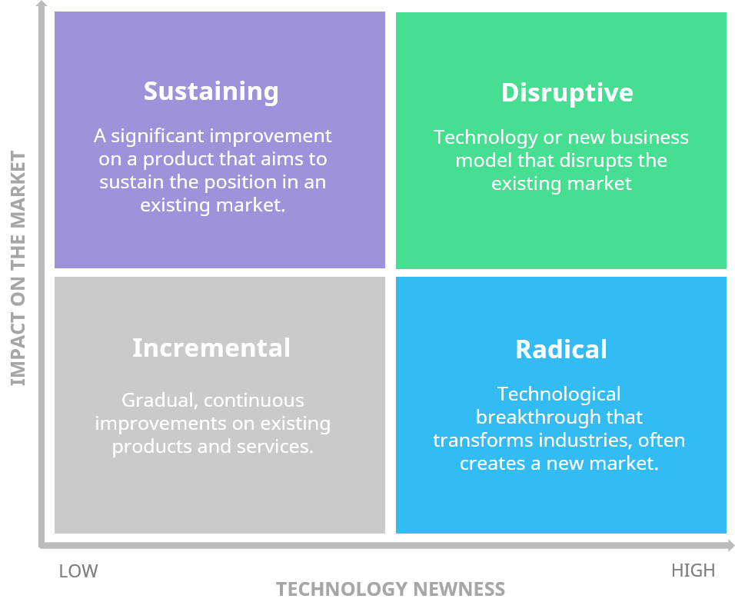

(Kylliäinen, 2019)

Appendix B

Stage-Gate Process Model

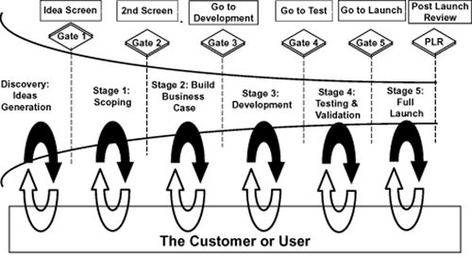

(Cooper, 2011)

Appendix C

Innovation funnel diagram / Open innovation

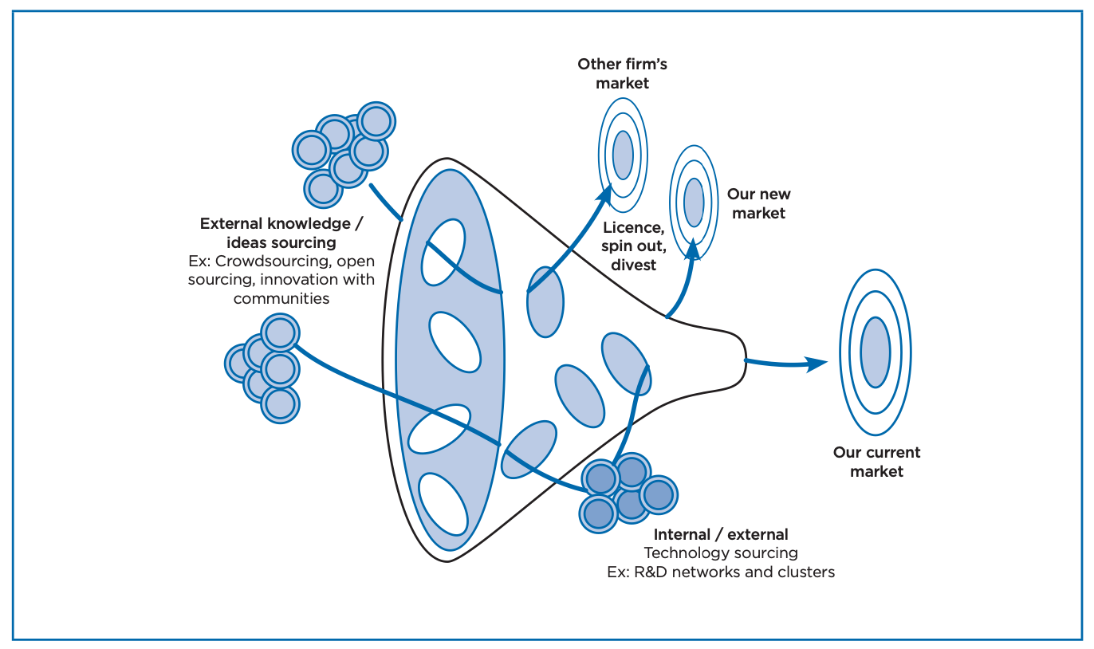
(Brant and Lohse, 2014)

Appendix D

Three components of creativity

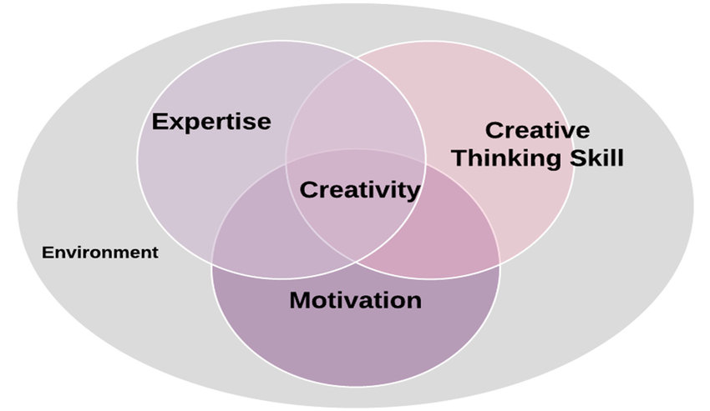

(Zhang, Bohemia and McCardle, 2018)

