REPORT 2019
Shelina Begum (1704954)
University of Wales Trinity Saint David
5th July 2019


Project Planning and Management in Workplace (Swansea Council)

Executive Summary

This report contains a critical analysis of project management tools and techniques of a work project for Swansea Council. The tools and techniques have been utilised are the Project Lifecycle, Mendelow’s Matrix for stakeholder analysis, the Quad Chart for the project scope, Iron Triangle, Risk Analysis, Work Breakdown Structure (WBS) and Gantt Chart.

The report discusses the project plan and implementation by utilising the Project Lifecycle. Thus, it contains a conclusion and recommendation for the improvement of communication and negotiation skills.
Contents

Executive Summary 1
1.0 Introduction 3
2.0 Main Body 4
2.1 Project Management Process 4
2.2 Project Management Tools and Techniques 4
2.3 Initiating Process 5
2.3.1 Project Team 5
2.3.2 Stakeholder Analysis 5
2.3.3 Project Scope 6
2.4 Planning Process 6
2.4.1 Iron Triangle 6
2.4.2 Risk Analysis 7
2.4.3 Work Breakdown Structure (WBS) 8
2.4.4 Gantt Chart 8
2.5 Executing Process 9
2.6 Monitoring and Controlling Process 10
2.7. Closing Process 10
3.0 Conclusion 12
4.0 Recommendation 13
4.1 Communication Skills 13
4.2 Negotiation Skills 13
5.0 Appendices 14
Appendix A – The Quad Chart (Project Scope) 14
Appendix B – Risk Analysis 15
6.0 References 16

1.0 Introduction

Project Management benefits a business to lessen creation growth time to marketplace, make use of restricted resources, manage the technological difficulty, react to stakeholder agreement and increment worldwide market rivalry (Patanakul and Milosevic, 2010). Papke-Shields and Boyer-Wright (2017) point out previous research regarding project management concentrated on analytical success issues and project management methods that sets out rules and agendas to guarantee that practices are being pursued appropriately. Thus, project management tools and techniques are expected to assist professionals to do their work and implement activities.

The Project Management Institute defined project as “a temporary endeavor undertaken to create a unique product, service or result” which “has a defined beginning and end in time and therefore defined scope and resources” (PMI, 2019). The work project which will be discussed is the Community Cohesion Survey for Swansea Council and the tool and techniques were utilised to implement the project. Swansea Council was carrying out the survey for Safer Swansea Partnership which brings public, private and voluntary sector organisations together to reduce crime in the City and County of Swansea. The survey was to enable Safer Swansea Partnership to enhance the resident’s quality of life and create a safer living, working and learning environment (Safer Swansea, 2019).

2.0 Main Body

2.1 Project Management Process

PMI (2019) states according to their “Guide to the Project Management Body of Knowledge,” it identified repeated components of project management procedures which are the initiating, planning, executing, monitoring and controlling and closing process. This is also known as a Project Lifecycle which allows a project team to plan, do and review.
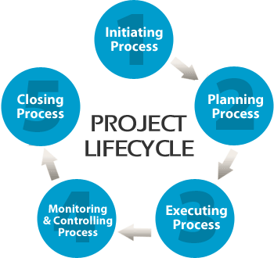
(Search Group, 2018)

The PMI (2019), Papke-Shields and Boyer-Wright (2017) and Patanakul, Iewwongcharoen and Milosevic (2010) state project management knowledge relies on these fields which are integration, scope, time, cost, quality, procurement, human resources, communications, risk management and stakeholder management.

2.2 Project Management Tools and Techniques

For the project, the tools and techniques which were utilised are the Mendelow’s Matrix for Stakeholder Analysis, the QUAD Chart for the scope, the Iron Triangle, Risk Analysis, Work Breakdown Structure (WBS) and the Gantt Chart. It was declared by Patanakul, Iewwongcharoen and Milosevic (2010) that these tools and techniques are significantly utilised in the planning phase.

2.3 Initiating Process

2.3.1 Project Team

A project team is a group of members from various work fields in a company taken to achieve a particular task inside a limited time (Buchanan and Huczynski, 2017). To form a team for this project the Belbin Test was utilised to identify if the team members were able to work together. The team consisted of three members and according to the test results, the team members were in different category roles. A project manager was selected to manage the project and the team. The project manager was in charge of leading the team and arranging the work (Project Manager, 2019).

2.3.2 Stakeholder Analysis

It is essential to identify the stakeholders of the project. Therefore, to analyse the stakeholders the Mendelow’s Matrix was utilised. A stakeholder is defined as “anyone who is concerned with how an organisation operates, and who will be affected by its decisions and actions” (Buchanan & Huczynski, 2017, p.40). Mendelow’s Matrix allows grouping stakeholders, based on their power (high or low) and interest (high or low) (Erikson-Coats, 2018).

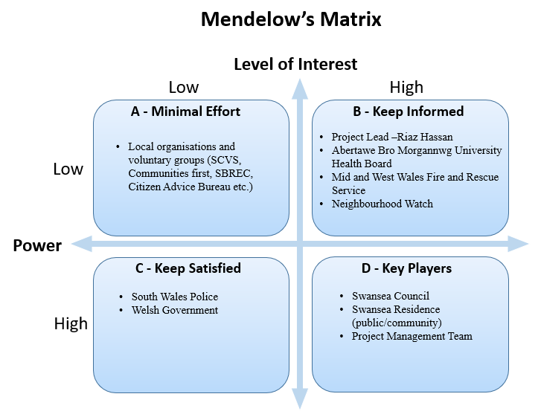
To identify the stakeholders, first, the team identified the Safer Swansea Partnership stakeholders which are South Wales Police, the Welsh government, local organisations, voluntary groups, etc. After, the stakeholders were put into the categories by their importance of interest and power. The Swansea Council and the project team has high power and high interest as they are the one who required the survey to be accomplished. Swansea residents were crucial as without them the survey would not be accomplished and information would not be received. However, for the project, it only required informing the project lead, although Swansea Council were required to inform the outcome to the rest of the stakeholders.

2.3.3 Project Scope

Project scope is defined as “adopting a clear vision and an agreement on the outcomes of the project” (Jamaledine, 2017). The Quad Chart has been utilised to provide the project scope, it is an effective tool to describe in brief the process of the project (The Audiopedia, 2018). The QUAD Chart (see Appendix A) contains the purpose, the stakeholders, the desired end result and the measures of success of the project.

The team had the first meeting with the project leader on the 22nd May 2019 and it was discussed what the team had to do. The project leader wanted the team to survey 100 individuals each, which was 5 a day until 16th June 2019.

2.4 Planning Process

2.4.1 Iron Triangle

The Iron Triangle was developed in 1969 by Dr. Martin Barnes, also known as the Triple Constraint or the Project Management Triangle. It illustrates the most fundamental criteria that project success is measured, either the project is accomplished by the due date, within the cost and to a certain standard of approved quality, performance or scope. The quality, cost and time are interconnected. Resolving one point of the triangle impacts the other two points. In other terms, the other two points need to move. Accordingly, if the quality is resolved, time and cost possibly need to increment (Pollack, Helm and Adler, 2018).

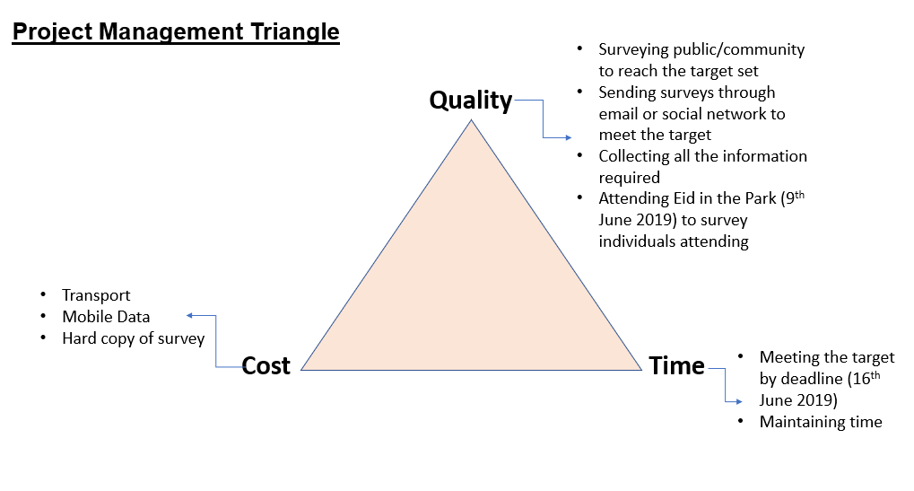
The Project Management Triangle indicates that quality and time were the most crucial for this project. Consequently, for quality, it is crucial to gather as much information for Swansea Council, how Brexit is impacting individuals and community. Thus, for time, it is vital to meet the target and the deadline.

2.4.2 Risk Analysis

Risk Analysis Chart enabled the team to identify “where there is a lack of complete certainty regarding the outcomes of various courses of action” (French, et.al, 2015, p.338). Therefore, by assessing the risk impact and likelihood by high, medium and low risk, then actions can be implemented to achieve the goals (Eccles & Bruce, 2010). The project Risk Analysis (see Appendix B) illustrates the risk involved in the project and how it would impact the project. Thus, it illustrates the mechanism warning and mitigating action to be taken for each risk.

The chart (see Appendix B) demonstrates what risks would be involved in the project and if it is low, medium or high. For example, the team has identified that a server system crash, survey counter faulty and a team being ill would be high risk and it will impact the project. The server system crash failure will delay the process and the action to be taken is to keep a printout of a survey as a backup. If the survey counter gets faulty, it would be impossible to know how many surveys have been completed, therefore, the action required is that each team member should keep count of how many surveys they have completed. If a team member is ill, it is essential to inform the rest of the team so the work pending could be accomplished by other team members.

2.4.3 Work Breakdown Structure (WBS)

“Work Breakdown Structure (WBS) is an important tool for projects because it scopes and defines the work” (Hillson, 2003).
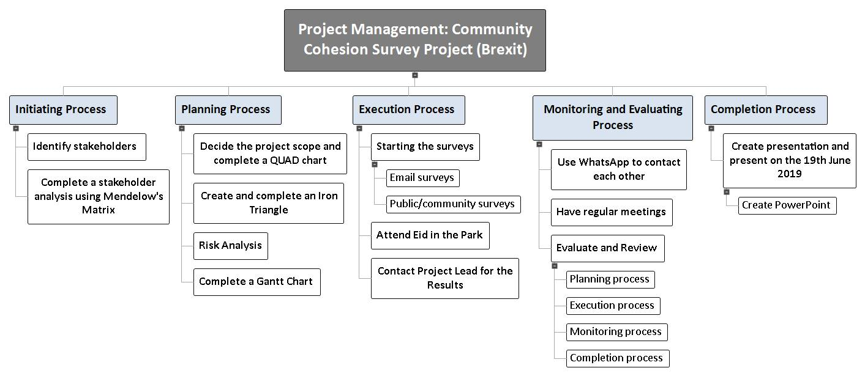
The Work Breakdown Structure of the project is a top-down approach, it illustrates the breakdown of the tasks in each process.

2.4.4 Gantt Chart

Gantt Charts were constructed in 1910 by a management consultant engineer, Henry Gant. It is mainly used in project management for the project to run smoothly. It is a chart showing the start date and the end date of each task (Totem, 2017).
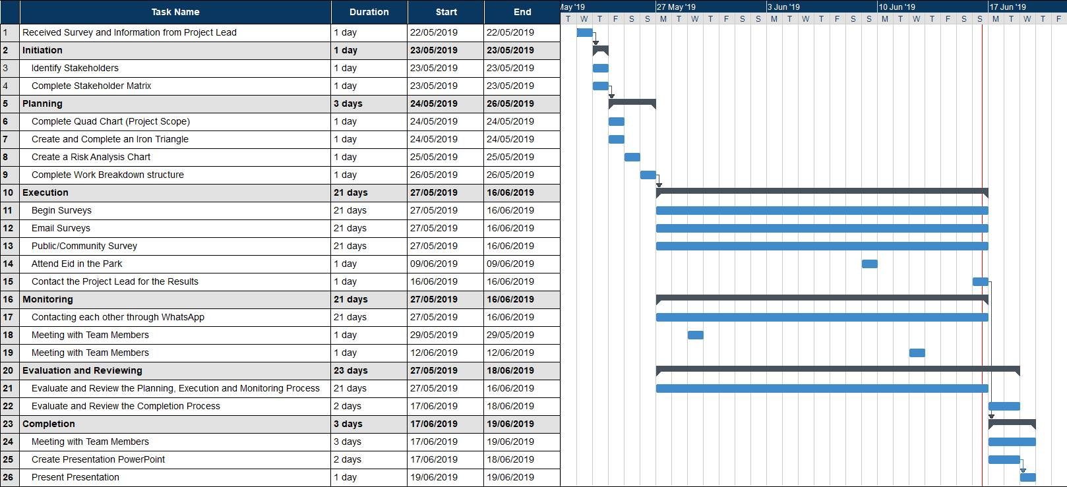
The Gantt Chart illustrates the plan of the project that the team should follow.

2.5 Executing Process

Executing process is also known as the implementation phase where the planning of the tools and techniques are put into action. The main purpose of the executing process of the Project Lifecycle is to accomplish the project’s desired outcomes. Thus, during this process, most resources are implemented (Coventry University, 2019). During this process, the team utilised all the plans and procedures that were made during the planning process.

As planned, the team completed surveys and attended Eid in the Park on the 9th June 2019 where the 10-15 survey were completed. The team tried surveying five a day by sending links through e-mail, WhatsApp, Facebook, LinkedIn and surveying family and friends. On the 30th May 2019, the team attended the level 4 Skills for the Workplace lecture to survey the students and 16 surveys were completed. Thus, a lecturer completed further 22 surveys in the Digital Research level 4 lecture, upon the project team request.

2.6 Monitoring and Controlling Process

It was declared by Montes-Guerra, Gimena, Perez-Ezcurdia and Diez-Silva (2014) that monitoring and controlling process is based on monitoring the development, recognising adjustments and implementation of preventive activities along with executing changes. In addition, recommendations from experts and standard associations in project management confirm that the process of monitoring and controlling assists in the reduction of abnormalities throughout the implementation and to the completion of better outcomes.

The project manager kept contact with the team ensuring the tasks were being executed as planned. The team communicated on all forms such as WhatsApp, face to face and phone. Thus, to keep contact with the project lead, a WhatsApp group was created. Furthermore, it was crucial to monitor the project to make sure that there was a minimum risk and the project was undertaken within the scope and on time.

2.7. Closing Process

The closing process is the last process of the Project Lifecycle. In this process, the project is officially closed and a project report is created to produce an overall level of outcomes of the accomplished project (Coventry University, 2019). However, for this project, a presentation was produced and an evaluation was accomplished. The project was completed on time as scheduled.

This closing process will incorporate the Kolb Learning Cycle. There are other methods such as the McKinsey 7S Model which was utilised for the presentation. The Kolb Learning Cycle provides useful insights, it enables the understanding of the experience, reflection, learning and planning (Mullins and Christy, 2016).

The outcome of this project:
- The target of 300 was not met, only 120 surveys were completed among the team according to the project results feedback received from the project leader.
- The survey was too long and participants were not willing to complete a very long survey.
- Eid in the Park was not as successful as the team thought, no proper banners were arranged and the team was informed by the project lead a day before to attend the Eid in the Park. However, the team managed to arrange some sweets, cookies and a tablecloth for the day.
- The team was unable to monitor how many surveys were being completed as there was no facility to monitor, only Swansea Council could monitor as it was an online survey.

The outcome of the project team working together:
- Communicated accordingly.
- Had regular meetings to discuss the project progress.
- Worked hard to meet the target.
- Cooperated with each other.
- Worked according to the schedules as planned.

What could have been better:
- More motivation and communication from the project leader would have made the team complete further surveys.
- The team should have negotiated with the project leader when the target of one hundred surveys each was given.

What the team learned from the project:
- Gained experience on how to approach individuals.
- Communication skills such as communicating formally and informally.
- Individuals views about the impact Brexit is having on them personally and on the community.
- Developed knowledge to manage a project and what tools and techniques are required to complete a project.

What would be done differently next time:
- Ask the project leader in advance if there is any specific need for the project.
- Communicate more with the project leader. It is essential for the project manager to contact the project leader on a regular basis.
- Negotiate with the project leader so it is possible to meet the target.

3.0 Conclusion

The report has discussed the project management tools and techniques for managing a project for Swansea Council. Project Lifecycle has been utilised to breakdown the process of the project. However, it was identified there were some skills which were lacking such as communication and negotiation skills. Additionally, it was recognised that the project leader needed to communicate more and motivate the project team.

4.0 Recommendation

It is recommended to improve the communication and negotiation skills for the benefits of project management:

4.1 Communication Skills

Communication is crucial to an organisation's in decision-making processes that all project managers need the skills to start and react to all types of communication. It is recommended to complete a four day Project Management Skills for Success course and a three-day Communication Skills Training course which is available online at the Learning Tree International website (LTI, 2019).

4.2 Negotiation Skills

Complete a sixty hours online Negotiation Programme available online at the LSE website. It is necessary to contact the organisation for the costs and for further information (LSE, 2019).

5.0 Appendices

Appendix A – The Quad Chart (Project Scope)

TITLE: Community Cohesion Survey (Brexit)
PURPOSE  (AIMS/OBJECTIVES)  Aim:  - To complete many surveys as possible and finding out the impact Brexit has on individuals, communities and nationally.  Objectives:  - Complete 100 surveys each by 16th June 2019.  - Attend Eid in the Park to complete further surveys and find out public views on 9th June 2019. | CUSTOMERS  STAKEHOLDERS  - Swansea Council  - South Wales Police  - Mid and West Wales Fire and Rescue Service  - Abertawe Bro Morgannwg University Health Board  - Neighbourhood Watch  - Welsh Government  - Swansea Residence (Public/Community)  - Local organisations and voluntary groups with a common interest  - Project Lead (Riaz Hassan)  - Project management team (Shelina, Saniya and Morom)
DESIRED END RESULT  (CRITICAL SUCCESS FACTORS)  - Achieving the target of 100 surveys each.  - Delivering the information to Swansea Council how Brexit has impacted on individuals, communities and nationally (at past, present and if it will impact in the future). | MEASURES OF SUCCESS  (STANDARDS / CRITERIA)  - Complete target by the deadline (16th June 2019).  - Making sure each member has completed the target set for each week. Gantt chart will be utilised to measure.  - Swansea Council survey counter.  - Having regular meetings with the team and project lead.

Appendix B – Risk Analysis

Impact  H/M/L | Likelihood  H/M/L | Risk | Warning Mechanism | Mitigating Action
M | L | Technology having no internet connection to complete the survey | Laptop, tab or mobile not having an internet connection. | Keep a printout copy of the survey.
H | M | Server system crash | System failure will delay the process. | Use hard copy for the public to answer the survey.
M | M/L | Not achieving enough surveys | Public not willing to complete.  Not reaching the target every week. | Each member should keep track of how many surveys are being completed every day.
M | M | Not obtaining surveys from all areas of Swansea | Not receiving different areas point of views. | Send links to public living in different areas of Swansea through social media and e-mails.
L | H/M | A great number of surveys from the same background | Having similar views | Survey other individuals from different backgrounds.
H | M/L | Survey counter faulty | Not knowing the total reached. | Each team member should keep count of how many surveys completed.
H | M/L | Time management | Not completing the target on time.  Meeting the deadline. | Updating what target is met to the team manager.  Regularly viewing the Gantt chart.  Effective time management.
H | M | Illness/ unforeseen circumstances | Health and family problems. | Inform team members so they can accomplish the required.

6.0 References

Buchanan, D.A and Huczynski, A.A. (2017). Organizational Behaviour. 9th ed. Harlow: Pearson.
Coventry University (2019). The five stages of the project life cycle. Future Learn. [Online] available at: www.futurelearn.com/courses/importance-of-project-management-in-global-construction/0/steps/46418 [accessed on 25.06.19].
Eccles, B. & Bruce, Prof. I. (2010). How to complete a risk assessment. KnowHow. [Online] available at: https://knowhow.ncvo.org.uk/organisation/strategy/internalanalysis/how-to-complete-a-risk-assessment-1 [accessed on 25.05.19].
Eriksen-Coats, F. (2018). What is Mendelow’s Matrix and how is it useful? Oxford College Marketing. [online] available at: https://blog.oxfordcollegeofmarketing.com/2018/04/23/what-is-mendelows-matrix-and-how-is-it-useful / [accessed on 30.05.19].
French, R. et. al (2015). Organizational Behaviour. 3rd ed. Chichester: Wiley.
Hillson, D. (2003). ‘Using a Risk Breakdown Structure in project management’, Journal of Facilities Management, Vol. 2 (1), pp.85-97. [online] available at: https://doi.org/10.1108/14725960410808131 [accessed on 31.05.19].
Jamaledine, R. (2017). 6 Steps to Successfully Define the Scope of a Project. Potential. [online] available at: https://www.potential.com/articles/project-scope/ [accessed on 23.05.19].
LSE (2019). Negotiation Programme. The London School of Economics and Political Science. [Online] available at: https://onlinelearning.lse.ac.uk/lse-programme-on-negotiation-online-certificate-course-lf/?&ef_id=c:355311788810_d:c_n:g_ti:kwd-19453644772_p:_k:%2Bnegotiation%20%2Bskills_m:b_a:69170103248&gclid=EAIaIQobChMIyaqN3tGL4wIVDpPtCh2_lwuuEAMYAiAAEgLccfD_BwE [accessed on 28.12.19].
LTI (2019). Communication Skills. Learning Tree International. [Online] available at: https://www5.learningtree.co.uk/pmpitfalls/communication.htm [accessed on 27.06.19].
Montes-Guerra, M.I., Gimena, F.N., Perez-Ezcurdia, M.A. and Diez-Silva, H.M. (2014). ‘The Influence of Monitoring and Control on Project Management Success.’ International Journal of Construction Project Management, 6(2), pp.163-184.
Mullins, L.J. and.Christy, G. (2016). Management & Organisational Behaviour. 11th ed. Harlow: Pearson.
Papke-Shields, K.E. and Boyer-Wright, K.M. (2017). ‘Strategic planning characteristics applied to project management’ International Journal of Project Management. Vol. 35(2), pp. 169-179. [Online] available at: https://doi.org/10.1016/j.ijproman.2016.10.015 [accessed on 21.06.19].
Patanakul, P., Iewwongcharoen, B. and Milosevic, D. (2010) ‘An Empirical Study on the use of Project Management Tools and Techniques across Project Life-Cycle and their Impact on Project Success’, Journal of General Management, 35(3), pp. 41–66. Doi: 10.1177/030630701003500304.
PMI (2019). What is Project Management? Project Management Institute. [Online] available at: https://www.pmi.org/about/learn-about-pmi/what-is-project-management [accessed on 22.06.19].
Pollack, J., Helm, J. and Adler, D. (2018). ‘What is the Iron Triangle, and how has it changed?’ International Journal of Managing Projects in Business, 11(2), pp. 527-547.
Project Manager (2019). The Ultimate Guide to: Project Management. Project Manager. [Online] available at: https://www.projectmanager.com/project-management [accessed on 23.06.19]
Safer Swansea (2019). Community Cohesion Survey. Swansea Council. [Online] available at: http://www1.swansea.gov.uk/snap/snapforms/2019/03_19/ComCohesion/English/community_cohesion_survey_2019.htm [accessed on 23.05.19].
Search Group (2018). Project Management. Search. [Online] available at: https://www.search.org/solutions/public-safety-emergency-communications/project-management/ [accessed on 16.05.19].
The Audiopedia (2018). What is QUAD CHART? What does QUAD CHART mean? QUAD CHART meaning, definition & explanation. YouTube. [Online] available at: https://www.youtube.com/watch?v=TkRyzUVWtm0 [accessed on 21.05.19].
Totem (2017). What is a Gant Chart? YouTube. [Online] available at: https://www.youtube.com/watch?v=zwseLrxkKKE [accessed on 28.05.19].

