James Cawte (2313853)

Shaped Charges
Advanced Physics

Table of Contents
Table of Figures 3
Table of Tables 3
Abstract 4
Section 1: Shaped Charge Research 5
1.1 Summarized History of Shaped Charges 5
1.2 Definition of a Shaped Charge 5
1.3 The Munroe Effect 6
1.4 Liner Geometry 6
1.5 Liner Materials 7
1.6 Gurney Theory 7
Section 2: Finite Element Simulation 8
2.1 Introduction 8
2.2 Design 8
2.3 Materials 10
2.4 2D Assembly 11
2.5 2D Simulation 12
2.6 2D Results 13
2.6.1 Copper 14
2.6.2 AZ31 Magnesium Alloy 16
2.6.3 Conclusion 18
2.7 2D Adaptive Remeshing 18
2.8 3D Meshing 19
2.9 3D Simulation 20
2.10 3D Results 20
2.11 3D SPH 23
2.12 3D Adaptive Meshing 23
Conclusions 25
References 26

Table of Figures
Figure 1 - Design used in simulations 7
Figure 2 - Case Sketch 8
Figure 3 - Charge Sketch 8
Figure 4 - Liner Sketch 9
Figure 5 - List of materials used in simulation 9
Figure 6 - Case mesh 10
Figure 7 - Liner mesh 11
Figure 8 - Charge mesh 11
Figure 9 - Output settings for the simulation 12
Figure 10 - Copper: Pre-detonation 13
Figure 11 - Copper: Moment of detonation 13
Figure 12 - Copper: During Detonation, Shockwave hits liner 14
Figure 13 – Copper: Post detonation, Jet formed 14
Figure 14 – Copper: Graph of jet velocity 15
Figure 15 - Magnesium: Detonation 16
Figure 16 - Magnesium: Jet Forming 16
Figure 17 - Magnesium: End of Simulation 16
Figure 18 Magnesium: Velocity Graph 17
Figure 19 - 3D Case Mesh 18
Figure 20 - 3D Charge Mesh 18
Figure 21 - 3D Liner Mesh 19
Figure 22 - 3D: Pressure, Pre-detonation 19
Figure 23 - 3D: Pressure, Mid-detonation 20
Figure 24 - 3D: Pressure, Post-detonation 20
Figure 25 - 3D: Pressure, Isolated Jet 21
Figure 26 - 3D: Graph showing velocity of jet 21
Figure 27 - Smoothed Particle Hydrodynamics 22
Figure 28 - Redefining boundaries 23
Figure 29 - Creating a new step 24
Figure 30 - Setting remeshing rules 24

Table of Tables
Table 1 - Johnson Cook values [11] 9

Abstract
Shaped charges are a form of munition that make use of a metal liner to direct the energy from a high explosive charge into a target more efficiently. Several instances of these were modelled using Abaqus to compare 2 liner materials.

Section 1: Shaped Charge Research

Summarized History of Shaped Charges
Shaped charges have existed conceptually since the 19th century and earlier however their first major use was seen in the second World War. The term ‘shaped charge’ is presumed to have been created in the USA during the 1920s [1]. The earliest shaped charges lacked liners and simply demonstrated that arranging the pre-detonation products in a certain way could improve the penetrative power of the charge. The first lined shaped charge was likely used in tests by Charles Monroe of the US Navy. This device was rudimentary and was a few sticks of dynamite surrounding a tin can acting as a liner. The successes in the USA prompted further research to be conducted by others around the world leading to shaped charges being wide commonly used by WWII. The Germans put them to use in the ‘Panzerschreck’ [2] and the USA utilised them in the ’Bazooka’. This was due to shaped charges being excellent anti-armour weapons that could be utilised by infantry. In the modern day they are used in both the military and civilian sectors. The civilian sector uses shaped charges for oil drilling, quarry mining and demolition of unwanted buildings. The military sector uses them in anti-armour munitions and breaching explosives.

Definition of a Shaped Charge
Shaped charges are a casing filled with high explosive which detonates to produce a jet formed from a metallic liner. The liner is subject to intense strain and shockwaves when the filling detonates leading it to collapse into the jet with a velocity gradient ranging from as fast as 10km/s at the tip [2]. The jet will elongate due to the velocity gradient with the slower ‘slug’ of the jet lagging behind. Eventually the jet will separate into pieces. If this occurs the final impact into the target will be less effective due to energy loss. Shaped charges are usually conical or ridged.
In weapons, shaped charges often work in conjunction with other payloads. Tandem charges utilise a high explosive to remove reactive armour that would interrupt a shaped charge jet. Shaped charges can improve their effectiveness by increasing the number of layers they have as well. This acts as many smaller shaped charges in quick succession [3].
If the liner is a shallow dish shape, then it is a distinct type of munition called an Explosively Formed Projectile (EFP) which use similar principles as a shaped charge however will not produce a jet. Instead, these use a high explosive detonation to propel a wide projectile which will maintain its shape over much farther distances than a shaped charge would. These have the benefit of not requiring a set stand of distance like shaped charges.

The Munroe Effect
Also known as the Von Foerster effect or the Neumann effect, the Munroe effect is a phenomenon which increases the effectiveness of an explosion by redirecting the energy in the desired direction. The deformable liner impacts the target in two stages [3]. The first stage is a hole being punctured by the tip of the jet. The second stage is the hole widening and deepening due to the immense pressures of the rest of the liner material forcing its way into the initial point of entry. At these velocities the material that the liner consisted of will act hydrodynamically. The penetration into the target material will continue until all the energy from the jet has been expended. This is what allows shaped charges to puncture through metal.
If the jet broke apart due to incorrect stand off detonation, the parts of the jet would impact the target individually resulting in a lack of the pressure created by the jet continuously forcing its way into the impact. The damage will be far less in such a scenario. Similarly, if the stand of for the charge was too short then the jet would not properly form leading to a flatter impact point. This would result in the initial hole being wider and shallower due to the impact force being spread over a larger area.
The Munroe effect can be interrupted if the target is not stationary when the jet impacts. This can result in the jet breaking apart during impact especially if the motion of the target is lateral [4].

Liner Geometry
The geometry of shaped charges impacts how they behave when detonated. Changing the angle in the centre of the liner or the ‘steepness’ of the liner will have varying outputs [5].
Some liner types are more prevalent than others. The most common, possibly due to the simplicity to design and manufacture, is a conical liner. This is a cone of metal inserted with the point facing into the high explosive filling. This produces a jet of material when detonated. Another common shape for the liner is a flared liner that does not have straight interior edges which are designed to produce a larger diameter hole. Also commonly used are linear shaped charges which are not circular but have a line of symmetry along the length of the charge. When detonated these produce a long cutting jet which can be used for breaking through rebar.
Another way the liner geometry can be altered is to vary the thickness of the material. This will affect the jet by increasing or decreasing the velocity. This is due to the same driving force from the charge accelerating a smaller or larger mass of metal.
It is essential for shaped charges to be symmetrical for a jet to form properly. If there is a larger amount of material on one side of a liner, then the force of the extra material deforming into the centre would ruin the jet and prevent it acting as expected [6]. Any voids or impurities in the liner could also affect the coherence of the jet formed. Consistency of the high explosive is also important for a uniform propulsion of the liner from all sides.

Liner Materials
Liners can be made of many materials depending on the desired output. Copper is the most common material used as its hydrodynamic properties are predictable. This means it flows like a liquid under extreme strain and pressure rather than being brittle and breaking. Many other materials crack or spall under the same conditions neither of which are advantageous to producing a smooth jet to capitalise on the Munroe effect.
Magnesium is rarely used but has the advantage of producing jets with much higher maximum velocities than copper liners due to lower density. The consequence of this is that the jet has far less momentum so will not penetrate as far as a copper jet propelled by the same charge. However, if the desired effect is cracking the target rather than penetrating it then magnesium jets can be more effective than copper liners. They also have the potential to produce secondary thermal effects.
There are a variety of unconventional liner materials which could produce similar effects to a copper liner but are never used due to expense or difficulty to manufacture. Gold is one example of a theoretically good liner due to is hight malleability and ductility but due to the disproportionate cost it would not be suitable to use in a device where it gets consumed. A substantial amount would be required to produce a liner thick enough to be effective as well. Tungsten is another potential liner material that is not used. This can be attributed to the difficulty in manufacturing it to the required shapes and tolerances for it to be effective.

Gurney Theory
Gurney theory is a simplified mathematical model to estimate the velocity something with a known mass will be propelled away from a detonation. It does not take into account jet formation which makes its usefulness to shaped charge modelling limited [7]. Information on the initial velocity of the objects and how close they are to the epicentre of detonation are all required to work any useful data out. While not suitable for calculations involving the jet formed from shaped charges, Gurney theory is suitable for calculating how far the fragments of the case will go as they are blown apart by the charge’s detonation.

Section 2: Finite Element Simulation

2.1 Introduction
For the purposes of simulating an accurate depiction of a shaped charge detonating and forming a jet, Abaqus software package was selected as the most suitable program available to use. This is a finite element analysis program. Initially a 2-dimensional simulation was carried out for simplicity then a subsequent 3-dimensional simulation was run. These simulations would then be run with different material properties on the liner which would provide insight into how important the selected liner material was to the jet formed in the simulation.

2.2 Design
The proportions for the shaped charge were taken from a journal article showcasing a real-world example of a relatively small, shaped charge measuring 0.7m in size [7]. This was chosen as the shaped charge was a simple conical design which would be easier for the software to handle than a design with complex shapes. Keeping the design simple meant that it would be easy to run the simulation for a longer in simulation time before errors became likely. 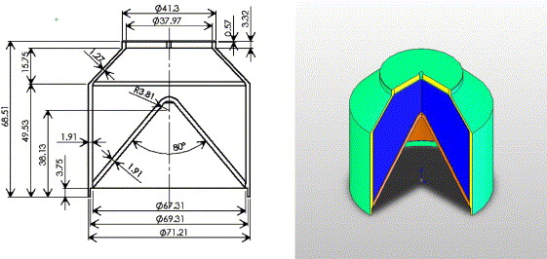
Figure 1 - Design used in simulations
A sketch was drawn in the program representing half of the diagram in figure 1. This was then converted to a part to be simulated.
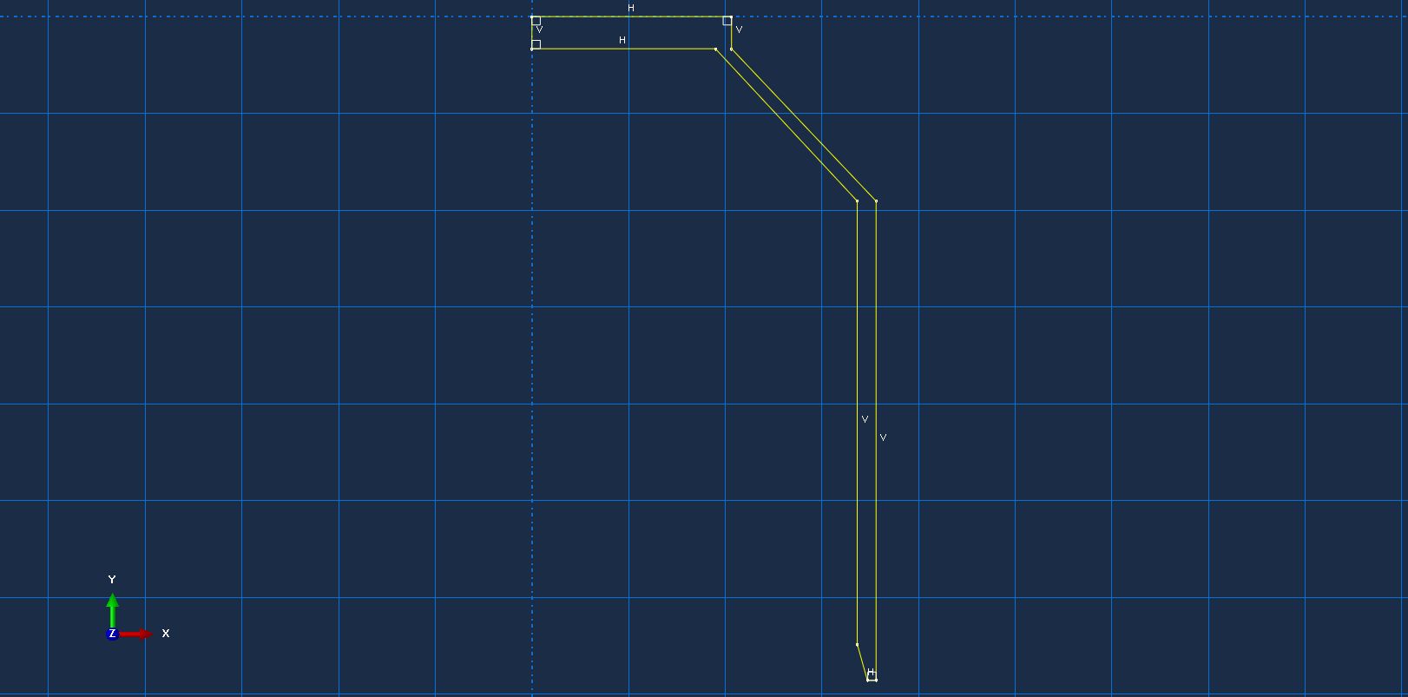
Figure 2 - Case Sketch

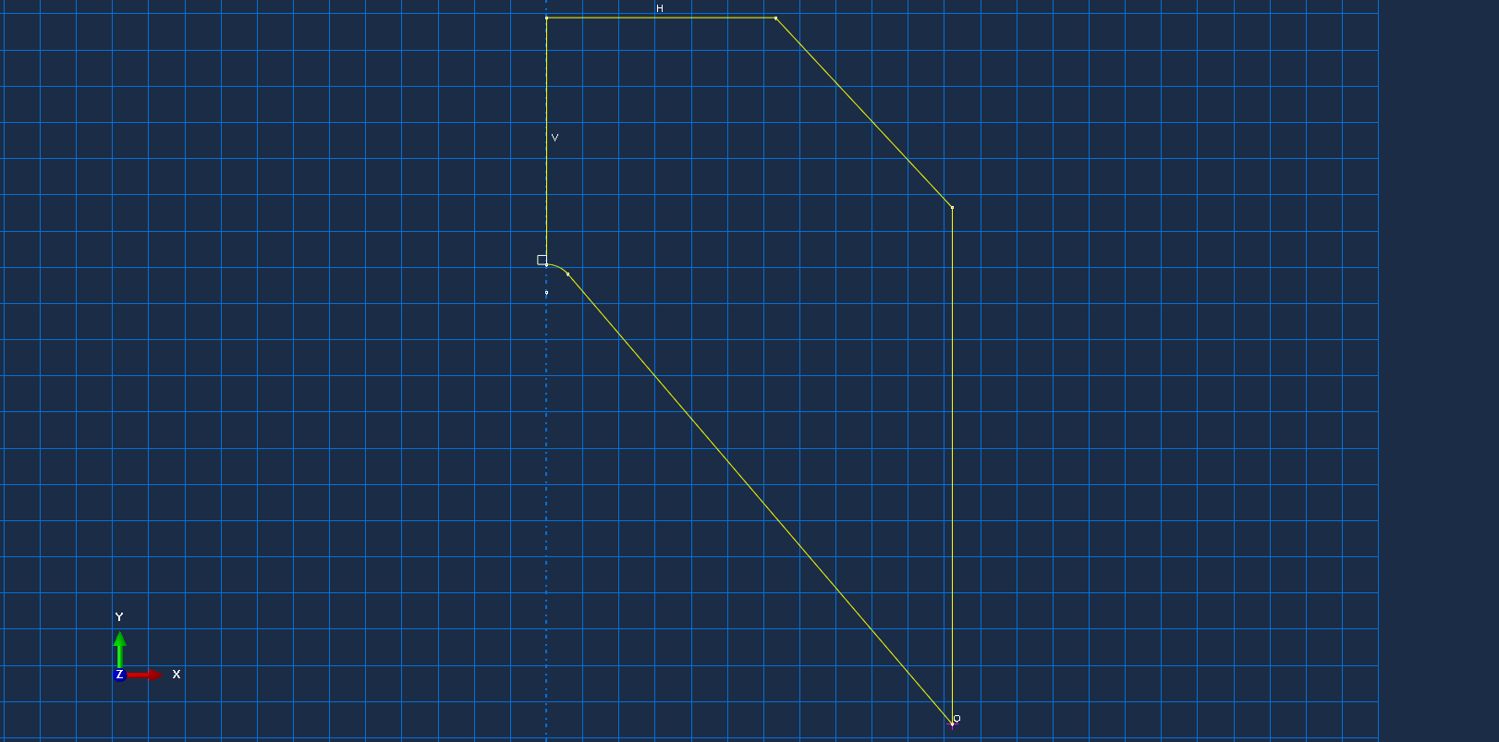
Figure 3 - Charge Sketch
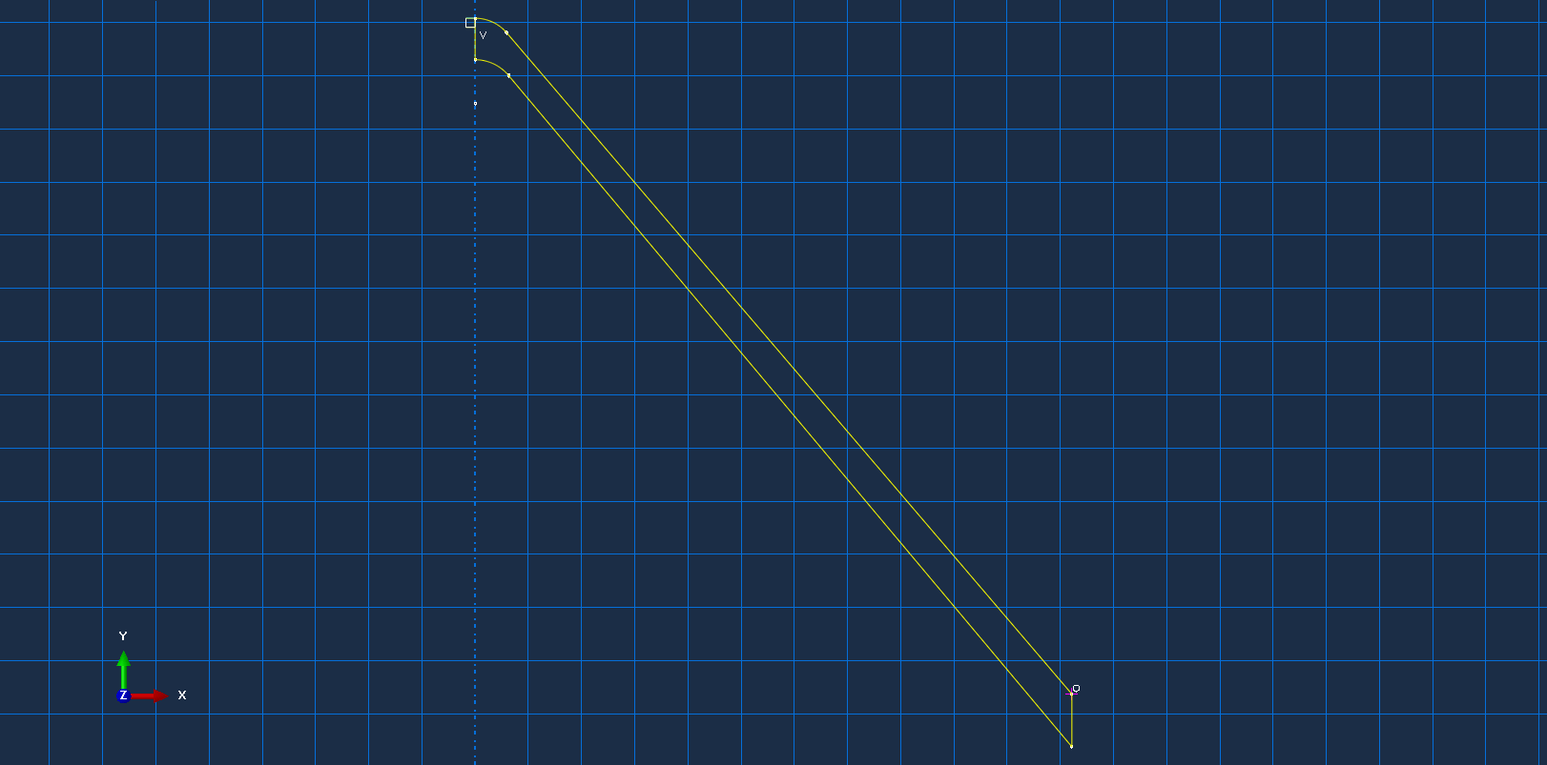
Figure 4 - Liner Sketch

2.3 Materials
The material properties for the 2D simulations were as follows: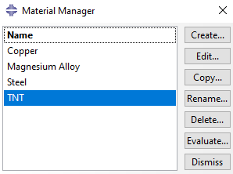
Figure 5 - List of materials used in simulation
All Materials were given densities and other basic parameters to allow them to interact with each other. Copper [8] was also modelled using the Johnson Cook (JC) [9] damage model to accurately simulate the deformation. Steel was not modelled using JC damage as it only needed to act as the case to prevent the detonation being uncontained. This saved the simulation from doing unnecessary work and delaying the final output. AZ31 Magnesium Alloy [10] was an alternative liner material used and was therefore fully modelled using JC damage.
Table 1 - Johnson Cook values [11]
Material | A  (MPa) | B  (MPa) | n | m | C | $ρ$  (kgm⁻³) | E (GPa) | v | $$θ_{transition}$$ | $$θ_{melt}$$
Copper | 250 | 250.4 | 0.81 | 0.73 | 0.0137 | 8913 | 117.2 | 0.33 | 22 | 1083
AZ31 Magnesium Alloy | 175.33 | 2332.23 | 0.205 | 1.849 | 0.014 | 1730 | 45 | 0.34 | 0 | 891

2.4 2D Assembly
These material properties were applied to the relevant 2D parts then they were arranged together. Contact between all parts was enabled.
All parts were meshed. The coarseness of the mesh was decided by the amount of movement that would be affecting the part. The mesh was created with as many nodes as the software allowed for the simulation to run.
Below are the final individual meshes for each part of the assembly. The case had a uniform mesh throughout; the charge had a slight gradient where the mesh got finer where it met the centre of the liner. The liner’s mesh had a gradient getting finer closer to the centre.
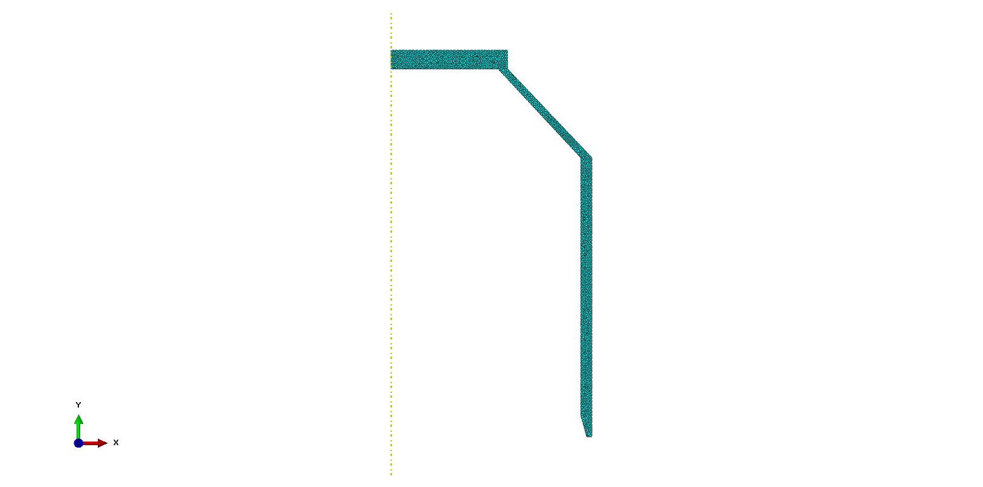
Figure 6 - Case mesh
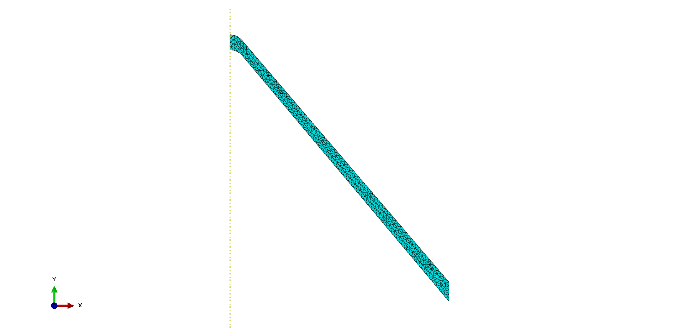
Figure 7 - Liner mesh
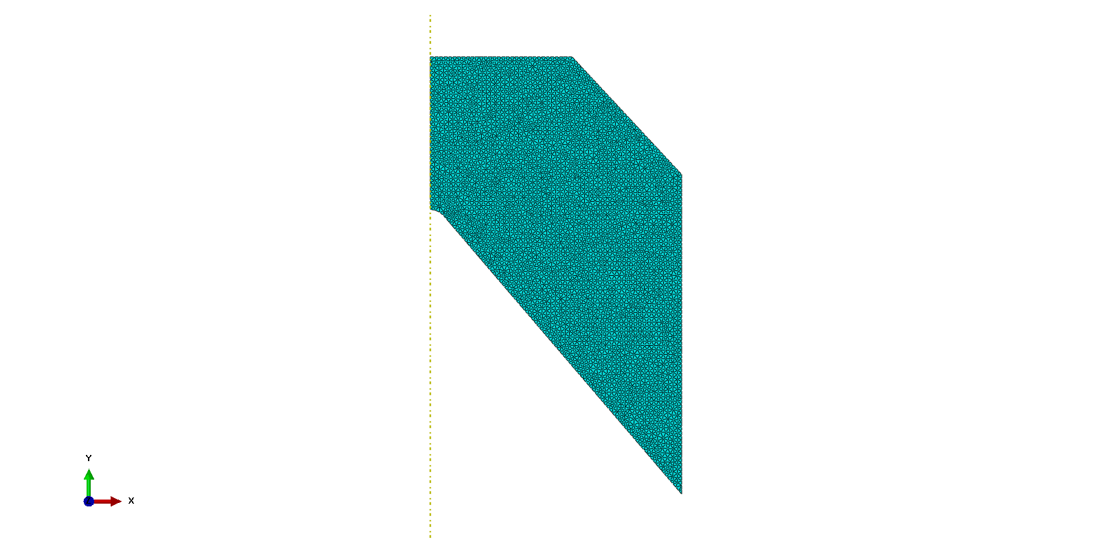
Figure 8 - Charge mesh

2.5 2D Simulation
Due to the method of only simulating half of the 2-dimensional shaped charge, the simulation was able to run more efficiently therefore reducing the time between iterations. Initially the simulation crashed due to inconsistent mesh sizes between the charge and the liner in the very centre. This was rectified by matching the mesh along this boarder.
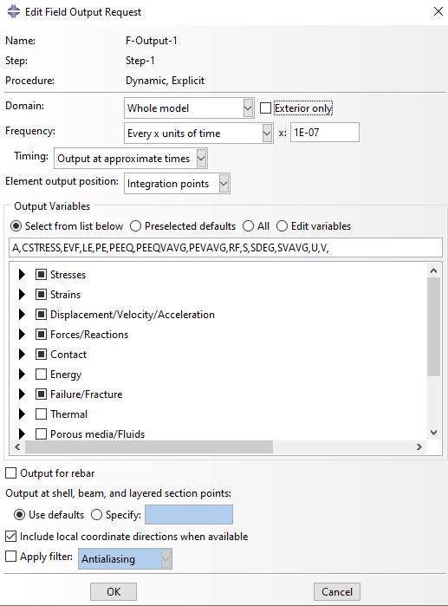
Figure 9 - Output settings for the simulation

2.6 2D Results
The results for each simulation were mirrored to give the illusion of a full 2-dimensional result. This reduced processing time by half and produced a picture identical to if the whole simulation had been completed. On the other hand, this required the creation of an impassable barrier vertically between the two halves. This prevented any material passing horizontally across even if it would have in a real scenario. It is unlikely that this skewed the result in any way but is a limitation of this simulation.

2.6.1 Copper
For the Copper liner the results are as follows:
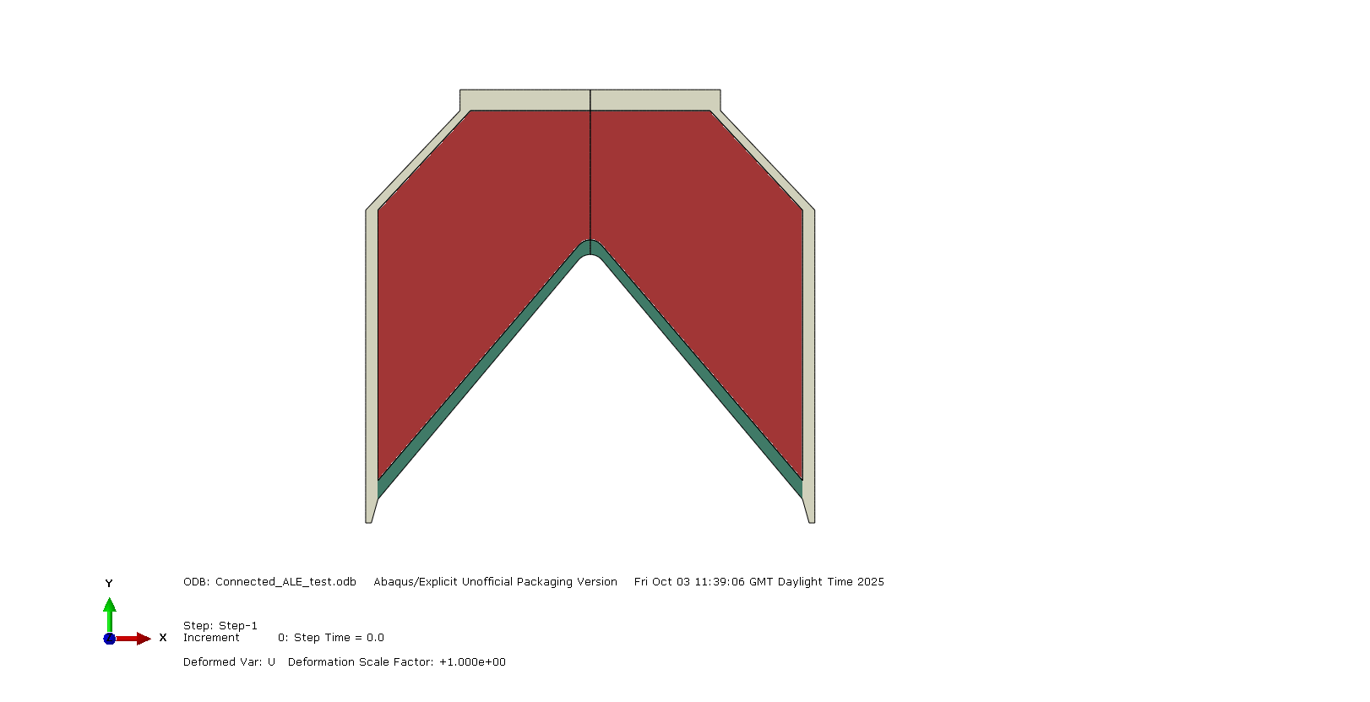
Figure 10 - Copper: Pre-detonation
This figure shows the arrangement of the assembly before the simulation begins.
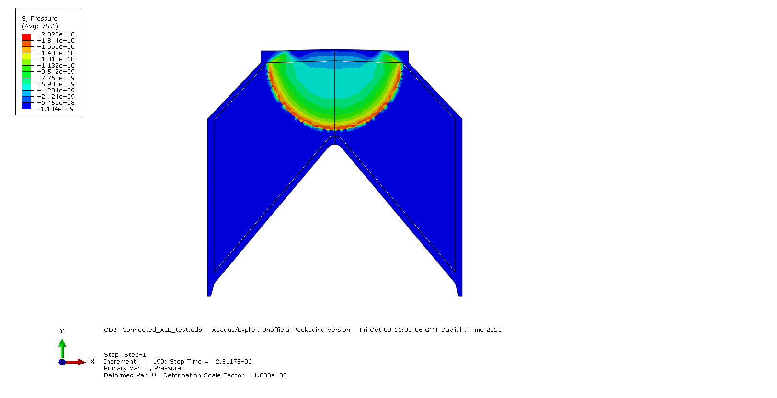
Figure 11 - Copper: Moment of detonation
This figure shows the moment the TNT detonates producing a detonation wave that propagates through the fill.
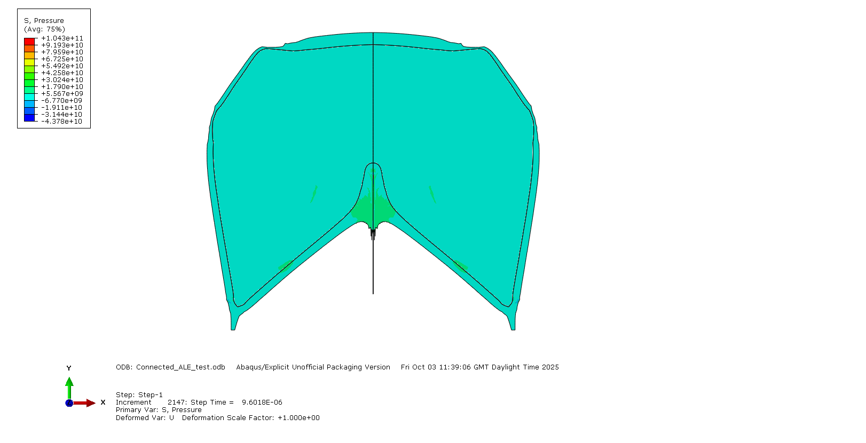
Figure 12 - Copper: During Detonation, Shockwave hits liner
This figure shows the detonation wave colliding with the case and liner and instantly distorting both. As the liner is compressed into the centre a jet begins to form.

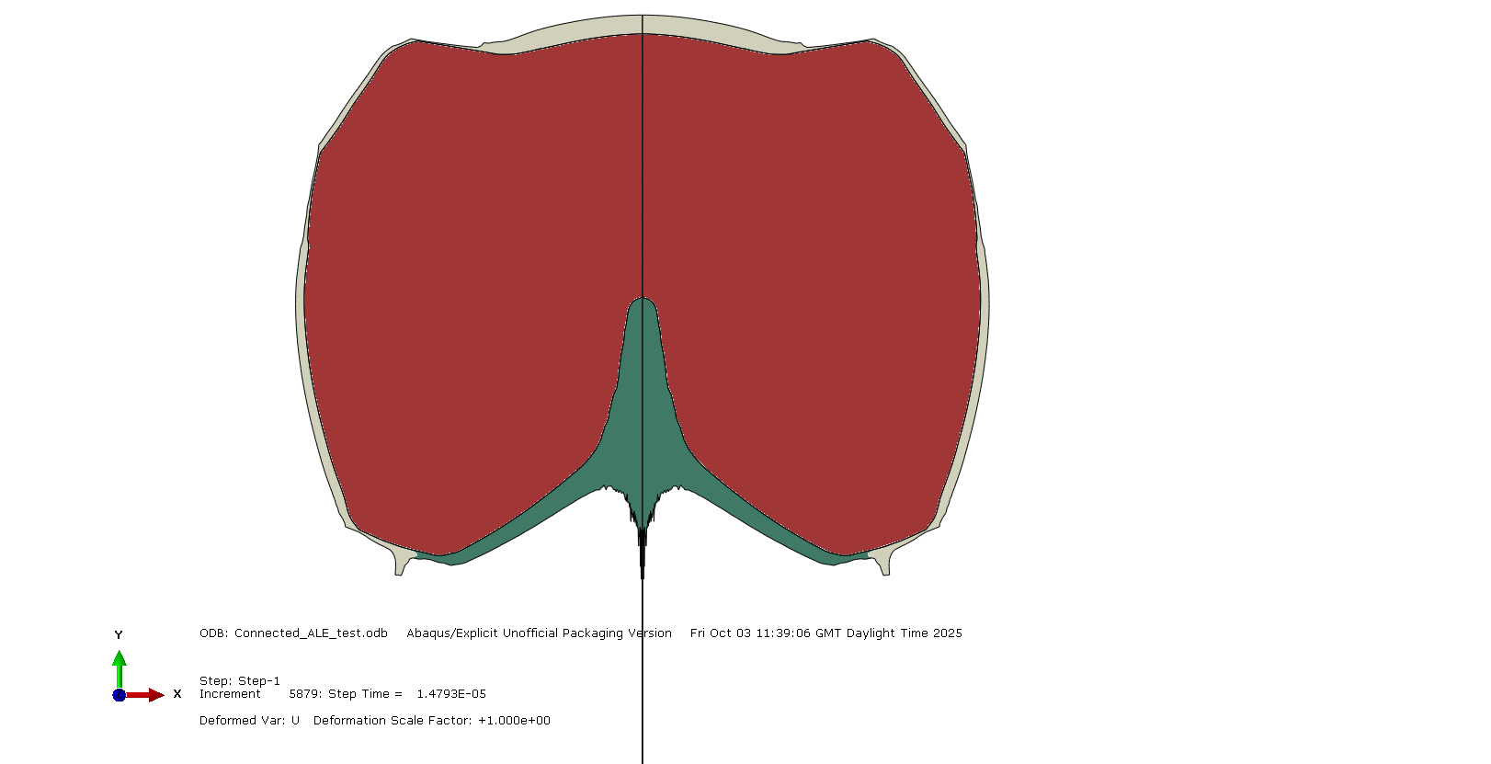
Figure 13 – Copper: Post detonation, Jet formed
This figure shows the moment before the simulation crashes due to over distorted parts.
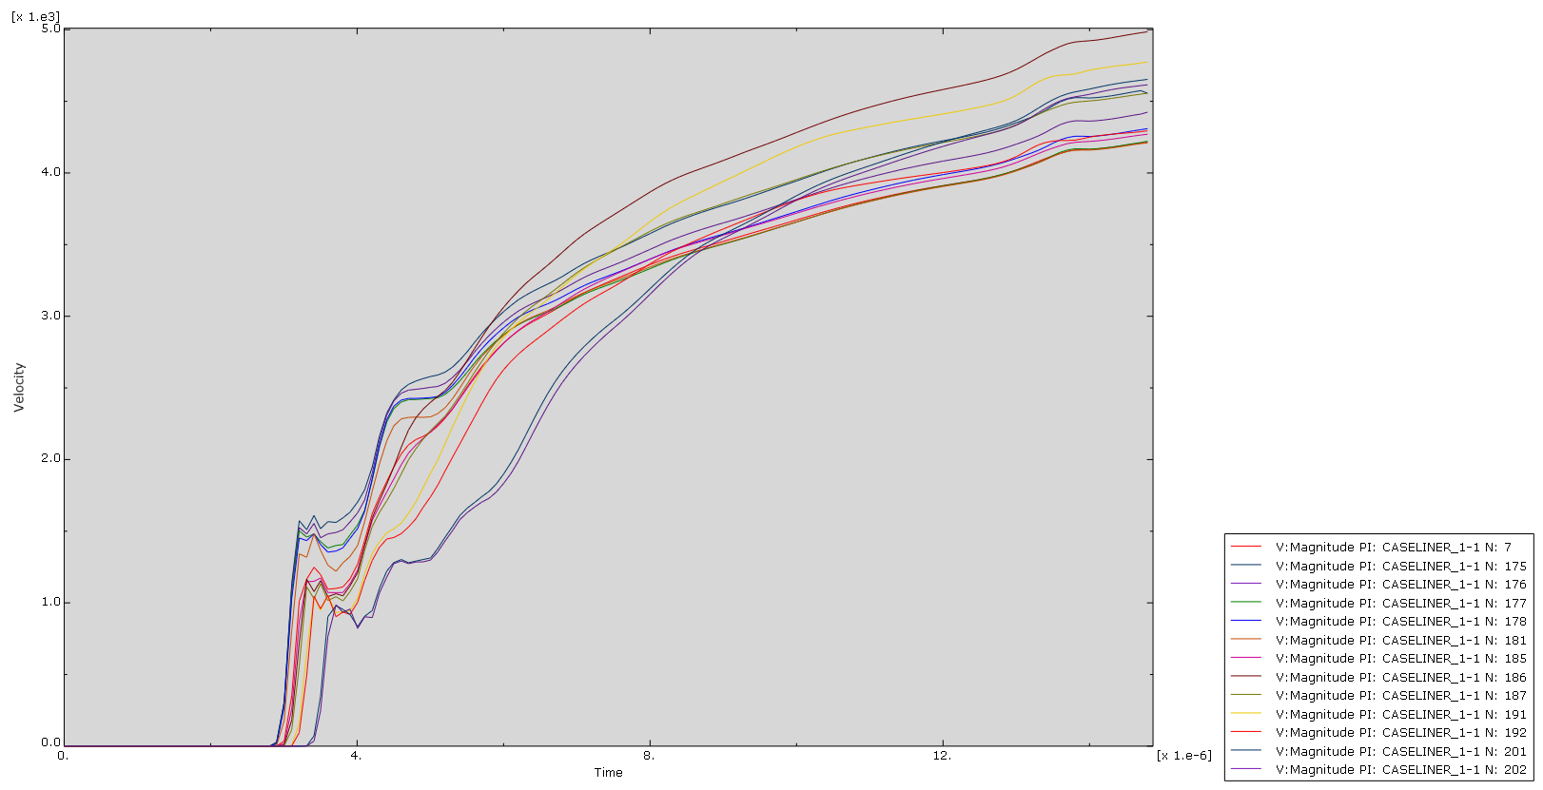
Figure 14 – Copper: Graph of jet velocity
The graph shows the magnitude of the velocity of a selection of nodes from the liner. These nodes make up the tip of the jet which, in a real shaped charge, travel the fastest. The graph here shows they reach speeds of around 4-5 kilometres per second. This is far below the expected maximum, and it therefore can be assumed that the jet did not have sufficient time to form completely before the simulation failed.

2.6.2 AZ31 Magnesium Alloy
All aspects of the simulation remained identical except for the material properties of the liner being switched to represent AZ31 magnesium alloy instead of copper. Both are utilized in real world situations for different purposes.

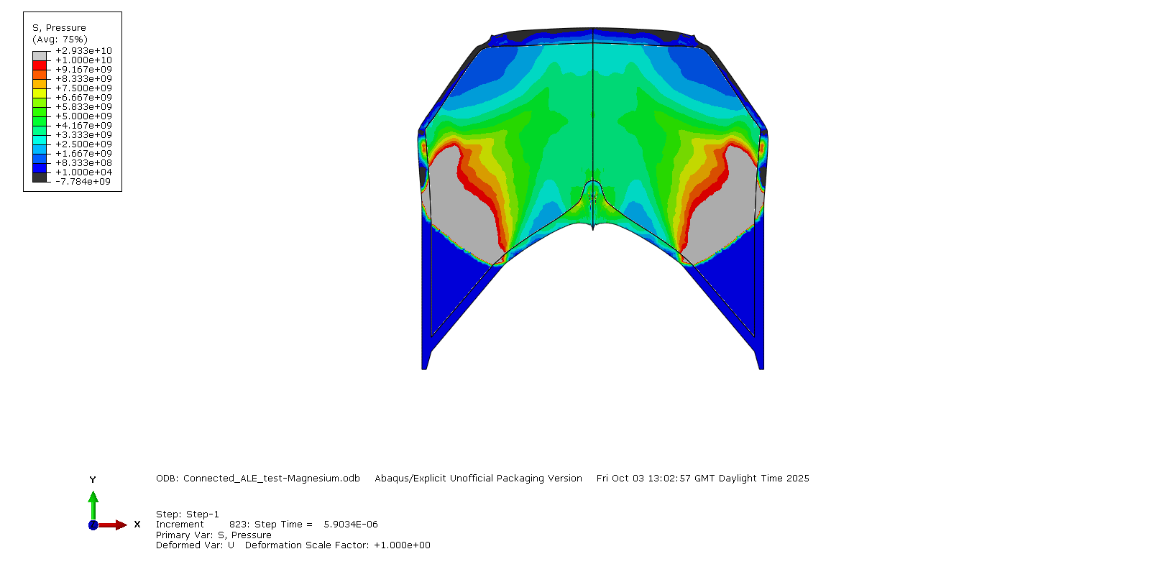
Figure 15 - Magnesium: Detonation
Figure 11 shows the moment the detonation wave reaches the liner and case. Unlike the copper liner simulation, the jet is not instantly formed unlike with the copper liner simulation from before.

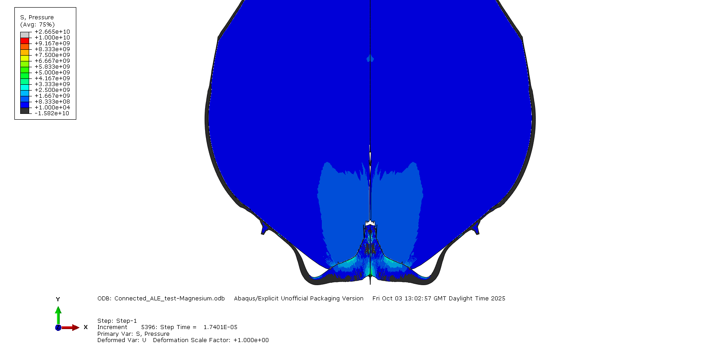
Figure 16 - Magnesium: Jet Forming
Figure 12 shows the liner being far more malleable than the copper liner. Rather than instantly being displaced and acting as a liquid, the magnesium liner contorts in an unexpected way.

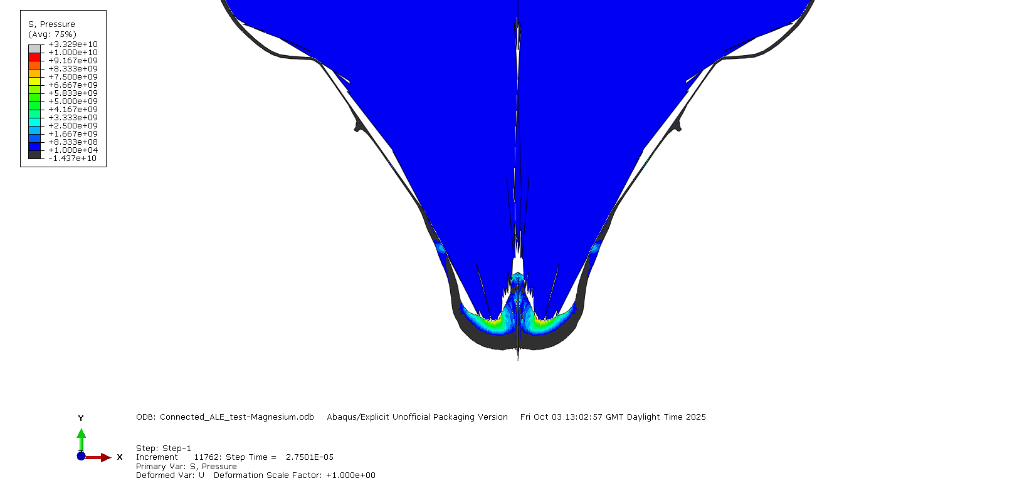
Figure 17 - Magnesium: End of Simulation
The figure shows the mass of magnesium remaining in its shape rather than forming a conventional jet. It is possible that the simulation was not able to run for long enough and the jet could not properly form however the velocities of the nodes within the mass suggest it would not elongate.
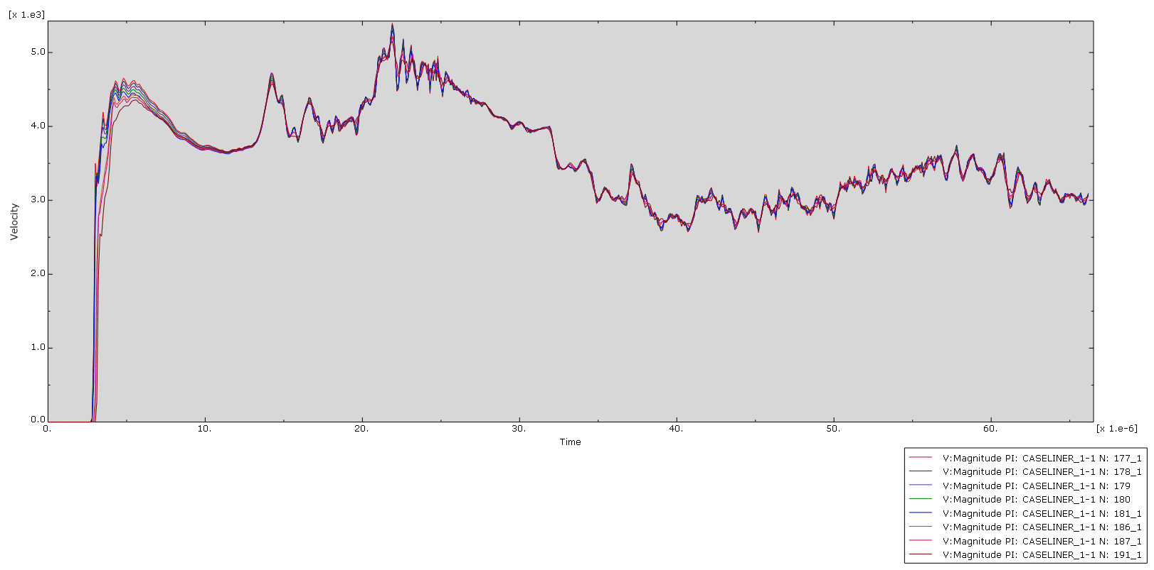
Figure 18 Magnesium: Velocity Graph
The graph shows the velocity for a group of nodes selected from the front of the jet produced by the liner. Worth noting with this simulation is that the majority of the jet remained the same velocity which is more consistent with an explosively formed projectile. This was not the expected effect of a magnesium liner. Instead, the expected result would be for the jet to remain the same shape but for the velocity to be much higher due to the lower density of magnesium.

2.6.3 Conclusion
While the simulations may have been flawed due to inaccurate data entry or poor mesh rules and assembly, the results seem to show that both jets formed were travelling at comparable speeds. This goes against the expectations for magnesium to travel faster than copper due to the same detonation energy propelling a less dense material. Secondly, the magnesium did not form a coherent jet and instead bunched up into a mass that travelled forward uniformly. There is not enough data to suggest if this is characteristic of magnesium shaped charges or if it is a fault in the simulation.

2.7 2D Adaptive Remeshing
Once the initial results had been recorded, the settings of the simulation were changed to adaptively re-mesh the simulation every other step. This should have improved the smoothness of the simulation and reduced the amount of overly distorted shapes. Unfortunately, this seemed to make no improvements at all for either the copper or magnesium simulations.

2.8 3D Meshing
The 3-dimensional simulation was created using the same sketch as the 2-dimensional was. The only difference was revolving the part 180° to create half the 3-dimensional shaped charge.
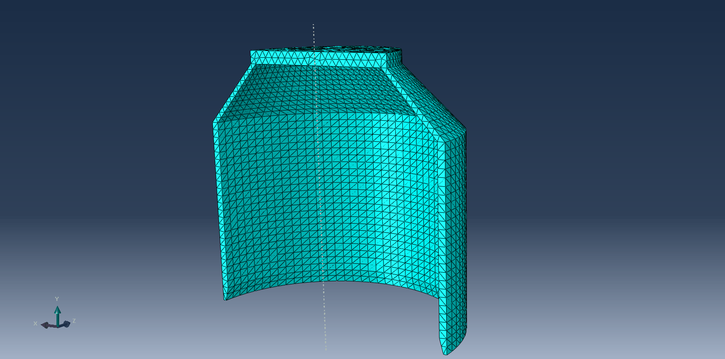
Figure 19 - 3D Case Mesh
The mesh for the 3D case was uniform throughout and matched the charge mesh along its boarder.
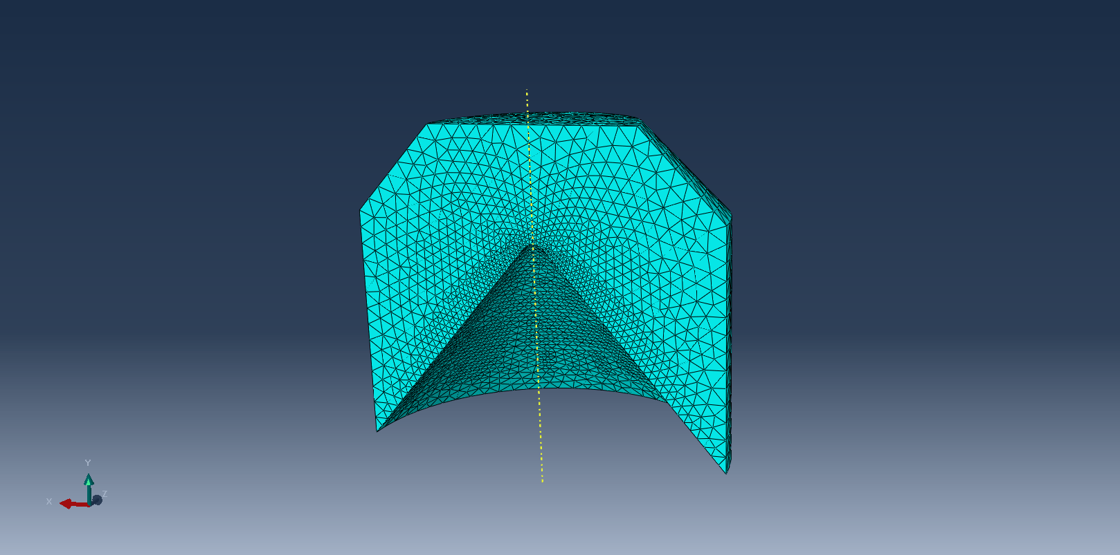
Figure 20 - 3D Charge Mesh
The charge mesh was graduated to the centre where the most movement and distortion would take place. The mesh matched the liner along its boarder.
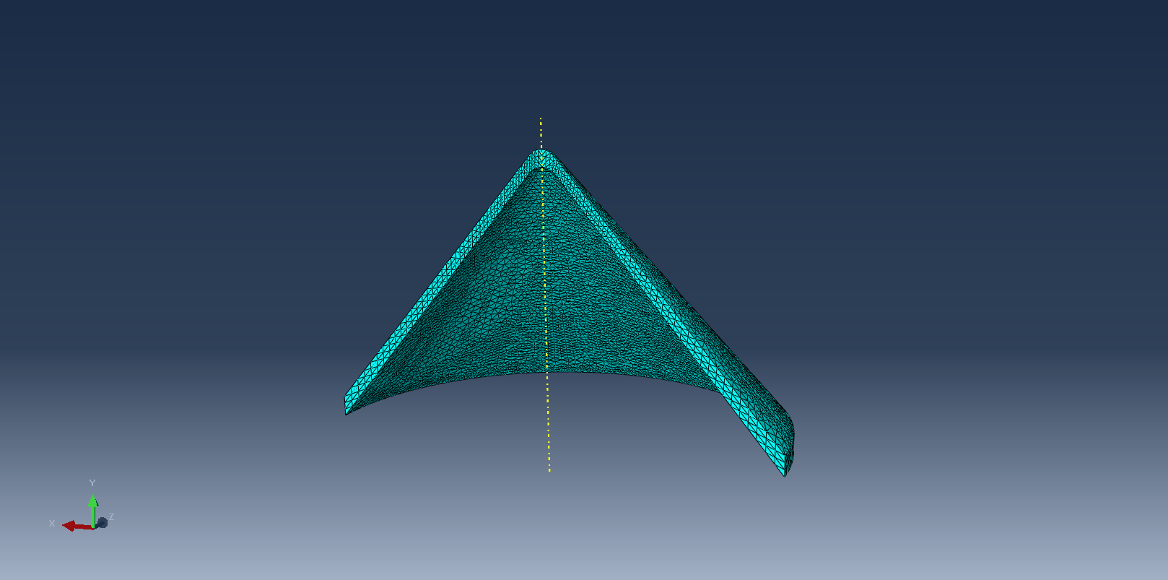
Figure 21 - 3D Liner Mesh
The liner mesh was much finer than the case because it was necessary to accurately simulate the deformation into a jet.

2.9 3D Simulation
The simulation was far slower to run than the 2-dimensional version due to the number of nodes being utilized in various directions. The simulation was set to calculate the positions of everything in steps of 1e-7 seconds.

2.10 3D Results
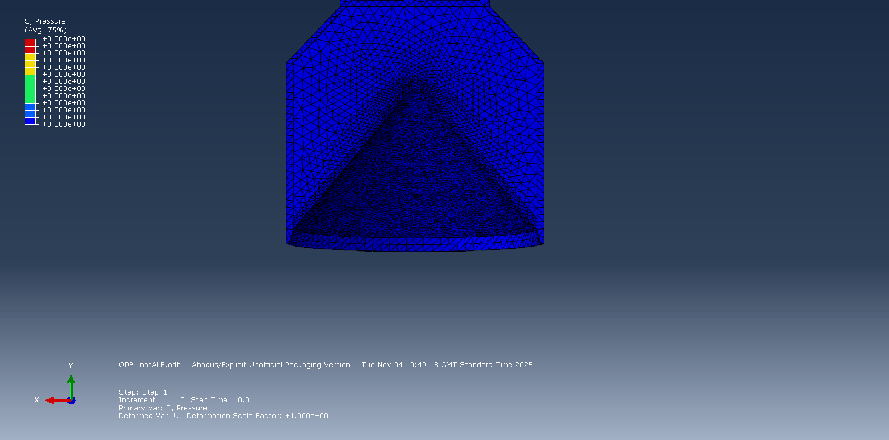
Figure 22 - 3D: Pressure, Pre-detonation
Figure 18 shows the 3-dimensional model the moment before the charge detonates. All the pressure is shown as being 0 Pascals.

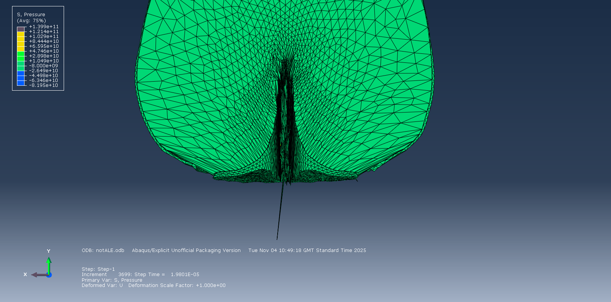
Figure 23 - 3D: Pressure, Mid-detonation
Figure 19 shows the pressure during the detonation. There are a few overly distorted elements from the charge which should not be mistaken for a jet forming from the liner.

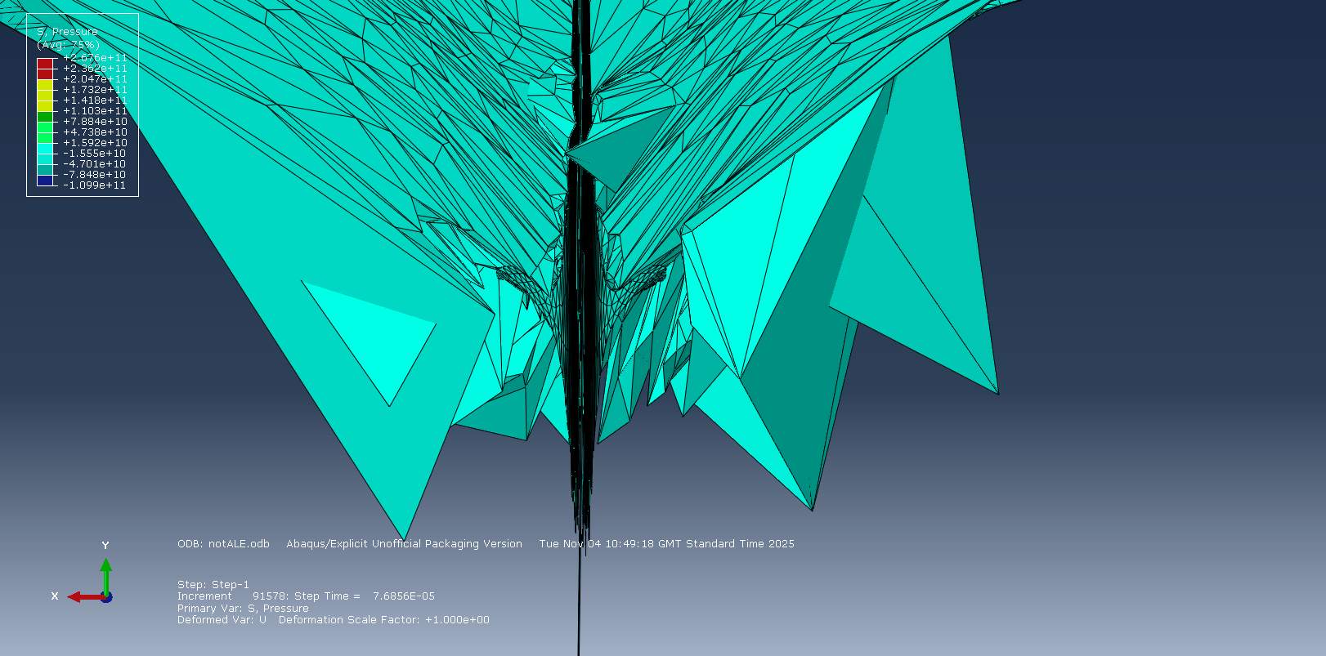
Figure 24 - 3D: Pressure, Post-detonation
Figure 20 shows the moment the simulation crashes due to overly distorted elements. This is because of the immense forces expanding due to the detonation and the simulation having no means to expand other than enlarging the elements. However, a jet formed from the liner can be clearly seen and follows the expected shape.

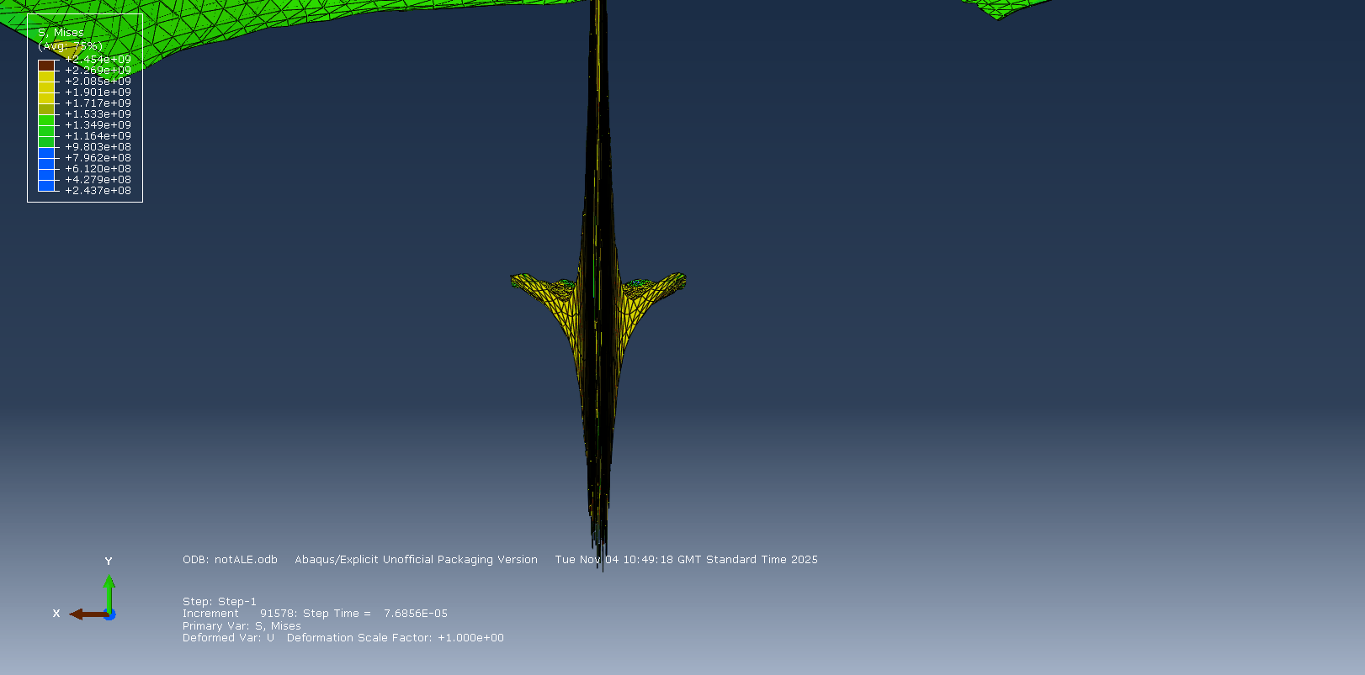
Figure 25 - 3D: Pressure, Isolated Jet
Figure 21 shows the jet formed from the copper liner without the mesh of the charge covering it.

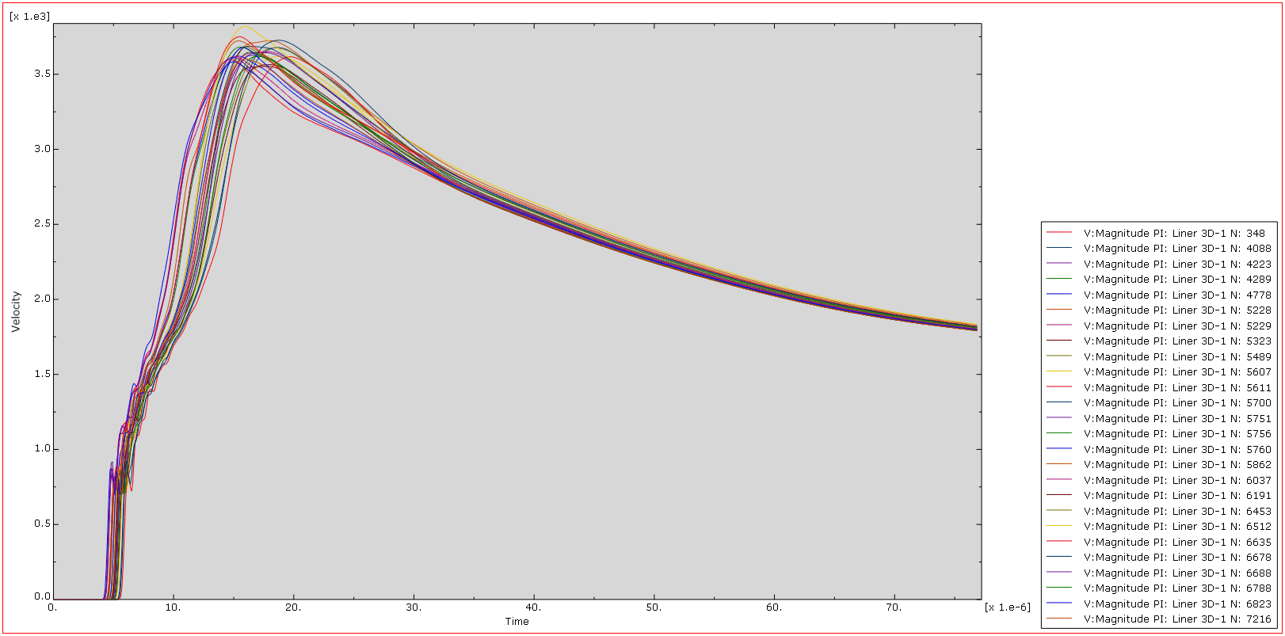
Figure 26 - 3D: Graph showing velocity of jet
Figure 22 shows the magnitude of the velocity of a selection of nodes at the front of the jet. These nodes average about 3.5 kilometres per second at their peak before they begin to diminish in speed. This is far below expected velocities and is likely due to an incomplete simulation allowing for materials to behave in ways they would not in a real-world situation.

2.11 3D SPH
Smooth Particle Hydrodynamics (SPH) is a method of treating each node as a single point for better simulation efficiency and better fluid simulation. To do this a new step was created just before the jet begins to form. This then switches the conventional mesh to become smooth particles which will not distort making it less likely for the simulation to encounter an error. Though this works well in certain scenarios, it did not function well in this simulation and drastically reduced the time it took for the simulation to crash.
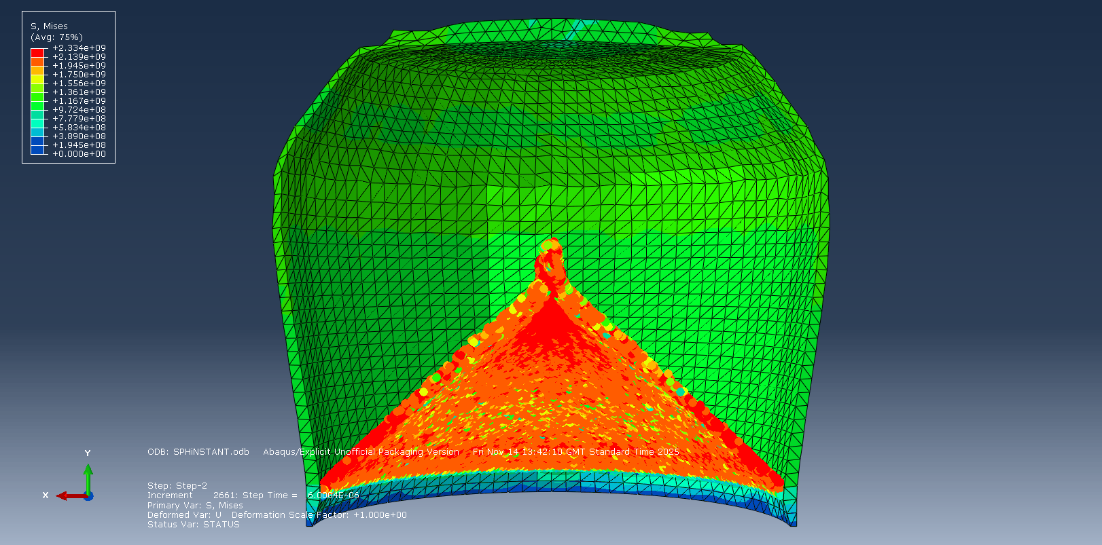
Figure 27 - Smoothed Particle Hydrodynamics

2.12 3D Adaptive Meshing
A method to improve the accuracy of the simulation is to enable adaptive meshing. This causes the simulation to pause at set increments and reapply the mesh therefore creating new nodes which will not be over distorted. This makes it less likely for a crash to occur. The remeshing should be set to only apply when necessary, otherwise the simulation time will take far longer.
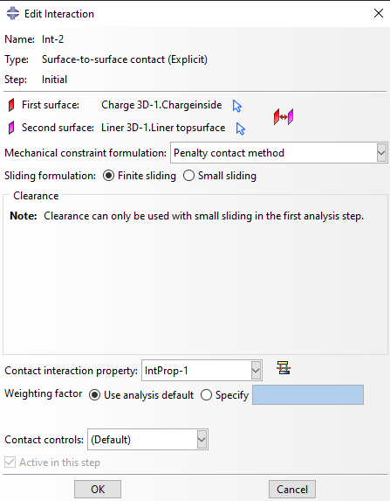
Figure 28 - Redefining boundaries
Figure 28 depicts redefining the contact between the parts to prevent them from phasing into each other. This makes the simulation more accurate and removes the issue from the earlier simulations with the charge overflowing through the case and liner.

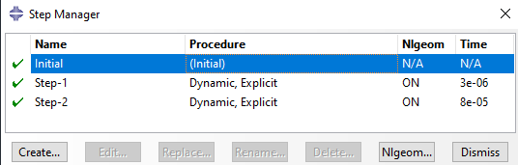
Figure 29 - Creating a new step
Figure 29 shows the process to define a new step to begin at the exact moment the jet begins to form, and it becomes advantageous to commit extra time and processing to remeshing.

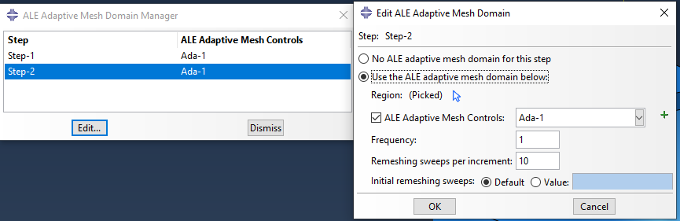
Figure 30 - Setting remeshing rules
Figure 30 shows the setting up of the remeshing rules. It gets applied to the liner only as that is the part which distorts the most during the simulation.

Unfortunately, the remeshing rule failed to function to any useful degree. The simulation crashed much sooner when utilizing the adaptive remeshing.

Conclusions
The simulations in 2D clearly show that the copper liner was more effective although this may be due to errors in putting the simulation together. The 3D simulation effectively showed the jet being formed by the copper liner but both 3D and 2D simulations lacked the expected velocities for the jets. This may be an error in the TNT parameters. Abaqus as a software struggles with simulations taking place as quickly as these did leading to many crashes throughout the process.

References

[1] | W. Walters, A Brief History of Shaped Charges vol. 1, New Orleans: Army Research Laboratory, 2008, pp. 22-.
[2] | D. R. Kennedy, History of the Shaped Charge Effect: The First 100 Years, Los Altos: Defense Technology Support Services, 1990.
[3] | Z. W. Y. W. C. D. a. Q. J. Z. Hao, “The effect of three-layer liner on the jet formation and penetration capability of shaped charge jet,” Scientific Reports, vol. 13, 2023.
[4] | D. C. P. a. W. M. Evans, Penetration by High-Velocity (`Munroe’) Jets: I, Proceedings of the Physical Society, 1951.
[5] | J. Y. X. Z. J. Y. a. X. L. Y. Wang, Study on jet dynamic impact performance under the influence of standoff, Scientific Reports , 2024.
[6] | C. F. J. D. A. W. J. L. D. M. Sterbentz, “Linear shaped-charge jet optimization using machine learning methods,” Journal of Applied Physics, 2023.
[7] | O. Ayisit, “The influence of asymmetries in shaped charge performance,” International Journal of Impact Engineering, vol. 35, no. 12, 2008.
[8] | A. Catovic, “View of An overview of Gurney method for estimating the initial velocities of fragments for high explosive munition,” DSS, vol. 1, 2020.
[9] | M. H. a. M. G. Vigil, “Design, analyses, and field test of a 0.7m conical shaped charge,” International Journal of Impact Engineering, vol. 32, no. 8, p. 1201–1213, 2006.
[10] | E. R. O. C. I. M. E. L. N. a. C. B. D. M. Iordache, “etermination of Johnson-Cook material constants for Copper using traction tests and inverse identification,” IOP Conference Series Materials Science and Engineering, vol. 1182, 2021.
[11] | V. Y. G. V. Kumar Reddy Sirigiri, “A review on Johnson Cook material model,” Materials Today: Proceedings, vol. 62, 2022.
[12] | F. Zhang, “ The modified temperature term on Johnson-Cook constitutive model of AZ31 magnesium alloy with {0002} texture,” Journal of Magnesium and Alloys, vol. 8, 2020.
[13] | M. M. A. I. A. M. A. H. M. N. a. A. A. M. S. Zakaria, “Finite Element Modelling of Serrated Chip Formation During Turning AZ31 Magnesium Alloy,” Journal of Physics: Conference Series, vol. 2643, 2023.

