

MODULE CODE: Digital Skills for Personal Development and Business Growth BMSW4008

ASSESSMENT COMPONENT: PORTFOLIO

STUDENT NAME: Elleesha Jade Lewis

STUDENT NUMBER: 2528501

LECTURER: Phillippa Fitzgerald

DATE: 16.03.2026
Contents
Task 1 3
Assessment of Digital Skills 3
References 3
Task 2 4
LinkedIn Learning Certificates for Office365 4
Task 3 5
Essay on Relevance of Excel in professional and personal life. 5
References 5
Task 4 6
7 Minute Reflective Presentation 6
References 6

Task 1

Assessment of Digital Skills
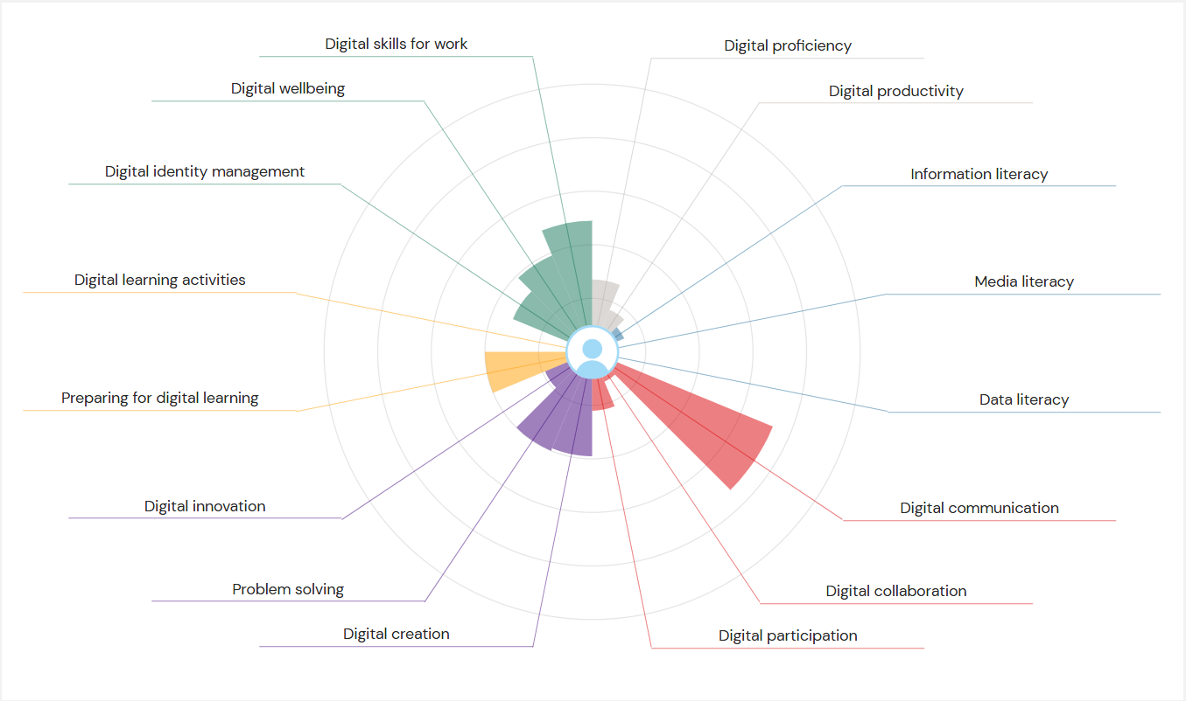
Digital skills are really important in both education and the workplace, as most learning activities and professional tasks now rely on the heavily technology. At the university, students are expected to use the digital learning platforms, complete online research, communicate through digital tools, and manage information responsibly. In the workplace, digital skills are essential for communication, organisation, collaboration, and career progression. For this reason, understanding my own digital strengths and weaknesses is important in helping me improve my academic performance and prepare for my future career.
To assess my digital capabilities, I completed the JISC Digital Capability Tool using my university email address. This self-assessment provided an overview of my confidence across a range of digital skill areas, including communication, learning, information use, and employability. The results gave me a more clearer understanding of where my strengths lie and which areas require more improvement. Reflecting on these results has helped me consider how I can use the recommended tools from the JISC report to further develop my digital skills.The JISC report highlighted my two main strengths: Digital Communication and Digital Skills for Work. Digital communication refers to the ability to communicate effectively using digital media and the online networks. This is one of my strongest points, as I am confident using my emails, messaging platforms, and virtual meeting tools to communicate clearly and more professionally. I am comfortable enough to responding to messages promptly, and sharing any information that’s required. These skills are important in both the academic and professional environment, as they allow me to stay connected with others and work efficiently in digital spaces.Another strength identified in my report is Digital Skills for Work, which focuses on the digital abilities needed to succeed in a workplace. This includes using workplace software, adapting to new digital systems, and maintaining a professional online presence. Having confidence in this area is important for my future career, as strong digital skills will help me work productively, communicate effectively, and manage tasks efficiently in a professional environment. These skills are particularly valuable for my long-term goal of working independently, where organisation and communication are essential.To build on these strengths, my next steps will be to continue improving my digital skills by learning how to use the workplace software and online collaboration tools more effectively. I will focus on developing my confidence with tools used for communication, file sharing, and virtual meetings. I will also continue to practise clear and professional digital communication by responding promptly to messages and actively contributing during online meetings. Strengthening these skills further will help me remain organised, productive, and connected in both academic and professional settings.
However, the JISC report also identified two areas where improvement is needed: Information Literacy and Media Literacy. Information literacy involves the ability to find, evaluate, and use reliable academic sources. I currently find this challenging, particularly when identifying credible academic materials for university assignments. This can affect the quality of my research and make it harder to support my work with strong and reliable evidence.Media literacy was also highlighted as my weakness. Media literacy refers to the ability to critically analyse media content, including identifying bias, misinformation, and unreliable sources. I sometimes find it difficult to recognise bias in news articles and social media content, which is an important skill in a digital environment where information can be misleading or inaccurate.To improve my information literacy, I plan to make better use of reliable academic sources such as Google Scholar and the university’s online library databases when completing assignments. I will also focus on evaluating sources more carefully by checking the author, publication date, and credibility of the publisher. These steps will help improve the quality of my research and strengthen my academic work.
To develop my media literacy, I will begin analysing news and social media content more critically by questioning who created the content, why it was created, and whether it may contain bias. I will also verify information using trusted and reputable sources before accepting it as accurate. Improving this skill will help develop my critical thinking and allow me to engage more responsibly with digital media during my studies.In conclusion, completing the JISC Digital Capability Tool has helped me gain a more clearer understanding of my digital strengths and weaknesses. By building on my strengths in digital communication and digital skills for work, and by using the recommended tools from the report to improve my information and media literacy, I will be able to develop stronger and more balanced digital skills. These improvements will support my learning at university and help prepare me for my future career

References
Beetham, H. (2019) Digital literacy in higher education. London: Jisc.
Jisc (2023) “Building digital capabilities”. Available at: https://www.jisc.ac.uk/digital-capabilities (Accessed: 18 January 2026).
Livingstone, S. (2018) “Media literacy and the challenge of fake news”. London: London School of Economics. Available at: https://www.lse.ac.uk/media-and-communications (Accessed: 18 January 2026).
Redecker, C. (2017) European framework for the digital competence of educators (DigCompEdu). Luxembourg: Publications Office of the European Union.
Selwyn, N. (2016) Education and technology: Key issues and debates. London: Bloomsbury.

Task 2

LinkedIn Learning Certificates for Office365
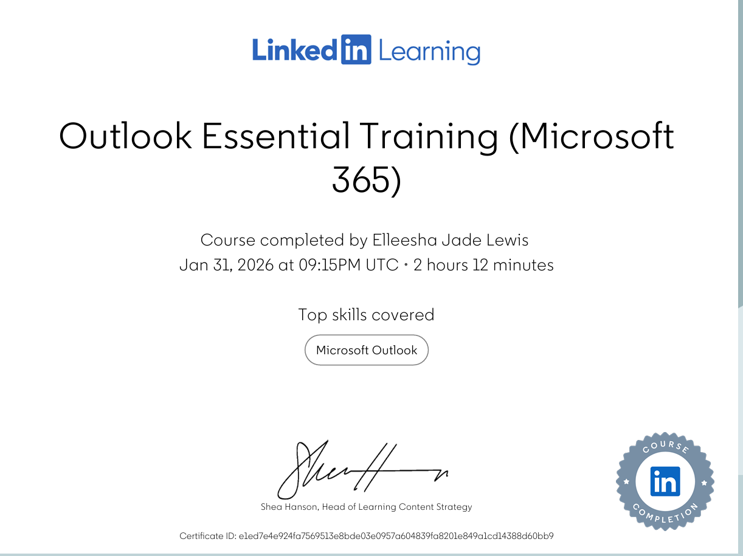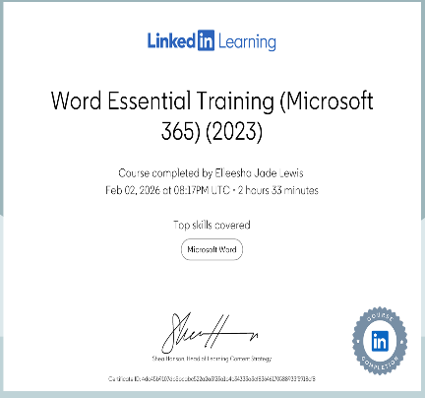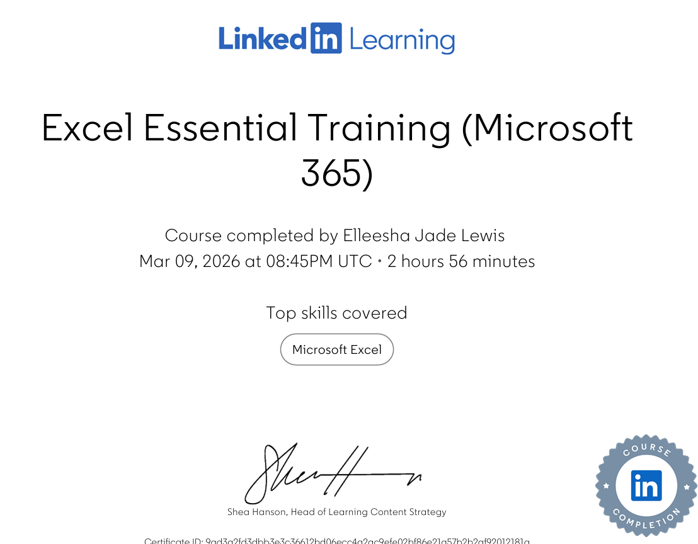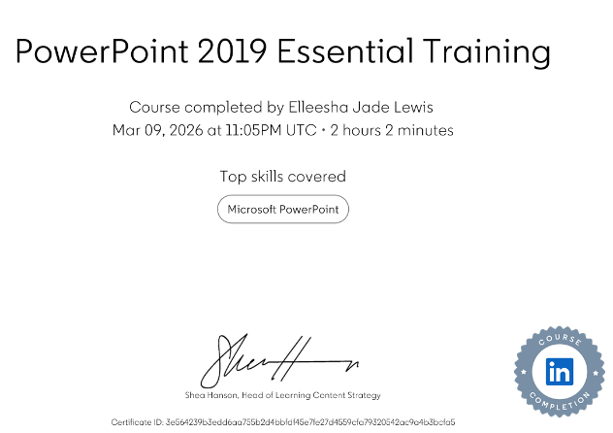

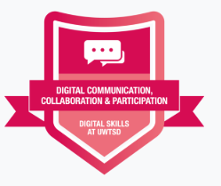

Task 3

Essay on Relevance of Excel in professional and personal life.

The Relevance of Microsoft Excel in Professional and Personal Life
Microsoft Excel is one of the most widely used spreadsheet applications in both the professional and personal environments. As part of the Microsoft Office 365 suite, Excel allows users to organise, analyse and present data efficiently. In modern workplaces and in the everyday life, the ability to manage information and interpret data is an essential digital skill. Excel provides tools that allow individuals and organisations to perform the calculations, manage financial information and visualise data through charts and tables. Because businesses and individuals increasingly rely on data to support decision making. Excel continues to play a really important role in both the professional and personal contexts.
In professional environments, Excel is widely used for managing and analysing data. Many organizations use the spreadsheets to record any financial transactions, monitor business performance and produce the reports. Excel enables users to store large amounts of information in structured tables, which makes it easier to analyse trends and identify patterns. Tools such as formulas, pivot tables and charts allow organisations to interpret complex data quickly and accurately. According to Kaplan (2024), Excel remains a highly relevant tool in the modern workplaces because it helps the organisations improve efficiency and to make a better decisions using data.
Another important advantage of Excel in professional settings is its ability to automate calculations. Functions such as SUM, AVERAGE and IF. It allow users to perform calculations instantly. This saves time and reduces the risk of human error when working with large datasets. Many businesses rely on these functions to analyse sales performance, monitor expenses and evaluate financial outcomes. As highlighted by School of Coding UK (2024), spreadsheet tools are essential in many industries because they allow the organisations to organise and analyse data more effectively.
Excel is also strongly connected to digital skills and employability. In the United Kingdom, the Essential Digital Skills Framework highlights the importance of digital competence for employment. The framework identifies the ability to handle information and use spreadsheets as an important workplace skill (Department for Education, 2019). Employers often expect employees to have a basic understanding of the Excel because it demonstrates the ability to work with data and perform analytical tasks. High Speed Training (2022) suggests that strong Excel skills can significantly improve employability because many roles require employees to analyse and present information using spreadsheets.
While Excel is widely used in professional environments, it is also valuable in personal life. Individuals frequently use spreadsheets to organise information, manage their budgets and track their personal goals. One of the most common uses of Excel in everyday life is financial budgeting. By recording income and expenses in a spreadsheet, individuals could gain a better understanding of their financial situation. This allows them to identify spending patterns and make informed decisions about saving or reducing any costs.
Excel can also be used for organising personal activities and projects. Students may use the spreadsheets to track their coursework deadlines, plan revision schedules or monitor academic progress. Similarly, individuals may use Excel to organise their travel plans, track fitness goals or manage the household inventories. Because spreadsheets allow users to structure information clearly and perform automatic calculations, they provide a practical tool for improving productivity in everyday life.
Another key feature of Excel is the ability it has to support data analysis and visualisation. Charts and graphs allow numerical data to be presented in a visual format that is easier to understand. This is particularly useful when presenting information to others, as visual representations make it easier to identify trends and patterns. ExperTrain (2026) explains that Excel continues to be a valuable tool for analysing and presenting data in many organisations. By transforming raw data into visual insights, Excel supports better communication and decision making.
A practical example of Excel in personal life is the creation of a household budget spreadsheet for a family of four. This spreadsheet records monthly income and expenses to help the family understand their financial position. Income sources may include wages, benefits and additional payments. Excel formulas can then calculate the total income using the SUM function. Household expenses such as rent, utilities, food and transportation can also be recorded and calculated automatically. By subtracting total expenses from total income, the spreadsheet can show the remaining monthly balance.
This type of spreadsheet allows families to understand where their money is being spent and identify opportunities to reduce unnecessary expenses. Charts can also be created to show how different spending categories contribute to overall costs. Visualising financial data in this way makes it easier to manage budgets and plan future spending.
In conclusion, Microsoft Excel is an essential digital tool that supports both professional and personal activities. In professional environments, Excel helps organisations manage data, analyse the financial information and produce the reports. Its ability to automate calculations and visualise information improves efficiency and supports informed decision‑making. In personal life, Excel can be used to manage budgets, organise tasks and track progress towards any goals. The household budget example demonstrates how spreadsheets can help individuals manage their finances more effectively.

Embed your excel here

References
Department for Education (2019) Essential digital skills framework. Available at: https://www.gov.uk/government/publications/essential-digital-skills-framework (Accessed: 4 March 2026).
ExperTrain (2026) The most valuable Microsoft Office skills for jobs in 2026. Available at: https://www.expertrain.co.uk/post/the-most-valuable-microsoft-office-skills-for-jobs-in-2026 (Accessed: 5 March 2026).
Government Analysis Function (2022) Analysis of data. Available at: https://www.gov.uk/government/publications/ges-technical-framework-2022/2-analysis-of-data (Accessed: 1 March 2026).
High Speed Training (2022) What Excel skills are employers looking for? Available at: https://www.highspeedtraining.co.uk/hub/what-excel-skills-are-employers-looking-for/ (Accessed: 2 March 2026).
Kaplan (2024) Is Microsoft Excel still relevant? Available at: https://kaplan.co.uk/blog/features/is-microsoft-excel-still-relevant (Accessed: 28 February 2026).
School of Coding UK (2024) Importance of Microsoft Excel in business. Available at: https://schoolofcodinguk.com/blog/importance-of-microsoft-excel-in-business/ (Accessed: 3 March 2026).
Skills for Careers (2025) Essential digital skills for work. Available at: https://www.skillsforcareers.education.gov.uk/pages/skills-for-life/digital-skills/essential-digital-skills-for-work (Accessed: 6 March 2026).
Virtual College (2025) Benefits of Microsoft Office training. Available at: https://www.virtual-college.co.uk/resources/what-are-the-benefits-of-microsoft-office-training (Accessed: 7 March 2026).

Task 4

7 Minute Reflective Presentation
Embed PowerPoint here

