
UWTSD
Electronic System Design

ACDA6002

14 Day Weather and Air quality measurement and logging system
Adam Spanswick
11-28-2022

Contents
Table of Figures/content 3
1.0 Introduction 5
2. 0 Task 1 6
Automatic Weather Station- weather monitor system--JXCT 8
Weather Meter Kit -- 8
3.0 Task 2 10
3.1 Selecting Appropriate Microcontroller 10
3.2 What is a Microcontroller 10
3.3 What is a microcontroller used for? 12
3.4 Specification 13
3.5 Micro controller selection 14
4.0 Task 3 18
4.1 Proaim Mitchell Heavy-duty Camera Tripod Stand with Spreader 18
4.2 Suitable Package 22
4.3 Senor Current Rates 24
4.4 Battery Selection 25
336 26
2688 26
4.5(NON – Volatile) Memory 26
SUNLIGHT 27
UV 27
4.7 SD CARD SELECTION 28
4.8 Connectors selection 30
5.0 Sensor Selection 34
5.1 Temperature and Humidity 34
TE Connectivity Temperature & Humidity Sensor, Voltage Output, Through Hole Mount 34
Eliwell SH0NPM100I400 Humidity Probe, +60°C Max, 100%RH Max 34
5.2 Wind Speed / Direction 35
Meteo Anemometer for Wind Speed and Direction (meteoprobe) 35
Anemometer & wind direction [Pro-D] 35
5.3 Air borne particle count 36
Panasonic SN-GCJA5, Air Quality Sensor 36
Gravity: PM2.5 Air Quality Sensor 36
Honeywell HPMA115C0-004, Air Quality Sensor 36
5.4 Sunlight brightness 37
Grove - Sunlight Sensor 37
Outdoor stainless steel light sensor industrial RS485 light sensor light intensity meter detector 37
Outdoor light intensity sensor PHOTASGARD® AHKF-I 37
5.5 UV Levels Sensor 38
Adafruit SI1145 38
VEML6075 38
SENS-43UV 38
5.6 GPS Sensor 39
QK-AS07-0183 NMEA 0183 GPS 39
GPS ACTIVE ANTENNA RRPA-PB0-486392-1-G-001 39
Garmin 16x GPS Sensor 39
2614021137000 39
100Ma 39
-30 ~ +80˚C 39
5.7 VOC Level 40
Volatile Organic Compound (VOC) Sensor 40
Room air quality sensor (VOC) and measuring transducer AERASGARD® RLQ-W VA 40
Analox AX60CUQYXA Quick Connect AX60 Gas Monitoring System 40
PS1-VOC-1000 40
6.0 Task 4 41
6.1 Circuit Design 41
Proteus Overview Design 41
6.2 SD Card Proteus Design 42
6.3 Air Borne Particle Count Sensor Proteus Design 42
6.4 Battery Regulator Proteus Design 43
6.5 10 Second Flashing LED Proteus Design 43
6.6 GPS Proteus Design 44
6.7 PIC18F24K50 Proteus Design 44
6.8 Sunlight Brightness Sensor Proteus Design 45
6.9 Temperature/ Humidity Sensor Proteus Design 45
6.10 USB Proteus Design 46
6.11 UV Level Sensor Proteus 46
6.12 VOC Level Sensor Proteus Design 47
6.13 Wind Speed/ Direction Proteus Design 47
7.0 Easy PC 48
7.1 Air Borne Particle Count Sensor Easy PC Design 49
7.2 Battery Regulator Easy PC Design 49
7.3 GPS Easy PC Design 50
7.4 Temperature/ Humidity Sensor Easy PC Design 50
7.5 PIC18F24K50 Easy PC Design 51
7.6 SD Card Easy PC Design 52
7.7 Start Button/ Flashing 10 Second Led Easy PC Design 53
7.8 Sunlight Brightness Sensor Easy PC Design 53
7.9 USB Easy PC Design 54
7.10 UV Level Sensor Easy PC Design 54
7.11 VOC Level Sensor Easy PC Design 55
7.12 Wind Speed/ Direction Sensor Easy PC Design 55
8.0 PCB Design 56
8.1 PCB Design Check 57
9.0 Task 5 61
9.1 Structure Diagram Flow Chart 61
9.2 Software Diagram 62
10.0 Task 6 63
10.1 Prototype Build Costs 63
10.2 Costings 66
GUVA-S12SD 66
QK-AS07-0183 66
T-ION-TVOC 66
Sterling AMPS AL12300 LiFePO4 Lithium Battery 66
11.0 Task 7 Analysis 68
12.0 Sensor Data Sheets 69
12.1 Temperature and Humidity 69
12.2 Wind Speed / Direction 69
12.3 Air borne particle count 69
12.4 Sunlight brightness 69
12.5 UV Levels Sensor 69
12.6 GPS SENSOR 69
12.7 VOC SENSOR 69

Table of Figures/content

Table 1 Comparison Table of weather Stations 6
Table 2 Parts of a Microcontroller Consists 9
Table 3 Sensor Requirements 11
Table 4 Specification table for tripod 18
Table 5 Sensor Current Rating 22
Table 6 Non Volatile Memory 24
Table 7 Sensor Data Download 25
Table 8 Temperature and Humidity 32
Table 9 Wind Speed / Direction 33
Table 10 Air borne particle count 34
Table 11 Sunlight brightness 35
Table 12 UV Levels Sensor 36
Table 13 GPS Sensor 37
Table 14 VOC Level 38
Table 15 Overall Costng Table 64

Figure 1 Weather station 6
[5]Figure 2Weather Station Forecasting 7
[10]Figure 3 Weather Station 9
Figure 4MicroController Architechure 10
Figure 5 MicroController Architecture 12
Figure 6PIC18(L)F2X/45K50 Product Brief 14
Figure 7PIC18(L)F2X/45K50 Pin Summary 15
Figure 8PIC18(L)F2X/45K50 Pin Summary 15
Figure 9PIC18(L)F2X/45K50 Pin Summary 16
Figure 10PIC18(L)F2X/45K50 Prices 16
Figure 11PIC18(L)F2X/45K50 Cost 17
Figure 12Tripod Stand with Spreader 18
Figure 13Tripod Stand with Height adjustment 18
Figure 14Tripod Stand with Spreader 18
Figure 15 Tripod packaging 19
Figure 16 Tripod carry bag 19
Figure 17 Tripod strengthening spreader 19
Figure 18Tripod checkout cost 20
[39]Figure 19 Tripod scaffold pole attachment 21
[40]Figure 20 Mounting Clamps 21
[41]Figure 21 Fibreglass battery wall box 22
[43]Figure 22 PCB ENCLOSURE 23
[44]Figure 23 PCB Enclosure specification 23
[45]Figure 24 Silica Gel 24
[46]Figure 25 Battery Selection 25
Figure 26 SD CARD 28
Figure 27 SD/SPI Configuration 28
Figure 28 SD Pin Configuration [49] 29
Figure 29 Connector Selection [158] 30
Figure 30 Connector Selection [159] 31
Figure 31 Connector Selection [160] 32
Figure 32 Connector Selection [161] 32
Figure 33 Tri Rated Panel Wire [162] 33
Figure 34 Connector for 9 Pin on PCB [164] 33
Figure 35 Proteus Overview 41
Figure 36 SD CARD PROTEUS 42
Figure 37 AIR BORNE PARTICLE COUNT PROTEUS 42
Figure 38 Battery Regulator Proteus 43
Figure 39 10 Second Flashing LED Proteus 43
Figure 40 GPS Proteus 44
Figure 41 PIC18F24K50 Proteus 44
Figure 42 Sunlight Brightness Sensor Proteus 45
Figure 43 Temperature/ Humidity Sensor Proteus 45
Figure 44 USB Proteus 46
Figure 45 UV Level Sensor Proteus 46
Figure 46 VOC Level Sensor Proteus 47
Figure 47 Wind Speed/ Direction Proteus 47
Figure 48 Easy PC Overview 48
Figure 49 Air Borne Particle Count Sensor Easy PC 49
Figure 50 Battery Regulator Easy PC 49
Figure 51 GPS Easy PC 50
Figure 52 Temperature/ Humidity Sensor Easy PC 50
Figure 53 PIC18F24K50 Easy PC 51
Figure 54 SD Card Easy PC 52
Figure 55 Start Button/ Flashing 10 Second Led Easy PC 53
Figure 56 Sunlight Brightness Sensor Easy PC 53
Figure 57 USB Easy PC 54
Figure 58 UV Level Sensor Easy PC 54
Figure 59 VOC Level Sensor Easy PC 55
Figure 60 Wind Speed/ Direction Sensor Easy PC 55
Figure 61 PCB Design Overview 56
Figure 62 PCB DESIGN CHECK 57
Figure 63 PCB DESIGN CHECK REPORT 58
Figure 64 PCB 3D VIEWBACK 59
Figure 65 PCB 3D VIEW 59
Figure 66 PCB 3D VIEW 60
Figure 67 PCB 3D VIEW 60
Figure 68 Structure Diagram Flow Chart 61
Figure 69 Software Diagram 62
Figure 70 JLC PCB DESIGN BUILD 63
Figure 71 JLC PCB DESIGN BUILD 64
Figure 72 JLC PCB DESIGN BUILD COST 64
Figure 73 JLC PCB DESIGN BUILD COST 65
Figure 74 JLC PCB DESIGN BUILD DELIVERY 65

1.0 Introduction
Design a simple microcontroller-based weather and air quality monitor/logger which takes measurements and logs the data over a 14-day period The data acquisition system is intended for use by amateur weather forecasters to aid in their predictions. The system must be portable and adaptable for any number of potential monitoring sites.

The following data will be acquired during the 14-day cycle:-

- Temperature
- Humidity
- Wind speed
- Wind direction
- Air borne particle count
- Sunlight brightness
- UV levels
- GPS position
- VOC level

The system must:- store the collected data to non-volatile memory which may be externally read and cleared when connected to a computer via USB. have its own battery so that it may continue monitoring even when the site is remote and unpowered. Ensure that your design is portable, adaptable and suitable for operation in its intended environment. This design does not require a display except for a LED which flashes once every 10 secs for 1 sec to indicate operation. You must ensure that adequately sized variables are used for each parameter measured.

You must provide details of;

- Package design
- PIC microcontroller design and selection
- Memory sizing with justification
- Sensor selection and specification
- Circuit diagrams
- PCB design
- Software structure

2. 0 Task 1

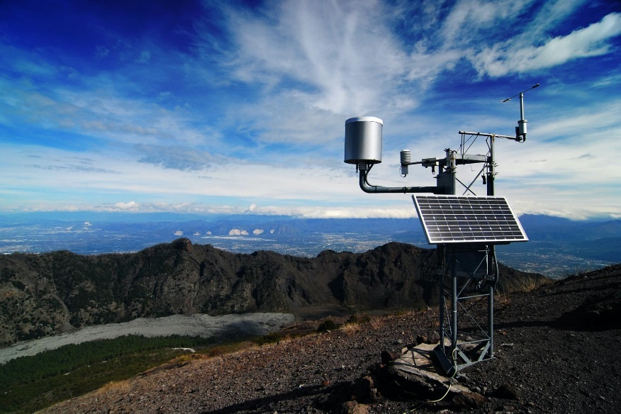

Figure 1 Weather station
[1]

“Other names for a weather station include a weather park or a weather shelter. It is a measuring tool with a variety of sensors serving a range of purposes.
A group of devices and sensors used to detect atmospheric and ground conditions is known as a weather station. Environmental factors including light, temperature, relative humidity, rain, and wind are frequently monitored.
Together with satellites, weather buoys, meteorological probes, and radars, weather stations, sometimes known as meteorological stations, are facilities for weather observation and data collection. However, there are more than 40.000 official weather stations worldwide, making them the most prevalent facility. They convey data to the big data processing centres after registering it at a certain location on the map.
The majority of the time, stations are set up on the land, but they may also be found at sea aboard ships or even in airplanes. Stations are frequently set up at airports as well, where it is crucial to continuously monitor the weather.
The following are some applications for weather stations Anyone who requires precise weather data, including gardeners, farmers, sailors, navigators, hikers, mountain bikers, carpenters, and laborers, may gain a lot from a weather station. The primary purpose of weather stations is to track environmental concerns like changing climates ( Global Warming).

Some of them are intended for the general population, despite the fact that there are huge, extremely advanced ones that are utilized by national meteorological agencies. The following can be measured by a weather station:” [2] [3] [4]

- “Temperature;
- Atmospheric pressure;
- Wind speed and direction;
- Rain gauge;
- Hygrometer (humidity level);
- Precipitation forecasts;
- The height and type of clouds;
- The dew point;
- Visibility.
- Air quality;
- The level of pollution (especially NO2, CO2, fine particles);
- The noise level.”



[5]Figure 2Weather Station Forecasting

Table 1 Comparison Table of weather Stations
Weather System | Automatic Weather Station- weather monitor system--JXCT | Weather Meter Kit --  SparkFun Electronics | Atmos 41 All in one Weather Station | BRESSER Weather Center 5-in-1 black
Picture | [6]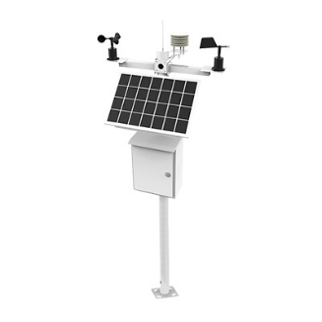 | [7]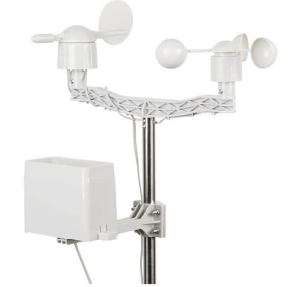 | [8]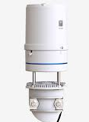 | [9]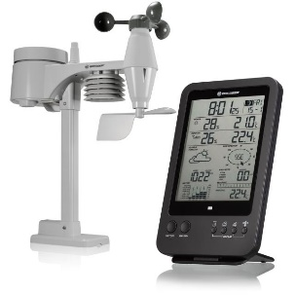
Sensors | - Wind speed  - Wind direction  - Temperature  - Humidity  - Atmospheric pressure  - Precipitation  - Noise  - Rainfall  - Soil  - SO2  - NO2  - O3  - CO2  - Illuminance  - PM10  - PM2.5 | - Rainfall  - Wind Direction  - Wind Speed | - Solar Radiation  - Precipitation  - Air Temperature  - Relative Humidity  - Humidity Sensor Temperature  - Vapor Pressure  - Barometric Pressure  - Horizontal Wind Speed  - Wind Gust  - Wind Direction  - Tilt  - Lighting Strike Count  - Lighting Average Distance | - Wind Speed  - Wind Direction  - Temperature  - Humidity  - Precipitation  - Air Pressure
Power Supply | Solar Panel / Battery 12V/24V | Battery 5V | Battery | Battery
Control Panel Display | YES | NO | NO | Yes
4G | YES | NO | NO | NO
Cost | £289.62 | £62.06 | £1323.26 | £52.54

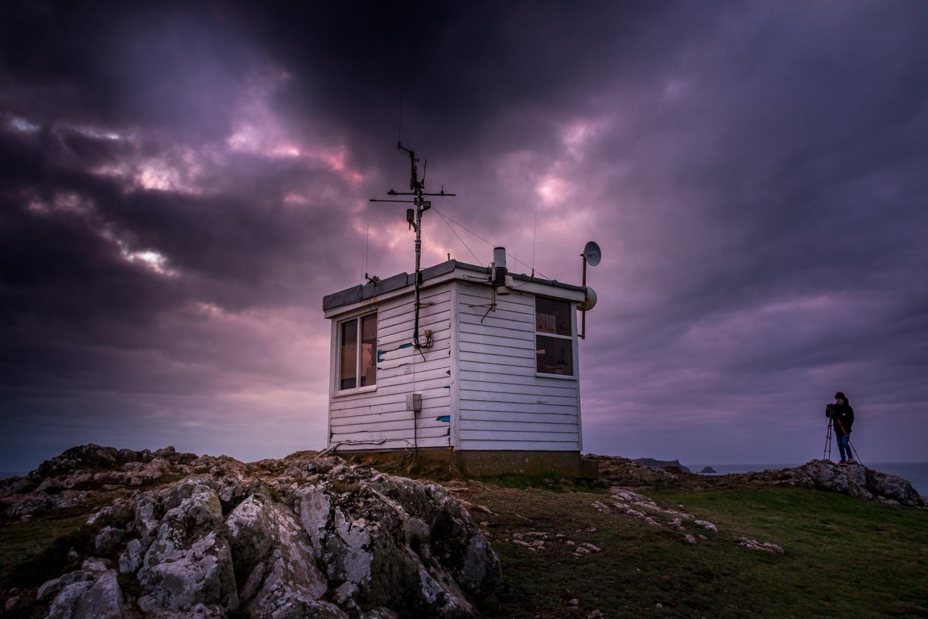
[10]Figure 3 Weather Station

3.0 Task 2

3.1 Selecting Appropriate Microcontroller

3.2 What is a Microcontroller?
“The microcontroller is like a brain. It’s a simple one IC (integrated circuit). Micro means small. Controllers situate on a small chip. In this era of technology, everything getting smaller in size with rapid performance. This is achieved through Microcontrollers. it is nothing but the circuit. This is designed as compact as possible. “ [11]
[12]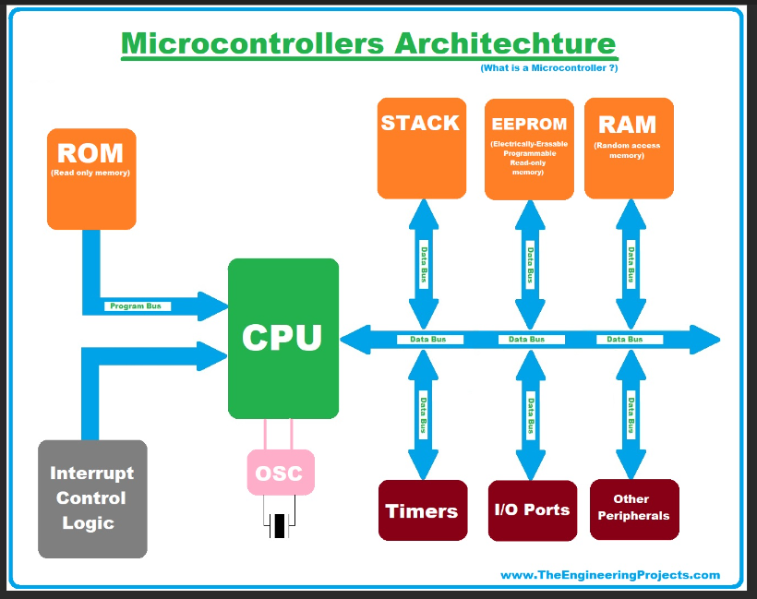
Figure 4MicroController Architechure

A Microcontroller consist of the following parts:
Table 2 Parts of a Microcontroller Consists

Components | Description
CPU | “as the processing unit to fetch data and to distribute the instructions to related parts.” [13]
Memory | “ROM (Read Only Memory) for program memory and RAM (Random Access Memory) for data memory.” [14]
Input/Output ports | “as the interface to a specific task such as LCD (display), regulating LED’s on-off pattern, or even instruction for a printer.” [15]
Serial ports | “Serial ports have a role as the interface to communicate with various other external devices or peripherals. The most commonly used is the Universal Asynchronous Receiver-Transmitter (UART).” [16]
Timers/Counters | “it provides the time delays and counting features of external events. It also has more use to provide such as function generation, pulse width modulation, and clock control.” [17]
ADC: | “to convert the input analog signal into the digital form that is then used for further process or application such as a measurement instrument.” [18]
DAC: | “the opposite function of ADC. It is mainly to produce the analog signal output from the processed digital information.” [19]
Interrupts: | “to give a delayed control when a program is running or working. It can be internal, external, software, or hardware-related.” [20]

[21]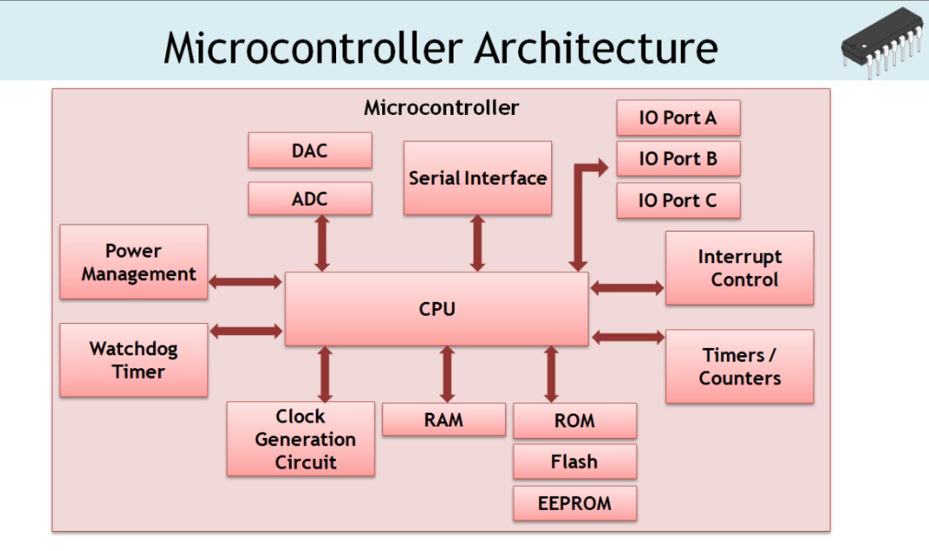
Figure 5 MicroController Architecture

3.3 What is a microcontroller used for?
“Nowadays you can find microcontrollers in all types of electronic devices. Any automobile or other device which measures, controls, calculates, stores, or displays information must have a microcontroller chip inside it.
The microcontrollers used widely are in the industries (microcontrollers widely used for controlling engines and power controls in automobiles). Various other equipment contains microcontrollers inside it, such as keyboards, printers, computer mice, modems, and other peripherals. In various equipment, microcontrollers make it easy to add some features like the power to store measurements, to form and store user routines, and to display messages and waveforms.
Various other products that use microcontrollers include digital camcorders, optical players, LCD/LED display units, etc.” [22]

3.4 Specification
- 28 Pins
- 8 Analogue
- 5 Digital IO
- 4 POWER
- 1 USB
- 1 SD CARD Memory
- 9 ANALOGUE INPUT FOR SENSORS
- 2 DIGITAL INPUTS FOR SENSOR
- CLOCK FREQUENCY 40Mhz
- 4 Digital Pins for SD Card
- 4 Pin for power
- 1 digital OP for LED Tell
- 1 Digital in for Start Button
- 4 Digital pins vdd,vss,D+,D-
- 1 SPI (Serial Peripheral Interface)

Sensor | Signal | PINS | BITS
TEMPERATURE | ANALOGUE | 1 | 8
HUMIDITY | ANALOGUE | 1 | 8
WIND SPEED | ANALOGUE | 1 | 8
WIND DIRECTION | ANALOGUE | 1 | 8
SUNLIGHT | ANALOGUE | 1 | 8
UV LEVEL | ANALOGUE | 1 | 8
VOC | ANALOGUE | 1 | 8
ABPC | ANALOGUE | 1 | 8
GPS | DIGITAL | 2 | 8

Table 3 Sensor Requirements

3.5 Micro controller selection

[23]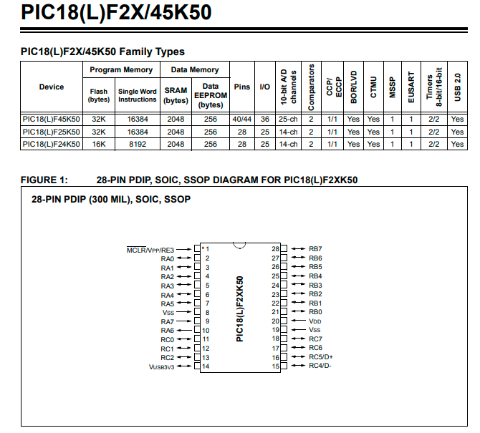
Figure 6PIC18(L)F2X/45K50 Product Brief

[24]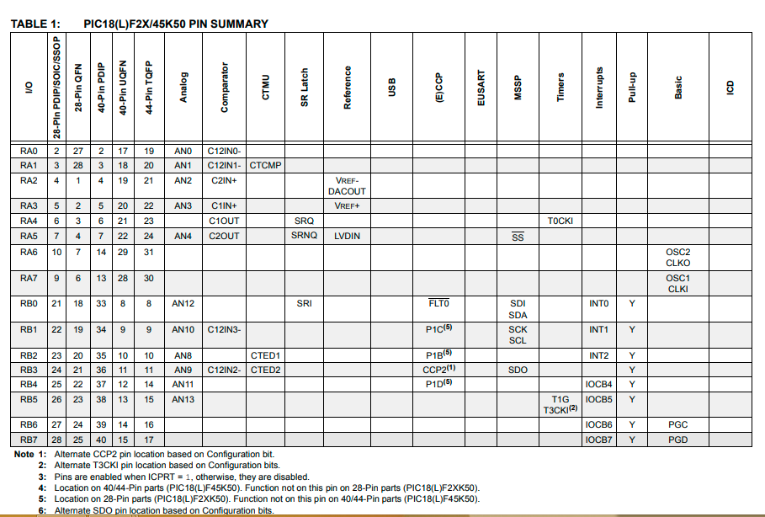
Figure 7PIC18(L)F2X/45K50 Pin Summary

[25]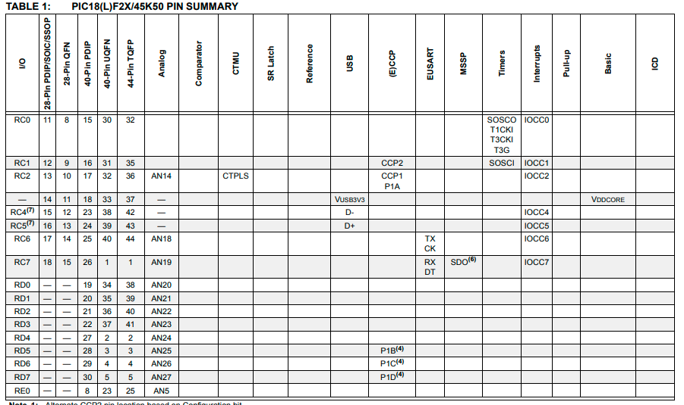
Figure 8PIC18(L)F2X/45K50 Pin Summary

[26]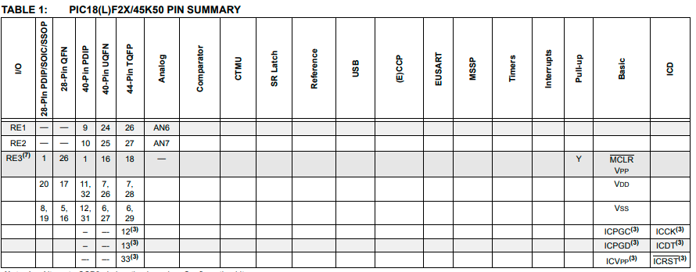
Figure 9PIC18(L)F2X/45K50 Pin Summary

[27]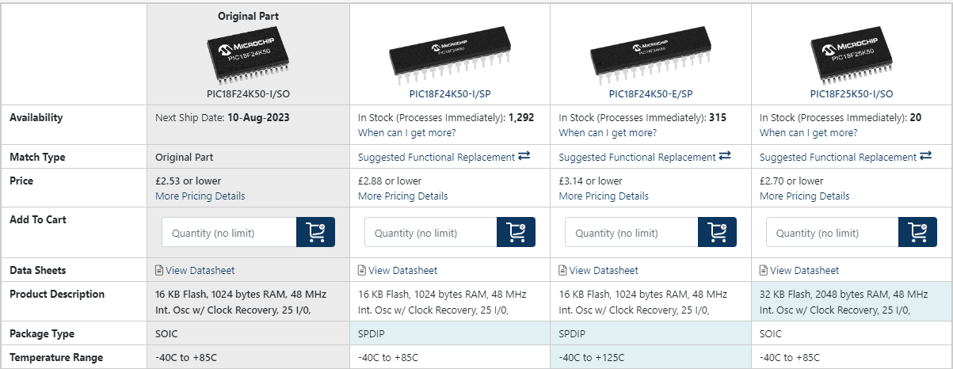
Figure 10PIC18(L)F2X/45K50 Prices

[28]
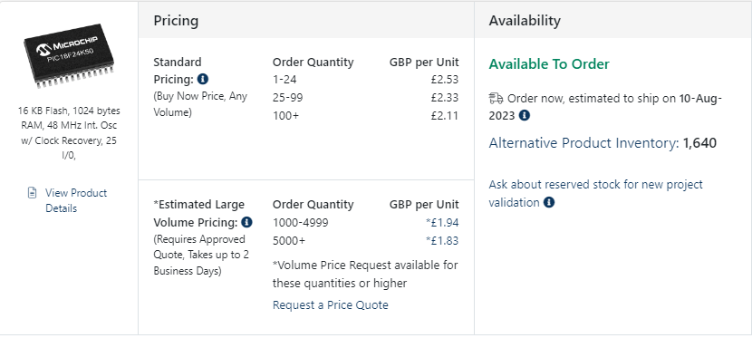

Figure 11PIC18(L)F2X/45K50 Cost

4.0 Task 3

4.1 Proaim Mitchell Heavy-duty Camera Tripod Stand with Spreader

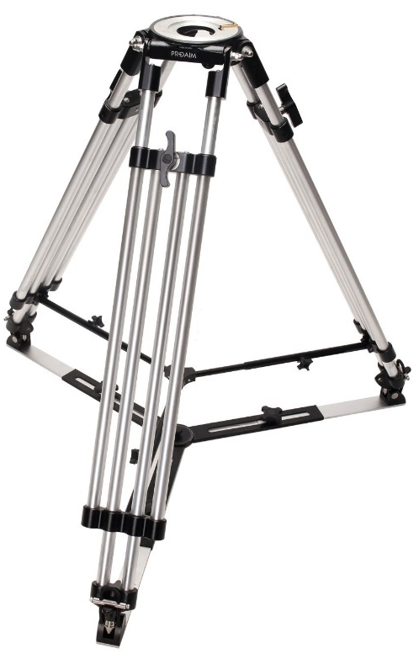
Figure 12Tripod Stand with Spreader

[29]

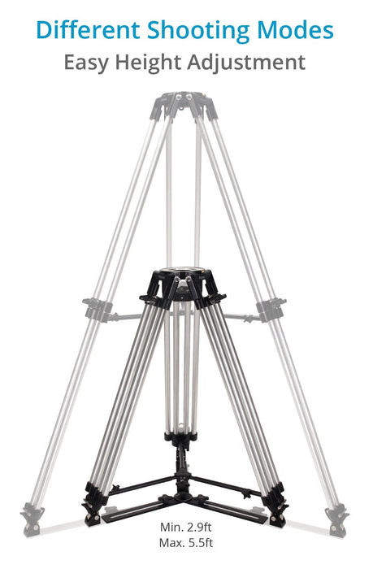
Figure 13Tripod Stand with Height adjustment
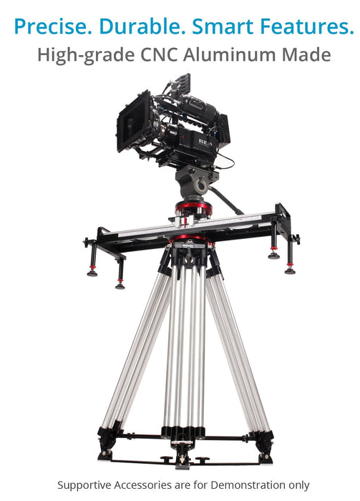
Figure 14Tripod Stand with Spreader

[30]
[30]
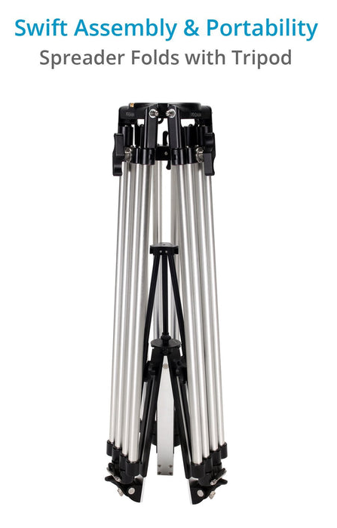
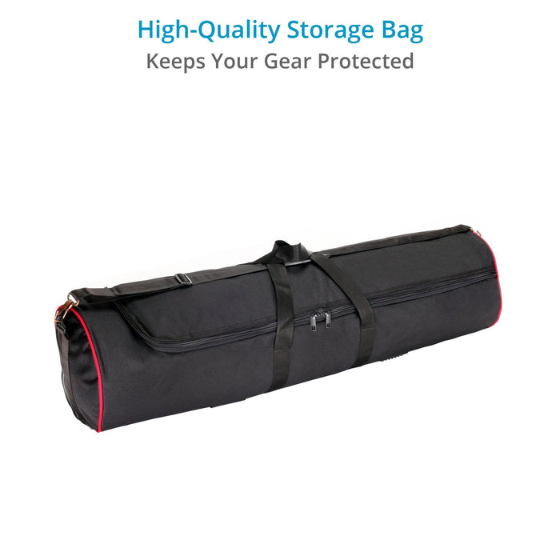
[32] [33]
Figure 15 Tripod packaging
Figure 16 Tripod carry bag

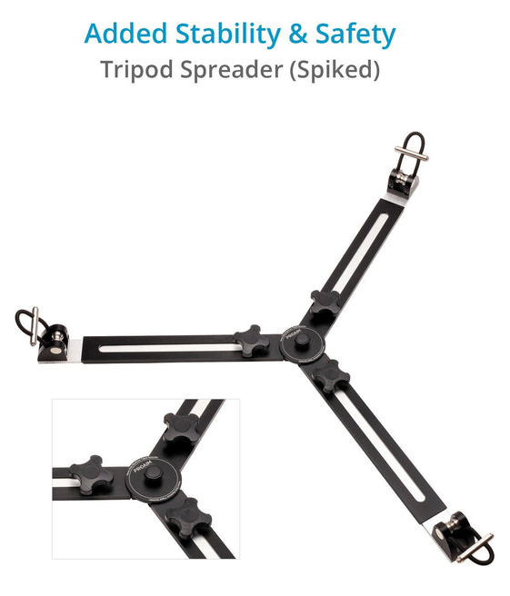
Figure 17 Tripod strengthening spreader

[34]

“Benefits

- Extreme Stability & Strength
- Strong Base For Tripod
- User Convenience
- Ideal Support Solution “ [35]

“Specification” [36]

Table 4 Specification table for tripod
Construction | - Tripod Stand: High-grade CNC Aluminum  - Tripod Levers: Pressure Die Cast Aluminum
Height | - Maximum: 5.5 ft / 66”  - Minimum: 2.9 ft / 35”  - Collapsible: 3.2 ft / 39.5”
Payload Capacity | - On Maximum Height: 80 kg / 176 lb  - On Minimum Height: 250 kg / 551 lb
Number of legs | 3
Leg Lock Type | Rotating Locking Lever
Independent Leg Spread | Yes
Bubble Level | No
Tube Diameter | 25mm
Product Weight (Without Packaging) | 11.28 kg / 24.86 lb
Packing Dimensions | 111 x 36 x 33 cm
Product Weight (With Packaging) | 20 kg / 44 lb

Total Cost £562
Free Express Delivery

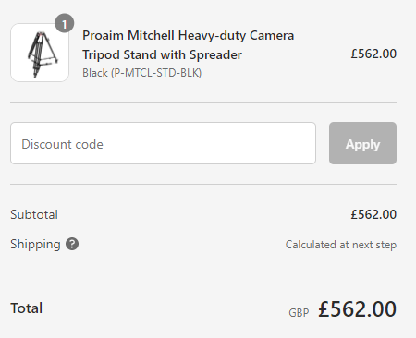
Figure 18Tripod checkout cost

[37]

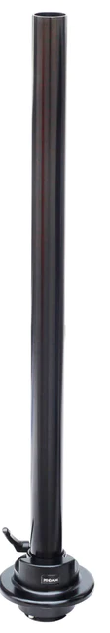
Proaim Scaffold Pole with Mitchell Mount

“Features
- Construction: Commercial-grade Aluminum
- Length: 3ft/36"
- Outer Diameter: 50mm
- Product Weight: 2.54kg/5.58lb
- Payload Capacity up to 500kg/1102lb
- Easy Clip on aspect to Tri Pod stand.” [38]

[39]Figure 19 Tripod scaffold pole attachment
Cost £272
Delivery 1 working day.

Mounting Clamps onto pole.
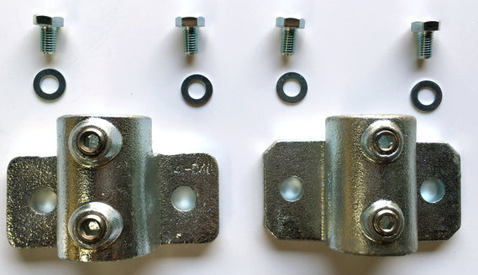

[40]Figure 20 Mounting Clamps
Cost £33.40
Delivery 3-5 days.
[41]Figure 21 Fibreglass battery wall box

4.2 Suitable Package
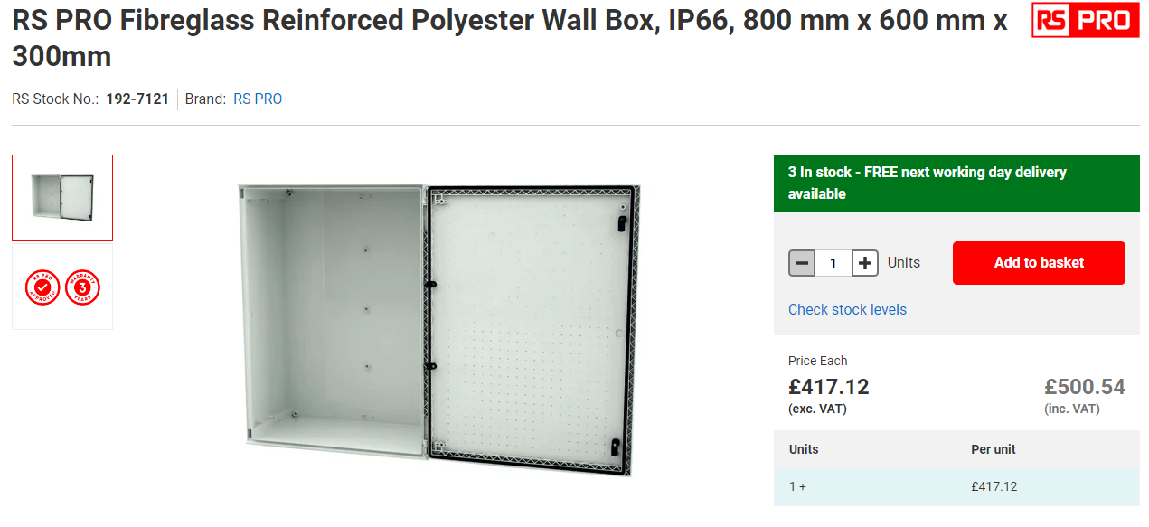

Dimensions H:800 x W:600 x D:300mm
Weight 19.05kg

“Feature
• Manufactured from fibre glass reinforced polyester, moulded by hot compression.
• Colour Light Grey RAL 7035
• Self-extinguishable: 960ºC test withstand. Halogen free. Double insulation. No electrical contact risks.
• Degree of protection IP66 UNE 20324 (EN 60529).
• Certification of compliance with IEC62208 enclosure standard. Suitable for indoor or outdoor use.
• Large door opening (180º). Reversibility for installation right or left door opening.
• Anti-intruder hinges system.
• Other lock options available
• Galvanised steel mounting plate.
• Resistant to harsh atmospheres.
• Light weight gives an easy installation.
• 10+ years. Long life lasting without maintenance under standard environmental conditions.” [42]

Cost £417.
Delivery 1 working day.
0900766b8173f705.pdf

This Junction Box will hold the batteries as they weigh 31Kg Each. Also all cable termination will be completed on this box.
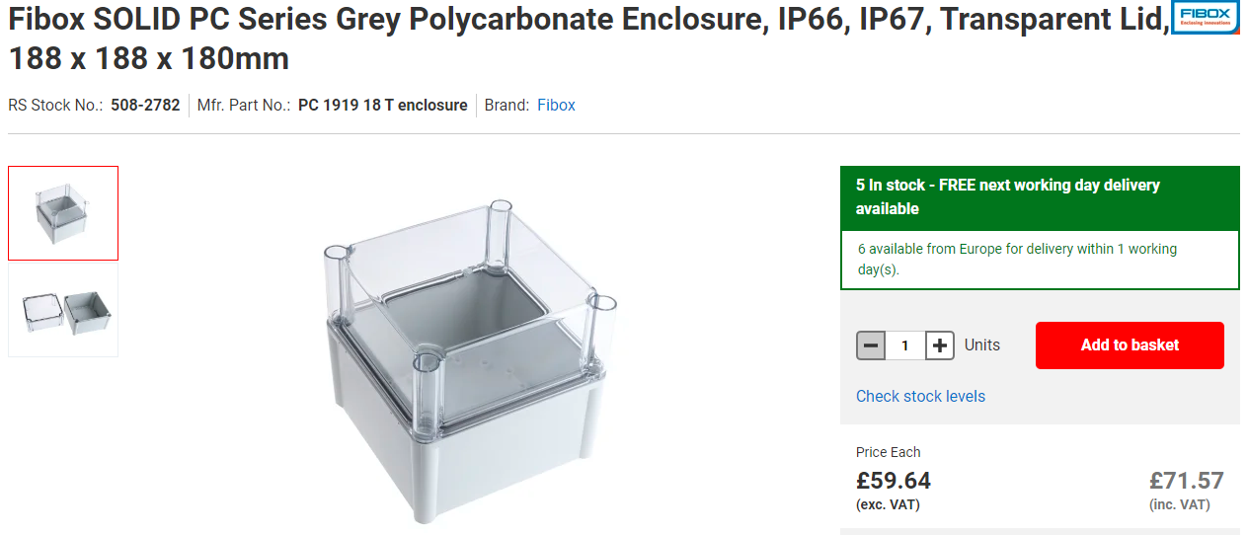
[43]Figure 22 PCB ENCLOSURE
PC 1919 18 T enclosure | Fibox SOLID PC Series Grey Polycarbonate Enclosure, IP66, IP67, Transparent Lid, 188 x 188 x 180mm | RS (rs-online.com)

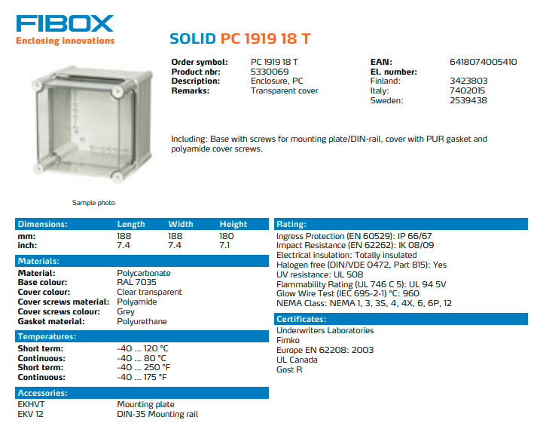

[44]Figure 23 PCB Enclosure specification

Cost £59.64
Delivery 1 working Day

This junction box will hold the PCB Microcontroller. This one will then be secured to the main junction box.

[45]Figure 24 Silica Gel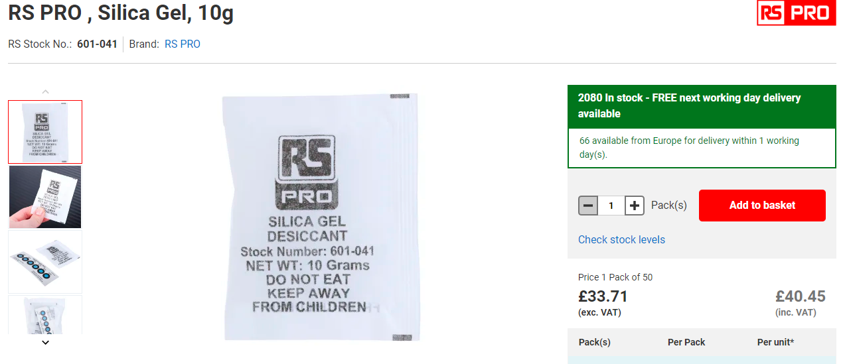

To help counter moisture build up inside box and help the see through window misting up these will be placed in enclosure.

Cost
£33.71
Delivery Next work day.

4.3 Sensor Current Rates

The sensors current rating below are Max output current.

Table 5 Sensor Current Rating
Sensor | Current
Temperature / Humidity | 1.2mA
Wind speed/ Direction | 100mA
Air borne particle count | 80mA
Sunlight brightness | 7mA
UV levels | 5mA
GPS position | 50mA
VOC level | 65mA
SD CARD | 163mA
USB | 500mA
Total | 0.971A

C = 0.971A x 24 hours = 23.3AH
30.84AH x 14 Days = 326.25AH

4.4 Battery Selection
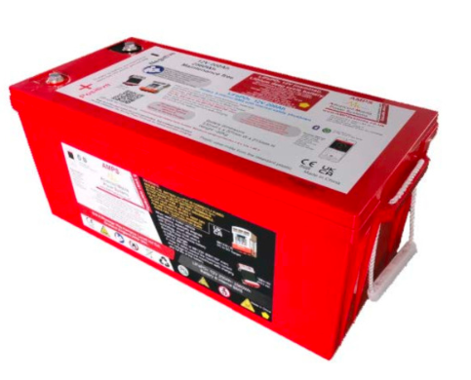
Sterling AMPS AL12300 LiFePO4 Lithium Battery c/w BT BMS - 12V / 300 Ah

[46]Figure 25 Battery Selection

Battery Capacity – 12V 300Ah
Weight -- 31Kg
H X W X L -- 53.2L x 20.7H x 21.5W
Operating Temperature -- -20'C to 60'C
- Price = £1569.95
The battery I am going to use is two 12V Batteries wired in Parallel with another one this will help increase the AMP – HOUR Capacity. Also allow for extra days if required and extras current such as LED Lamp and Microcontroller etc.

Total Cost of £3139.9

Sensor | Signal | Logging Rate | BYTES/READING | NUMBER/hours | TOTAL hours | TOTAL FOR 336HRS
TEMPERATURE | ANALOGUE |  | 8 | 1 | 336 | 2688
HUMIDITY | ANALOGUE |  | 8 | 1 | 336 | 2688
WIND SPEED | ANALOGUE |  | 8 | 1 | 336 | 2688
WIND DIRECTION | ANALOGUE |  | 8 | 1 | 336 | 2688
SUNLIGHT | ANALOGUE |  | 8 | 1 | 336 | 2688
UV LEVEL | ANALOGUE |  | 8 | 1 | 336 | 2688
VOC | ANALOGUE |  | 8 | 0.08 | 336 | 215
ABPC | ANALOGUE |  | 8 | 0.08 | 336 | 215
GPS | DIGITAL |  | 8 | 0.04 | 336 | 108
 |  |  |  |  | Total | 16666

4.5(NON – Volatile) Memory

Table 6 Non Volatile Memory
The Cycle Repeats for 14 days in total.

Table 7 Sensor Data Download
Start
Time
0.00 | TEMP | HUMI | SPEED | DIRECTION | SUNLIGHT | UV | VOC | ABPC | GPS
1HOUR | TEMP | HUMI | SPEED | DIRECTION | SUNLIGHT | UV
2HOUR | TEMP | HUMI | SPEED | DIRECTION | SUNLIGHT | UV
3HOUR | TEMP | HUMI | SPEED | DIRECTION | SUNLIGHT | UV
4HOUR | TEMP | HUMI | SPEED | DIRECTION | SUNLIGHT | UV
5HOUR | TEMP | HUMI | SPEED | DIRECTION | SUNLIGHT | UV
6HOUR | TEMP | HUMI | SPEED | DIRECTION | SUNLIGHT | UV
7HOUR | TEMP | HUMI | SPEED | DIRECTION | SUNLIGHT | UV
8HOUR | TEMP | HUMI | SPEED | DIRECTION | SUNLIGHT | UV
9HOUR | TEMP | HUMI | SPEED | DIRECTION | SUNLIGHT | UV
10HOUR | TEMP | HUMI | SPEED | DIRECTION | SUNLIGHT | UV
11HOUR | TEMP | HUMI | SPEED | DIRECTION | SUNLIGHT | UV
12HOUR | TEMP | HUMI | SPEED | DIRECTION | SUNLIGHT | UV | VOC | ABPC
13HOUR | TEMP | HUMI | SPEED | DIRECTION | SUNLIGHT | UV
14HOUR | TEMP | HUMI | SPEED | DIRECTION | SUNLIGHT | UV
15HOUR | TEMP | HUMI | SPEED | DIRECTION | SUNLIGHT | UV
16HOUR | TEMP | HUMI | SPEED | DIRECTION | SUNLIGHT | UV
17HOUR | TEMP | HUMI | SPEED | DIRECTION | SUNLIGHT | UV
18HOUR | TEMP | HUMI | SPEED | DIRECTION | SUNLIGHT | UV
19HOUR | TEMP | HUMI | SPEED | DIRECTION | SUNLIGHT | UV
20HOUR | TEMP | HUMI | SPEED | DIRECTION | SUNLIGHT | UV
21HOUR | TEMP | HUMI | SPEED | DIRECTION | SUNLIGHT | UV
22HOUR | TEMP | HUMI | SPEED | DIRECTION | SUNLIGHT | UV
23HOUR | TEMP | HUMI | SPEED | DIRECTION | SUNLIGHT | UV
24HOUR | TEMP | HUMI | SPEED | DIRECTION | SUNLIGHT | UV | VOC | ABPC | GPS
Repeat 13 Days

4.7 SD CARD SELECTION

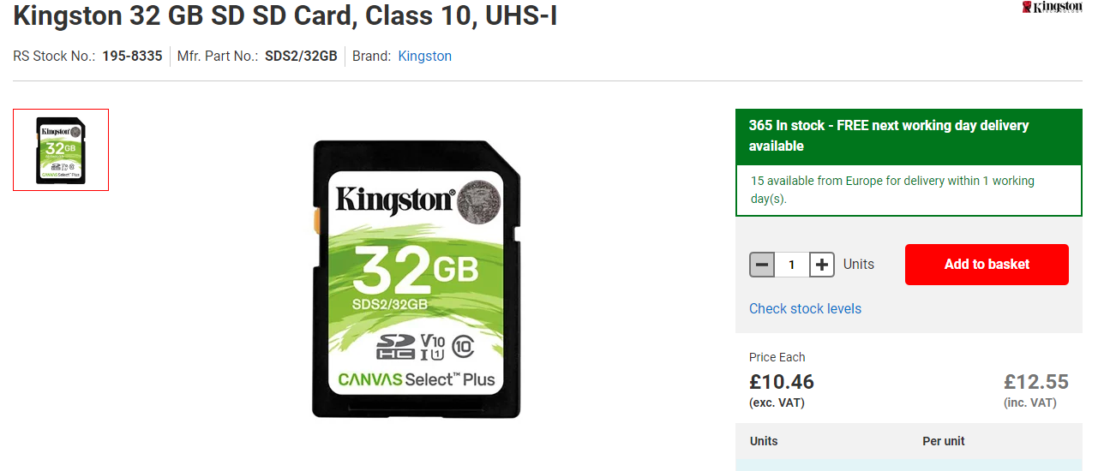
Figure 26 SD CARD
[47]
- Cost = £10.46

SD Card must have SPI (Serial Peripheral Interface)

[48]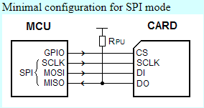
Figure 27 SD/SPI Configuration

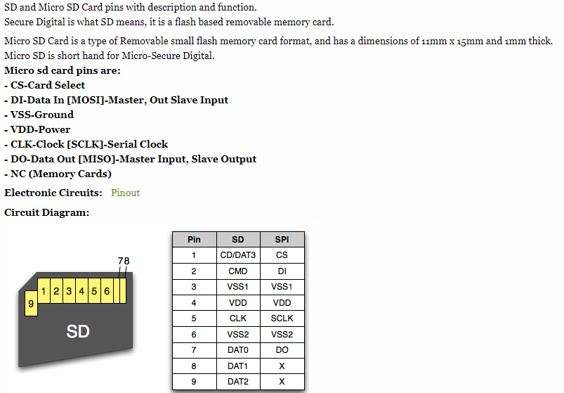
Figure 28 SD Pin Configuration [49]

4.8 Connectors selection

I will us ethe following connectors for my design. LEMO. They are ideal for data and communication systems they are designed at IP68 Protection waterproof and water tight.
Require one 8 contacts Female and Male.

Price of £94.64
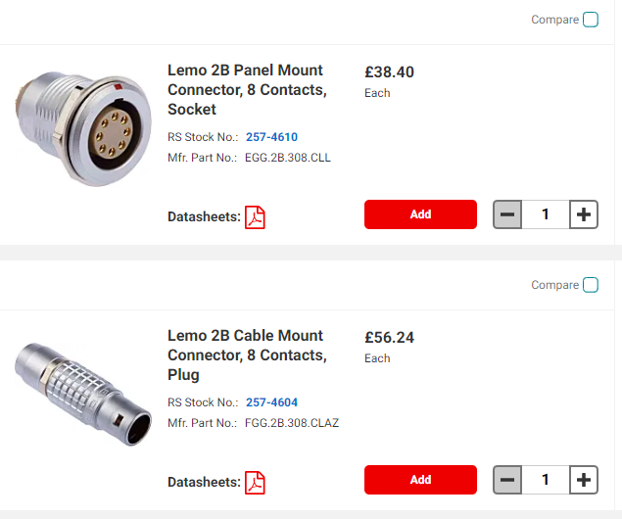
Figure 29 Connector Selection [158]

Require two 4 contacts Female and Male.

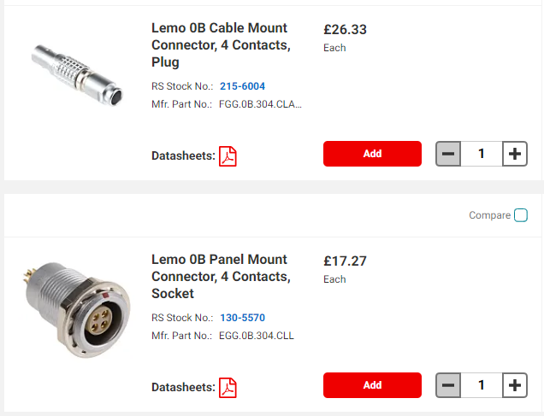
Price of £87.20
Figure 30 Connector Selection [159]

Require two 5 contacts Female and Male

Price of £163.52
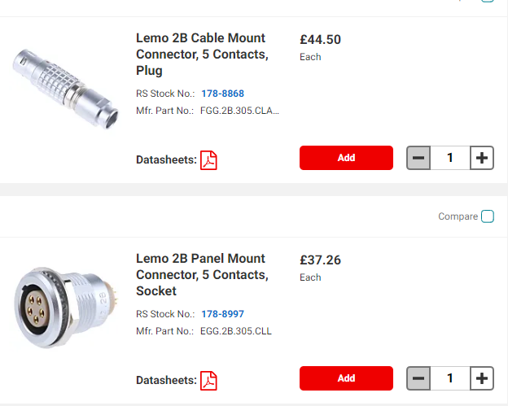
Figure 31 Connector Selection [160]

Industrial
Require two 3 contacts Female and Male

Price of £149.26
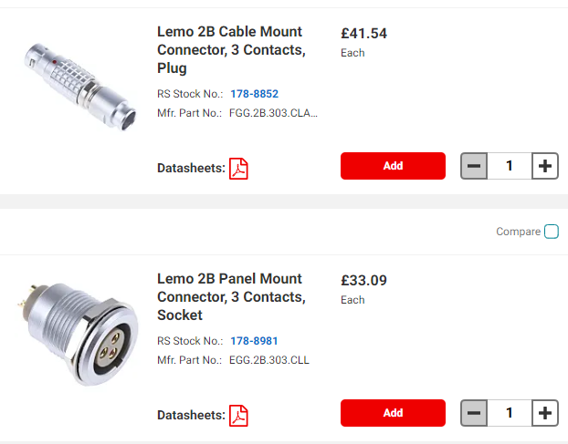
Figure 32 Connector Selection [161]

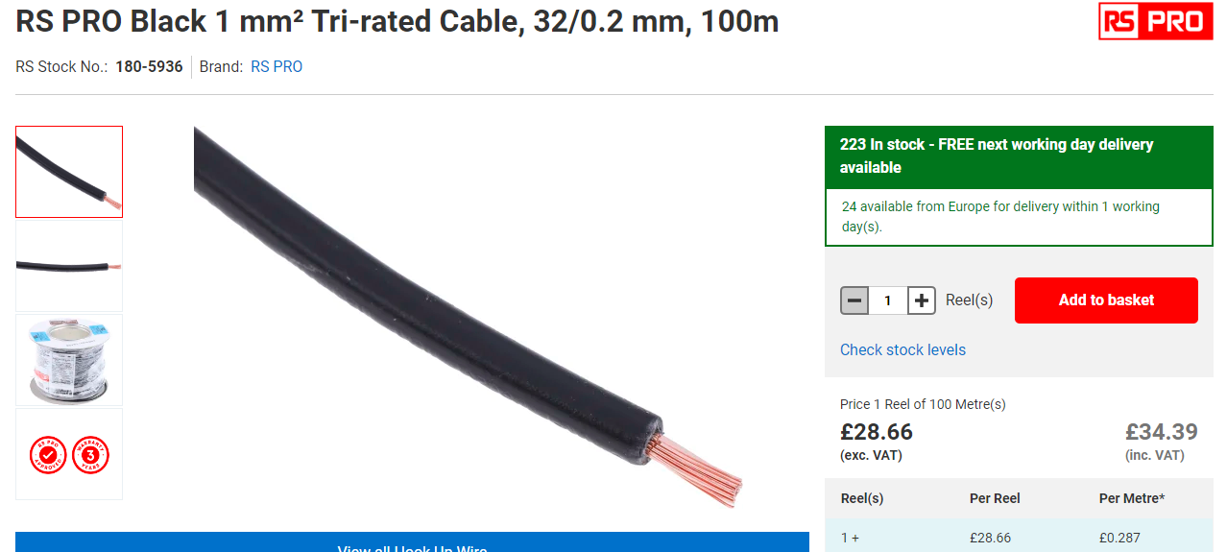
Figure 33 Tri Rated Panel Wire [162]
- “1 mm² Black
- Cost = £28.66
- High temperature
- Flame retardant
- Designed for use inside electrical equipment
- BS 6231 Cable “ [50]
The tri rated cable will be used for the electrical wiring from the microcontroller inside encloser to the female harting connections which will be mounted on encloser.
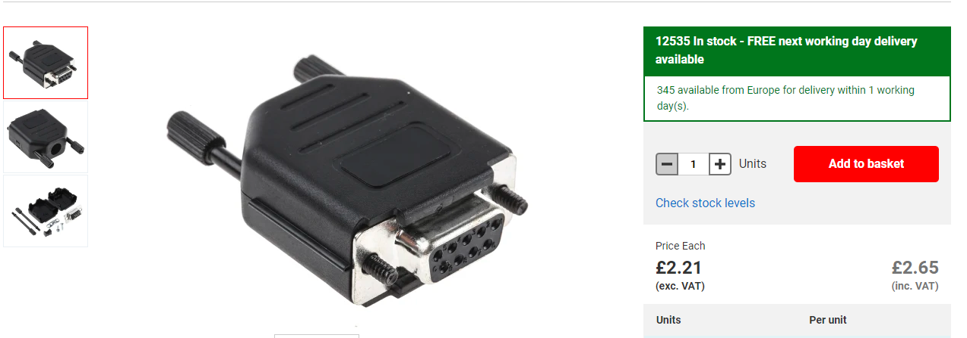
Connector For 9 Pin connector on PCB design
Figure 34 Connector for 9 Pin on PCB [164]
- Cost = £2.21

5.0 Sensor Selection

5.1 Temperature and Humidity

Table 8 Temperature and Humidity
Sensor  Name | TE Connectivity Temperature & Humidity Sensor, Voltage Output, Through Hole Mount | Eliwell SH0NPM100I400 Humidity Probe, +60°C Max, 100%RH Max | HYGRASGARD® AFTF-20-U LCD | SKU: RB-Dfr-460
Sensor Picture | [51]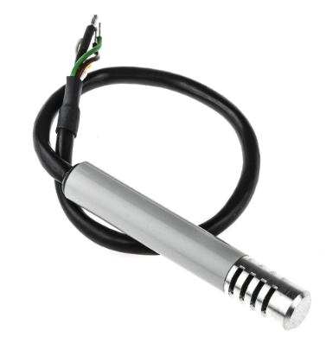 | [52]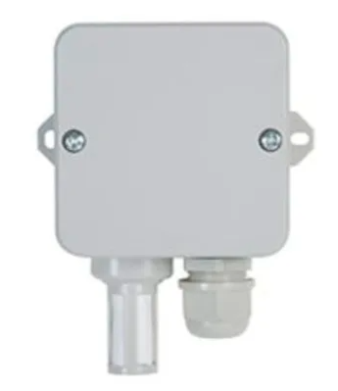 | [53]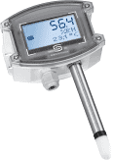 | [54]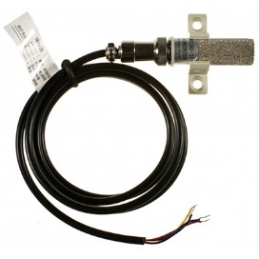
Range | -40 to 85ºC  0-100% RH | -40 ... 60 °C (-40 ... 140 °F)  0 ... 100 %RH | 0-100% RH  multi-range switching  –35...+35 °C; –35...+75 °C; 0...+50 °C; 0...+80 °C | Temperature Range: -10 - 80°C  Humidity Range: 0 - 100% RH
Input Voltage | 3-10V DC | 12V – 24V DC/AC | 24 V AC (± 20 %) and  15…36 V DC | 2.4 – 5.3V DC
Current | 1.2 mA | 50 mA | 1.1 VA/ 24 V DC ; < 2.2 VA/ 24 V AC | 0.15mW
Output | Analogue | Digital | Analogue | Digital
Accuracy | ±5%RH  Humidity calibrated within +/-2% @55%RH  Temperature measurement through NTC 10kOhms +/-1% direct output | ±3 %RH / 20...80 %RH (*); / ±0.6 °C / 5...60 °C (±1.08 °F / 41...140 °F) | Humidity  ± 1.8 % r. H. (10…90 % r. H. )  Temperature ± 0.2 K at +25 °C | Humidity Accuracy: ±5.0% RH  Temperature Accuracy: ±0.5°C
Operating Temperature | -40 to +85 °C | -40°C to 60°C | – 30...+80 °C, | 10 – 50°C
Pins | 5 | 5 | 4 | 4
Cost | £107.46 | £350.09 | £277.60 | £34.93

5.2 Wind Speed / Direction

Table 9 Wind Speed / Direction
Sensor  Name | Meteo Anemometer for Wind Speed and Direction (meteoprobe) | Anemometer & wind direction [Pro-D] | CALT Integrated wind speed and direction sensor YGC-FSFX wind vane ABS 3cup anemometer | FST200-205  Wind Speed and Direction Integrated Sensor
Sensor Picture | [55]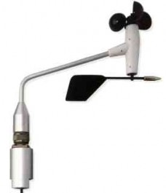 | [56]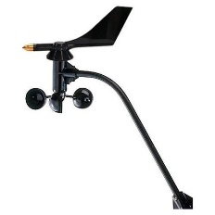 | [57]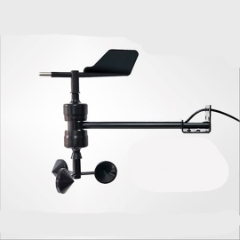 | [58]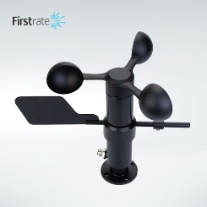
Range | Velocity Measurement  2.5 … 210 km/h  Direction  0 … 360° | 1…67m/s  0° to 360°, 360º = 20kOh | 0-70m/s (digital output), 0-45m/s (analog output)  0-360°C | Wind speed: 0-30m/s,0-60m/s;  Wind direction: 16 directions or 8 directions (0-360 degrees)
Input Voltage | Velocity  not necessary (alternator)  Direction  1 VDC | 5 - 12V DC | 5V, 12V, 24V optional | 12-30VDC/12-30VDC/12-30VDC/15-30VDC
Current |  | 0.1A |  | ≤500mW
Output | Analogue | Analogue | Analogue/Digital | Analogue
Accuracy | Velocity  ± 0,3 m/s + ±2 % rdg  Direction  ± 1 % | Expected 2%, guarantee ±5%  Wind Direction ±7° | ±(0.3 0.03V)m/s (V: wind speed)  ±1%° | Wind speed: ±3% (≥5m/s); wind direction: ±3 degrees
Operating Temperature | -30° - +65° C | -40°C to 60°C | -20 °C ~ 60 °C | -40-85℃
Pins | 4 | 4 | 4 | 4
Cost | £1137.26 | £225.00 | £203.74 | £188.94

5.3 Air borne particle count

Table 10 Air borne particle count
Sensor  Name | Panasonic SN-GCJA5, Air Quality Sensor | Gravity: PM2.5 Air Quality Sensor | MLMLH PM2.5 Sensor - G5 PMS5003 PM2.5 Sensor Air Quality Monitoring Dust Measuring Air Dust Haze Tester | Honeywell HPMA115C0-004, Air Quality Sensor
Sensor Picture | [59]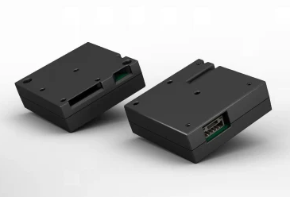 | [60]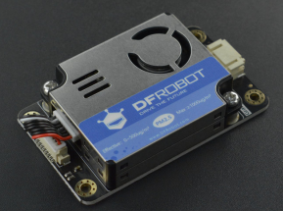 | [61]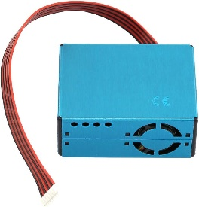 | [62]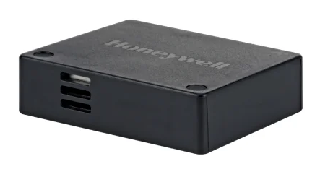
Range | 0μg/m3 – 2,000μg/m3 (UART) 0μg/m3 – X,XXXμg/m3 (I2 C) | 0.3 ~ 1.0μm; 1.0 ~ 2.5μm; 2.5 ~ 10μm | 0μg/m3 – 500μg/m3 | 0 µg/m3 to 1,000 µg/m3
Input Voltage | DC5V +/-10％ | 3.3V~5V | 1.8V ~ 5.5V | 5 V ±0.2 V
Current | Below 100mA | 100mA | 100mA | 80 mA
Output | Digital | Digital | Digital | Analogue
Accuracy | (±10%, from low to high concentrations) | 50% @ 0.3μm 98% @ ≥0.5μm | +10% @ 100 ~500μg/m3 | PM2.5: ±15µg/m3; PM1.0, PM4.0, PM10: ±25 µg/m3 PM2.5: ±15 %; PM1.0, PM4.0, PM10: ±25%;
Operating Temperature | -10 ~ 60℃, under 95%RH | -10~+60℃ | -30°C ~ 70°C | -20°C to 70°C [-4°F to 158°F] -40°C to 85°C [-40°F to 185°F
Pins | 5 | 4 | 8 | 8
Cost | £21.032 | £42.00 | £42.51 | £85.51

5.4 Sunlight brightness

Table 11 Sunlight brightness
Sensor  Name | Grove - Sunlight Sensor | Outdoor stainless steel light sensor industrial RS485 light sensor light intensity meter detector | Outdoor light intensity sensor PHOTASGARD® AHKF-I | INDUSTRIAL LIGHT INTENSITY SENSOr  Seeed Technology Co., Ltd
Sensor Picture | [63]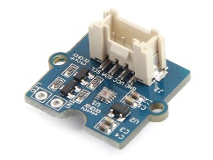 | [64]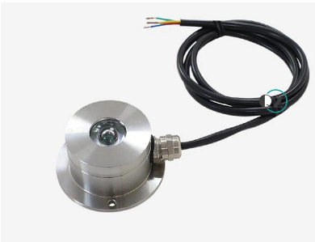 | [65]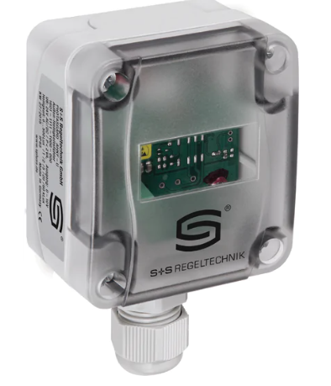 | 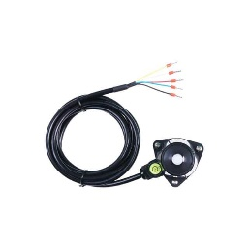
Range | 280-950nm | 0-65535lux | 0...500 Lux | Range:0～2000 Lux, Accuracy: ±5% , Resolution:1lux
Input Voltage | 3.0-5.5V | 12-24V | 15...36 V DC | 3.9V ~ 30V
Current | 3.5mA | 1A | < 1 W at 24 V DC; < 2 VA at 24 V AC | 7mA
Output | Digital | Analogue | Analogue | Analogue
Accuracy | I2C digital interface | +/-7% | < 5 % | 30°±3%,60°±6%,80°±24%
Operating Temperature | -45-85oC | -40-80oC | –30...+70 °C | -40°C ~ 85°C
Pins | 4 | 4 | 3 | 3
Cost | £10.30 | £33.56 | £88.54 | £54.17

5.5 UV Levels Sensor

Table 12 UV Levels Sensor
Sensor  Name | Adafruit SI1145 | VEML6075 | GaAsP photodiode | SENS-43UV
Sensor Picture | [66]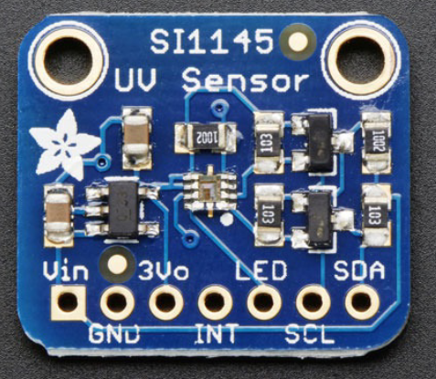 | [67]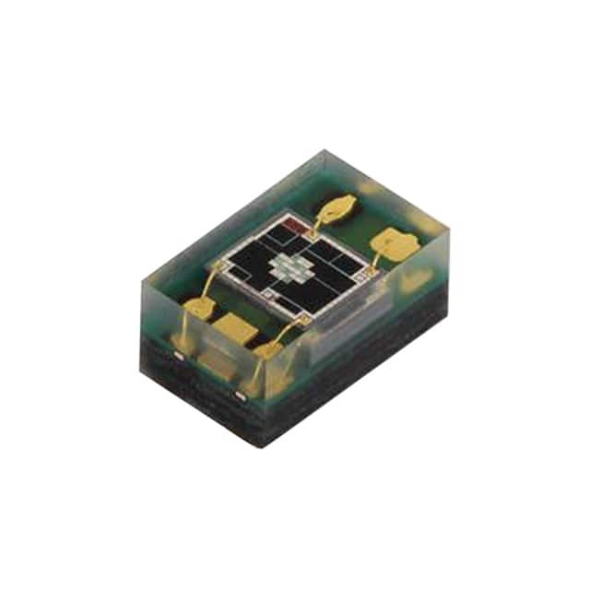 | [68]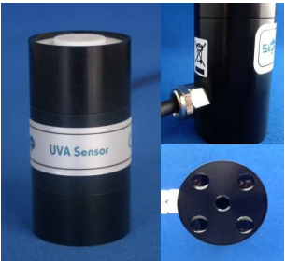 | [69]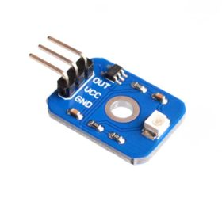
Range | 400nm | 330nm, 365nm | -2 0-100 W m | 0-10  200-370nm
Input Voltage | 3 to 5VDC | 1.7 V to 3.6 V | 5-15VDC | 5VDC
Current | 100mA | 480μA | 0.01A | 5mA
Output | Digital | Analogue/Digital | Analogue | Analogue
Accuracy | ±2% | ±2% | -2 20 mV / W m ±2% | +/- 1
Operating Temperature | -45-85oC | -40-85oC | -10 to +60°C | -20°C to 85°C
Pins | 4 | 4 | 3 | 3
Cost | £49.00 | £6 | £99.57 | £6.29

5.6 GPS Sensor

Table 13 GPS Sensor
Sensor  Name | QK-AS07-0183 NMEA 0183 GPS | GPS ACTIVE ANTENNA RRPA-PB0-486392-1-G-001 | Garmin 16x GPS Sensor | 2614021137000  Würth Elektronik
Sensor Picture | [70]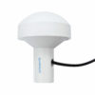 | [71]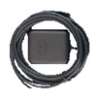 | [72]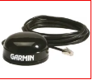 | [73]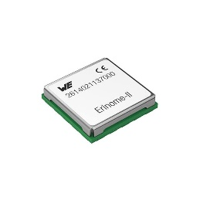
Update Rate | configurable 1-10Hz | 1575.42 ± 1.023 MHz | 20Hz | 10Hz
Input Voltage | 5- 12V DC | 3 – 5V | 3.3VDC to 6VDC | 1.71V ~ 1.89V
Current | ≤50mA | 8.5 ± 3.0 mA | 100Ma | 55mA
Output | Digital | Digital | Digital | Digital
Accuracy | Up to 5° compass heading accuracy | 3.0m | <15 METERS 95% TYPICAL | 2.5M
Operating Temperature | -5°C to +80°C | -40 ~ +85˚C | -30 ~ +80˚C | -40°C ~ 85°C
Pins | 5 | RG174 | 8 | 18
Cost | £165.72 | £12.72 | £127.36 | £29.79

5.7 VOC Level

Table 14 VOC Level
Sensor  Name | Volatile Organic Compound (VOC) Sensor | Room air quality sensor (VOC) and measuring transducer AERASGARD® RLQ-W VA | Analox AX60CUQYXA Quick Connect AX60 Gas Monitoring System | PS1-VOC-1000
Sensor Picture | [74]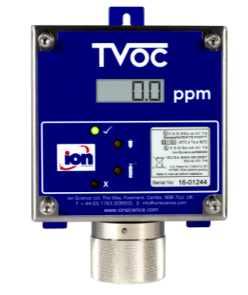 | [75]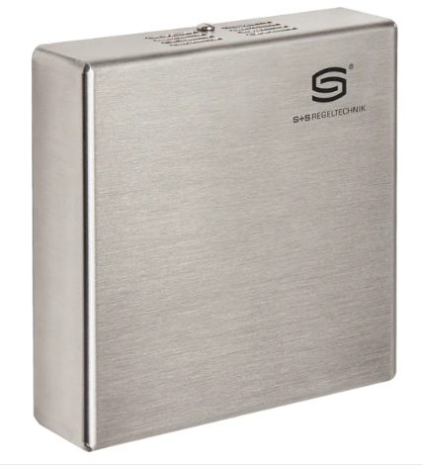 | [76]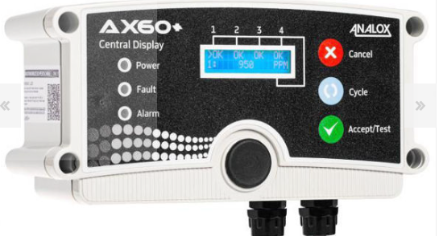 | [77]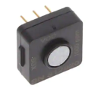
Range | selectable 0 - 10, 0 - 100, 0 - 1000 ppm (parts per million) | 0...100 % air quality; referred to calibrating gas;  multi-range switching | 0-1000ppm | 0 – 1000ppm
Input Voltage | 5 - 28 VDC, | 24 V AC/ DC (± 10 %) | 11-30v | 5 – 12v
Current | 65 mA | 200 mA | 80 mA | ± 100 nA
Output | Analogue | Analogue | Analogue | Analogue
Accuracy | (0-10 and 0-100 ppm) +/- 2%; (100-1000 ppm) +/- 5% | ± 20 % of final value | <±0.2ppm + 10% | 55 ± 15 nA / ppm
Operating Temperature | -200C to 500C (-40F to 1220F) | -30°C ~ 85°C | -40°C ~ 85°C | -40°C ~ 55°C
Pins | 4 | 4 | 5 | 3
Cost | £3595.34 | £288.87 | £155.15 | £36.83

6.0 Task 4

6.1 Circuit Design

Proteus Overview Design
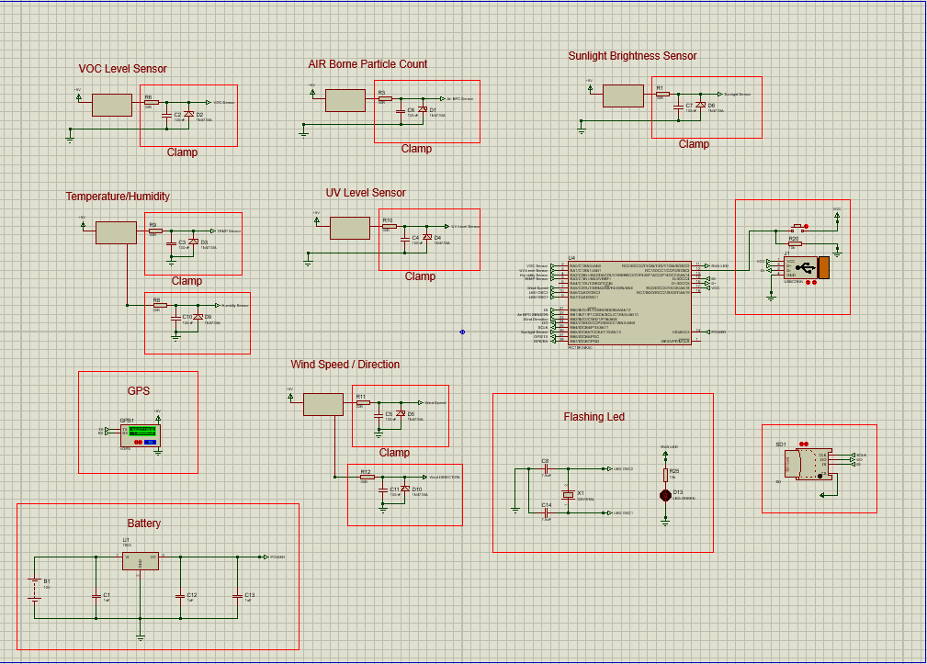
Figure 35 Proteus Overview
Proteus was used to build my Circuit I also used it to test the circuit to make sure the correct resistors and capacitors were used etc.
I selected all sensors which require 5v Input supply so I designed a voltage regulator to drop down the voltage to 5v. Used Voltage clamps in each sensor this helps the microcontroller against voltage speaks etc.

6.2 SD Card Proteus Design

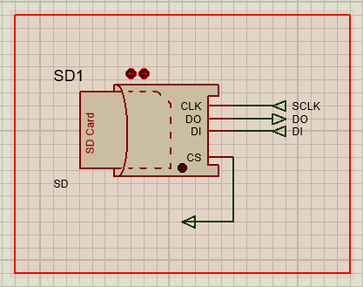
Figure 36 SD CARD PROTEUS

6.3 Air Borne Particle Count Sensor Proteus Design

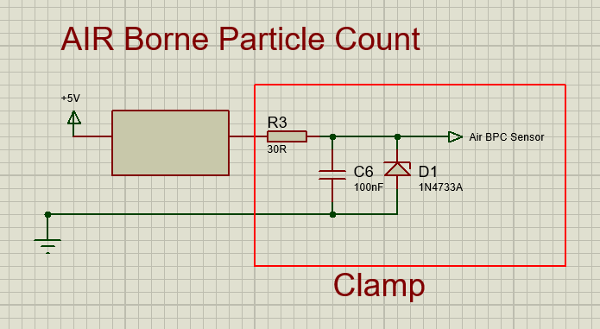
Figure 37 AIR BORNE PARTICLE COUNT PROTEUS

6.4 Battery Regulator Proteus Design

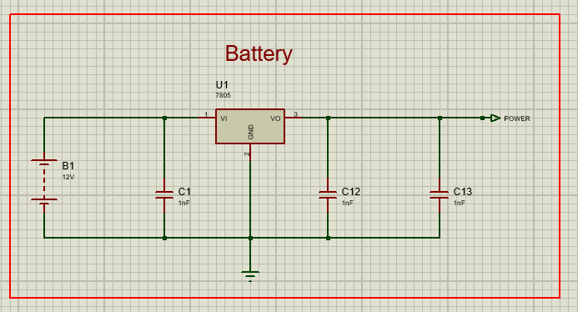
Figure 38 Battery Regulator Proteus

6.5 10 Second Flashing LED Proteus Design
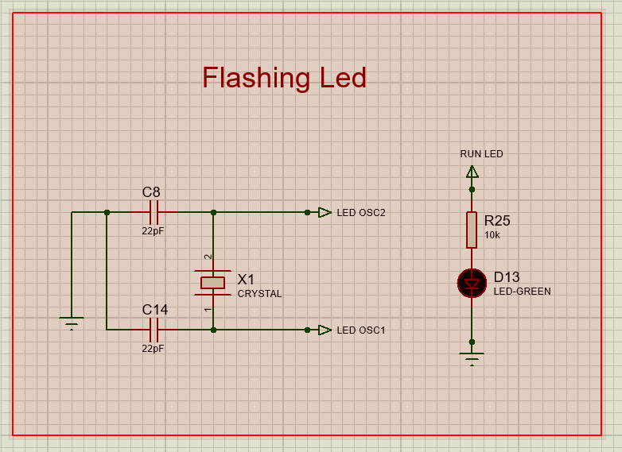
Figure 39 10 Second Flashing LED Proteus

6.6 GPS Proteus Design
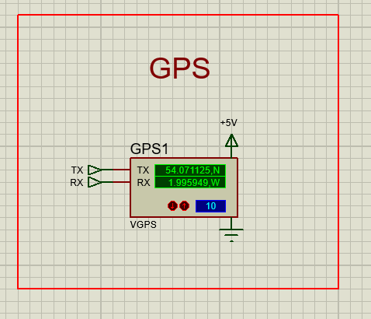
Figure 40 GPS Proteus

6.7 PIC18F24K50 Proteus Design

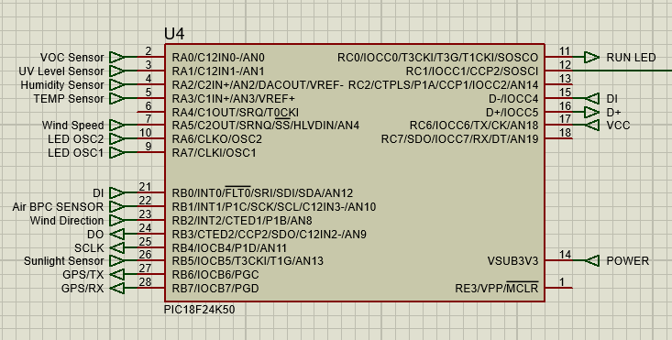
Figure 41 PIC18F24K50 Proteus

6.8 Sunlight Brightness Sensor Proteus Design
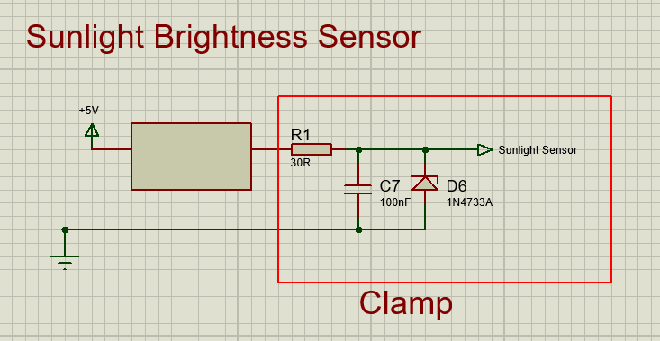
Figure 42 Sunlight Brightness Sensor Proteus

6.9 Temperature/ Humidity Sensor Proteus Design
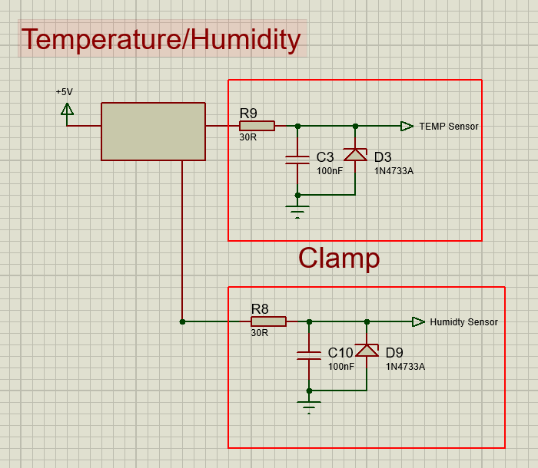
Figure 43 Temperature/ Humidity Sensor Proteus

6.10 USB Proteus Design
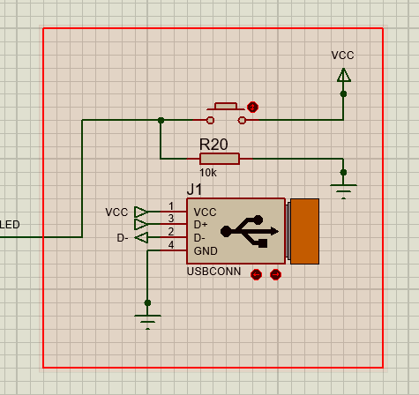
Figure 44 USB Proteus

6.11 UV Level Sensor Proteus

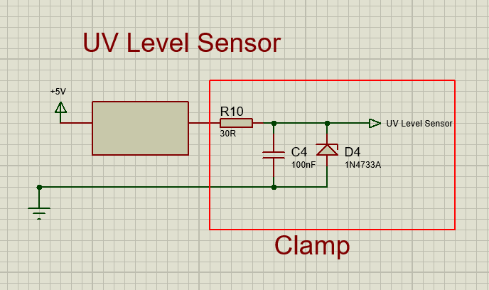
Figure 45 UV Level Sensor Proteus

6.12 VOC Level Sensor Proteus Design

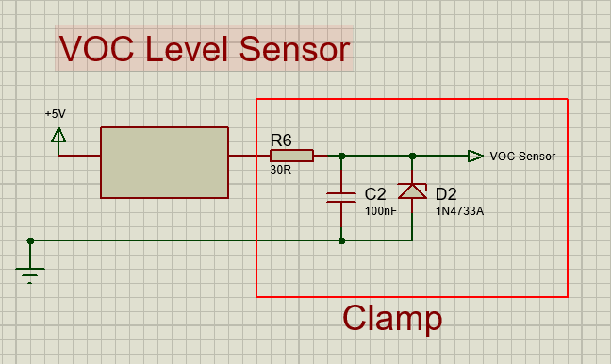
Figure 46 VOC Level Sensor Proteus

6.13 Wind Speed/ Direction Proteus Design

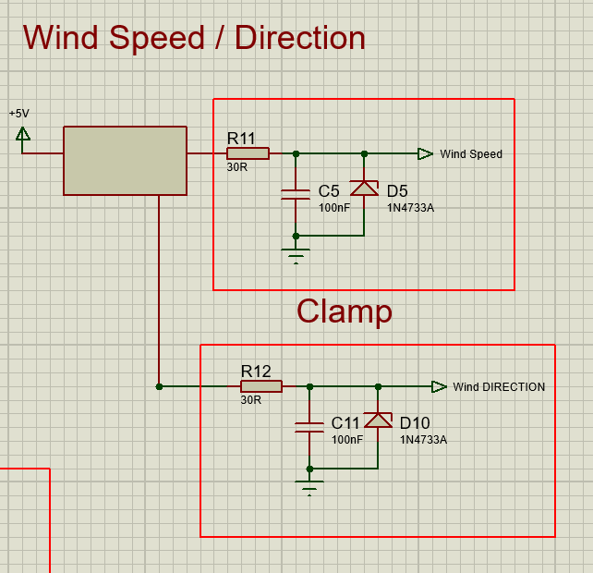
Figure 47 Wind Speed/ Direction Proteus

7.0 Easy PC

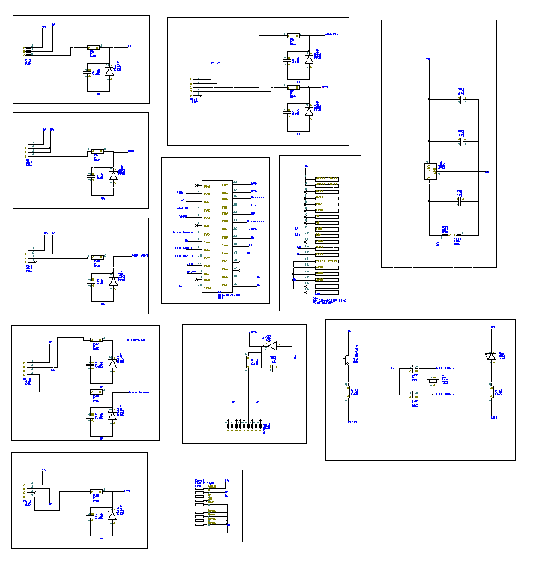
Figure 48 Easy PC Overview
Above is image of the Easy-Pc this was used to design our circuits from proteus so we can then be able to convert it to PCB form.
Above you can see all the sensors plus a voltage regulator from 12V DC to 5VDC this will supply all sensors and the microcontroller itself/ The flashing LED and Start button are all designed above . The USB AND SD also.

7.1 Air Borne Particle Count Sensor Easy PC Design
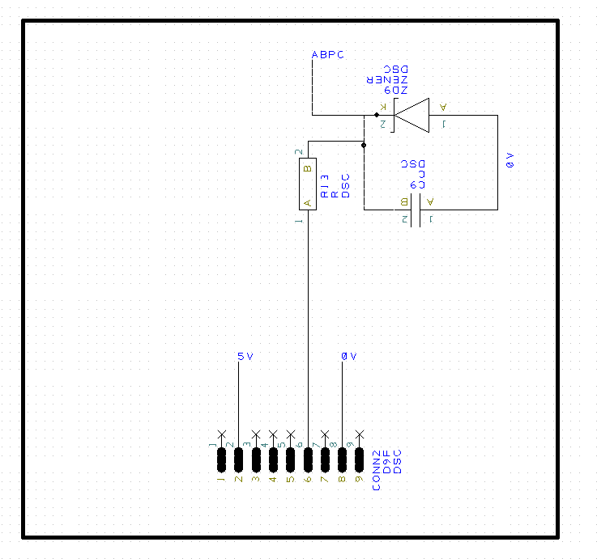
Figure 49 Air Borne Particle Count Sensor Easy PC

7.2 Battery Regulator Easy PC Design
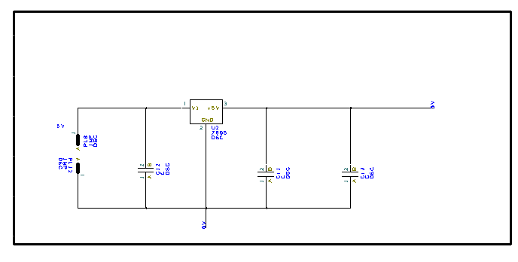
Figure 50 Battery Regulator Easy PC

7.3 GPS Easy PC Design

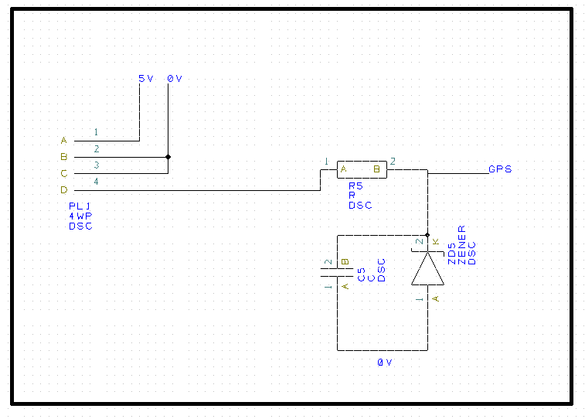
Figure 51 GPS Easy PC

7.4 Temperature/ Humidity Sensor Easy PC Design

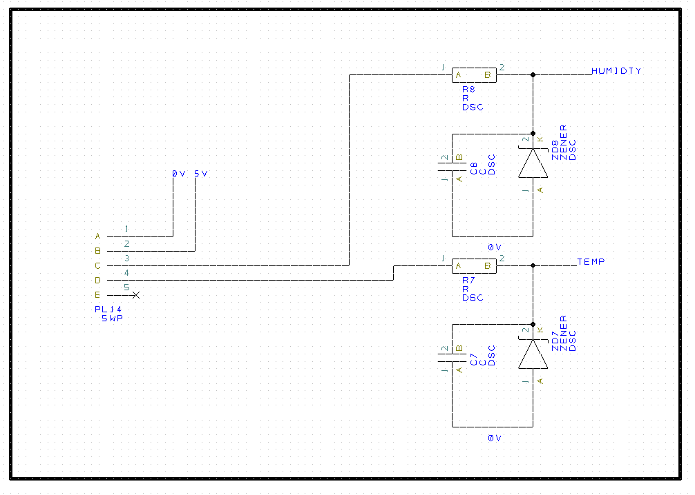
Figure 52 Temperature/ Humidity Sensor Easy PC

7.5 PIC18F24K50 Easy PC Design

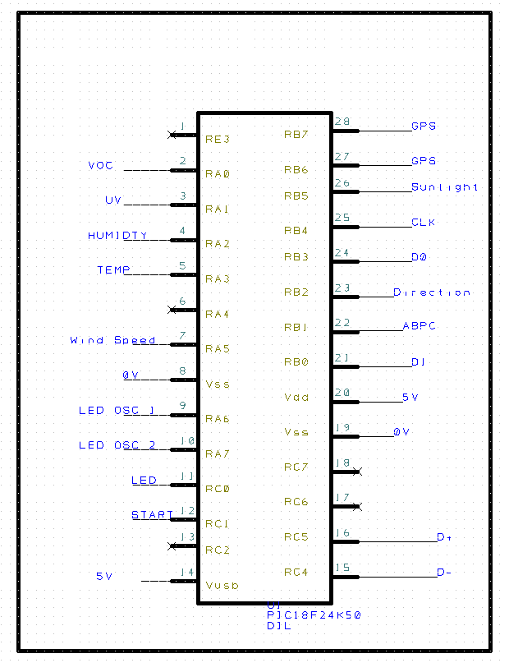
Figure 53 PIC18F24K50 Easy PC

7.6 SD Card Easy PC Design
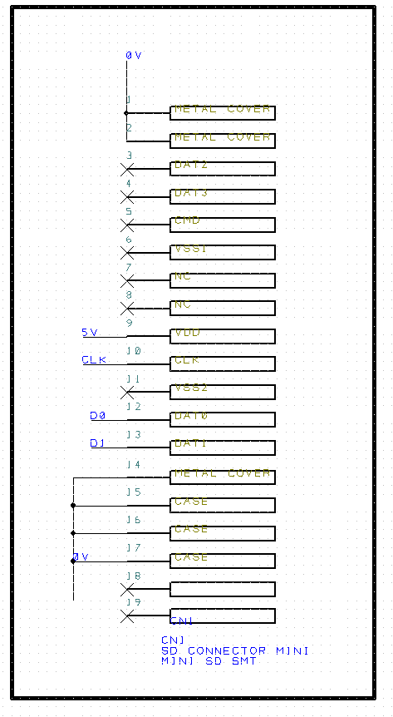
Figure 54 SD Card Easy PC

7.7 Start Button/ Flashing 10 Second Led Easy PC Design
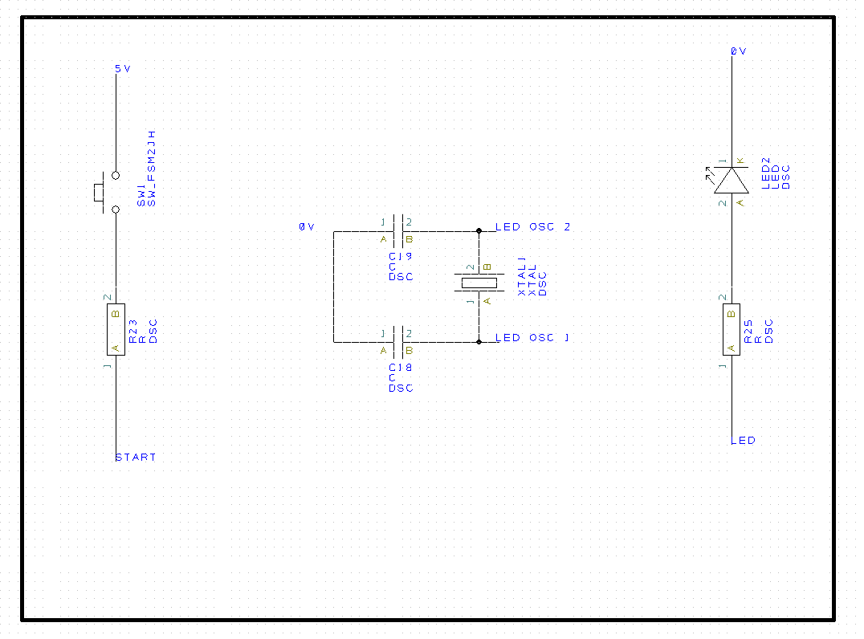
Figure 55 Start Button/ Flashing 10 Second Led Easy PC

7.8 Sunlight Brightness Sensor Easy PC Design

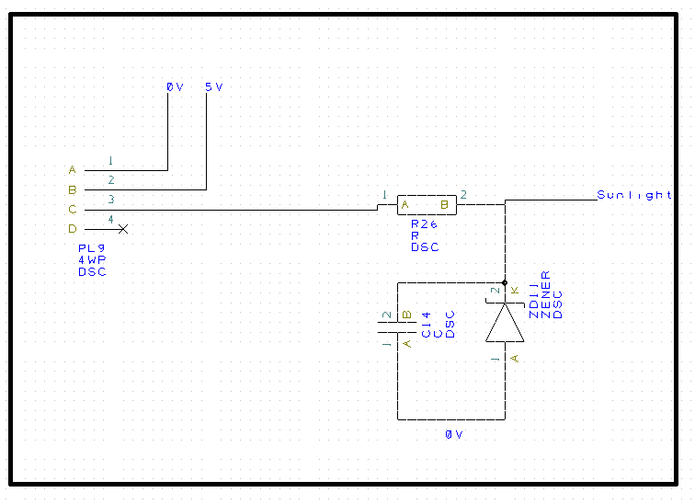
Figure 56 Sunlight Brightness Sensor Easy PC

7.9 USB Easy PC Design

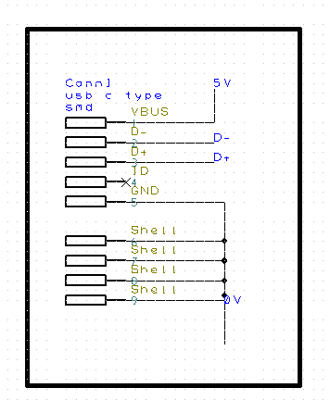
Figure 57 USB Easy PC

7.10 UV Level Sensor Easy PC Design
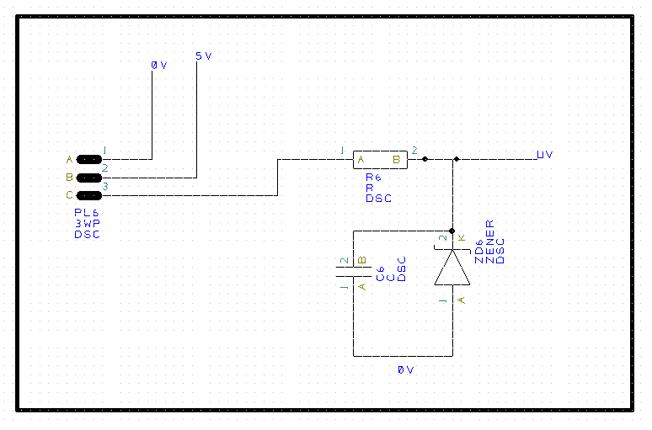
Figure 58 UV Level Sensor Easy PC

7.11 VOC Level Sensor Easy PC Design
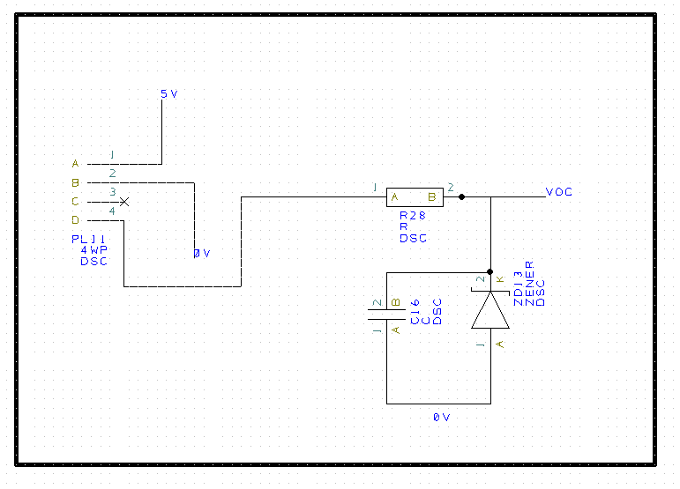
Figure 59 VOC Level Sensor Easy PC

7.12 Wind Speed/ Direction Sensor Easy PC Design
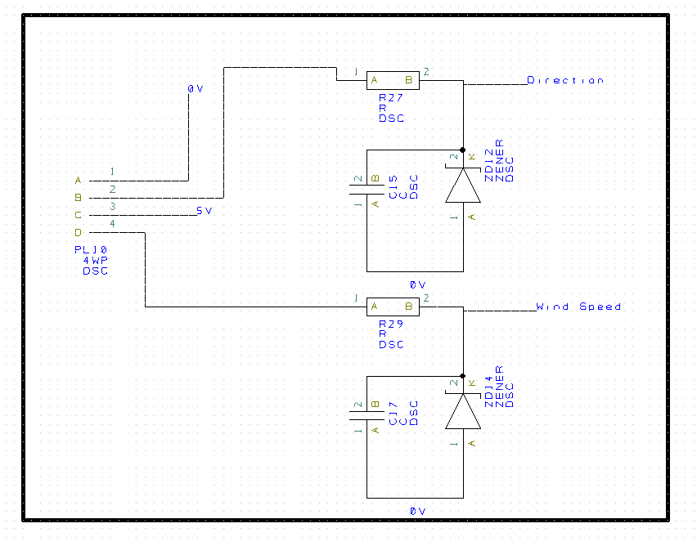
Figure 60 Wind Speed/ Direction Sensor Easy PC

8.0 PCB Design
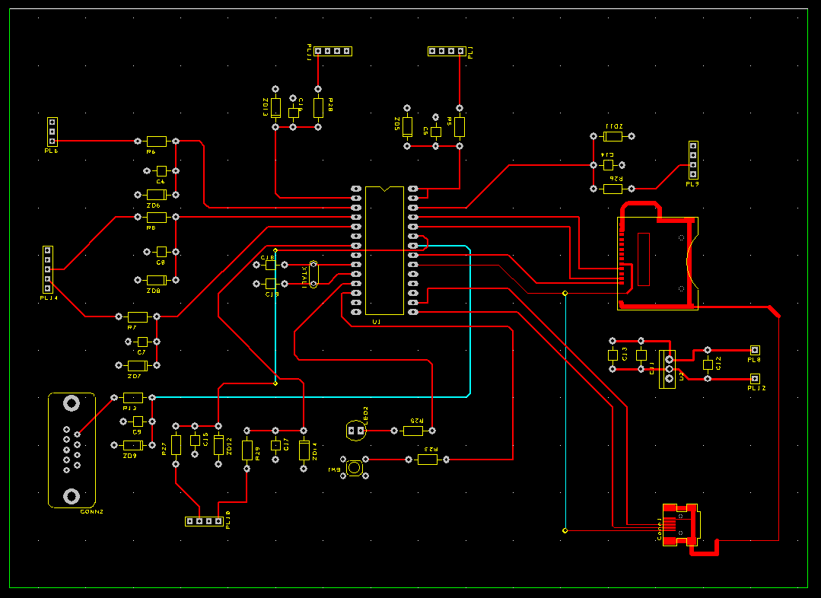
Figure 61 PCB Design Overview

The above image is of the PCB footprint Design. All components are laid out correctly and in tidy manner. The design is a four layered Board. The above image is of the top layer .

8.1 PCB Design Check

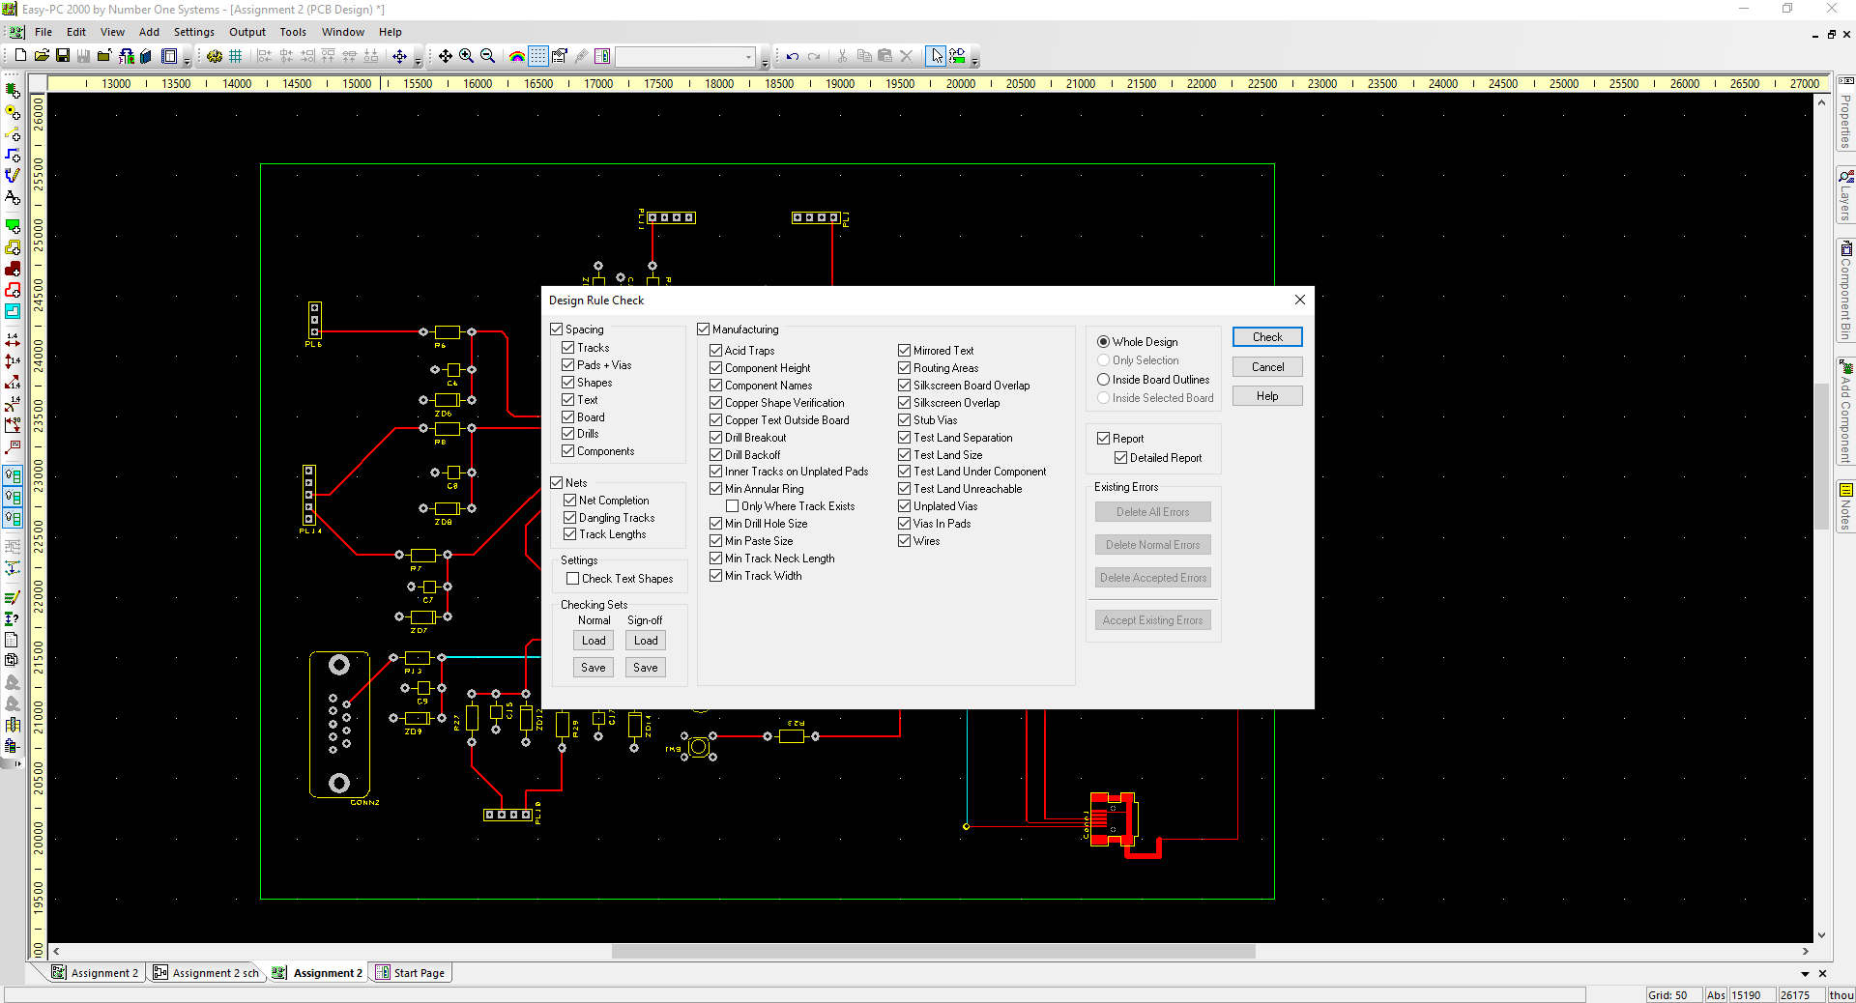
Figure 62 PCB DESIGN CHECK

The above image shows the PCB going through a Design Check. This is to check for any errors such as Acid Traps , Dangling tracks and silk screen overlaps etc.
As can see above all checks are ticked for a full Design Check

As can see below from the report no errors were found from the PCB Design.
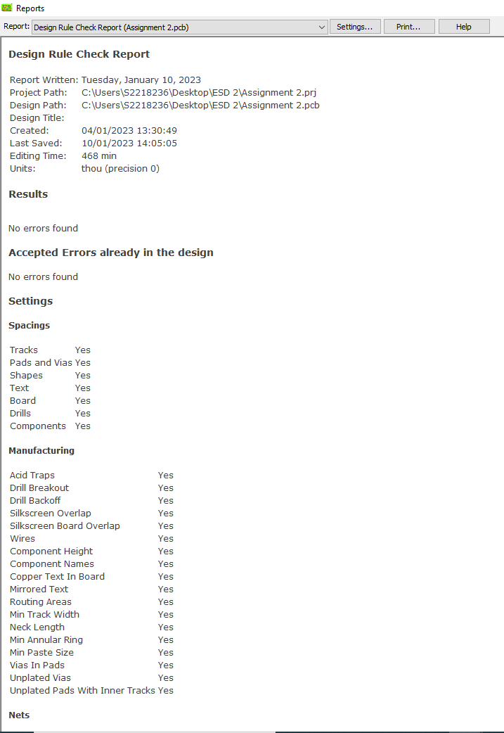
Figure 63 PCB DESIGN CHECK REPORT

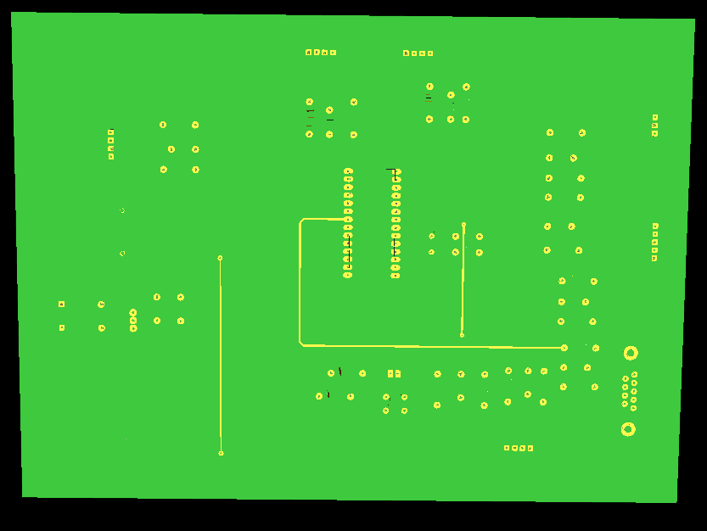
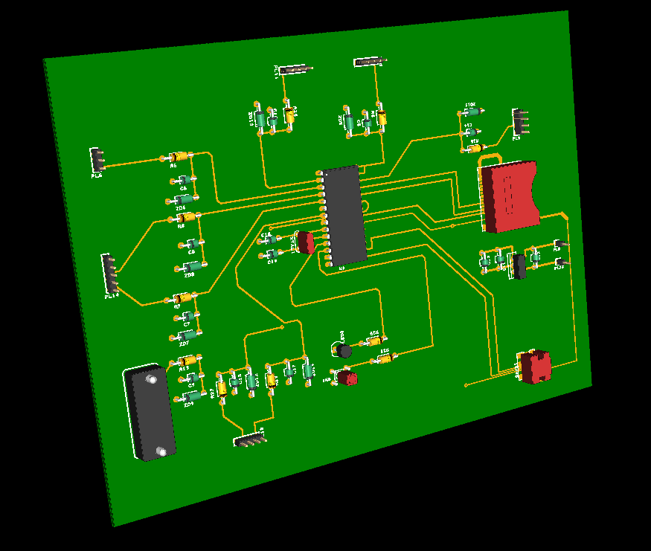
Figure 64 PCB 3D VIEWBACK
Figure 65 PCB 3D VIEW
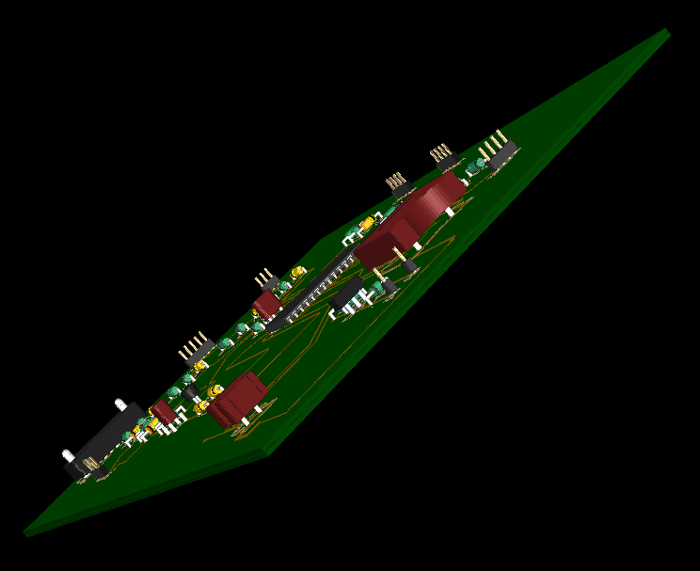
Figure 66 PCB 3D VIEW
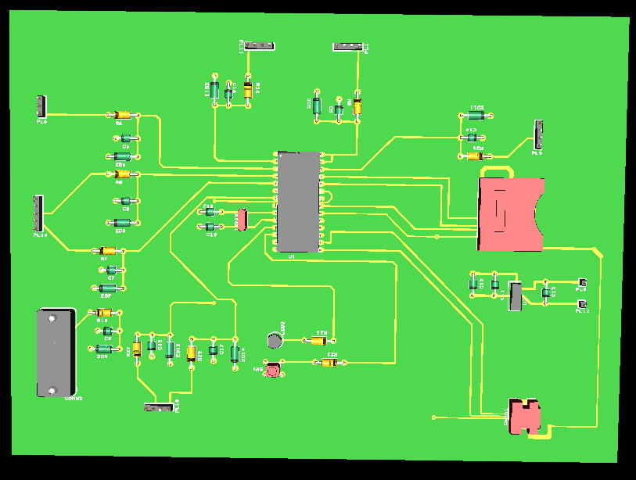
Figure 67 PCB 3D VIEW

9.0 Task 5

9.1 Structure Diagram Flow Chart

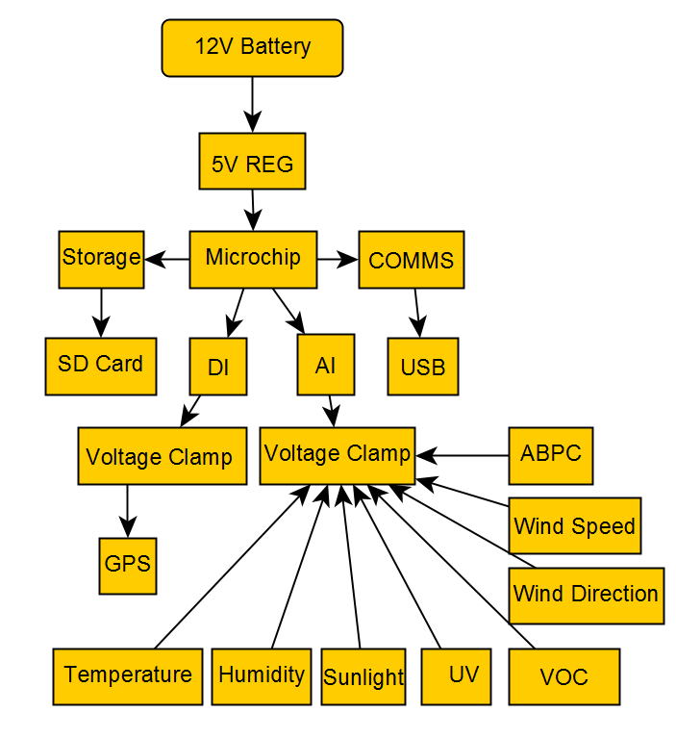
Figure 68 Structure Diagram Flow Chart

9.2 Software Diagram

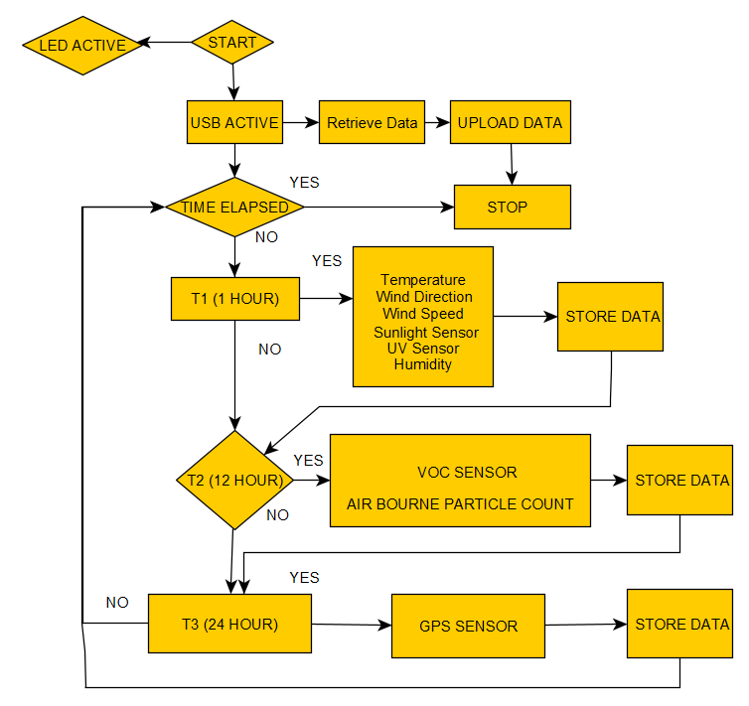
Figure 69 Software Diagram

10.0 Task 6

10.1 Prototype Build Costs

I used JLCPCB to obtain a prototype Build Cost for my Easy PC OCB Design

Figure 70 JLC PCB DESIGN BUILD

Uploaded ZIP File of Easy PC Plots Design
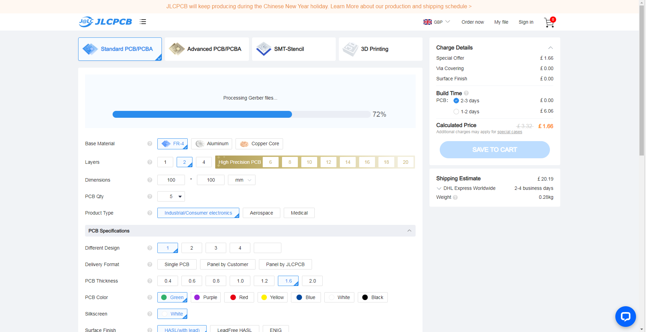
Figure 71 JLC PCB DESIGN BUILD

Selected 4 Layers and LEAD Free HASL
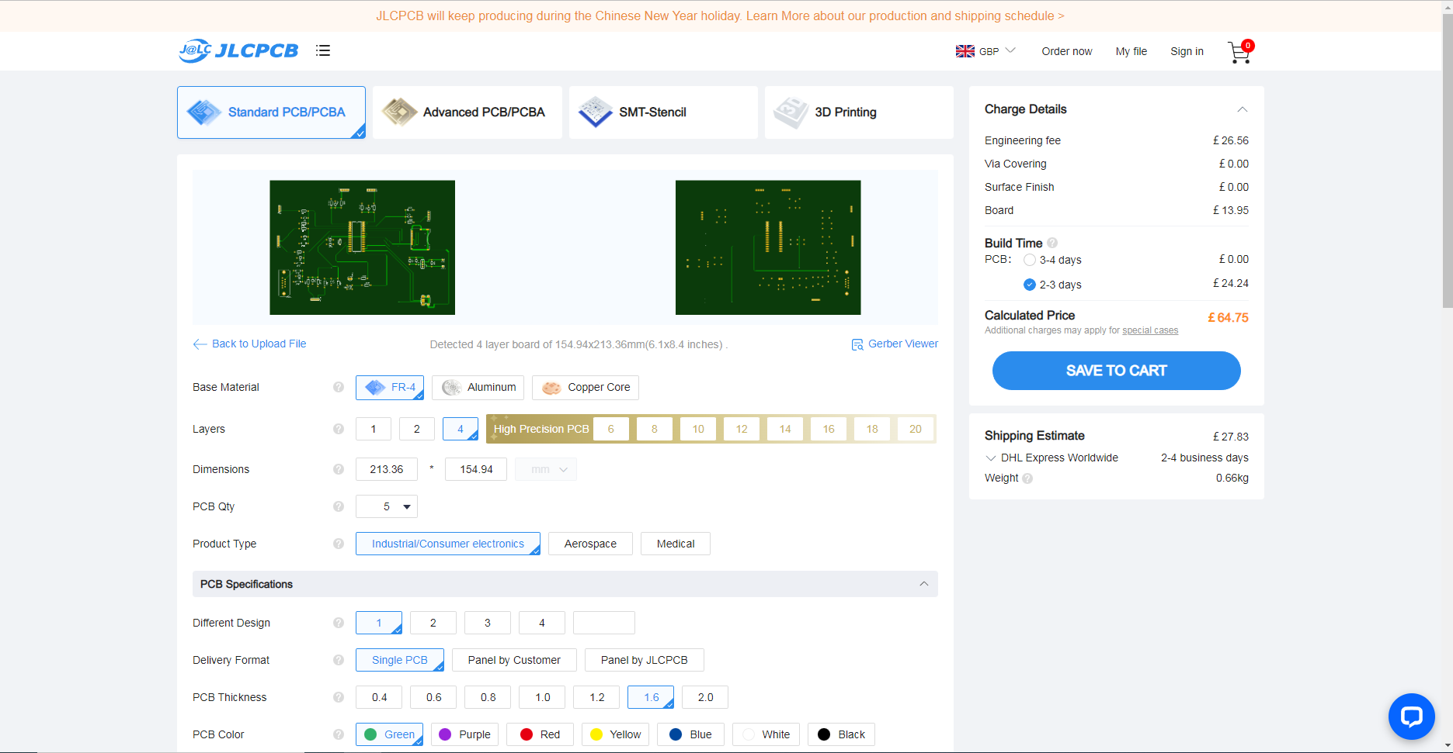
Figure 72 JLC PCB DESIGN BUILD COST

Delivery with 3 to 4 Days was £44.83
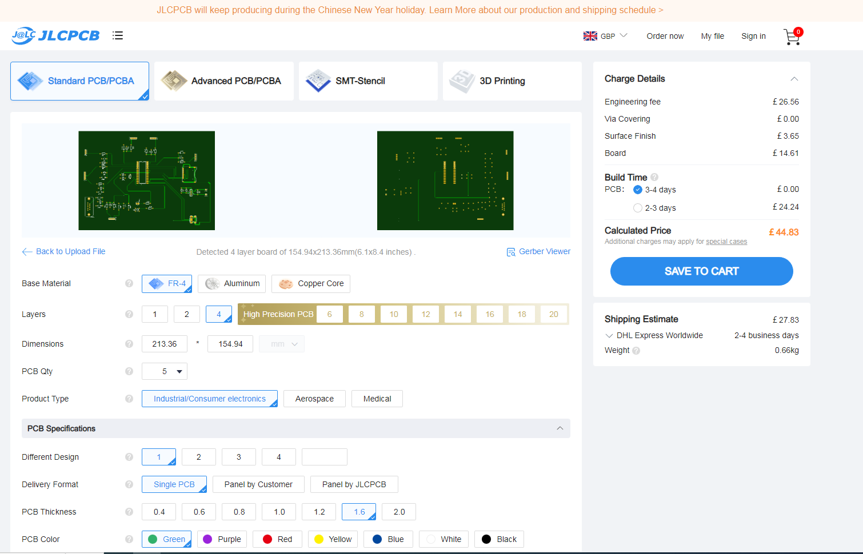
Figure 73 JLC PCB DESIGN BUILD COST

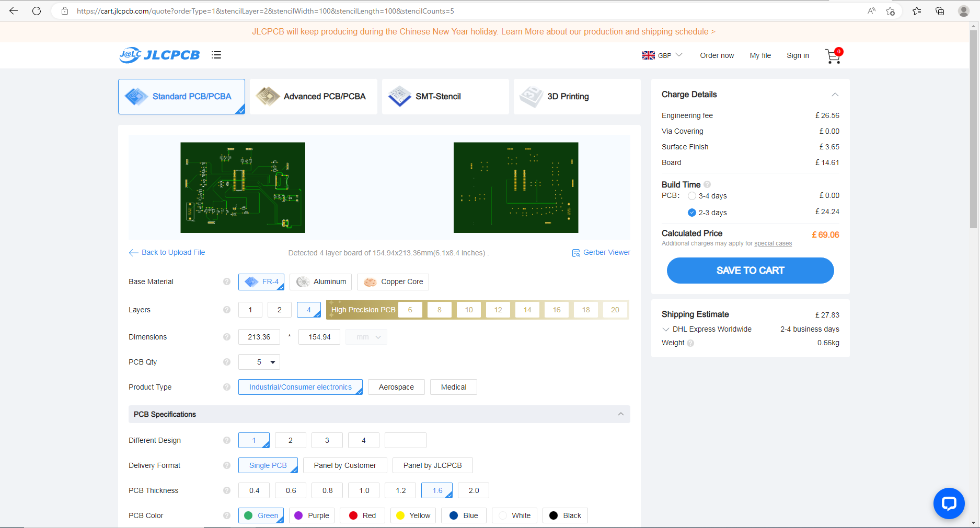
Delivery with 2 – 3 Days was £69.06
Figure 74 JLC PCB DESIGN BUILD DELIVERY

10.2 Costings
Table 15 Overall Costng Table
 | Manufacture | Info | Part Number | Ref | Cost
PCB | JLCPCB | 4 Layer  HASLFREE |  |  | £69.06
PIC28F24K50 | Microchip Technology |  |  |  | £2.53
Temperature and humidity | TE Connectivity | RS Stock No.:  893-7373 | Mfr. Part No.:  HPP809A031 |  | £107.46
Wind speed and direction | CALTSensoR | ALIEXPRESS | YGC-FSFX |  | £203.40
Air borne particle count | HONEYWELL | RS Stock No.:  214-1433 | HPMA115C0-004 |  | £85.51
Sunlight brightness | Seeed Technology Co., Ltd | 314990739 | 1597-314990739-ND |  | £54.17
UV levels | ADAFRUIT | GUVA-S12SD | SKU: ADA1918 |  | £6.50
GPS position | Quark-Elec | QK-AS07-0183 | NMEA 0183 |  | £165.73
VOC level | Ion science | TVOC | T-ION-TVOC |  | £3,599.35
SD Card | Kingston | RS Stock No. 195-8335 | SDS2/32GB |  | £10.46
Tripod | PRO AIM | SKU : P-MTCL-STD | Silver (P-MTCL-STD) |  | £867.4
Junction Box | RS | RS Stock No.:  192-7121 | RS PRO |  | £417.12
PCB Junction box | RS | 508-2782 | PC 1919 18 T enclosure |  | £59.64
Battery | Sterling | Sterling AMPS AL12300 LiFePO4 Lithium Battery | AL12300 |  | £1569.95 x 2 = £3139.9
3 Pin Connectors | LEMO | 178-8852 | FGG.2B.303.CLAD92Z |  | £149.26
4 Pin Connectors | LEMO | 215-6004 | FGG.0B.304.CLAD52Z |  | £87.20
5 Pin Connectors | LEMO | 178-8868 | FGG.2B.305.CLAD92Z |  | £163.52
8 Pin Connectors | LEMO | 257-4604 | FGG.2B.308.CLAZ |  | £94.64
Silca gEL | Rs pro | 601-041 |  |  | £33.71
9 Pin Connector | RS Components | RS Stock No.:  765-9555 | MHDPPK9-DB9S-K |  | £2.21
Tri Rated Cable | RS Components | 180-5936 |  |  | £29.33
Total = £9348.1

11.0 Task 7 Analysis

Enhancing the weather station To assist the system as a whole perform better, I would have added more sensors. To assist avoid misunderstanding while connecting the sensors to the micro controllers, I would also use coloured plugs rather than labels.
As certain regions can be inaccessible and require more time to visit, I would also extend the system's operational duration. This would enable the weather station to collect more data over a longer period of time.
The microcontroller should also include a stop button and a reset button, which will allow the user to halt the operation and do a reset if necessary.
Additionally, the microcontroller has an indicator LED for each sensor to demonstrate that it is functioning properly and recording Data.
I think some sensors, like wind speed and direction, might have been decreased to collect data more often, while other sensors, like GPS, could have been made longer. Since the weather station should not move unless tampered with, the 14-day placement period might be extended.

12.0 Sensor Data Sheets

12.1 Temperature and Humidity

HPP809A031 | TE Connectivity Temperature & Humidity Sensor, Voltage Output, Through Hole Mount, Analogue, ±5%RH | RS (rs-online.com)
HPC169_C HTM2500LF data sheet (rs-online.com)

12.2 Wind Speed / Direction

CALT Integrated wind speed and direction sensor YGC FSFX wind vane ABS 3cup anemometer|vane anemometers|wind speedwind vane - AliExpress

12.3 Air borne particle count

Honeywell HPMA115C0-004, Air Quality Sensor | RS (rs-online.com)
HPM Series Particle Sensor (rs-online.com)

12.4 Sunlight brightness

314990739 Seeed Technology Co., Ltd | Sensors, Transducers | DigiKey
LightIntensitySensor-UserGuide.pdf (seeedstudio.com)

12.5 UV Levels Sensor

Analog UV Light Sensor Breakout - GUVA-S12SD | The Pi Hut
GUVA-S12SD (adafruit.com)

12.6 GPS SENSOR

QK-AS07-0183 NMEA 0183 GPS & Heading Sensor with optional USB output - Quark-elec - NMEA 2000 & Marine electronics
QK-AS07-0183_manual.pdf (quark-elec.com)

12.7 VOC SENSOR

Volatile Organic Compound (VOC) Sensor | Onset's HOBO and InTemp Data Loggers (onsetcomp.com)
Ion Science VOC Monitor Connection Instructions (onsetcomp.com)

Bibliography

[1] | “What are weather stations and why do you need it for weather forecasting - Windy.app,” [Online].
[2] | “What are weather stations and why do you need it for weather forecasting - Windy.app,” [Online].
[3] | “Landscape: What is a Weather Station and Can it Benefit Ornamental Growers? | Center for Agriculture, Food, and the Environment at UMass Amherst,” [Online].
[4] | “What is the purpose of a weather station? | Netatmo,” [Online].
[5] | “What are weather stations and why do you need it for weather forecasting - Windy.app,” [Online].
[6] | “Automatic Weather Station- weather monitor system - Gas Detector&sensor/Soil Sensor/Water Quality/Weather Station - JXCT (jxdziot.com),” [Online].
[7] | “Weather Meter Kit - SEN-15901 (electromaker.io),” [Online].
[8] | “ATMOS 41 Tech Specs | METER Group, Inc. USA,” [Online].
[9] | “Folux | BRESSER Weather Center 5-in-1 black | Bresser Benelux,” [Online].
[10] | “What are weather stations and why do you need it for weather forecasting - Windy.app,” [Online].
[11] | “https://www.educba.com/what-is-microcontroller/,” [Online].
[12] | “https://www.bing.com/images/search?view=detailV2&ccid=%2bKdgPK1g&id=8EF1D51D9A0B46486E79763B5476E55D56774CDD&thid=OIP.-KdgPK1gh2Y19mO2EytpAQHaF3&mediaurl=https%3a%2f%2fwww.theengineeringprojects.com%2fwp-content%2fuploads%2f2018%2f03%2fWhat-is-a-Microcont,” [Online].
[13] | “https://www.fullyinstrumented.com/what-is-microcontroller/,” [Online].
[14] | “https://www.fullyinstrumented.com/what-is-microcontroller/,” [Online].
[15] | “https://www.fullyinstrumented.com/what-is-microcontroller/,” [Online].
[16] | “https://www.fullyinstrumented.com/what-is-microcontroller/,” [Online].
[17] | “https://www.fullyinstrumented.com/what-is-microcontroller/,” [Online].
[18] | “https://www.fullyinstrumented.com/what-is-microcontroller/,” [Online].
[19] | “https://www.fullyinstrumented.com/what-is-microcontroller/,” [Online].
[20] | “https://www.fullyinstrumented.com/what-is-microcontroller/,” [Online].
[21] | “https://www.bing.com/images/search?view=detailV2&ccid=l3E9XZQ%2F&id=982FFBBAE47F3B7288C1C8FEBB631924B4C212B4&thid=OIP.l3E9XZQ_9rVZ__czNPLp7gHaEK&mediaurl=https%3A%2F%2Fi.ytimg.com%2Fvi%2F9rHalQHp2_Y%2Fmaxresdefault.jpg&cdnurl=https%3A%2F%2Fth.bing.com%2Ft,” [Online].
[22] | “What Is A Microcontrollers: Its Types, Applications, And How Does It Work? - Tesca Technologies Pvt. Ltd. (tescaglobal.com),” [Online].
[23] | “PIC18(L)F2X/45K50 Product Brief (microchip.com),” [Online].
[24] | “PIC18(L)F2X/45K50 Product Brief (microchip.com),” [Online].
[25] | “PIC18(L)F2X/45K50 Product Brief (microchip.com),” [Online].
[26] | “PIC18(L)F2X/45K50 Product Brief (microchip.com),” [Online].
[27] | “PIC18F24K50-I/SO | Microchip Technology Inc. | World's Largest Inventory of Microchip Products (microchipdirect.com),” [Online].
[28] | “Microchip Products (microchipdirect.com),” [Online].
[29] | “Proaim Mitchell Heavy-duty Camera Tripod Stand with Spreader,” [Online].
[30] | “Proaim Mitchell Heavy-duty Camera Tripod Stand with Spreader,” [Online].
[31] | “Proaim Mitchell Heavy-duty Camera Tripod Stand with Spreader,” [Online].
[32] | “Proaim Mitchell Heavy-duty Camera Tripod Stand with Spreader,” [Online].
[33] | “Proaim Mitchell Heavy-duty Camera Tripod Stand with Spreader,” [Online].
[34] | “Proaim Mitchell Heavy-duty Camera Tripod Stand with Spreader,” [Online].
[35] | “Proaim Mitchell Heavy-duty Camera Tripod Stand with Spreader,” [Online].
[36] | “Proaim Mitchell Heavy-duty Camera Tripod Stand with Spreader,” [Online].
[37] | “Information - proaimuk - Checkout,” [Online].
[38] | “Proaim Scaffold Pole with Mitchell Mount,” [Online].
[39] | “Proaim Scaffold Pole with Mitchell Mount,” [Online].
[40] | “Domino Clamps Bolt-Ons: 48mm Tube Clamp Set,” [Online].
[41] | “RS PRO Fibreglass Reinforced Polyester Wall Box, IP66, 800 mm x 600 mm x 300mm | RS (rs-online.com),” [Online].
[42] | “RS PRO Fibreglass Reinforced Polyester Wall Box, IP66, 800 mm x 600 mm x 300mm | RS (rs-online.com),” [Online].
[43] | “PC 1919 18 T enclosure | Fibox SOLID PC Series Grey Polycarbonate Enclosure, IP66, IP67, Transparent Lid, 188 x 188 x 180mm | RS (rs-online.com),” [Online].
[44] | “0900766b80643c5b.pdf (rs-online.com),” [Online].
[45] | “RS PRO , Silica Gel, 10g | RS (rs-online.com),” [Online].
[46] | “Sterling AMPS AL12300 LiFePO4 Lithium Battery c/w BT BMS - 12V / 300 Ah (AL12300) (cactusnav.com),” [Online].
[47] | “SDS2/32GB | Kingston 32 GB SD SD Card, Class 10, UHS-I | RS (rs-online.com),” [Online].
[48] | “How to Use MMC/SDC (elm-chan.org),” [Online].
[49] | “ SD and Micro SD card pins with description and functions (electroniccircuitsdesign.com),” [Online].
[50] | “RS PRO Black 1 mm² Tri-rated Cable, 32/0.2 mm, 100m | RS (rs-online.com),,” [Online].
[51] | “HPP809A031 | TE Connectivity Temperature & Humidity Sensor, Voltage Output, Through Hole Mount, Analogue, ±5%RH | RS (rs-online.com),” [Online].
[52] | “HPC169_C HTM2500LF data sheet (rs-online.com),” [Online].
[53] | “A700000007572309.pdf (rs-online.com),” [Online].
[54] | “Digital Temperature & humidity sensor (With Stainless Steel Probe) - RobotShop,” [Online].
[55] | “Meteo Anemometer for Wind Speed and Direction (meteoprobe) (omniinstruments.co.uk),” [Online].
[56] | “Anemometer & wind direction [Pro-D] - Wind speed data loggers and anemometers (windlogger.com),” [Online].
[57] | “CALT Integrated wind speed and direction sensor YGC FSFX wind vane ABS 3cup anemometer|vane anemometers|wind speedwind vane - AliExpress,” [Online].
[58] | “Wind Speed and Direction Integrated Sensor_ Hunan Firstrate Sensor Co.,Lt,” [Online].
[59] | “Panasonic SN-GCJA5, Air Quality Sensor | RS (rs-online.com),” [Online].
[60] | “SEN0460 Dfrobot, Air Quality Sensor Module, PM2.5, 5 V | Farnell UK,” [Online].
[61] | “MLMLH PM2.5 Sensor - G5 PMS5003 PM2.5 Sensor Air Quality Monitoring Dust Measuring Air Dust Haze Tester : Amazon.co.uk: Business, Industry & Science,” [Online].
[62] | “Honeywell HPMA115C0-004, Air Quality Sensor | RS (rs-online.com),” [Online].
[63] | “Grove - Sunlight Sensor | The Pi Hut,” [Online].
[64] | “Outdoor stainless steel light sensor industrial RS485 light sensor light intensity meter detector brightness transmitter probe| | - AliExpress,” [Online].
[65] | “Outdoor light intensity sensor AHKF-I (spluss.de),” [Online].
[66] | “Adafruit SI1145 Digital UV Index/IR / Visible Light Sensor [ADA1777] – DirectNine - United Kingdom,” [Online].
[67] | “VEML6075 Vishay Semiconductor Opto Division | Sensors, Transducers | DigiKey,” [Online].
[68] | “UV Sensors - High specification sensors for measuring UV wavelengths (skyeinstruments.com),” [Online].
[69] | “Analog UV Light Sensor Breakout - GUVA-S12SD | The Pi Hut,” [Online].
[70] | “QK-AS07-0183 NMEA 0183 GPS & Heading Sensor with optional USB output - Quark-elec - NMEA 2000 & Marine electronics,” [Online].
[71] | “RS PRO Square GPS Antenna | RS (rs-online.com),” [Online].
[72] | “010-00258-63 | Garmin 16x GPS Sensor | RS (rs-online.com),” [Online].
[73] | “2614021137000 Würth Elektronik | RF/IF and RFID | DigiKey,” [Online].
[74] | “Volatile Organic Compound (VOC) Sensor | Onset's HOBO and InTemp Data Loggers (onsetcomp.com),” [Online].
[75] | “Room air quality sensor (VOC) and measuring transducer RLQ-W VA (spluss.de),” [Online].
[76] | “Cellar CO2 Gas Monitoring System Only £155.15 excl vat From Safety Gear Store Ltd,” [Online].
[77] | “PS1-VOC-1000 Amphenol SGX Sensortech | Sensors, Transducers | DigiKey,” [Online].
[78] | U3, “Laser displacement sensors (triangulation),” [Online]. Available: https://www.micro-epsilon.co.uk/download/products/cat-optoncdt/dax--optoNCDT-1750LL--en.html#page=2&zoom=Fit . [Accessed 11 11 2018].
[79] | Omega, “Linear Displacement Sensor, Non-Contact,” [Online]. Available: https://www.omega.co.uk/pptst/LD701.html . [Accessed 11 11 2018].
[80] | Omega, “LD400,” [Online]. Available: https://www.omega.co.uk/pptst/LD400.html. [Accessed 12 11 2018].
[81] | RS, “RS PRO Black Tri-rated Cable,” [Online]. Available: https://uk.rs-online.com/web/p/products/8034177/. [Accessed 11 11 2018].
[82] | “http://racingcardynamics.com/data-acquisition-fundamentals/,” [Online].
[83] | “http://racingcardynamics.com/data-acquisition-fundamentals/,” [Online].
[84] | “http://racingcardynamics.com/data-acquisition-fundamentals/,” [Online].
[85] | “https://dataloggerinc.com/product/delphin-loggitolab-usb-logger/,” [Online].
[86] | “https://dataloggerinc.com/product/delphin-loggitolab-usb-logger/,” [Online].
[87] | “https://dataloggerinc.com/wp-content/uploads/2021/09/Brochure_LoggitoLab_EN.pdf,” [Online].
[88] | “https://www.campbellsci.com/cr300,” [Online].
[89] | “CR300: Measurement and Control Datalogger (campbellsci.com),” [Online].
[90] | “Rebel LT Vehicle Data Logger from Influx - CAS DataLoggers (dataloggerinc.com),” [Online].
[91] | “Rebel-LT-spec-sheet-v19.1.pdf (dataloggerinc.com),” [Online].
[92] | “https://www.tempcon.co.uk/media/pdf/G210_DataTaker_DT80.pdf,” [Online].
[93] | “https://www.tempcon.co.uk/media/pdf/G210_DataTaker_DT80.pdf,” [Online].
[94] | “https://dataloggerinc.com/product/delphin-loggitolab-usb-logger/,” [Online].
[95] | “https://www.tempcon.co.uk/media/pdf/G210_DataTaker_DT80.pdf,” [Online].
[96] | “CR300: Measurement and Control Datalogger (campbellsci.com),” [Online].
[97] | “Rebel LT Vehicle Data Logger from Influx - CAS DataLoggers (dataloggerinc.com),” [Online].
[98] | “https://www.educba.com/what-is-microcontroller/,” [Online].
[99] | “https://www.bing.com/images/search?view=detailV2&ccid=%2bKdgPK1g&id=8EF1D51D9A0B46486E79763B5476E55D56774CDD&thid=OIP.-KdgPK1gh2Y19mO2EytpAQHaF3&mediaurl=https%3a%2f%2fwww.theengineeringprojects.com%2fwp-content%2fuploads%2f2018%2f03%2fWhat-is-a-Microcont,” [Online].
[100] | “https://www.fullyinstrumented.com/what-is-microcontroller/,” [Online].
[101] | “https://www.bing.com/images/search?view=detailV2&ccid=l3E9XZQ%2F&id=982FFBBAE47F3B7288C1C8FEBB631924B4C212B4&thid=OIP.l3E9XZQ_9rVZ__czNPLp7gHaEK&mediaurl=https%3A%2F%2Fi.ytimg.com%2Fvi%2F9rHalQHp2_Y%2Fmaxresdefault.jpg&cdnurl=https%3A%2F%2Fth.bing.com%2Ft,” [Online].
[102] | “What Is A Microcontrollers: Its Types, Applications, And How Does It Work? - Tesca Technologies Pvt. Ltd. (tescaglobal.com),” [Online].
[103] | “PIC18(L)F2X/45K50 Product Brief (microchip.com),” [Online].
[104] | “PIC18(L)F2X/45K50 Product Brief (microchip.com),” [Online].
[105] | “PIC18(L)F2X/45K50 Product Brief (microchip.com),” [Online].
[106] | “PIC18(L)F2X/45K50 Product Brief (microchip.com),” [Online].
[107] | “PIC18F24K50-I/SO | Microchip Technology Inc. | World's Largest Inventory of Microchip Products (microchipdirect.com),” [Online].
[108] | “PIC18F24K50-I/SO | Microchip Technology Inc. | World's Largest Inventory of Microchip Products (microchipdirect.com),” [Online].
[109] | “RS PRO Black Steel Project Box, 279 x 203 x 131mm | RS (rs-online.com),” [Online].
[110] | “RS PRO Grey Cold Rolled Steel Instrument Case, 245 x 137 x 105mm | RS (rs-online.com),” [Online].
[111] | “518-0910 | Hammond 518 Grey Steel Instrument Case, 248 x 197 x 121mm | RS (rs-online.com),” [Online].
[112] | “How to Use MMC/SDC (elm-chan.org),” [Online].
[113] | “SD and Micro SD card pins with description and functions (electroniccircuitsdesign.com),” [Online].
[114] | “SD Cards, 64GB SD Card, SD Memory Card & Adapter | RS (rs-online.com),” [Online].
[115] | “XUB2BPANL2R Schneider Electric (wiautomation.com),” [Online].
[116] | “Medical devices in-depth review: medical-grade thermocouples - Medical Device Network (medicaldevice-network.com),” [Online].
[117] | “Thermistors: NTC and PTC Thermistors Explained - Latest Open Tech From Seeed (seeedstudio.com),” [Online].
[118] | “Calex PN151 V Output Signal NFC Infrared Temperature Sensor, 1m Cable, 0°C to +1000°C | RS (rs-online.com),” [Online].
[119] | “Optris RSCCSLT15SFCB1K V Output Signal USB Infrared Temperature Sensor, 1m Cable, -20°C to +350°C | RS (rs-online.com),” [Online].
[120] | “RS PRO V Output Signal UART, USB Infrared Temperature Sensor, 1m Cable, 0°C to +1000°C | RS (rs-online.com),” [Online].
[121] | “Proximity Switch 1.5A - Unbranded | CPC UK (farnell.com),” [Online].
[122] | “TDP0,2 LT-4 B10 55 | Tachogenerator 60mV, at ≤ 10000rpm, EURO Flange B10, 11mm Shaft Diameter | RS (rs-online.com),” [Online].
[123] | “SS495A | Honeywell Hall Effect Sensor, Ratiometric Output, 4.5 → 10.5 V dc | RS (rs-online.com),” [Online].
[124] | “KUS Magnetoelectric Tachometer Sensor (5/8"-18 UNF) (asap-supplies.com),” [Online].
[125] | “IR Break Beam Sensor (5mm LEDs) - Pimoroni,” [Online].
[126] | “reflective IR measure rpm - Google Shopping,” [Online].
[127] | “Retro-reflective sensor ifm electronic OF5016 - OFR-FP… | Automation24,” [Online].
[128] | “Retro-reflective sensor ifm electronic O6P300 - O6P-FP… | Automation24,” [Online].
[129] | “Retro–reflective sensor ifm electronic O6P203 - O6P-FP… | Automation24,” [Online].
[130] | “HG4930AS36 Honeywell Aerospace | Sensors, Transducers | DigiKey,” [Online].
[131] | “540A Senther Technology | Sensors, Transducers | DigiKey,” [Online].
[132] | “IR Location System (columbia.edu),” [Online].
[133] | “Vzense ToF Sensor and Application,” [Online].
[134] | “http://2d-datarecording.com/Downloads/Datasheets/Sensors-dynamic/Pdf/SA-GYxxxV4-000-DINA4.pdf,” [Online].
[135] | “ADXRS450BRGZ Analog Devices, MEMS Gyroscope, Digital, Pitch | Farnell,” [Online].
[136] | “IGS-M027 – AGV/AMR Solutions and Components Supplier (myten-tech.com),” [Online].
[137] | “https://campaign.aliexpress.com/wow/gcp/tesla-pc-new/index?UTABTest=aliabtest344316_486351&_randl_currency=GBP&_randl_shipto=GB&src=google&memo1=freelisting&aff_fcid=72d43bf2c73349ddac0e4e051427707d-1669558426658-01239-UneMJZVf&aff_fsk=UneMJZVf&aff_platfo,” [Online].
[138] | “SG1-120-2 TE Connectivity Measurement Specialties | Sensors, Transducers | DigiKey,” [Online].
[139] | “https://campaign.aliexpress.com/wow/gcp/tesla-pc-new/index?UTABTest=aliabtest344316_486351&_randl_currency=GBP&_randl_shipto=GB&src=google&aff_fcid=c05b66c810a847d49ef2e33149c341fa-1669558583692-02739-UneMJZVf&aff_fsk=UneMJZVf&aff_platform=aaf&sk=UneMJZVf,” [Online].
[140] | “https://campaign.aliexpress.com/wow/gcp/tesla-pc-new/index?UTABTest=aliabtest344316_486351&_randl_currency=GBP&_randl_shipto=GB&src=google&aff_fcid=b4341b8bf90a4a6e9bb2b15175d337da-1669558667724-01435-UneMJZVf&aff_fsk=UneMJZVf&aff_platform=aaf&sk=UneMJZVf,” [Online].
[141] | “BUS0039 (BUS M30M1-PPX-20/130-S92K) Ultrasonic sensors with a digital output - BALLUFF,” [Online].
[142] | “Microsoft Word - SA-WPxxxxHQ-000.doc (datrontechnology.co.uk),” [Online].
[143] | “SG1-120-2 TE Connectivity Measurement Specialties | Sensors, Transducers | DigiKey,” [Online].
[144] | “SKD User Selectable 4..20mA / 0..10Vdc Output (te.com),” [Online].
[145] | “09200042611+19200030420 | HARTING Quick Lock Connector Set, 4 Way, 10.0A, Male, Han A, 230 → 400 V | RS (rs-online.com),” [Online].
[146] | “09200030301+09200042711 | HARTING Coupler Kit, 4 + PE Way, 10.0A, Female, Han A, 230 → 400 V | RS (rs-online.com),” [Online].
[147] | “RS PRO Black 1 mm² Tri-rated Cable, 32/0.2 mm, 100m | RS (rs-online.com),” [Online].
[148] | “MHDPPK9-DB9S-K | MH Connectors 9 Way D-sub Connector | RS (rs-online.com),” [Online].
[149] | “NP2.3-12 Yuasa 2.3Ah 12v VRSLA Battery | MDS Battery,” [Online].
[150] | “https://www.fullyinstrumented.com/what-is-microcontroller/,” [Online].
[151] | “https://www.fullyinstrumented.com/what-is-microcontroller/,” [Online].
[152] | “https://www.fullyinstrumented.com/what-is-microcontroller/,” [Online].
[153] | “https://www.fullyinstrumented.com/what-is-microcontroller/,” [Online].
[154] | “https://www.fullyinstrumented.com/what-is-microcontroller/,” [Online].
[155] | “https://www.fullyinstrumented.com/what-is-microcontroller/,” [Online].
[156] | “https://www.fullyinstrumented.com/what-is-microcontroller/,” [Online].
[157] | “https://www.fullyinstrumented.com/what-is-microcontroller/,” [Online].
[158] | Weather Stations , “Weather Stations,” [Online]. Available: https://www.weatherstations.co.uk/hhanemometers.htm. [Accessed 01 12 2018].
[159] | Omni Instruments , “Weather Stations,” [Online]. Available: http://www.omniinstruments.co.uk/weather-stations-and-instruments/weather-stations/metpak-automatic-weather-stations.html. [Accessed 01 12 2018].
[160] | Campbellsci , “Weather Stations,” [Online]. Available: https://www.campbellsci.eu/wxpro. [Accessed 01 12 2018].
[161] | Omni Instruments , “GMX301 Weather Station,” [Online]. Available: http://www.omniinstruments.co.uk/weather-stations-and-instruments/weather-stations/gmx301-weather-station.html. [Accessed 01 12 2018].
[162] | Omega, “Relative Humidity/Ambient Temperature Transmitters,” [Online]. Available: https://www.omega.co.uk/pptst/hx94b.html . [Accessed 04 12 2018].
[163] | Michell Online, “PC33 & 52 Analog Relative Humidity and Temperature Probe,” [Online]. Available: https://www.michellonline.com/eu/index.php?route=product/product&path=59&product_id=64?language=en&currency=GBP . [Accessed 05 12 2018].
[164] | Michell.com, “Temp and humidity sensors,” [Online]. Available: http://www.michell.com/uk/products/pfmini72.htm . [Accessed 05 12 2018].
[165] | RS, “Temperature and Humidity Sensors,” [Online]. Available: https://uk.rs-online.com/web/p/temperature-sensors-humidity-sensors/8937373/. [Accessed 05 12 2018].
[166] | Omega, “Wind Monitoring Station with Analog Outputs,” [Online]. Available: https://www.omega.co.uk/pptst/WMS-20.html . [Accessed 05 12 2018].
[167] | Campbellsci, “Wind Speed and Wind Direction Sensors / 05103,” [Online]. Available: https://www.campbellsci.eu/05103 . [Accessed 05 12 2018].
[168] | Campbellsci, “WINDSONIC1,” [Online]. Available: https://www.campbellsci.eu/windsonic1 . [Accessed 05 12 2018].
[169] | Campbellsci, “Wind Speed and Wind Direction Sensors 03002,” [Online]. Available: https://www.campbellsci.eu/03002-wind-sentry . [Accessed 05 12 2018].
[170] | JLCPCB, “PCB,” [Online]. Available: https://jlcpcb.com/quote. [Accessed 03 01 2019].
[171] | Angstrom Technology , [Online]. Available: https://angstromtechnology.com/product/aerotrak-remote-particle-counters-models-7510-01fv-7510-02fv-7510-a2fv/. [Accessed 13 12 2018].
[172] | LI-COR, “LI-210R Photometric Sensor,” [Online]. Available: https://www.licor.com/documents/yz9i70ahffuavsowacyckynjavf2assw. [Accessed 20 12 2018].
[173] | digikey, “Vishay Semiconductor / Opto Division,” [Online]. Available: https://www.digikey.co.uk/en/product-highlight/v/vishay-semi-opto/veml6075-uva-uvb-light-sensor?utm_adgroup=Sensors+%26+Transducers&mkwid=sPXJgxIQF&pcrid=267270544023&pkw=&pmt=b&pdv=c&productid=&slid=&gclid=EAIaIQobChMIl96Rg9GL3wIVz5ztCh0hkwFPEAAYAyAAEgJN. [Accessed 06 12 2018].
[174] | GPS Antennas, [Online]. Available: https://uk.rs-online.com/web/p/gps-antennas/1729300/. [Accessed 13 12 2018].
[175] | Onsetcomp , “VOC,” [Online]. Available: https://www.onsetcomp.com/products/sensors/t-ion-tvoc. [Accessed 19 12 2018].
[176] | RS, “Kingston 8 GB MicroSDHC Card Class 4,” [Online]. Available: https://uk.rs-online.com/web/p/products/6957334/?grossPrice=Y&cm_mmc=UK-PLA-DS3A-_-google-_-PLA_UK_EN_CatchAll-_-Ad+Group+Catch+All-_-PRODUCT_GROUP&matchtype=&aud-359456720600:pla-379154728750&s_kwcid=AL!7457!3!226080437215!!!g!379154728750!&gclid=EAIaIQo. [Accessed 10 01 2018].
[177] | weather weather weather, “https://www.weather-station-products.co.uk/catalog/product/view/id/23245/s/davis-mounting-tripod/?utm_source=google_shopping&keyword=&campaignID=233874262&matchtype=&adgroupID=14405733382&gclid=EAIaIQobChMIvpqnrMPh3wIVBpztCh2qlgBUEAQYBSABEgKlUPD_BwE,” [Online]. Available: https://www.weather-station-products.co.uk/catalog/product/view/id/23245/s/davis-mounting-tripod/?utm_source=google_shopping&keyword=&campaignID=233874262&matchtype=&adgroupID=14405733382&gclid=EAIaIQobChMIvpqnrMPh3wIVBpztCh2qlgBUEAQYBSABEgKlUPD_BwE. [Accessed 3 1 2019].
[178] | RS, “Floor Standing Enclosure, Single Door, PET, Grey, 500 x 500 x 320mm IP65 Thalassa PLA,” [Online]. Available: https://uk.rs-online.com/web/p/floor-standing-enclosures/1230645/. [Accessed 01 01 2019].
[179] | CPC, “12V 2Ah NP Series Lead Acid Battery - NP2-12,” [Online]. Available: https://cpc.farnell.com/yuasa/np2-12/battery-lead-acid-12v-2ah/dp/BT00574?mckv=sXL3yKkm6_dc|pcrid|224680288544|kword||match||plid||slid||product|BT00574|pgrid|48556615353|ptaid|pla-436764189069|&CMP=KNC-GUK-CPC-SHOPPING&gclid=EAIaIQobChMItY6utfPW3gIVS7DtC. [Accessed 20 11 2018].
[180] | AliExpress, “SP13 3 pin,” [Online]. Available: https://www.aliexpress.com/item/3Pins-Waterproof-Aviation-Connector-Plug-socket-IP68-wire-connector-Insulation-waterproof-connector-gold-plated-needle-core/32346782262.html. [Accessed 10 01 2018].
[181] | imall, “SP2110, waterproof LED cable connector ip68 male and female 4 pin, Industrial Power Panel mount connector 4 pin,” [Online]. Available: https://imall.com/product/?en&store=aliexpress.com&sku=32648734842&skuip=3440530. [Accessed 10 01 2018].
[182] | Alibaba.com, [Online]. Available: https://www.alibaba.com/product-detail/M14-male-and-female-5-pin_60096520172.html. [Accessed 10 01 2018].
[183] | “Proaim Mitchell Heavy-duty Camera Tripod Stand with Spreader,” [Online].
[184] | “ SD and Micro SD card pins with description and functions (electroniccircuitsdesign.com),” [Online].
[185] | “Industrial Circular Connectors | Heavy Duty | RS (rs-online.com),” [Online].
[186] | “Industrial Circular Connectors | Heavy Duty | RS (rs-online.com),” [Online].
[187] | “Industrial Circular Connectors | Heavy Duty | RS (rs-online.com),” [Online].
[188] | “Industrial Circular Connectors | Heavy Duty | RS (rs-online.com),” [Online].
[189] | “Industrial Circular Connectors | Heavy Duty | RS (rs-online.com),” [Online].
[190] | “RS PRO Black 1 mm² Tri-rated Cable, 32/0.2 mm, 100m | RS (rs-online.com),,” [Online].
[191] | “MHDPPK9-DB9S-K | MH Connectors 9 Way D-sub Connector | RS (rs-online.com),” [Online].

