Proto
Prototype update
User Experience Design

UWTSD
Tom Evans p145653

Introduction
This report will attempt to expand upon an earlier report detailing the prototyping of a design for a mobile application for students of the University of Wales Trinity St. David. This report will discuss a set of full colour story boards and how they were developed from the data collected from the previous assignment. A discussion will cover the changes made from the original wireframe. This will include some of the feedback gained from the wireframe created in this earlier part of the module. The appendix will contain a full selection of the designs storyboard in full colour and the original wireframe created in the original report for this project.
The report will then go on to cover the kind of feedback that was given on the original wireframe diagrams created and the positives and negatives that were gained from prototyping the original design. A discussion will cover the data that would and could be gathered from creating a working version of the application and how the data could be used to change and improve the application.
Finally in the last section of the report will discuss the overall process used for the development of the applications design and how it has been influenced over time by usability theory and feedback gained from potential users from creating several prototypes of the design.

Storyboards
The feedback from the original design discussed many things that could be added to the design to improve the application’s success. The original report found that the use of a drop-down menu could ease the complexity of some of the original designs. A drop down list has been incorporated for the timetable’s page. When a day is selected a list of all appointments or scheduled lectures will drop down showing all the appointments the user has on that selected day.
The original feedback also expressed that the original designs in the original wireframe may be too simple. The new storyboard designs that can be seen in Appendix 2 shows that later designs have been changed so that they’re far more in depth than the original wireframe. The designs show how the navigation from between all the pages works and how the pages change depending on weather the user has been logged in or not.
An example of the things changed due to this bit of feedback include the unlogged in user. Before the application has been logged into the user can only see the home screen and a button to allow them to log in. This screen only allows access to the applications list of open days. This way the application could be used for prospective students who may need to plan open days. Clicking the buttons for any of the individual campuses could take the user to the individual pages that will allow them to book a place for that open day should they actually not be a student at the university.
Once the user has logged into the application using the login page, the application will open up them up and provide them with a variety of more options. Once logged in the login button on the top right corner of the application will be replaced with a “Welcome (User)” line of text (With “User” being replaced with the user’s name). The application’s menu will also become available once the user has logged in. This includes the buttons for “Home”, “Modules” and “Timetables”. These pages only become available once a user has logged in because the app will require information on a student’s timetable and modules in order for the pages to work as intended.
The modules page will require data from Moodle in order to display some of the information on a student’s modules. Clicking a module would take them to the modules Moodle in a browser page so they can access all their module resources and information. The application would require a list of modules for each student in order to provide this feature for its users.
Finally the application’s timetable page will include a list of all working days. Each day will have a drop down list that will open to display all the appointments a user may have on this day. Lecturers will have the ability to add drop in sessions to their timetables for a selected module. All students enrolled on that module will then receive notifications from the application that the session has been added. This could also be applied to room changes and lecture cancellations with notification’s being sent out to all users. Of course this wouldn’t be able to be the only way of contacting students as it relays’ heavily on student having smart phones.

Feedback
When designing the original wireframes and the expanded storyboard for this applications design it was important to collect feedback from prospective users. Feedback aids in helping develop the applications design and make sure the design changes suit the needs of the user and help improve the application on not just adhere to what the develop believes is needed from the application. Gaining feedback can also help the developer see any faults that they may not recognise and improve upon them before the application is developed, this can help save developers a lot of money on fixing design problems before they are implemented.
In order to gain feedback for the final storyboard designs the author of this report introduced the some potential users to the storyboards and asked them to grade the designs. This was done using the system usability scale [1]. The scale provides 10 questions that will ask potential user to grade the designs on a scale of strongly agree to strongly disagree. The scores for the original wireframe designs when showed to prospective users ranged from 45 to 63. This score is traditionally considered low for the scale with 68 and higher being considered above average for the scale.
When deciding what people would be chosen to grade the designs it was important to consider the original personas outlined in the first half of this module for the applications. These personas were outline to ensure that all most potential users were covered and therefore the needs of the majority would all be considered for the applications design. For the most part finding people that matched the personas but five students were found of mixed ages that were applicable to the personas outlined to some extent.
The scores for the storyboard designs using the system usability scale range from 67 to 79. This can be seen as an obvious improvement on the scores seen from the wireframes scores. Most of the scores are in the mid to high seventies with 67 being the lowest score received and the only one that is considered below average by the scale. These scores are an obvious improvement from the scores provided for the wireframe diagram and show the effectiveness of using the scale to help improve the application.
Despite the improvement from the original use of the scale there were patterns that outlined room for improvement on the designs. The questions about feature integration and being unnecessarily complex scored quite average to low scores with many feeling they didn’t agree or disagree with the statements. When asked about this many expressed frustrations with the application’s module page only including links to the external Moodle. Many stated they’d like to be able to access their course resources from inside the app rather than being taken out of the application and onto Moodle to access their resources.
Many also stated they felt they would like a notification’s menu that would allow them to see a lift of previous notifications in case the original notification became inaccessible for some reason. They felt not having a notification’s list may lead to them missing notification on room changes and lecture cancelations and or rescheduling.
Data from development
The brief for this report suggests a hypothetical situation in which the application were developed and released according to the designs created for the application. The brief asks what kind of data would need to be collected by from the app’s users and how it could be used to improve upon the application.
Before looking at how the data could be used to improve the application firstly the way in which data can be collected should be considered. Firstly user usage data should be collected from the application. This data will show what features of the applications are being used most and what data the application is requesting most often. This will not only show the developer what parts of the application is being used most often but will show how what parts of the application is in need of improving in a future version.
Once that the user usage data has vaguely outlined what would need to be improved the developer will need data to outline how these imperfections can be improved. This will be done by gaining emotional response data. This could be done in the form of sitting down with users who have been using the app and interviewing them personally to retrieve more in depth data. The questions for the interview could be catered using the data gained from the users to ensure they look at the problem areas. The questions could also be used to find room for expansion on the application. Once again the users could be asked to grade the application using the system usability scale.

Reflection
Upon reflection of the design process the author of this report feels that evolution of the applications design has gone well throughout the course of the module. The evolution of the applications design proved to be worthwhile with the results from using the system usability scale showing that potential users felt the application had improved from the original wireframe diagrams created in the first half of the module. When developing the designs for the application the process of consulting potential users was different to what the author of this report was used to but felt it was a welcome to change to have someone to consult in order to find faults and room for improvements.
The factors learned from this module conflicts marginally with what has been previously learned in other modules in the past. Consulting with users before developing the application to find out what kind of features they were interested in the author feel greatly improved the final product of the assignment as oppose to a former module interaction design from first year where the author made little effort to consult in prospective users before designing the application. It may be wise in future to consult in things learned from both modules before starting the development of any project.

References
[1] Affairs, A. (2019). System Usability Scale (SUS) | Usability.gov. [online] Usability.gov. Available at: https://www.usability.gov/how-to-and-tools/methods/system-usability-scale.html [Accessed 10 May 2019].

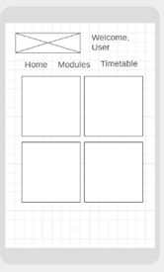
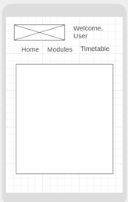
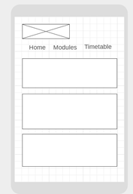
Appendix 1: Original Wireframe Diagrams

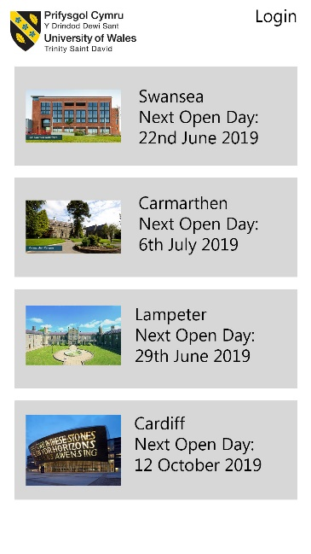
Appendix 2: Modified design storyboards


