DIGITAL ENTREPRENEURSHIP
BMMB 7002D
ASSIGNMENT 1 B.



Marjorie Klopper
Student Number: 1815039

Executive Summary
This assignment gives a systematic analysis of the organisation, Barnes & Noble, (B&N) regarding digital disruption and the nature of opportunities affecting the industry for digital media technologies. It includes the assessment of changing technology, regulatory and consumer dynamics in light of the products offered by the company.
The tools used for the analysis include the Business Model Canvas, Three Dimensions of Disruption, Value System, 6 Ps of marketing, SWOT analysis and Customer Life Cycle.
The assignment concludes that the bookselling business is digitally disrupted on a technology level, the value system, distribution channels, consumer dynamics, as well as the regulatory environment. B&N have adapted their business model to suit the digital era, but there is room for improvement.
Recommended improvements include addressing the high prices of their e-books and making their downloadable app more user-friendly and compatible with all devices. B&N should address risks associated with short-term contracts with third-party partners, and redesigning their brick and mortar stores to incorporate digital/techno systems and an environment that would attract new customers.

INDEX
Introduction 4
Industry Disruption 4
Business Model Canvas (BMC) 5
Customer Segments 5
Customer Relationships 6
Channels 6
Value Proposition 6
Key Activities 7
Key Resources 7
Key Partnerships 8
Cost Structure 8
Revenue Streams 8
PORTERS VALUE CHAIN 8
6 P’S OF MARKETING 9
BARNES & NOBLE SWAT ANALYSIS 10
Strengths 10
Weaknesses 10
Opportunities 11
Threats 11
CONSUMER DYNAMICS 11
REGULATORY ENVIRONMENT 12
CONCLUSION 12
RECOMMENDATION 13
REFERENCES 14
APPENDIX 18

INTRODUCTION
Barnes & Noble, Inc. (B&N or ' the business ') headquartered in the United States (US), a principal specialist in content, electronic media and educational products. The company runs six hundred and twenty-seven bookstores in over 50 states as well as BN.com, one of the largest e-commerce Websites.
(In June 2019 B&N announced that Elliott Management would acquire the company).
This assignment aims to give a systematic analysis of the organisation, in light of digital disruption and the opportunities affecting the industry for digital media technologies. The task includes assessments of changing technology, regulatory and consumer dynamics in light of the products offered by B&N.
Included in the book industry, are physical and e-books. The online segment of the book industry comprises of e-books read on computers or other digital devices like tablets.
INDUSTRY DISRUPTION
Over 100 years after its formation, B&N’s most significant threat came to life. In its early web days, Amazon, striking at the very core of B&N book sales, transformed the face of the retail book market (Manning, Brian, 2016). Initially, B&N seized digital technology quickly. In 1997, two years after the launch of Amazon.com, B&N opened their online bookstores. They launched the Nook e-reader in 2009, two years after Amazon introduced the Kindle. Buyers looked at such tools as pure e-readers. Aspects like screen size, weight, and pricing were competitive, which enabled B&N to win market share from Amazon (Manning, Brian, 2016). They produced ten different Nook generations. Nevertheless, the Nook’s revenues kept decreasing, and they separated the unsuccessful Nook category in June 2014.
By 2012, the e-book market share grew to 22.6%. Publishers feared that this was the end of physical books. But in 2013 e-book sales for the 1,200 largest publishers began decreasing and have continued to do so. These 1200 publishers are losing market share due to high digital book prices.
In 2017, Amazon e-book sales grew, and reader base numbers for Kobo and Apple increased. Amazon owns 80% of the book market, and they do not report sales of self-published e-books. Audiobooks grew by 29.5% in 2017 and by 32.1% in the first quarter of 2018. The digital retail business in the US is expected to reach a value of US$447.4 billion by 2022 from US$297.8 billion in 2017.
E-Books shape a relevant market category and will continue to do so. The market is at a point where electronic and conventional books can co-exist in a compatible environment with one another.
BUSINESS MODEL CANVAS (BMC)
Both traditional and digital business models are reflected in Illustration 1 below. Points highlighted in red suggest how B&N could improve its business model.
Customer Segments
Barnes and Noble have a diverse target market (Cleverism, 2019).

Illustration 1. Business Model Canvas comparing traditional bookstores and e-bookstores.
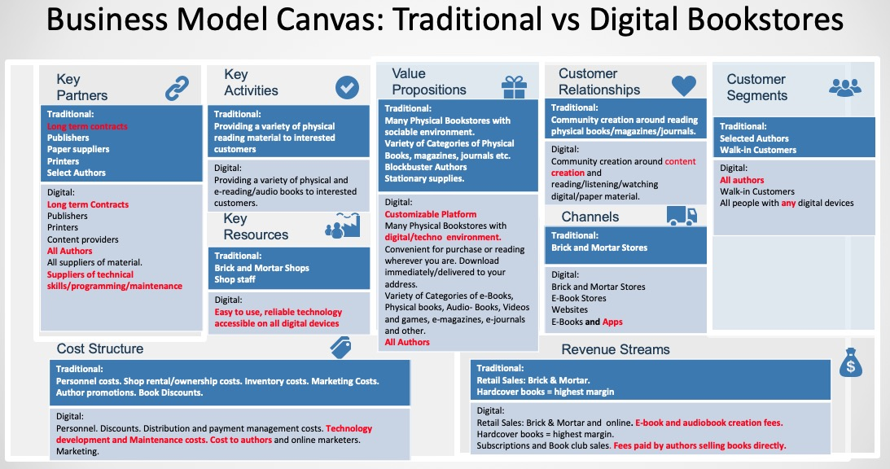
Customer relationships
Consumers buy directly on a self-service basis, search for titles on mobile devices, tablets and e-readers while books are delivered immediately to their devices (Cleverism 2019).
Channels
The NOOK platform provides a collection of digital books, available online or over mobile devices, read on NOOK devices and NOOK applications for iOS and Android devices. (Cleverism 2019).
Value Proposition
Christensen (2004), said transformative innovation creates a new value proposition. B&N added value because online purchases or reading is possible wherever you are, downloads are immediate or deliveries are made directly to you.
They can reorganise current markets and develop new ones (Christensen, 2003). Transformative technologies form two groups: low end and new market. (Christensen, 2003). Illustration 2 demonstrates the three-dimensional levels of disruption. E-books are less expensive than paper books, (RVwest, 2011; Vaara, 2010) thus affordable to customers who could not afford books before. E-Books are easily accessible from e-stores; you can buy e-book readers and download apps for free on most devices. New markets for e-readers, e-books and audio-books were created.
Illustration 2. The three dimensions of the disruption model showing low-end disruption and new-market disruption
(Christensen & Raynor, 2003; Cheeks, 2016).
e-book readers can be bought and apps are free to download on most devices. New markets for e-readers, e-books and audio-books have been created.
By 2012, the e-book market share had grown to 22.6%.
People who could not afford traditional books
Key Activities
NOOK is the companies digital business, providing sales of e-books, e-readers, and accessories. (Cleverism 2019).
Key Resources
Essential resources are its catalogue of products, its digital platforms and technologies, its IT infrastructure, its partnerships, and its personnel. (Cleverism 2019).
Key Partners
Key partners include Suppliers and Vendors, Strategic and Alliance Partners, Affiliate and Marketing Partners and College Partners. All contracts are short term, making B&N very vulnerable. In June 2019 they included self-publishing authors. (Cleverism 2019).
Cost structure
The costs include the acquisition of inventories, channel operation, maintenance of IT infrastructure and digital platforms, management of their partnerships and personnel retention. (Cleverism 2019).
Revenue Streams
E-books and other digital goods contribute to the traditional income streams. (Cleverism 2019).
PORTERS VALUE CHAIN
Illustration 3 demonstrates how e-books have disrupted the value chain. E-books involve more players are from content creation to distribution. There are more user interfaces available to use.
Illustration 3. The traditional value system of book publishing and the (Cheeks, 2016) emerging digital value system (Traditional value system information by Joensuu et al. 2001. Model by Porter, 1985, adopted for media industry analysis by Wang, 2008 (Cheeks, 2016; Vaara, 2010).
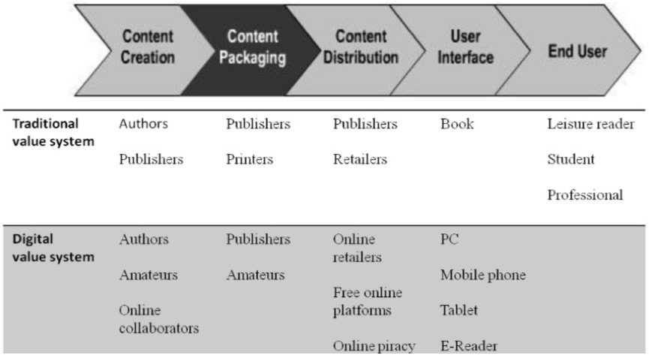

Six P’s of Marketing
B&N have a comprehensive marketing strategy covering all aspects of the 6P’s. Their e-books, however are expensive, causing them to lose market share. See illustration 4.

Illustration 4. The Six P’s of Marketing

BARNES & NOBLE SWOT ANALYSIS

Illustration 5.

STRENGTHS
Strategic.
B&N uses different forms of advertising and sales to drive business. The multi-channel e-commerce platform delivers various promotions and merchandising initiatives to increase traffic (Marketline, 2019). The website www. Barnesandnoble.com provides a clear corporate identity with direct shipping services to improve client interaction. B&N introduced new tools that support the omnichannel approach on the BN.com platform (Marketline, 2019).
Operational
Barnes & Noble's robust distribution networks minimise its reliance on third parties (Marketline, 2019). Those distribution centres enable the client to directly procure orders and shipments in time (Marketline, 2019).

WEAKNESSES
Dependence on suppliers.
E-Book prices are high.
B&N depends on a few domestic and global suppliers. (Marketline, 2019).
B&N has no long-term contracts with providers to ensure access to products, materials or services, content, specific terms and conditions of payment or extension of credit limits.
Digital Technology developments
The NOOK app is not compatible with all devices and is cumbersome to use.

OPPORTUNITIES
Growth of the US online retail industry and the growth of traditional book markets could benefit Barnes & Noble.

THREATS
Growing organised crime.
Competitive environment.
Cybersecurity risks

CONSUMER DYNAMICS
Customer expectations changed when the iPad was introduced in 2010. Apple highlighted the importance of getting close to your customers to uncover their unmet needs. More media outlets are open to users than ever was. Consumers are multi-tasking, expanding and shifting from conventional to modern digital forms of media. They've adjusted their communication and their means of engagement with media companies, and one another. (Korgaonkar and Gironda, 2014; Pynta et al., 2014). Digital apps must support the phases of the online customer journey to improve customer relationships and boost sales. See Illustration 6.

Illustration 6. Customer Life Journey
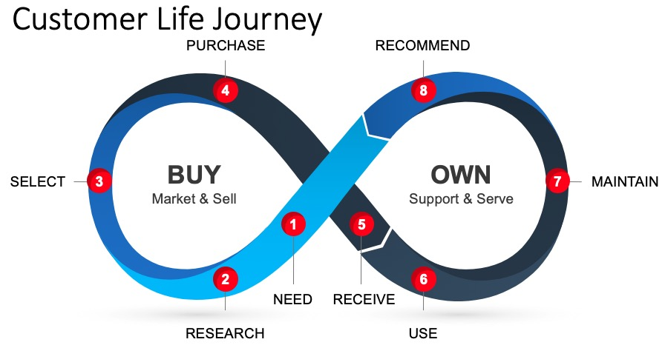

Getting closer to customers, listening to them, identifying their problems and providing solutions will help to grow B&N e-business.

Regulatory Environment
Complications around ownership of e-material for online distributors and individuals buying books is an ongoing issue, and the finalisation of the legalities is not final. Online piracy remains a problem.

Conclusion
The bookselling business has been digitally disrupted on a technology level, the value system, distribution channels, consumer dynamics, as well as the regulatory environment. B&N have adapted their business model to suit the digital era, but there is room for improvement. In June 2019 Barnes & Noble services allowed self-published authors and unproduced screenplay writers to publish on their site which will add an income stream to their business.

Recommendation
For their success going forward, B&N should improve the technology of the downloadable app, making it user-friendly and compatible with all devices. They should address their pricing strategy as they are losing market share because of high-priced e-books. They must eliminate risks associated with short-term contracts with third party suppliers. Finally, they could redesign their brick and mortar stores to incorporate digital/techno systems and environment.

References:
Anderson, C. and Wolff, M. (2010), “The web is dead: long live the internet”, Wired Magazine, California, August, p. 18.

Blankfield, S. & Stevenson, I. Pub Res Q (2012) Towards a Digital Spine: The Technological Methods that UK and US Publishers are Using to Tackle the Growing Challenge of E-Book Piracy. 28: 79. https://doi.org/10.1007/s12109-012-9265-4

BusinessWire. (2018). Online Retail Market in the US to Grow 8x More Than Brick-and-Mortar Retail | Technavio. August 31 2018.
https://www.businesswire.com/news/home/20180831005177/en/Online-Retail-Market-Grow-8x-Brick-and-Mortar-Retail

Chipp, K. and Chakravorty, D. (2016), "Producer push to consumer pull: Who curates new media content? Developing strategies for new media environments", Journal of Product & Brand Management, Vol. 25 No. 4, pp. 373-386. https://doi.org/10.1108/JPBM-06-2015-0918

Cleverism (2019). Barnes & Noble. https://www.cleverism.com/company/barnes-and-noble/

Dawson, Angus; Hirt, Martin; Scanlan, Jay. (2016). The economic essentials of digital strategy. McKinsey & Company. March 2016.
https://www.mckinsey.com/business-functions/strategy-and-corporate-finance/our-insights/the-economic-essentials-of-digital-strategy

Digital Disruption | What's Next: Top Trends.
https://toptrends.nowandnext.com/2018/10/11/digital-disruption/
Jibu Elias. (2017).How Amazon Kindle made bookstores archaic in 10 years. PCMag, NOV. 22, 2017. https://in.pcmag.com/amazon/117709/opinion/how-amazon-kindle-made-bookstores-archaic-in-10-years

Kaivo-oja, J. and Lauraeus, I. (2018), "The VUCA approach as a solution concept to corporate foresight challenges and global technological disruption", Foresight, Vol. 20 No. 1, pp. 27-49. https://doi.org/10.1108/FS-06-2017-0022

Kathryn, R. (2015). Barnes & Noble: Playing the Digital Game All Wrong. Digital Initiative. 13 Sep 2015.
https://digital.hbs.edu/platform-digit/submission/barnes-noble-playing-the-digital-game-all-wrong/

Ketron, Seth; Naletelich, Kelly. (2010). How e-readers have changed personal connections with books. Department of Marketing and Logistics, University of North Texas, Denton, Texas, USA. 2010. www.emeraldinsight.com/1352-2752.htm

Manning, Brian. (2016). Barnes & Noble Needs To Improve Its Customer Experience. Centric Digital. November 11 2016.
https://centricdigital.com/blog/customer-experience/barnes-noble-needs-to-improve-its-customer-experience/

Marketline (2019). Books in the United States. February 2019.
www.marketline.com

Marketline. (2019). Barnes and Noble, Inc. October 11, 2019. www.marketline.com

Marketline. (2013). Amazon’s Kindle Dominating the e-book market while selling at cost price. www.marketline.com

Motoko Rich. (2010). Math of Publishing Meets the E-Book. New York Times. 28 Feb 2010.
https://www.nytimes.com/2010/03/01/business/media/01ebooks.html#whats-next
Porter, M.E.(1985). Competitive advantage: creating and sustaining superior performance, 1985. Kindle Edition.

Prasetya, D., Fontana, A. and Afiff, A.Z., (2018). Defensive Strategy: Exploring the Incumbents' Orientation in Seizing Disruptive Opportunities. Manchester: The International Society for Professional Innovation Management (ISPIM).
https://search-proquest-com.ezproxy.uwtsd.ac.uk/abicomplete/docview/2186209853/19F0BAE823E44C7EPQ/3?accountid=130472

Pynta, P., Seixas, S.A.S., Nield, G.E. and Hier, J. (2014), “The power of social television: can social media build viewer engagement? A new approach to brain imaging of viewer immersion”, Journal of Advertising Research, Vol. 54 No. 1, p. 71.

Quotes about Books and computers (43 quotes). https://www.quotemaster.org/books+and+computers

RVwest Nov/Dec 2011 11:5 Page 8. https://www.bluetoad.com/publication/?i=89981&p=8

Skog, D A., Wimelius, H., Sandberg, J. (2018). Digital Disruption. Business & Information Systems Engineering, 60(5): 431-437 https://doi.org/10.1007/s12599-018-0550-4

Truong, Y. and Simmons, G. (2010), “Perceived intrusiveness in digital advertising: strategic marketing implications”, Journal of Strategic Marketing, Vol. 18 No. 3, pp. 239-256.

Vaara, Matias. (2010). Digital Disruption Faced by the Book Publishing Industry. Tampere University, 2010. https://trepo.tuni.fi/handle/10024/81883

Appendix
1. SWOT analysis
In the 1960s and 1970s, Albert Humphrey headed the Stanford University research project collecting information from several leading companies using SWOT analysis methodology. It was initially called SOFT – Strengths, opportunities, faults and threats. At a meeting in 1964, Urick and Orr switched F to W and soFt to sWot remained as we know it now.
SWOT analyses are a method for plotting the strengths, weaknesses, opportunities and threats involved in a project or a company. The goal of the organisation, or plan, is to be defined and internal and external influences established that benefit or are not helpful to the achievement of this purpose. SWOT is part of the strategic thinking process. Strengths and Weaknesses refer to the organisation itself, while opportunities and threats are those posed by the external industry.
Strengths inherent to a company are positive or intangible characteristics. They are under the control of the company.
Weaknesses are factors under the control of an organisation, which affect its ability to achieve the desired objective. What things can strengthen the organisation?
Opportunities are enticing external influences that are why a company persists and evolves. What are the environmental possibilities that push the company? Identify the "time frames."
Threats outside the control of a company are external influences that could jeopardise the purpose or function of the entity. The company will profit from contingency plans if they occur. Group them by their "weight" and "likelihood that they will happen."
2. Disruptive Technology Model.
Christensen (2004) used the disruptive technology model (Figure 1.) to (Vaara, 2010) illustrate how innovations (Vaara, 2010) are reaching and (Vaara, 2010) changing the marketplace. Innovations (Vaara, 2010) divided into two broad categories (Vaara, 2010): innovation sustainability and (Vaara, 2010) innovation disruption.
Christensen describes innovation sustainability as small improvements to historically ignored aspects for current clients. (Example: An Indian company called Bakeys, has developed cutlery is consumed as a way to deal with seas and landfills of plastic waste).
Transformative Innovation creates a new value proposition that (Vaara, 2010) can reorganise current markets (Vaara, 2010) and develop new ones (Vaara, 2010). Transformative technologies can be (Vaara, 2010) separated into two (Vaara, 2010) groups: low end and new market (Vaara, 2010).

Figure 1. The three dimensions of the disruption model showing low-end disruption and new-market disruption (Christensen & Raynor, 2003; Cheeks, 2016).
Low-end Disruptions (Cheeks, 2016)
Low-end (Cheeks, 2016) disruption is an inexpensive, convenient and relatively simple offering. (Vaara, 2010). It is (Vaara, 2010) aimed at the (Vaara, 2010) lower end of the market (Vaara, 2010) ignored by the existing companies. An example is traditional Britannica Encyclopaedia which was disrupted by internet reference providers such as Wikipedia.
New-market disruption
As new value systems form, the third axis reflects new environments for consumption and competition. Christensen terms these new-market disruptions. The main differentiator of new-market disruptions is that previously excluded populations, like poorer or less skilled people, are now included. Problems confronted by these new markets can be solved. For example, when first introducing the personal computer to the market, a unique growth opportunity was created and the companies that produced mainframe computers gradually encountered problems.
Utterback in 2005, challenged Christensen’s model on the basis that not all digital disruptions enter at the lower end of the market as with the example of digital cameras that were more expensive than film cameras and they successfully disrupted the market. He also argued that disruptive technologies should not be identified for displacing existing goods, but rather for broadening and developing markets.

