Developing Emotional Intelligence Skills for the Workplace
Student Name: Ehsan Meerza
Student Id: 1604560
Module Number: BMSK6006

Executive summary:
Leadership plays a vital role over employee’s performance. Leaders try to gain best output from employees. So they focus on the sustainable development of teamwork and collaboration. This assessment will ensure how an organization will achieve the target using emotional intelligence. Emotional intelligence is not only effective for achieving competitive advantage but also effective for achieving business target. This will discuss about communication management and business advantage for EI (Bar-On and Parker, 2016). Four key issues directly impact on getting potential advantage over UK market. for implementing EI in workplace, it increases employee performance which helps to increase operating from in 2018. A review on frozen foods for Sainsbury, it was negatively commented by customers for its packaging problem. So, it is important for Sainsbury to develop emotional intelligence in their business properly for developing the relationship with management and business advantage. Sainsbury is now focusing on EI tool for understanding the employee’s emotion and motivate them in workplace.

Table of Contents
Executive summary: 2
Introduction: 4
1) Explain the importance of developing emotional intelligence in the workplace and the relationship between emotional intelligence, effective management communication and business advantage. 4
2) Critically evaluate ‘models of emotional intelligence’ you can apply to your chosen organisation and explain the extent to which you think they are appropriate in meeting the development needs of the individual. 8
3) Critically appraise the importance of emotional intelligence and mindfulness in the workplace and how developing emotional intelligence can help an organisation to gain competitive advantage. 13
Conclusion: 17
References 18

Introduction:
Several factors impact on the emotional intelligence in business. They are social, environmental and economic factors. All those strongly contribute to sustainable development of quality workplace as employee can performance better. There are four components of emotional intelligence which impacts on decision making, relationship development, reducing communication gap etc. Digital technologies for an organization shows how to move on target easily and effectively. According to Clarke (2017) the target of EI is to ease of workplace for employees and communicate for increasing their productivity. Three models of EI shows how emotions and intelligence impact on employee performance and how to improve productivity. Achieving competitive advantage is not easy task for any business. but EI creates a new era to ease of taking competitive advantage. Sainsbury is 3rd largest supermarkets in UK and taking 16.9% share of UK market. James Sainsbury developed this business in 1869 with a small shop in London. Several competitors are creating high market pressure to Sainsbury to decrease customers and profit. Tesco is the largest competitor of Sainsbury. Sainsbury has taken market expansion strategy in 2019 as merge with Asda. It has three different sections of business as supermarkets, bank and Argo. For merger with Asda, Sainsbury has taken 30% of market share in UK for grocery products. Sainsbury has 1415 shops in UK. Mike Coupe has concerned about investment on EI as £2 million in 2018. The total revenue in 2018 was £28.45 billion and operating income was £518 million. 186,000 employees are working in Sainsbury company.

1) Explain the importance of developing emotional intelligence in the workplace and the relationship between emotional intelligence, effective management communication and business advantage.
Brackett and Rivers (2015) stated that Emotional intelligence is the ability of understanding owns and others emotions and manage emotions. From the controversies on emotional intelligence, there are three different factors which constitutes the emotional intelligence such as emotional awareness or identification one’s emotion, harness of emotion for applying in specific task for thinking and problem solving, managing emotions. In recent times. Manager applies emotional intelligence to understand the needs of employees, customers etc. In interview process of an organization, Emotional intelligence is very effective method. Job performance and emotional intelligence is correlated with each other. Sainsbury applies three different models of EI for developing workplace relationship.
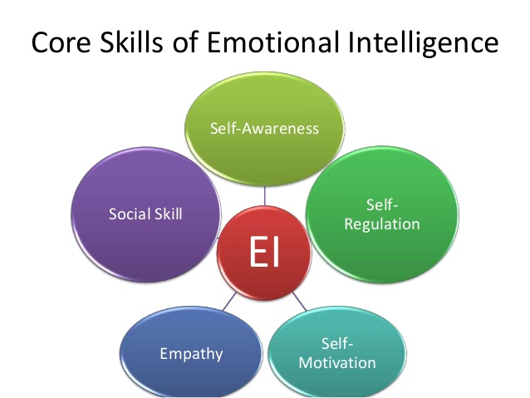
Source: (Slideshare.net)
According to Bracket and Salovey (2015) Emotional intelligence is important term in business for identifying, understanding and managing the emotions. It can help to a manager of Sainsbury for identifying the emotions of customers and employees and manage for meeting their needs and achieve competitive position over global market. There are five terms directly related with EI. Self-awareness is the term which includes the strengths and weakness and how react for a particular situation by a person. Self-regulation means controlling the emotional intelligence and check when it requires. Motivation is essential term of EI for making people more optimistic. Empathy provides better situation for connecting with people. Social skills require for respect others and emotionally caring (Clarke, 2017).
Emotional intelligence skill is important for workplace:
Connell and Travaglione (2016) differed that Each business deals with emotional intelligence for managing own stress in workplace and employee stress. For proper management of emotional intelligence in workplace for Sainsbury, it will help to manage the employees properly. Sainsbury concerns about emotional intelligence in their workplace while employees are working on time. Feelings on working helps to deal with the productivity. For changing the workplace of Sainsbury, it is now introducing the emotional intelligence as manager can achieve the goals and objectives. To develop the healthier environment for employees, manger must have to understand the emotional intelligence of employees and how to develop the possible employee relationship. The importance of emotional intelligence on workplace for Sainsbury are showing with the real example of Sainsbury.
Better workplace relationship with employees will develop for introducing emotional intelligence. EI can identify the emotions of employees (Connell and Travaglione, 2016). After identification of emotions of employees, manager use different motivational theories like two factor theory, Maslow hierarchy of needs theory, goals setting theory as employees get motivated in workplace. After that it will develop the better workplace relationship for Sainsbury.
Effective communication can ensure through proper identification and managing emotions. Leader always try to communicate with employees to get the best performance from hem. To get best outcome for teamwork and individual employees, leaders uses autocratic style, democratic, directive, participate etc. But all these require effective communication. If leader can understand the emotions of employees, it will be effective to provide them their needs. Sainsbury manage effective communication by managing EI. For effective communication, it has increased 16.9% of additional sales in 2018.
Employee performance will increase. EI helps manager of Sainsbury for determining the emotions in workplace of employees. As human behaviour is complex issue in business, manager should conduct proper styles and models for determining their emotions. Manager of Sainsbury determines the emotions and manage it for providing better environment for employees. Alter getting better environment in working, employees provide better service in 2018 from 2017. 18.8% sales have increased for employee performance.
According to Cory (2018) Employees can adapt with fast-changing digital age. EI targets employees, customers and other parties as Sainsbury can deal with them properly. If any business can understand emotions of employee, customers, it will be effective for adapting with new technologies. For development of technologies, Sainsbury involves in online selling products. it helps to increase its sales by 18.8%, growth by 17.8%. for this reason, it is the third largest supermarket in UK market. Sainsbury introduced emotional intelligence which helps employees to adapt with digital technologies such as AI, Machine learning, online selling, CSR etc.
Navigating workplace and organizational change is essential part of business. EI can help Sainsbury to tale better decision about business. EI helps to take information from employees and impose them on the decision making for Sainsbury. If any business can successfully navigate the workplace and employees. it will be good sign for building the better working relationship with employees in team.
Cory et. al (2018) argued that Rational environment will be developed for EI. So, Sainsbury introduces EI in their business plan and decision making. For implementing the emotional intelligence, it will help to develop the rational environment. For quality environment, it can connect with more customers than other supermarkets like Tesco, Aldi etc.
Emotional intelligence ensures flexibility in workplace. Employees always wants their workplace flexibility. Sainsbury provides flexibility as they can be optimistic in their workplace. For reducing the abuse, harassment in workplace, EI should ensure.
The relationship between emotional intelligence, effective management communication and business advantage:
HUTCHINSON and HURLEY (2017) differentiated that Emotional intelligence is effective for combining the effective management communication skills. It can build up the effective communication which helps to develop the better workplace relationships with different stakeholders for organization with employees, managers, customers etc. Proper control over emotional intelligence and ability to understand the emotional intelligence of others can help to build up the better workable relationship. Understanding emotional intelligence helps a person to communicate with that person.
If a person doesn’t have enough emotional intelligence, this person won’t be able to communicate with others. Business advantage also relates with EQ. For proper communication in organization with different stakeholders, a person can deal with the needs and problems of employees. After understanding the needs of customers, this organization can solve the problem and achieve business advantage (HUTCHINSON and HURLEY, 2017).
According to Saini (2018) Misunderstanding can create workplace conflicts. If manager cannot understand emotions of employees, it will impact on the decision making part of Sainsbury. For effective communication, manage can easily understand the emotions of employees, customers and other parties. So, it is essential part of EI. EI, effective communication and business advantage all are related with each other. For failure on effective communication in Sainsbury, it can create frustration, confusion and bitterness among employees. By implementing the EI, manager of Sainsbury willable to understand the emotions of employees and reduce the workplace conflicts, obstacles. It will not only reduce the conflicts but also develop strong employee relationship.
By developing workplace relationship, Sainsbury will able to get more productivity from workplace and production department. By understanding emotions of employees and customer’s needs, manager can employ the best possible tools and techniques to produce quality products. After that, it will impact on getting the best reward from the market. It can develop the better working relationship and achieve the competitive advantage.

2) Critically evaluate ‘models of emotional intelligence’ you can apply to your chosen organisation and explain the extent to which you think they are appropriate in meeting the development needs of the individual.
Saini et. al (2018) argued that Emotional intelligence is categorised in three different models based on the research on emotional intelligence in the workplace. Emotional intelligence is essential for removing workplace conflict, reduces misunderstanding, workplace relationship, solving workplace problem and providing betters service to customers. Emotional intelligence is not effective for employees but also effective for customers. Sainsbury is the retiling supermarket in UK providing several quality products in online and offline selling methods. To communicate with customers, Sainsbury applies Emotional intelligence. There are three different models of EI which directly and indirectly impact on business outcome.
1. Ability model of Emotional Intelligence:
Peretr Salovey developed this model on emotional intelligence. He described about the EI and how it impacts on emotions, and enhances for creativity of person (Bar-On and Parker, 2016). This model helps a manager to perceive the emotions, to identify emotions and to manage emotions for providing better knowledge as it can regulate with the intellectual growth of person.
The main target of this model is to perceive emotions which includes understanding the non-several symptoms of individual person. Manager of Sainsbury imposes this model in their business to understand the employee behaviour on workplace. This model helps Sainsbury to determine the facial recognition and language without verbal or oral communication. But it not only uses non-verbal way of communication but also uses verbal communication.
According to Bar-On and Parker (2016) This model also helps Sainsbury to use emotions for reasoning. It helps Sainsbury to promote the cognitive ability of person. This method helps Sainsbury to solve the complex problem of business. For Example, after review on products of Sainsbury by customers they get information for solving the immediate problem. A review on frozen foods for Sainsbury, it was negatively commented by customers for its packaging problem. Sainsbury uses quality package after negative review. Sometimes, Sainsbury uses art therapy for solving the problem and take immediate action.
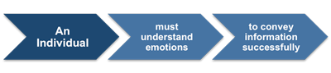
Figure: Ability Model
Source: (Bar-On and Parker, 2016)
This stage clearly understands the emotions of person. Human emotions is very complex. Manager of Sainsbury cannot easily determine the human emotions for providing better workplace. Manager needs to understand the emotional state of employees and interact with time. For example, an employee angry with another employee in innovation team of Sainsbury. So, manager of Sainsbury needs to determine the reason behind the angriness and how to provide the better workplace to work and increase productivity.
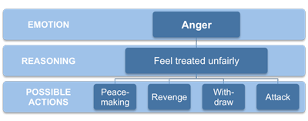
Figure: Ability Model- Example of emotion
Source: (Cherniss and Goleman, 2018).
Managing emotions is essential part of understanding emotions. After understanding emotions of employees in workplace by manager of Sainsbury regulates emotions, responds with emotions consistently.
2. Mixed Model of Emotional Intelligence:
Daniel Goleman described about 25 characteristics of intelligence. Mixed model is based on those characteristics such as self-awareness, teamwork, collaboration, initiative, motivation, service orientation etc. For mixed up all those qualities in emotions, this model is called mixed model of EI. Although several controversies include on this model (Cherniss and Goleman, 2018). This model consists of personal traits and qualities of EI. Sainsbury considers this model for understanding the emotional intelligence qualities of a person. There are five components includes in this model which involves in EI for Sainsbury. To increase the performance of employees, Sainsbury applies this model of EI.
Self-awareness: Emotion can be different person to person. But manager of Sainsbury should determine the emotion of employees. Sainsbury considers the emotions of employees and manage it. There are two issues directly reacted with it confidence, recognition. Confidence increase self-capabilities of employees and awareness impacts on emotional effects of employees to increase productivity by involving in working.
Self-regulation: According to Cherniss and Goleman (2018) This element discus about the controlling of emotional feelings. A piston can control the negative emotion by walking, exercise, mediation and prayer. But in workplace, it is different, a person needs motivation, self-regulation and impulsive behaviour from manager or leaders in team. Adaptability in workplace and team can control the emotions. Negative emotions strongly impact on trustworthy, innovation for Sainsbury. Sainsbury always tries to innovate new thing for satisfying customers. So, Mixed EI can apply for employees and manager for controlling by oneself.
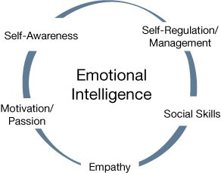
Source: (Cherniss and Goleman, 2018)
Motivation: Each business must have specific goals and objectives. This has ability to think positively to involve in workplace. Positive motivation in workplace can increase the output of employees. Sainsbury’s manager should initiate positive motivation and thinking and reframe the negative thoughts. Optimism can reduce the obstacles in set of goals. Sainsbury uses some initiative which take to lead and get new opportunities in workplace. Commitment and achievement also relates in mixed EI for Sainsbury in workplace decision and achieve competitive advantage.
Empathy: this element helps to understand others. For proper understanding of emotions of others can develop powerful relationship in workplace. Sainsbury mostly relates with service orientation. It always tries to provide better service to customers. So, it requires to understand the needs of customers and their emotions to particular beverages, foods etc.
Social Skills: This element of Mixed model for Sainsbury helps to relate manager for developing team in the workplace, creating collaboration, cooperation with each member in team. For mixed model of EI in Sainsbury, it helps to develop positive workplace relationship by proper communication, managing conflicts etc.

3. Trait Model of Emotional Intelligence:
Petrides developed this model with supporting from his colleagues in 2009. Each person has ones’ personality, personal behaviour, traits and emotions etc. Trait is the constellation of emotional personality, perception constituted in the person’s behaviour (Clarke and Howell, 2018).
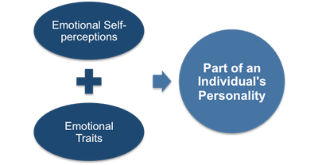
Source: (Clarke and Howell, 2018)
This model concerns about the personal perception of a person which relates with emotional perceptions. Trait is not easy to measure by Sainsbury for determining the quality of employees in workplace (Clarke and Howell, 2018). Leader of Sainsbury company can’t measure the trait of employees. They apply their own emotions and intelligence for understanding the transits of person from report. Trait emotional questionnaire can determine the trait of employees. By understanding of traits of employees, leaders can apply each employee where they will deliver their best service.
Explain the extent to which you think they are appropriate in meeting the development needs of the individual:
Colverd and Hodgkin (2017) stated that Sainsbury is the chain supermarket in UK and providing quality products to customers. But Sainsbury needs to determine emotions of employees as manager of Sainsbury can provide better workplace for employees. Three different models of emotional intelligence show how Sainsbury can apply the EI models for achieving the business goals. Three different models provide different facility to a business. Managers of Sainsbury evaluates the employee report and apply all three for getting the best output.
First of all, ability based model helps an employee for use their emotions in workplace. Other side, managers us their emotional intelligence as they can recruit the skilled employees and manage them properly. controlling is essential part of this model for Sainsbury. To meet with development needs of employees, this model is effective. For example, by understanding emotions of customers and employees. Sainsbury can desire in which products needs to develop, how to increase quality and employee will engage in teamwork for better service. Manager can provide the employee needs as they can provide better service. Sainsbury increases its total sales in 2018 for availability based teamwork in the workplace.
Secondly, mixed model helps Sainsbury to meet with individual needs in workplace. This model helps to understand the self-awareness, motivation and awareness of employees. Manager of Sainsbury provide employee needs as they can involve in workplace. On the other hand, motivational theories apply by leader in workplace to get best output from employees. As employee needs changes overnight. So, Sainsbury applies this model and uses motivational theories as they can motivate employee in workplace by increasing their self-creativity awareness etc.
Rose and Cherbosque (2015) differed that trait model of EI shows the self-perception and traits of person. This model initiate the individual needs in workplace. Sainsbury provides the employee needs which they deserve. Performance based pay is essential way of motivating employees. Emotional intelligence helps Sainsbury; manager and leaders to develop the needs of employees and communicate to achieve goals of business.

3) Critically appraise the importance of emotional intelligence and mindfulness in the workplace and how developing emotional intelligence can help an organisation to gain competitive advantage.
Cherbosque et. al (2015) argued that importance of emotional intelligence and mindfulness in workplace has strong impact on business decision. Emotional intelligence needs for understanding the employee concentration in workplace. For better understanding of emotions of employees, it can help Sainsbury to determine needs of employees. Employees needs should be fulfilled as they can concentrate on workplace. Without their concentration on workplace, Sainsbury will not able to achieve the target. Sainsbury has earned £28.45 billion revenue in 2018 which increased from 2017 by 10% for proper implementation of teamwork and collaboration. EI helps Sainsbury to initiate teamwork and collaboration.
Sainsbury can easily postpone the conversation of meeting in workplace by proper understanding of emotions (Stein, 2017). Emotional intelligence can determine the regular needs of employees and can understand the opinion in workplace. Leaders can find out the required techniques to motivate them. workplace communication also increases in Sainsbury for introducing EI. It has increases total employees by 6% in 2018 from 2017. It is creating 0.8% jobs for unemployed person in UK.
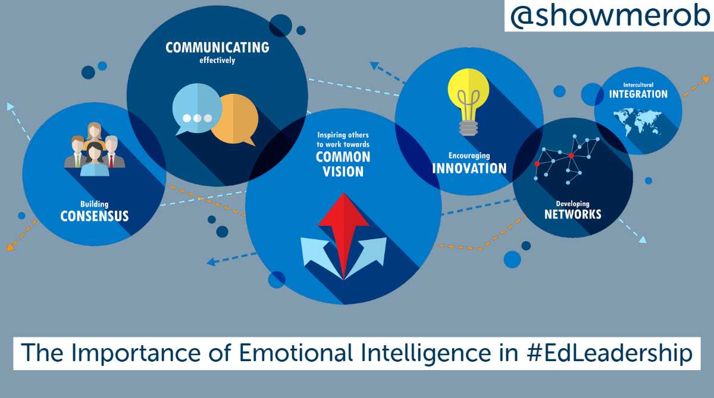
Source: (Slideshare.net)
According to Stein (2017) leadership and emotional intelligence is correlated with each other. Leaders use their own leadership styles for motivating employees in workplace. Sainsbury categorised their business process in several team. Because teamwork increases productivity 30-35% in Sainsbury than individual performance. Before developing team, Sainsbury uses EI for understand emotions and conduct with employees where they will perform better (Emotionalintelligenceatwork.com, 2019).
Relationship management also develops for EI. EI also creates a new era on Sainsbury for increasing productivity. For implementing EI on workplace and develops EI, Sainsbury easily communicate with employees. Relationship management is essential part of EI which helps Sainsbury to develop employee relation with management.
Self-awareness will develop among employees. For emotional intelligence and critical thinking on workplace, employee can understand their duties without guidance of leaders and manager. It reduces workplace conflicts. For reduction of workplace conflicts, unemployed people wants to work on Sainsbury.
Gaining Competitive Advantage with Emotional Intelligence
Stein et. al (2017) argued that Organizational workplace is going to be more competitive for internal and external pressures of business. there are several issues which impacts on dynamic workplace of Sainsbury such as timeliness, cross-cultural issues, working pressures, customer demands, workplace conflicts etc. for all those factors, employee gets pressure in workplace. It provides negative impact over employee’s mind. It reduces the effectiveness of employee performance and organizational productivity. EI uses in Sainsbury as a tool for taking competitive advantage. Because EI is used as a tool for Sainsbury for employee competencies and teamwork. Collaboration and teamwork will increase for gaining the competitive advantage.
According to Clarke and Howell (2018) EI has ability to identify and manage the emotions and interact with different emotions in an effective manner. Emotional intelligence should focus on the empowerment to others in workplace. It doesn’t focus on how employees say but also how they react. For advancement of new technologies and internet development, face-to-face communication and tasting has decreased in workplace. Face-to-face communication is effective way of understanding the emotions of particular person. Emotional intelligence can help to achieve the competitive advantage over the global market for a business. Sainsbury is operating its business in UK market with high competition. As it has taken 19.3% market share of UK market for supermarket. But Tesco, Asda, Aldi also takes the large portion of market. So, Sainsbury has taken a decision for achieving the competitive position (HelpGuide.org, 2019). So, it is required to understand the emotions of employees to provide them best input to get output.
Emotional intelligence is used as skills by people in Sainsbury for understanding the skills and providing emotional signal to others that can increase their productivity. By imposing on several skills and knowledge of employees, it can achieve the competitive advantage for Sainsbury. Some skills are empathy, optimism, self-awareness and problem solving.
EI contributes for developing the emotional awareness of employees and increase IQ level to workplace. For proper implementation of EI in workplace, employee can provide their level best. For EI in workplace, employees of Sainsbury can take better decision and achieve competitive advantage (Bizjournals.com, 2019). For better decision and IQ level, Sainsbury has earned 20% customer references in 2018. A static of employee emotions and organizational productivity shows that organizational success 20% increased for employee contribution on workplace. So, Sainsbury provides opportunity to employees as they can share their emotions and contribute to decision making.
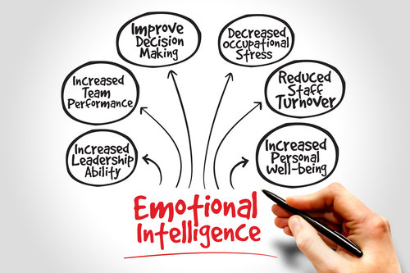
Source: (slideshare.net)
According to Bizjournals.com (2019) Leadership skill is essential part for Sainsbury and its workplace. Leaders contribution strongly impacts on decision making and teamwork. Teamwork and collaboration helps Sainsbury to increase its total sales from 2017 to 2018 by 19.8%. Emotional intelligence can ensure better working position in team. EI can reduces workplace and family conflicts which increases mental stability of business. From the report of UK government and industries shows that 67% employees face conflicts in personal and workplace. So, Sainsbury should concern about how to improve mental condition of employees and achieves the competitive advantage.
EI can determine the customer’s emotion and Sainsbury will engage in qualitative products production as they can satisfy their customers. Customer satisfaction is the key to achieve the competitive advantage. Customers loyalty is another factor for gaining competitive advantage. EI helps to provide digital technologies as Sainsbury can develop the quality of products, reduces lead time and increases customers.
Controversies with Emotional Intelligence:
Ackerman et. al (2019) differed that Most of the businesses and entrepreneurs think EI is the key way of gaining competitive advantage. But several analysts argued that EI cannot provide sufficient output to business. Emotional intelligence is the moral quality than skills of employees. EI manipulates employees rather than skill development. Another controversy of EI is validity of comparison. On the other hand, Emotional intelligence can’t easily and strongly measure the emotions properly as it can achieve the competitive position. Sainsbury cannot get quality output which it serves from its business planning for overrating EI. Sainsbury has invested £2 million on digital technologies and EI for increasing employee’s performance. But the improvement was very little. So, manager of Sainsbury considers the development of new process, increasing skills and motivate existing EI for increasing teamwork, collaboration, cooperation.

Conclusion:
For ever changing policies, customer demands and employee empowerment, many organizations are trying to initiate new processes, policies and technologies to gain market advantage. To take market advantage, each businesses needs to concern about the new technologies how capture outcome from employees. Success of business depends on employee performance. Sainsbury has increased opts total sales in 2018 and market gain by 19% for its proper understanding of emotions. Self-awareness, empathy, creativity, motivational all are the key tools of emotional intelligence. Ability based model provides output to Sainsbury to initiate the ability of employees and how much capable they are on the workplace. Based on their emotional ability, Sainsbury should develop the team and workplace. Relationship building is key target for EI in workplace for Sainsbury. This organization should impose on EI in each stage of organization for developing workplace relationship and reducing conflicts.

References
Ackerman, C. (2019). How to Improve Emotional Intelligence in the Workplace (31 Tips + Activities). [online] Positivepsychologyprogram.com. Available at: https://positivepsychologyprogram.com/emotional-intelligence-workplace/ [Accessed 10 May 2019].
Bizjournals.com. (2019). Employee Performance in Workplace. [online] Available at: https://www.bizjournals.com/bizwomen/news/latest-news/2018/12/is-emotional-intelligence-training-a-new-workplace.html [Accessed 10 May 2019].
Emotionalintelligenceatwork.com. (2019). » Why emotional intelligence is important in the workplace. [online] Available at: http://www.emotionalintelligenceatwork.com/resources/why-emotional-intelligence-is-important-in-the-workplace/ [Accessed 10 May 2019].
HelpGuide.org. (2019). Improving Emotional Intelligence (EQ). [online] Available at: https://www.helpguide.org/articles/mental-health/emotional-intelligence-eq.htm [Accessed 10 May 2019].
Brackett, M., Rivers, S. and Salovey, P. (2015). Emotional Intelligence: Implications for Personal, Social, Academic, and Workplace Success. Social and Personality Psychology Compass, 5(1), pp.88-103.
65-0790985., M. (2019). The Importance of Emotional Intelligence in the Work Place | Michael Page US. [online] Michael Page. Available at: https://www.michaelpage.com/advice/management-advice/development-and-retention/importance-emotional-intelligence-work-place [Accessed 10 May 2019].
Clarke, N. (2017). Emotional intelligence and learning in teams. Journal of Workplace Learning, 22(3), pp.125-145.
Connell, J. and Travaglione, T. (2016). Emotional intelligence: a competitive advantage in times of change?. Strategic Change, 13(2), pp.55-59.
Cory, H. (2018). Can competitive intelligence lead to a sustainable competitive advantage?. Competitive Intelligence Review, 7(3), pp.45-55.
HUTCHINSON, M. and HURLEY, J. (2017). Exploring leadership capability and emotional intelligence as moderators of workplace bullying. Journal of Management, 21(3), pp.553-562.
Saini, S. (2018). Emotional Intelligence at Workplace – A Conceptual Study. International Journal of Management Studies, V(3(5), p.53.
Bar-On, R. and Parker, J. (2016). The handbook of emotional intelligence. 16th ed. San Francisco, Calif.: Jossey-Bass.
Cherniss, C. and Goleman, D. (2018). The emotionally intelligent workplace. 17th ed. San Francisco: Jossey-Bass.
Clarke, N. and Howell, R. (2018). Emotional intelligence and projects. 18th ed. Newtown Square, Pa.: Project Management Institute.
Colverd, S. and Hodgkin, B. (2017). Developing emotional intelligence in the primary school. 16th ed. Abingdon, Oxon: Routledge.
Gardenswartz, L., Rose, A. and Cherbosque, J. (2015). Emotional intelligence for managing results in a diverse world. 21st ed. Boston, MA: Nicholas Brealey Publishing.
Stein, S. (2017). Leading with Emotional Intelligence. 8th ed. Somerset: John Wiley & Sons, Incorporated.

