Student name: Georgia McDonald
Student P number: 1702499
Program of study: Graphic Design
Word count: 2,306
Tutor: Louise Burston
Question: How does graffiti influence the psychogeography of an ephemeral urban environment?

Key words
-Psychogeography
-Graffiti
-Ephemeral

Key thinkers
Guy Debord
Situationist International
Banksy
Merlin Coverley

Introduction
This proposal will focus on three keywords, psychogeography, graffiti and ephemeral. These keywords will be defined and given context within a social, political and cultural background. For the purpose of developing a question for my dissertation, it will be explored: the definition of the key words, the political, historical context and social cultures which have influenced their evolution and expansion in relation to corresponding theories. The connotation of the key words has been explored in depth. The complexities of their connections with contemporary culture has been examined in order to develop a question for this academic dissertation.
It will be analysed how graffiti can influence the psychogeographical form of the city. How graffiti’s message with its ephemeral nature can remain strong even after it has been removed from the urban environment. This essay will discuss these issues in context with theorists and artists such as: Guy Debord, Situationist International, Banksy and Merlin Coverley.
How the ephemeral narrative of graffiti, the voices of the anarchistic and oppressed manifest in public displays of rebellion through protest by maintaining its strong influences and connections with the community.

Psychogeography
Psychogeography is a term coined by Guy Debord in 1955 (Tate, 2019). Psychogeography explores the notion of the derive (drift) and the flaneur (wanderer). Debord often referred to Marx’s phrase;
Men can see nothing around them that is not their own image; everything speaks to them of themselves. Their very landscape is alive. (Debord 1959 in Knabb 2006, p.63)

Often situated in the urban environment, the derive is a walk without a predetermined purpose. The flaneur wanders through different areas without a preconceived plan of where he or she is going - without following the path that is already paved. Wandering where you drift; not necessarily the route the town planner subliminally wants to encourage you to travel. Creating their own path, the flaneur drifts along to discover and interpret the environment in a new way. Papadimitriou (2013) talks of how the flaneur engages the senses and brings their personal knowledge and experience to their interpretation of the streets they walk. For example, he offers a rich description of one derive;
[A] brown rat emerges from the roadside herbage and rummages in a shopping bag dumped by a chipped concrete bollard […] unperturbed by the arc lamps and the purring fire engines, it hunches over its find. (Papadimitriou, 2013, p.20)

The psychogeographer aims to bring a new interpretation of the manmade roads they travel bringing to it their own human stories. For each flaneur there is a fresh interpretation of a different path.
Bakhtin (1981) argues that there is a distinct and ‘categorical boundary between the actual world as source of representation and the world presented in the work’. Influenced by Guy Debord, psychogeography became a tool that could be used in an attempt to ‘transform urban life’, and as Coverley writes, firstly for aesthetic reasons and later for more political purposes (Coverley, 2006).
Debord was a part of the Situationist International, which is where his theory of the derive was born. In a time where consumer capitalism began suggesting peoples ‘wants’ were their ‘needs’. Debord suggests that by wandering aimlessly the flaneur will happen upon moments of truth. This belief informed the situationists to expand the flaneur’s derive to disrupt the monotonous routine of consumer capitalism. This disruption inspired the French riots of 1968 against capitalism. In figure 1 there is an example of the Situationists map of Paris encouraging other people to walk a path to experience a politically driven derive. This is in contrast with contemporary psychogeographers, such as Nick Papadimitriou who focuses on a more personal and individual perspective.
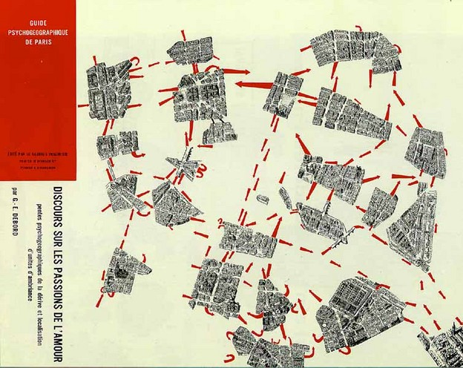
Figure 1: The Situationists map of Paris.

The association in which an environment connects with an individual helps to create a personal and solely subjective opinion to be formed. Whereas someone could interrupt it as a way to challenge the establishment, others may gain a new perspective and insight about our society thereby forming a sense of personal political meaning as the flaneur.
Psychogeography seeks to overcome the processes of ‘banalisation’ by which the everyday experience of our surroundings becomes one of drab monotony. (Coverley, 2006, p.13)

Situationists found ways to disrupt monotonous routines of consumer capitalism, without having to buy anything; graffiti is an example of this.

Graffiti
The contemporary graffiti that we know today is also known as hip hop graffiti (McAuliffe and Iveson, 2011). Graffiti is a form of expression that has evolved through the ages, that has changed forms over the years to something that we know today. There are conflicting roots of modern-day graffiti. Portigal and Noevaisas (2011) traced it the origins of graffiti as far back as ancient Greece.
Reviled or celebrated, graffiti is ubiquitous in even the least urban environments. With roots in the wall-scrawled slogans of ancient Greece, it is a physical yet ephemeral expression of the personality of a neighborhood [sic]. (Portigal and Noevaisas 2011, p.12)

It has been argued that contemporary graffiti we recognize today, began in Philadelphia, USA, Cool Earl and Cornbread where known as the original taggers (Ehlrich and Ehlrich, 2006) and became figures of notoriety for writing their names all over the city. Yet according to Christen (2003) it started in New York. Cooper and Chalfant (1984) write about how New York graffiti artist, Taki 183, influenced other young people to tag the streets with their names developing a sense of community among urban youth.
Kids impressed by the public notoriety of a name appearing all over the city realized that the pride they felt in seeing their name up in the neighborhood [sic] could expand a hundredfold if it travelled beyond the narrow confines of the block. The competition for fame began in earnest as hundreds of youngsters, emulating Taki 183, began to “tag” trains and public buildings all over town. (Cooper and Chalfant, 1984, P.14)

Street art in the UK has been influenced by America Hip Hop graffiti (McAuliffe and Iveson, 2011) and that influence extends worldwide. There are now many street artists who have gained global celebrity status including ‘Blek le Rat, Andre, Shepard Fairey, Invader, and Banksy’ (Portigal and Norvaisas, 2011, p.12).
Anarchistic in nature, graffiti is a powerful tool used to engage and speak to the public. Graffiti is a tool that can often speak to the unrepresented masses; for the silent and unheard community. In this respect graffiti is a political act and can be more politically charged because of its illegal status. But it is not only what is said in the graffiti, it is also how it resonates within the urban environment.
Thus graffiti, as a transgressive performance in space, tells us much of the ways space is configured, constructed and reproduced in the city. Graffiti, as a spatial practice that draws attention to the complex processes at work in the social, cultural and political construction of urban space, has long been of interest to geographers. (McAuliffe and Iveson 2011, p.129).

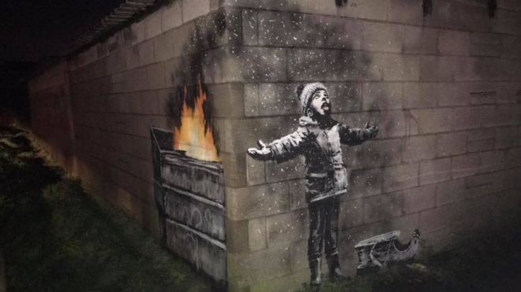
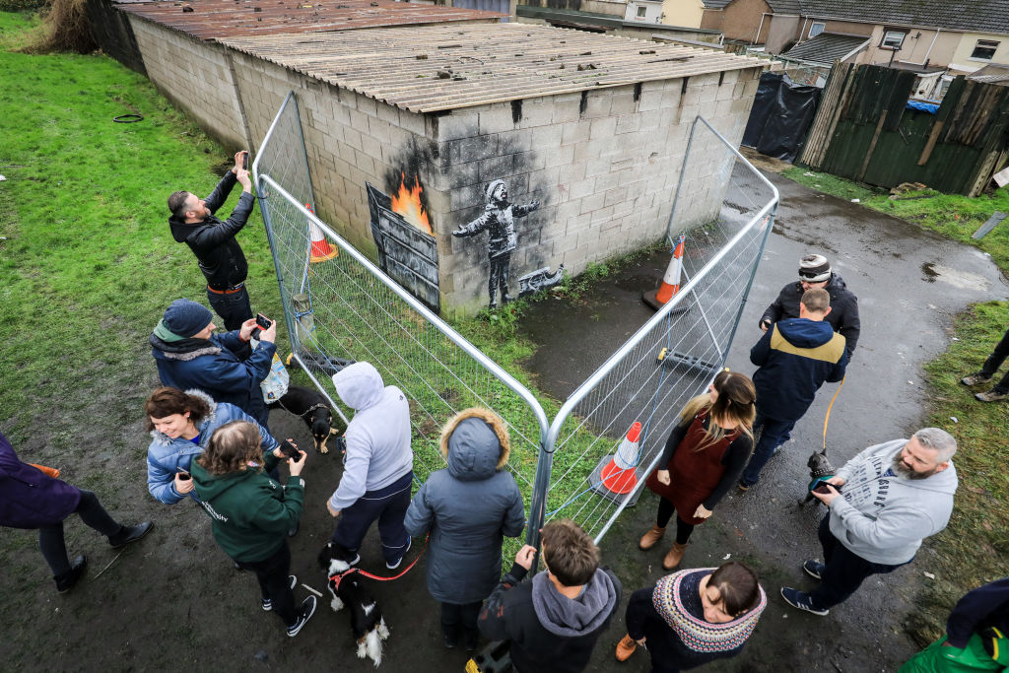
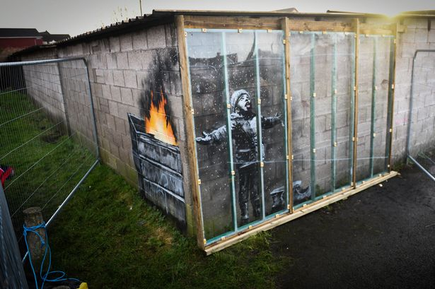
Social values towards graffiti are inconsistent and prone to hypocrisy. Where graffiti brings in tourism and therefore revenue to the city, local councils will protect and preserve street art. An example of this is Banksy’s ‘Seasons Greetings’ (2018) fig 2 in Port Talbot that has been cordoned off with barriers to protect it, in preparation for it being moved to the new street art museum, currently under construction, in the town.
Figure 2: Season's Greetings

Where graffiti has little, or no monetary value the City councils’ policy is to remove illegal and vandalistic street art. But attitudes to graffiti changes over time.
Sometimes good intentions prove worse than the problem they attempt to solve. A seventy-member youth group was invited to the Mayrieres Cave in France to help get rid of modern-day graffiti that was scrawled over some of the walls. Unfortunately, in their ignorance, they accidently destroyed some of the cave’s ancient paintings of bison that had been estimated to be 15,000 years old. (McDonald, 2013, p. 18)

McDonald (2013) sites a case, quoted above, where ancient and modern graffiti are seen in great contrast. Its intriguing that value and esteem are associated with an ancient painting, which can be considered a form of graffiti even with its historical acclimation within art communities. However, contemporary graffiti is considered illegal and something to be removed from the streets. It’s a hypocritical paradox within social values towards graffiti to be in such contrast, just because these forms of art are from different times.
Capitalism influences social values of graffiti in ways that oppose graffiti’s ideologies and rebellious characteristics. It challenges aspects such as monetary value, notoriety and high/low art status. In relation to this Banksy’s artwork in Hull (BBC, 2018), ‘Draw the Raised Bridge’. Banksy is famous, notable and bankable, the fact that the artwork is illegal is conveniently over looked by the local council who may make their own use of it for substantial financial gain. The work was whitewashed over by someone wishing to negate its financial value. This maintains the street level value of the right to artistic expression and denying the capitalist system to make money wherever it can. Some may consider painting over a Banksy a crime and that Banksy is now above the law. If it’s a Banksy the capitalist system will overlook its illegality and put up protective screens. According to the BBC (2018), ‘Draw the Raised Bridge’ was ‘defaced’ or in other words vandalised. Do graffiti artists now require the assistance of vandals to question the dominant systems of capitalism?

Ephemeral
Traditionally, graffiti is a temporary art form. There is something emotionally powerful about temporary art. All the more precious because of its impermanence knowing that soon its passing will be mourned.
Graffiti art is the voice of the community, as discussed earlier, there are always things that should be talked about and in the form of ‘community arts’ that can be ‘emblematic of the experience for many lower-income communities’ that are otherwise silenced (Kayza, 2016). But the policy of local councils to remove illegal street art undermines and undervalues the voice of the community.
Legal street art, however, can regenerate the urban environment and create ‘an important shift in city dwellers’ perception’ (Zaporozhets, Riise & Kolesnik, 2014). Kayza (2016) writes about how this can lead to the gentrification of an area. In doing so makes it attractive to private investors who inject money into capital investment that raises local rents and prices in social spaces. The economy is given a financial boost, but the original community can get pushed out as they can no longer afford to live there.
As it pertains to private property, money power ranks above community efforts to improve their situation, even when the outcome is institutionally applauded. (Kayza, 2016, p. 40)

Traditionally, graffiti art is ephemeral. The competition for spaces to create tags and throw-ups developed a custom of one artist over writing their work or that of another. Graffiti has its own language and artists compete with each other to literally have their work on top. Never intended to be permanent, graffiti is characterised by its short life span. Purpura (2009) states that ‘through over-painting’ the works are ‘disassembled forever’ and asks the question that is it the artist’s labour rather than their work that is the ‘enduring’ quality?
Traditions of collecting high art place value on rare and original works of art (for instance the first edition of a book rather than one of the many later copies). Ephemeral art challenges the ways in which art works are valued as they cannot be owned. It becomes problematic for the art market ‘who handle or possess works’ for works made from ephemeral materials (Lydiate, 2013).
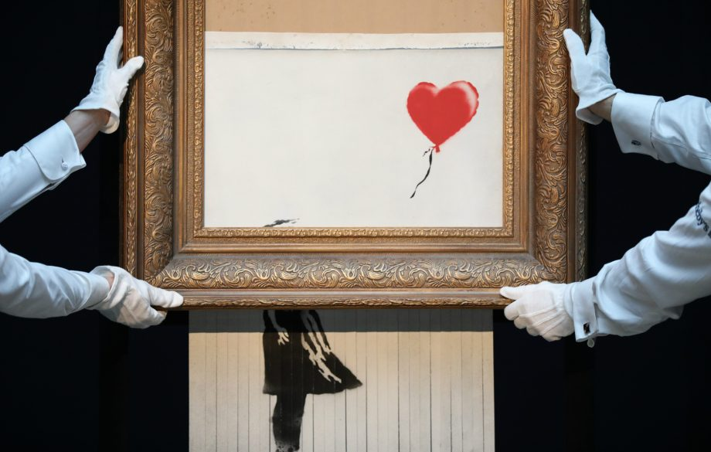
Banksy is one graffiti artist who has critiqued the desire of the collectors’ market to own his work. When his piece, ‘Girl with balloon’ was sold at auction for £1.4 million it was shredded at the point of sale challenging traditions of art collecting within a consumer society that asserts its temporary nature as graffiti. Ironically, this act is reported to have doubled the monetary value of this piece (Calfas, 2018).
Figure 3: Girl with balloon, Bansky,2018

Ephemerality defies conventional expectations around the preservation, display, and commodification of art and confounds the museum’s mission to preserve works in perpetuity (Purpura 2009, p.11).

Conclusion
This proposal identifies 4 key areas for further investigation:
Point 1- How people respond to the urban environment and the effect it has within the communities social and political values?
Point 2 - How graffiti can be used as a political tool to challenge the capitalist notions of contemporary society?
Point 3 - How capitalism threatens the social values of graffiti and confuses the boundaries between monetary value, notoriety and art status?
Point 4 - How ephemeral art can influence and raise awareness among local communities in urban environments?
The next step would be to develop these points in my dissertation through extended reading around the key themes and research of artists and their art practice. By reading about Marx’s theory of alienation it will address a key area identified within this proposal and develop the discussion about capitalism and its impact on ideas about monetary and social values. Further reading around Debord and the Situationists International will develop the theories around psychogeography that have been introduced within this proposal. In addition, research into contemporary graffiti and street artists will be explored through emailing artists to learn more about their work in relation to the focus of this study. Investigating the development of the Street Art Museum (SAM) in Port Talbot is another avenue for research, including emailing the deputy culture minister, Lord Dafydd Elis-Thomas and Mr Brandler (the owner of Banksy’s ‘Seasons greetings’). This research has helped me concluded a question ‘How does graffiti influence the psychogeography of an ephemeral urban environment?’ which will be further developed and discussed within my academic dissertation.

References:

Books:

Bakhtin, M.M. (1981) The Dialogic Imagination. University of Texas Press, USA.

Cooper, M., & Chalfant, H. (1984). Subway art. Thames and Hudson, London.

Coverley, M. (2006) Psychogeography. Pocket Essentials, Harpenden.

Debord, G. (1959) Theory of the derive. In Knabb, K. (Edited and translated) (2006) Situationist International: anthology. Bureau of Public Secrets.

McDonald, F. (2013) The Popular History of Graffiti: from the ancient world to the present. Skyhorse Publishing, New York.

Papadimitriou, N. (2013) Scarp. Hodder & Stoughton, London.

Journal articles:

Christen, R. (2003) Hip Hop Learning: Graffiti as an Educator of Urban Teenagers. Educational Foundations 17:4, pp. 57-82.

Ehrlich, D., & Ehrlich, G. (2006) Graffiti in Its Own Words, New York, 39(24), p. 48–124.

Kayza, B. (2016) Ephemeral Conciliation: Community-Based Art and Redevelopment.
Association of Pacific Coast Geographer, APCG YEARBOOK, Vol. 78, pp. 28-46.

Lydiate, H. (2013) Material Ephemerality. In, Art Monthly, Vol. 371, p.37.

McAuliffe, C. and Iveson, K. (2011) Art and Crime (and Other Things Besides …): Conceptualising Grafﬁti in the City. Geography Compass Vol. 5, No. 3, pp. 128–143.

Portigal, S. and Norvaisas, J. (2011) "Kilroy Was Here." Interactions 18.6: p.12.

Pupura, A. (2009) Framing the Ephemeral. MIT Press, pp.11-15.

Zaporozhets, O., Riise, E. &, Kolesnik, A. (2014) The Permanence of Ephemeral: TSOI wall 23 years after. Coactivity: Philosophy, Communication, Vol. 22, No. 1, pp. 38-52.

Websites:

BBC (2018) Banksy's Hull bridge mural 'to be moved' ahead of works available at

https://www.bbc.co.uk/news/uk-england-humber-44710815?fbclid=IwAR3DCvgFzQdq8PF-X9kFJpgXmjz3TH7Ou0XzIwiif7VMY2bwQ1eLPbcZKDg(accessed:28th April 2018)

BBC (2018) Hull window cleaner saves defaced Banksy mural available at: https://www.bbc.co.uk/news/uk-england-humber-42857424?fbclid=IwAR04st5TpbGqKte6DISgtFww_tViE1Ew0MZahfVvlGQZ3ELZAFS73b9vLls
(accessed: 28th April 2019)

Calfas, J. (2018) Banksy Shredded a Piece of Art That Sold for $1.4 Million. Now It's Worth Double, According to an Art Expert. available at: http://money.com/money/5418695/banksy-girl-with-a-balloon-self-destruct-double/ (accessed: 28th April 2019)

Tate (2019) Art term Psychogeography available at: https://www.tate.org.uk/art/art-terms/p/psychogeography (accessed: 28th April 2019)

Images

figure 1: ‘Situationists map of Paris’
https://jacket2.org/commentary/avant-garde-iii-situationist-maps-take-one

Figure 2: Banksy port Talbot, ‘Season’s Greetings’

https://www.walesonline.co.uk/news/wales-news/protected-hidden-screen-goes-up-15587782
https://www.bbc.co.uk/news/uk-wales-47338314
https://www.lifegate.com/people/news/port-talbot-banksy-seasons-greetings

figure 3: ‘Banksy girl with balloon’
http://money.com/money/5418695/banksy-girl-with-a-balloon-self-destruct-double/

