Lecturer: Dr. Nik Whitehead
Module: Business Information Systems
Assignment: 1
Module Code: M6X01088
Business Intelligence Systems – Data Analysis & Mining
Business Report on The Northeast sales territory of the adventureworks dataset
Kevin Moses P144089
Contents
1. Introduction 2
2. Overview of Dataset 2
2.1. Production_Product 3
2.1.1. Color 3
2.1.2. ListPrice 3
2.1.3. ProductLine 4
2.1.4. Style 4
2.1.5. SellStartDate & SellEndDate 4
2.2. Production_ProductCategory 4
2.3. Production_ProductSubCategory 4
2.4. Sales_SalesOrderDetail 4
2.5. Sales_SalesOrderHeader 5
2.6. Sales_SalesTerritory 5
2.7. Sales_SpecialOffer 5
3. Overall Sales Figures and Forecast 5
4. Sales Breakdown 6
4.1. Sales by State 6
4.2. Sales by Colour 8
4.3. Sales by Product Line 9
4.4. Sales by Style 10
4.5. Sales by Special Offer 11
4.6. Sales by Category 11
5. Market Basket Analysis 12
6. Conclusion 14
References 15

Introduction
This report will provide an overview of the sales of the AdventureWorks Company for the Northeast sales territory.
The AdventureWorks dataset covers a time period of the second two quarters of 2001 to the first two quarters of 2004 (see Fig 1), this report will cover this time period solely for the Northeast Sales Territory (see Fig 2).
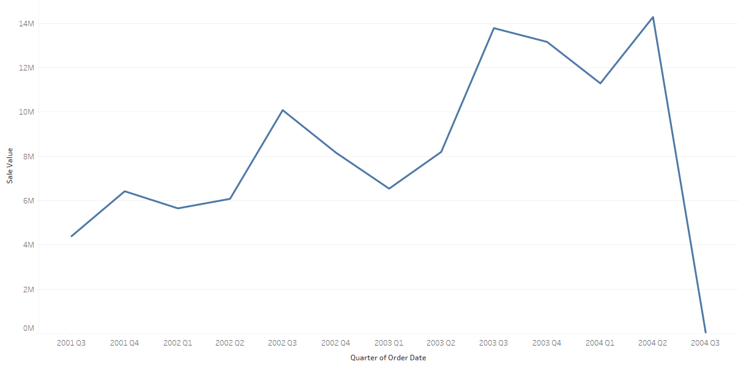
Fig 1 – Total Due from Sales Orders for All Sales Territories by Quarter

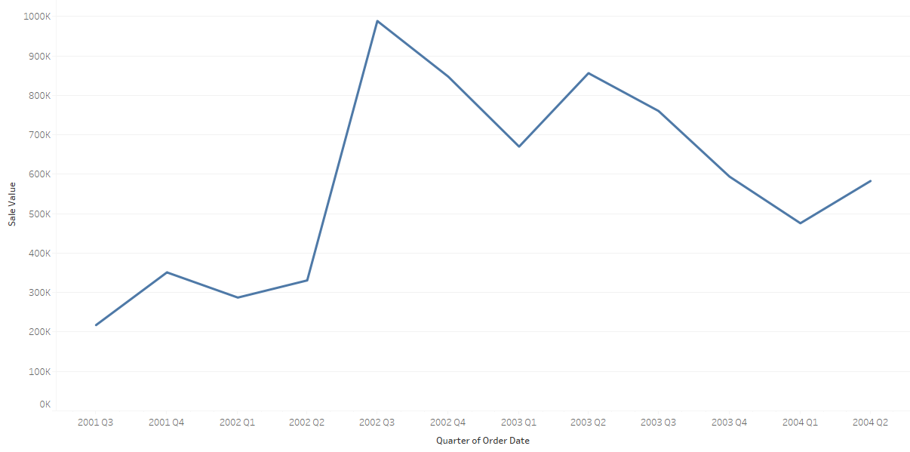
Fig 2 - Total Due from Sales Orders for the Northeast Sales Territory by Quarter

Overview of Dataset
The full dataset provided contains data covering the following main categories; Human Resources, Person, Production, Purchasing and Sales.
For the purpose of this report, the following tables were added into the Business Information System (BIS) for analysis:
- Production_Product
- ProductionProductCategory
- Production_ProductSubCategory
- Sales_SalesOrderDetail
- Sales_SalesOrderHeader
- Sales_SpecialOffer
Other tables that were added for reference and filtering were Person_Address, Person_StateProvince and Sales_SalesTerritory
No Human Resources or Purchasing tables are included in this subset as the purpose of this report is to describe the company’s sales.
Below follows a brief overview of the main tables included in the dataset for analysis.

Production_Product
The Production_Product table contains details of the individual products available from AdventureWorks. All items include a Product ID and Name. This table is linked to the Production_ProductSubCategory table by the ProductSubCategoryID field, although not all products have a value ProductSubCategoryID.
In regards to information that may of value in Sales analysis, this table also includes fields for Color, ListPrice, ProductLine, Style, and SellStartDate & SellEndDate.

Color
The Color field describes the colour of the product, where it has been recorded. Of all the items recorded, approximately 16% for items do not have a colour recorded (see Fig 3).
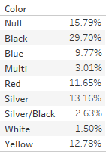
Fig 3 – Percentage of Products by Colour

ListPrice
The ListPrice field is a NonNull field (it cannot be left as null), however there are several Products that have a ListPrice Value of 0.00. Of the 504 individual products, 200 have a list price of 0.00.
Of the remaining 304 records, the list price ranges from 2.29 to 3,578.27.

ProductLine
The ProductLine field has four possible values (not including Null) R, M, S and T. According to the AdventureWorks Data Dictionary for Product Table [1], these values represent Road, Mountain, Standard and Touring respectively.
Of the 504 products, 226 do not have a value recorded for ProductLine.

Style
The Style field has 3 possible values (not including Null) M, W and U. According to the AdventureWorks Data Dictionary for Product Table [1], these values represent Men’s, Women’s and Universal respectively.
Of the 504 products, 293 do not have a value recorded for Class.

SellStartDate & SellEndDate
The SellStartDate field is a NonNull field, so all Products in the Production_Product table have a value for this field. The date range in this dataset for this field is from 1st June 1998 to 1st July 2003.
The SellEndDate field can have null values (as some products were still available for sale). Only 98 records had a value for this field with a date range from 30th June 2002 to 30th June 2003.

Production_ProductCategory
This table is a reference table for Product categories. It contains a ProductCategoryID and a corresponding Name for that ID (see Fig 4).
Production_ProductCategory
ProductCategoryID | Name
1 | Bikes
2 | Components
3 | Clothing
4 | Accessories
Fig 4 – Extract From Production_ProductCategory Table

Production_ProductSubCategory
This table is a reference table that contains 37 separate ProductSubCategoryIDs with corresponding name values. Each entry has a value for the ProductCategoryID field so the entry can also be categorised into a ProductCategory.

Sales_SalesOrderDetail
The Sales_SalesOrderDetail table are the line items from customer orders (see Sales_SalesOrderHeader below). This table is linked to the Sales_SalesOrderHeader by the SalesOrderID field, the Sales_SalesTerritory by the TerritoryID field and the Sales_SpecialOffer table by the SpecialOfferID.
Each row contains information on an individual ProductID, order quantity (OrderQty), unit price (UnitPrice), unit price discount (UnitPriceDiscount) and the total value of the line item (LineTotal).
Of the fields mentioned, none have a Null value in any rows, although UnitPriceDiscount can have a value of 0.00.

Sales_SalesOrderHeader
The Sales_SalesOrderHeader table are the individual orders received. Each row has a number of dates: OrderDate, DueDate and ShipDate. This table is linked to the Person_Contact table by the ContactID field.
Each row contains fields about charges which include SubTotal, TaxAmt, Freight and TotalDue.

Sales_SalesTerritory
This table is a reference table for Sales Territories. It contains a TerritoryID and a corresponding Name for that ID (see Fig 5).
Sales_SalesTerritory
TerritoryID | Name
1 | Northwest
2 | Northeast
3 | Central
4 | Southwest
5 | Southeast
6 | Canada
7 | France
8 | Germany
9 | Australia
10 | United Kingdom
Fig 5 - Extract From Sales_SalesTerritory Table

Sales_SpecialOffer
This table contains information about different special offers. Each row contains a value for SpecialOfferID, Description, DiscountPct (Discount Percentage), Category (Customer or Reseller), StartDate, EndDate and MinQty (Minimum Quantity). Some rows also have values for the MaxQty (Maximum Quantity) field.

Overall Sales Figures and Forecast
The trend for overall value of sales (before tax and freight charges) for the Northeast Sales Territory over the reported period is on a steady incline (see Fig 6). The forecast for the next 18 months would indicate that this incline in sales is unlikely to continue, with the trend of sales flattening out.

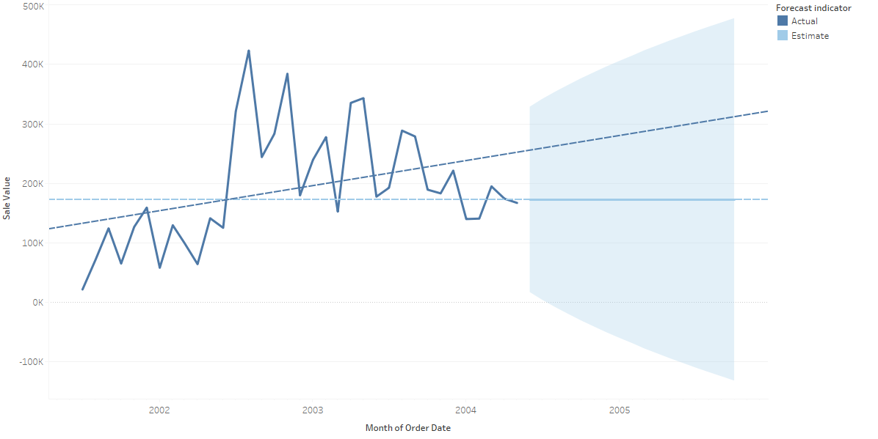
Fig 6 – Overall Value of Sales & Forecast for Northeast Sales Territory by Month
The value of sales for just 2002 and 2003 (the only compete years in the available dataset) show that there is an overall trend of the value of sales going up throughout the year in 2002, with peak value of sales reached in August (see Fig 7). In 2003, there is a declining trend in the value of sales throughout the year, with the peak in sales occurring in May.
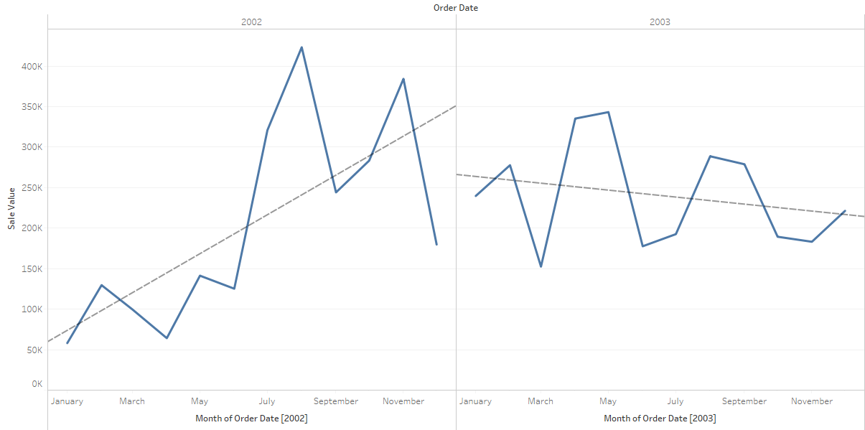
Fig 7 - Overall value of Sales & Forecast by Month for 2002 & 2003 for Northeast Sales Territory

Sales Breakdown

Sales by State
Orders shipped to New Hampshire contributed the most to the value of sales (before tax and freight charges) in the Northeast Sales Territory for the reported period (see Fig 8).
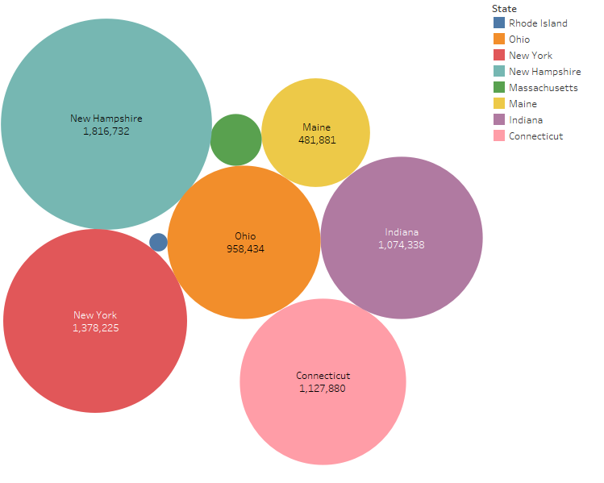
Fig 8 – Value of Sales by State Shipped To in the Northeast Sales Territory
Although the state where most individual orders were shipped to in the Northeast Sales Territory in the reported period was actually Ohio (see Fig 9).
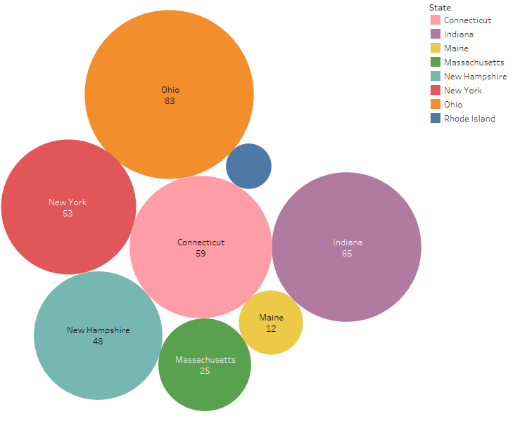
Fig 9 – Number of Sales by State Shipped To in the Northeast Sales Territory

Sales by Colour
Viewing the total value of sales (before tax and freight charges) for the reported period in the Northeast Sales Territory (see Fig 10) shows that black products generated the highest value of sales and the value of black and red items sold combined makes up over half the total value of sales for products where the colour is recorded.
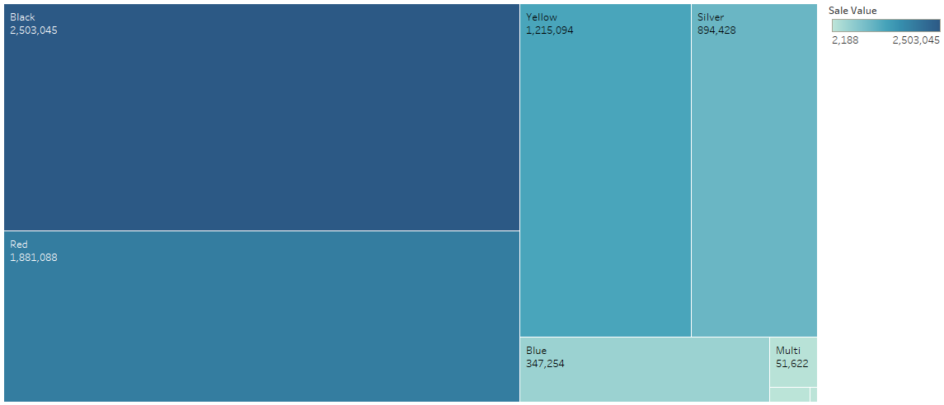
Fig 10 – Value of Sales of Products by Colour in the Northeast Sales Territory
Viewing the sales of the five most popular colours over the reported time period (see Fig 11) show that by the end of the reporting period, yellow products were actually generating the highest value of sales. Red products which generated the highest value of sales until June 2002 provided much less of the value of overall sales post June 2003.
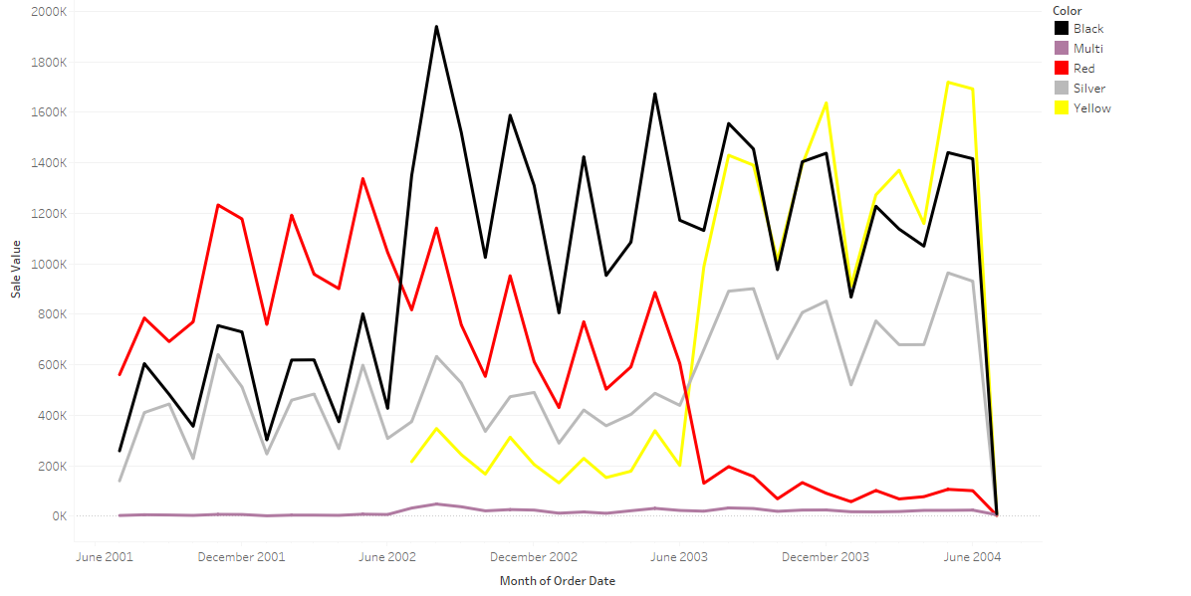
Fig 11 – Top Five Value of Sales for Northeast Sales Territory by Product Colour between June 2001 and June 2004

Sales by Product Line
Sales value (subtotal) by product line over the reported period in the Northeast Sales Territory show that the Road Product Line generated the highest value of sales (before tax and freight charges) (see Fig 12).
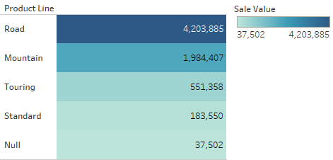
Fig 12 – Value of Sales by Product Line
Breaking down the value of sales (before tax and freight charges) by Product Line per quarter for the whole of AdventureWorks sales shows that the Touring Product Line only started to generate sales in the second quarter of 2003 (see Fig 13). This view shows that for the next four quarters from the third quarter 2003, without the Touring Product Line, overall value of sales would have been approximately equal or only slightly higher with the same quarter of the previous year.
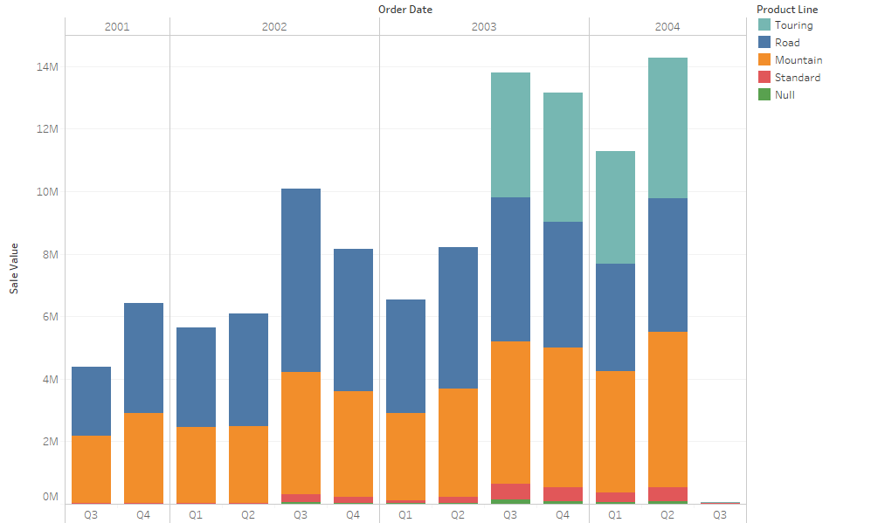
Fig 13 – Value of Sales of Product Lines by Quarter
However, for the Northeast Sales Territory, the same pattern cannot be seen due to the decrease from the previous year in the value of sales in the quarters from 2003, quarter 3 (see Fig 14). But as there is a distinct correlation between the addition of the Touring Product Line and an increase in the value of sales for AdventureWorks as a whole, it is possible that the value of sales for the Northeast Sales Territory may have been even lower if not for the sales of products in the Touring Product Line.
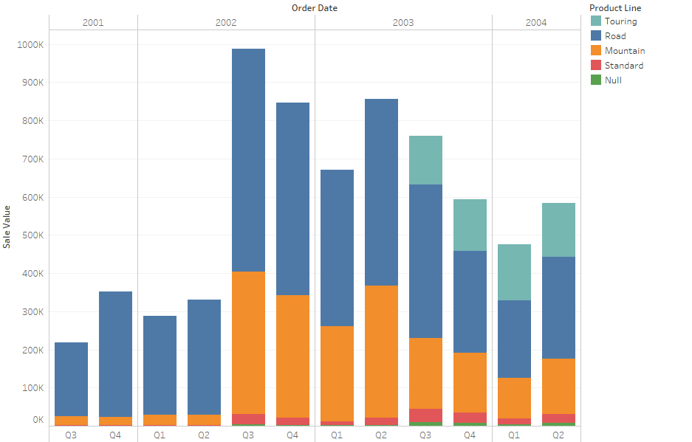
Fig 14 – Value of Sales of Product Lines by Quarter for the Northeast Sales Territory

Sales by Style
Where style is recorded, the Universal style generated the highest value of sales (before tax and freight charges) of the reported period (see Fig 15) for the Northeast Sales Territory. The styles for men and women only started generating sales after June 2002, however there were no sales of products in a specific style for men after June 2003.
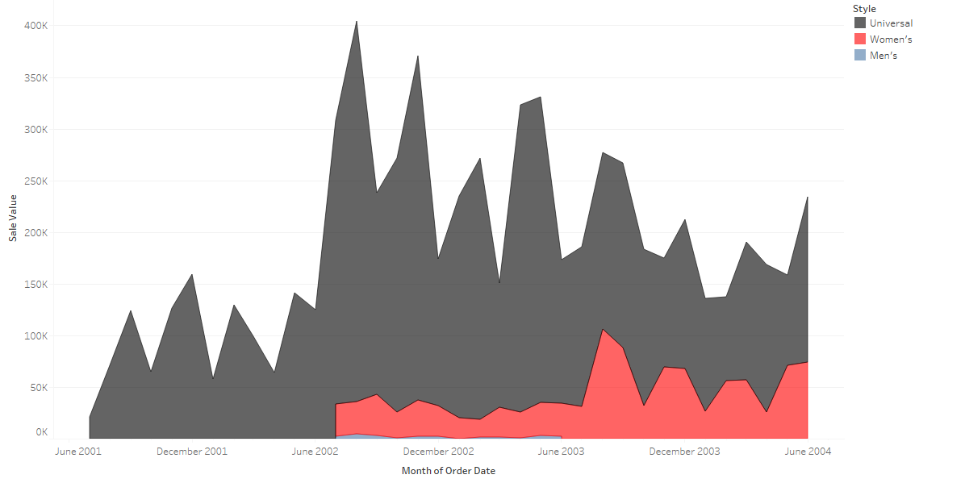
Fig 15 – Value of Sales of Products of Specific Styles
The introduction of products styles for specific gender does coincide with an overall increase in the value of sales, but as the universal style saw a much greater increase in sales at the same time, it is difficult to say that gender specific products contributed to an overall increase in the value of sales.

Sales by Special Offer
Throughout the reported period AdventureWorks have run a number of sales promotions. The Special Offer that has the highest value of Sales for the Northeast Sales Territory is the ‘Volume Discount 11 – 14’. The Special Offer ‘Volume Discount 11 – 14’ has the second highest value of sales at approximately two thirds of the value of sales of ‘Volume Discount 15 – 24’ (see Fig 16).
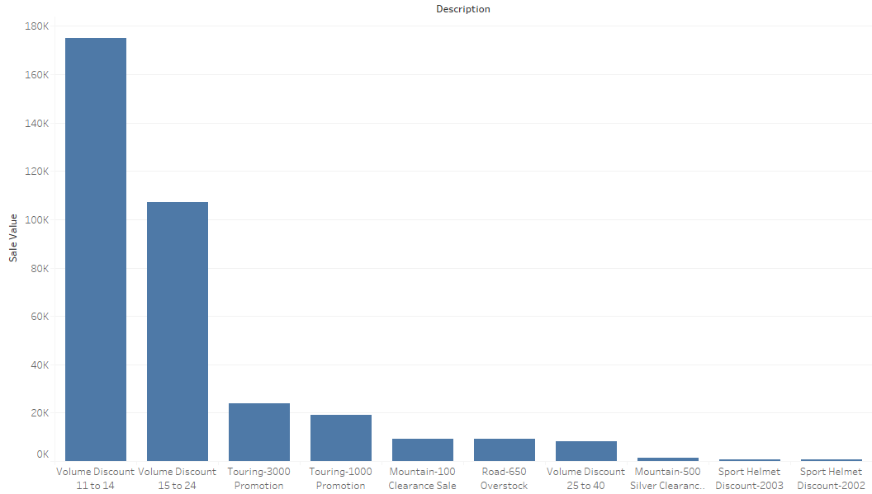
Fig 16 – Value of Sales for the Northeast Sales Territory That Include a Special Offer
Many Special Offers did not generate a significant amount of sales, but some only ran for a short period of time (see Fig 17).
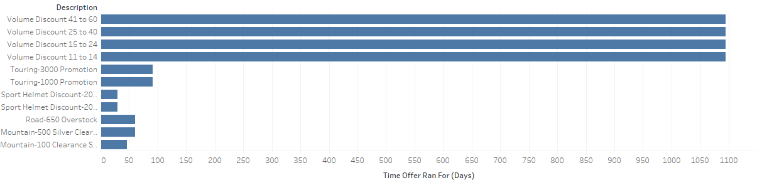
Fig 17 – Period of Time Special Offers Ran For

Sales by Category
Throughout the reported period, the ‘Bike’ category has provided the highest value of Sales in the Northeast Sales Territory, with components providing the second highest value. The value of sales from the ‘Components’ and ‘Clothing’ categories are minimal (see Fig 18).
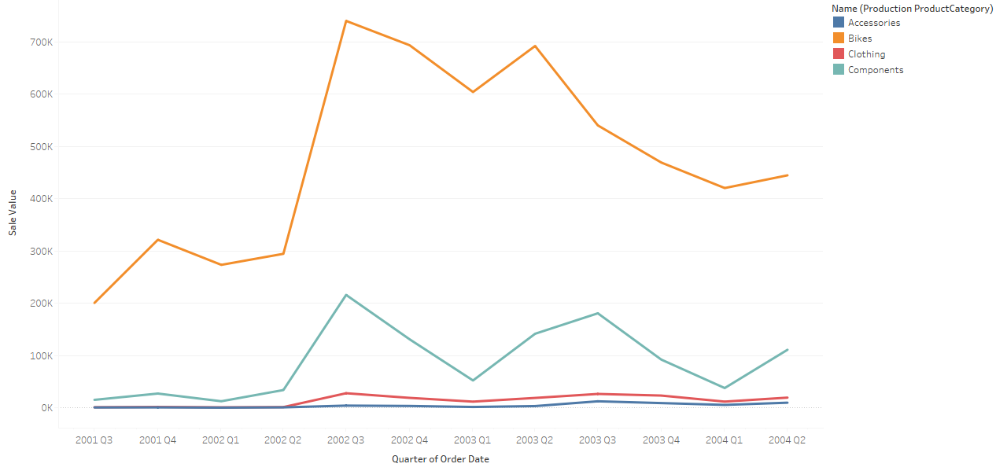
Fig 18 – Value of Sales by Product Category in the Northeast Sales Territory

Market Basket Analysis
According to Albion Research Ltd [2] “Market Basket Analysis is a modelling technique based upon the theory that if you buy a certain group of items, you are more (or less) likely to buy another group of items”.
By looking at what different Product Sub Categories were purchased in the same order, it is possible to see which pairs of Sub Categories are most likely to be purchased together.
Using the Tableau workbook “Adventureworks Sales – Market Basket Analysis” provided, a heat map was created (see Fig 19) for the Northeast Sales Territory showing the number of times Products from different sub categories were purchased.
The highest number of pairings by far is between Road Bikes & Road Frames. Road Bikes appear to be one half of many common pairings. Along with Road Frames, Road Bikes can also be seen to have often be purchased with Helmets, Jerseys and Wheels. Road Frames are also (to a lesser degree) commonly purchased with Products from other Sub categories.
It is likely that Road Bikes are the most popular individual sellers as they belong to the ‘Bikes’ Product category (the category which generated the highest value of sales) and the ‘Road’ product line (the Product Line which generated the highest value of sales).
Bikes & frames appear to be a common pairing as there is a significant pairing of Mountain Bikes & Mountain Frames. Similarly to Road Bikes, Mountain Bikes are often purchased with Wheels, although there is not as a significant correlation between Mountain Bikes and Helmets & Jerseys as there is with Road Bikes and Helmets & Jerseys.
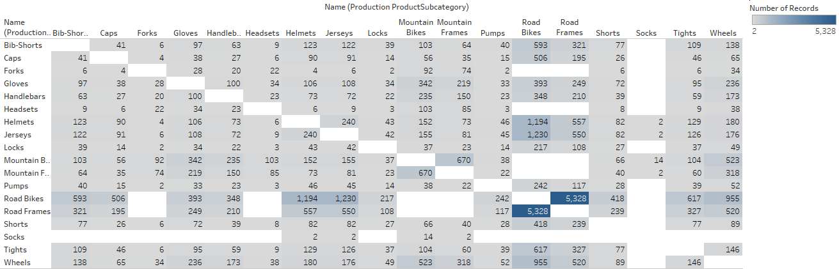
Fig 19 – Market Basket Analysis for Northeast Sales Territory

Conclusion
Overall sales figures show that the general trend of value of sales for the Northeast Sales Territory has been on an incline in the reported period, but is forecasted to even out over the next year. From the analysis in this report several recommendations can be made.
Thought should be given to increasing the number of Product Lines, as the addition of the Touring product line has led to an increase in sales for AdventureWorks as a whole.
Products of a yellow colour are gaining in popularity, so increasing the range of products of this colour could stimulate further sales.
Sales to individual states in the Northeast Sales Territory are not even, with Maine, Rhode Island and Massachusetts being particularly under represented. Advertising in these areas should be a priority.
Sales of bikes have provided the greatest value of sales, so increasing the products available in this category as well as advertising of this category could stimulate further sales. This would be particularly beneficial, as the Market Basket Analysis shows that customers often purchase these products with additional items.
While Special Offers (excluding ongoing bulk discounts), have failed to generate substantial value of Sales in the past, a Special Offer on Road Bikes should be considered, as any increase in sales in this area is likely to generate additional sales of other products.

References

[1] | Microsoft, “Product Table (AdventureWorks),” [Online]. Available: https://technet.microsoft.com/en-us/library/ms124719(v=sql.100).aspx. [Accessed 12 January 2018].
[2] | Albion Research Ltd., “Market Basket Analysis,” [Online]. Available: http://www.albionresearch.com/data_mining/market_basket.php. [Accessed 13 January 2018].

