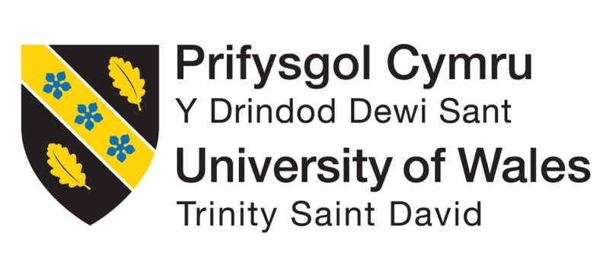

Individual Report

Proletina Petkova
Student ID:2233645
Module: Marketing Fundamentals
Module Code: LCBB4004

Lecturer : Dr. Piyumika Kithulgoda Gamage

August 26th , 2023

Table of Contents

1.Introduction 3
2. The marketing strategy process 3
3. Application of strategic tools on the company Zara 4
3.1 PESTEL analysis 4
3.2 Porter’s Five Forces 6
3.3 SWOT Analysis 8
3.4 Ansoff matrix 9
4. Recommendations for the company Zara 11
5. Conclusion 11
6. References 12

1.Introduction

The aim of marketing is to create, communicate, deliver and exchange products and services, that are valuable for customers, partners and society at large. The definition is very comprehensive and yet concise, encompassing product development, marketing communications, pricing, and strategic considerations (Chaddha, 2015). There are five simple steps in the marketing process, which marketers follow , in order to build long-lasting customer relationship and create value for the customer. These steps include understanding the customer needs and marketplace, designing a marketing strategy, developing an integrated marketing program, creating profitable relationship with customers and capturing customers value in return (Kotler, 2020). The chosen company for this report is one of the biggest fast-fashion retailers Zara. The Spanish brand exists and runs successfully since 1975 in 96 countries around the world and it is a part of the big company “Inditex” (Inditex, 2022). The aim of this report is to understand the processes and stages of marketing and the role of the marketing environment. In addition, the frameworks that will be used in this report to analyse the company Zara are Pestel , Porter’s five forces and SWOT. Two elements, such as Market development and Product development from the Ansoff matrix will be discussed. Furthermore, future recommendations for the company will be provided, that will help Zara to continue operating its store successfully, with good strategies.

2. The marketing strategy process

Marketing strategy can be viewed on three main levels: setting a core strategy, the establishment of the company’s competitive positioning and its implementation (Hooley, 2019).
The marketing strategy process
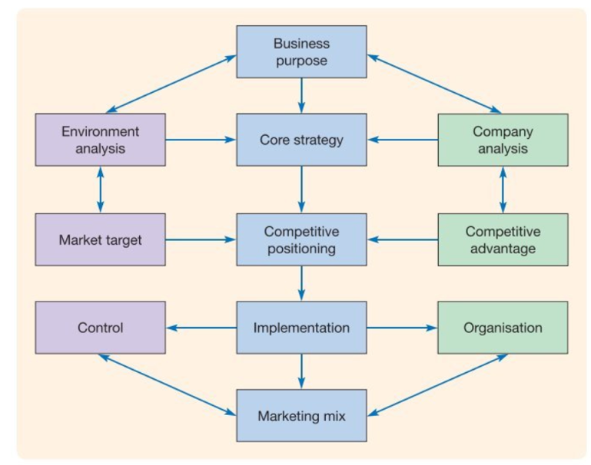
Source: (Hooley, 2019)
To develop an effective marketing strategy, it is essential to conduct a detailed and creative assessment both company’s capabilities, as well as the opportunities and threats that exist in its environment. A core strategy will be developed based on the analysis, identifying marketing objectives and how they will be achieved. The next step involves selecting and identifying market targets, including both customers and competitors. Furthermore, the company's differential advantage, or competitive edge, is recognized as the ability to meet the customer's needs more effectively than its competitors. As a result of the identification of targets and the definition of differential advantages, the organization and its products develop their competitive positioning. When it comes to implementation level, an organisation capable of implementing the strategy must be established. Establishing a combination of goods, pricing, promotions, and distribution that will express both positioning and the goods or services themselves is a crucial part of the implementation. To guarantee that the plan is successfully implemented, control measures must also be created. Control involves two main things: how well a strategy is put into action and how effective that strategy is in the end (Hooley, 2019).

3. Application of strategic tools on the company Zara

3.1 PESTEL analysis

PESTEL is a strategic tool, commonly used to identify external forces, which interfere with the performance of an organization. It can also be extensively used in the context of foreign market entry, or the establishment of a new company. There are six key external factors identified in PESTEL analysis, which include political, economic, social, technological, environmental, and legal factors (Johnson, 2017).
- Political factors
Due to Zara's Spanish roots and the fact that Spain is part of the European Union, the company benefits from the European union free trade agreement. As a result of this agreement, the company has been able to obtain a stable supply of raw materials and export its products smoothly around the world (Inditex, 2022). Working internationally is necessary and profitable for multinational brands like Zara, but it also comes with the burden of complying with local regulations. Moreover, the company could incur millions of dollars in losses, if it fails to comply with these regulations (Pons & Reid, 2023).
- Economic factors
As previously mentioned, Zara is a Spanish brand. Spain has a low labor cost, which can be attributed to its high unemployment rate - especially when compared to countries in western Europe, such as Germany, France and the United Kingdom (Statista, 2023). Due to the low labor cost in Spain, Zara can manufacture the majority of its products there, which reduces their costs and increases their profitability (SCM Globe, 2020). As one of the leading fashion brands with competitive pricing, the company is attracting a large number of customers. In addition, a loyal customer base has already been built, and the firm's strong brand image is making it easier to attract new customers. Zara is operating its stores all around the world, thus the global economy contributes significantly to the growth of the brand (Statista, 2022). Currently, most of the countries around the world are experiencing difficulties because of the war between Ukraine and Russia (Mirza, 2023). Zara may experience a negative impact on its business ,if the inflation rate is high and customers have less money available to spend. As a result of these economic conditions, the brand may also experience a limitation in its financial growth.
- Social factors
Zara provides affordable prices and has a high demand, because it is aware of the communities it serves. Moreover, the brand focuses on reaching out to different communities and age groups who are seeking for fashionable clothes and accessories. The popularity of online purchasing has grown in the past years and Zara is dedicated to provide a flawless, online shopping experience (Inditex, 2022).
- Technological factors
Zara’s innovation extends beyond its product lines. The company has used innovative approaches to supply chain management, data tracking, staff operations, inventory management. The Spanish headquarters receives information about sales and inventories every day from the store staff through wireless communication. Having access to quick information on what people purchase the most ,allows the group to respond to the public desires and to deliver more of the most wanted designs to areas ,where they are needed quickly (Destination innovation, 2020).
- Environmental factors
Usually, the concept of fast fashion is associated with wastefulness. Most of the products are not made to last long, instead they are made to be affordable for people to buy and to make them look great. In addition, fashion trends are changing fast, and people are aiming to stay on track with what is modern, thus they are throwing away their old clothes and keep buying new ones. Zara is a fast fashion brand and has been also accused of wastefulness, so the company seeks to reduce waste ,by streamlining its manufacturing process.
A promise has already been made by the company that its products are going to be produced in an environmentally sustainable manner. For example, the company respects issues such as animal welfare, the use of sustainable materials, biodiversity, and so on (Wondershare EdrawMax, 2022).

- Legal factors
There have been several instances ,where Zara has been accused for illegally stealing the designs of other brands. Fashion is an industry that is very volatile ,when it comes to copyright infringements. Zara must be vigilant about not stealing designs from other brands and therefore, the company must implement copyright laws accurately. Furthermore, many of Zara's designs have been taken away as well. One of the companies that stole Zara’s designs is the Los-Angeles fashion brand “Thilikó”. Zara have filled a complaint in the court law against them for acquiring Zara’s garments, replacing Zara’s tags with the name Thilikó and selling the products as their own (TFL, 2023). Zara is one of the largest fashion brands and it is employing many workers , but it is being accused of labor abuses ,as workers in China and Brazil are being subject to extremely bad working conditions. As a result of these allegations , consumers have been boycotting Zara’s products. In most cases, Zara has been able to avoid difficult ,legal circumstances such as these, but if the company does not follow the law, it is not known how long this good fortune will last (BNR, 2021).

3.2 Porter’s Five Forces

In order to determine industry attractiveness, Porter's Five Forces Framework identifies five competitive forces that contribute to industry analysis. They include rivalry between competitors, threat of entry, threat of substitutes, buyer power, and supplier power. In combination, these five forces determine the attractiveness and structure of an industry (Whittington, 2020).

The five competitive forces framework
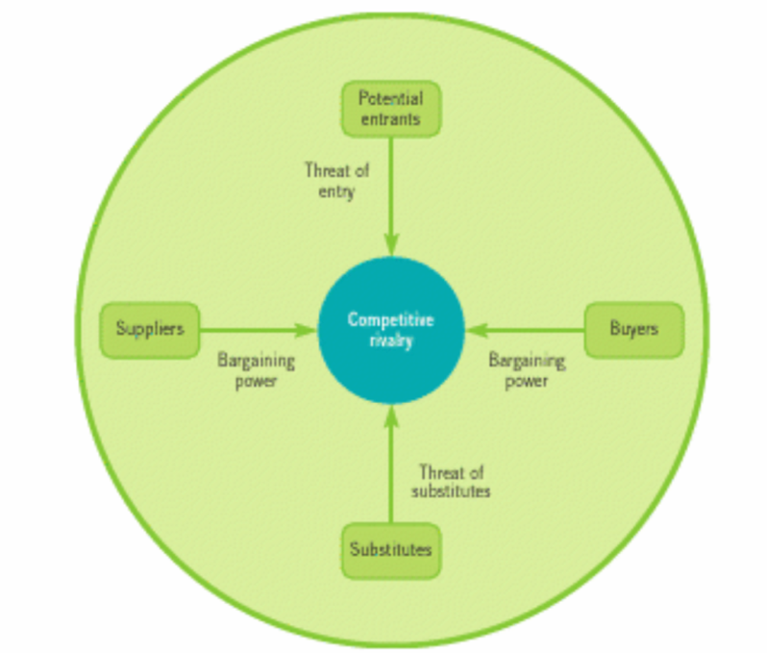
Source: (Whittington, 2020)
- Industry or competitive rivalry - High
The competition among fast fashion brands is very intense. Some of Zara’s main competitors in the market are H&M , ASOS, Mango, Primark, SHEIN and Uniqlo. In general, Zara's clothes are of higher quality, than those of other fast fashion brands. Zara's clothes tend to retain their style value, even when a new season is introduced, therefore the issue is less severe than for some of its competitors. There is a high level of differentiation among the competitors of Zara. As an example, H&M is offering its customers more of a casual wear, other brands like Adidas and Nike are offering sportswear, while Zara’s styles are more formal or semi-formal. The marketing strategies of the fast fashion brands are usually very aggressive. They spend millions of pounds on promotional activities and advertisement , while Zara spends more money on better in-store experience for its customers and allocating its stores in central locations (Chiffey, 2022).
- Threat of new entrants - Moderate
A threat of new entrants is another factor that impacts Zara's competitive position in the industry. Shein and Zaful are two other fast fashion companies that have entered the clothing and apparel industry relatively easily. For the company, this threat represents a moderate level of risk. Zara would be at risk of a high threat of new entrants ,if due to a lack of brand loyalty, consumers are able to switch brands and if new brands can easily build a distribution network. In order to combat this threat , Zara is working hard to remain loyal to its fast-fashion model and fashion-forward philosophy ,so it can maintain its products attractive and affordable (Garcia, 2022).
- Threat of substitutes - Low
Clothing serves as a protective and warming tool for the human body; thus, they are a crucial necessity for the people. The apparel industry is not affected by the threat of substitutes, since there is no real substitute for clothes. If there are no clothing shops, people will have to either make their clothes or have them tailored, both of which are neither popular nor time-efficient options (Rony, 2022). Nevertheless, subgroups exist in the retail industry, that differ in terms of price , products and quality, which gives a chance to consumers to move one group to another group. As an example, a customer who has a lower budget, but wish to purchase a high-end fashion, may choose to shop from a store with more affordable offers, such as Zara (Kidd, n.d.).
- Bargaining power of buyers - Moderate
With a wide variety of alternative clothing products available in the market, consumers have greater bargaining power over companies and their brands. This offers Zara significant advantage. However, the company strives to innovate and differentiate its designs and product portfolio, as part of its efforts to manage the influence of its consumers and the overall target market. There is stiff competition in the market and consumers are exposed to multiple brands and options to find what they are seeking. The availability of alternatives and a range of outlets of distribution enables consumers to choose between brands without incurring any additional costs. Customers' bargaining power is an indication of the pressure they exert on businesses to obtain high quality products, at reasonable prices, but also with good customer service. Zara can manage its bargaining power of buyers by adopting product diversification strategies, introducing new products and target new market segments (Garcia, 2022).
- Supplier power – Low
There is a limited and insignificant bargaining power, among fashion retail suppliers. Because of the saturated market, many fashion brands, including Zara outsource their production , manufacturing and raw materials to developing countries in Asia. In 2021, more than half of Inditex’s suppliers were situated in Asia, with a small decrease from 2018 (Alim & Telling, 2023). Suppliers have very low power , as there are too many suppliers on the retail market. In addition, Zara does not work in the suppliers’ favour, because it is procuring and manufacturing most of the stuff itself. The bargaining power of supplier might be high for Zara ,If a supplier is more concentrated in the market than the industry it serves, and if there an only a few competitors in the industry. Among the other factors, which might increase the power of suppliers is also if suppliers offer high product differentiation to consumers and if Zara does not have good market knowledge and it is not sensitive to price changes (Tipalti, 2022).

3.3 SWOT Analysis

The SWOT analysis is a comprehensive review of your organization's strengths, weaknesses, opportunities, and threats. Its primary goal is to help organizations gain a full understanding of all factors that affect the decisions they make and to determine the best course of action for the future. (Whittington, 2020).

SWOT Analysis table - ZARA
Strengths | Weaknesses
- Good quality products with affordable prices  - Trendy clothing  - Strong global presence  - Stores located in central locations  - Brand awareness  - Loyal customers  - Team of designers | - Ethical and labor issues  - Limited marketing advertising  - Designs often imitated by other brands  - Concerns regarding sustainability  - Less presence in Asia and USA
Opportunities | Threats
- Opportunity to open more global stores  - Advertisement opportunities  - Collaboration with celebrities  - Focusing more on online sells | - Increasing number of competitors  - Changing customers preferences  - Changes in trade policies, regulations and tariffs  - COVID-19 impact  - War between Ukraine and Russia  - Currency fluctuation

3.4 Ansoff matrix

The Ansoff matrix Is a strategic, planning tool that helps companies to identify more growth opportunities thru market penetration, market development, product development and diversification (Kotler, 2020).

The product/market expansion grid
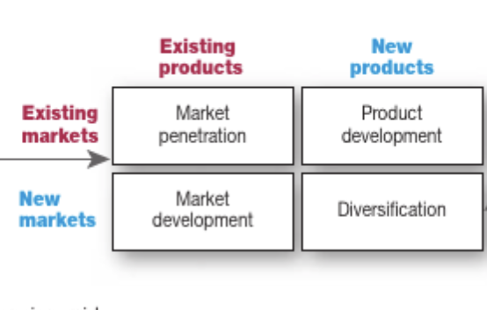
Source: (Kotler, 2020)

- Market penetration

Revenue collection and store openings in different locations worldwide demonstrate the focus of Zara towards market penetration. Zara is the flagship of the company Inditex and for the year 2022 , the total sales that have been reported are €32.6 billion , which is a net income increase of 27%. In addition, the company managed to achieve these results with less stores and less commercial space, compared to 2021. This success has been attributed to Zara's continuous store optimization and digitalization. Zara continues to see strong growth opportunities. The company's priorities include constantly improving its products, improving customer service, and increasing commitment to sustainability. Zara intends to take its business model to the next level by extending its differentiation in the coming years. With this market penetration, the company has become a global leader and has remained competitive, otherwise the company would have experienced a negative impact (Loeb, 2023).

- Product development

A key focus of Zara's growth strategy is to develop its products, which is one of the company's core areas of growth. Zara believes in consistent and regular growth in various aspects. In addition, significant part of the growth of the company has been the development of new product lines and improvements or innovations to existing products. Zara started out as an apparel company and has since expanded by creating other goods. Since the company began offering shoes, bags, swimwear, beauty products and perfumes, it has been able to attract a broader customer base, resulting in the company's financial success (Khankasi, 2020).

4. Recommendations for the company Zara

A few, very important recommendations will be provided for the company Zara , based on the analyses made in this report. One of the main issues the company is facing are concerns regarding sustainability. Many people are becoming more and more aware of what damage fast fashion brands are causing to the environment. It Is a good recommendation for the company to consider having a pre-owned clothes collection in their stores and all the clothing products to be made from 100% sustainable fabrics (Jordan, 2023). Another recommendation is the company to consider opening more stores in Asia and USA , as for the moment the presence of the brand in these continents is still very low. Since the war between Russia and Ukraine have started, Inditex took the decision to close its stores there. Opening more stores in the USA will help to offset this closure, as Russia was the second largest market of Inditex (Wright, 2023).

5. Conclusion

In a conclusion, Zara is one of the top, most successful fast fashion brands in the world, with high quality products at affordable prices. The brand has loyal customers and strong brand image , which makes it easier to attract new customers. The competition among fast fashion brands is very high and one of the biggest competitors of Zara are H&M, ASOS, Uniqlo and SHEIN. Even though the competition is very aggressive, and the rest of the companies are spending a lot of money on marketing advertising, Zara is a brand who invests more on better in-store experience and central store locations. There is always potential risk for new entrants , entering the market, but Zara is working hard to keep its products affordable and its customers loyal and satisfied. Zara is manufacturing most of its clothes itself and the suppliers do not really have a power over the company. There are many opportunities for Zara , such as expanding more stores globally , investing more on advertising and being more focused on the online sells. Some of the threats for Zara are the impact of the global pandemic COVID-19 and the war between Russia and Ukraine, which led to closing its stores there. With the recommendations provided and with strong marketing strategy , the brand will be able to keep its leadership in the fast fashion business and continue being so successful and preferred by many customers around the world.

6. References

Alim, A. N. & Telling, O., 2023. Clothing companies look to reduce China manufacturing exposure. [Online]
Available at: https://www.ft.com/content/0e23cf24-ed9c-4a0a-916c-7059d3795b93
[Accessed 13 08 2023].
BNR, 2021. Fenced Camps And Humiliating Conditions… Zara Workers’ Face Violations In Supply Chains. [Online]
Available at: https://www.bnreport.com/en/zara/
[Accessed 07 08 2023].
Chaddha, K., 2015. Marketing and Consumer Behavior: Concepts, Methodologies, Tools, and Applications. 1 ed. s.l.: IGI Global.
Chiffey, M., 2022. Zara Competitors Analysis. [Online]
Available at: https://businesschronicler.com/competitors/zara-competitors-analysis/
[Accessed 08 08 2023].
Destination innovation, 2020. INNOVATION LESSONS FROM FASHION LEADER, ZARA. [Online]
Available at: https://www.destination-innovation.com/innovation-lessons-from-fashion-leader-zara/#:~:text=Innovation%20at%20Zara%20does%20not,store%20layout%20and%20staff%20operations.&text=Designs%20and%20ideas%20are%20tested%20quickly.
[Accessed 04 08 2023].
Garcia, C., 2022. Porter's five forces analysis of Zara. [Online]
Available at: https://www.konsyse.com/articles/porters-five-forces-analysis-of-zara/?utm_content=cmp-true
[Accessed 08 08 2023].
Hooley, G., 2019. Marketing Strategy and Competitive Positioning. 7 ed. s.l.:Pearson Education.
Inditex, 2022. History. [Online]
Available at: https://www.inditex.com/itxcomweb/en/group/history
[Accessed 02 08 2023].
Inditex, 2022. INDITEX GROUP ANNUAL REPORT 2022. [Online]
Available at: https://static.inditex.com/annual_report_2022/pdf/Inditex-group-annual-report-2022.pdf
[Accessed 04 08 2023].
Johnson, G., 2017. Exploring strategy : text and cases. 11 ed. Harlow: Pearson.
Jordan, D., 2023. Is Zara Ethical and Sustainable?. [Online]
Available at: https://wear-next.com/news/is-zara-ethical-or-sustainable/
[Accessed 14 08 2023].
Khankasi, A., 2020. Ansoff Matrix Analysis for Zara. [Online]
Available at: https://ansoffs.com/ansoff-matrix-analysis-for-zara/
[Accessed 14 08 2023].
Kidd, D., n.d. How to Market to High-End & Low-End Customers. [Online]
Available at: https://fleximize.com/articles/001582/marketing-to-high-end-low-end-customers
[Accessed 11 08 2023].
Kotler, P., 2020. Principles of marketing. 8 ed. Harlow: Pearson.
Loeb, W., 2023. Zara’s 30% Expansion And 2022 Outstanding Results. [Online]
Available at: https://www.forbes.com/sites/walterloeb/2023/03/22/zaras-30-expansion-and-2022-outstanding-results/
[Accessed 14 08 2023].
Mirza, R., 2023. The UN and Ukraine: year-long war spreads global fallout. [Online]
Available at: https://news.un.org/en/story/2023/03/1134122
[Accessed 04 08 2023].
Pons, C. & Reid, H., 2023. Zara-owner Inditex enjoys strong start to summer. [Online]
Available at: https://www.reuters.com/business/retail-consumer/zara-owner-inditexs-quarterly-profit-rises-54-sale-boom-continues-2023-06-07/
[Accessed 04 08 2023].
Rony, J., 2022. 10 Key Reasons for Wearing Clothes. [Online]
Available at: https://fashion2apparel.com/necessities-of-wearing-clothes/
[Accessed 09 08 2023].
SCM Globe, 2020. Zara Clothing Company Supply Chain. [Online]
Available at: https://www.scmglobe.com/zara-clothing-company-supply-chain/
[Accessed 04 08 2023].
Statista, 2022. ZARA brand awareness, usage, popularity, loyalty, and buzz among fashion online shop users in the UK in 2022. [Online]
Available at: https://www.statista.com/forecasts/1252292/zara-fashion-online-shops-brand-profile-in-the-uk#:~:text=How%20loyal%20are%20the%20customers,show%20loyalty%20to%20the%20brand.
[Accessed 04 08 2023].
Statista, 2023. Unemployment rate in Spain from 1st quarter 2005 to 1st quarter 2023. [Online]
Available at: https://www.statista.com/statistics/453410/unemployment-rate-in-spain/#:~:text=The%20situation%20in%20the%20European,as%20of%20the%20same%20period.
[Accessed 04 08 2023].
TFL, 2023. Thilikó is "Passing off" Zara clothes as its own,per new lawsuit. [Online]
Available at: https://www.thefashionlaw.com/zara-sues-responsible-brand-thiliko-for-passing-off-zara-wares-photos-as-its-own/
[Accessed 07 08 2023].
Tipalti, 2022. Bargaining Power of Suppliers. [Online]
Available at: https://tipalti.com/en-uk/bargaining-power-of-suppliers/#:~:text=Likely%20High%20When…-,The%20relative%20bargaining%20power%20of%20suppliers%20is%20most%20likely%20high,of%20switching%20suppliers%20is%20high.
[Accessed 13 08 2023].
Whittington, R., 2020. Exploring strategy : text and cases. 12 ed. Harlow: Pearson.
Wondershare EdrawMax, 2022. Detailed PESTEL Analysis of Zara. [Online]
Available at: https://www.edrawmax.com/article/zara-pestel-analysis.html
[Accessed 07 08 2023].
Wright, G., 2023. Zara: Why store expansion is a priority despite having 6,000 shops. [Online]
Available at: https://www.retailgazette.co.uk/blog/2023/03/zara-sales-stores/
[Accessed 14 08 2023].

