
The impact of Virtual Learning Environment (VLE) – Moodle on students' learning experience at the University of Wales Trinity Saint David London Campus.
Digital Skills and Research Methods
Mr. Amitave Bhanik
Mohammed Arif Khan
Student No. 1818579

Abstract
This research report aims to assess the learning experiences of students that are currently using VLE as their learning assistant. This report shows that VLE has significant benefits, such as remote accessibility, affordability, flexibility, and skill development opportunities. However certain negative aspects are also present, for example, technological complexity and impersonal learning environment which need to be resolved as soon as possible. Therefore, the concerned educational organisation is suggested to make sure that the VLE platforms are being maintained properly and students are receiving proper assistance.
Make 100

Contents
Title of the Research 4
Introduction & Background 4
Rationale 4
Objectives 5
Methodology 5
Secondary Data Analysis 6
Primary Data Analysis 8
Conclusion & Recommendation 12
References 13

Title of the Research
Impact of Virtual Learning Environment (VLE) – Moodle on students’ learning experience in the University of Wales Trinity Saint David London Campus.

Introduction & Background
Virtual learning can be described as a technology-based learning platform. Virtual learning websites primarily depend on digital technologies to reach students from varied locations conveniently. VLE can easily be integrated with educational institutions and their operational mechanisms. VLE has become extremely popular as a learning web-platform in the entire English speaking world now a day (De Boer et al., 2016). It offers varied facilities to students and their institutions, for example, content management, student administration & engagement, curriculum mapping, collaboration & communication, and real-time communication are certain core facilities of modern VLE platforms. Moodle is a prominent example of virtual learning platforms; it is an open-source education or learning management system that provides free services to students. This web platform has been developed based on the pedagogical principles of learning, Moodle provides services such as distance education, blended learning, e-learning and flipped classroom (Hew and Syed Abdul Kadir, 2016). The objective of the VL mechanism is nothing but enhancing students' learning experience, this research report, therefore, will focus on identifying the impacts of VLE (Moodle) on students’ learning experience keeping the university of Wales Trinity Saint David London at the centre of this discussion. This research report will include all relevant sections associated with a research structure, namely research rationale, objective, methodology, primary & secondary data analysis, conclusion, and recommendation.

Rationale
Digital or virtual learning has gain immense popularity in English speaking countries in recent years for various reasons. According to scholar’s various benefits of virtual learning are there, for example, it makes students more comfortable with digital data and digital technologies. It also motivates students to manage their learning activities and behave in an accountable manner. Both students and teachers receive a better opportunity to get involved with the entire education system (Cassidy, 2016). VLE facilitates fast information sharing and the development of digital employability skills within students. However certain disadvantages of the virtual learning environment are also there, scholars argue that digital learning is reducing the level of face to face or direct interaction that used to be present in the education system previously. Due to the excessive amount of freedom offered by the virtual learning platforms, the aspect of self-discipline is being ignored. Added to that, virtual learning environment is difficult for many students to cope with as it involves complex technological mechanisms (multimedia, customisation of the web platform, complex user-interface, etc.) which may affect their learning experiences negatively (Kerimbayev, 2016). Therefore it has become essential for scholars and researchers associated with this field to investigate the experiences of students that are currently using Virtual learning platforms. The researchers should find out, whether their experiences are positive or not.

Objectives
The primary aim of this research report is to assess the impacts of Virtual Learning Environment (Moodle specifically) on the learning experiences of students at the University of Wales Trinity Saint David London Campus. The objectives of this project are
- To assess the positive impacts of Virtual Learning Environment on students in the University of Wales Trinity Saint David London Campus
- To assess the negative impacts of VLE on students as well.
- To recommend valid solutions to the current problems.

Methodology
A methodological frame-work will be developed in this section. The researcher will use both primary and secondary data to carry out the proposed research work. Therefore, the most effective research philosophy for this task will be nothing but post-positivism. Post positivism research philosophy believes that data should be analysed with an objective mindset, however, it also believes that the actual nature of reality is subjective as human values, believes and knowledge is bound to affect the data analysis process. This philosophy establishes a balance between positivism & interpretations. The suitable research approach for this paper will be a deductive approach (Kumar, 2019). Deductive reasoning is a great example of logical reasoning techniques, the deductive approach aims to test established concepts and theories since this research paper wants to evaluate whether or not the impacts of VLE on students are positive, this approach will be significant for this paper. The descriptive research design will be followed by the researcher to carry out this project successfully. The core objective of this design is nothing but describing the population or phenomena as accurately as possible. The learner aims to describe information (both primary and secondary) collected from students and various secondary sources from a neutral perspective. Thus this approach will be extremely suitable for this project.
Both primary (directly from sources) and secondary data (gathered and analysed by others) will be used in this paper. The researcher would mostly rely on quantitative (countable, numerical data) so that a reliable and valid result can be obtained. Primary data will be collected through a survey procedure, a questionnaire will be developed based on the suggested area of study and will be distributed among students of UWTSD (London campus) through a reliable and easy to use survey. The sample size for this research will be 50, the simple random sampling method will be relied on in this case, within which each member of a particular subset of the population is provided with equal opportunity to be selected as the survey participant (Flick, 2015). Participants' personal information will remain concealed and protected (stored in the password-protected device) and no one will be forced to take part in the process. Data will be handled ethically and transparently. In the case of secondary data, the information will be gathered from reliable online and library sources. Data related to ‘students’ experience regarding virtual learning environment’ only will be used by the researcher, all of the selected sources will be less than 5 years old (after 2014). Data published in languages other than English will be excluded from this research. All information will be sited properly.

Secondary Data Analysis
As mentioned previously virtual learning environment is an emerging technological trend in the English speaking countries. Moodle is a popular and leading VLE which is compatible with various kinds of professional environment, such as training, business, and education. According to ‘Moodle Statistics’ near about 20,000,000 courses are already available on the Moodle website. A total of 834,000,000 enrolments have already taken place on Moodle and around 175,000,000 people use this VLE platform regularly. Based on this data it can be said that Moodle is extremely popular among its targeted audience (Stats.moodle.org., 2019).
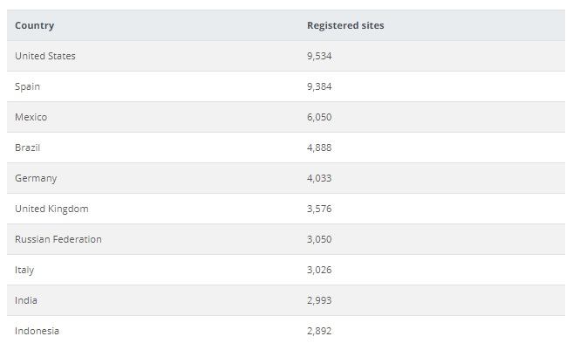
Source: stats.moodle.org
The development of the e-learning industries in recent years makes it clear that students are finding it effective. The total worth of the e-learning industry will be $325billion by 2025. It has been observed that VLE facilities help business firms to retain their staffs (25%-60% increased). Companies that used VLE platforms for employee skill development projects have also increased their revenue generation rate by 24% which clearly shows that VLE helps learners to enhance their professional skills (Fowler, 2015).
A study conducted by Luo et al., (2017) showed that people whose ‘internet age’ is six years or below are not very capable with VLE, on contrary people whose ‘internet age’ is more than 10 years are extremely comfortable with the same. Therefore, the effectiveness of any VLE platforms including Moodle depends on the level of basic literacy of the user. A statistical report published by Statista shows that VLE and online learning is mostly popular among technologically advanced younger generations, (16 to 34 years). On the contrary people above the age of 55 years are not very comfortable with VLE.
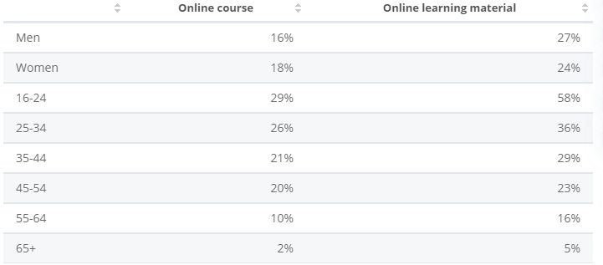
Source: statista.com
The aspect of flexibility cannot be avoided when it comes to VLE, near about 24% of the UK students (612,200) are associated with part-time education. VLE has helped such students to efficiently carry out their duties along with their academic activities. Part-time education is being offered by 158 out of 163 institutions in the UK associated with higher education and VLE is their main resource (Universitiesuk.ac.uk., 2019).

Primary Data Analysis
Five questions were formulated to gather relevant data on the suggested research topic.

Q1. Do you want a virtual learning environment to be a part of your education system?
Yes | NO
36 | 14

This question was aimed at evaluating the level of acceptance among students of UWTSD towards VLE (Moodle). It is evident from the above chart that most of the students (72%) want virtual learning to be part of their education system. This result proves that VLE has improved students’ learning experiences considerably in most of the cases. The rest (28%) of the students are experiencing certain problems that will be investigated later.
Q2, what is the most prominent benefit of Moodle?
Easily Accessible and convenient | 5
Flexible Learning Experience | 17
Improvement of digital & technological Skills | 13
Secure | 4
Accessible from remote locations | 11

This question wanted to gather information regarding the possible impacts of VLE on students. It has been found that most of the students (34%) think that flexible learning experience is the most prominent benefit of VLE, time and place are no longer a barrier to them. 26% of the students said that VLE platforms like Moodle have improved their technological skills considerably as they are residing within the virtual learning environment now a day. Aspects of accessibility and security have not received much attention, however many students focused on the fact that VLE is a great resource for distance education.

Q3. Do you feel comfortable with VLE?
Yes | No
33 | 17

This question was included to examine whether or not pupils have any negative opinion regarding VLE (Moodle). Even though the result is vastly positive (66%), a large number of students (34%) also said that they face certain problems. These problems need to be taken into consideration as soon as possible.
Q4. What is the most prominent disadvantage of using VLE?
Lack of self-discipline | 5
Impersonal | 9
Isolation | 6
Solo learning | 12
Technology issues | 18

This question tried to find out which are the main problems that they are currently encountering in relation to Moodle. 36% of the students said that technological issues are major sources of concern for them, any kind of technical issue (connection problem, server problem, maintenance issues, etc.) can be extremely frustrating for a student. 24% of the students talked about the aspect of solo training, lack of direct human interaction compels students to learn on their own sometimes, which is a negative aspect of VLE. Many people have directly indicated towards the absence of actual human relationships (18%).

Q5. What kind of learning do you prefer the most?
Traditional | 14
Complete Virtual Learning | 9
Combination of both | 27

The final question aimed to receive a definitive answer from students. The question was what kind of learning do students prefer and the result is very clear, 54% of the respondents said that they wanted a combination of traditional and virtual learning environments. Only 18% of the students said that they want an educational system completely equipped with virtual learning technologies. Therefore, it can be suggested that students should be provided with the best facilities for both of the above-mentioned kinds of learning mechanisms.
Ethical Considerations
The research has maintained strict anonymity and confidentiality of the participants from whom the feedback shall be generated. Moreover, the personal information of none of the participants, both in qualitative and quantities aspects of data collection, has been reflected on to the research work. According to the protocols mentioned in the UK Data Protection Act of 2018, the researcher shall refrain from disclosing any personal information and would also abide by the fact that the gathered data shall only be used for academic purposes (Taylor et al,. 2015). The gathered data shall be stored in password protected storage devices and shall only be accessible by the researcher and would be destroyed once the research and probable publication gets completed.

Conclusion & Recommendation
This research report focused on a very important issue of the modern age, impacts of virtual learning environment on students’ learning experiences. Both primary and secondary data were collected to answer the question. Based on the secondary data analysis it can be said that VLE is most certainly beneficial for learners, it helps them develop essential skills easily and conveniently. However, it has been observed that in order to enjoy the benefits of VLE one must have adequate technological skills. The primary data analysis shows that students are extremely positive about VLE, they enjoy the benefits it offers. However certain problems are also there, for example, VLE is directly associated with sudden technological problems, isolation and so on, therefore it is recommended that universities make sure that the VLE platforms are being maintained properly and students are being provided with proper educational and technological assistance while required.

References

Cassidy, S., 2016. Virtual Learning Environments as Mediating Factors in Student Satisfaction with Teaching and Learning in Higher Education. Journal of Curriculum and Teaching, 5(1), pp.113-123.
De Boer, I.R., Wesselink, P.R. and Vervoorn, J.M., 2016. Student performance and appreciation using 3D vs. 2D vision in a virtual learning environment. European Journal of Dental Education, 20(3), pp.142-147.
Flick, U., 2015. Introducing research methodology: A beginner's guide to doing a research project. Sage.
Fowler, C., 2015. Virtual reality and learning: Where is the pedagogy? British journal of educational technology, 46(2), pp.412-422.
Hew, T.S. and Syed Abdul Kadir, S.L., 2016. Predicting instructional effectiveness of a cloud-based virtual learning environment. Industrial Management & Data Systems, 116(8), pp.1557-1584.
Kerimbayev, N., 2016. Virtual learning: Possibilities and realization. Education and Information Technologies, 21(6), pp.1521-1533.
Kumar, R., 2019. Research methodology: A step-by-step guide for beginners. Sage Publications Limited.
Luo, L., Cheng, X., Wang, S., Zhang, J., Zhu, W., Yang, J. and Liu, P., 2017. Blended learning with Moodle in medical statistics: an assessment of knowledge, attitudes, and practices relating to e-learning. BMC medical education, 17(1), p.170.
Stats.moodle.org. (2019). Moodle statistics. [online] Available at: https://stats.moodle.org/ [Accessed 6 Dec. 2019].
Universitiesuk.ac.uk. (2019). [online] Available at: https://www.universitiesuk.ac.uk/policy-and-analysis/reports/Documents/2018/flexible-learning-the-current-state-of-play-in-higher-education.pdf [Accessed 6 Dec. 2019].
The Integration of Virtual Learning Environments (VLE) into Your Studying.
-Moodle-
The purpose of this research project is to collect feedback regarding the significance of Moodle into your learning. This is a research project being conducted by Arif Khan at UWTSD. You are invited to participate in this research project because you are valued students at UWTSD.
Under the General Data Protection Regulation (GDPR) (EU) 2016/17, we have a legal duty to protect any information we collect from you. Information contained in this survey and any attachments may be privileged or confidential and intended for the exclusive use of the original recipient.

Name: Student ID:
Program of study:
Age: 18-25
25-30
30+
Gender: Male Female Prefer not to say
- Do you like having Moodle be a part of your education system?
Yes
No
- What is the most prominent benefit of Moodle? (Circle)
Easily Accessible | Flexible Learning Experience | Improvement of technological Skills | Secure | Accessible from remote locations
- What is the most prominent disadvantage of using VLE?
Lack of self-discipline | Isolation | Technological issues | Solo learning | Impersonal

- Do you feel comfortable with VLE?
Yes
No

- What method of learning do you prefer the most? (Circle)
Traditional | Complete Virtual Learning | Combination of both

- What platform/device do you use to Access Moodle? (Circle)
Smartphone | Laptop | PC | Tablet | Other

- How often do you access Moodle? (Circle)
When I need to | Often | Frequent | Rarely | Never

