Information Engineering

Database Design (The Book Store)
Student number: 1806461 Name: Jacob Harry Moseley
Data management is an important part of any business and in a digital world it becomes crucial to the survival of a business to computerise the data into a database. For the purposes of this report the business takes the form of a book shop wanting to update its system, and the database itself is made using Microsoft Access. In order to put the database together one must think about customer requirements and so from the details provided on the brief several diagrams have been drawn out; a context level DFD, a level 0 DFD, and an ERD. From this tables have been made and queries written in order to form a basis for the system, then tables have been linked together to be able to access the data in a practical way, providing a menu system for the user. A brief user guide has also been written in order to explain the functionality of the system and how to navigate the menus. Lastly any improvements that could be made have been listed as well as areas of difficulty while building the system.

Contents
Introduction 3
1 – Diagrams 4
1.1 – DFDs 4
1.2 – ERD 5
2 – Database outputs/forms 6
2.1 – Reports 6
2.2 – Forms 6
3 – Queries 8
4 – User Guide 9
5 – Evaluation 10

Introduction
The aim of this report is to demonstrate skills which have been learnt about Microsoft Access and the process of making database management systems in general. It will start by showing diagrams which will be drawn out, two DFDs and an ERD, and justifying why the ERD has been drawn out the way it has and the relationships between the tables. It will then look at some of the forms which have been made for the system. Next it will cover the queries which have been written which aided in the creation of the tables, and the reports that will be generated. Then we will give a brief user guide for the system. Lastly, any improvements that could be made to the system and any areas that need further reading into will be discussed.

1 – Diagrams

1.1 – DFDs
Figure 1 Context Level Diagram
Figure 2 Level 0 Diagram

1.2 – ERD
Figure 3 ERD

The diagram above illustrates the entity relationship diagram for what will be the database. The diagram includes a bridge table (stock requests) linking the supplier, employee, and book tables together; for each request for stock for the book store we need to know which supplier the stock is coming from, the specific stock being requested, and the employee who put in the request. The second bridge table (order) links the employee, book, and customer tables together; each time a order is made by a customer we need to keep track of their details, the book(s) being ordered, and the employee who took the order from the customer. These bridge tables can be recognised as such as they have multiple attributes making up their primary key, the unique combination of these gives us the primary key for each entry in the table, two of the values could be the same as another entry in the table providing the third value is different, thus making the entry unique.

2 – Database outputs/forms

2.1 – Reports

2.2 – Forms
The system starts with an index page giving the option to look at either stock information or customer records (which also includes order information). The forms these buttons lead to both have the same general layout with the destinations of the buttons/text on the buttons being different. Below shows the stock information form.
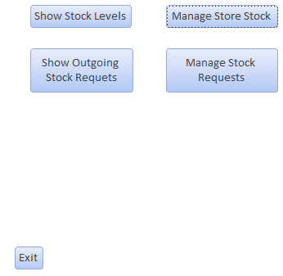
Figure 4 Stock Information Form
And next the customer records form.

Figure 5 Customer Records Form
Additionally see included screenshots of the insertion forms.

Figure 6 Form to add book entry

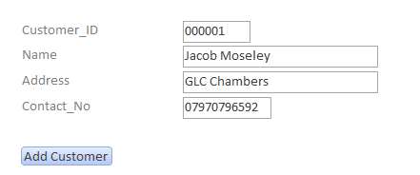
Figure 7 Form to add customer entry

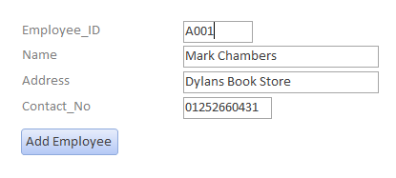
Figure 8 Form to add employee entry

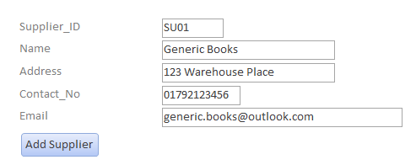
Figure 9 Form to add supplier entry

3 – Queries
Several queries have been used, primarily for the initial creation of the tables, and then to test that data could be inserted into the tables correctly; checking that the datatypes used were correct and whether the length limits set for the input was enough. An example of a table creation query and the insertion query can be seen below.
CREATE TABLE Book (ISBN TEXT(15)
CONSTRAINT book_isbn_pk PRIMARY KEY,
Title TEXT(25),
Author TEXT(25),
Quantity INT);

INSERT INTO Book ( ISBN, Title, Author, Quantity )
VALUES ('9780552167512', 'Small Gods', 'Terry Pratchett', 10);

For the most part the creation queries worked well enough for the tables in the system, for the bridge tables however slight bit of extra work was required. The query itself was essentially the same for the either of the bridge tables, but it’s important to think about the fact that them being bridge tables will mean they will have a composite key. This is simple enough to manage, in the initial creation query only one of the keys can be set, then once the query has been executed and the table created open the table in design view, select all the fields that will make up the composite key and, with them highlighted, press the primary key button on the ribbon above.

4 – User Guide
The system itself is basic in nature but a few points are worth pointing out to the user, upon opening access as there are no macros that have been written one will need to manually open the index form. In an ideal situation there would be the macro to open the index page upon opening the database file, unfortunately this hasn’t been implemented. From the index form navigation is self-explanatory, the only part that may not be immediately obvious is that order history is beyond the customer records button.
Beyond either of the buttons on the index form are buttons giving the user the option to make changes to data in the system, the buttons labelled with ‘manage’, or to display data in the system in the form of a report, the buttons labelled with ‘show’.

5 – Evaluation
The overall system is more basic than initially planned and there is certainly room for improvement. A knowledge of the way the tables will interact has been demonstrated with the primary, foreign, and composite keys, but labels could have been included in the ERD in order to explain the rational behind the relationships. There has been some use of SQL but less than desirable, SQL could have been used in order to fetch data from the system using select statements. Macros haven’t been used and would definitely be beneficial to a future system that may be made.

