UNIVERSITY OF WALES
TRINITY SAINT DAVID
LCHS7009
POPULATION HEALTH AND
DIGITAL HEALTH PROMOTION
COMPONENT 1 – TWO BLOGS
Digital health apps to prevent physical inactivity and obesity

Student name | mohammadyusuf kasim motala
Student ID number | 2534789
Programme | MSc Public Health and Social Care in Practice
Module | LCHS7009 – Population Health and Digital Health Promotion
Lecturer | Dr Raheela Shaikh
Submission deadline | 23 October 2026, 14:00

BLOG 1 | NHS Weight Loss Plan app
BLOG 2 | MoveWell 360 (proposed app)

BLOG 1 | EXISTING DIGITAL TECHNOLOGY
Managing Obesity with the NHS Weight Loss Plan App: A Critical Review
Existing digital health promotion technology | Adult weight management
The public-health challenge
Obesity and physical inactivity are related public-health challenges but are not the same. In England in 2023–24, 64.5% of adults had overweight or obesity and 22.0% were physically inactive (OHID, 2025). Obesity increases the risk of type 2 diabetes and cardiovascular diseases, while physical activity benefits even without weight loss. Adults are recommended to work up to a minimum of 150 minutes of moderate physical activity weekly and limit sedentary behavior (DHSC, 2026).
What the NHS app offers
The NHS Weight Loss Plan is a free 12-week program to set weight goals, learn about portions, keep track of food intake and monitor calories (NHS, n.d.). These features might be helpful to find patterns and lose weight more systematically. It will be useful for those who would be able to register regularly and make changes sustainable.
What the evidence says
In a 2024 meta-analysis of 27 randomized controlled trials, mobile apps were correlated with an average loss of 1.38 kg in weight and 0.44 kg/m2 in body mass index (Li et al., 2024). However, these results relate to apps collectively, and it does not mean that the NHS Weight Loss Plan app causes such results. The Cochrane review considered the evidence about effects of stand-alone smartphone-based interventions to be of limited or uncertain quality (Metzendorf, Wieland and Richter, 2024). Thus, the evidence suggests the possibility but not certainty of its effectiveness.
Limitations and next steps
The main limitation is that weight and calories tracking do not measure physical activity. The food diary does not reflect for how long a person was sitting and if he/she moves more. The process of logging can be burdensome while disabilities, dangerous streets, high costs, caring for others, or lack of time can prevent physical activity. The app can include additional features of setting exercise goals, prompts to change sitting time, options of doing exercise when sitting and references to experts. Evaluation should measure physical activity, well-being and equal access, not only the number of downloads.
CRITICAL TAKEAWAY The evidence suggests potential, not certainty: weight and food tracking can support self-management, but the NHS app should not be presented as a direct physical-activity tracker or a stand-alone solution to obesity.
BLOG 1 | VISUAL EVIDENCE
The public-health problem and intervention pathway
A visual summary of the evidence and a cautious interpretation of how the app may help.
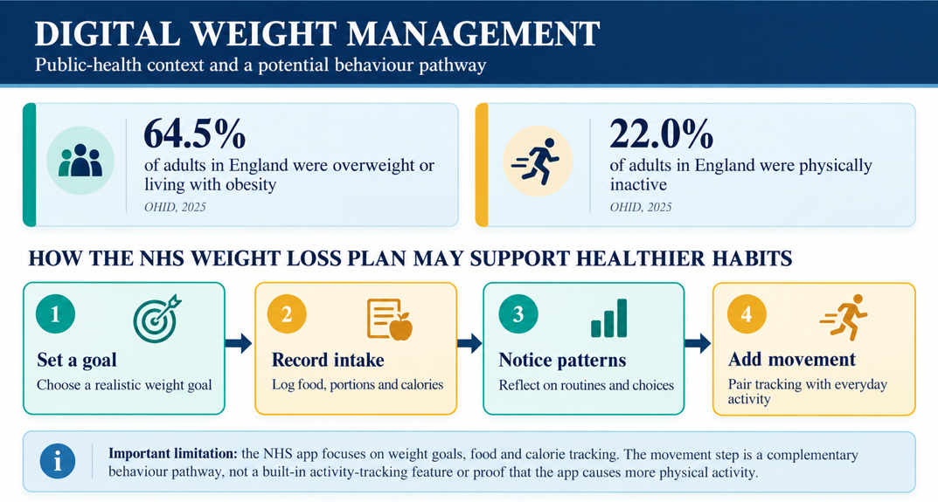
Figure 1. Adult weight and activity indicators, with a conceptual pathway for the NHS Weight Loss Plan app.
Source: Statistics adapted from OHID (2025); pathway self-developed from NHS (n.d.). The pathway is illustrative, not evidence of causation.
Explore the technology: NHS Weight Loss Plan app – official NHS guidance
Interpretation: the proposed pathway suggests how self-monitoring might support healthier choices; effectiveness for this specific app must be tested rather than assumed.

BLOG 2 | PROPOSED DIGITAL TECHNOLOGY
MoveWell 360: A Digital App to Prevent Physical Inactivity
Proposed digital health promotion intervention | Adult health and everyday movement
The case for a practical solution
In 2023-24, 64.5% of English adults were obese or overweight and 22.0% were physically inactive (OHID, 2025). People should aim for 150 minutes per week of moderate exercise (DHSC, 2026); however, advice may not equal action. MoveWell 360 is an idea, not a real-life intervention.
How MoveWell 360 would operate
The app would begin with easy checks for activity level, mobility, confidence, and preferred times for reminders. Its dashboard would include minutes active per week, prompt breaks following long periods of being sedentary, and brief exercises for walking, standing or seated. Users would choose incremental targets; social challenges and wearables sync would be optional. Low-data accessibility, screen readers, printed plans, and offline tools would facilitate usage by those lacking device access. Information links would take users to NHS guidance, not individual medical advice.
Behavior change and evidence
The COM-B model of behavior combines capability, opportunity, and motivation (Michie, van Stralen and West, 2011). Demonstrations and realistic goals can develop capability; prompts and seated activities create opportunities; encouragement can motivate users. A 2024 review demonstrated small gains in physical activity and some cardiometabolic health outcomes from using digital health apps, including gamification (Nishi et al., 2024). However, this does not provide evidence that MoveWell 360 would be effective; standalone weight management apps have yielded inconclusive evidence (Metzendorf, Wieland and Richter, 2024).
Safeguards and evaluation
Users should be able to manage reminders, make their dashboard private, and choose to use the social features. Avoid stigmatizing terminology and collect minimal data. The 12-week pilot project should measure activity, sitting break frequency, user retention, and wellbeing among different age groups, disabilities and levels of deprivation. If the success of MoveWell 360 is limited to confident smartphone users, health disparities will be exacerbated. Sustained activity, not downloads or weight loss promises (Dup, 2020), is the goal of the pilot.
DESIGN PRINCIPLE Technology should enable realistic movement and supportive habits, not blame users or promise weight loss. MoveWell 360 is a proposal to be tested, not an existing product.
BLOG 2 | VISUAL DESIGN
MoveWell 360: prototype and behavioural design
The concept connects individual prompts with practical opportunities to move.
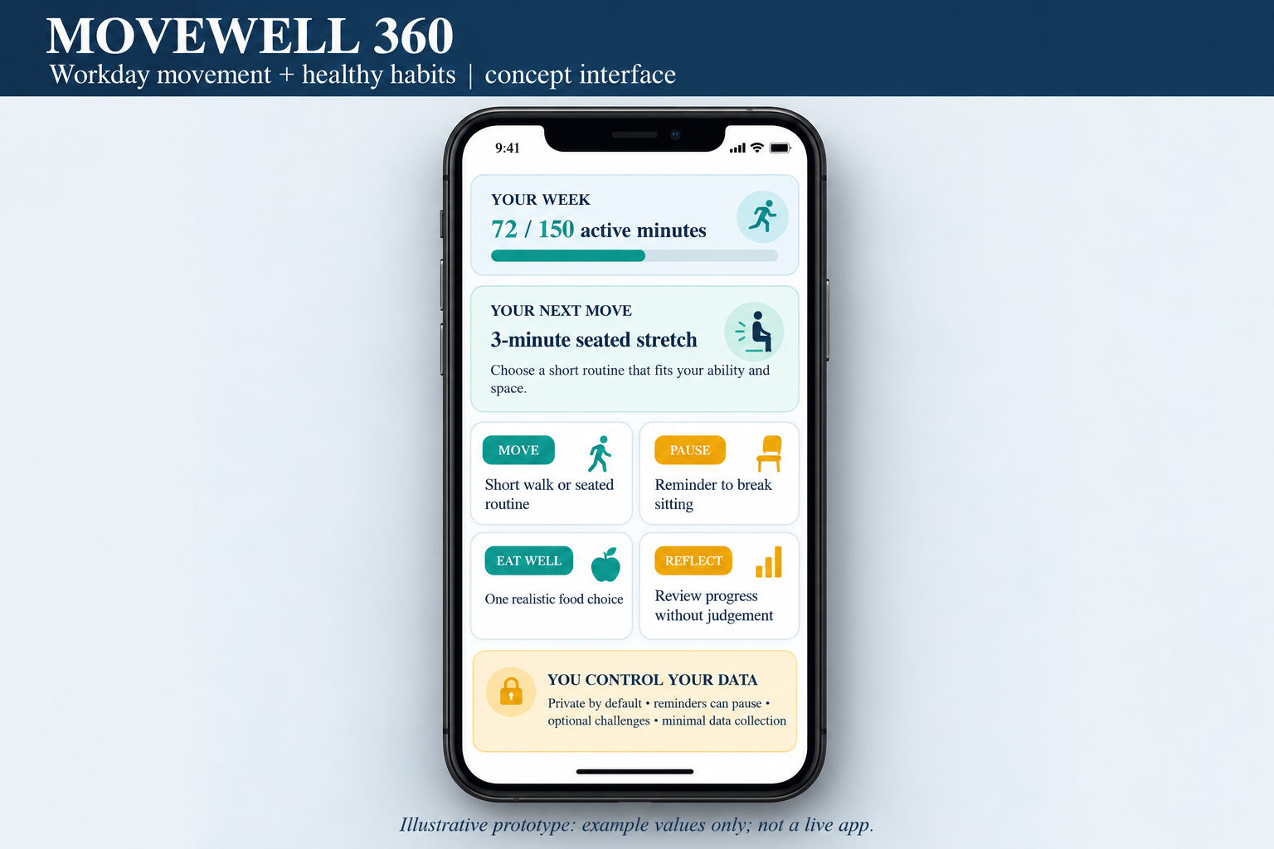
Figure 2. MoveWell 360 proposed user-interface concept.
Source: Self-developed illustrative prototype; example values only; not a live product.
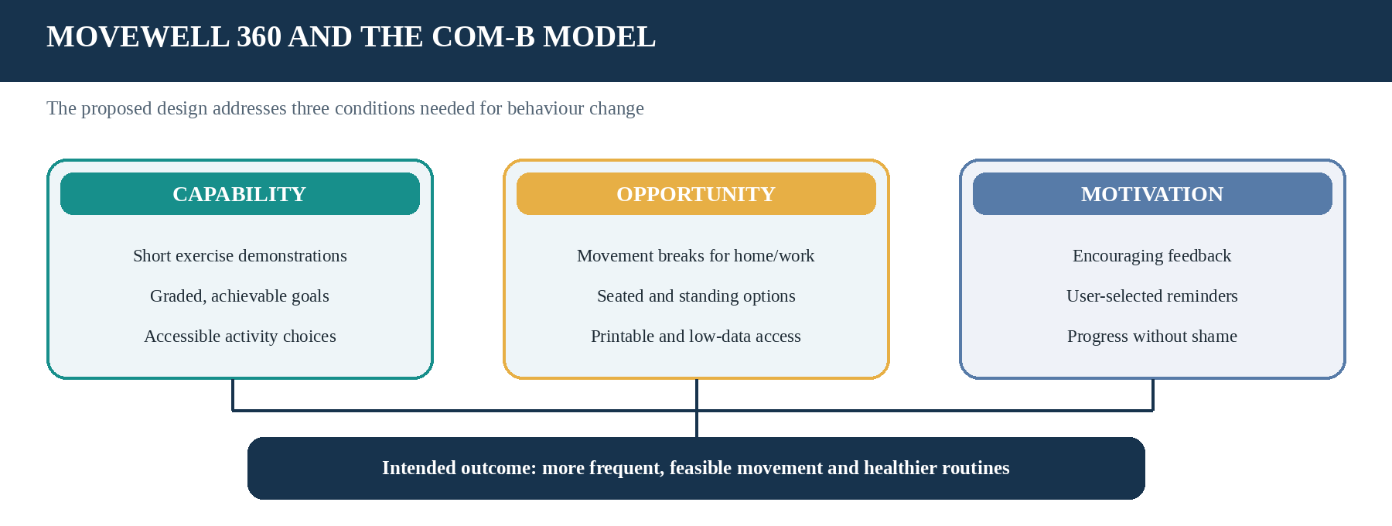
Figure 3. Applying COM-B to MoveWell 360.
Source: Self-developed, informed by Michie, van Stralen and West (2011). Intended behaviour pathway, not a claim of proven impact.
BLOG 2 | IMPLEMENTATION PLAN
Implementation risks and safeguards
Practical responses to reduce barriers and support an equitable pilot.
Risk | Design response
Reminder fatigue or work pressure | User-controlled timing; pause reminders during meetings; no more than a small number of prompts daily.
Disability or limited device access | Seated and standing routines; screen-reader support; printable activity plans and non-digital options.
Privacy and stigma | Collect minimum data; private dashboard by default; neutral language; optional social features.
Uncertain effectiveness | Pilot for 12 weeks; measure activity minutes, sitting breaks, retention and wellbeing; report differences between population groups.
Guidance to explore: UK Chief Medical Officers’ physical activity guidance

References
Department of Health and Social Care (2026) ‘Physical activity for adults and older adults: 19 and over (text of the infographic)’. Updated 16 July 2026. Available at: https://www.gov.uk/government/publications/physical-activity-guidelines-adults-and-older-adults/physical-activity-for-adults-and-older-adults-19-and-over-text-of-the-infographic (Accessed on: 19 October 2026).
Li, S.-J., Zhou, Y., Ma, H.-M., Wang, A.-Q., Tang, X.-Y., Pei, R.-Y. and Piao, M.-H. (2024) ‘Effects of mobile applications on weight-related, behavior and metabolic outcomes for adults with overweight and obesity: a systematic review and meta-analysis’. Studies in Health Technology and Informatics, 315, pp. 386–391. Available at: https://doi.org/10.3233/SHTI240175 (Accessed on: 19 October 2026).
Metzendorf, M.-I., Wieland, L.S. and Richter, B. (2024) ‘Mobile health (m-health) smartphone interventions for adolescents and adults with overweight or obesity’. Cochrane Database of Systematic Reviews, 2024(2), CD013591. Available at: https://doi.org/10.1002/14651858.CD013591.pub2 (Accessed on: 19 October 2026).
Michie, S., van Stralen, M.M. and West, R. (2011) ‘The behaviour change wheel: a new method for characterising and designing behaviour change interventions’. Implementation Science, 6, 42. Available at: https://doi.org/10.1186/1748-5908-6-42 (Accessed on: 19 October 2026).
NHS (n.d.) ‘Calories and weight loss’. NHS Better Health. Available at: https://www.nhs.uk/better-health/lose-weight/calorie-counting/ (Accessed on: 19 October 2026).
Nishi, S.K., Kavanagh, M.E., Ramboanga, K., Ayoub-Charette, S., Modol, S., Dias, G.M., Kendall, C.W.C., Sievenpiper, J.L. and Chiavaroli, L. (2024) ‘Effect of digital health applications with or without gamification on physical activity and cardiometabolic risk factors: a systematic review and meta-analysis of randomized controlled trials’. eClinicalMedicine, 76, 102798. Available at: https://doi.org/10.1016/j.eclinm.2024.102798 (Accessed on: 19 October 2026).
Office for Health Improvement and Disparities (2025) ‘Obesity profile: short statistical commentary, May 2025’. Published 7 May 2025. Available at: https://www.gov.uk/government/statistics/obesity-profile-may-2025-update/obesity-profile-short-statistical-commentary-may-2025 (Accessed on: 19 October 2026).

