Module name: Introduction to Health and Social Care
Student name: Iqra Wajid
Student number: 2410757
Assignment Title: Portfolio – Two Tasks
Module code: LCHS4003
Lecturer name: Daniel Hanura







*
What is a Residential Care Home?
Before the NHS was introduced in 1948, care for vulnerable and older people was mostly provided through workhouses under the Poor Law system which often failed to offer dignity or appropriate care (The King’s Fund, 2023).
The National Assistance Act 1948 placed the responsibility for residential care on the local authorities from institutional care (Legislation.gov.uk, 1948, s21). Further changes occurred in relation to the NHS and Community Care Act 1990 where the care needs assessment was announced and individuals were assisted to live independently for as long as possible (Legislation.gov.uk, 1990, s.47).
The Care Standards Act 2000 had initiated the minimum specifications and improved regulations across the care provisions (Legislation.gov.uk, 2000, s3, s22). In 2009, the Care Quality Commission became the official body responsible for overseeing adult social care services in England. More recently, the Care Act 2014 brought all adult social care law into one legal framework promoting individual’s wellbeing and strengthening safeguarding by placing adult protection on legal footing. It also, emphasised personalisation by involving residents in plannings. (Legislation.gov.uk). These developments reflect a shift towards person-centred, accountable and quality focused residential care.

Residential Care Home in The UK
According to the NHS England, an estimate of 360,000 people live in care homes which highlights the magnitude of residential care homes within the wider health and social care sector (NHS England, 2023).

Unlike nursing homes, residential care homes do not only emphasise on medical care rather, they focus on aiding to the daily needs of older adults in a safe and comfortable environment. Moreover, residential care homes focus on offering emotional and social aid by coordinating with other professionals such as; GPs, district nurses, physiotherapists, dietitians and many more. (NHS, 2023) Combined with the population rising in the UK, the demands for residential care homes are also increasing which primarily plays the role of maintaining dignity, safety and best quality of life for the vulnerable adults (Uberoi, 2025).

Residential care homes are a vital service that provides accommodations, personal care and emotional support for individuals who require the constant care within their daily life. Vulnerable adults who cannot live independently due to age, illness, disability or cognitive impairment require 24-hour assistance with a structured routine (NHS, 2023). Residential care homes are most commonly used by a variety of individuals such as adults who have reduced mobility or health declining, are in need of structured routines and supervisions to remain safe and require the need of respite care while family carers take a break.
1948
1980s-1990s

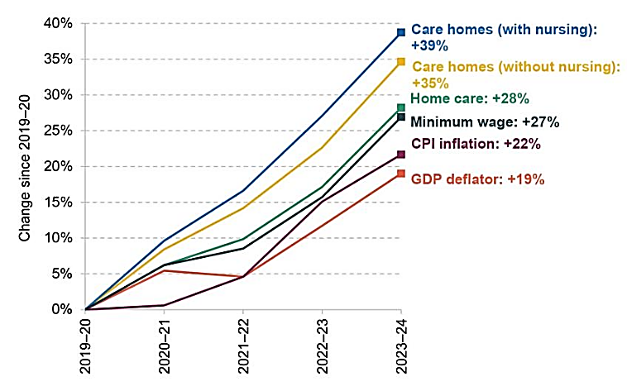
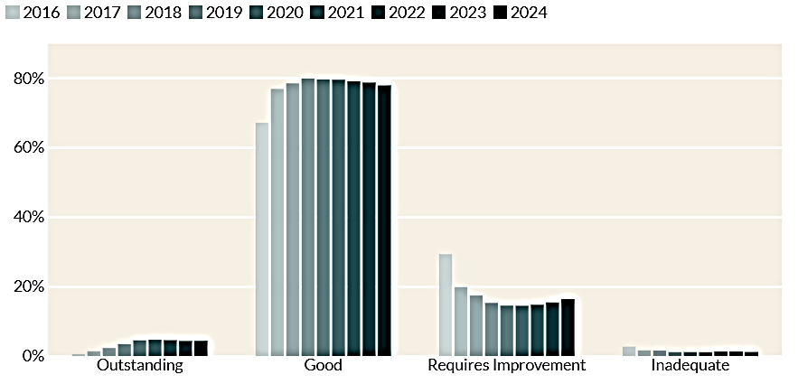
Figure 3: Average weekly residential care fees in the UK (Which?, 2025)
conditions. Moreover, plans are reviewed and updated regularly to ensure that the care stays safe, appropriate aligned with the outcomes of the residents.
nurses depending on the service type. They work closely with NHS professionals such as general practitioners, district nurses, physiotherapists and mental health teams to provide holistic care (Skills for Care, 2025). Person centred care plans are tailored to individual needs and reviewed regularly to ensure appropriate support is given by working in partnership with families and residents. This approach is essential in supporting residents with long term

Current Functioning of Residential Care Homes
Residential care homes today operate within a combined health and social care system which is designed to ensure the residents receive the best continuous support and coordination. Admissions for a place within residential care often begins with a care needs assessment that is followed by the local authorities under the Care Act 2014. This assessment analyses an individual’s physical and mental health, their emotional wellbeing and mobility. The purpose of carrying out this assessment is for care home workers to determine the type of support that would be required and also, whether the care home provision is best fit for the individual. Thereafter, a financial assessment is undertaken to establish whether care will be funded by the local authority, self-funded or covered by NHS Continuing Healthcare (NHS, 2025).
Residents that become registered, receive support from specialist professionals including care assistants, senior carers, registered managers and sometimes

Residential care costs vary significantly. Local authorities pay an average of £908 per week, while self-funding residents pay approximately £1,278 per week. This highlights the inequalities within funding (Which?, 2025).
Figure 2: Percentage of registered residential care homes in England (Bacalar, A. and Zaranko, B. 2024).
Figure 1: Most adult social care services in England are rated Good or Outstanding, indicating generally positive quality standards across the sector (The King’s Fund, 2025)

Challenges Faced by Residential Care Homes
Workforce shortages:
Residential care homes continue to face recruitment and retention difficulties. Skills for Care report that vacancy rates of approximately 5% can lead to staff being burnout and reduce the continuity of care for the residents (Skills for Care, 2024c, pp.9-10).

Funding and system pressure:
Rising costs and limited local authority funding place significant pressure on care homes. The Care Quality Commission reports that 45% of delayed hospital discharges are linked to waiting for social care placements. This impacts hospitals, care homes residents and families highlighting the need for better funding and system integration.

Task 2: Ambulance Services: Historical Development, Current Function and Importance.

Introduction
Ambulance services are essential elements of the healthcare systems as they provide rapid medical responses that are emergency and out of hospital care to individuals who are suffering from an illness, injury or are bed bound. The progress of the ambulance services has been formed by historical events, improvements in medicine and changes to the needs of the community. This has resulted in ambulance services being vastly professional today.


Figure 1: A row of ambulances queued outside NHS facility (NHS Confederation, 2021).

Origins and Historical Context
The origins of the ambulance services is outlined from the military medicine. During the late 18th century, Dominique-Jean Larrey (French military surgeon), initiated “flying ambulances” during the Napoleonic wars. The horse-drawn carriages were created to transport wounded soldiers from the battlefield to the clinic promptly which led to major improvement in the survival rates (Ballard, H.S, 1997). This change emphasised the significance of speed and early intervention in emergency care.
In the 19th century, the infectious disease outbreaks such as cholera in the Europe, required patient transport to be arranged so that mortality rate is reduced and the spread of the disease is limited (Pollock. A, 2013; Peter. H, 2026). Likewise, official ambulances developed further in the UK when the Metropolitan Asylums Board established ambulance services to transport patients safely to the hospitals (London Ambulance Service, 2025).
In the 20th century, developments in motor vehicles, enhancement with the communication technologies and additional trained medical knowledge permitted ambulances to develop beyond patient transportation. After the launch of the National Health Service (NHS) in the 1948, the ambulance services in the UK had a huge turnover when becoming publicly funded and combined within the national system ensuring that there is reasonable access to the emergency healthcare (NHS England, 2022).
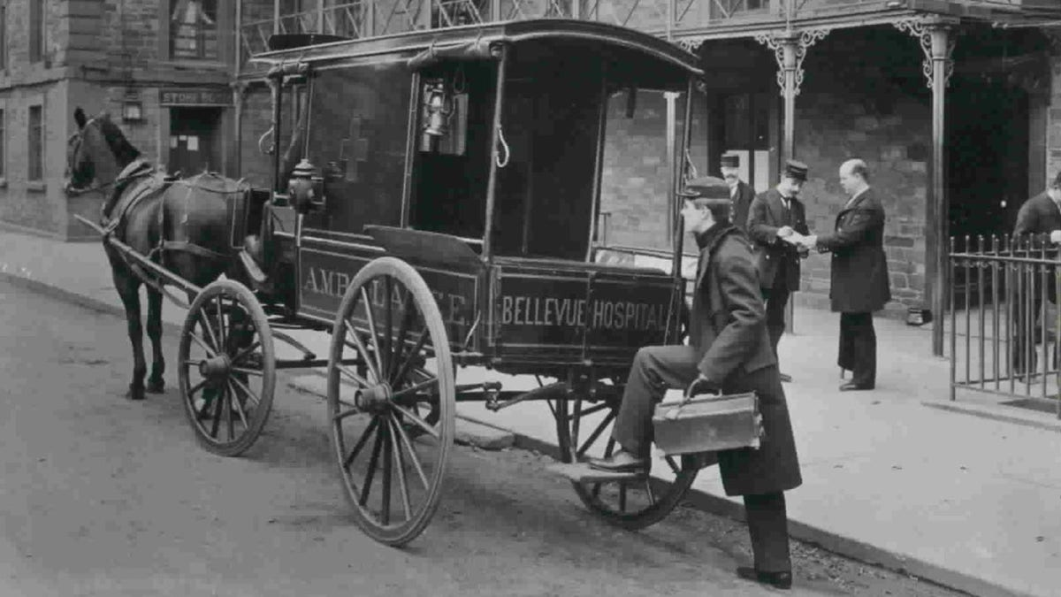

Figure 2: Ambulance in New York City (Fox News, 2023).

How Ambulance Services Function Today
Modern ambulance services operate combined emergency medical systems. In the UK, ambulance services are accessed through the emergency number 999 and are managed through advanced control centres that prioritise calls using clinical triage systems (NHS England, 2022). This ensures that life-threatening emergencies are met with immediate attention whilst non-urgent cases are managed correctly.
Ambulances are staffed by trained professionals such as Emergency Medical Technicians (EMTs) and paramedics, who are qualified to assess, diagnose and treat patients. Paramedics can prescribe medications, perform advanced life-support procedures and make decisions clinically regarding the need for hospital transport (College of Paramedics, 2023). This method reduces excessive hospital admissions and ensures patients receive timely care in the most effective setting.
Technological progressions have enhanced further as modern vehicles are equipped with defibrillators, oxygen therapy, cardiac monitors and digital communication systems that allow paramedics to share patient information with hospitals before arrival, refining continuity of care (Turner et al., 2015).

Significance in Enhancing Quality of Life
Ambulance services have a vital role when it comes to improving the quality of life for service users by reducing mortality, disability and long-term health conditions. Likewise, rapid responses and early treatments are crucially important during critical conditions such as cardiac arrest, stroke and major trauma as delays can lead to irreversible damage or death (Perkins et al., 2021).
Other than the outcomes of the patients, ambulance services influence the wider public health and social wellbeing. They support vulnerable individuals, provide emergency responses and reduces the pressure on the emergency departments by dealing with patients safely (NHS England, 2022). This also enhances the confidence and resilience of the public due to the urgent medical help being available instantly.
Overall, ambulance services are an essential component of modern healthcare aligning historical lessons with current clinical practices to ensure lifesaving care and improvement of health outcomes is delivered across the community.


Figure 3: Ambulance image from UK Health Security Agency blog (UK Health Security Agency, 2017).
References

Ballard, H.S. (1997). The Hematological Complications of Alcoholism. Alcohol Health and Research World, 21(1), pp.42–52. Available at: https://pmc.ncbi.nlm.nih.gov/articles/PMC6826798/ (Accessed on: 24th January 2026).
Bancalari, A. and Zaranko, B. (2024). Adult social care in England: what next? | Institute for Fiscal Studies. Institute for Fiscal Studies. Available at: https://ifs.org.uk/publications/adult-social-care-england-what-next (Accessed: 28th January 2026).
Fox News. (2023). Ambulance in New York City. [Online image]. Available at: https://a57.foxnews.com/static.foxnews.com/foxnews.com/content/uploads/2023/03/1200/675/Ambulance-NYC-1886-public-domain.jpeg?ve=1&tl=1 (Accessed: 8th February 2026)
Legislation.gov.uk. (1948). National Assistance Act 1948. Sections 1 and 21. Available at: https://www.legislation.gov.uk/ukpga/Geo6/11-12/29/section/1 and https://www.legislation.gov.uk/ukpga/Geo6/11-12/29/section/21 (Accessed on: 28th January 2026).
Legislation.gov.uk. (1990). National Health Service and Community Care Act 1990. Section 47. Available at: https://www.legislation.gov.uk/ukpga/1990/19/contents (Accessed on: 28th January 2026).
Legislation.gov.uk. (2000). Care Standards Act 2000. Section 3 and 22. Available at: https://www.legislation.gov.uk/ukpga/2000/14/section/3 and https://www.legislation.gov.uk/ukpga/2000/14/section/22 (Accessed: 28th January 2026).
London Ambulance Service. (2025). The beginning: horse-drawn ambulances to WW2. Our History – a timeline. Available at: https://www.londonambulance.nhs.uk/about-us/our-history/our-history-a-timeline/ (Accessed on: 25th January 2026).
NHS (2025) NHS Continuing Healthcare. Available at: https://www.nhs.uk/conditions/social-care-and-support-guide/money-work-and-benefits/nhs-continuing-healthcare/ (Accessed: 28th January 2026).
NHS Confederation. (2021). A row of ambulances outside an emergency care centre. [Online image]. Available at: https://www.nhsconfed.org/sites/default/files/styles/og_image/public/2021-05/Ambulances-in-row.jpg?itok=qb0J8oOx (Accessed: 8th February 2026)
NHS England (2022) Ambulance services explained. Available at: https://www.england.nhs.uk/urgent-emergency-care/nhs-ambulance-services/ (Accessed: 29th January 2026).
NHS England. (2023). Milestones of the NHS. Available at: https://www.england.nhs.uk/about/nhs-history/ (Accessed on: 25th January 2026).
NHS England. (2023). Providing proactive care for people living in care homes: Enhanced Health in Care Homes framework. Available at: https://www.england.nhs.uk/long-read/providing-proactive-care-for-people-living-in-care-homes-enhanced-health-in-care-homes-framework/ (Accessed on: 28th January 2026).
Pollock, A. (2013). Ambulance services in London and Great Britain from 1860 until today: a glimpse of history gleaned mainly from the pages of contemporary journals. Emergency Medicine Journal – BMJJournals. Available at: https://emj.bmj.com/content/30/3/218 (Accessed on 25th January 2026).
Skills for Care (2024c) The state of the adult social care sector and workforce in England 2023/24, p.9-10. Available at: https://www.skillsforcare.org.uk/Adult-Social-Care-Workforce-Data/workforceintelligence/resources/Reports/National/The-state-of-the-adult-social-care-sector-and-workforce-in-England-2024.pdf (Accessed: 28th January 2026).
Skills for Care (2025) The state of the adult social care sector and workforce in England. Available at: https://www.skillsforcare.org.uk/Adult-Social-Care-Workforce-Data/workforceintelligence/Reports-and-visualisations/National-information/The-State-of-report.aspx (Accessed: 28th January 2026).
The King’s Fund (2025) Social Care 360: Quality — adult social care ratings overview. Available at: https://www.kingsfund.org.uk/insight-and-analysis/long-reads/social-care-360-quality (Accessed: 28th January 2026).
The King’s Fund. (2023). A History Of Social Care Funding Reform. The King’s Fund. Available at: https://www.kingsfund.org.uk/insight-and-analysis/data-and-charts/short-history-social-care-funding (Accessed on: 28th January 2026).
Uberoi. (2025). The implications of population ageing for social policy. House of Commons Library. Available at: https://commonslibrary.parliament.uk/research-briefings/cbp-10338 (Accessed on: 24th January 2026).
UK Health Security Agency. (2017) Ambulance. [Online image]. Available at: https://ukhsa.blog.gov.uk/wp-content/uploads/sites/33/2017/02/ambulance.jpg (Accessed: 8th February 2026)
Which? (2025) Care home costs rise to £1,400 a week. Available at: https://www.which.co.uk/news/article/care-home-costs-rise-to-1400-a-week-avlc06q7c4mr (Accessed: 28th January 2026).

