Managing Enterprise in the 21st Century

Business Plan
Student Name:
Simona Anastasiu
Student Number:
STU2422719
Module Title:
Enterprise and Entrepreneurship (LCLM4006_LON)
Tutor Name
Said Usman.
Word Count
1500 or equivalent
Submission Date
Monday 24/11/2025

Table of Contents
Executive Summary 4
Business Concept 5
Business Description 5
Product Description 5
Business Objectives (SMART Objectives) 5
Short-Term Objectives (less than a year) 6
Long-Term Objectives (More than a year) 6
Market Analysis and Marketing Plan 7
Market Analysis (Competitors, Customers, Target Groups) 7
PESTEL Analysis 7
SWOT Analysis 7
Marketing Mix (4Ps) 8
Management Team 8
Management Team and Their Background 8
Organisational Chart 9
Figure 1: Organisational Chart. 9
Key Milestones 9
Financial Plan (One Year) 10
Sources of Finance 10
Cash Flow Forecast 10
Table 1: Cash Flow Forecast 10
Table 2: Calculations 11
Sales Forecast 11
Cost of Production Forecast 11
Break Even Analysis 11
Operations and Management Plan 12
Production of Good and Service 12
Technology Plan 12
Human Resource Plan 12
Expansion Plan 12
Reference List 13

Business Concept
Simo’s Beauty Salon is a modern, affordable, high‑tech beauty salon offering hair, nails, and skincare services. The project focuses on combining traditional beauty treatments with digital tools such as online booking, automated reminders, and digital skin analysis to enhance customer experience and service efficiency. (GOV.UK, no date)

Business Description
Simo’s Beauty Salon will operate as a Limited Company (Ltd) based in a convenient urban location. The salon will offer a one‑stop beauty experience, allowing guests to obtain various procedures in one visit. The business values affordability, technology, inclusivity, and quality service. (Burns, 2023; Wapshott and Mallett, 2024)

Product Description
The services that will be included in the salon would be haircuts, styling, colouring, treatments, gel/acrylic nails, manicures, pedicures, facials, dermaplaning, LED light therapy, and digital skin analysis. Retail products such as haircare and skincare lines will be taken in consideration and later introduced.

Business Objectives (SMART Objectives)
For the Smart objectives I went through and came up with 5 objectives for the business:
- Acquire 150 regular clients within 12 months.
- Achieve £10,000 monthly revenue by month 10.
- Build a consistent customer satisfaction score above 90%.
- Grow social media audience to 2,000 followers by end of year one.
- Introduce a customer loyalty programme and achieve at least 80 active loyalty members within the first 10 months.

Short-Term Objectives (less than a year)
For the short-term objectives they will be focused on establishing the foundations of Simo’s Beauty Salone within its first year of operation, they are aimed at building brand awareness and create a stable customer base.
- Launch the salon and build brand awareness.
- Develop a strong online presence and booking system.
- Build partnerships with local influencers.
- Achieve early break‑even momentum.

Long-Term Objectives (More than a year)
The long-term objectives outline the strategic directions of the salon after the first year. These goals aim to support growth and service expansion but also focuses on the development of the salon.
- Expand salon space or open a second location.
- Introduce advanced skincare services.
- Launch a retail line of beauty products.
- Grow membership and loyalty programmes.

Market Analysis and Marketing Plan

Market Analysis (Competitors, Customers, Target Groups)
Competitors will include other local beauty salons, nail bars, and premium hair studios. Simo’s Beauty Salone will stand out through its modern, affordable, tech‑enabled approach. Target customers include students, working adults, and beauty‑conscious individuals aged 17–45 who prefer quick digital interactions, as these age group is mostly seen around at other places. (British Beauty Council, 2023)

PESTEL Analysis
The Pestel Analysis helps with the analysis of the external factors that would have and impact of the success and operation of Simo’s Beauty Salone. Understanding this PESTEL Analysis would help the business in planning effectively and adapt to market conditions (Statista, 2024)
- Political: Beauty licensing, hygiene rules, chemical regulations.
- Economic: Inflation impacting spending; affordability provides advantage.
- Social: Rising interest in self‑care and social‑media beauty trends.
- Technological: Digital booking tools, beauty tech equipment.
- Environmental: Demand for eco‑friendly products.
- Legal: GDPR compliance and health & safety standards.

SWOT Analysis
For the SWOT Analysis it is important to get the insights into the internal strengths and weaknesses of the salon and the external opportunities and threats that it may face. It identifies the key areas for growth while highlighting the potential threats and challenges the business must manage .
- Strengths: Tech‑enhanced services, affordability, wide service variety.
- Weaknesses: Competition and training requirements.
- Opportunities: Product retailing, expansion, aesthetic services.
- Threats: Economic downturns, changing beauty trends.

Marketing Mix (4Ps)
The rule of the 4Ps helps to outline the key strategies the salon will use to deliver value to the customers and build a strong name in the market. By focusing on these 4 things the salon will ensure its services are attractive, competitive and easily accessible to the target audience. (Sage, 2025)
- Product: Complete beauty service ranges from hair styling to skincare services with LED therapy thru advanced technology.
- Price: Affordable price strategy will be used to attract the customers which will be benchmarked on nearby salons to ensure accessibility.
- Place: Modern salon in high‑traffic area and be well made to create a comfortable and organized environment for the customers and reduce the waiting times thru the online bookings.
- Promotion: Social media, influencers, opening discounts, loyalty scheme would be targeted at the audience thru TikTok Instagram and other social media apps to promote the salon and attract more people.

Management Team

Management Team and Their Background
The success of the salon relies on a skilled and professional management team who can help deliver high-quality services and maintain efficient daily operations, each team member is going to play a crucial role in ensuring the customer satisfaction and long-term business growth.
- Owner/Manager – oversees operations, marketing, and finance, and has a passion for the beauty industry.
- Lead Hair Stylist – experienced in colouring and advanced treatments.
- Nail Technician – Brings strong technical skills in gel, acrylic, and nail art.
- Skincare Specialist – Has professional training in facials, dermaplaning, LED therapy.
- Receptionist – Contributes to the smooth running of the salon through efficient appointment scheduling, experienced in the receptionist role.

Organisational Chart
In the fallowing figure you can see the organisational chart of the Beauty Salon and how each of the team member contributes to the overall operations
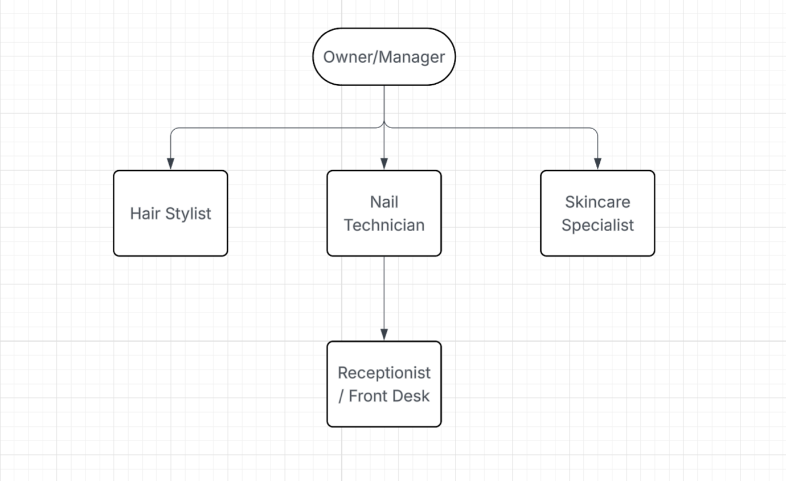

Figure 1: Organisational Chart.

Key Milestones
To analyse how to business will develop over time, it’s important to outline the key steps Simo’s Beauty Salon would fallow during its first year. The milestones below help track the progress and make sure the task is completed on schedule but also guide the salon from planning to full operation.
- Months 1–2: Secure premises and renovate.
- Month 3: Purchase equipment and install technology.
- Month 4: Hire staff.
- Month 5: Soft launch.
- Month 6: Grand opening.
- Month 12: Financial review and expansion planning.

Financial Plan (One Year)

Sources of Finance
Simo’s Beauty Salone will use a combination of personal savings combined with a small bank loan and a private investor to fund the initial setup capital of the business. This will lower the financial risk and provide enough money for the equipment’s, rent deposit and interior setup but also allow for the marketing which will be need for the early stages of the business.
- Personal Savings: £20,000.
- Bank Loan: £15,000.
- Private Investor: £5,000.
- Total Funding: £40,000.

Cash Flow Forecast
Bellow you can see the table for the cash flow forecast which shows the expected monthly income and expenses during the first year of operation of Simo’s Beauty Salon. It provides the business with information of when it will have positive cash flow and manage spendings and be able to plan for periods of maybe lower revenues. The table also points out how the salon will be more profitable as customer number increase throughout its first year of opening
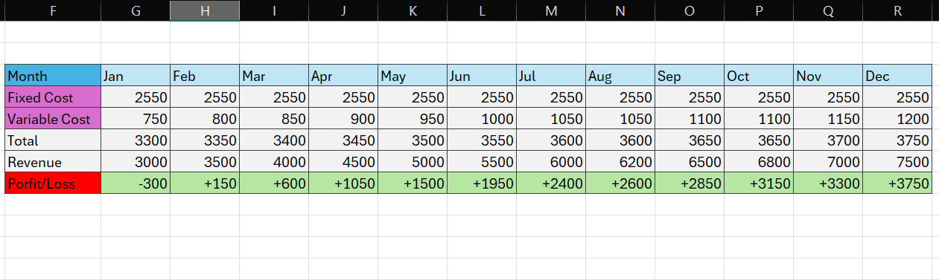

Table 1: Cash Flow Forecast

Here you can see a few more calculations that will help the business understand more things and see more things clearly with the start-up, running cost and others, it gives the business a roughly idea of what to expect and prepare for it
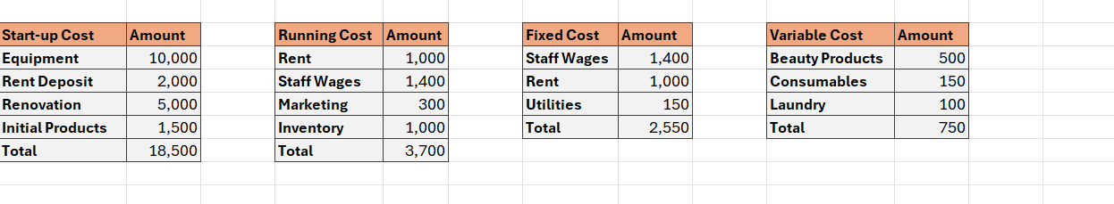

Table 2: Calculations

Sales Forecast
Sales for the salon are expected to grow slowly through its first year of opening due to the factors that it will build customer loyalty and attract more people thru the marketing it will have a from other happy customers spreading the word around. It will expect this thing from May onward as even show in the forecast table due to increased bookings and customer coming back.
- Early months (Jan-Mar): Lower revenue due to the new business launch
- Mid-year (Apr-Aug): Increased demand from marketing and customer revisit.
- End of year (Sept-Dec): Strongest sale period for the salon.

Cost of Production Forecast
The cost of production will include all the expenses required to deliver the beauty services to clients, such as beauty products, tools and small equipment replacements. All these costs are variable and increase as the salon serves more customers. An estimate of a monthly cost of production would be around £750-£1,200 depending on the demand and product use the salon has and number of customers it serves during that month.

Break Even Analysis
The break Even for Simo’s Beauty Salon would be achieved when the total revenue equals total costs were based on the current financial calculations the salon is expected to reach that break-even between Month 8 and Month 10. This is again because of the lower customers expected during the first few months and then higher volumes later down the year.

Operations and Management Plan

Production of Good and Service
Simo’s Beauty Salon would provide its services through well trained staff using professional tools and safe, hygienic methods. Each of the service, nails, hair and skincare would be carried out using the best quality products and equipment to maintain and ensure the consistent result that customers are after. The customers would be able to book thru the online system so that everything would be organized and bring efficiency and comfort to the salon.

Technology Plan
Technology has a key part in how the salon will operate smoothly and offer a modern customer experience. Using digital tools and other technologies it will make sure that the clients are satisfied and have a great experience at the salon.
- Online booking and scheduling system
- Card‑only and digital wallet payment systems
- Digital skin analysis device
- Social media management tools and CRM system

Human Resource Plan
The salon would hire qualified and friendly staff which are able to deliver high-quality beauty services. All the employees will receive regular training to keep their skills updated. Also introducing a simple reward and performance system it will help the staff be motivated and more positive in the environment.

Expansion Plan
Simo’s Beauty Salon aims to add advanced aesthetic services, expand retail product offerings, and open a second location within 3 years to increase its revenue and attract a larger customer base overall. Membership programmes and service packages will also grow long‑term revenue for the salon and attract more customers.

Reference List
Revenue of the Beauty & Personal Care Market in the United Kingdom.
Available at: https://www.statista.com
British Beauty Council (2023) The Value of Beauty: Industry Report.
Available at: https://britishbeautycouncil.com
The King’s Trust (no date) Business plans and templates. Available at: https://www.kingstrust.org.uk/how-we-can-help/tools-resources/business-tools/business-plans
GOV.UK Write a business plan. Available at: https://www.gov.uk/write-business-plan
Sage: How to write a business plan. Available at: https://www.sage.com/en-gb/blog/how-to-write-a-business-plan/
Start Up Loans Business plan template. Available at: https://www.startuploans.co.uk/support-and-guidance/business-guidance/business-planning-templates/business-plan-template
Wapshott, R. and Mallett, O. (2024) ‘Small business stories in the formation of enterprise policy: a narrative policy analysis of the UK Bolton Committee’, Small Business Economics,

